Analysis of the Physiological Effects of Spaceflight
Using Open Data and Development of an Interactive Dashboard
Internship Report
TUNSA — Tunisian Space Association
Prepared by: Rayen Karous
2nd-Year Preparatory Engineering Student
August 2026

Abstract
This report presents the results of a one-month internship project analyzing the physiological effects of spaceflight on the human body, and the development of an accompanying interactive dashboard for data exploration. The project combines three complementary open data sources: a 570-astronaut career metadata dataset, a literature-compiled dataset of 38 published physiological findings spanning bone, muscle, cardiovascular, and sleep systems, and a real longitudinal blood-panel dataset from NASA's Inspiration4 civilian mission. Rather than assuming data availability, the project began with a systematic, column-by-column verification of what each source could and could not support, which shaped a realistic, defensible final scope. Key findings include site-specific bone density loss patterns, duration-dependent muscle and cardiovascular effects, and a real post-flight hematological recovery trajectory — alongside an honest identification of a likely data-entry anomaly and a correction of an initially overstated finding. The resulting Streamlit dashboard presents all findings with explicit, traceable limitations rather than implied completeness.

1. Introduction

1.1 Context
Human spaceflight subjects the body to a set of stressors with no equivalent on Earth: sustained microgravity, radiation exposure, and disrupted circadian rhythm chief among them. As missions grow longer — from short Shuttle flights to multi-month ISS stays and eventually planned Mars transits — understanding how the body adapts, and how well it recovers, becomes increasingly important for mission planning and astronaut health.
This project was carried out as part of a preparatory engineering internship at TUNSA (Tunisian Space Association), with the goal of applying data science methodology to a real, if data-constrained, domain: space medicine.

1.2 Project Objectives
- Quantify how key physiological systems (bone, muscle, cardiovascular, sleep) change during and after spaceflight
- Compare physiological impact across mission durations (short vs. long-duration flights)
- Enable exploration and comparison across astronauts and missions
- Deliver an interactive, filterable dashboard for non-technical exploration of the findings
- Practice a complete, professional data science workflow: collection → verification → cleaning → analysis → dashboard → reporting

2. Methodology

2.1 Data Source Selection
Three datasets were selected after directly verifying access constraints rather than assuming availability. Initial plans to use NASA's Life Sciences Data Archive (LSDA) for individual-level astronaut biomedical records were abandoned after confirming that identifiable data requests require Institutional Review Board approval and a multi-month process — incompatible with a one-month internship timeline. Similarly, NASA's Open Science Data Repository (OSDR/GeneLab) was found to be dominated by 'omics data (genomics, proteomics) from model organisms such as mice, rather than accessible human tabular data.
The final data strategy instead combined:
- Astronaut and mission metadata (Kaggle, 570 astronauts) — for population-level, career-based comparison
- A literature-compiled dataset of 38 findings drawn from peer-reviewed publications — covering aggregate, cross-study findings across four physiological systems
- Real blood-panel data from NASA OSDR's Inspiration4 mission (OSD-569/LSDS-7) — the project's only genuinely longitudinal, individual-level dataset (4 subjects, 7 timepoints, 23 blood analytes)

2.2 Systematic Coverage Verification
Before any analysis code was written, every originally desired parameter (e.g. bone turnover markers, resting heart rate, heart rate variability, muscle fiber-type atrophy, countermeasure adherence) was checked against the actual columns and values present in each dataset — not assumed from the dataset's general subject matter. This produced a parameter-by-parameter coverage table (full version in the project's docs/data_coverage_analysis.md) classifying each parameter as fully covered, partially covered (proxy or aggregate), or missing.
This verification step surfaced an important structural finding: none of the three datasets contain any in-flight/during-mission measurement timepoint, for any physiological system. All available data is either pre-flight, post-flight, or aggregate cross-study. This directly shaped the final project scope, redirecting emphasis toward what the data could genuinely support — particularly post-flight recovery — rather than an unsupported "during-mission adaptation" narrative.

2.3 Data Cleaning
- Astronaut records: parsed cumulative flight time into numeric days; split free-text mission lists into individual entries; validated parsed mission counts against the source's own flight-count column (0 mismatches across 570 records)
- Mission records: extracted individual astronaut-mission pairs from free text; classified vehicle type via best-effort name matching, explicitly documented as non-authoritative
- Blood panel data: computed each subject's own pre-flight baseline per analyte, then percent change from that baseline at every timepoint, to power recovery-trajectory analysis

2.4 Data Quality Handling
During analysis, 16 of 553 blood panel readings were found to fall outside the lab's own reference range. Investigation showed 7 of these belonged to a single subject/timepoint (C003, pre-flight L-92) with simultaneous extreme abnormalities across nearly every white blood cell parameter — a pattern far more consistent with a data entry or unit-scaling error (e.g. a platelet volume reading of 330 against a normal range of 7.5–12.5) than a genuine physiological finding. This timepoint was flagged and excluded from headline trend analysis, with the reasoning documented transparently rather than the data point being silently deleted or silently retained.

2.5 Statistical Approach
Given that the literature dataset contains only 8-10 rows per physiological system, often just 2-5 rows per short/long duration bucket, a deliberate decision was made not to run formal hypothesis tests (t-tests, ANOVA) on these aggregate study-level figures, since a p-value computed on such small group sizes would imply false statistical precision. Descriptive comparisons are reported instead, clearly labeled as directional patterns rather than statistically confirmed differences.

3. Results

3.1 Bone Health
Bone mineral density loss during spaceflight is site-specific rather than uniform. Weight-bearing skeletal regions (lumbar spine, pelvis, lower limbs) show the largest losses — up to 6% over a long-duration mission — while the skull shows a slight density increase. This pattern is consistent with the mechanical-loading theory of bone remodeling: bones that normally bear body weight lose density fastest when that load disappears in microgravity.
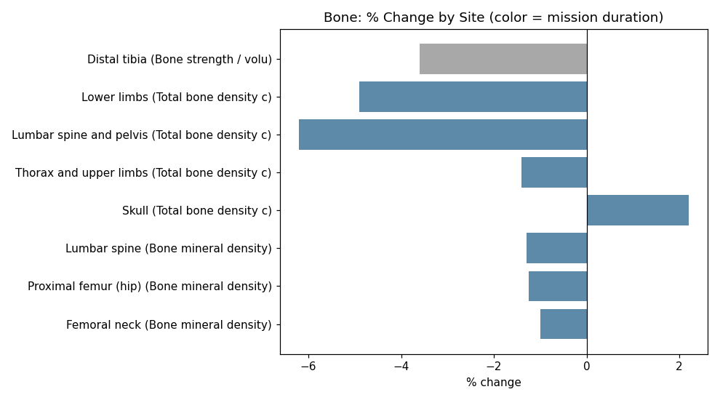
Figure 1 — Bone mineral density % change by skeletal site, colored by mission duration.
At one year post-flight, recovery remains incomplete for many astronauts: only 34.0% had fully recovered baseline hip bone density, and 46.8% had recovered spine density, based on the literature reviewed.
⚠ Limitation: this data is aggregated across published studies (cross-study means), not longitudinal measurements on individual astronauts. No bone-density-vs-lean-mass relationship or bone turnover marker data was available in any dataset used in this project.

3.2 Muscle Health
Muscle mass loss shows a clear duration-dependent pattern: for matching muscle groups, long-duration mission losses are consistently larger than short-duration losses. For example, calf muscle loss was approximately 6% after an 8-day mission, compared to approximately 13% after a 6-month mission.
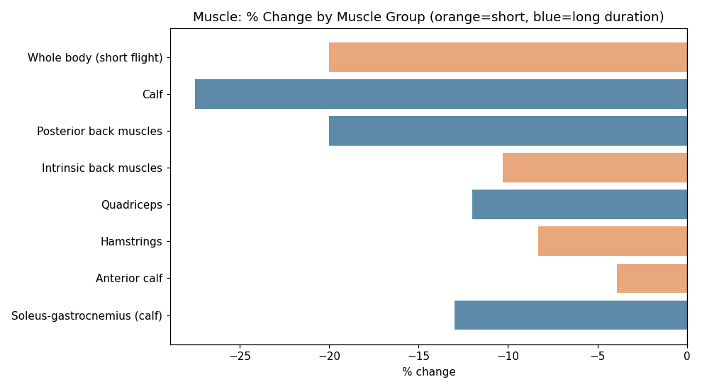
Figure 2 — Muscle % change by group; orange = short-duration, blue = long-duration missions.
⚠ Limitation: only one muscle strength data point (calf twitch force, long-duration missions only) was available. No muscle fiber-type (Type I atrophy) data exists in any open, non-gated dataset identified during this project.

3.3 Cardiovascular System
Orthostatic intolerance — dizziness or fainting risk upon standing after return to Earth — shows one of the strongest duration effects found in this project: incidence rises from approximately 25-30% after short-duration missions to as high as 83% after long-duration missions.
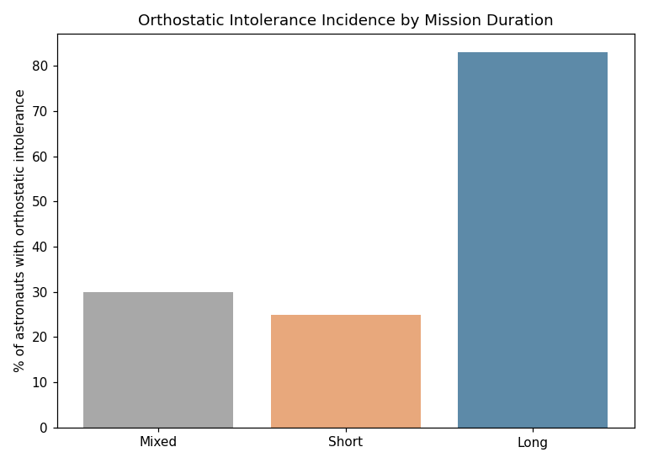
Figure 3 — Orthostatic intolerance incidence by mission duration category.
Early in-flight, fluid shifts toward the upper body were found to increase cardiac output and stroke volume, before cardiovascular deconditioning develops over a longer mission — an interesting non-monotonic pattern worth further investigation.
⚠ Limitation: resting heart rate, blood pressure, and heart rate variability (HRV) — all originally desired parameters — were not available in any of the three datasets used. This represents a genuine gap in open, individual-level cardiovascular spaceflight data, not an oversight.

3.4 Sleep
Astronauts consistently sleep less than NASA's own 8.5-hour in-flight schedule, averaging approximately 6.0-6.1 hours per night regardless of mission duration. This appears to be an operational/environmental effect rather than a duration-dependent physiological adaptation, since the deficit is similar for both short and long missions.
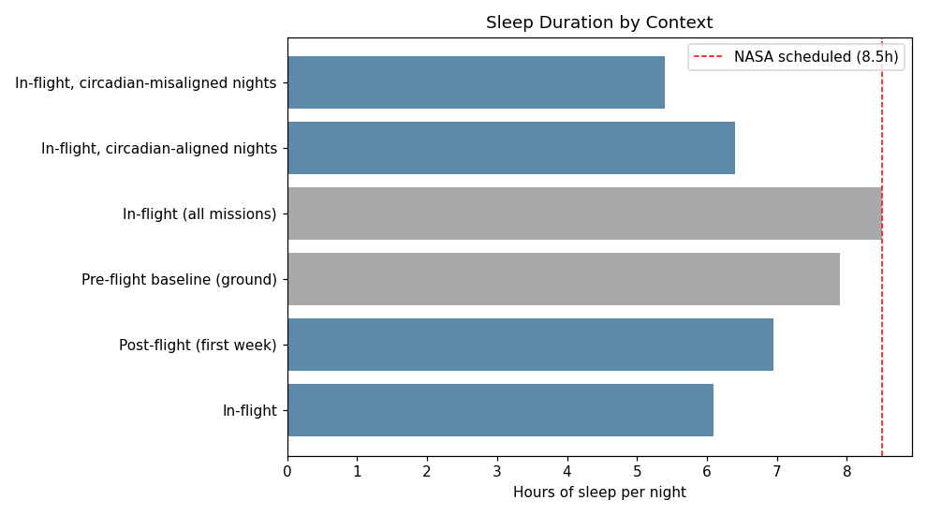
Figure 4 — Average sleep duration by mission phase and context.
⚠ Limitation: no validated sleep quality or sleep efficiency score was available. "Percent of nights under 6 hours" is used as a rough disturbance proxy, not a clinical insomnia measure.

3.5 Recovery Case Study — Inspiration4 Blood Panel
The Inspiration4 blood panel dataset is the only genuinely longitudinal, individual-level dataset used in this project, tracking 4 real astronauts across 23 blood analytes from 92 days before launch to 194 days after return.
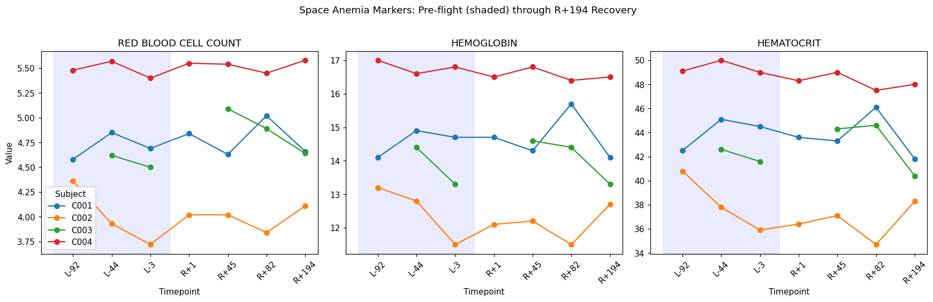
Figure 5 — Red blood cell count, hemoglobin, and hematocrit trajectories for all 4 Inspiration4 crew members, pre-flight through R+194.
A well-documented phenomenon in longer-duration spaceflight is "spaceflight-induced anemia" — a post-flight dip in red blood cell parameters. This hypothesis was tested directly against the Inspiration4 data rather than assumed, and the expected pattern was not clearly present: one subject's values remained essentially flat throughout, and another's lowest reading occurred pre-flight rather than post-flight. The most plausible explanation is that Inspiration4, at approximately 3 days, was too short to trigger the red-cell-mass loss documented in much longer ISS missions. This is treated as a genuine, duration-dependent finding rather than forced to match the literature's typically longer-duration-based narrative.
A note on scientific process: an early draft of this analysis stated the classic anemia pattern was present in this data, based on the general shape of the chart. On checking the actual pivoted values, this claim did not hold up and was corrected before being included in this report — a useful reminder that visual impressions from a chart should always be checked against the underlying numbers.

3.6 Astronaut & Mission Comparison
The astronaut dataset (570 individuals) is dominated by United States and Soviet/Russian program astronauts, reflecting the long operational history of the Space Shuttle, Mir, and Soyuz programs.
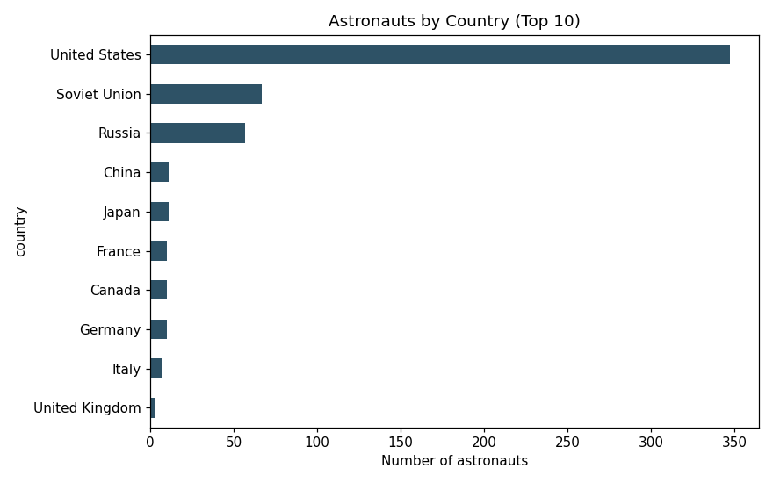
Figure 6 — Astronauts by country (top 10).
Career time-in-space is fairly evenly distributed across short, medium, and long duration categories, supporting balanced filtering in the dashboard's comparison tools.
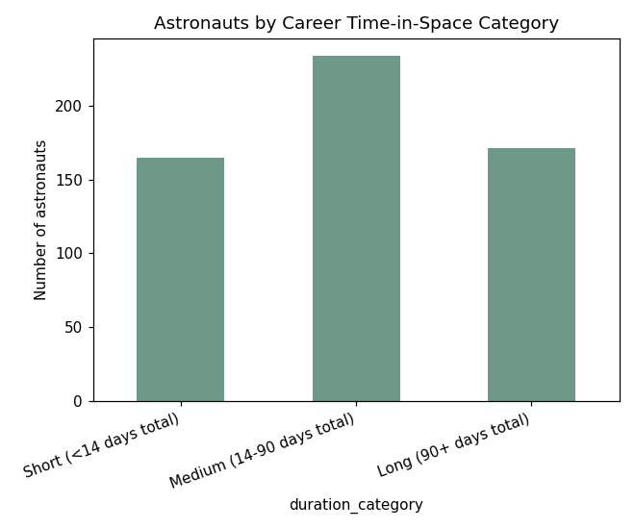
Figure 7 — Astronaut distribution by career time-in-space category.
⚠ Limitation: mission duration in the astronaut dataset is cumulative across an astronaut's entire career, not per individual mission. No astronaut age or exact per-mission dates/duration were available in the source data.

4. Interactive Dashboard
An 8-page Streamlit dashboard was developed to make all findings above explorable interactively. Pages include: Home, Bone Health, Muscle Health, Cardiovascular, Sleep, Recovery Case Study, Astronaut Comparison, and Mission Comparison. Every page includes an explicit, source-linked limitation notice, ensuring the dashboard and this report never present findings inconsistently.
The dashboard was verified using Streamlit's AppTest framework, executing every page's real logic against real data with zero runtime exceptions, in addition to a live local server boot check.

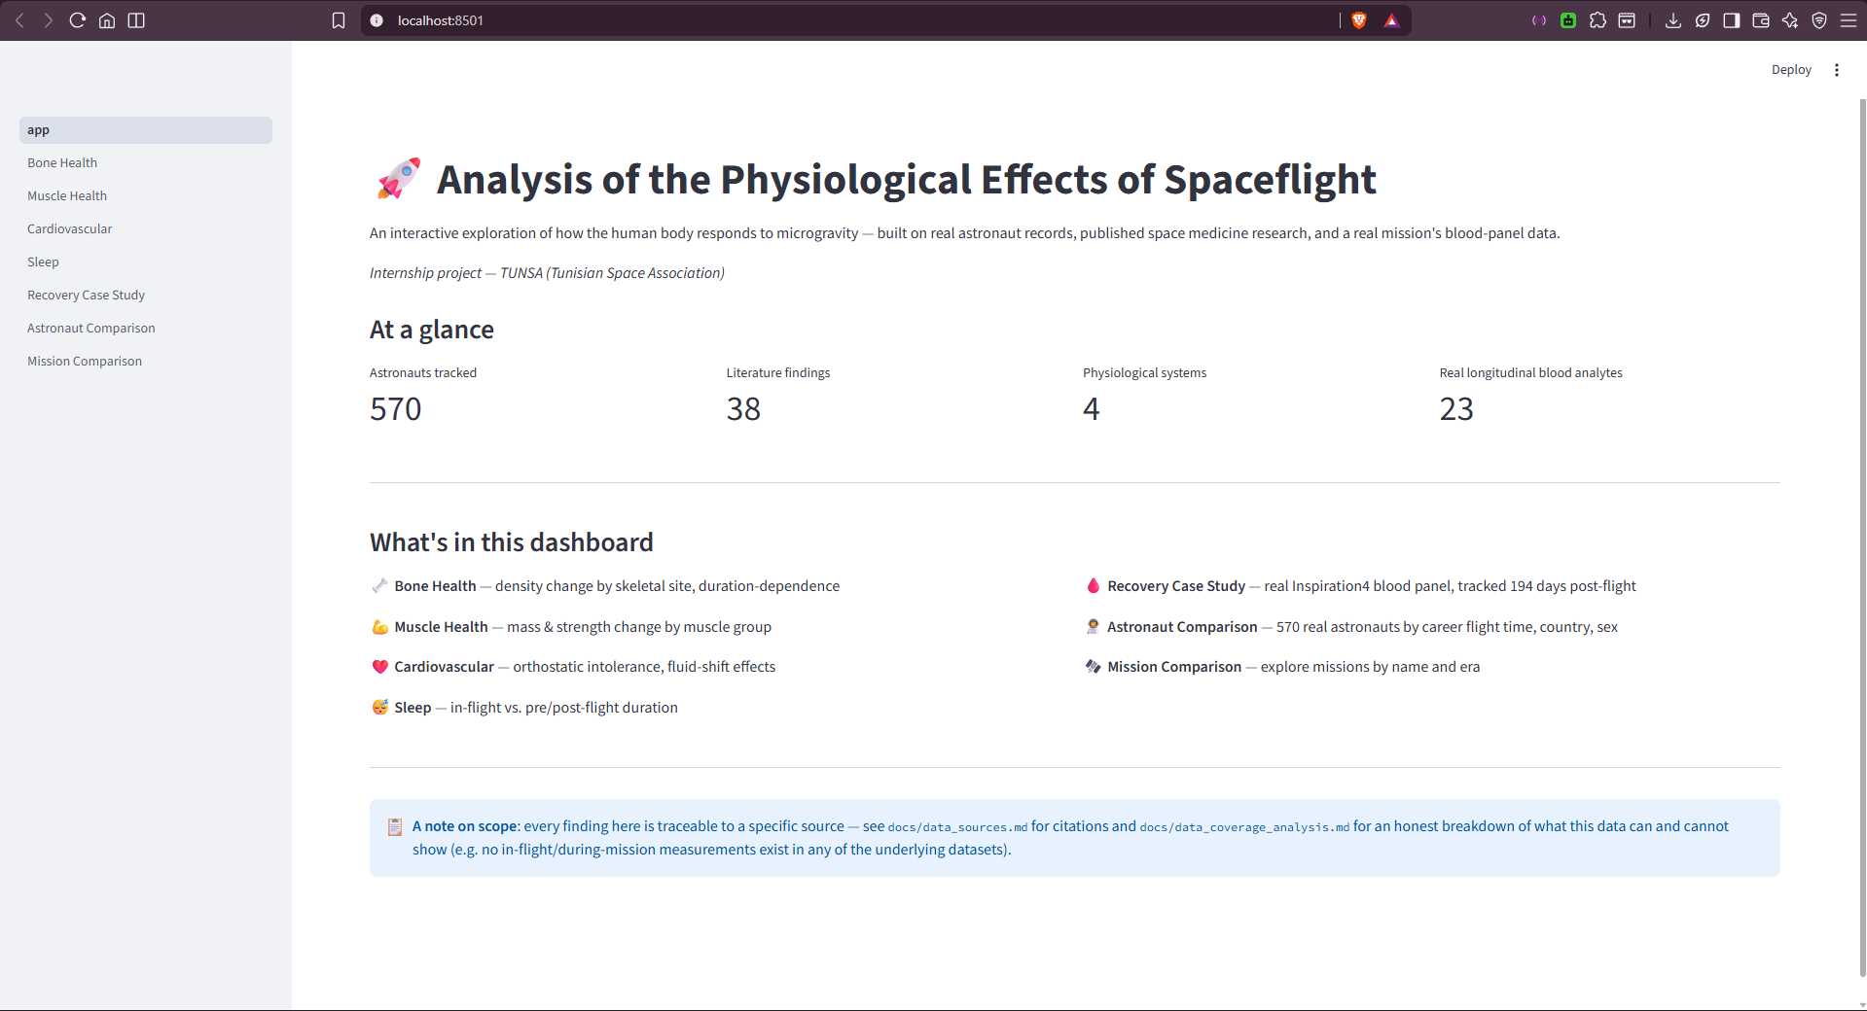

5. Limitations & Future Work

5.1 Known Limitations
- No in-flight/during-mission measurement exists in any dataset used, for any physiological system
- No bone turnover markers, muscle fiber-type data, resting heart rate, blood pressure, or HRV
- No astronaut age or countermeasure (exercise protocol) adherence data
- Literature-compiled findings are cross-study aggregates, not individual longitudinal measurements
- Mission metadata (duration, dates, vehicle type) is only approximately recoverable via text parsing, not from clean structured fields

5.2 Future Work
- Pursue formal LSDA data access (with appropriate institutional support) for individual-level longitudinal records
- Incorporate NASA OSDR 'omics data for molecular-level analysis, given appropriate bioinformatics resources
- Check sibling Inspiration4 OSD studies (OSD-570 through OSD-687) for additional non-omics clinical panels
- Add predictive modeling to estimate physiological impact for planned mission durations

6. Conclusion
This project demonstrates that a rigorous, honest data science workflow is achievable even under significant data-access constraints — provided those constraints are identified early and the project scope is adapted accordingly, rather than assumed away. By systematically verifying data coverage before writing analysis code, the project avoided both an unsupported "complete" narrative and a paralyzed stall waiting for inaccessible data. The resulting dashboard and findings, while scoped more narrowly than the original ambition, are fully traceable to real, cited sources — a foundation that can be extended in future work as data access permits.

7. References
Full citations with URLs are maintained in docs/data_sources.md in the project repository. Key sources include:
- NASA HHP Bone and Mineral Lab — bone density loss reviews
- Systematic review & meta-analysis of bone loss in space travelers, npj Microgravity
- LeBlanc et al. (1995) — STS-47 muscle volume changes, PubMed
- Update on effects of microgravity on the musculoskeletal system, npj Microgravity (2021 review)
- Orthostatic intolerance in spaceflight: systematic review & meta-analysis (2026)
- The Cardiovascular System in Space, PMC review
- Barger et al. (2014) — actigraphy sleep study, Shuttle and ISS astronauts
- NASA Open Science Data Repository — OSD-569 / LSDS-7, Inspiration4 Complete Blood Count
- Kaggle — International Astronaut Database

