**Name-Surname : Rayene BECH Email : l1118115@std.yildiz.edu.tr**

**No :18011115 Signature :**

HOME WORK 1 (Return by 20.12.2021)

_______________________ **BLM3590 – Statistical Data Analysis** ______***_****_*_______________

|  |  |  |  |  |  |  |  |  |  |  |
| --- | --- | --- | --- | --- | --- | --- | --- | --- | --- | --- |
| T1(10) | T2(15) | T3(15) | T4(15) | T5(15) | T6(15) | T7(15) |  |  |  | Total(100) |
|  |  |  |  |  |  |  |  |  |  |  |

The attached Excel file (**SdA-HW**) consists of two clases of data (embolic signals (**class 1**), and Doppler speckle (**class 2**)) recorded from stroke patients and some relevant numerical variables (**tpthrt**, **pkthrt**, **dfdrrt**, **time**, **rrt**, **frt**). Using this data file, implement the following tasks in **R**. You must include the **R** scripts in your answers.

**============================================================================**

**T1:** Show how to read this Excel datafile into **R** environment.

----------------------------------------------------------------------------------------------------------------------------------------------------------------------------------------

**#First the package that allow us to read “.xls” files should be installed using the following instruction:**

*> install.packages("readxl")*

**#The following code is executed:**

*library("readxl")*

*df <- read_excel("2k21-SdA-HW1.xls")*

**#Note: The working directory should be selected prior to the execution of the program using the following instruction:**

*setwd("working_directory_path")*

**============================================================================**

**T2:** This data file requires some preprocessing as it inludes a column with no value, some cells with no numerical value (divide by 0 error, etc.), and some cells with zero. Write required script in **R** to remove the empty column and correct the cells with no numerical value and zero by using simple interpolation.

----------------------------------------------------------------------------------------------------------------------------------------------------------------------------------------

**#The empty column can be identified using the function sapply() :**

*empty_column <- sapply(df, function(x) all(is.na(x) | x == ""))*

**#This function returns True for the empty columns and False for non-empty columns as it can be seen bellow:**

*> empty_column*

*class tpthrt pkthrt dfdrrt time rrt frt*

*FALSE FALSE FALSE FALSE TRUE FALSE FALSE*

**#Now the empty column can be deleted:**

*df= df[, !empty_column]*

**#To get rid of zero valuesw, we turn them to NA and then To replace non numerical values the package “imputeTS” is installed and used:**

*df[df == 0] <- NA*

*install.packages("imputeTS")*

*library(imputeTS)*

*df = na_interpolation(df)*

**This package “imputeTS” contains many other functions that we could use to replace the NA values. For example, we could use “na_mean” to replace the missing values with the mean.**

**All the functions of this package are listed in this table:** 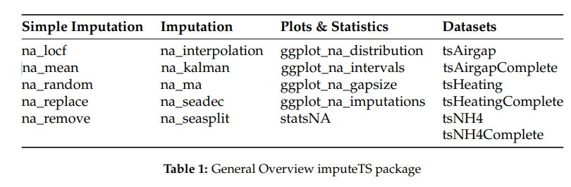

**============================================================================**

**T3:** Find **Five-number data summary** of the **variables** for each **data class** in this dataset.

----------------------------------------------------------------------------------------------------------------------------------------------------------------------------------------

**Requirements: to use the pipeline operator %>% we need to install and import the “dplyr” package**

*install.packages(“dplyr”)*

*library(“dplyr”)*

**Then to access each class we use the function filter()**

**We finally call the function summary which will give us the five number summary**

**For class 1:**

> summary(subset(df %>% filter(df$class==1), select = -c(class)))

tpthrt pkthrt dfdrrt rrt frt

Min. : 0.3364 Min. :-8.359 Min. : 0.2601 Min. :-59.765 Min. : 0.9525

1st Qu.:12.0774 1st Qu.: 3.320 1st Qu.:12.2683 1st Qu.: 2.925 1st Qu.: 4.5475

Median :14.8535 Median : 5.949 Median :17.8565 Median : 5.655 Median : 6.5960

Mean :15.6507 Mean : 5.793 Mean :17.5927 Mean : 4.236 Mean : 7.5667

3rd Qu.:19.4746 3rd Qu.: 8.319 3rd Qu.:22.4063 3rd Qu.: 9.469 3rd Qu.:10.1026

Max. :28.8640 Max. :19.907 Max. :45.4140 Max. : 20.610 Max. :24.7323

**For class 2:**

> summary(subset(df %>% filter(df$class==2), select = -c(class)))

tpthrt pkthrt dfdrrt rrt frt

Min. : 0.008013 Min. :-9.623 Min. :-3.476 Min. :-68.801 Min. : 0.05729

1st Qu.: 8.038797 1st Qu.:-1.003 1st Qu.: 7.022 1st Qu.: -7.168 1st Qu.: 2.16383

Median :11.451826 Median : 1.277 Median :13.799 Median : 2.211 Median : 3.90122

Mean :11.093465 Mean : 1.301 Mean :14.419 Mean : -3.131 Mean : 4.93257

3rd Qu.:14.265218 3rd Qu.: 4.161 3rd Qu.:21.877 3rd Qu.: 4.616 3rd Qu.: 6.30550

Max. :20.963047 Max. : 7.324 Max. :40.545 Max. : 26.127 Max. :32.28238

**============================================================================**

**T4:** Plot **boxplots** of the **variables** for each **data class** and determine if there is any outlier in these variables.

----------------------------------------------------------------------------------------------------------------------------------------------------------------------------------------

**For class 1:**

*boxplot(subset(df %>% filter(df$class==1), select = -c(class)))*

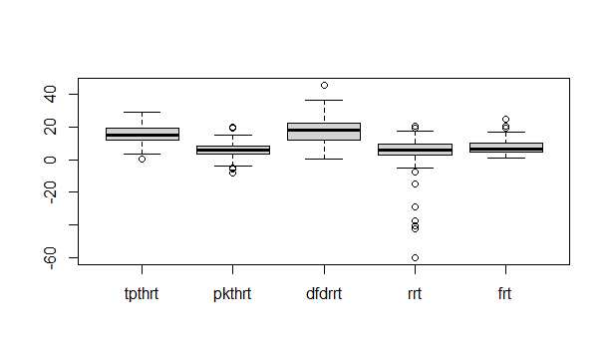

Figure 1: boxplot of class 1

Yes there are outliers for all variables shown by the circle

**For class 2:**

*boxplot(subset(df %>% filter(df$class==2), select = -c(class)))*

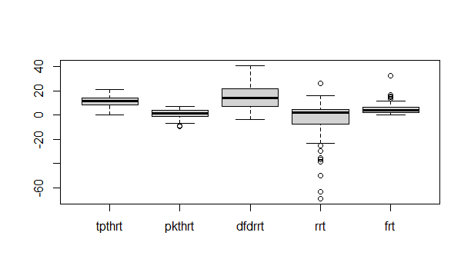

Figure 2: boxplot of class 2

Yes there are outliers for the following variables: “pkthrt”, “rrt”, “frt”

**============================================================================**

**T5:** Plot histogramsof the **variables** for each **data class**, compare the histograms, and comment on the distributions.

----------------------------------------------------------------------------------------------------------------------------------------------------------------------------------------

**Plotting “tpthrt”**

*c1 <- subset(df %>% filter(df$class==1), select = c(tpthrt))*

*hist(c1$tpthrt)*

*c2 <- subset(df %>% filter(df$class==2), select = c(tpthrt))*

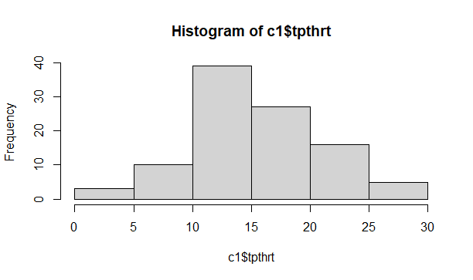*hist(c2$tpthrt)*

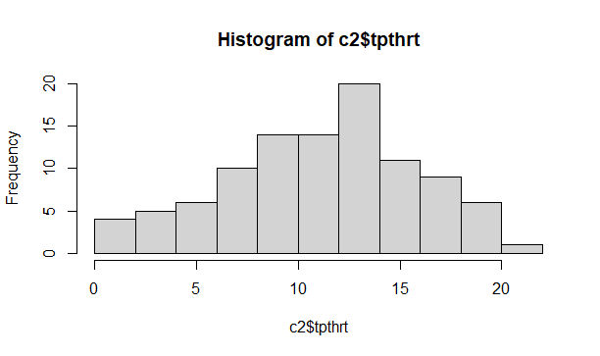

Histogram of “tpthrt” for class 2

Histogram of “tpthrt” for class 1

**Both distributions can be considered as normal distributions. Note that class 1 has greater range (from 0 to 30) comparing to class 2 (from 0 to 25) While class 2 has greater number of cells. Class 1 has greater mean and median (around 15) than class 2 has (around 12)**

**Plotting “pkthrt”**

*c1 <- subset(df %>% filter(df$class==1), select = c(pkthrt))*

*hist(c1$pkthrt)*

*c2 <- subset(df %>% filter(df$class==2), select = c(pkthrt))*

*hist(c2$pkthrt)*

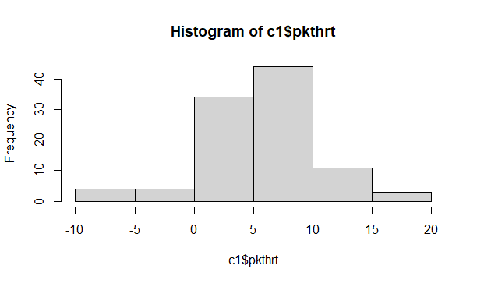 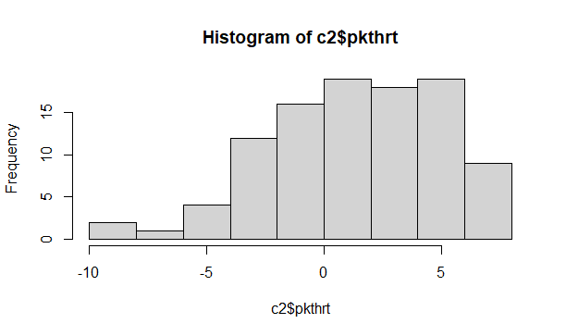

Histogram of “pkthrt” for class 2

Histogram of “pkthrt” for class 1

**The class 1 has normal distribution while class 2 has left-skewed distribution. Also class 1 has greater range (from -10 to 20) comparing to class 2 (from -10 to 10). We can also notice that the histogram of class 2 has greater number of cells. Class 1 has greater mean and median (around 5) than class 2 has (around 1)**

**Plotting “dfdrrt”**

*c1 <- subset(df %>% filter(df$class==1), select = c(dfdrrt))*

*hist(c1$dfdrrt)*

*c2 <- subset(df %>% filter(df$class==2), select = c(dfdrrt))*

*hist(c2$dfdrrt)*

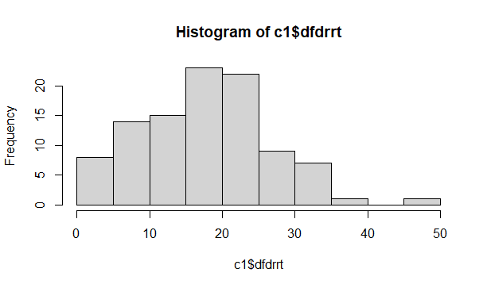 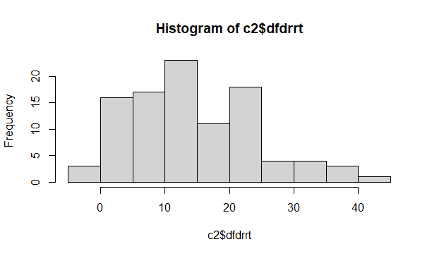

Histogram of “dfdrrt” for class 1

Histogram of “dfdrrt” for class 1

**The class 1 has right-skewed distribution while class 2 seems to have bimodal distribution. Also class 1 has greater range (from 0 to 50) comparing to class 2 (from 0 to 40). That’s because class 1 has an outlier at 50.**

**Plotting “rrt”**

*c1 <- subset(df %>% filter(df$class==1), select = c(rrt))*

*hist(c1$rrt)*

*c2 <- subset(df %>% filter(df$class==2), select = c(rrt))*

*hist(c2$rrt)*

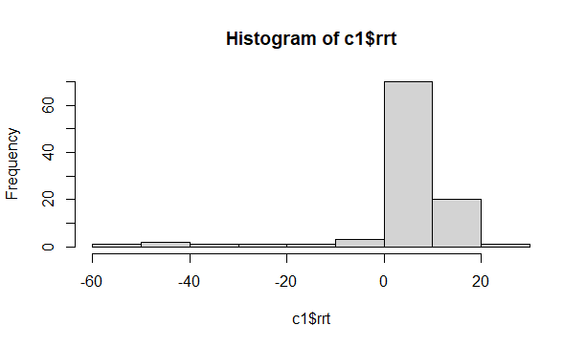 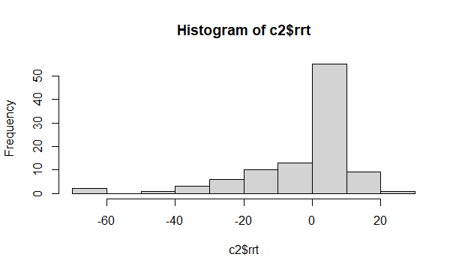

Histogram of “rrt” for class 1

Histogram of “rrt” for class 2

**Both classes have left-skewed distributions and equal ranges. Class 2 has more standard deviation than class 1 .**

**Plotting “frt”**

*c1 <- subset(df %>% filter(df$class==1), select = c(frt))*

*hist(c1$frt)*

*c2 <- subset(df %>% filter(df$class==2), select = c(frt))*

*hist(c2$frt)*

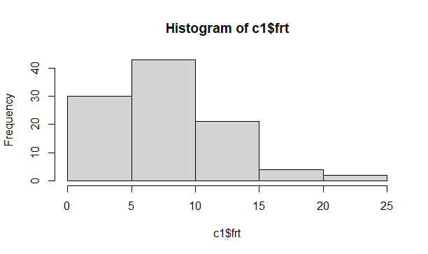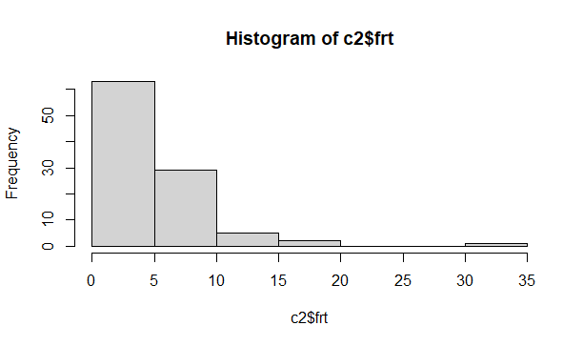

Histogram of “frt” for class 2

Histogram of “frt” for class 1

**Both classes have right-skewed distributions. Class 2 has more standard deviation than class 1 . Also class 2 has greater range (from 0 to 35 ) comparing to class 2 (from 0 to 25). That’s because class 2 has an outlier at 35. Finally, Class 1 has greater mean and median (around 7) than class 2 has (around 4)**

**============================================================================**

**T6:** First, normalize the **variables** for each **data class** so that the values of these variables range between **0** and **1**, and then line-plot (using different colors) each variables for both data classes in one figure (total 5 figures). Comment on the similarities of the variables for each plot.

----------------------------------------------------------------------------------------------------------------------------------------------------------------------------------------

**To normalize we define the following function:**

*normalize <- function(x) {*

*return ((x - min(x)) / (max(x) - min(x)))*

*}*

**To normalize the first class:**

*c1 <- subset(df %>% filter(df$class==1), select = -c(class))*

*for(i in 1:ncol(c1)) { # for-loop over columns*

*c1[ , i] <- normalize(c1[ , i])*

*}*

**To normalize the second class:**

*c2 <- subset(df %>% filter(df$class==2), select = -c(class))*

*for(i in 1:ncol(c2)) { # for-loop over columns*

*c2[ , i] <- normalize(c2[ , i])*

*}*

**We could also use the “data.Normalization” function which provides mmany methods to do the normalization:**

**Usage**

**data.Normalization (x,type="n0",normalization="column",...)**

**type of normalization:**

n0 - without normalization, n1 - standardization ((x-mean)/sd), n2 - positional standardization ((x-median)/mad), n3 - unitization ((x-mean)/range), n3a - positional unitization ((x-median)/range), n4 - unitization with zero minimum ((x-min)/range), n5 - normalization in range <-1,1> ((x-mean)/max(abs(x-mean))), n5a - positional normalization in range <-1,1> ((x-median)/max(abs(x-median))), n6 - quotient transformation (x/sd), n6a - positional quotient transformation (x/mad), n7 - quotient transformation (x/range), n8 - quotient transformation (x/max), n9 - quotient transformation (x/mean), n9a - positional quotient transformation (x/median), n10 - quotient transformation (x/sum), n11 - quotient transformation (x/sqrt(SSQ)), n12 - normalization ((x-mean)/sqrt(sum((x-mean)^2))), n12a - positional normalization ((x-median)/sqrt(sum((x-median)^2))), n13 - normalization with zero being the central point ((x-midrange)/(range/2))

**line-plot for “tpthrt”**

*plot(c1$tpthrt, type="l", col="green",lwd=2, ylim=c(0,1.3))*

*lines(c2$tpthrt, col="red", lwd=2)*

*title("Plotting 'tpthrt' values for booth classes")*

*legend("topleft", legend=c("class 1", "class 2"),col=c("green", "red"), lwd=c(2,2), cex=0.7)*

**We can notice that the graphs are almost negatively corelated. Class 1 has values that are almost the opposite of Class 2:**

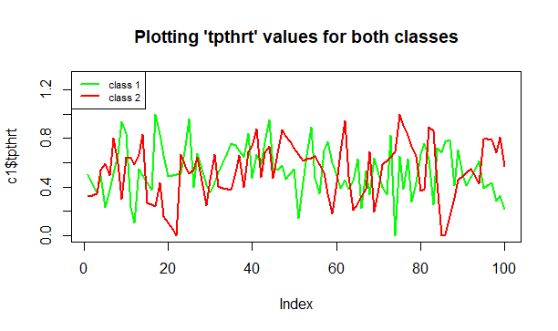

**Now let’s compare the distribution of “tpthrt” for both classes using this command:**

*plot( df$tpthrt,df$class, type="p", col=c("red","green")[df$class],lwd=2, ylim=c(0.9,2.1))*

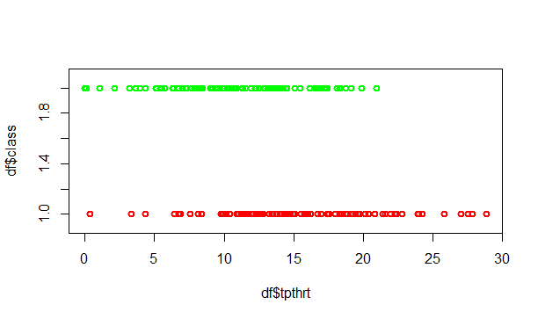

**We notice that the variable tpthrt has different values and density function for each class.**

**line-plot for “pkthrt”**

*plot(c1$pkthrt, type="l", col="green",lwd=2, ylim=c(0,1.3))*

*lines(c2$pkthrt, col="red", lwd=2)*

*title("Plotting ' pkthrt ' values for booth classes")*

*legend("topleft", legend=c("class 1", "class 2"),col=c("green", "red"), lwd=c(2,2), cex=0.7)*

**We can notice that the graphs are almost negatively corelated. Class 1 has values that are almost the opposite of Class 2. But the are a bit similar in the interval [50-80]:**

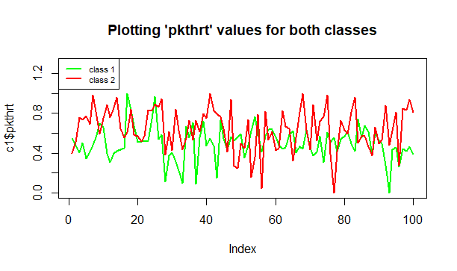

**Now let’s compare the distribution of “pkthrt” for both classes using this command:**

*plot( df$pkthrt,df$class, type="p", col=c("red","green")[df$class],lwd=2, ylim=c(0.9,2.1))*

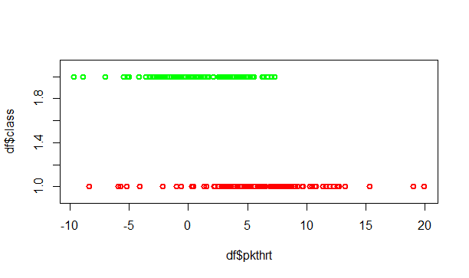

**Again we notice that the variable pkthrt has different values and density function for each class.**

**line-plot for “dfdrrt”**

*plot(c1$dfdrrt, type="l", col="green",lwd=2, ylim=c(0,1.3))*

*lines(c2$dfdrrt, col="red", lwd=2)*

*title("Plotting 'dfdrrt' values for both classes")*

*legend("topleft", legend=c("class 1", "class 2"),col=c("green", "red"), lwd=c(2,2), cex=0.7)*

**We can notice that the graphs are very similar for many intervals.**

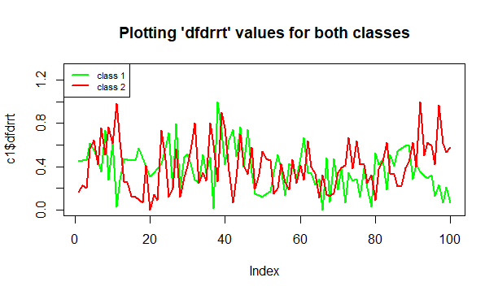

**Now let’s compare the distribution of “dfdrrt” for both classes using this command:**

*plot( df$dfdrrt,df$class, type="p", col=c("red","green")[df$class],lwd=2, ylim=c(0.9,2.1))*

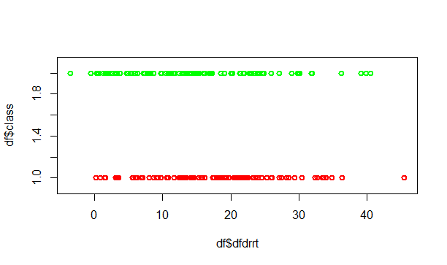

**We notice that the variable dfdrrt has almost same values and density function for both class. THUS WE CONCLUDE THAT IT IS A REDUNDANT DATA and can be deleted when comparing the classes or performing a classification task.**

**line-plot for “rrt”**

*plot(c1$rrt, type="l", col="green",lwd=2, ylim=c(0,1.3))*

*lines(c2$rrt, col="red", lwd=2)*

*title("Plotting 'rrt' values for both classes")*

*legend("topleft", legend=c("class 1", "class 2"),col=c("green", "red"), lwd=c(2,2), cex=0.7)*

**We can notice that the graphs are a little bit similar in the range [5-20]. But values of class 2 has opposite values of class 1 in the range [30-100]**

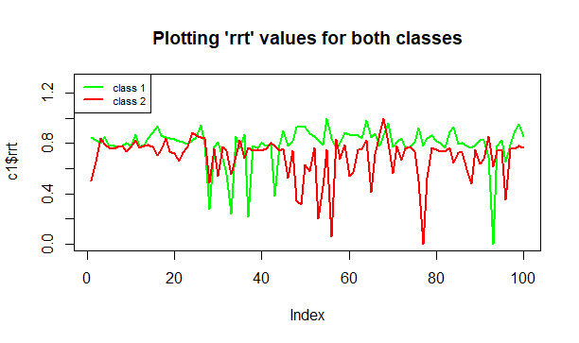

**Now let’s compare the distribution of “rrt” for both classes using this command:**

*plot( df$rrt,df$class, type="p", col=c("red","green")[df$class],lwd=2, ylim=c(0.9,2.1))*

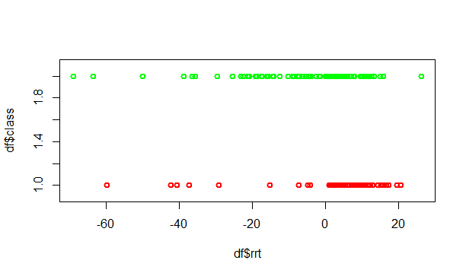

**We notice that the variable rrt has different values and density function for each class.**

**line-plot for “frt”**

*plot(c1$frt, type="l", col="green",lwd=2, ylim=c(0,1.3))*

*lines(c2$frt, col="red", lwd=2)*

*title("Plotting 'frt' values for both classes")*

*legend("topleft", legend=c("class 1", "class 2"),col=c("green", "red"), lwd=c(2,2), cex=0.7)*

**Again we can notice that the graphs are very similar for some intervals . But the values of class 1 are much bigger.**

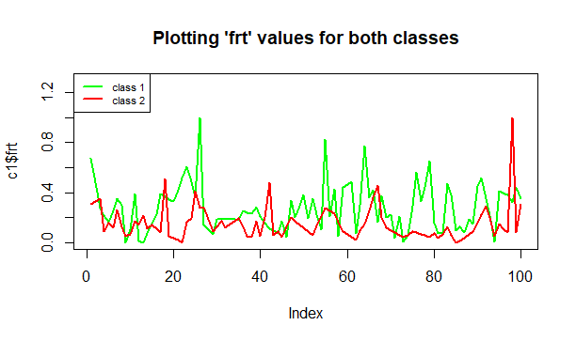

**Now let’s compare the distribution of “frt” for both classes using this command:**

*plot( df$frt,df$class, type="p", col=c("red","green")[df$class],lwd=2, ylim=c(0.9,2.1))*

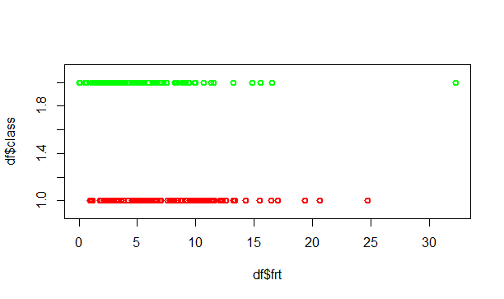

**We notice that the variable frt has almost same values and density function for both class. THUS WE CONCLUDE THAT IT IS A REDUNDANT DATA and can be deleted when comparing the classes or performing a classification task.**

**============================================================================**

**T7:** First, determine how similar the variables **tpthrt** and **pkthrt** are for each **data class**, and thendetermine how similar **tpthrt of data class 1** and **tpthrt of data class 2** by using similarity metric (correlation).

----------------------------------------------------------------------------------------------------------------------------------------------------------------------------------------

**For class 1:**

*c1 <- subset(df %>% filter(df$class==1), select = -c(class))*

*cor(subset(c1,select= c(tpthrt,pkthrt)))*

**output:**

**tpthrt pkthrt**

**tpthrt 1.0000000 0.6007039**

**pkthrt 0.6007039 1.0000000**

**This means the variables “tpthrt” and “pkthrt” of class 1 are 60.07039% similar**

**For class 2:**

*c2 <- subset(df %>% filter(df$class==2), select = -c(class))*

*cor(subset(c2,select= c(tpthrt,pkthrt)))*

**output:**

**tpthrt pkthrt**

**tpthrt 1.0000000 0.2726601**

**pkthrt 0.2726601 1.0000000**

**This means the variables “tpthrt” and “pkthrt” of class 2 are 27.26601% similar**

**Comparing “tpthr” of both classes:**

*cor(subset(c1,select= c(tpthrt)),subset(c2,select= c(tpthrt)))*

**output:**

**tpthrt**

**tpthrt -0.1982791**

**This means the variable “tpthrt” has similarity value of -0.1982791 between both classes.**