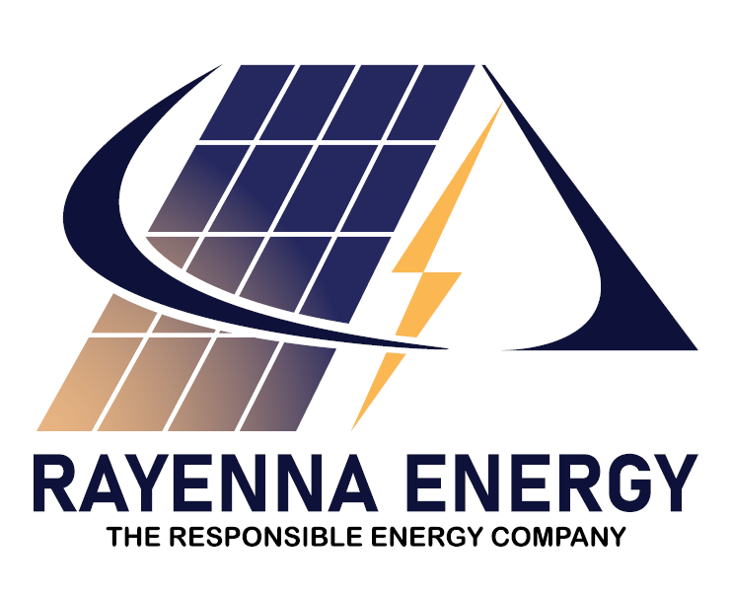 PROPOSAL

DATE | CLIENT | REF
 | TO , | RYN/PROPOSAL/000

PROPOSAL FOR KW ONGRID SOLAR POWER PLANT

Submitted by:

RAYENNA ENERGY PRIVATE LIMITED
Door No 3324/52, Ray Bhavan, NH Bypass, Thykoodam, Kochi - 682019 | Tel: +91 7907 369 304 | E-mail: sales@rayenna.energy
www.rayennaenergy.com

GST NO:
32AANCR8677A1Z6

BILL OF QUANTITIES FOR KW SOLAR POWER PLANT

SL NO | ITEMS | DESCRIPTION | QUANTITY
1 | PV MODULES
2 | INVERTERS
3 | MOUNTING STRUCTURE | - GP Structural Sections(16 Guage)  - Leak proof Foundation on poles if applicable  - SS304 Grade Nuts and J Bolts  - 35mm Aluminium Mid & End Clamps | As Required
4 | DC COMBINER BOX | - IP 66/67 Enclosure  - DC SPD per strin (Finder)  - DC Isolato Havells)  - 15 A Fuses Per String Mersen)  - IP 66/67 Cable Glands | 1Nos
5 | AC COMBINER BOX | - IP 66/67 Enclosure  - AC SPD Finder)  - AC MCB Havells)  - IP 66/67 Cable Glands | 1Nos
6 | DC CABLE | - 4 sq.mm 1.8kV UV DC cable  - Tinned Cu, Stranded Polycab/Reputed  - MEDIUM Grade PVC Conduits. | As Required
7 | AC CABLE | - 4 Sq mm 1.2kV Fire retardant flexible wire Polycab/Havells/Reputed)  - 4C 16 Sq mm copper UG Cable  - MEDIUM Grade PVC conduit | As Required
8 | EARTHING | - 10 SWG Copper for AC&DC Side.  - 250µ Cu Bounded Rod electrode (Excel)  - Earthing compound (Excel)  - Lightning Arrester (16sq.mm Aluminium cable) | As Required
9 | INSTALLATION, COMMISSIONING | - Transportation, Loading Unloading  - Installation, Cabling & panel Mounting | -

COMMERCIALS

SL NO | PARTICULARS | QTY | AMOUNT
1 | Design, Supply, Installation & commissioning of 25KW System including electrical and structural work. | 1 NO
PROJECT COST WITHOUT GST |  |  | 000/-
GST AMOUNT |  |  | 000/-
TOTAL PROJECT COST INCLUDING GST |  |  | 000 /-
RUPEES _ONLY

CLIENT SCOPE

- Clear shadow free rooftop area for the installation of PV panels.
- Space for installation and commissioning of electrical panels.
- A secured area for storage of supplied equipment till commissioning.
- Electricity – construction power/Water shall be arranged by the owner at its own cost.
- Customer need to provide internet connectivity for the system.
- Feasibility Charges - Rs.1000 + 18%GST
- Registration Charges - 25KW * Rs. 1000 (RS.25000/-)+ 18%GST
- NET METER AGREEMENT - Rs.200/-

TERMS AND CONDITIONS

- GST rates are subject to periodic changes. GST rates as on the date of Invoice will be only considered.
- Capacity that can be installed is subject to allocation of feasibility by KSEB.
- Any additional super structure required for the project needs to be taken up by the customer.
- Any modification to the existing electrical system due to non-conformity to Electrical inspectorate / Utility standards will have to be carried out by the customer.
- Net Meter cost will be additional if not supplied by Utility.
- Customer shall provide necessary support for getting approvals from the concerned utility section offices.
- VALIDITY: The offer is valid for 15 days from the date of proposal. The rate may vary after 15days.
- WARRANTY PERIOD:
- 12 Year product warranty and 30 year performance warranty for PV modules
- 7 Years warranty for Inverter.
- MATERIAL DELIVERY: 7 to 15 working days from the date of confirmed purchase order with advance.
- SERVICE DETAILS:
- Regular Monitoring of the system and complaint support for 5years
- Panel cleaning and inspection of the system in every 6months for 5years.

PAYMENT TERMS

- 50% advance of the total invoice value to be paid along with the Purchase Order.
- 30% of the total invoice value to be made towards supply of material at site.
- 10% against work completion and balance 10% to be paid immediately after meter installation.
ACCOUNT DETAILS:
Name: Rayenna Energy Private Limited
Type: Current Account
Bank: Axis Bank Limited
Account Number: 924020063493172
IFSC Code: UTIB0000827
All payments to the company should be in the form of NEFT or RTGS in favour of “Rayenna Energy Private Limited.”

We hope our offer is in line with your requirements and meets your expectations. Please contact for classifications, if any.

Looking forward for your valuable order confirmation.

Thanking you and assuring you of our best attention and services at all times.

FOR RAYENNA ENERGY PRIVATE LIMITED

GANESH VENKITACHALAM
MANAGING DIRECTOR

RAYENNA ENERGY PRIVATE LIMITED, Door No 3324/52, Ray Bhavan, NH Bypass, Thykoodam, Kochi – 682019. Tel: +91 7907 369 304 | E-mail: sales@rayenna.energy

