 | REF: RYN/QTN/  DATE: 00/00/2024  PROPOSAL FOR _KW ON GRID SYSTEM  CLIENT:__________________    RAYENNA ENERGY PRIVATE LIMITED  Door No 3324/52, Ray Bhavan, NH Bypass, Thykoodam, Kochi - 682019 | Tel: +91 7907 369 304 | E-mail: sales@rayenna.energy  www.rayennaenergy.com
ABOUT US
Rayenna Energy is a leading provider of innovative solar energy solutions dedicated to transforming the way you harness and use energy. With a deep commitment to delivering high-quality solar installations that prioritize sustainability, efficiency, and affordability, we believe in creating a greener future.
WHAT WE OFFER
Explore Our Extensive Services and Discover What Fits You Best!
We at Rayenna, understand that energy requirements vary from one client to another, which is why our services are designed with flexibility in mind. Whether you are a homeowner looking to reduce your electricity bills or a business seeking to achieve long-term cost savings, our team offers customized solar solutions to meet your specific requirements. We take great pride in providing top-grade components, exceptional installation services and ongoing support to guarantee that each system operates at its optimal level.
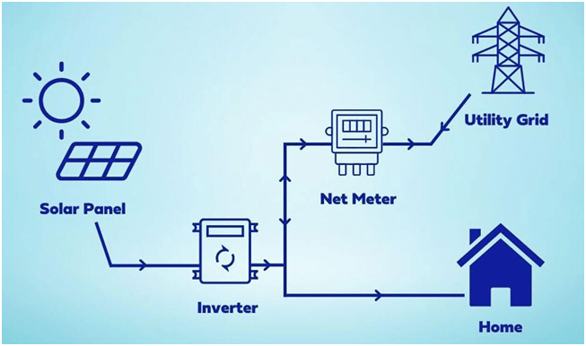
OUR SERVICES
- DOMESTIC SERVICES
- COMMERCIAL SERVICES
- CONSULTATION SERVICES

OUR PROCESS FOR SEAMLESS SOLAR INTEGRATION
The Rayenna journey is clear and easy. It starts with understanding your goals during a consultation and executing them seamlessly with a process-oriented approach.
1. CONSULTATION
2. SITE EVALUATION
3. SYSTEM DESIGN
4. INSTALLATION
5. ONGOING SUPPORT

SCOPE OF WORK
Design, Procure, Installation & Commissioning of the system as per BOQ.

BILL OF QUANTITIES
SL NO | EQUIPMENT | SPECIFICATION | QTY | WARARNTY | MAKE
1 | SOLAR PV MODULE | Monoperc Half cut 540- 550Wp | _Nos | 10 year product warranty and 25 years performance warranty | WAAREE/ ADANI/<BRANDS>
2 | On grid Inverter | _KW | 1 Nos | _ years warranty | Sofar/ Growatt/ Solis/<BRANDS>
3 | DCDB | _ In _ Out for _KW | 1 No | - | <BRANDS>
4 | ACDB | _ Phase for _KW | 1 No | - | <BRANDS>
5 | Structure for _Kw | GP _inch square pipe 16 Gauge | As per approved design | - | _
6 | DC Cable | 4 sqmm | As per approved design | _ | Polycab/ Waacab<BRANDS>
7 | AC Cable | 4 sqmm/6 sqmm | As per approved design | _ | VGuard/ Havells<BRANDS>
8 | Lightning & Earthing | _ | 3 Nos | - | ISI Make
9 | Accessories | Hardware and Accessories | 1 Lot | - | Visiontek/ Genus
10 | Meters | Uni directional & Bidirectional _ phase | 1 No each | - | Included
11 | Laisoning | KSEB sanctions, approvals, documentation process | _ | _ | Included
12 | Transportation | Transport, lifting & material handling | _ | _

COMMERCIALS
SL NO | PARTICULARS | QTY | AMOUNT
1 | Design, Supply, Installation & commissioning of _Kw system including electrical and structural work. | 1 NO
TOTAL PROJECT COST |  |  | 000 /-
RUPEES _ONLY

CLIENT SCOPE
- Clear shadow free rooftop area for the installation of PV panels.
- Space for installation and commissioning of electrical panels.
- A secured area for storage of supplied equipment till commissioning.
- Electricity – construction power shall be arranged by the owner at its own cost.
- Customer need to provide internet connectivity for the system.
- Feasibility Charges - Rs.1000 + 18%GST
- Registration Charges - _Kw * Rs. 1000 + 18%GST
- NET METER AGREEMENT - Rs.200/-

TERMS & CONDITIONS
- The contract price quoted shall be inclusive of GST.
- Capacity that can be installed is subject to allocation of feasibility by KSEB.
- Any additional super structure required for the project needs to be taken up by the customer.
- Any modification to the existing electrical system due to non-conformity to Electrical inspectorate / Utility standards will have to be carried out by the customer.
PAYMENT TERMS
- 90% advance of the total invoice value due upon signing the agreement.
- 10% of the total invoice value to be made after completion.
- The offer is valid for 10 days from the date of proposal. The rate may vary after 10days.
ACCOUNT DETAILS
Name: Rayenna Energy Private Limited
Type: Current Account
Bank: Axis Bank Limited
Account Number: 924020063493172
IFSC Code: UTIB0000827

MATERIAL DELIVERY PERIOD
15 to 30 working days from the date of confirmed purchase order with advance.

FOR RAYENNA ENERGY PRIVATE LIMITED CUSTOMER NAME & SIGNATURE

GANESH VENKITACHALAM
MANAGING DIRECTOR

RAYENNA ENERGY PRIVATE LIMITED, Door No 3324/52, Ray Bhavan, NH Bypass, Thykoodam, Kochi – 682019. Tel: +91 7907 369 304 | E-mail: sales@rayenna.energy

