OrchidApp
Prepare OrchidApp for First Use
First-run setup checklist for Raspberry Pi / Linux
Applies to: Raspberry Pi / Linux
User guide

Use this guide after OrchidApp has been installed on the Raspberry Pi and the OrchidApp service is running.
It shows the minimum setup needed before adding plants to the collection.

Before you start
You only need to do this setup once.
You can add more plant groups, species / hybrids, growing locations and growth media later from Setup.

Quick checklist
- Start OrchidApp for the first time and wait for setup to complete.
- Open Setup from the Home page.
- Add at least one plant group, also called a genus.
- Add at least one species / hybrid under that genus.
- Add the growing locations and growth media you use.
- Return to Home. OrchidApp is then ready for adding plants.

Step-by-step setup

1. Start OrchidApp
Make sure the Raspberry Pi is powered on and OrchidApp is running.
Open OrchidApp in a web browser from your computer, tablet or phone using the OrchidApp address provided during installation.
On first use, OrchidApp may need to prepare the local database and supporting files. This may take a few minutes.
Wait until the Home page opens in your browser before continuing.

First-use performance note
The first few pages may feel a little slower when OrchidApp has just started.
This is normal. OrchidApp prepares parts of the app as they are first used, so it often feels quicker after a short while.

2. Open Setup
On the Home page, select Setup.
Setup is where the basic lists are prepared before plants are added.
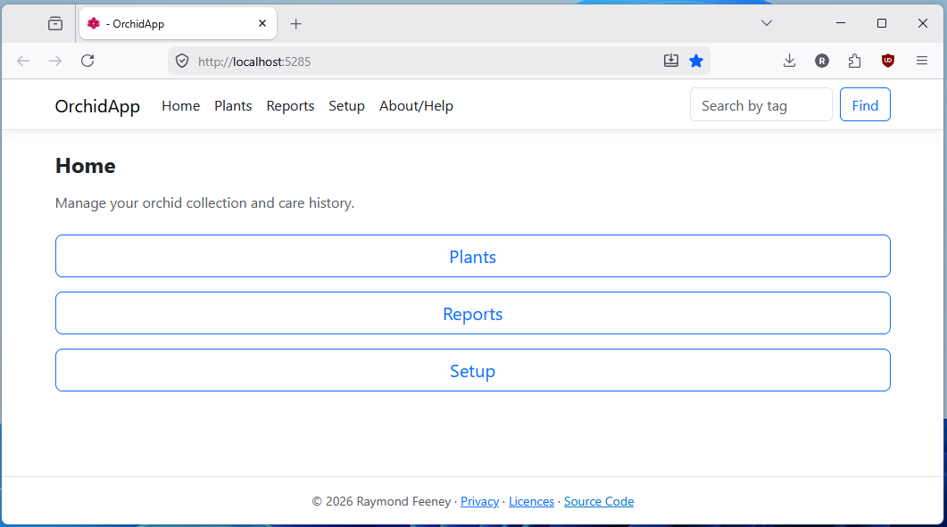

3. Choose what to set up first
The Setup page groups the main things OrchidApp needs:
- plant groups, also called genera
- species / hybrids
- growing locations
- growth media
Start with Plant groups (Genera) because species / hybrids belong inside a plant group.
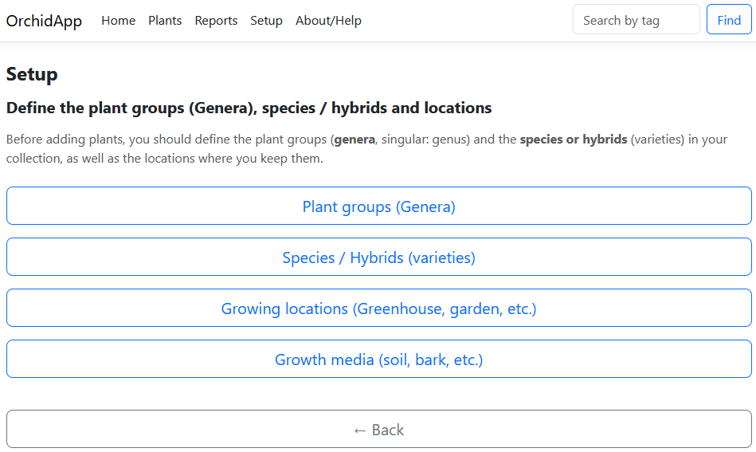

4. Add a plant group
A plant group is formally called a genus.
Examples include:
- Cattleya
- Phalaenopsis
- Dendrobium
Select Plant groups (Genera), then select Add genus.
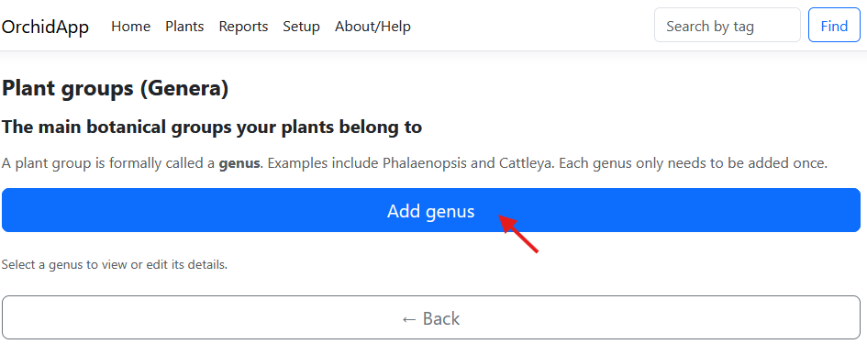

5. Enter the genus details
Enter the genus name.
Notes are optional but useful for general care reminders that apply to the group.
Complete the details you require, then select Add genus.
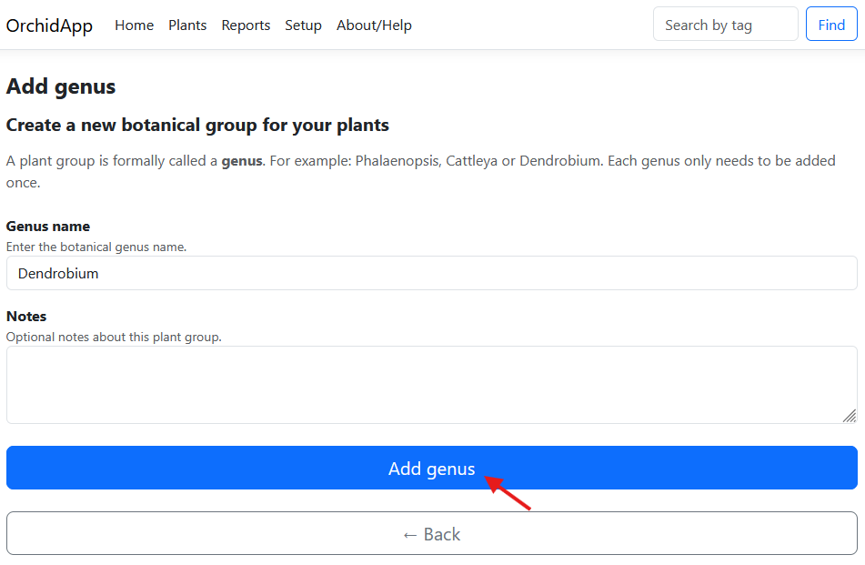

6. Check the genus has been added
After saving, the genus is confirmed and select Back to return to the list.
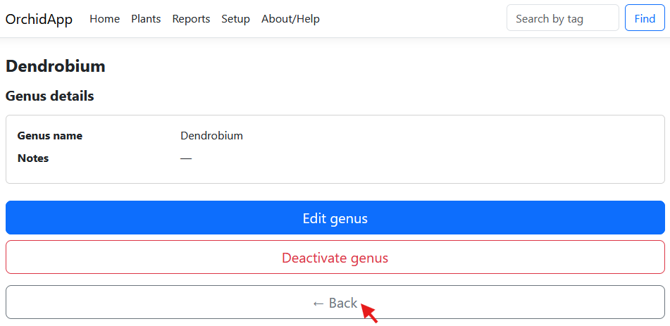
It appears in the Plant groups list.
Select it later if you need to view or edit its details.
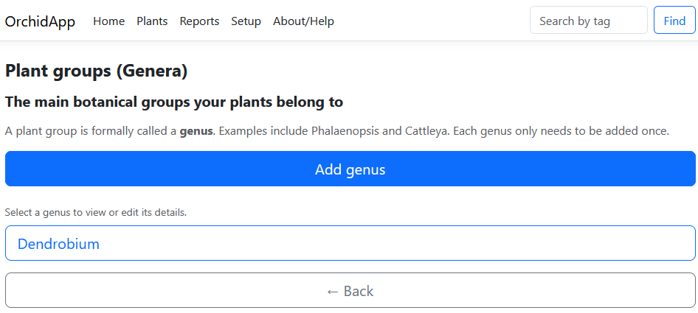

7. Open Species / Hybrids
Return to Setup and select Species / Hybrids.
Species and registered hybrids define the full botanical names used for plants. Note that a default Species / Hybrid has been created for your genus. This is for plants that belong to the genus but have not yet been identified as a species or hybrid.
When you identify a plant later by species or hybrid, you can edit the plant to use the correct identification.
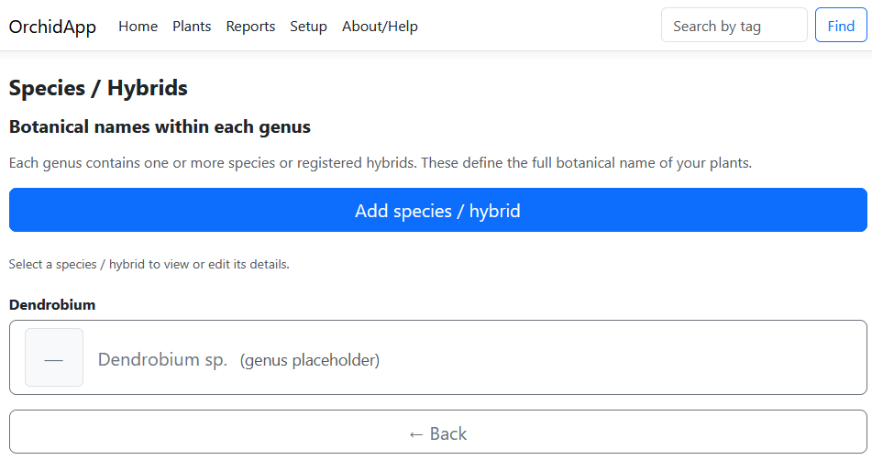

8. Add a species or hybrid
Select Add species / hybrid.
Choose the genus first, then enter either a species name or a hybrid name.
Enter one name only.
You may also add a representative image and notes.
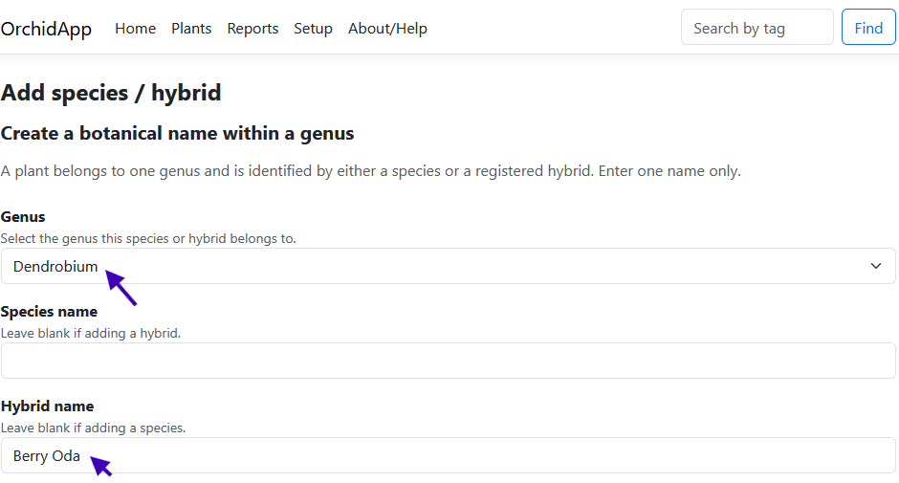

9. Save the species / hybrid
Complete the form and select Add species / hybrid.
Representative images and notes are optional, but they make the list easier to recognise later.
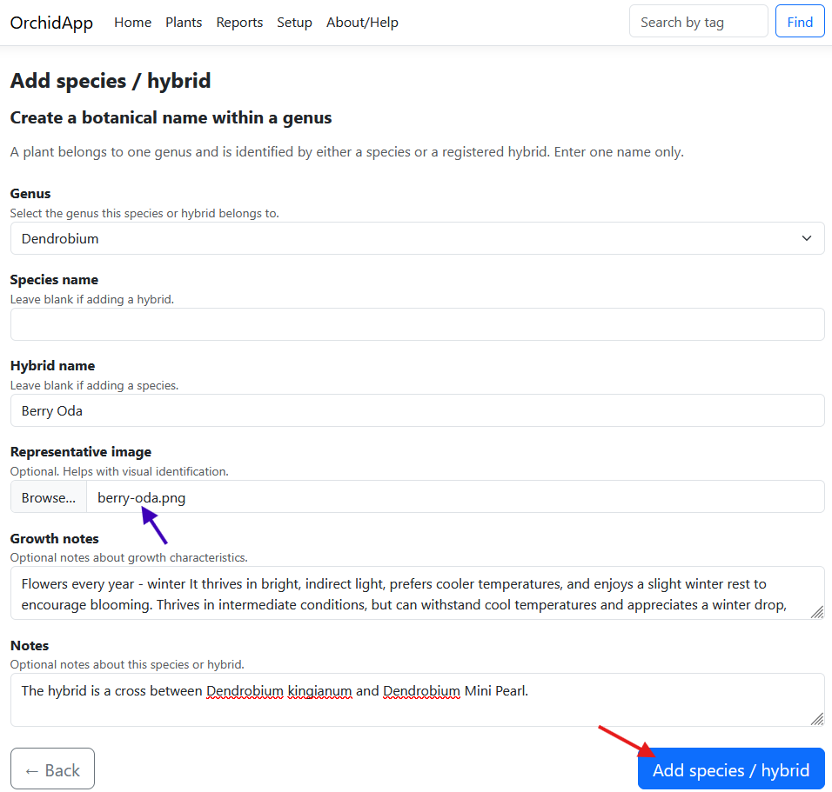

10. Confirm the species / hybrid
After saving, the details page shows the genus, name, notes and image.
From here you can edit the record or go back to the list.
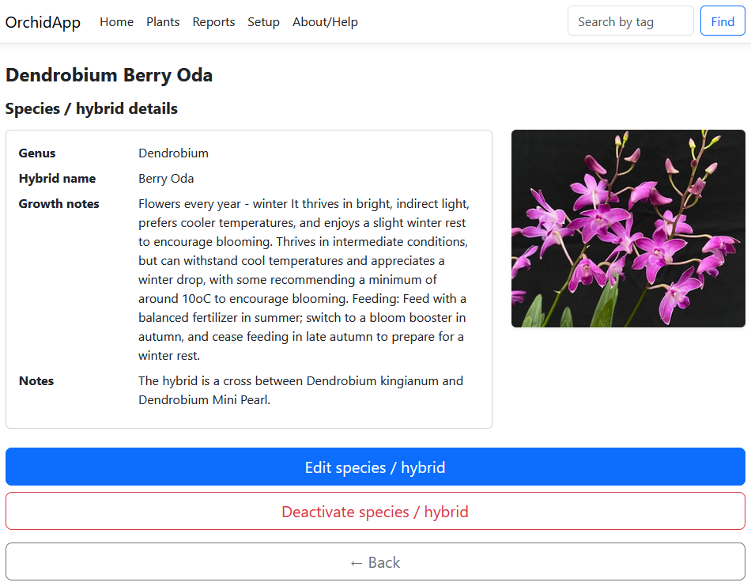

What to do next
Repeat the same basic process from Setup for:
- growing locations, such as greenhouse, windowsill, garden or grow tent
- growth media, such as bark, moss, leca or mixed media
Once those are set up, return to Home and start adding plants from the Plants section.

Keep the setup simple
You do not need to add everything on day one.
Add enough information to start using OrchidApp, then improve the setup as your collection grows.

Optional reference: editing later
The first-run checklist deliberately avoids every edit screen. Everything can be edited for correction.
Use the edit pages later if you need to correct notes, replace an image or deactivate an item that should no longer be used for new plants.
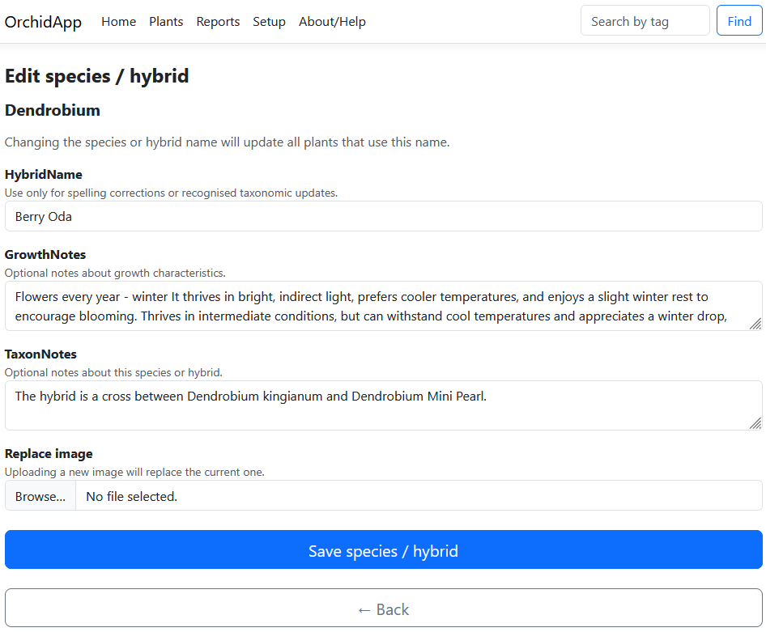

Setup complete
OrchidApp is ready for adding plants when you have added:
- at least one plant group / genus
- at least one species / hybrid
- the growing locations you use
- the growth media you use
You can then continue with:
03 - Add and Manage Plants in OrchidApp

