OrchidApp
Add and Manage Plants in OrchidApp
User guide for creating plant records and using the Plant Details page
Applies to: Windows 11
User guide

Use this guide after OrchidApp has been installed or upgraded using the Windows installer, and the first-use setup has been completed.

Purpose
This guide explains how to:
- add a plant
- understand the Plant Details page
- record day-to-day events
- add and manage photos
- record flowering
- record repotting
- move a plant between growing locations
- split a plant
- propagate a plant
- view plant heritage

Before you start
Before adding a plant:
- add the plant group, also called the genus
- add the species / hybrid before adding the plant
- add the growing locations you use
- add the growth media you use
Each plant gets a permanent Plant Tag automatically when it is saved.
Use events to build the plant history over time rather than keeping everything in one large note.

Typical workflow
- Open Plants from the Home page or the top menu.
- Choose Add plant.
- Select the species / hybrid.
- Enter acquisition details and save the plant.
- Use the Plant Details page to add observations, photos, feeding, movements, flowering and repotting records.

Quick reference: Plant Details actions
Action | Use it for | Result
Add observation | General notes or quick observations, including photo observations. | Adds an observation card to the plant history.
Move plant | Recording that the plant has moved to a new growing location. | Updates the current location and keeps previous locations in history.
Add flowering | Recording a flowering period, spike count, flower count and notes. | Adds flowering to history and updates the summary on the Plant Details page.
Add repotting | Recording potting medium, root condition, pot size and reason for repotting. | Adds repotting to history and updates the repotting summary.
Split plant | Ending one plant and creating two or more new independent plants. | The parent becomes ended/read-only. Child plants receive new permanent Plant Tags.
Propagate plant | Creating a new plant while keeping the existing plant alive. | Creates a new plant linked to the original plant as provenance.
Tap image | Opening the plant photo page. | Lets you browse photos, upload more and set the main image.

1. Open Plants
You can open Plants from either the Home page or the top menu.
Both take you to the same place.
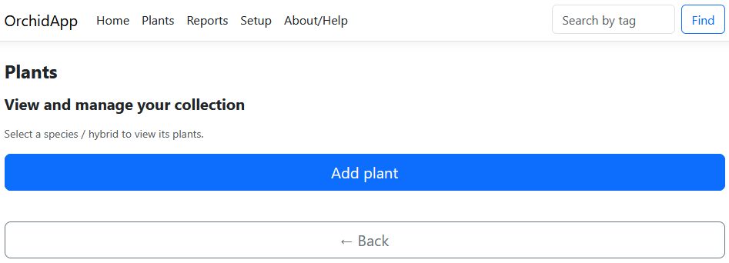
On the Plants page, choose Add plant to create a new plant record.

2. Add a plant

Select the species / hybrid
OrchidApp first asks which species / hybrid the new plant belongs to.
This is why the species / hybrid should already exist before adding a plant.
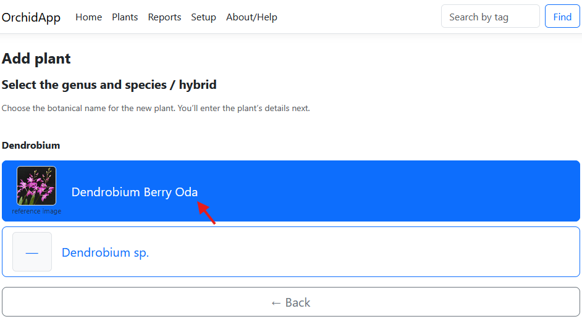

Enter plant details
The plant name is optional.
The acquisition date and acquisition source are useful for collection history, but they can be left blank if unknown. Use the date picker for the acquisition date, if known.
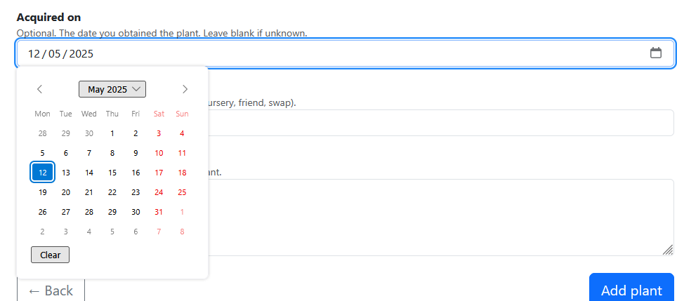
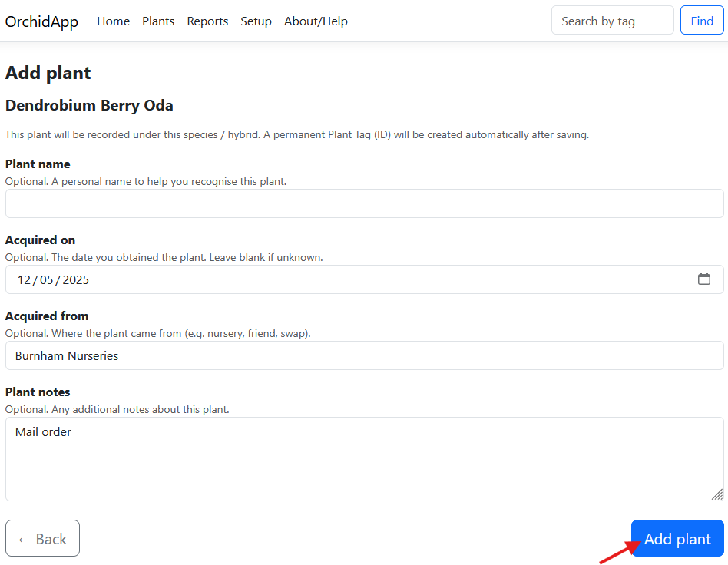

3. Save the plant and note the Plant Tag
When you save, OrchidApp automatically creates a permanent Plant Tag.
The Plant Tag is the plant’s stable ID. It should not be changed or reused.
It is recommended that the physical plant label includes the Plant Tag.
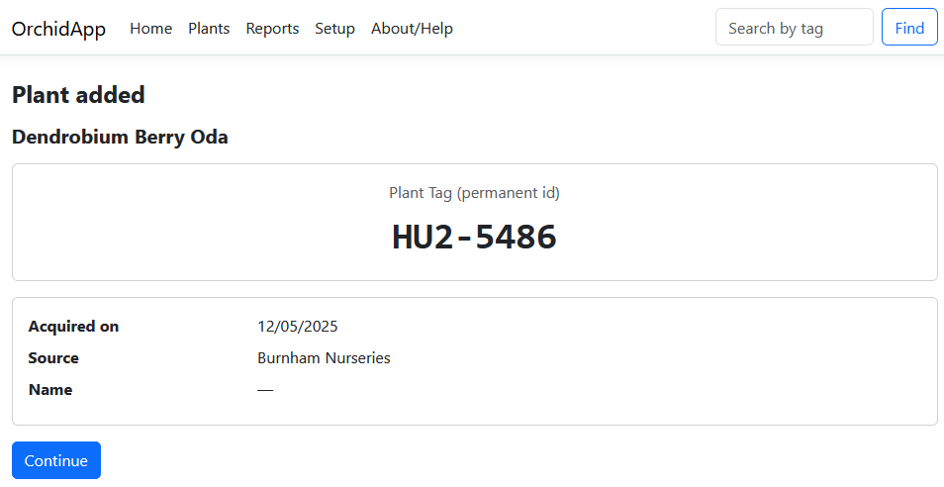

4. Understand the Plant Details page
The Plant Details page is the main working page for each plant.
It shows:
- the permanent Plant Tag
- current location
- acquisition details
- recent repotting information
- recent flowering information
- plant history
- available plant actions
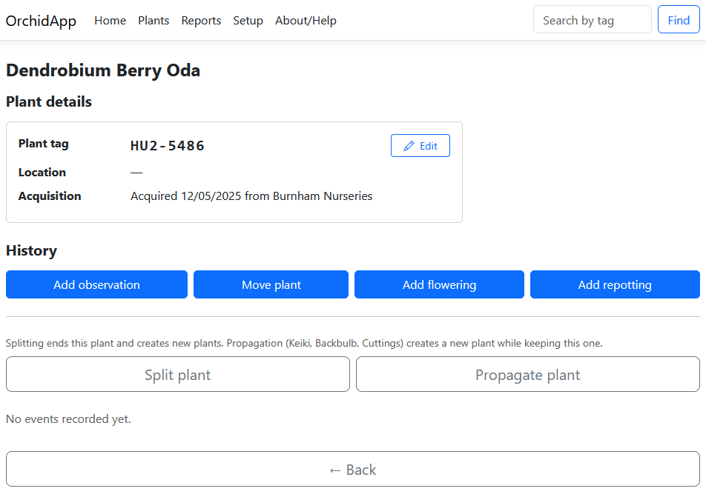
The Plant Details page works as follows:
- The Edit button changes basic plant details for corrections.
- The large action buttons add new history records.
- History cards show observations, moves, flowering and repotting in date order.
- The plant image opens the Photos page when tapped.

5. Add an observation
Use observations for ordinary notes about the plant, such as:
- feeding
- leaf condition
- root growth
- pests
- treatment notes
- watering notes
- general care comments
To add an observation:
- Open the plant.
- Choose Add observation.
- Enter the observation date.
- Type the notes.
- Choose Add observation.
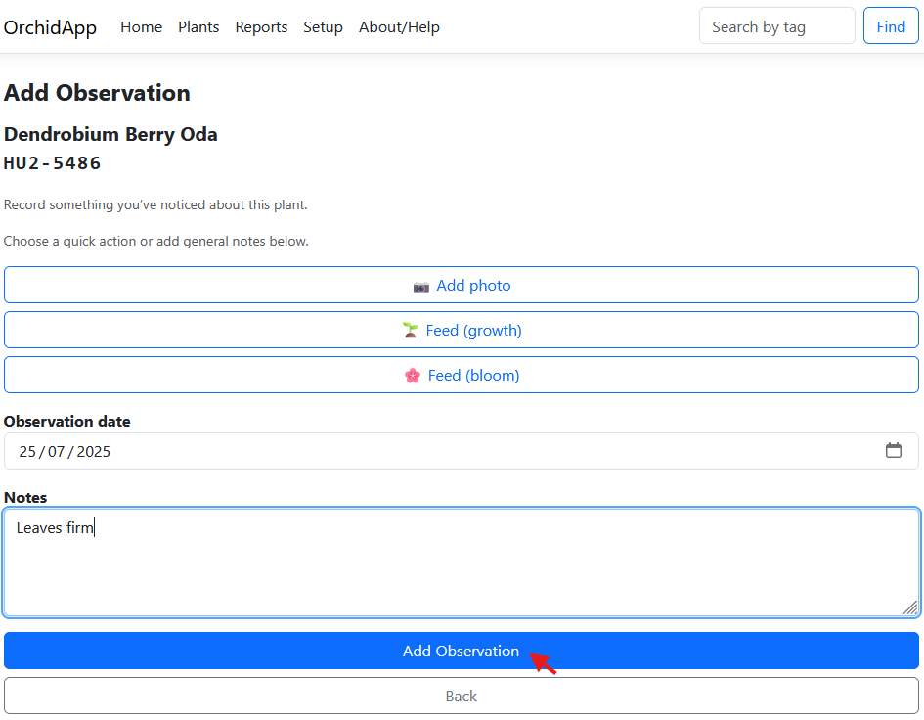
The observation appears in the plant history.

6. Add a photo observation
Photos are added through observations.
Use Add photo when the main purpose of the observation is to attach one or more plant photos.
To add a photo observation:
- Open the plant.
- Choose Add observation.
- Choose Add photo.
- Choose Browse.
- Select the image file or files.
- Save the observation.
The photo observation is added to the history.
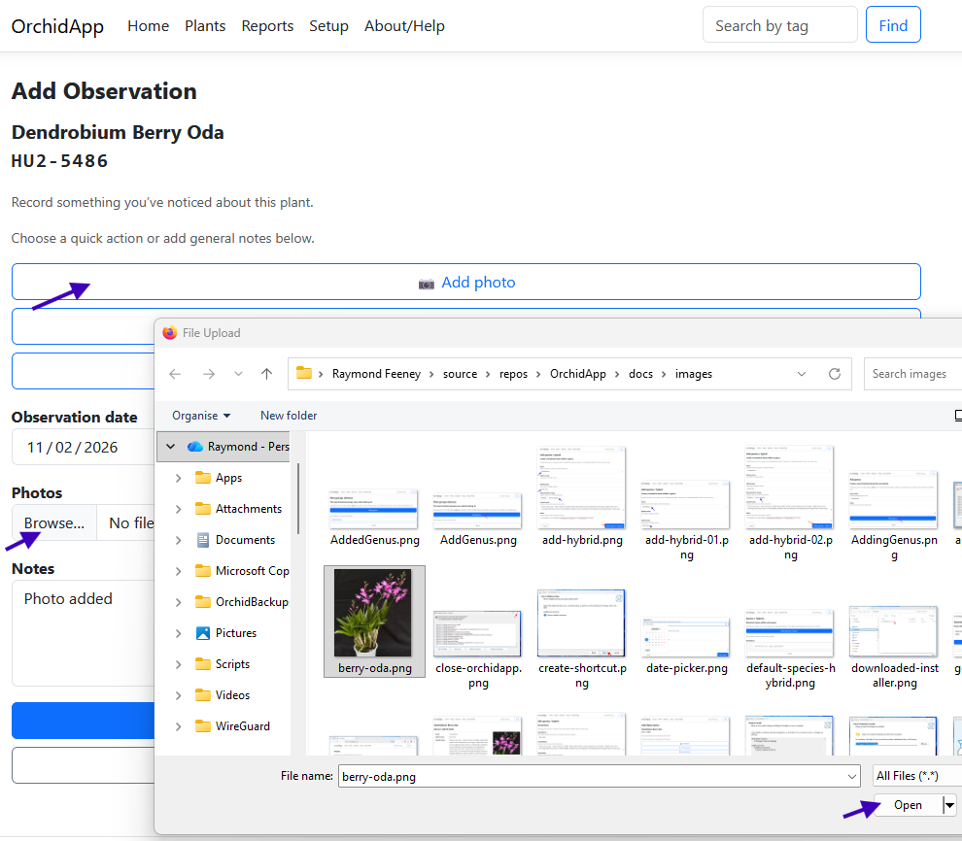

7. Use the Photos page
Tap the plant image on the Plant Details page to open the Photos page.
The Photos page is for:
- browsing all plant photos
- uploading more photos
- choosing the main image for the plant
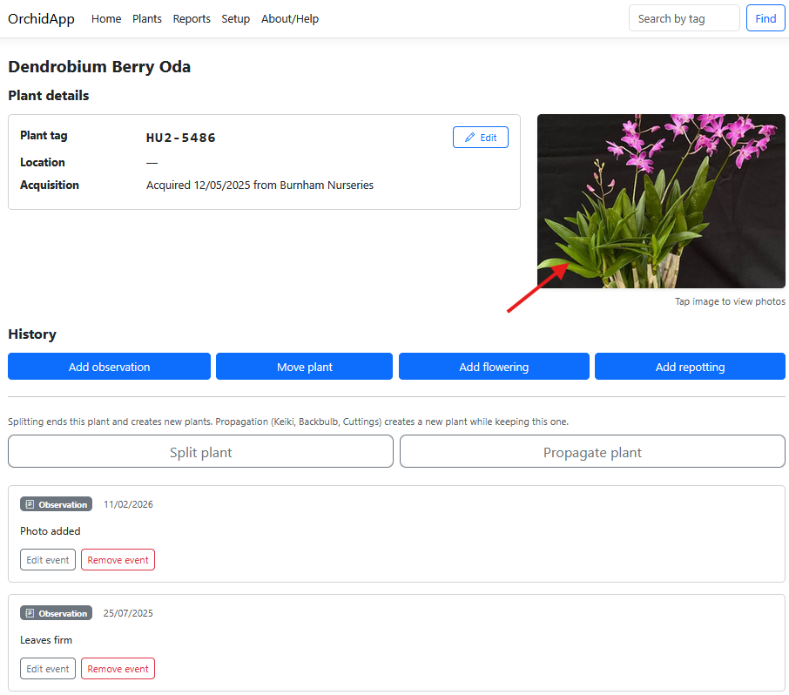

8. Upload more photos and set the main image
On the Photos page, you can upload more than one image at a time.
Select the files, choose Open, then upload them.
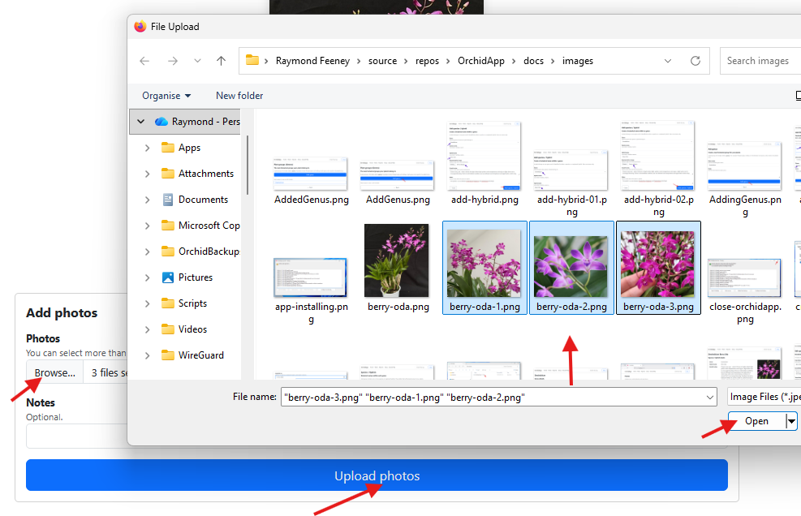
When viewing a photo that is not currently the main image, choose Set as main image.
The Plant Details page then shows the selected photo as the plant image.
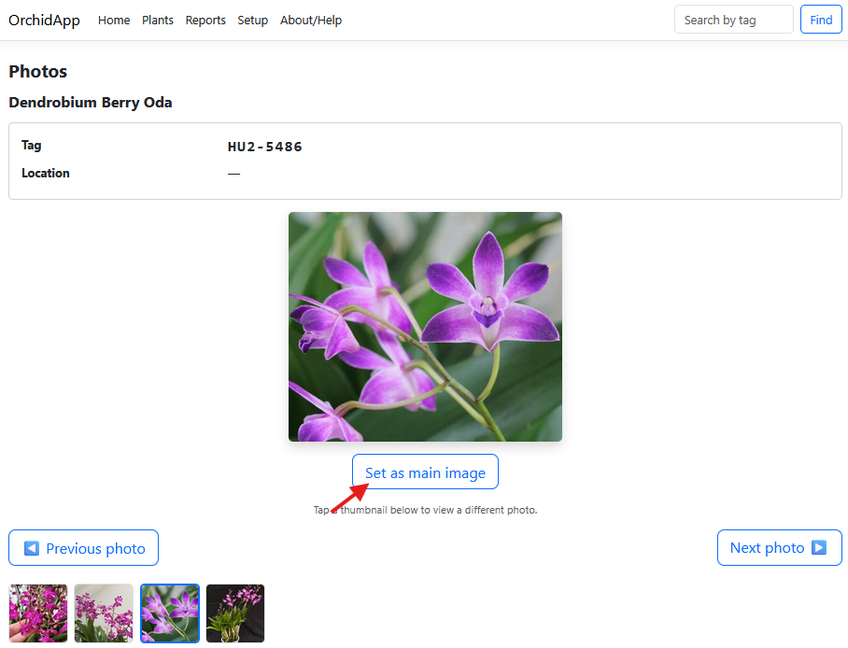

9. Move a plant
Use Move plant when the plant changes growing location.
This updates the current location and preserves previous locations in the plant history.
To move a plant:
- Choose Move plant on the Plant Details page.
- Select the new location.
- Enter the move date.
- Add a move reason or location notes, if useful.
- Choose Move plant.

The current location is shown in the plant summary.

10. Add flowering
Use Add flowering to record when a plant flowers.
Leave the end date blank if the plant is still flowering.
Flowering fields include:
- Start date — when flowering began
- End date — optional, and can be added later
- Spike count — useful for comparing future flowering
- Flower count — useful for comparing future flowering
- Notes — anything useful about the flowering
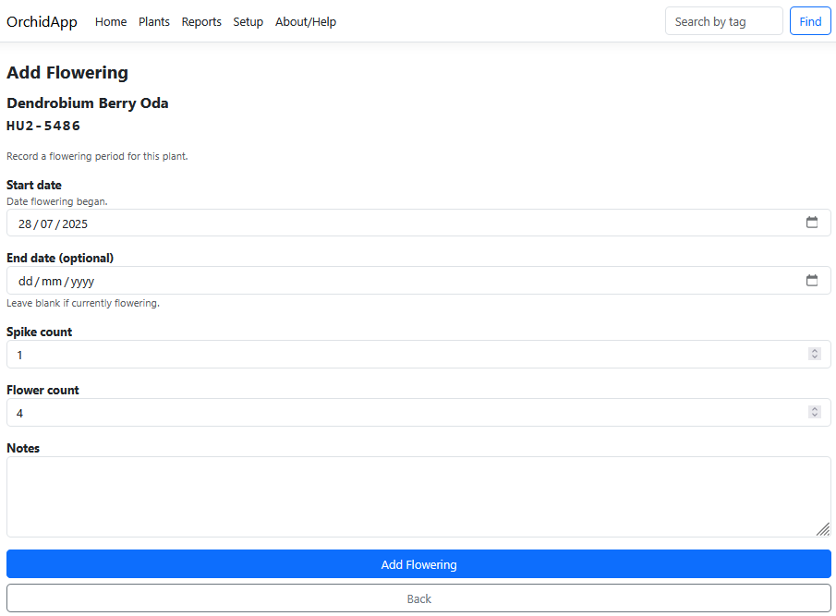
Flowering appears in the history and summary.

11. Edit flowering when it ends
If you left the end date blank, use Edit event on the flowering history card when flowering has finished.
Add the end date and save.
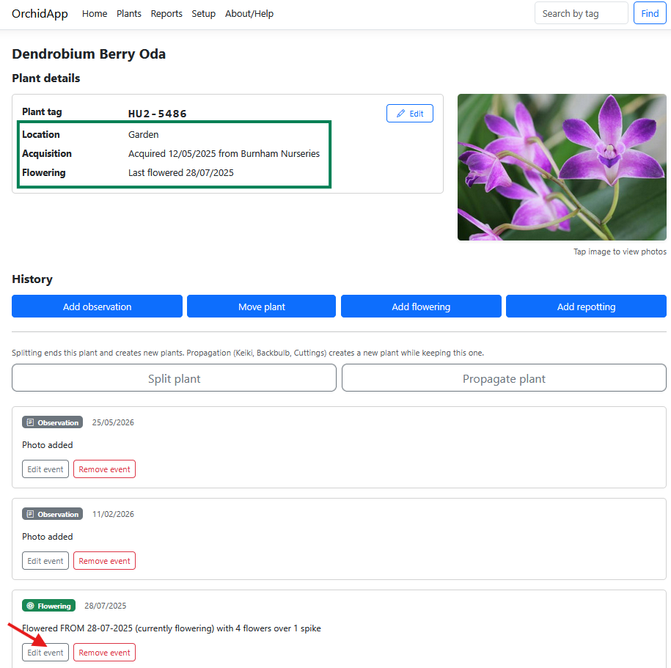
The flowering history updates after editing.
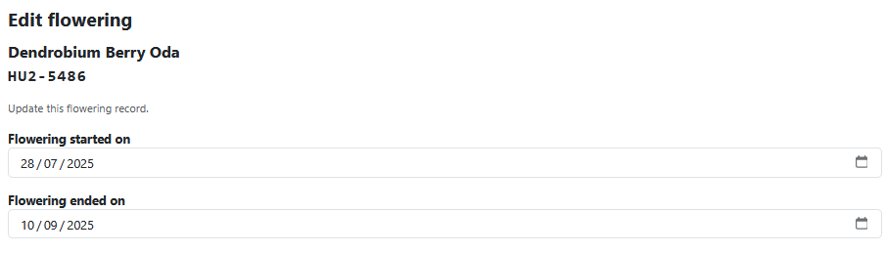

12. Add repotting
Use Add repotting to record potting changes, medium condition and the reason for repotting.
This helps build a useful care history.
Repotting fields include:
- Previous growing medium — what the plant was in before repotting
- Condition notes — root, pot or medium condition
- New growing medium — what the plant was repotted into
- Reason for repotting — why the change was made
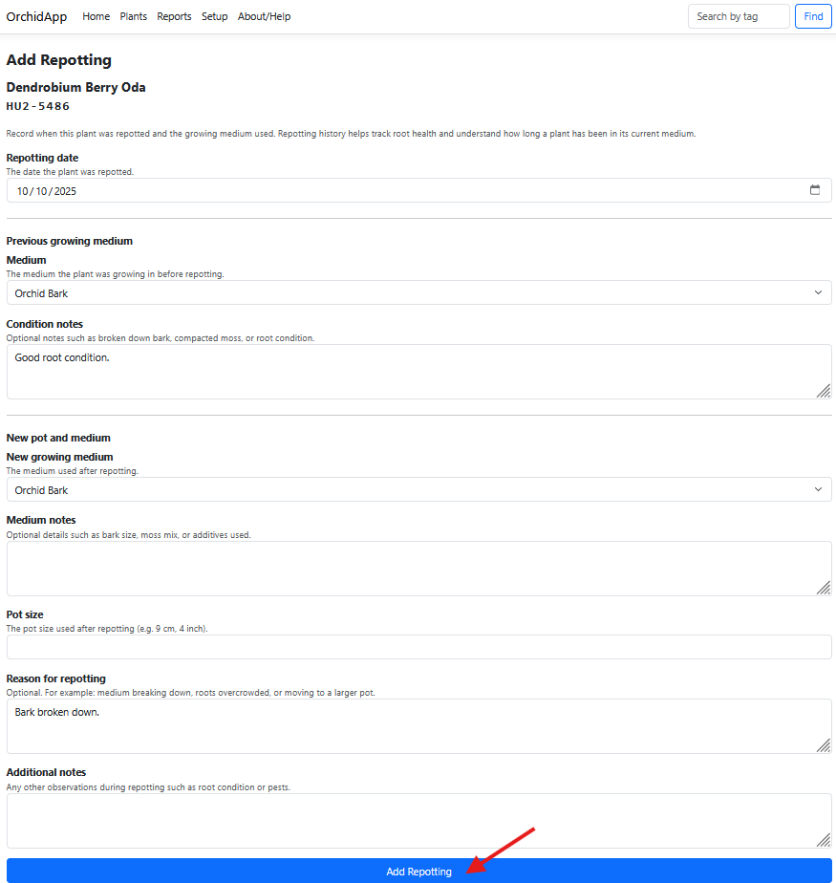
The repotting record appears in the history and updates the summary.

13. Edit or remove history events
Each history card has Edit event and Remove event buttons where the event type allows changes.
Use these to correct mistakes rather than creating duplicate records.
Use Remove event carefully.
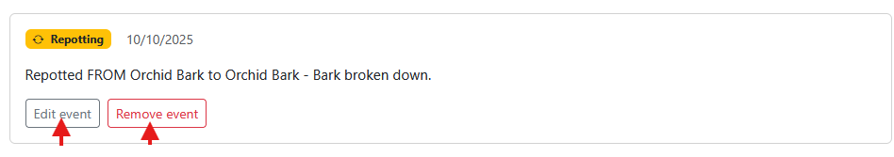
For ordinary corrections, editing the existing event is usually better than removing it and adding a new one.

14. Split or propagate a plant
Split and propagation are more advanced than ordinary history events.
They both create new plant records, but they mean different things.

Split plant
Use Split plant when the original plant is ending and becoming two or more new independent plants.
The original plant becomes ended/read-only.
The new plants receive their own permanent Plant Tags and independent histories.

Propagate plant
Use Propagate plant when creating a new plant while keeping the original plant active.
Use it for propagation such as:
- keiki
- backbulb
- cutting
The new plant is linked to the original plant as provenance.
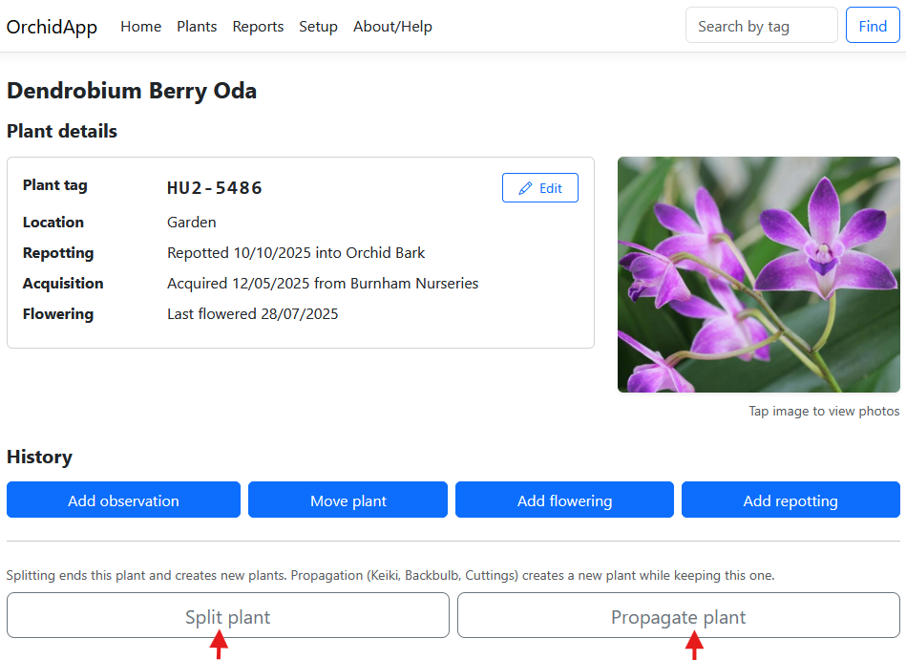

15. Split a plant
Splitting is permanent.
OrchidApp warns that the original plant will end and new plants will be created.
Enter:
- split date
- reason
- notes
- details for each new plant
Confirm the split only when you are sure.
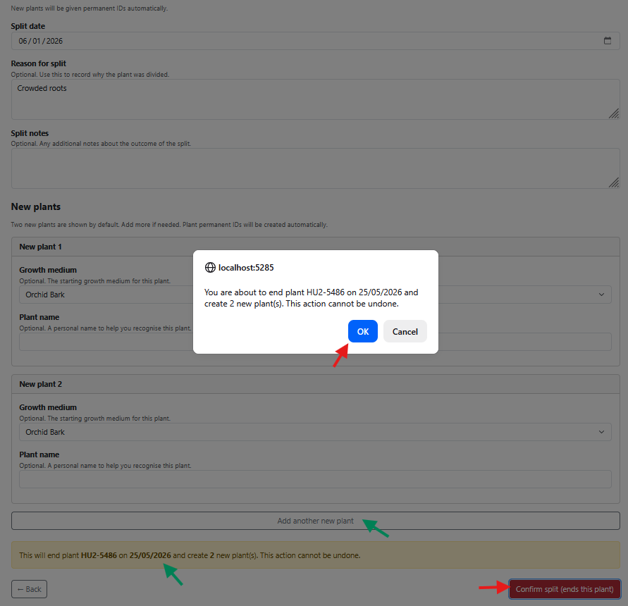

16. After a split
After the split, OrchidApp shows the new permanent IDs.
The original plant becomes ended and read-only.
The new child plants are linked back to the parent through heritage.
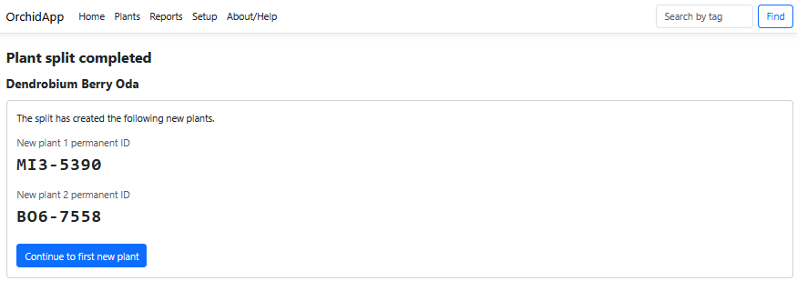
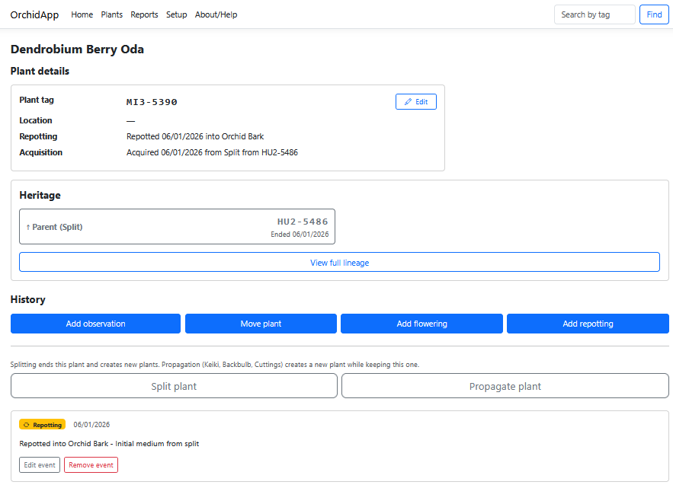

17. View plant heritage
When a plant has a parent or child relationship, the Heritage section appears on the Plant Details page.
Use it to move between related plants and view the full lineage.
A child plant has its own Plant Tag and its own independent history.
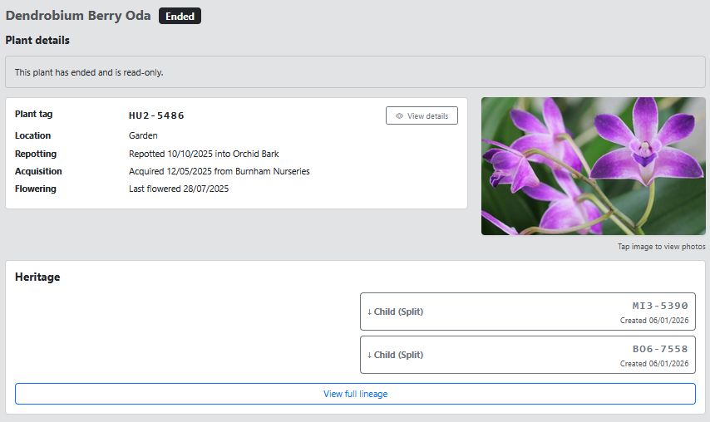
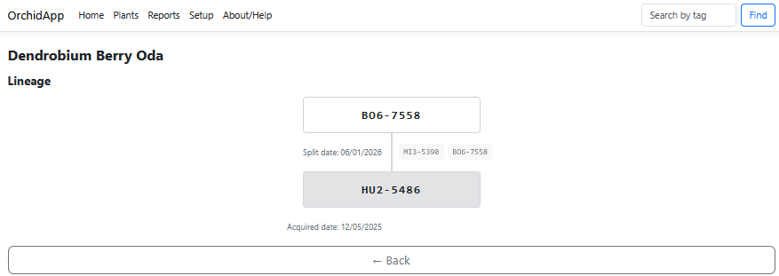

Plant management checklist
- Create the genus and species / hybrid before adding the plant.
- Use Add plant for each individual plant in the collection.
- Record ordinary care notes as observations.
- Add photos through observations or the Photos page.
- Use Move plant for location changes.
- Use Add flowering and Add repotting for structured care history.
- Use Split plant only when the original plant ends.
- Use Propagate plant when the original plant stays active.
- Use the Plant Tag to find and identify the plant later.

Common mistakes to avoid
- Do not create a new plant just because it moved location.
- Do not create a new plant just because it was repotted.
- Do not split a plant unless the original plant is ending.
- Do not rely on memory for plant identity: use the Plant Tag.

Getting support
If OrchidApp does not behave as expected, email:
OrchidApp@proton.me
When asking for help, include:
- what you were trying to do
- what happened
- any message shown by OrchidApp or the OrchidApp Launcher
- the plant name or Plant Tag, if the problem relates to a specific plant
The launcher support log is stored at:
C:\ProgramData\OrchidApp\logs\launcher.log

Guide complete
You can now use OrchidApp to add plants and build each plant’s history over time.

