OrchidApp
Configure Cloud Backup Folder in OrchidApp For Windows
User guide for protecting your OrchidApp backups against total computer failure
Applies to: Windows 11
User guide

Use this guide after OrchidApp has been installed or upgraded using the Windows installer and OrchidApp has been opened successfully.
The OrchidApp Launcher includes a Configure cloud backup button.

Purpose
OrchidApp keeps local backups on the computer.
This guide explains how to choose a cloud-synced folder where OrchidApp will also copy the latest successful backup.
This is the safest everyday recovery option because the backup is stored away from the computer running OrchidApp.
If the computer is lost, damaged or replaced, the backup can be downloaded again from the cloud provider and restored on a new machine.

Important
A cloud backup is only useful after the cloud provider has finished syncing the backup file.
After configuring the folder, check that OneDrive, Google Drive, iCloud Drive or your chosen provider shows the backup as synced.
Do not manually edit, unpack or rename the backup ZIP file.

Before you start
- Install or upgrade OrchidApp using the Windows installer.
- Open OrchidApp at least once so the OrchidApp Launcher starts.
- Make sure you are signed in to your cloud provider on the computer.
- Create or choose a folder that is synced to the cloud, such as OneDrive, Google Drive, iCloud Drive or another trusted provider.
- Use a clear folder name, such as OrchidBackups.
- Do not choose a temporary folder.
- Do not choose a folder that is not included in cloud sync.

How OrchidApp cloud backup works
OrchidApp stores its normal local backups under:
C:\ProgramData\OrchidApp\backups
When a cloud backup folder is configured, OrchidApp also copies the latest successful backup to the selected cloud folder.
The cloud copy is normally named:
OrchidAppDataBackup.zip
This cloud copy is intended for disaster recovery. It gives you a recent backup that should still be available even if the original computer fails completely.
Note: When you start OrchidApp, it automatically checks when the last backup was made. If it was more than 7 days ago, OrchidApp creates a backup automatically without interrupting your use of the app.

Quick checklist
- Close the OrchidApp browser tab if it is covering the launcher window.
- Open or bring forward the OrchidApp Launcher window.
- Select Configure cloud backup.
- Choose a folder that is synced by your cloud provider.
- Confirm that OrchidApp saves the cloud backup folder.
- Run Back up now or wait for the next automatic backup.
- Check that the cloud provider has synced the backup file.

Step-by-step setup

1. Close the browser tab if required
If OrchidApp is open in your browser and the launcher is hidden behind it, close the browser tab or switch back to the launcher window.
Closing only the browser tab does not stop OrchidApp.

2. Bring the OrchidApp Launcher to the front
Select the OrchidApp icon on the taskbar to bring the launcher window to the front.
The launcher window must remain open while using OrchidApp.


3. Choose Configure cloud backup
In the OrchidApp Launcher, select Configure cloud backup.
This opens a folder picker so you can choose where the latest cloud backup should be copied.
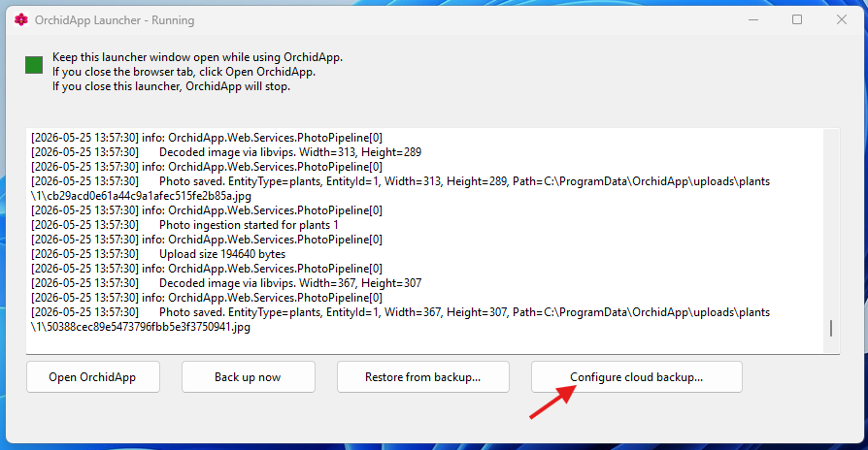

4. Select a cloud-synced folder
Choose a folder that your cloud provider already syncs.
Examples include:
- OneDrive
- Google Drive
- iCloud Drive
- another trusted cloud-synced folder
You can use an existing folder or create a new one.
The important point is that the folder must be included in cloud sync.
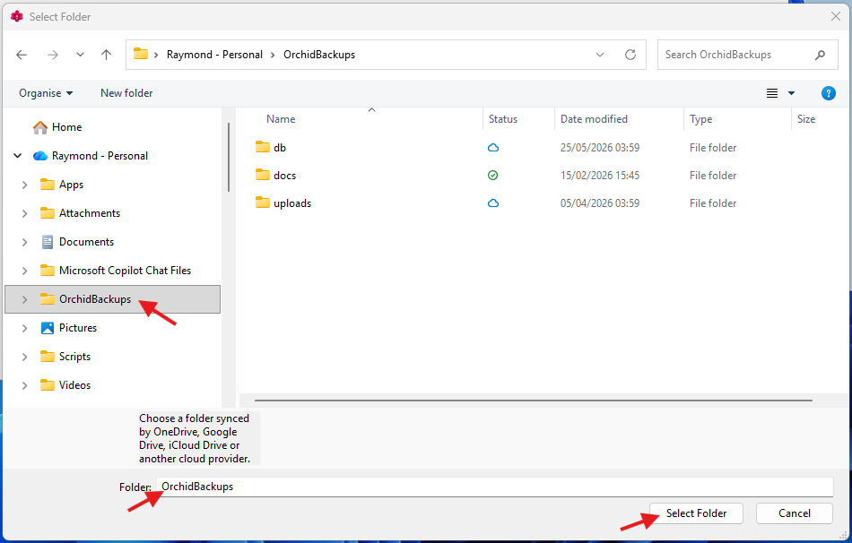

5. Confirm the folder
Select the folder, then choose Select Folder.
OrchidApp saves the selected folder as the cloud backup location.
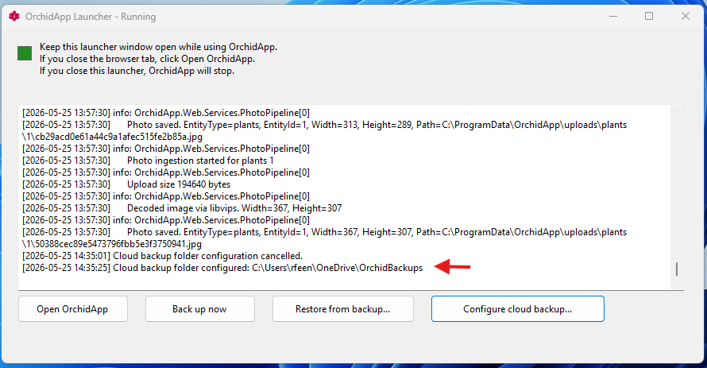

6. Check the backup log
After the folder is saved, the launcher log should show that the cloud backup folder has been configured.
When a backup completes, OrchidApp creates the local backup first, then copies the latest backup to the configured cloud folder.
If the log says the cloud backup folder is not configured, repeat the steps above and select the cloud-synced folder again.

7. Run a backup now
After choosing the cloud backup folder, it is sensible to run a backup straight away.
In the OrchidApp Launcher, select Back up now.
Wait until the launcher reports that the backup completed.
Then check the selected cloud folder for the backup ZIP file.
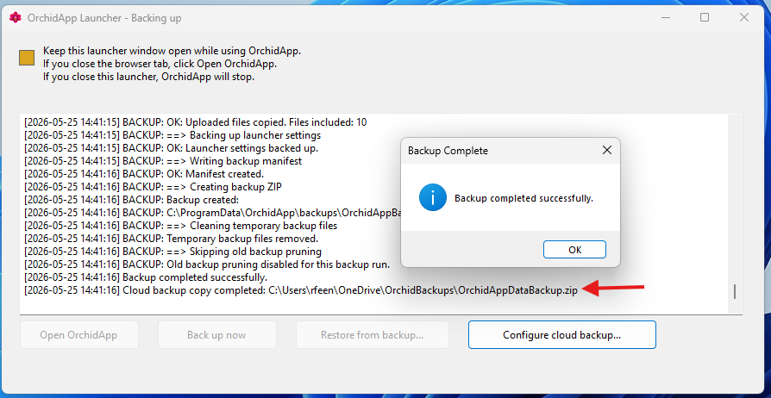

Choosing a good cloud backup folder
Good choice | Avoid
OneDrive\Documents\OrchidBackups | Downloads
Google Drive\OrchidBackups | Desktop, unless it is definitely synced
iCloud Drive\OrchidBackups | Temporary folders
A clearly named cloud-synced backup folder | External drives that are often unplugged

How to check the backup is protected
- Open the cloud folder in File Explorer and check that OrchidAppDataBackup.zip or an OrchidApp backup ZIP is present.
- Check the cloud sync status icon. It should show that the file is synced or available in the cloud.
- Open your cloud provider on another device or in a web browser and confirm that the backup file is visible there.
- Do not manually edit the backup ZIP file.

What is stored in the backup
Every time OrchiApp is started it automatically checks for the date of the last backup. If the backup was more than 7 days previously, a backup is created. An OrchidApp backup is intended to protect the OrchidApp data needed for recovery.
This includes:
- the plant database
- setup data such as plant groups, species / hybrids, locations and growth media
- plant history
- uploaded photos and files included in the backup
- relevant launcher settings

What the cloud backup is for
The cloud backup is for disaster recovery.
Use it if:
- the computer fails
- the computer is replaced
- Windows is reinstalled
- the local OrchidApp data is lost
For recovery steps, use:
05 - Recover OrchidApp on Replacement Machine

Troubleshooting
Problem | What to do
I cannot see the OrchidApp Launcher | Select the OrchidApp icon on the taskbar or close the browser tab to reveal the launcher.
The log says the cloud backup folder is not configured | Select Configure cloud backup again and choose a cloud-synced folder.
The backup file is in the folder but not in the cloud | Wait for your cloud provider to sync. Check that you are signed in and that syncing is not paused.
I moved or renamed the cloud folder | Open the OrchidApp Launcher and configure the cloud backup folder again.
The cloud copy fails but local backup succeeds | Your local backup still exists. Fix the cloud folder or sync problem, then run Back up now again.
I cannot find the cloud backup on another computer | Check that you are signed in to the same cloud account and that the folder has fully synced.
I need support | Email OrchidApp@proton.me. Include what you were doing, what happened, and any launcher message.

Cloud backup checklist
- The OrchidApp Launcher shows the cloud backup folder has been configured.
- A backup has completed successfully.
- The backup ZIP exists in the selected cloud folder.
- The cloud provider shows the file as synced.
- You know where to find the cloud backup if the computer fails.

Getting support
If cloud backup does not behave as expected, email:
OrchidApp@proton.me
When asking for help, include:
- what you were trying to do
- which cloud provider you are using
- whether the local backup completed successfully
- whether the backup file appears in the cloud folder
- any message shown by the OrchidApp Launcher
The launcher support log is stored at:
C:\ProgramData\OrchidApp\logs\launcher.log

Keep this simple
The best backup is one that runs automatically and is easy to find later.
Use one obvious cloud-synced folder and let OrchidApp keep the latest cloud copy there.

