OrchidApp
Recover OrchidApp on a Replacement Windows Computer
Step-by-step restore guide for a new, repaired or reinstalled Windows computer
Applies to: Windows 11 and a previous OrchidApp backup saved to a cloud-synced folder such as OneDrive, Google Drive or iCloud Drive.
User guide

Purpose
Use this guide when the old computer has failed, been replaced or been reinstalled, and you need to restore OrchidApp on a Windows computer.
The safest recovery route is:
- install OrchidApp using the Windows installer
- sign in to the cloud provider that holds the backup
- wait for the backup file to sync to the computer
- restore the latest OrchidApp backup ZIP using the OrchidApp Launcher

Start here
Follow the 01 - Install or Upgrade OrchidApp on Windows guide first.
Install OrchidApp using the Windows installer before starting the restore steps in this guide.
Do not install OrchidApp by extracting a ZIP file or copying files over an older OrchidApp folder.

Before you start
- Install OrchidApp on the new or repaired computer using the normal Windows installer.
- Open OrchidApp once so the OrchidApp Launcher starts.
- Sign in to the cloud service that contains the OrchidApp backup folder.
- Wait until the backup file has synced to the new computer.
- Use the OrchidApp backup ZIP.
- Close the OrchidApp browser tab before restoring.
- Leave the OrchidApp Launcher window open.
Important: Restoring a backup replaces the current OrchidApp database and uploaded files on this computer. Continue only when you are sure you have selected the correct backup file.

Which backup file should I use?
Use the latest trusted OrchidApp backup ZIP.
The cloud copy is usually named:
OrchidAppDataBackup.zip
A dated local backup may have a name similar to:
OrchidAppBackup_YYYYMMDD_HHMMSS.zip
Only restore from a backup you trust.
Do not manually edit, unpack or rename the backup ZIP before restoring.

Quick checklist
- Install OrchidApp on the new computer using the Windows installer.
- Open OrchidApp once so the launcher starts.
- Close the browser tab, but keep the launcher open.
- Sign in to the cloud provider that contains your backup.
- Wait for the backup ZIP to sync to the computer.
- Optional but recommended: configure the cloud backup folder again.
- Choose Restore from backup in the OrchidApp Launcher.
- Select the OrchidApp backup ZIP from the cloud backup folder.
- Confirm the restore warning.
- Wait for Restore completed successfully.
- Close and reopen OrchidApp.
- Check that your plants, photos and setup information are present.

Step-by-step recovery

1. Install OrchidApp on the new computer
Begin with the 01 - Install or Upgrade OrchidApp on Windows guide.
Use the Windows installer to install OrchidApp as per the guide.

3. Close the browser tab before restoring
Close the OrchidApp browser tab before restoring.
This helps make sure the database and uploaded files can be safely replaced.
Do not close the OrchidApp Launcher window.

4. Bring the OrchidApp Launcher to the front
Select the OrchidApp icon on the taskbar to bring the launcher window to the front.
The restore is started from the launcher, not from the browser page.


5. Optional: If you previously configured the cloud backup folder
If this is a new computer, it is sensible to configure the cloud backup folder again after the cloud provider has synced the backup folder locally. This will allow you to use this as your restore source.
This does not perform the restore by itself.
Use the guide:
04 - Configure Cloud Backup Folder in OrchidApp

6. Start the restore
In the OrchidApp Launcher, choose Restore from backup.
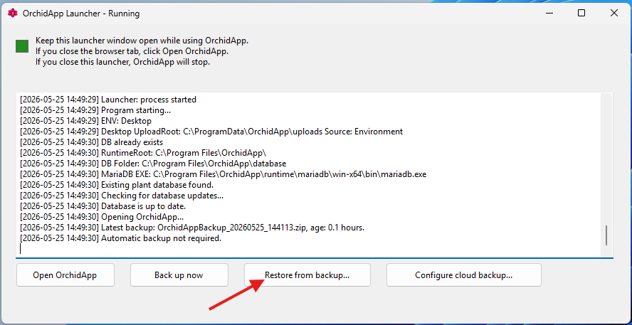
You will now be presented with the files in your backup location. Select the backup to restore.
This starts the recovery process.
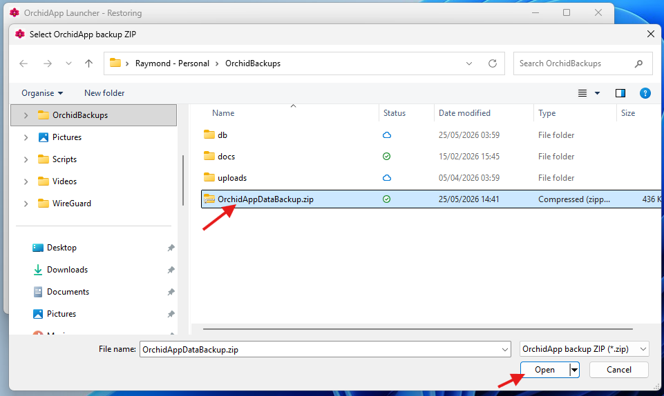

7. Confirm the restore warning
OrchidApp warns that restoring a backup will replace the current OrchidApp database and uploaded files.
Choose Yes only when you are sure you have selected the correct backup file.
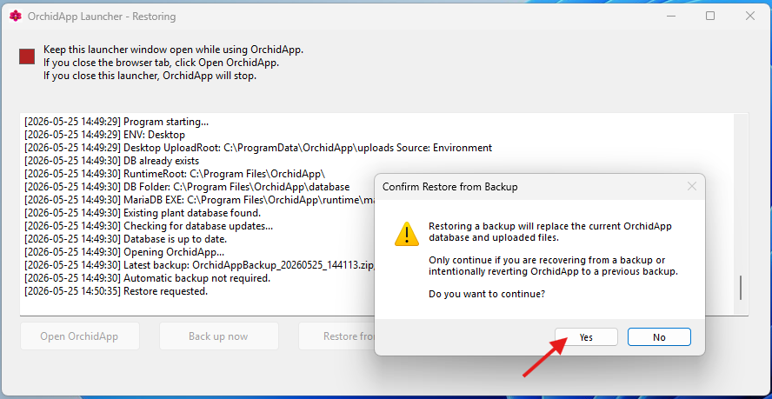

8. Wait for the restore to complete
Wait until OrchidApp reports that the restore completed successfully.
Do not close the launcher while the restore is running.
When the restore is complete, choose OK.
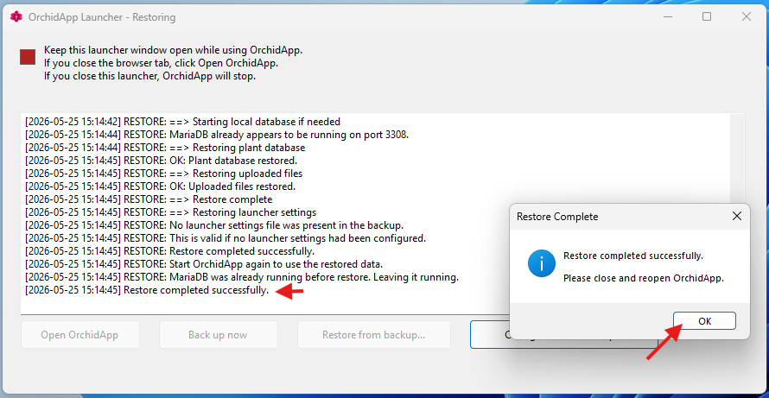

9. Close and reopen OrchidApp
Close OrchidApp fully.
Then open OrchidApp again from the Start Menu or Desktop shortcut.
This makes sure OrchidApp starts using the restored data.

10. Check your data
When OrchidApp opens, check that your information is present.
Check:
- plant records
- Plant Tags
- plant photos
- plant groups / genera
- species / hybrids
- growing locations
- growth media
- observations
- movements
- flowering records
- repotting records
- splitting, propagation and heritage
If anything looks wrong, do not add new data immediately.
Close OrchidApp and restore again from the correct backup file.

What the restore brings back
Restored item | What this means
Plant records | Plant names, Plant Tags, acquisition details and active or ended plant status.
Setup data | Plant groups, species / hybrids, locations and growth media.
Plant history | Observations, movements, flowering, repotting, splitting, propagation and heritage.
Uploaded files | Plant photos and other uploaded files, if they were present in the backup.
Settings included in the backup | Relevant launcher and backup settings included in the backup file.

Important safety notes
- Restoring replaces the OrchidApp data currently on the computer.
- Only restore from a backup you trust.
- Keep the OrchidApp backup ZIP in a folder that is synced by your cloud provider.
- After recovery, configure cloud backup again so future backups are copied to the cloud folder.
- Do not edit or unpack the backup ZIP manually.
- Do not copy database folders manually.
- Do not copy files into C:\Program Files\OrchidApp manually.

After recovery
After recovery is complete:
- keep using the Start Menu or Desktop shortcut to open OrchidApp
- keep the OrchidApp Launcher window open while using OrchidApp
- check that cloud backup is configured
- run Back up now after confirming the restored data is correct
- check that the cloud provider syncs the new backup copy

Troubleshooting
Problem | What to do
I cannot find the backup file | Check that you are signed in to the correct cloud account and that the cloud folder has finished syncing.
The Restore from backup button is unavailable | Close the OrchidApp browser tab and wait for the launcher to return to the normal running state.
The restore completed but photos are missing | Check that the backup selected was the complete OrchidApp backup ZIP and not a partial or manually edited file.
I selected the wrong backup | Restore again using the correct backup file. Do this before adding new information.
The app does not open after restore | Close OrchidApp fully, reopen it from the shortcut and check the launcher messages. If needed, restore again from the latest trusted backup.
My plants are not visible after restore | Do not add new data. Close OrchidApp and restore again using the latest trusted backup.
The backup file is in the cloud but not on this computer | Wait for the cloud provider to finish syncing, or download the backup file from the cloud provider’s website.
I need support | Email OrchidApp@proton.me. Include what you were doing, what happened, and any launcher message.

Getting support
If recovery does not behave as expected, email:
OrchidApp@proton.me
When asking for help, include:
- what you were trying to do
- whether this is a new computer, repaired computer or Windows reinstall
- which cloud provider you are using
- the name of the backup ZIP file you selected
- what happened during the restore
- any message shown by the OrchidApp Launcher
The launcher support log is stored at:
C:\ProgramData\OrchidApp\logs\launcher.log

Recovery complete
Recovery is complete when OrchidApp opens and your plant records are visible.
Keep the cloud backup folder configured so the next backup is copied to the cloud automatically.

