Optimizing CDC Model Performance for High-Resolution Image Compression and Reconstruction under HPC Environments
Jooho Kim¹, Yifan Yang², Anish Shakya³, and Jacob Kelly⁴
¹Institute for a Disaster Resilient Texas (IDRT), Texas A&M University, College Station, TX, USA
²Department of Geography, Texas A&M University, College Station, TX, USA
³Department of Marine and Coastal Environmental Science, Texas A&M University, Galveston, TX, USA
⁴Department of Computer Science and Engineering, Texas A&M University, College Station, TX, USA

Abstract
High-resolution drone imagery supports urban monitoring and disaster assessment, but large-area collections can reach hundreds of gigabytes. This summary aligns the SC26 poster with a PPO-based bitrate-allocation conditional diffusion compression (PCDC) framing. The public experiments evaluate the CDC/HPC operating point needed before trained block-wise PPO allocation results are reported.

Summary
The workflow compresses urban drone images cropped to 5440 x 3648 pixels with a pretrained x-parameterized CDC model and reconstructs them on NCSA DeltaAI. The broader PCDC design pairs this decoder with PPO-based block-wise bitrate allocation. The committed results do not yet evaluate that policy allocator; they measure the runtime, memory, bitrate, and visual-quality signals it will need. Each experiment records wall time, peak GPU memory, bits per pixel (BPP), compression ratio, PSNR, SSIM, high-percentile error, and tiling seam metrics. We report compression ratio against uncompressed 8-bit RGB storage:
R = 24 / BPP
S_T(theta) = 1 - T_theta / T_base, G_M(theta) = M_base / M_theta
These equations make the systems trade-off explicit; they do not replace image-quality review.
The native full-image baseline is feasible but costly. With 65 denoising steps, fp32 reporting, and batch size 1, the DeltaAI GH200 run takes about 144 seconds per image and peaks near 52 GB of GPU memory. Step reduction speeds decoding but does not remove the memory footprint. Resolution reduction is faster, but it discards spatial detail before compression. In the 20-image sweep, 2K lowers runtime to about 7.36 seconds per image, yet SSIM drops to about 0.689.
Tiling gives the strongest current operating point because it keeps the native image boundary while reducing the tensor size seen by the decoder. On 50 full-resolution images, 256 x 256 tiling lowers runtime from 144.35 to 79.84 seconds per image and peak memory from 52.01 to 1.66 GB. This is a 44.7% runtime reduction and a 31.3x peak-memory reduction. It is also faster and smaller than 512 x 512 tiling, with only small PSNR and SSIM losses.
Table 1. Selected DeltaAI GH200 tiling validation, 50 full-resolution images, 65 denoising steps, fp32.
Setup | Sec./img | GPU GB | PSNR | SSIM
No tiling | 144.35 | 52.01 | 28.96 | 0.8616
256^2 tile | 79.84 | 1.66 | 28.78 | 0.8552
512^2 tile | 87.71 | 3.02 | 28.86 | 0.8583
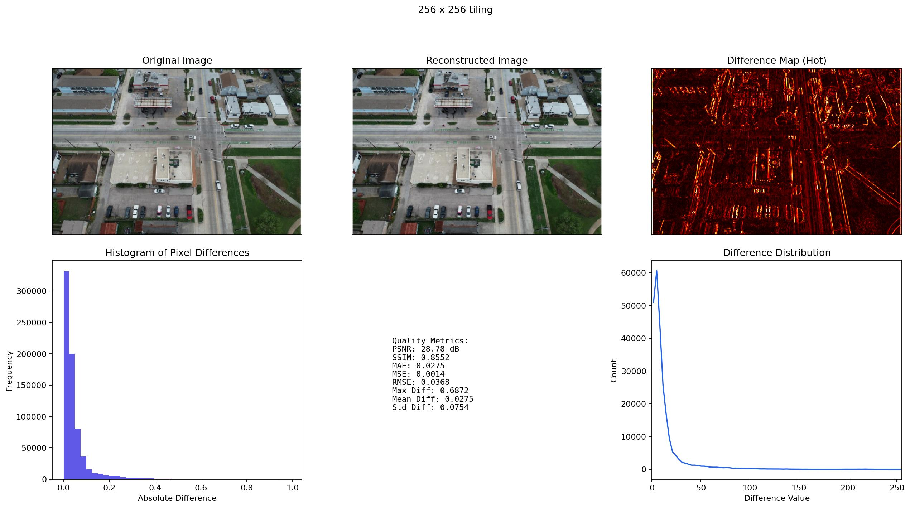
Figure 1. Existing experiment output for the selected 256 x 256 tiling case: original preview, reconstruction, difference map, histogram, metrics, and difference distribution.
CDC and future PCDC deployment for disaster imagery must be reported as a joint systems and image-quality problem. BPP and compression ratio are not enough. A useful setting must fit GPU memory, reconstruct quickly, preserve inspection details, and expose artifacts through comparisons and heatmaps. The current evidence supports 256 x 256 tiling as the best speed-memory candidate for the poster draft. Final updates should add a larger sample, more visual panels, downstream checks, and the PPO-based block-wise allocator.

Acknowledgment
Portions of this research used Texas A&M High Performance Research Computing and NCSA DeltaAI/Delta resources through the Advanced Cyberinfrastructure Coordination Ecosystem: Services and Support (ACCESS) program. OpenAI ChatGPT/Codex was used as a general writing assistant only. No AI-generated figures, tables, experimental data, or scientific claims were used. The authors reviewed the text and are responsible for its content.

