RAY: Resilience Assistant for You
  - An Accountable GeoAI System for Place-Based Disaster Intelligence
Yifan Yang — Department of Geography, Texas A&M University — yyang295@tamu.edu
Lei Zou — Department of Geography, Texas A&M University — lzou@tamu.edu
Wenjing Gong — Department of Landscape Architecture and Urban Planning, Texas A&M University — wenjinggong@tamu.edu
Ziyi Wang — Department of Computer Science and Engineering, Texas A&M University — ziyiwang@tamu.edu
Draft for co-author editing — single column; the LaTeX source remains the submission format
Abstract
Most GeoAI disaster systems demonstrate autonomy: a language model that runs a spatial pipeline. RAY (Resilience Assistant for You) demonstrates accountability: a risk-analyst agent that operates inside the Steward Harness, a technical layer that enforces outcome, process, and institutional validity during operation rather than promising them in prose. Every artifact is hashed into an append-only audit log; a declarative claim policy scopes what the agent may assert by role, evidence tier, spatial resolution, and geographic authority; a separate distribution policy scopes what a build may publish, verified by a CI gate that fails the deploy on violation; and every factual sentence must cite an artifact identifier or be refused. A third axis, verifiability (retained $>$ re-derivable $>$ cited-only), states what a reader can do to check a claim, including the case where license terms forbid retaining the evidence at all. We exercise the harness on a nationwide hourly hazard watch (USGS, NWS, NHC, NIFC) and three deep cases across two hazard types — the 2025 Eaton Fire, Hurricane Milton (2024), and Hurricane Ian (2022) — joining ground-truth structure damage, county debris volumes, social vulnerability, 2020 census population, and reliability-gated cross-view street imagery on H3 grids, delivered through an installable, keyless web app with resident and planner modes. The test suite doubles as a verifiable evaluation environment (362 tests in CI), and the audit record preserves two incidents where the harness caught the system violating its own rules — evidence, we argue, that the mechanism does work that documentation alone does not.
Keywords: GeoAI agents, accountability, disaster resilience, social vulnerability, provenance, policy enforcement, H3

Introduction
Large-language-model agents can now operate geographic information systems: they select tools, write spatial queries, and produce maps and narratives with little human intervention [4, 6]. In disaster response this capability meets an unforgiving audience. An emergency manager acting on a tile-level damage estimate, or a resident reading a sentence about their own street, cannot audit a transformer. The prevailing answer is disclaimers — operational platforms ship forecasts with the caveat that they “complement, do not replace” official warnings — which locates accountability in the reader rather than in the system.
RAY locates it in the system. Following the framing of [5], we treat an agent’s claim as valid only when three conditions hold at once: the outcome passes executable spatial checks, the process that produced it is preserved and inspectable, and the claim is institutionally authorized — the right actor asserting the right thing at the right resolution. The Steward Harness enforces all three in code, and adds a fourth question that arises the moment third-party data enters: what can a reader do to check this, and may the evidence be kept at all?
This paper describes the deployed system and reports what its enforcement actually caught. Our contributions are: (1) a harness architecture with two declarative policy planes — claim and distribution — that fail closed, plus a per-claim verifiability axis with weakest-link semantics; (2) three harness-built deep cases across two hazard types, joining structure-level damage ground truth, debris volumes, CDC social vulnerability, and cross-view street imagery on H3 r9 grids, behind a nationwide hourly watch; (3) a test suite designed as a verifiable evaluation environment, and an append-only audit record that preserves two self-caught violations — including one where the deployed site violated the project’s own written distribution constraint and the fix was a new policy plane, not a patch.

The Steward Harness
The harness sits between every pipeline stage, and between the language model and every sentence it emits.
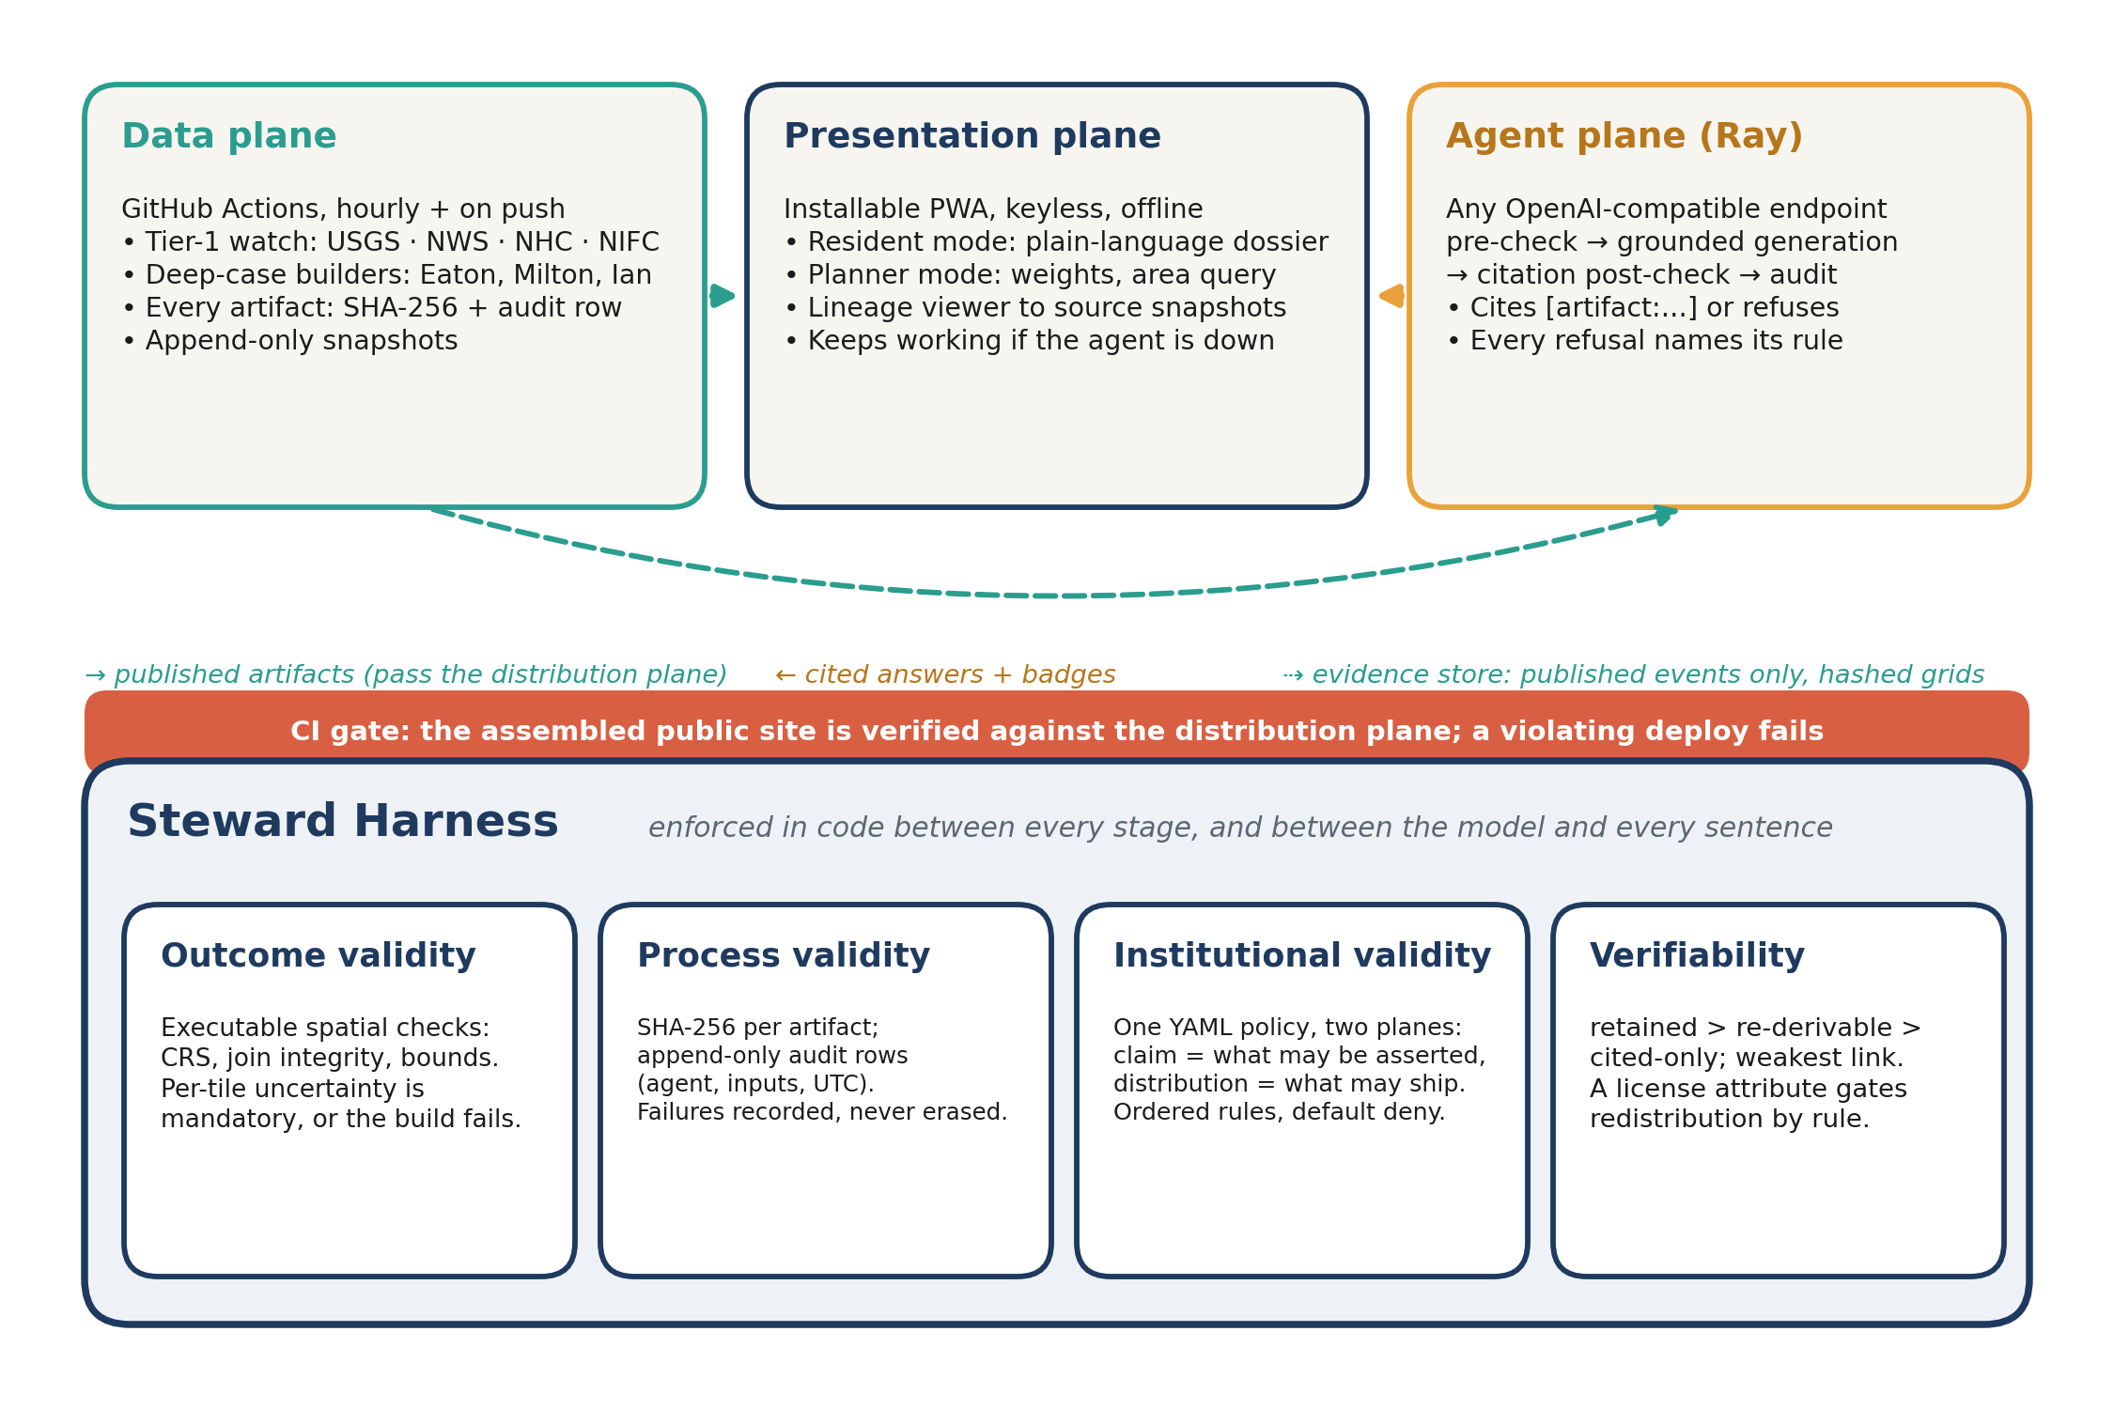
Figure 1. RAY is three loosely coupled planes on top of one harness. The Steward Harness sits between every pipeline stage and between the model and every sentence it emits, enforcing outcome, process, and institutional validity, plus a per-claim verifiability axis. The distribution plane is verified by a CI gate that fails the deploy on violation.
Outcome validity. Executable spatial checks run inside each build: CRS assertions, raster$×$vector and tract-join integrity, sanity bounds, and mandatory per-tile uncertainty fields — a grid cell without a declared uncertainty structure fails the build.
Process validity. Every registered artifact receives a SHA-256 digest and an append-only audit row naming its agent, inputs, and UTC timestamp. Failures are recorded, never erased; the app renders lineage from any map layer back to timestamped source snapshots. Audit logs are treated as immutable: when run-grouping logic later changed, the reader was taught to recover runs from structural markers rather than the logs being rewritten. The gateway’s own audit is redacted by one rule — it holds no finer location than the claim plane lets any answer use: a point is stored as its H3 r9 cell, an area’s corners rounded to $∼$110 m, and the question as sha256 plus length, so a caller can prove their question produced a row without the log retaining what a resident typed about their own home.
Institutional validity. A single YAML policy file carries two planes of ordered, first-match rules with default deny, validated at construction time — an unknown match key fails loudly at load rather than silently broadening authorization. The claim plane scopes what may be asserted, by role (resident vs. planner), evidence tier, spatial resolution, and geography: tile-level evidence never yields parcel-level claims. The distribution plane scopes what a build may publish, by artifact class, resolution cap, and audience; CI verifies the assembled public site against it and fails the deploy on violation. Section 4 explains why the second plane exists.
Citation by default. Every factual sentence the agent produces must cite an artifact identifier. The exemption set is closed (questions, imperative safety advice, statements about what the answer cannot say), so a sentence form nobody anticipated costs a refusal, not an uncited claim. Refusals name the policy rule that triggered them.
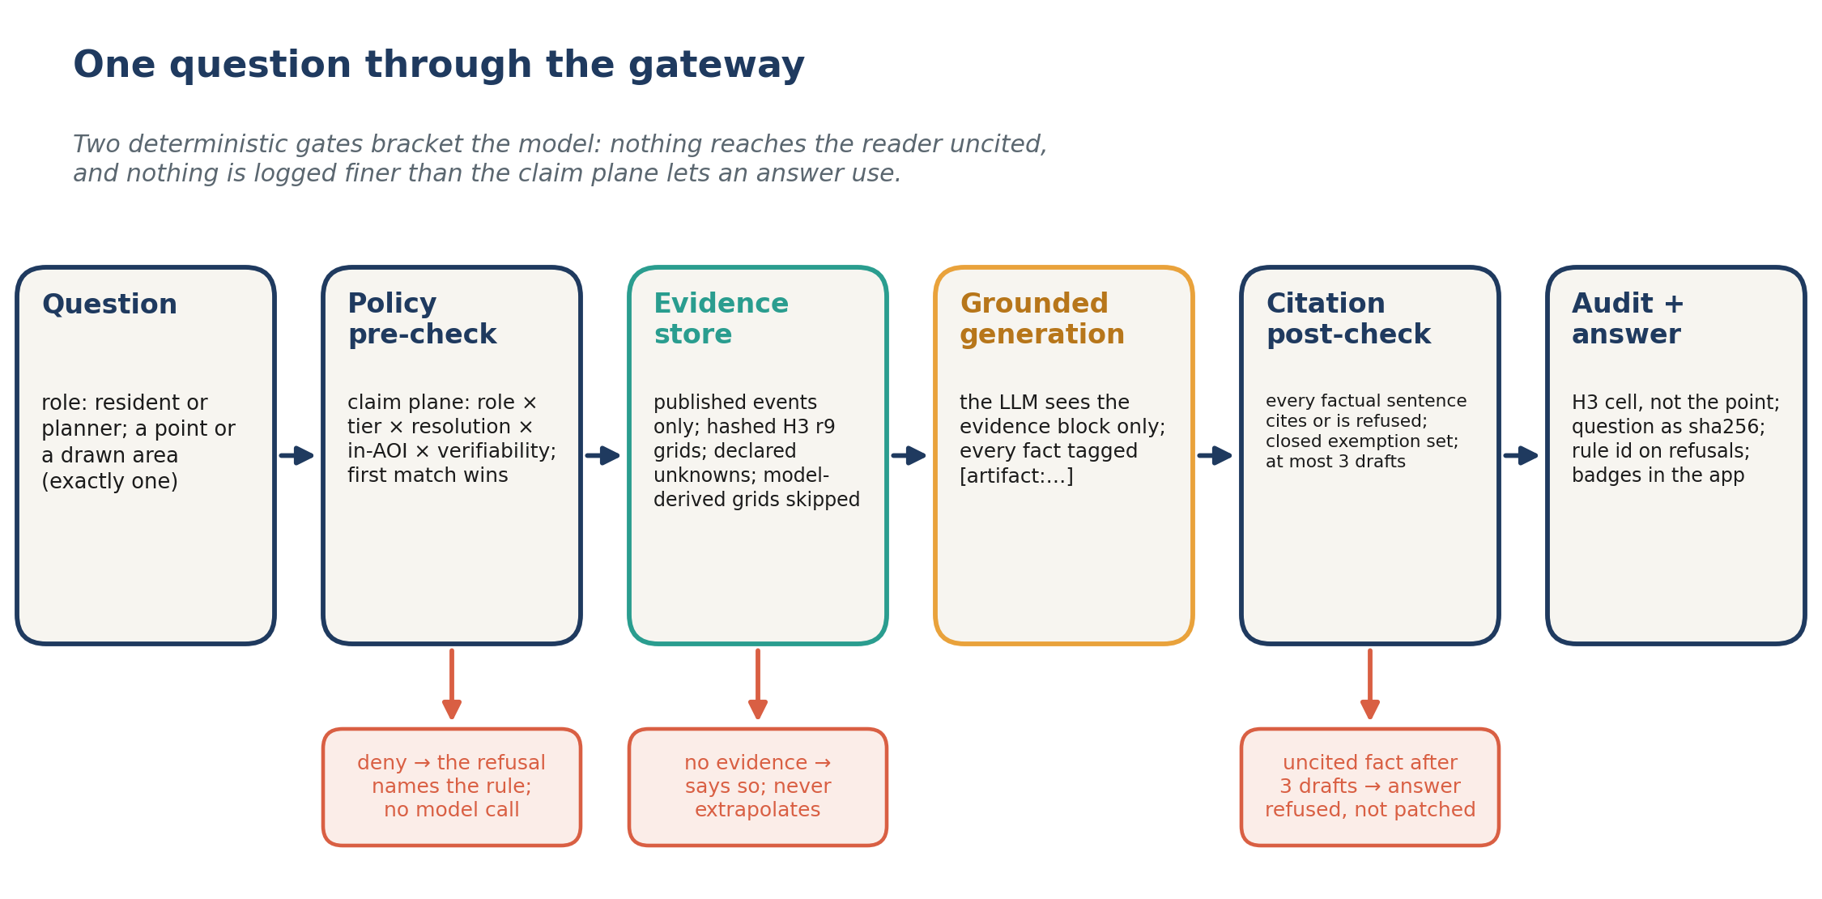
Figure 2. One question through the agent gateway. Two deterministic gates bracket the model: the claim-plane pre-check decides whether this role may ask this of this place at this resolution before any model call, and the citation post-check refuses any factual sentence without an artifact identifier. The audit stores the H3 cell, not the point, and the question as a digest.
Verifiability. Evidence tiers describe depth; they do not say whether a reader can check a claim. Each artifact therefore carries verifiability $∈$ {retained, re-derivable, cited-only} with weakest-link aggregation, and a license attribute gates redistribution by rule. The axis earns its keep where retention is forbidden: map-platform terms disallow storing map content, which is structurally incompatible with proving traceability by hashing inputs. The harness resolves this by attesting to the request plus a response digest — a lookup record that is publishable precisely because it holds no content — and a containment property test enforces that no response payload ever reaches the audit record. Grounded free-text generation is not reproducible even at temperature zero, so it falls through to default-deny: the citable unit is the citation, never the prose. The license attribute is exercised in production by a fourth value — open-license-attribution — for OSM-derived facility context (ODbL): redistributable, but only with its attribution, which therefore travels inside the artifact itself.
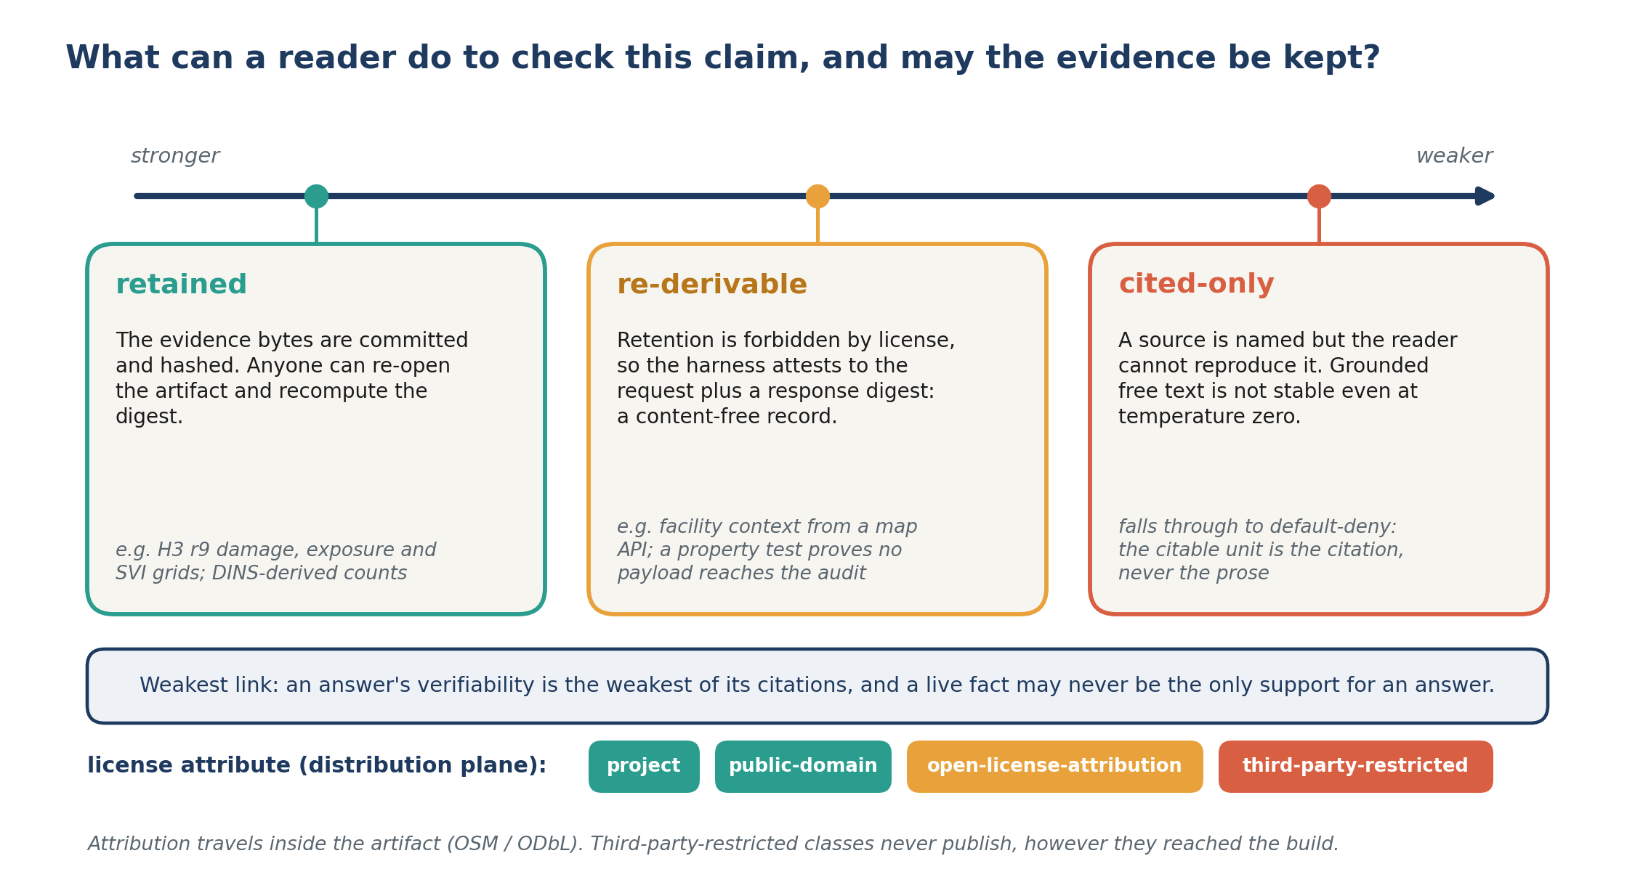
Figure 3. The verifiability axis states what a reader can do to check a claim, with weakest-link aggregation across an answer’s citations. Re-derivable evidence covers the case where license terms forbid retention: the harness attests to the request plus a response digest, a record that is publishable precisely because it holds no content. The license attribute gates redistribution by rule.

System and Deep Cases
RAY is three loosely coupled planes: a data plane (GitHub Actions pipelines through the harness, publishing hashed artifacts), a presentation plane (an installable React + MapLibre PWA, keyless and offline-cacheable), and an agent plane (any OpenAI-compatible endpoint wrapped in policy pre-check $→$ grounded generation $→$ claim post-check $→$ audit). If the agent plane is down, the maps and analysis keep working — graceful degradation as fail-closed design made visible.
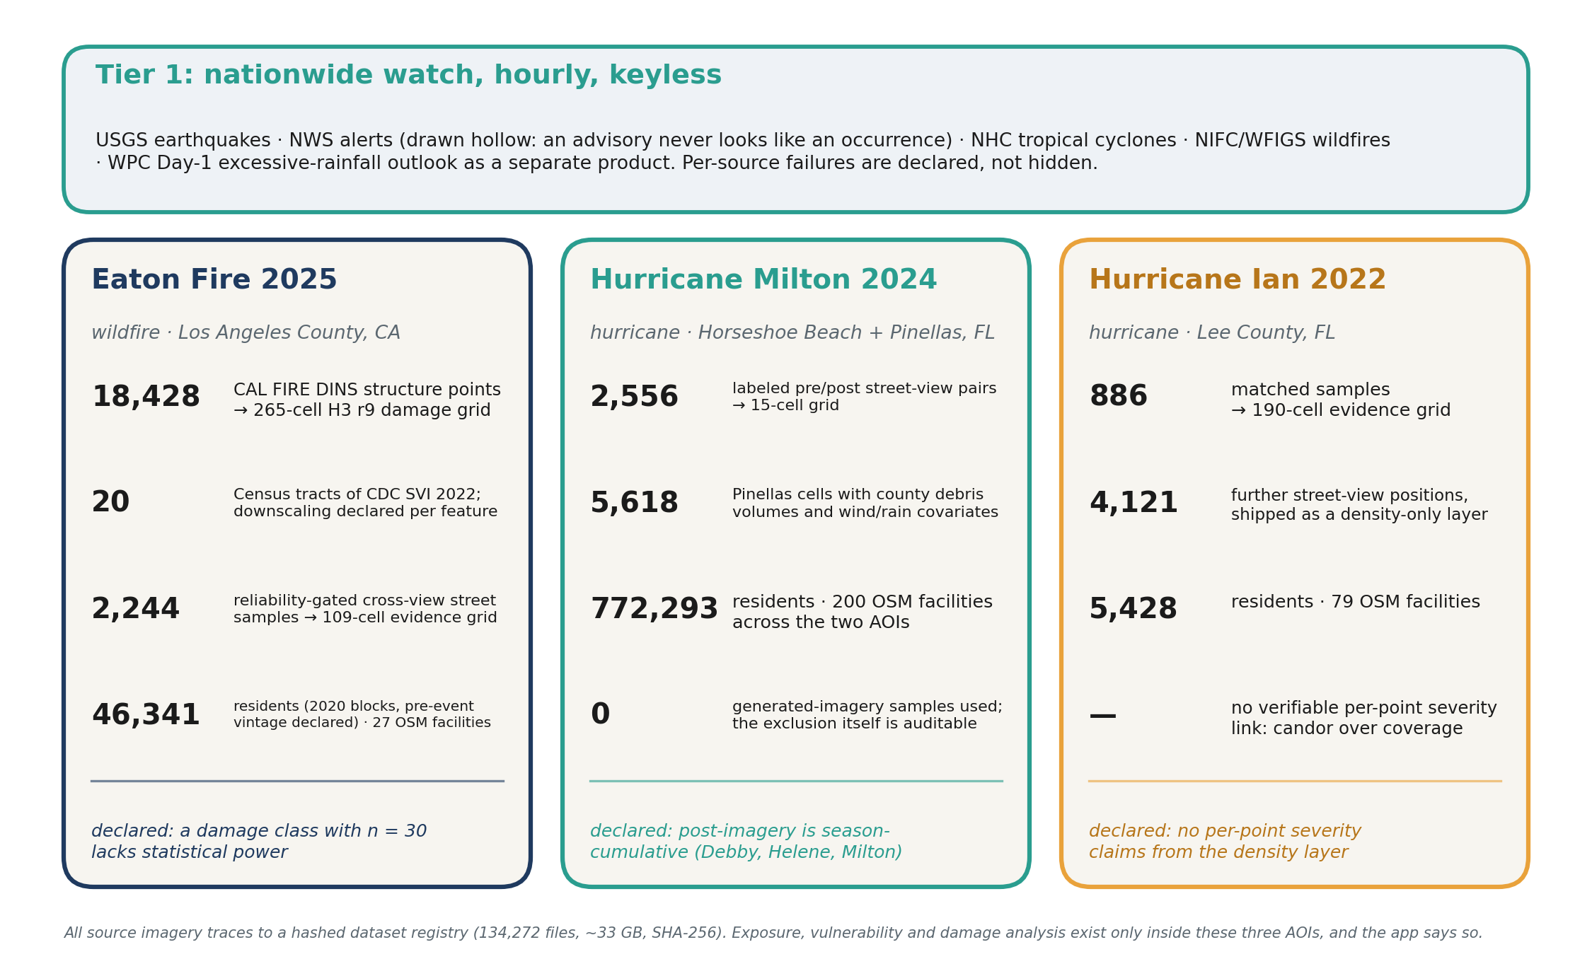
Figure 4. Three deep cases across two hazard types, behind a nationwide hourly watch. Every number is a committed, hashed artifact; every card carries a declared unknown alongside its findings.
Tier 1 — nationwide watch. Four keyless federal connectors (USGS earthquakes, NWS alerts, NHC tropical cyclones, NIFC/WFIGS wildfires) refresh hourly in CI, writing append-only gzip snapshots and a national watch product. Per-source failures are declared, not hidden: the map badge reports mapped-of-total features and names sources that failed, and an ArcGIS error envelope fails the wildfire connector closed instead of reporting zero fires. NWS alerts render hollow — an advisory about what may come never looks like an occurrence. A Day-1 flash-flood outlook (NOAA/WPC Excessive Rainfall Outlook, public domain) publishes as a separate product beside the watch — polygons and a forecast, never merged into the point layer — carrying its own declared boundary: outlook only, no damage conclusions, never a replacement for official warnings.
Tier 2/3 — three deep cases, one harness. Exposure, vulnerability, and damage analysis exist only inside three areas of interest, and the app says so rather than extrapolating:
- Eaton Fire 2025 (CA): 18,428 CAL FIRE DINS structure points $→$ a 265-cell H3 r9 damage grid with per-severity counts and mandatory uncertainty; CDC SVI 2022 joined across 20 Census tracts with the downscaling approximation declared per feature; 2,244 reliability-gated cross-view street-imagery samples $→$ a 109-cell evidence grid; 46,341 residents (2020 census blocks, centroid-allocated with the pre-event vintage declared) and 27 OSM critical facilities. A damage class with $n=30$ is declared as lacking statistical power rather than hidden.
- Hurricane Milton 2024 (FL): 2,556 labeled pre/post street-view pairs $→$ a 15-cell grid at Horseshoe Beach, each feature carrying the attribution caveat that post-imagery is season-cumulative (Debby, Helene, Milton); 5,618 Pinellas County cells with county debris-program volumes and wind/rain covariates. 772,293 residents and 200 OSM facilities across the two AOIs. A generated-imagery dataset was excluded, and the exclusion itself is auditable in the event dossier.
- Hurricane Ian 2022 (FL): 886 matched samples $→$ a 190-cell evidence grid; 4,121 further street-view positions ship as a density-only layer because no verifiable per-point severity link exists — candor over coverage; 5,428 residents and 79 OSM facilities.
All source imagery traces to a hashed dataset registry (134,272 files, $∼$33 GB, SHA-256). Facility context declares OSM presence, never operational status; population outside the evaluated tiles is declared as a total, never mapped into tiles the event has no evidence for; and no claim-plane rule authorizes facility claims, so the agent’s answers about them default-deny.
Two modes. Residents geocode an address and receive a plain-language dossier — stat callouts with their qualifiers attached, declared unknowns rendered as prominently as findings, and one of three coverage answers: covered, outside the evaluated areas, or not determined when a layer could not be read (the system will not claim an address is outside areas it failed to look at). Planners weight structural damage against social vulnerability on a live slider (every adjustment audit-logged), inspect lineage, and can draw an area and ask about it; the answer covers only the evaluated tiles the selection contains, never merges statistics across events, and highlights the tiles it cited.

The Harness Catching Its Own System
Two preserved incidents are, we believe, the strongest evidence the mechanism does real work.
The publication boundary. A parcel-level DINS file (18,428 points with per-structure damage) reached the public site through an asset-copying script, violating four written statements in the repository — while breaking zero policy rules, because the claim plane governs what the agent asserts and nothing had asserted the file. The fix was structural: a distribution plane in the same policy file, a publication-boundary planner, and a CI gate that verifies the assembled site; the public surface dropped from 30 files to 16. The incident report is committed alongside the code it indicts.
Citation by default, inverted. The claim post-check originally required citations only on sentences containing digits, so “Your neighborhood was not significantly affected” passed uncited. The check was inverted to citation-by-default with a closed exemption set; acceptance on a representative draft set fell from 9/13 to 7/13 sentences — the two newly refused sentences being exactly the uncited reassurances a resident should not receive.
The audit log also preserves an over-strict join assertion the harness rejected during the Eaton SVI build (envelope tracts vs. burn-area tracts), recorded as a failure and corrected in a subsequent run — append-only history, including of our own mistakes.

Evaluation Environment
Following [5], the test suite is designed as the paper’s verifiable evaluation environment rather than an afterthought: 301 Python tests and 67 app tests run in CI on every push, including a cell-by-cell policy-matrix sweep (every role $×$ tier $×$ resolution combination against expected authorization), adversarial claim-check cases, fail-closed connector tests against real error envelopes, and the containment property test for content-free lookup records. Anchor checks resolve every path-shaped reference in the documentation against the repository, so the manual cannot silently rot. Judges can run the environment in two commands from the README.

Related Work
Autonomous-GIS agents demonstrate that LLMs can operate spatial tooling [4, 6]; our contribution is orthogonal — a harness that constrains any such agent’s claims to its evidence. Operational platforms such as the Texas Disaster Information System [3] field forecast-forward flash-flood impact and exposure summaries at state scale; accountability there rests on interface disclaimers, whereas RAY binds each sentence to a hashed artifact and a policy rule. Global registries (EM-DAT [1], GDACS [2]) record that events happened; none carries, per row, what resolution of claim the evidence authorizes or whether a reader may keep it — the two fields this system computes for every artifact.

Limitations
The deep-case builders read a $∼$33 GB corpus on the maintainer’s workstation, so third parties can verify the committed artifacts, hashes, and audit logs but not regenerate them. The agent gateway runs locally (no hosted endpoint; no auth or rate limiting yet), so the public demo ships without chat. The re-derivable regime is implemented and tested against a stub but has never run against a live commercial API. Inspection routing is not implemented. Nationwide coverage is Tier-1 watch only; the app declares this boundary instead of smoothing over it, which we consider a feature, but reviewers should not mistake three deep cases for national analysis capability.

Acknowledgments
RAY is an MIT-licensed research prototype. It is not an official forecasting or warning service.

References
[1] Delforge, D. et al. 2025. EM-DAT: The emergency events database. International Journal of Disaster Risk Reduction. 124, (2025), 105509. https://doi.org/10.1016/j.ijdrr.2025.105509.
[2] European Commission Joint Research Centre and United Nations OCHA 2026. Global disaster alert and coordination system (GDACS). https://www.gdacs.org/.
[3] Institute for a Disaster Resilient Texas 2026. Texas disaster information system (TDIS) portal. https://portal.cloud.tdis.io/.
[4] Li, Z. and Ning, H. 2023. Autonomous GIS: The next-generation AI-powered GIS. International Journal of Digital Earth. 16, 2 (2023), 4668–4686. https://doi.org/10.1080/17538947.2023.2278895.
[5] Yang, Y. and Zou, L. 2026. From autonomous GIS to accountable GeoAI agents: Verifiable evaluation environments and geospatial harness engineering.
[6] Zhang, Y. et al. 2024. GeoGPT: An assistant for understanding and processing geospatial tasks. International Journal of Applied Earth Observation and Geoinformation. 131, (2024), 103976. https://doi.org/10.1016/j.jag.2024.103976.

Live site, app, and repository: https://rayford295.github.io/ray-resilience/

