**Project Phase One**

**Team: Webcoholics**

**Birinder’s Features**

**1. Login/Registration System**

A widget on the home page, wherein user enters his/her username and password. Both the fields are validated on the client side and password field in encrypted using MD5 encryption. The username and encrypted passwords will be sent to server side for verification. If the user is verified, then the flow will be redirected to a new page. Otherwise the flow control will move back to the home page displaying an appropriate error.

Clicking on ‘New User’ link will take the user to a registration form. User will enter his first name , last name, email as username, password and some demographic details. After clicking the submit button, a confirmation link will be mailed to the user’s email. Only after clicking the confirmation link, will the user will get registered.

**2. Add/Update/Remove Recipes**

When the user is logged in, a button “Your Recipes” will be visible in the upper right area of the header. Clicking on this button takes the user to a page where all the recipes submitted by the logged in user are shown in a table. Options for editing, sharing and deleting the recipe will be shown against each submitted recipe. A button “Add New Recipe” present on the top of the table will open a pop up form where user will be able to add a new recipe. When a recipe is added, the page will reload and updated list of submitted recipes will be shown.

**3. Save Favourite Recipes / Create custom cookbook**

Each recipe will have a heart button against it. When any logged in user clicks it, we will make an entry in the database table which will contain information like recipeID and userID. User will have an option of downloading a single PDF file containing all of his/her liked recipes by click of a button.

**4. Rating System**

All logged in users will be able to rate the recipe from 1-5. This information will be counted towards the overall rating of the recipe. User will also be able to give comments regarding the rating he/she is providing. An automated email will be sent to the author whenever a rating of 1 or 5 is given to his/her recipes. This rating will be used as one of the filters on the home page for search results.

**Amandeep’s Features**

**1. Commenting System**

At the end of each recipe, there will be a comment box containing a Textbox field to get the comment from a registered logged in user. An automated email will be sent to

the author whenever a comment is given to his/her recipes. The author can approve and disapprove the comment from his account for his/her recipes.

**2. Contact the Author Form**

If a logged in user is reading a recipe and wants to contact the author of the recipe, then he needs to click the button (Visit Author’s Profile).   
On the author's profile, there will be a button (Get in touch) which will open a window where the logged in user can type his query in the text field provided. We will not provide attachments in this window to avoid spam or virus attachments.

**3. View Similar Recipes**

There will be categories (like vegetarian, non- vegetarian, bakery etc.) for a different type of recipes being submitted. The author will be responsible to add his recipe in a category that it belongs to while creating or submitting the recipe. The author can change the Category later also in the update/Edit mode for the recipe.

A logged in user can directly select the category option from the header menu to get all the recipes that belong to that particular category.

**4. Search/Filter Recipes**

At the top right corner, we will be having a search bar, where the user can enter the value to be searched in the website.

The first level of search will compare the value with the recipe’s title and description. The searched result will be shown in a new window.   
The second level of search comprises of filter options in this new window where a different type of options will be provided to logged in user to narrow down his search.  
Few filter parameters are as follow:-

1. Date (Month, Year)
2. Category

**Raymond’s Features**

**1. A feature that lets people upload the results for recipes they tried and upload a picture.**

This feature will be an add on to each recipe page. There will be a section on the page where registered users can upload their results. Clicking on upload will take you to a form where you can upload a picture of your results as well as leave a comment on how the recipe worked for you. Upon submission of this form your picture will appear as a thumbnail in the recipe page.

**2. Meal Plan System, lets the user plan out recipes they want to try for the week/month**

The idea for this feature is that it will be a page that a registered user can access and personalize. It will display an interactive calendar for the current month and two months in the future. The month being viewed can be changed via a dropdown list. Clicking on a day in the calendar will have a modal window popup that lets you choose if you want to add a recipe to that day, view a recipe saved to that day, or delete a recipe saved to that day.

**3. Sending reminders based on your meal plan, ask you for feedback on recipes.**

If a user had a recipe saved to a date on the calendar, and the calendar date has passed, then the user will receive an email that will request feedback for the recipe. The email will contain links that will allow the user to leave a comment on the recipe, rate the recipe, upload a picture of their results.

**4. Can select a group of recipes and create a shopping list, generates a list based on the ingredients.**

This feature will be part of the user’s dashboard. They can choose to create a shopping list. This will lead to a page where users can select a group of recipes, either from their favourites list or by entering a recipe number. Based on the recipes they selected a shopping list will be generated that includes a list of ingredients and the quantity needed.

**Mariya’s Features**

**1. Section that lets users request recipes**

This section will let u­sers to request recipes they would like to cook but don’t know how. The page will contain a generated table with requests of recipes with short description.

There will also be the “New request” button that takes a user to another page when clicked. A user must be logged in to be able to create a new request. As the new request form page pops up, user will be asked to fill out the form to create the request. The form will consist of the “Title” and “Description” fields. In the “Title” field users should insert the meal name they are seeking, and in the “Description” field – a short description. Both fields are mandatory and have required field validation. If any field is left out empty the error message would be displayed under the field asking to fill it. After users submit the filled out form the data will go to the database request_recipes table, and then the table on the request recipe section will be automatically populated with a new request.

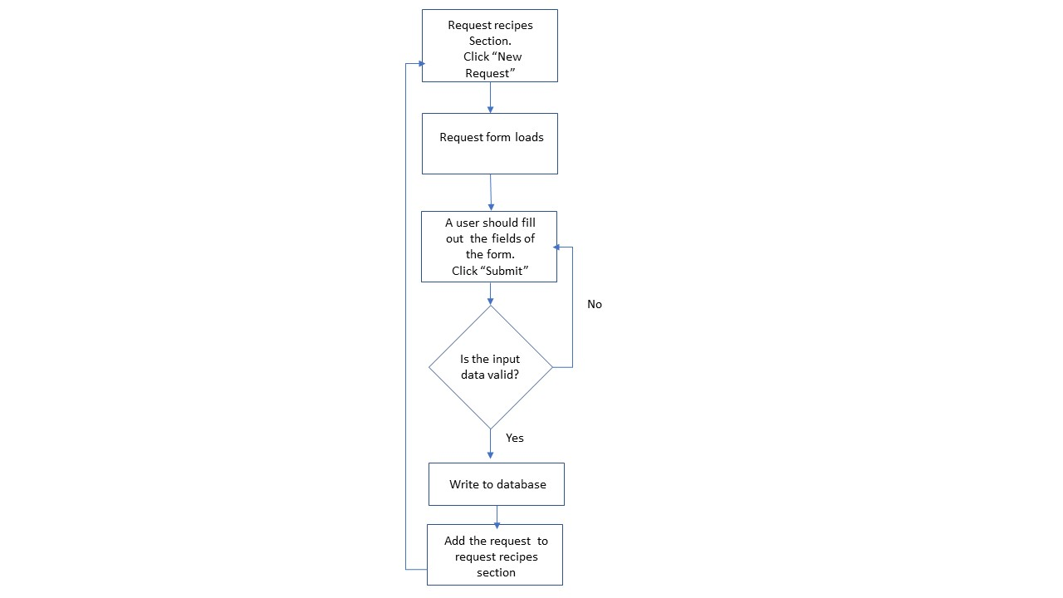

**2. Feature to customize users’ profile. Creating a dashboard with different views for admin and user.**

This feature will display two different views, depending on who is logged in user or admin.

The dashboard for users will contain fields with their personal information they inserted when creating their profile: First Name, Last Name, Username, Password, Phone, Email, Bio, Image and posted recipes. Users can update/delete any current information. If they click “Update”, they will be presented with the pre-populated form, then they can update information and click “Save”. After clicking “Save” the data for the user will be replaced with the new data in database user_table.

The admin dashboard will display the view where the admin can see statistics – number of the website visitors and which recipes are the most popular. The dashboard will contain generated table and graphs showing the dynamic.

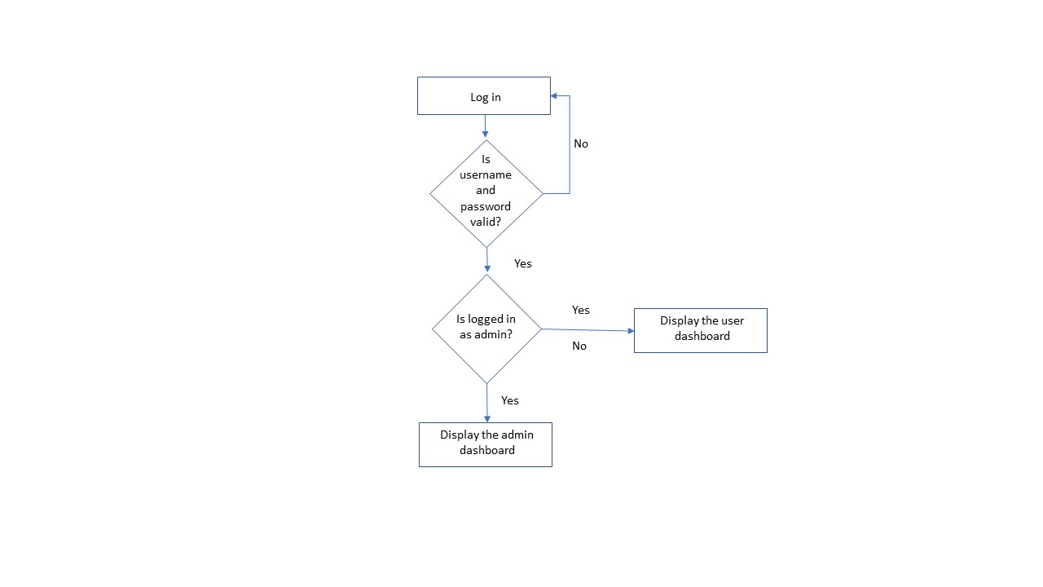

**3. Timer feature**

The feature will facilitate users’ cooking process and enable time control to comply with recipes. Cooking Timer is an easy-to-use feature that alerts users in preparing their meal. It will be displayed on the recipe page. If a user wants to use the timer, they just click “Start” button and the timer pulls meal cooking time from database’s recipe table and starts counting down. The timer predicts when the meal will have been ready.

**Tier 1, 2, 3**

We intend to start with all features at tier 1. We will then add to each feature to bring them up to tier 2. As a group we will then discuss which features we should bump up to tier 3.