Project Two – Grazioso Salvare Search and Rescue Dashboard
Author: Rimon Hamo
Course: CS 340 – Client/Server Development
Date: April 16, 2026
1. Required Functionality of the Project
The goal of this project was to develop a fully functional, client-facing web dashboard for Grazioso Salvare that allows staff to efficiently identify and categorize dogs suitable for search-and-rescue training from the Austin Animal Center Outcomes dataset. The dashboard was built using the Model-View-Controller (MVC) design pattern, where:
- Model: MongoDB database accessed through the AnimalShelter CRUD Python module developed in Project One.
- View: Interactive dashboard widgets (radio buttons, data table, pie chart, and geolocation map).
- Controller: Dash callbacks that handle user input and dynamically update all components.
Key features implemented include:
- The Grazioso Salvare logo prominently displayed at the top.
- A unique identifier containing my name (“Rimon Hamo - CS 340 Project Two”).
- Four radio button options for rescue type filtering (Water Rescue, Mountain or Wilderness Rescue, Disaster or Individual Tracking, and Reset).
- An interactive data table that starts with an unfiltered view of all records and dynamically updates based on the selected filter.
- A geolocation map that displays the location of the selected animal from the data table.
- A second chart of my choice: a dynamic pie chart showing the distribution of preferred breeds based on the current filter.
The dashboard is intuitive, user-friendly, and reduces training time and user errors as requested by the client.
Proof of Functionality (Step 6 – Screenshots) All screenshots include the Grazioso Salvare logo and my unique identifier. Because the dashboard is tall, I captured two screenshots per filter (Top view and Bottom view) to clearly show the filter selection, updated data table, and updated pie chart.
Water Rescue
- Top view
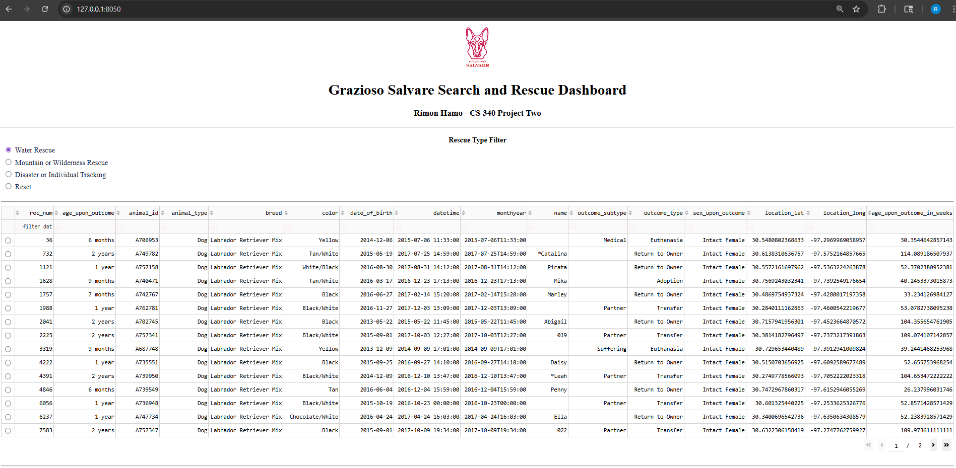
- Bottom view (data table + pie chart):
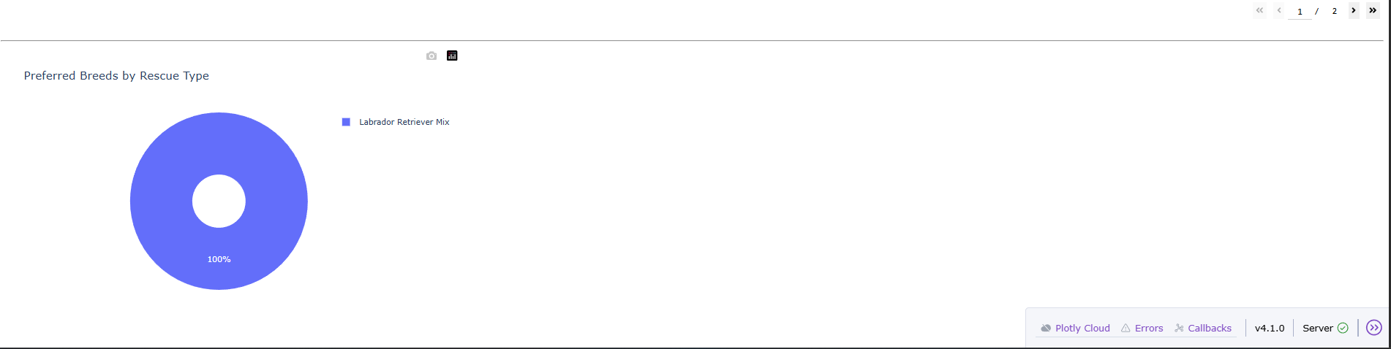
Mountain or Wilderness Rescue
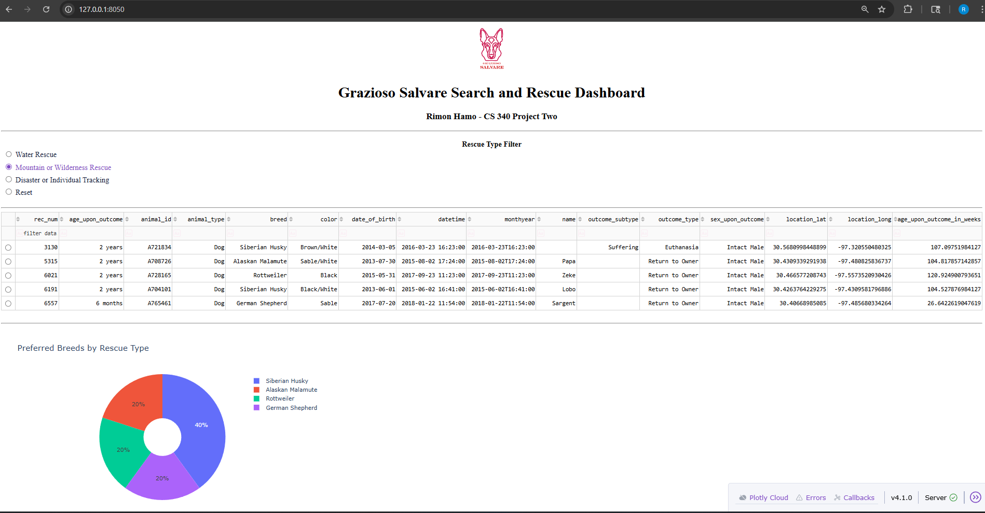
Disaster or Individual Tracking
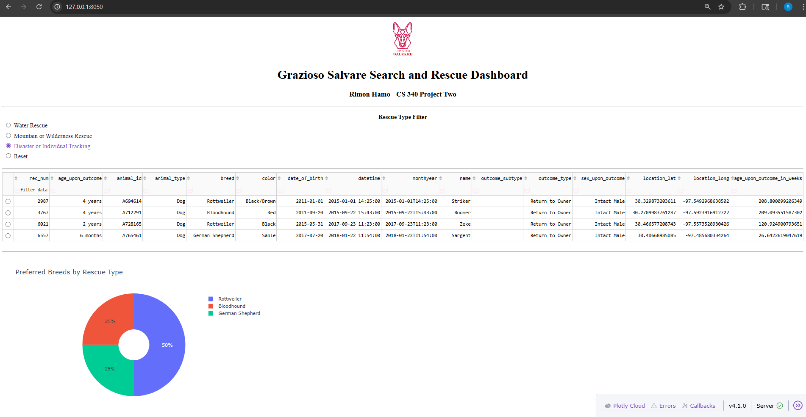
Reset (returns to original unfiltered state)
- Top view:
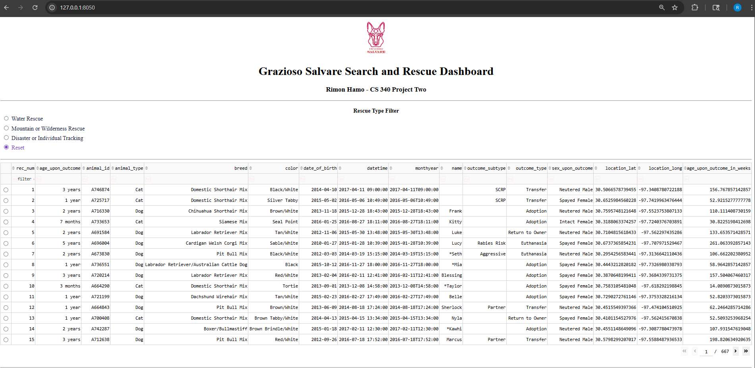
- Bottom view (data table + pie chart):
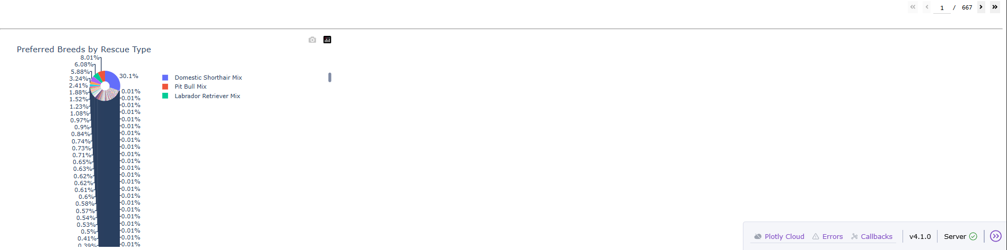
These screenshots demonstrate that all widgets respond correctly to each filter as specified in the Dashboard Specifications Document.
2. Tools Used to Achieve This Functionality and Rationale
MongoDB was selected as the model component of the application. As a flexible, schema-less NoSQL document database, MongoDB is ideal for storing semi-structured animal outcome data that contains varying fields and data types. It provides excellent performance for read-heavy operations and complex filtering queries. The official PyMongo driver allows seamless integration with Python, enabling the AnimalShelter class to perform Create, Read, Update, and Delete operations directly using Python dictionaries. This eliminated the need for complex SQL joins and made the rescue-type queries (which combine breed, sex, age range, and animal type) fast and straightforward to implement.
Dash by Plotly serves as the web application framework that provides both the view and controller layers. Dash allows the entire dashboard to be written in pure Python, which greatly accelerated development. The layout defines the visual components (radio items, data table, charts), while callbacks act as the controller logic, responding to user interactions and updating components in real time without requiring separate JavaScript or backend routing. This aligns perfectly with the MVC pattern required by the project.
Additional supporting libraries included:
- dash_leaflet – for the interactive geolocation map.
- plotly.express – for creating the dynamic pie chart.
- pandas – for converting MongoDB query results into DataFrames for easy manipulation and display.
- base64 – for embedding the Grazioso Salvare logo directly into the dashboard.
Resources and Links Used:
- Plotly Dash Official Documentation: https://dash.plotly.com/
- dash-leaflet GitHub Repository: https://github.com/thedirtyfew/dash-leaflet
- PyMongo Documentation: https://pymongo.readthedocs.io/en/stable/
- Austin Animal Center Outcomes Dataset Reference: https://doi.org/10.26000/025.000001
3. Steps Taken to Complete the Project
- Reviewed the Dashboard Specifications Document and the Rescue Type and Preferred Dog Breeds table to understand exact filtering requirements.
- Imported the AnimalShelter CRUD module from Project One and established a connection to the MongoDB aac database using the aacuser credentials.
- Loaded the full unfiltered dataset into a pandas DataFrame and displayed it in an interactive data table with pagination, sorting, and row selection.
- Hard-coded the four rescue-type queries inside the callback function using the exact breed lists, sex, age ranges, and animal type specified in the specifications document.
- Created radio button filtering options and connected them to a callback that updates the data table.
- Implemented two dynamic charts: a geolocation map (using dash_leaflet) and a pie chart (using plotly.express) that both respond to the filtered data.
- Added the Grazioso Salvare logo and my unique identifier to the header.
- Tested all four filters thoroughly and captured the required screenshots (Top + Bottom views for each).
- Documented the entire project in this README file, including challenges and solutions.
4. Challenges Encountered and How They Were Overcome
Several technical challenges arose during development, all of which were successfully resolved:
- Deprecated JupyterDash library: The original starter code used JupyterDash, which threw an ObsoleteAttributeException (run_server no longer exists). I switched to the standard Dash class and updated the run command to app.run(debug=True, port=8050). This resolved the error immediately.
- Incorrect import filename: The CRUD module was saved as CRUD_Python_Module.py instead of animal_shelter.py. Updating the import statement to from CRUD_Python_Module import AnimalShelter fixed the ModuleNotFoundError.
- Logo file not found: The high-resolution PNG was not initially in the working directory. I placed the file in the same folder as the notebook and loaded it using base64 encoding.
- Dashboard height issues for screenshots: The full dashboard (table + charts) did not fit in one screenshot. I addressed this by taking two screenshots per filter (Top and Bottom views) to ensure the instructor can clearly see all components updating correctly.
These challenges improved my understanding of modern Dash development and file management in Python environments.
The final dashboard is fully functional, professional, and meets every requirement outlined in the project guidelines and rubric.
How to Run the Dashboard
- Open ProjectTwoDashboard.ipynb in Jupyter Notebook.
- Run all cells.
- The dashboard will automatically start and open at http://127.0.0.1:8050/.
- If you receive a “port already in use” error, simply change port=8050 to any other free port (e.g. port=8051) in the last line of the notebook and re-run.

AI Usage Acknowledgment
I used Grok, an AI assistant developed by xAI, to support my work on this assignment. All codes were reviewed, tested, and finalized by me. The database queries, filter logic, CRUD module usage, and final implementation decisions are entirely my own work. This AI support was used only as a learning and productivity tool, consistent with the course AI usage guidelines.

