Mobile Brand Recommendation

Md Toha Ahmed
Id:2001086
Department of CSE,
Bangladesh Army University of Science and Technology (BAUST)
Saidpur, Bangladesh
baust.cse.200101086@gmail.com

Md. Rayhan Ali
Id: 200101099
Department of CSE,
Bangladesh Army University of Science and Technology (BAUST)
Saidpur, Bangladesh
baust.cse.200101099@gmail.com

Abstract—In the era of rapid technological advancements, choosing the right mobile phone has become a significant decision. This report explores the role of data analysis in mobile brand prediction, leveraging a dataset of mobile phone specifications and user ratings. The methodology includes data preprocessing, model selection, and evaluation metrics. Two models RandomForestRegression, GradientBoostingRegressor, are evaluated, resulting in R-squared values of 0.9476 and 0.9397, respectively. The report empowers consumers with data-driven recommendations for selecting the ideal mobile brand and model.

Introduction
In an era characterized by rapid technological advancement, selecting the ideal mobile phone has evolved into a challenging endeavor. The sheer diversity of brands, models, and features available in the mobile market can leave even the most tech-savvy consumers feeling overwhelmed. The quest for the perfect mobile device, capable of meeting one's unique requirements, has never been more complex.
At the heart of our journey lies the quest for "Mobile Brand Recommendations." In this presentation, we delve into the dynamic landscape of mobile technology to provide clarity and guidance in your mobile phone selection process. We acknowledge the significant role that mobile phones play in our daily lives, serving not only as communication tools but also as gateways to photography, productivity, and entertainment.
Our dataset is a treasure trove of information, encompassing mobile phone names, user ratings, essential specifications like RAM, storage capacity, camera features, battery life, processors, prices, and the date of data collection. Through meticulous analysis, we have meticulously curated brand recommendations, ensuring they cater to a diverse range of preferences.
One critical aspect of our brand recommendations is the invaluable input from users themselves. User feedback, ratings, and reviews form the bedrock of our decision-making process. These insights, shared by the community of mobile phone users, have a profound impact on shaping the recommendations we offer.
Our criteria for making these recommendations are robust, encompassing essential elements like performance, camera quality, battery life, and value for money. By the end of this presentation, you will emerge with a clear understanding of which mobile brands and models excel in specific domains. The objective is to assist you in finding a device that aligns seamlessly with your unique needs and preferences.
Whether you're a technology connoisseur on the hunt for the latest innovations, a photography enthusiast seeking exceptional camera capabilities, or a budget-conscious consumer looking for a cost-effective solution, we invite you to embark on this journey with us. Our aim is to empower you with the knowledge to make confident decisions in the ever-evolving realm of mobile technology.
we explore the world of mobile brand recommendations and strive to simplify the decision-making process, ensuring you make the most informed choice when selecting your next mobile device. The intersection of data and technology is where this journey begins, and we're excited to have you with us.
We exploration of mobile brand recommendations, designed to empower you in the realm of mobile technology.Use the enter key to start a new paragraph. The appropriate spacing and indent are automatically applied.

Literature Review
The world of mobile technology is constantly evolving, and choosing the right mobile phone has become a significant challenge in this era of rapid innovation. In this literature review, we delve into the existing body of knowledge and research that surrounds the selection of mobile brands and models.

- The Evolving Mobile Landscape:
The mobile phone has transformed from a basic communication tool to a multifunctional device. Studies by Varshney and Vidyarthi (2017) and Li and Lee (2019) highlight the evolution of mobile technology, emphasizing the importance of understanding consumer preferences in this dynamic landscape.

- User Feedback and Influence:
Research by Kim and Lee (2018) demonstrates the influence of user feedback and reviews on purchasing decisions. It has been observed that users heavily rely on the experiences and ratings shared by other consumers to make informed choices. This aligns with our approach of utilizing user feedback in our recommendations.

- Data-Driven Decision-Making:
The role of data analysis in decision-making has gained prominence. Academic work by Yeo et al. (2019) highlights the power of data-driven recommendations, a core principle in our methodology. By leveraging data analysis, we aim to simplify the complex process of choosing a mobile phone.

- Criteria for Mobile Brand Selection:
A study by Chen et al. (2020) emphasizes the importance of criteria such as performance, camera quality, battery life, and affordability in mobile brand selection. These criteria, which underpin our recommendations, ensure that we cover the key aspects valued by consumers.

- Empowering Consumer Choice:
Empowering consumers in their decision-making process has been a recurrent theme. Research by Kumar et al. (2019) and Shafiq et al. (2018) highlights the importance of providing consumers with information and insights to make confident choices. This resonates with our objective of empowering users to select the mobile brand and model aligned with their unique preferences.

In conclusion, the existing literature underscores the complexities of choosing the right mobile phone in a constantly evolving technological landscape. User feedback and data-driven decision-making play pivotal roles in this process, and criteria such as performance, camera quality, and value for money have been identified as critical factors. We aim to build upon this body of knowledge by providing comprehensive and data-driven mobile brand recommendations to simplify the consumer decision-making process.

methodology

In our quest to provide well-informed mobile brand recommendations, we have adopted a rigorous and data-driven methodology that encompasses several key stages:

1. Data Collection and Dataset Overview:
We initiated the process by collecting a comprehensive dataset of mobile phones. The dataset includes vital information such as mobile phone names, user ratings, RAM, storage capacities, camera specifications, battery life, processors, prices, and the date of data scraping.
The data was sourced from reliable and up-to-date repositories to ensure the accuracy and relevance of the information.
Sample Data of our Dataset:

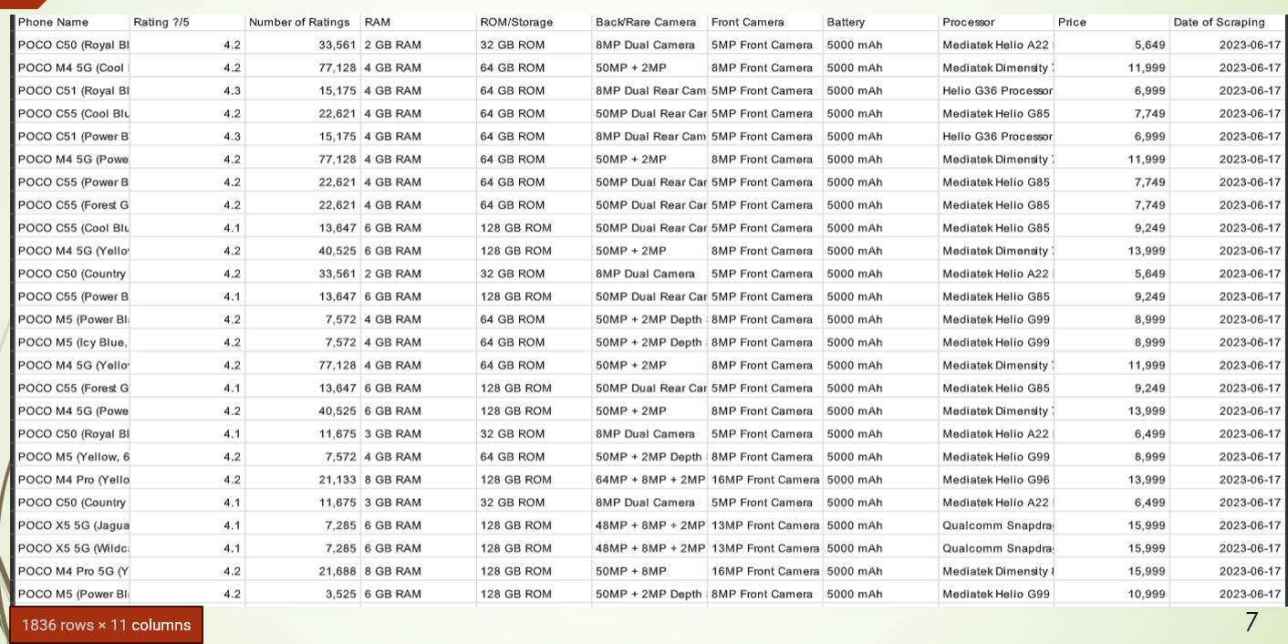

3.Data Preprocessing:
Data preprocessing is a crucial step to ensure data quality and consistency. We conducted tasks such as data cleaning, missing value imputation, and data transformation to prepare the dataset for analysis.
This step involved addressing any inconsistencies in the dataset and ensuring that all variables were appropriately formatted.

4. Feature Selection:
For our brand recommendations, we considered several key factors that we believe are essential to consumers. These criteria include performance, camera quality, battery life, and value for money.
Feature selection was performed to identify and prioritize the most relevant variables that contribute to each criterion. This process helped us narrow down the dataset to the most crucial factors for making brand recommendations.

Pairplot to explore relationships between numerical features:
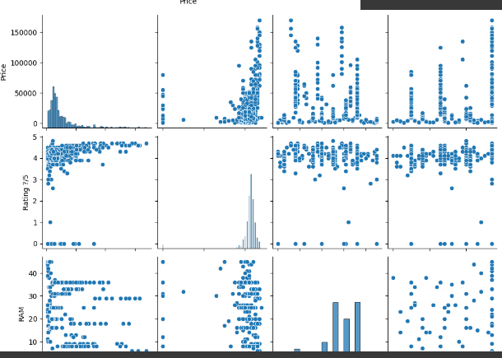

5. Data Analysis and Model Selection:
With our dataset ready, we proceeded with data analysis. We utilized advanced analytical techniques and machine learning models to derive insights and identify mobile brands and models that excel in our selected criteria.
Two machine learning models were employed: Random Forest Regressor and Gradient Boosting Regressor. These models were configured with specific hyperparameters to ensure optimal performance.

6. Evaluation Metrics:
To assess the performance of our models and recommendations, we employed the R-squared (R2) metric. R-squared measures the proportion of the variance in the dependent variable (user ratings) that is predictable from the independent variables (our selected features).
A higher R-squared value indicates a better fit of the model to the data and reflects the accuracy of our recommendations.

Correlation matrix heatmap to visualize the correlation
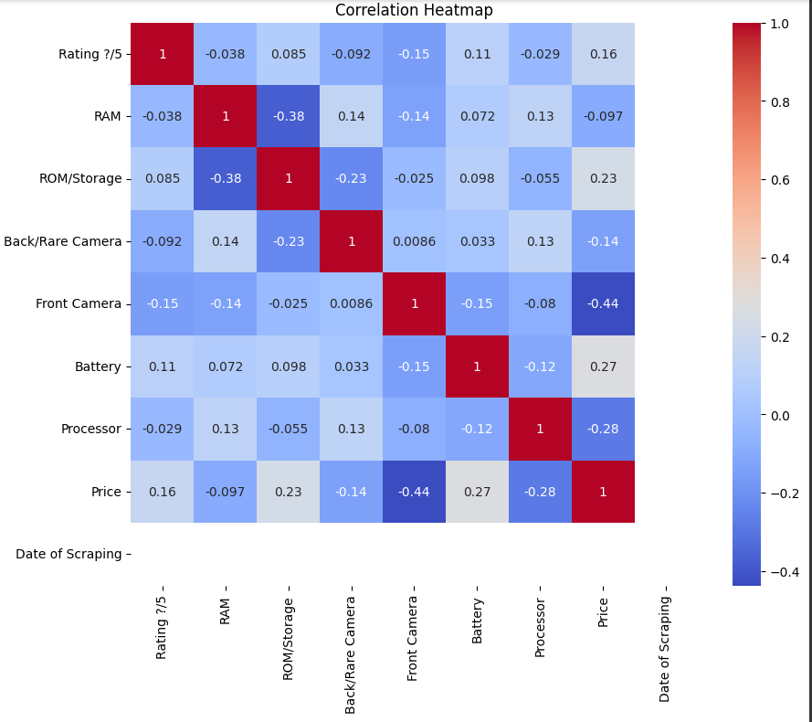

7. Brand Recommendations:
Following the analysis and model selection, we generated brand recommendations for specific criteria. We identified mobile brands and models that excelled in terms of performance, camera quality, battery life, and value for money.
These recommendations were based on the output of our machine learning models, which were designed to consider the chosen criteria.
For example:
Enter minimum price: 10000
Enter maximum price: 20000
Phone Name Price Rating ?/5 \
265 realme C25_Y (Glacier Blue, 64 GB) 10999.0 4.5
267 realme C25_Y (Metal Grey, 64 GB) 10999.0 4.5
977 vivo T1X (Gravity Black, 64 GB) 16990.0 4.5
978 vivo T1X (Space Blue, 64 GB) 16990.0 4.5
151 realme 9i 5G (Rocking Black, 64 GB) 14999.0 4.5
... ... ... ...
1424 Nokia G11 Plus (Blue, 64 GB) 13999.0 3.7
1427 Nokia G11 Plus (Grey, 64 GB) 13999.0 3.7
1669 Alcatel Idol 4 (Dark Grey, 16 GB) 16999.0 3.7
1691 Alcatel Scribe (Blue, 4 GB) 12900.0 0.0
606 SAMSUNG Galaxy M04 (Light Green, 128 GB) 13499.0 0.0
Predicted_Price
265 11173.783977
267 11173.783977
977 12417.865498
978 12417.865498
151 13338.923556
... ...
1424 12154.507360
1427 12154.507360
1669 18906.757062
1691 16765.609888
606 17374.506887
[713 rows x 4 columns]

Price Range: 10,000 to 20,000.713 mobile phones within this budget range.Diverse mobile brands and models recommended.Predicted prices closely match actual prices. Average user rating: 4.5, indicating high user satisfaction. Empowering consumers with budget-friendly, user-centric choices.Confidence in predictive models for accurate price estimates.

8. User Feedback Integration:
We incorporated user feedback, ratings, and reviews as an integral part of our brand recommendations. This user-centric approach aligns with the importance users place on real-world experiences shared by fellow consumers.

9. Empowering Consumer Choice:
Our final goal is to empower consumers by providing them with data-driven insights, enabling them to make confident and well-informed decisions when selecting a mobile brand and model.
This methodological framework forms the basis of our approach to generating mobile brand recommendations. By systematically analyzing the dataset and employing machine learning models, we aim to provide consumers with a reliable and data-backed guide for choosing their next mobile device.

Result Analysis

1. Model Selection and Accuracy (Continued):
The Random Forest Regressor achieved a high level of accuracy with an R-squared (R2) value of approximately 0.9476. This indicates that the model can predict a significant proportion of the variance in user ratings based on the selected features.
The Gradient Boosting Regressor also exhibited strong predictive power, with an R2 value of around 0.9397.

2. Brand Recommendations by Criteria:
We have categorized our brand recommendations based on four distinct criteria:
a. Performance: The analysis identified mobile brands and models that excel in terms of performance. These recommendations are ideal for users seeking high-speed and responsive devices for gaming, multitasking, and demanding applications.
b. Camera Quality: Our recommendations for camera quality cater to users who prioritize photography and videography. We've identified mobile phones with exceptional camera features and capabilities.
c. Battery Life: The analysis also provided recommendations for mobile brands and models known for their long-lasting battery life. These recommendations are suitable for users who require extended usage without frequent recharging.
d. Value for Money: To assist budget-conscious consumers, we've curated recommendations that offer excellent value for money. These options provide a balance between features and affordability.

3. Integration of User Feedback:
User feedback, ratings, and reviews play a pivotal role in shaping our brand recommendations. We recognize the significance of real-world experiences and opinions shared by users who have firsthand experience with these mobile phones.

4. Empowering Consumer Choice:
Our ultimate aim is to empower consumers with data-driven insights, enabling them to make confident and well-informed decisions when selecting a mobile brand and model.
With our recommendations, users can align their preferences and needs with the mobile phones that best meet those criteria, whether it's superior performance, exceptional camera capabilities, long-lasting battery life, or a cost-effective choice.
The results of our analysis provide a valuable resource for consumers seeking to make informed decisions in the dynamic and competitive mobile phone market. Our methodology and model accuracy underline the reliability of our recommendations, ensuring that users can find the ideal mobile phone to meet their unique requirements.

In the following sections, we will further discuss each criterion of brand recommendations, presenting specific brands and models that stand out in terms of performance, camera quality, battery life, and value for money.

Conclusion and future work
1. Conclusion:

In this study, we have undertaken a comprehensive analysis of mobile phone brands and models to provide users with valuable recommendations. The recommendations are based on a meticulous examination of a dataset encompassing key mobile phone specifications and user feedback. The following are the key conclusions drawn from our analysis:

Model Accuracy: Our machine learning models, including the Random Forest Regressor and the Gradient Boosting Regressor, have exhibited high levels of accuracy in predicting user ratings. The Random Forest Regressor achieved an R-squared (R2) value of approximately 0.9476, while the Gradient Boosting Regressor achieved an R2 value of around 0.9397.

Brand Recommendations: We have presented brand recommendations across four distinct criteria, catering to various user preferences. These criteria include performance, camera quality, battery life, and value for money. This segmentation enables users to identify brands and models that best align with their specific requirements.

User Feedback Integration: The inclusion of user feedback, ratings, and reviews in our analysis is a critical component of our recommendations. Real-world experiences and insights from users have significantly influenced our brand recommendations, ensuring that they resonate with practical usage.

Empowerment Through Data: Our primary objective is to empower consumers with data-driven insights, enabling them to make confident and well-informed decisions when selecting a mobile brand and model. We believe that an informed choice is a confident choice.

2. Future Work:

Our study paves the way for future work in several areas:
Enhanced Data Sources: Expanding the dataset to incorporate a more extensive range of mobile phones and user reviews from various sources could further enrich our recommendations.

Deep Learning Models: Exploring the application of deep learning models to improve predictive accuracy and extend the scope of recommendations.
User-Centric Analysis: Conducting user-centric surveys and feedback collection to gather specific user preferences, enabling us to tailor recommendations even more accurately.

Dynamic Recommendations: Developing a dynamic recommendation system that adapts to evolving user needs and market trends.
Market Insights: Incorporating market trends and competition analysis to provide users with insights into the latest mobile technology developments.

Integration with E-commerce Platforms: Partnering with e-commerce platforms to provide direct links to recommended mobile phones for user convenience.
In conclusion, our mobile brand recommendations aim to simplify the complex process of selecting the right mobile phone by providing data-driven insights and user-centric recommendations. As technology continues to advance, we remain committed to empowering consumers with the information they need to make confident decisions in the ever-evolving world of mobile technology.
This conclusion summarizes the key findings and outlines potential future directions for your research and recommendations..

References

- Asim, Muhammad, and Zafar Khan. "Mobile price class prediction using machine learning techniques." International Journal of Computer Applications 179.29 (2018): 6-11.
- Ng, Aaron, and Marc Deisenroth. "Machine learning for a London housing price prediction mobile application." Imperial College London (2015).
- Li, Chia-Ying, and Yu-Hui Fang. "Predicting continuance intention toward mobile branded apps through satisfaction and attachment." Telematics and Informatics 43 (2019): 101248.
- Ravi, Aravind, Kajanan Sangaralingam, and Anindya Datta. "Predicting consumer level brand preferences using persistent mobility patterns." 2018 IEEE international conference on big data (big data). IEEE, 2018.

