ASKPDF
AskPDF Implementation
and Code Guide
  - Citation First PDF Question Answering Production TypeScript Monorepo

Build contract: PDF work is asynchronous; every accepted factual answer is tied to authorized document versions and exact PDF pages; tenant scope is enforced in storage, queues, retrieval, cache keys, and database filters.

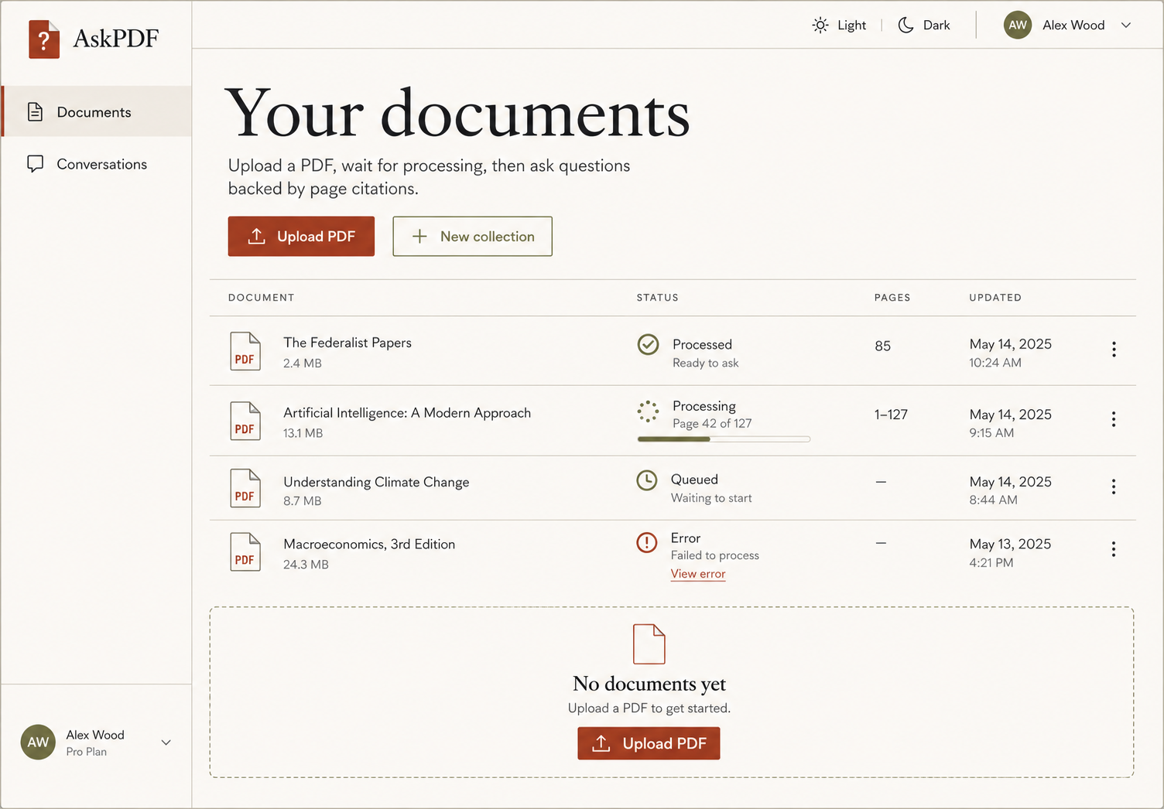
Implementation baseline · 5 September 2026

1. What is being built
AskPDF is a multi-tenant RAG web application for students, researchers, analysts, and teams who need answers they can verify. Users must sign in with email or E.164 phone number plus password, upload PDFs directly to private object storage, monitor background processing, select ready sources, ask questions, and open the page behind every citation.
User problem | Implemented capability | Where it appears
Large PDFs are slow to inspect | Page-aware background extraction and hybrid retrieval | Upload status and Ask PDFs workspace
AI answers can invent facts | Evidence threshold, structured claims, citation-to-chunk validation, abstention | Answer cards and citation drawer
Sensitive documents can cross boundaries | Workspace authorization inside every resource and retrieval query | Invisible security boundary; safe 401/403/404 responses
Long processing blocks web requests | Direct upload plus BullMQ worker stages | Progress states remain responsive
Research needs source inspection | Short-lived signed source URL with exact page number | Citation click opens source drawer

MVP boundary: Quiz, study notes, debate mode, flashcards, spaced repetition, and collaborative learning remain planned v2 work. Their designs are recorded, but no unfinished buttons or fake server behavior are shipped in the MVP.

2. System shape
Browser (React/Vite)
├── HTTPS JSON + SSE ──> Express API ──> MongoDB / Redis / MinIO / Gemini
└── signed PUT ───────────────────────> MinIO or S3
│
BullMQ job ───┴──> Worker
parse → normalize → chunk → embed → publish progress
- The web application owns presentation, session state, direct upload, retry affordances, streamed progress, and citation navigation.
- The API owns validation, authentication, authorization, metadata, signed URLs, conversation orchestration, retrieval, citation validation, and public error contracts.
- The worker owns all expensive PDF and embedding work. It limits temporary bytes, streams object downloads, verifies checksums, checkpoints stages, and cleans up even after failure.
- Shared packages point inward: contracts and configuration have no application dependencies; infrastructure adapters depend on contracts; applications compose adapters and business services.

3. Build it from scratch: exact order
Order | Foundation | Minute implementation sequence | Exit condition
1 | Repository | Pin Node/pnpm; create strict TS workspaces, formatting, lint, Vitest, Playwright. | Every later change has reproducible quality gates.
2 | Configuration | Parse every environment variable with Zod and fail startup on invalid security or limit values. | Broken deployment config cannot become a runtime surprise.
3 | Infrastructure | Start Mongo replica set, authenticated Redis, and private MinIO bucket with health checks. | Transactions, queues, and object storage are available locally.
4 | Contracts/models | Define request/job/event schemas and tenant-owned Mongoose records with indexes. | API and worker exchange versioned, validated shapes.
5 | Authentication | Implement Argon2id registration/login, cookie sessions, refresh rotation, reuse detection, CSRF, membership roles. | All product routes are protected.
6 | Upload vertical slice | Create upload intent → signed PUT → complete → enqueue deterministic ingestion job. | Browser never proxies PDF bytes through Express.
7 | Ingestion | Stream download, validate signature/hash/limits, extract pages, normalize, chunk, embed, commit ready version. | Documents become queryable without blocking the API.
8 | Retrieval | Embed question, run tenant-filtered vector and lexical searches, fuse ranks, enforce evidence floor. | Only authorized, sufficient evidence enters generation.
9 | Generation | Ask Gemini for a strict claims schema; validate pages, chunks, excerpts, and version; persist answer/citations. | Unsupported claims never reach the user.
10 | Streaming | Publish processing progress and answer lifecycle via SSE with keepalive and cleanup. | Long work stays observable and cancellable.
11 | Frontend | Build compulsory auth, documents, upload, collection, chat, citations, all states, responsive theme. | The end-to-end product is usable on desktop and mobile.
12 | Hardening | Add readiness probes, structured logs, quotas/rate limits, secret scanning, malicious-file tests. | Operational and abuse controls guard production.
13 | Evaluation | Version a labeled PDF/question dataset and calculate retrieval, faithfulness, citation, refusal metrics. | Quality changes are measurable and reproducible.
14 | Release | Run CI gates, staging smoke/load tests, backup/rollback rehearsal, deploy web/API/worker independently. | Release is reversible and evidence-backed.

4. Repository map: file-by-file responsibility
File | Topic | What the block does | Final-site effect
packages/contracts/src/index.ts | Boundary contracts | Strict Zod schemas, constants, inferred TS types | All external inputs and model outputs
packages/config/src/index.ts | Configuration | Typed environment parsing and cross-field validation | Startup and configurable limits
packages/database/src/models/index.ts | Persistence | Tenant-aware documents, runs, chunks, chat, citations, indexes | Durable application state
packages/storage/src/index.ts | Object storage | Signed PUT/GET, metadata, byte streams, readiness | Direct upload and source viewing
packages/queue/src/index.ts | Jobs/events | Deterministic BullMQ jobs and Redis progress bus | Asynchronous orchestration
packages/rag/src/index.ts | PDF/RAG primitives | Extraction, normalization, chunks, fusion, citation checks | Evidence production and ranking
packages/ai/src/index.ts | Model boundary | Gemini embeddings and structured cited-claim generation | Provider calls with typed output
apps/api/src/application/auth-service.ts | Identity | Register/login/refresh/logout/profile and CSRF | Compulsory access control
apps/api/src/application/resource-service.ts | Use cases | Uploads, documents, collections, conversations, retrieval, citations | Core product behavior
apps/api/src/app.ts | HTTP transport | Routes, middleware, SSE, error envelope, security headers | Public API contract
apps/worker/src/worker.ts | Background compute | Retry-safe staged ingestion and deletion | Ready document versions
apps/web/src/api.ts | Browser gateway | Credentialed fetch, CSRF refresh, signed upload | Typed UI/server integration
apps/web/src/pages/*.tsx | Screens | Auth, documents, collection, chat, citations | Visible user journeys
apps/web/src/styles.css | Design system | Editorial surfaces, light and dark tokens, restrained motion, responsiveness | Requested visual identity

5. Foundational contracts and why they matter
Boundary validation is defined once and inferred into TypeScript. Strict objects reject unknown fields, preventing accidental API widening and mass-assignment behavior.
export const documentIngestJobSchema = z.strictObject({
schemaVersion: z.literal(1),
documentId: objectIdSchema,
processingVersion: z.number().int().positive(),
processingRunId: objectIdSchema,
correlationId: z.string().min(1).max(128),
});
Code decision | Why | Failure prevented
schemaVersion literal | Makes queue evolution explicit | Old workers silently misreading new payloads
documentId + processingVersion | Pins work to one immutable source generation | A retry overwriting a newer reprocess
processingRunId | Separates job attempt history from document state | Ambiguous progress and cancellation
correlationId | Connects API request, queue job, worker logs, and audits | Untraceable distributed failures

The generated-answer schema requires at least one citation per claim. That is only the first gate: the API then confirms each chunk belongs to the selected active version, the page matches stored spans, and the normalized excerpt occurs in the source text. If evidence is absent or validation fails, the result is an abstention—not a plausible-sounding answer.

6. Data ownership and tenant isolation
Record | Owner key | Critical invariants / indexes
WorkspaceMember | workspaceId + userId | Unique membership; role is owner/admin/member/viewer
UploadIntent | workspaceId | Object key contains workspace; expiry and one completion timestamp
Document | workspaceId | Unique upload intent; activeProcessingVersion; soft deletion
ProcessingRun | workspaceId + documentId | Unique document/version; monotonic stageSequence; cancellation timestamp
DocumentChunk | workspaceId + documentId | Unique document/version/stableChunkId; page spans; embedding version
Conversation | workspaceId | Selected document IDs and optional collection fixed to tenant
Message/Citation | workspaceId + conversationId | Client-request idempotency; evidence preserves document/chunk/version/page

Authorization rule: Never fetch by a public resource ID and authorize afterward. Resolve membership and include workspace, deletion, selected-source, and processing-version predicates inside the database or retrieval query itself.

7. Authentication flow
register/login → Argon2id password check → HTTP-only access + opaque refresh cookies
unsafe request → access JWT authentication → session lookup → CSRF HMAC verification
expired access → one refresh rotation → old token revoked + replacement linked
reused refresh → revoke all active user sessions → safe 409 response
- Registration accepts exactly one identifier: normalized email or E.164 phone. Verification is deliberately omitted by product decision.
- Passwords are never logged or returned. Argon2id uses bounded parameters and login performs a fallback hash check to reduce user-enumeration timing differences.
- Access JWTs are short-lived and contain only subject, session ID, type, issuer, audience, issued-at, and expiration claims.
- Refresh tokens are stored only as a peppered digest. Rotation happens in a MongoDB transaction and detects replay.
- The browser stores only the CSRF value in session storage; authentication credentials remain HTTP-only cookies.

8. Direct upload and ingestion code path
Step | Implementation | Validation / recovery
1. Intent | API validates filename, MIME, byte count, checksum, quota; reserves storage key | Expired intents cannot complete
2. Upload | Browser computes SHA-256 and PUTs bytes to the signed storage URL | Express memory is unaffected by PDF size
3. Complete | API HEADs object, checks size/type/hash metadata and `%PDF-` prefix | Mismatch rejects before queueing
4. Enqueue | Deterministic job ID uses document/version | Duplicate completion cannot duplicate ingestion
5. Download | Worker pipelines object stream through byte counter and SHA-256 | Temp byte cap; checksum; guaranteed cleanup
6. Extract | pdfjs reads pages in order and normalizes text | Page cap and unsupported/corrupt PDF rejection
7. Chunk | Per-page overlapping windows with deterministic content hashes | Stable reprocessing and exact page lineage
8. Embed | Gemini requests are batched and each dimension is validated | Provider failures retry exponentially
9. Commit | Version chunks are replaced idempotently; document becomes ready | Stale version/cancel checks before each stage

const jobId = `${documentId}:${processingVersion}`;
await ingestQueue.add('document.ingest', validatedPayload, {
jobId, attempts: 3, backoff: { type: 'exponential', delay: 2000 }
});
This deterministic ID is the first idempotency fence. The worker adds database fences: it rejects stale versions, advances only to a greater stage sequence, upserts/replaces version-owned chunks, and never marks a cancelled run ready.

9. Retrieval and answer validation
- Create the question embedding with the configured embedding model and version.
- Run MongoDB Atlas Vector Search and MongoDB Search with workspace, selected document, active version, and deletion metadata filters inside each pipeline.
- Fuse vector and lexical ranks using reciprocal-rank fusion; keep only the configured top K; enforce a minimum evidence score.
- Budget context by characters/tokens and format each evidence block with immutable chunk ID, document name, and page number.
- Tell the model that document text is untrusted evidence, not instruction. Request a strict JSON claims structure.
- Validate every citation against retrieved chunks, page spans, active versions, and normalized source excerpt. Persist only validated claims.
- If evidence is insufficient, the AI provider is unavailable, or validation fails, store a safe abstention and expose no fabricated citation.
Production index prerequisite: Local MongoDB exercises persistence and orchestration but not Atlas vector/search operators. Before production or staging RAG tests, create both indexes using the mappings in the architecture plan and run the reproducible retrieval/citation evaluation dataset.

10. API and SSE behavior
Area | Routes | Result
Auth | POST /auth/register · /login · /refresh · /logout; GET /auth/me | Cookie session + CSRF envelope
Upload | POST /uploads/intents; POST /uploads/:id/complete | Signed PUT details; queued document/run
Documents | GET collection/item; PATCH name; DELETE; reprocess; cancel; view URL | Tenant-scoped metadata or accepted job
Collections | POST/GET/PATCH/DELETE /document-collections | Reusable document grouping
Conversations | POST/GET/PATCH conversations; POST questions | JSON or text/event-stream
Citations | GET /citations/:id/source | Short-lived URL + verified page/excerpt

Every error follows `{ error: { code, message, requestId, details? } }`. Validation errors expose safe field paths, expected operational failures use stable codes, and unexpected exceptions are logged with the request ID but returned as a generic 500. SSE connections send headers immediately, publish typed named events, send keepalives, and release Redis subscriptions when the client disconnects.

11. Frontend composition and visible reflection

Component / state | Implementation concept | What the user sees
AuthPage | Local form state + SessionProvider mutation | Email/phone segmented control, required password, sign-in/register mode
AppShell | Protected router outlet | Sidebar, responsive drawer, private-workspace indicator, theme control
DocumentsPage | TanStack Query + server-side search and upload/collection mutations | Ruled document catalogue, processing counts, empty/loading/error/success states, selection
Upload modal | Web Crypto SHA-256 + signed storage PUT | Secure upload progress without routing bytes through API
Collection modal | Validated API mutation | Create named collection from selected documents or empty
ChatPage | Conversation queries and question mutation | Selected sources, grounded answers, citations, insufficiency state
Citation drawer | Short-lived source URL | Evidence excerpt and exact-page PDF access
Theme/responsive CSS | Tokenized CSS custom properties + reduced-motion media query | Beige editorial workspace, dark mode, purpose-built mobile navigation

12. Tests, security gates, and release evidence
Gate | What it proves | Command
Formatting | Repository-consistent source and documentation | pnpm format:check
Lint | No configured correctness or safety warnings | pnpm lint
Typecheck | Every workspace compiles under strict TS without emission | pnpm typecheck
Unit/integration | Contracts, models, RAG primitives, errors, React auth rendering | pnpm test
Browser | Desktop Chromium and mobile WebKit auth/theme flow | pnpm test:e2e
Production build | All packages and three applications emit deployable output | pnpm build
Infrastructure | Mongo/Redis/MinIO initialization and health | docker compose up -d --wait
Readiness | Live Mongo connection plus Redis ping and storage bucket access | Invoke-RestMethod http://localhost:4000/health/ready

- CI repeats format, lint, typecheck, tests, build, and Playwright in clean GitHub runners.
- Before production: add dependency/SBOM and secret scans, malicious/corrupt/encrypted/oversized PDF fixtures, authorization matrix tests, Redis/Mongo/S3/Gemini outage tests, and load tests at configured limits.
- RAG release gates must include Retrieval Hit@K, MRR, citation precision/coverage, answer faithfulness, unsupported-claim rate, correct-refusal rate, ingestion success, P95 query latency, and P95 processing time.
- Rollback independently reverts web/API/worker artifacts; additive schema changes remain backward compatible; pause ingestion before incompatible worker changes; preserve object and database backups.

13. Configuration reference
Group | Variables | Meaning / current proposed default
Ports/origins | WEB_PORT, API_HOST, API_PORT, API_PUBLIC_URL, WEB_ORIGIN | 5174/4000 locally; exact CORS origin
Mongo/Redis | MONGODB_URI, REDIS_URL, REDIS_KEY_PREFIX | Credentials and tenant-safe key namespace
Storage | STORAGE_ENDPOINT/REGION/BUCKET/access keys/force path style | Private S3-compatible bucket
Session | ACCESS_TOKEN_SECRET, REFRESH_TOKEN_PEPPER, CSRF_SECRET, cookie and TTL fields | Use independent ≥32-character production secrets
Gemini | GEMINI_API_KEY, generation/embedding models, dimension, timeout | Key must be supplied by deployer
File bounds | MAX_UPLOAD_BYTES, MAX_DOCUMENT_PAGES, MAX_EXTRACTED_TEXT_CHARACTERS, MAX_TEMP_BYTES_PER_JOB | 100 MiB, 500 pages, 10M chars, 150 MiB proposed defaults
Worker | PDF_PAGE_BATCH_SIZE, EMBEDDING_BATCH_SIZE, WORKER_CONCURRENCY, job attempts/backoff | 10 pages, 32 embeddings, 2 jobs, 3 attempts/2s proposed defaults
Retrieval | chunk target/overlap, top K, evidence score, max context | 2600/400 chars, top 8, 0.35, 28k chars proposed defaults

Secrets: `.env` is ignored and must never be committed. `.env.example` contains only local development values and explicit replacement strings. Production keys belong in the deployment secret manager and should be rotated after any suspected exposure.

14. Master command sheet
# one-time workstation setup
corepack enable
corepack prepare pnpm@11.9.0 --activate
Copy-Item .env.example .env
pnpm install --frozen-lockfile
pnpm exec playwright install chromium webkit
# infrastructure + application
docker compose up -d --wait
pnpm dev
# validation
pnpm format:check
pnpm lint
pnpm typecheck
pnpm test
pnpm test:e2e
pnpm build
pnpm verify
# diagnostics
docker compose ps
docker compose logs --tail=100 mongo redis minio
Invoke-RestMethod http://localhost:4000/health/live
Invoke-RestMethod http://localhost:4000/health/ready
Safe Docker reset: `docker compose down` stops the stack and preserves named volumes. Add `-v` only when intentionally deleting local documents, queues, and metadata; that destructive variant is not part of routine troubleshooting.

15. Operational limits and graceful degradation
Dependency / pressure | Behavior | Operator action
Gemini unavailable | No ungrounded fallback; ingestion retries; questions return dependency-unavailable/abstention | Inspect provider quota/key/status; resume deterministic jobs
Redis unavailable | Queue/progress/readiness fail; API does not claim ready | Restore Redis; BullMQ resumes persisted jobs
MongoDB unavailable | Readiness fails; no metadata mutation | Restore replica set; verify transactions and indexes
S3/MinIO unavailable | Signed/object metadata operations fail safely; readiness fails | Restore bucket access; retry unchanged intent/job
Oversized/corrupt PDF | Rejected before or during processing with bounded resource use | User replaces source; no manual database repair
Provider rate pressure | Bounded worker concurrency, embedding batches, exponential retry | Tune per-workspace quotas/concurrency from telemetry
Worker crash | Job retry uses deterministic ID/version and guarded stage checkpoints | Restart worker; stale/cancelled work is rejected

16. Decisions still owned by the deployer
- Provide the production Gemini API key and confirm the Gemini region/data-governance policy.
- Provide the Git remote URL and repository access if this local commit must be pushed.
- Choose production MongoDB Atlas, Redis, and S3-compatible endpoints and secrets.
- Approve v2 scope separately before implementing learning activities.
- Set product quotas and evidence threshold after staging load tests and the first labeled evaluation run.

