**GP Global API Documentation**

Version: 1.0 (**New**)

Created: 03 January 3, 2024

Updated: 03 January 3, 2024

Creation From

**B2M Technology**

Contents

1. Service List 3

2. Flowchart 4

3. Subscription/On-Demand,Un-Subscription 4

• Subscription/On-Demand API: 4

• Un-Subscription API: 5

3. Redirect Portal API 5

# 1. Service List

**Base URL**: [**https://gpglobal.b2mwap.com**](https://gpglobal.b2mwap.com)

* **E-Sports**

|  |  |  |  |  |  |
| --- | --- | --- | --- | --- | --- |
| **#** | **Name** | **Type** | **Keyword** | **Validity** | **Charge** |
| 1 | E-Sports Daily | subscription | ESD | Daily | 5 tk |
| 2 | E-Sports Weekly | subscription | ESW | Weekly | 40 tk |
| 3 | E-Sports | on-demand | ES1 | Daily | 50 tk |
| 4 | E-Sports | on-demand | ES2 | Daily | 80 tk |

* **Matchroom**

|  |  |  |  |  |  |
| --- | --- | --- | --- | --- | --- |
| **#** | **Name** | **Type** | **Keyword** | **Validity** | **Charge** |
| 1 | MatchroomPACK A | on-demand | MRPA | Daily | 10 tk |
| 2 | MatchroomPACK B | on-demand | MRPB | Daily | 25 tk |
| 3 | MatchroomPACK C | on-demand | MRPC | Daily | 50 tk |

# 2. Flowchart

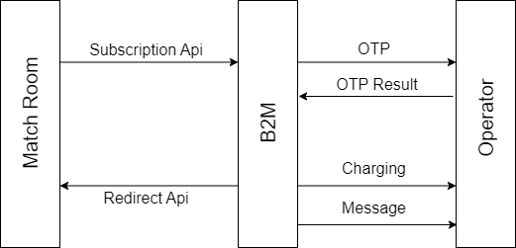

# 3. Subscription/On-Demand,Un-Subscription

**Base URL**: <https://gpglobal.b2mwap.com>

## Subscription/On-Demand API:

You will redirect your request to This API for subscription/on-demand with including MSISDN & service keyword as query string. Then, user will be get an OTP page from operator. After successfully match with user input OTP, then we will try to deduct balance from user MSISDN. Then B2M will redirect you with success/fail details in your redirect API.

|  |  |  |  |
| --- | --- | --- | --- |
| **End Point** | **API End Point URL** | **Method** | **Parameters** |
| Subscription | <**base_url**>/api/subscription | **GET** | keyword * (required), msisdn* (required) |

**Response,**

|  |  |
| --- | --- |
| **Type/Action** | Go to Redirect Portal API |
| **Parameters** | msisdn = ******* |
| acr = ******* |
| type = ondemand/subs |
| result = success/failed |
| **Example** | < **Redirect Portal API** >?msisdn=**&acr=**&type= ondemand/subs&result= success/failed |

## Un-Subscription API:

You should send an http request to un-subscription API with required parameters by GET method and you will get a JSON response regarding in API response.

|  |  |  |  |
| --- | --- | --- | --- |
| **End Point** | **API End Point URL** | **Method** | **Parameters** |
| Un-Subscription | <**base_url**>/api/unsubscription | **GET** | keyword * (required), msisdn* (required),  acr * (required) |

**Response,**

|  |  |
| --- | --- |
| **Type/Action** | JSON |
| **Response** | "**message**": "Unsubscribed successful", |

# 3. Redirect Portal API

This is partner API. Partner will be create this API for getting response of subscription/on-demand. B2M will send notification/callback to partner via this API. You should ready this API with bellow format.

Example: < **Redirect Portal API** >?msisdn=**&acr=**&type= ondemand&result= success/failed