**United International University**



**Report On**

**ProTutorBD**

**Submitted to**

Dr. Suman Ahmmed

Associate Professor, CSE, UIU

**Submitted by**

|  |  |
| --- | --- |
| **Name** | **Id No.** |
| Rayhan Al Shorif | 0122410022 |
| Iftekharul Islam | 0122410013 |
| F. M. Shefat Hossain Niloy | 0122310011 |
| Arnab Protim Mondal | 0122320014 |

Date of Submission: 04th May, 2024

**ProTutorBD**

**Contents**

1. Introduction:…………………………………………………………………………………………...4

1.1 Problem Statement: 4

1.2 Objective: 4

1.3. Methodology: 5

2. Detail System Study:…………………………………………………………………………………..6

2.1 Benchmark Table Analysis 7

2.2 Research Paper Study: 12

2.3 Business Model: 16

2.4 Feasibility Analysis: 16

2.4.1 SWOT Analysis: 17

2.4.2 Cost Model and Cost Flow Diagram 18

2.5 User Feedback 18

2.5.1 Questionnaire for This Product: 18

2.5.2 Survey Report or User feedback: 18

2.5.3 Industry Visit 19

3. System Analysis:……………………………………………………………………………………...19

3.1 Features List Fixation: 20

3.1.1 Functional Requirement: 20

3.1.2 Non-functional Requirement: 20

3.1.3. Novelty: 21

4. UML Design………………………………………………………………………………………….21

4.1 Use case diagram: 22

4.2 Activity Diagram: 24

4.3 Sequence diagram: 25

4.4 Class Name: 26

4.5 State Diagram: 27

5. UI Design……………………………………………………………………………………………..27

5.1 UI Design Rules 28

5.2 Figma Design 30

6. Tools and Technologies………………………………………………………………………………39

7. Conclusion:…………………………………………………………………………………………...40

8. References:…………………………………………………………………………………………...40

8.1 Paper Based: 40

8.2 Information Based: 40

# 1. Introduction:

Welcome to "**ProTutor.BD**", your premier destination for personalized academic support in Bangladesh! Tutoring services can be incredibly helpful for students looking to enhance their academic skills or prepare for exams. Although after searching many places for academic help in personal life we find a premium or tutor of our choice. It takes us a lot of time and we have to deal with various problems in life starting from studies. In this digital era, we have created these products to find a solution to find our favorite teacher without wasting time.

### 1.1 Problem Statement:

In a world where access to quality education is not evenly distributed, there is a growing need for an accessible and efficient tutoring platform that connects students with qualified tutors in Bangladesh. The existing educational infrastructure faces challenges such as limited resources, geographical constraints, and lack of personalized attention. Thus, the aim of the "**ProTutor.BD**" project is to develop a comprehensive online tutoring platform tailored to the needs of Bangladeshi students, offering affordable, flexible, and personalized tutoring services across various subjects and academic levels. The platform seeks to address the disparities in educational opportunities by leveraging technology to bridge the gap between students and tutors, ultimately empowering learners to achieve their academic goals and unlock their full potential.

### 1.2 Objective:

The objectives of ProTutor.BD, assuming it's a tutoring service in Bangladesh, could include:

**Accessibility:** To provide accessible tutoring services to students across Bangladesh, irrespective of their geographical location or socioeconomic background.

**Quality Education:** To ensure the delivery of high-quality tutoring by employing qualified and experienced tutors who are proficient in their respective subjects.

**Personalized Learning:** To offer personalized tutoring sessions tailored to the individual needs and learning styles of each student, thereby maximizing their academic potential.

**Affordability:** To make tutoring services affordable for students from diverse economic backgrounds, ensuring that financial constraints do not hinder access to educational support.

**Technology Integration:** To leverage technology effectively in the tutoring process, utilizing interactive online platforms, educational resources, and tools to enhance the learning experience.

**Continuous Improvement:** To continuously evaluate and improve tutoring methodologies and materials based on feedback from students, parents, and tutors, ensuring ongoing enhancement of the service quality.

**Student Progress Tracking:** To implement systems for tracking and monitoring student progress, enabling tutors to assess learning outcomes and adapt their teaching strategies accordingly.

**Community Engagement:** To foster a supportive learning community by encouraging collaboration among students, tutors, and parents, facilitating knowledge sharing and peer support.

**Expansion and Reach:** To expand the reach of ProTutor.BD to serve a larger number of students across different regions of Bangladesh, thereby contributing to the overall improvement of educational standards in the country.

**Partnerships and Collaborations:** To establish partnerships with schools, educational institutions, and other stakeholders to complement formal education and provide additional support to students.

### 1.3. Methodology:

Speaking of methodology, we will generally follow a few things in providing the structural framework for our product. Addressing aspects such as tutor recruitment or hire a tutor, proper training, regular supervision as well as evaluation is very necessary for this product which we are aiming for more. Here's a breakdown of key areas to consider:

1. **Proper Training and Guidance:**

* Provide comprehensive training to tutors on effective teaching methodologies, communication skills, and subject-specific content.
* Offer workshops or seminars to enhance tutors' understanding of pedagogical principles and learner-centered approaches.
* Provide ongoing professional development opportunities to keep tutors updated on best practices and educational trends.

1. **Monitoring and Evaluation:**

* Develop performance metrics and evaluation criteria to assess tutors' effectiveness in supporting student learning.
* Implement systems for collecting feedback from students, parents, and other stakeholders to evaluate the quality of tutoring services.
* Use data-driven insights to identify areas for improvement and make informed decisions about tutor allocation and resource allocation.

1. **Recognition and Incentives:**

* Recognize and reward tutors for their contributions and achievements in supporting student learning and academic success.
* Offer incentives or bonuses for tutors who demonstrate exceptional performance, such as high student satisfaction ratings or improved academic outcomes.
* Foster a positive and supportive work environment that values the efforts and dedication of tutors.

1. **Continuous Improvement:**

* Regularly review and refine tutor management policies, procedures, and practices to ensure alignment with organizational goals and educational standards.
* Solicit feedback from tutors, students, and other stakeholders to identify areas for improvement and implement necessary changes.
* Stay abreast of emerging trends and innovations in education to adapt and enhance tutor management methodologies accordingly.

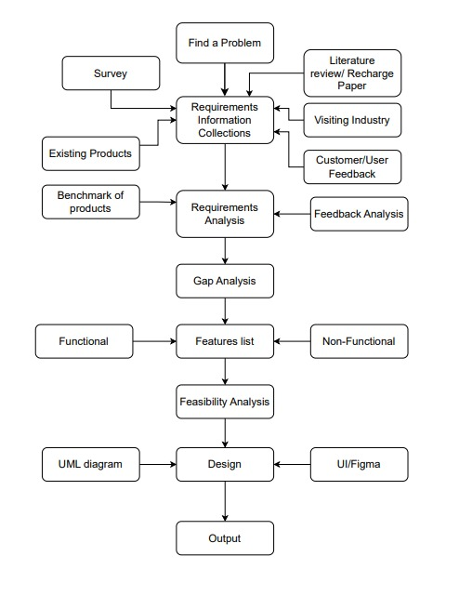

# 2. Detail System Study:

Although the main purpose of this project is to facilitate the learning process of the students. We know that a tutor is a lifesaver for a child's education. "**ProTutor.BD**" suggests a connection to education and guidance. However, it implies a sense of leading or piloting through the educational journey, which aligns with the idea of guiding and supporting students. It involves helping the student understand concepts, acquire new skills, and improve their overall academic performance. Tutors often provide personalized support tailored to a student's specific needs. Tutors aim to build the student's confidence in their abilities. By providing guidance, positive reinforcement, and constructive feedback, tutors help students feel more capable and confident in their academic pursuits. For everything, we have taken the initiative so that every parent can find a good and decent teacher to educate their children through our plot form.

## 2.1 Benchmark Table Analysis

Benchmarking education-related systems like “**ProTutor.BD**” involves evaluating the functionality, features, and capabilities of educational technology in its context. We have selected some of the top-tier products on the market to benchmark our products. There are a few products currently running that we want to benchmark with and test our product's capabilities. List of selected products from the ongoing marketplace: [tutorsheba.com](https://www.tutorsheba.com/)*,* Bdtutors.com,[caretutors.com](https://caretutors.com/), [dhakatutors.com](https://www.dhakatutors.com/), [deshtutor.com](https://deshtutor.com/)etc**.**

TutorSheba.com

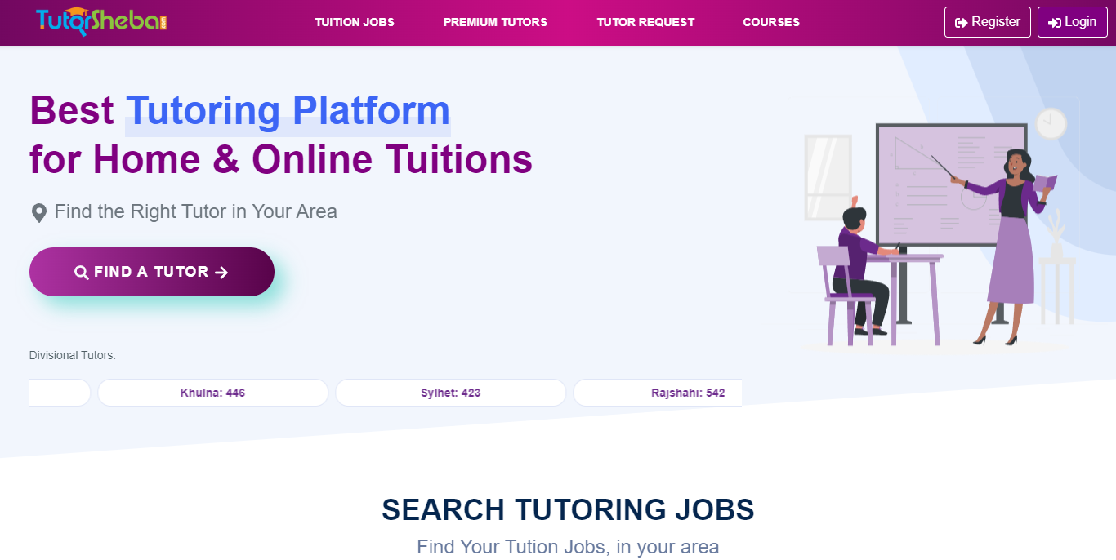

Figure :[tutorsheba.com](https://www.tutorsheba.com/)

TutorSheba.com is created for the students and teachers of Bangladesh. The key features and

limitations are as following:

Key Features:

• Tutors can create account and give tuition post

• Students can create account and hire tutor from available tutors

• Students can request for tutors according to their own requirements

• one day demo session over phone is conducted before hiring a tutor

Limitations:

• Features like online tuition, review and rating, payment gateway, assignment help is unavailable

bdtutors.com

Figure 2: bdtutors.com

*bdtutors.com* is made for Bangladeshi students and tutors. The key features and limitations are as following:

**Key Features:**

• Tutor can create account and give tuition post

• Student can create account, give tutor searching post based on requirements and Hire tutor from available tutors

• Student can find tutor using filter options

• Payment gateways: VISA, MasterCard, bKash, DBBL Master, IBBL iBanking, Islami Bank M CASH

**Limitations:**

• Online tuition is unavailable

• Students cannot find tutor using map

• Blog posting, downloading books and preview sessions are unavailable

[caretutors.com](https://caretutors.com/)

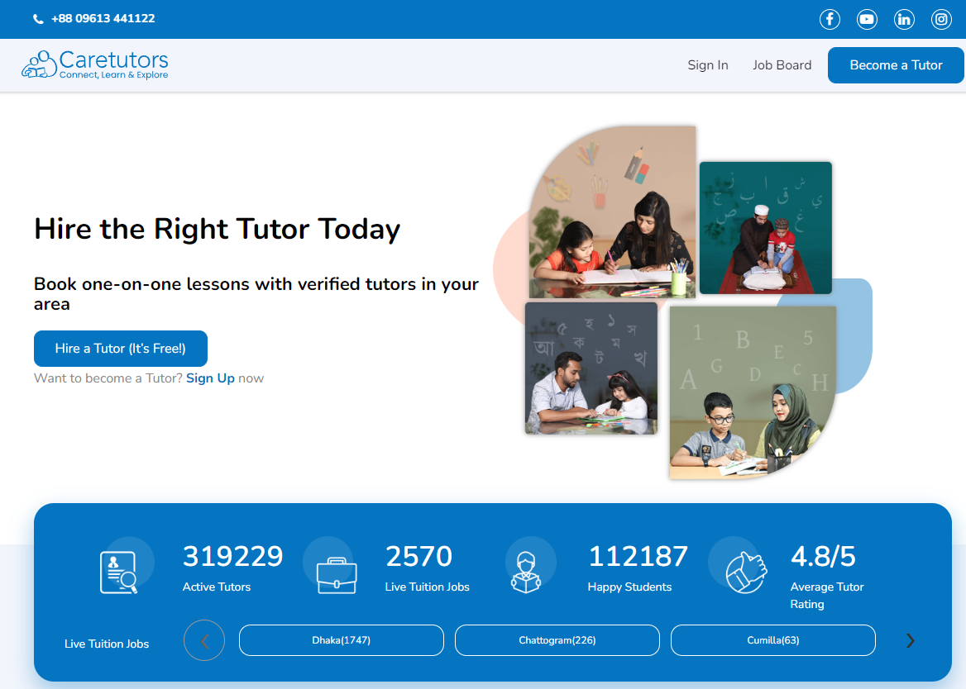

Figure 3:caretutors.com

Caretutors.com is created for Bangladeshi students and tutors. The key features and limitations are as following:

**Key Features:**

• Tutors can create account and give tuition post

• Students can create account and hire tutor from available tutors’ list

• Students can ﬁnd tutor using ﬁlter options

**Limitations:**

• Online tuition is unavailable

• Payment, blog posting and downloading books options are unavailable

• Students cannot give tutor searching post based on their own requirements

[dhakatutors.com](https://www.dhakatutors.com/)

Figure 4:dhakatutors.com

dhakatutors.com is created for Bangladeshi students and tutors. The key features and limitations are as following:

**Key Features:**

• Tutors can create account and give tuition post

• Students can create account and hire tutor from available tutors’ list

• Students can ﬁnd tutor using ﬁlter options

**Limitations:**

• Online tuition is unavailable

• Payment, blog posting and downloading books options are unavailable

• Students cannot give tutor searching post based on their own requirements

[**deshtutor.com**](https://deshtutor.com/)

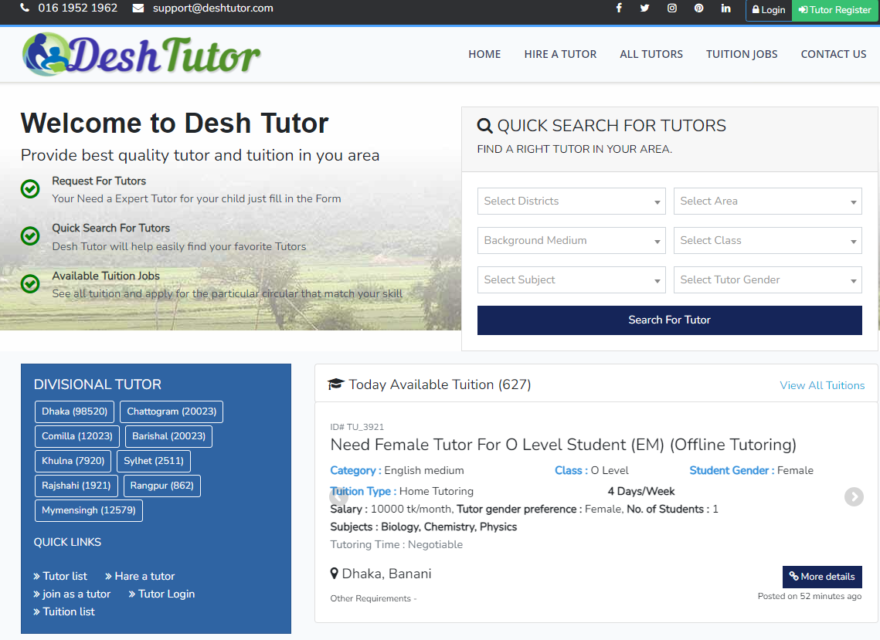

Figure 5:deshtutor.com

DeshTutor is made for the students and teachers of our country. The key features and limitations are as following:

**Key Features:**

• Tutors can create account and give tuition post

• Students can create account and hire tutor from available tutors

• Students can request for tutors

• Online tuition available

• Quick search for tutors

• Payment gateways: Rocket, bKash

**Limitations:**

• Students cannot search tutor using map

• Students cannot give tutor searching post based on their requirements

**Benchmark of products:**

|  |  |  |  |  |  |  |  |
| --- | --- | --- | --- | --- | --- | --- | --- |
| **Features** | | **Existing Products** | | | | | |
| **tutorsheba.com** | **bdtutors.com** | **caretutors.com** | **dhakatutors.com** | **deshtutor.com** | **our product** |
| Roles | Admin | ✔ | ✔ | ✔ | ✔ | ✔ | ✔ |
| Tutor | ✔ | ✔ | ✔ | ✔ | ✔ | ✔ |
| Students | ✔ | ✔ | ✔ | ✔ | ✔ | ✔ |
| Guardian |  |  |  | ✔ |  | ✔ |
| Available Tuitions | | ✔ | ✔ | ✔ | ✔ | ✔ | ✔ |
| Payment System | | ✔ | ✔ | ✔ | ✔ | ✔ | ✔ |
| Premium Tutors Search | | ✔ | ✔ | ✔ |  | ✔ | ✔ |
| Affiliate Partner | | ✔ | ✔ |  |  |  | ✔ |
| Notifications System | | ✔ |  | ✔ |  |  | ✔ |
| FAQ | | ✔ | ✔ | ✔ | ✔ |  | ✔ |
| Contact Us | | ✔ | ✔ | ✔ | ✔ | ✔ | ✔ |
| Tutor Request | | ✔ | ✔ |  |  |  | ✔ |
| Quick Chat | | ✔ | ✔ | ✔ | ✔ | ✔ | ✔ |
| Online tuition | | ✔ |  |  |  |  | ✔ |
| Review & Rating | | ✔ | ✔ | ✔ | ✔ | ✔ | ✔ |
| About us | | ✔ | ✔ | ✔ | ✔ | ✔ | ✔ |
| Default auto-search | |  |  |  |  |  | ✔ |
| Default auto-suggest | |  |  |  |  |  | ✔ |
| Blog Post | |  |  |  |  |  | ✔ |
| Download Books | |  |  |  |  |  | ✔ |
| Suggested nearest tutors or students | |  |  |  |  |  | ✔ |
| Provides suggestions | |  |  |  |  |  | ✔ |

## 2.2 Research Paper Study:

**i. Paper Name:** The Demand for Shadow Education: Socioeconomic Determinants and Implications

**Summary:**

The authors of this paper found:

* Richer families and families where parents had more education were more likely to pay for extra tutoring.
* Kids who got extra tutoring did tend to score better in school.
* But this extra tutoring can be expensive, and it can make it harder for poorer families to keep up.
* Some kids get a big advantage because their families can afford extra help.
* This isn't fair, and it can make it harder for kids from poorer families to succeed in school.
* Maybe schools need to get better so that all kids get the help they need, without their families having to pay extra.
* If tutorial centers run alongside schools long-term, good teachers might leave schools, lowering education quality. This could make tutoring even more essential.
* More research is needed considering factors like student-teacher ratio and high-stakes test levels in various schools.

**ii. Paper Name:** The Expansion and Roles of Private Tutoring in India: From Supplementation to Supplantation

**Summary:**

This paper dives into the world of private tutoring in India, exploring how it's grown and changed over time.

**Here's the findings:**

* Private tutoring, also known as "shadow education", is HUGE in India. Many students get extra help outside of school from private tutors.
* It used to be seen as "supplementary," just filling in gaps from regular school. But now, it's more like "supplantation," meaning it's almost like a whole different school system happening alongside the official one.
* This shift has some big upsides and downsides. On the plus side, some say it helps students do better in exams and get into competitive colleges. But on the other side, it creates pressure, adds financial strain on families, and can widen the gap between rich and poor students.
* The authors studied tutoring in Maharashtra, India**.** They found that students rely heavily on tutors, especially for key subjects like math and science. Tutors often focus on exam preparation and specific strategies, rather than broader learning.
* This raises concerns about what it means for regular schooling like Is the official system good enough or are students missing out on important skills by focusing too much on tutoring.

**iii.** **Paper Name:** The impact of shadow education on student academic achievement: Why the research is inconclusive and what can be done about it

**Summary:**

**Findings:**

1. The research on the impact of shadow education on student achievement is inconclusive. Studies have shown:
   * Positive impacts on some students and contexts.
   * Also no significant difference in academic performance between students who participated in shadow education and those who didn't..
   * potentially negative consequences like increased stress and increases educational inequality.
2. Research methods face challenges in data collection and analysis, limiting the ability to isolate the true impact of shadow education.

**Limitations:**

* **Inconsistent definitions:** Lack of standardization regarding what constitutes "shadow education" interrupts comprehensive analysis.
* **Methodological limitations:** Challenges in data collection and study design restrict the ability to establish clear cause-and-effect relationships.
* **Individual factors:** Difficulty in accounting for individual student characteristics and motivations, as well as the quality of tutors, which can significantly impact outcomes.

**iv. Paper Name:** The Issue of Private Tuition: An Analysis of the Practice in Mauritius and Selected South-East Asian Countries

**Summary:**

**Findings:**

* **Prevalence:** Private tuition is widespread at both primary and secondary levels across Mauritius and Southeast Asian countries.
* **Motivations:** Competitive exams, pressure for success, and perceived shortcomings in formal education drive demand.
* **Financial Burden:** Significant cost burden on families, potentially widening social inequalities.
* **Mixed Effects:** Some students benefit, others experience stress and decreased motivation.
* **Teacher Involvement:** Raises ethical concerns, potential conflicts of interest, and exploitation of students.
* **Ineffective teaching-learning processes** , **Insufficient Regular Class Instruction**,
* Students seek private tuition **for better understanding and individual attention**.
* Teachers, often demotivated in regular classes, become **more engaged in tuition** as they work for themselves.
* **Class Size Challenges:**  Large class sizes, Financial constraints, inadequate infrastructure, and a shortage of qualified teachers
* Students opt for private tuition due to **peer pressure and competition**

**Limitations:**

* Limited data availability on specific impacts and student outcomes.
* Difficulty isolating true effects of private tuition from other factors.
* Generalization of findings across diverse countries and contexts.

**v.** _**Paper Name:** The more, the better? Intensity of involvement in private tuition and

examination performance

**Summary:**

**Findings:**

* There is no significant advantage to taking private tuition, even for students who took a lot of it.
* This suggests that other factors, such as a student's natural ability and attitude towards learning, may be more important for exam success than private tuition.

**Limitations:**

* The study was conducted in Ireland, so the results may not be generalizable to other countries.
* The study relied on self-reported data, which can be subject to bias.
* The study did not control for all possible factors that could affect exam performance

**vi.** **Paper Name:** The Shadow Education System in Bangladesh: A Blessing or a Curse?

**Summary:**

**Findings**:

* **Prevalence:** This system is widespread, especially in urban areas, with many students relying on it to succeed in exams.
* **Determinants:** Low teacher salaries, parental aspirations for children's academic success, and perceived inadequacies of formal education are driving factors.
* **Impact:** Can improve academic performance, boost confidence, and offer personalized attention.
* **Open question:** Whether the shadow system is ultimately a blessing or a curse remains debatable.
* **Economic Implications:** Private tutoring can contribute to economic development, but mainly benefits wealthier individuals, further widening the economic gap.
* **Prohibition:** Banning private tutoring entirely, as attempted in some countries, is difficult to enforce and may limit educational opportunities.

i**.** Questionnaire for This Product:

1. Why do you want to build this product?
2. How much logic is there in this approach to learning system development?
3. By adapting to modern technology, how much education will be able to progress through it?
4. In rural areas, is this system even possible to reach?
5. What steps can be taken to cover the rural area in the future?

ii. Survey Report or User feedback:

* Teachers Satisfaction 75%.
* User Friendly UI 80%
* Responsive Design for overall device 90%
* Auto Searching system is 98% satisfaction
* Payment satisfaction is overall nice.

## 2.3 Business Model:

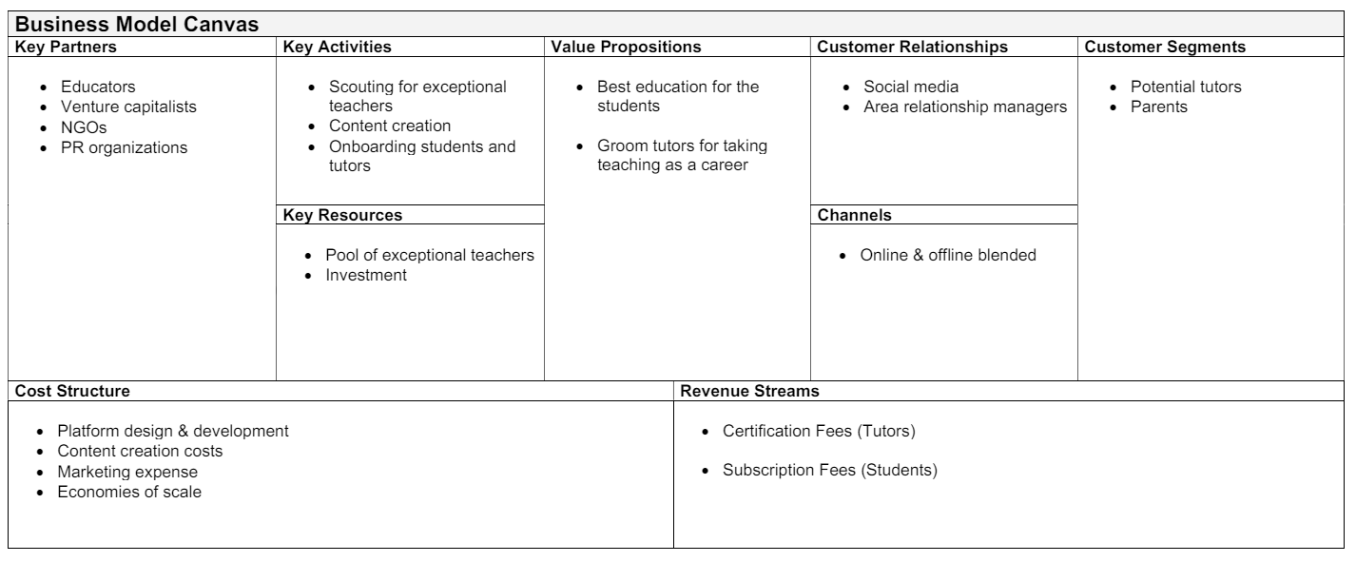

## 2.4 Feasibility Analysis:

A feasibility analysis for ProTutor.BD would typically involve assessing various aspects to determine the viability and potential success of the tutoring service. Here's a breakdown of key factors to consider:

**Market Demand:** Evaluate the demand for tutoring services in Bangladesh. Consider factors such as the number of students seeking additional academic support, their willingness to pay for tutoring, and any existing competitors in the market.

**Target Market:** Identify the specific demographic segments within Bangladesh that ProTutor.BD aims to serve. Analyze their educational needs, preferences, and accessibility to online tutoring services.

**Competitive Landscape:** Conduct a thorough analysis of existing tutoring services in Bangladesh. Identify their strengths, weaknesses, pricing strategies, and market positioning to determine ProTutor.BD's competitive advantage.

**Technology Infrastructure:** Assess the availability and reliability of internet connectivity and digital devices among the target demographic. Ensure that the technological infrastructure can support the delivery of online tutoring sessions effectively.

**Tutor Network:** Evaluate the availability of qualified tutors in Bangladesh across various subjects and academic levels. Determine the recruitment strategies to attract and retain skilled tutors for ProTutor.BD.

**Financial Viability:** Prepare a comprehensive financial projection, including revenue streams, cost structure, and potential profitability. Consider startup costs, operational expenses, and revenue generation through subscription fees or pay-per-session models.

**Regulatory Compliance:** Understand the regulatory requirements for operating an online tutoring service in Bangladesh, including any licensing, taxation, or legal considerations.

**Marketing and Branding:** Develop a marketing strategy to promote ProTutor.BD and attract students. Utilize digital marketing channels, partnerships with educational institutions, and targeted advertising to reach the target audience effectively.

**Customer Feedback and Validation:** Gather feedback from potential customers through surveys, focus groups, or pilot testing to validate the demand for ProTutor.BD and refine its offerings based on user preferences.

**Risk Analysis:** Identify potential risks and challenges that could impact the success of ProTutor.BD, such as technological disruptions, changes in market dynamics, or regulatory hurdles. Develop contingency plans to mitigate these risks effectively.

By conducting a thorough feasibility analysis covering these aspects, ProTutor.BD can make informed decisions and enhance its chances of success in the Bangladesh tutoring market.

### 2.4.1 SWOT Analysis:

SWOT analysis is a strategic planning tool used to evaluate the strengths, weaknesses, opportunities, and threats involved in a project or business venture. Here's a breakdown of each component:

* Strengths:
  + Accessibility: Students can access educational content from anywhere, at any time.
  + Customization: Allows for personalized learning experiences tailored to individual student needs.
  + Scalability: Can easily accommodate a growing number of students and courses.
  + Tech-Savvy: Appeals to middle school students who are generally comfortable with technology.
* Weaknesses:
  + Technology Dependence: Requires reliable internet access and devices, which may not be available to all students.
  + Limited Social Interaction: Reduced face-to-face engagement with teachers and peers.
  + Self-Discipline: Students need a high level of self-motivation to succeed.
  + Adaptation Curve: Tutors and students may require time to adapt to the new mode of learning.
* Opportunities:
* Market Growth: The e-learning market is expanding, with more parents and institutions recognizing its benefits.
* Innovation: New technologies like VR and AR can enhance the learning experience.
* Partnerships: Potential to collaborate with educational content creators and tech companies.
* Global Reach: Opportunity to attract students from different geographical locations.
* Threats:
* Competition: A rapidly growing market means more competitors entering the space.
* Cybersecurity: Increased risk of data breaches and privacy concerns.
* Regulatory Changes: Potential changes in educational policies and regulations affecting online learning.
* Technical Issues: Platform downtime or technical glitches can disrupt the learning process.

### 2.4.2 Cost Model and Cost Flow Diagram

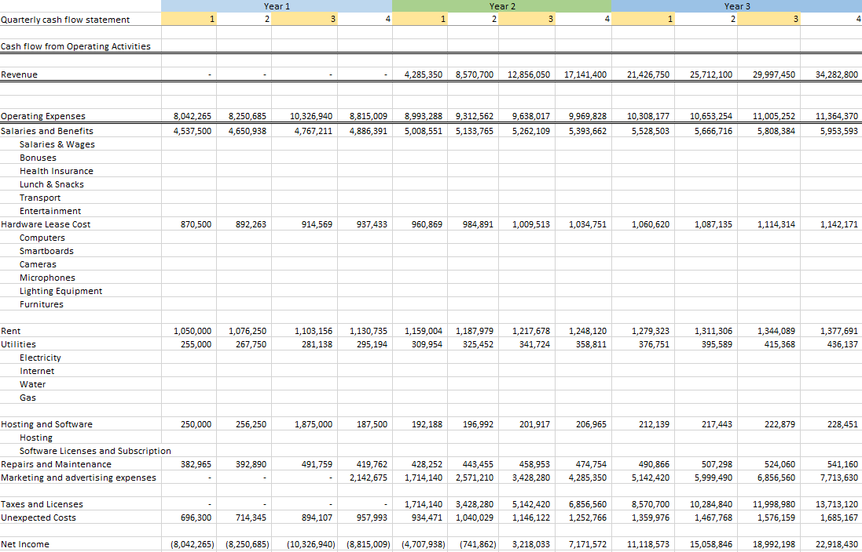

## 2.5 User Feedback

"User feedback" refers to the opinions, comments, or reviews provided by users or customers about a particular product, service, or experience. When someone asks for "user feedback of **ProTutorBD**," they're likely asking for opinions or reviews from people who have used the services provided by " **ProTutorBD**." So, if you're looking for feedback on **ProTutorBD**, you might be interested in what users have to say about their experience with the platform or service.

### 2.5.1 Questionnaire for This Product:

* Why do you want to build this product?
* How much logic is there in this approach to learning system development?
* By adapting to modern technology, how much education will be able to progress through it?
* In rural areas, is this system even possible to reach?
* What steps can be taken to cover the rural area in the future?

### 2.5.2 Survey Report or User feedback:

* Teachers Satisfaction 75%.
* User Friendly UI 80%
* Responsive Design for overall device 90%
* Auto Searching system is 98% satisfaction
* Payment satisfaction is overall nice.

### 2.5.3 Industry Visit

Industry visits are educational outings where students or professionals visit companies or organizations to gain practical insights into their operations, processes, and culture. These visits offer participants the opportunity to see firsthand how theoretical knowledge is applied in real-world settings, understand industry trends, network with professionals, and gain inspiration for their own career paths or business endeavors.

For students, industry visits are often organized as part of academic programs to complement classroom learning and provide exposure to different sectors. Professionals may also participate in industry visits as part of continuing education or professional development initiatives to stay updated on industry practices and technologies.

Industry visits can be beneficial for both the visitors and the host companies. Visitors gain valuable knowledge and experiences, while companies have the opportunity to showcase their operations, attract potential talent, and build relationships with educational institutions or professionals in their field.

If you're planning an industry visit, consider the objectives of the visit, the target audience, logistical arrangements, and any specific areas of interest or focus. Additionally, it's essential to communicate with the host company or organization in advance to coordinate the visit and ensure a meaningful experience for all participants.

# 3. System Analysis:

System analysis is the process of examining a system's components, interactions, and processes to understand its structure, behavior, and functionality. It involves studying both the technical and non-technical aspects of a system to identify requirements, evaluate performance, and propose improvements or solutions.

Key aspects of system analysis include:

**Understanding Requirements:** This involves gathering and documenting stakeholders' needs and objectives for the system. It includes defining functional requirements (what the system should do) and non-functional requirements (constraints on how the system should perform).

**Modeling and Representation:** System analysts use various techniques such as diagrams, charts, and mathematical models to represent the system's structure, data flows, processes, and interactions. These models help in visualizing complex systems and understanding how different components work together.

**Evaluation and Optimization:** System analysts assess the performance of existing systems to identify inefficiencies, bottlenecks, or areas for improvement. They may use techniques like simulation, benchmarking, or cost-benefit analysis to evaluate different solutions and optimize system performance.

**Communication and Collaboration:** Effective communication is essential in system analysis to ensure that stakeholders, including users, developers, and decision-makers, have a common understanding of the system's requirements and goals. Collaboration with stakeholders helps in gathering feedback, validating assumptions, and reaching consensus on design decisions.

**Documentation and Reporting:** System analysts document their findings, requirements, and proposed solutions in reports, specifications, or other formal documents. Clear and concise documentation is crucial for stakeholders to understand the system's design, functionality, and implementation details.

Overall, system analysis is a structured approach to understanding and improving systems, whether they are information systems, business processes, or technical systems, to meet the needs of stakeholders and achieve organizational objectives.

## 3.1 Features List Fixation:

### **3.1.1 Functional Requirement:**

A Functional Requirement (FR) describes the features that a system must oﬀer. A function is the description of the combinations of the inputs to the systems or its components, its behavior and the outputs. Functional requirements such as data manipulation, business process, calculations, technical details and other speciﬁc functionality deﬁne what a software system supposed to achieve. The functional requirements of this tuition management system are listing below:

* + Users (teacher and student) can register, log-in to the system and update their proﬁle
  + Teacher can create post by ﬁlling up the post related information and giving a certain amount for creating a post (if he/she has no free posts. After creating their proﬁle tutor will get 3/n-numbers of free posts.)
  + Tutor can search for tuition and send request to a corresponding tutor searching post(posted by any student)
  + Student can create post for free
  + Student can search for tutor and send request to a corresponding tuition searching post(posted by any tutor)
  + Tutor and student both can give ratings and reviews to each other’s
  + Tutor and student both will be able to download books
  + Tutor and student both will be able to create, read, edit, delete blogs
  + Admin can delete/block any user (student and Teacher) if the admin gets multiple complaints against the user
  + Admin will be able to upload, download and delete books
  + A searching mechanism will be provided by the system to get the post
  + The system will be accessible to online users

### **3.1.2 Non-functional Requirement:**

Non-functional Requirements can be deﬁned as a requirement that describes not what software will do, but how the software will do. Usually, they are evaluated subjectively as they are diﬃcult to test. Some of the non-functional requirements of our proposed system are listing below:

* + Users’ privacy should be protected
  + The system should have high availability
  + The system should be workable on diﬀerent cross-platform web browsers like (e.g. Chrome, Safari, Mozilla, Opera, Edge)
  + The system should be easy to learn by both sophisticated and novice users
  + The system should be user friendly so that both sophisticated and inexperienced users can learn to use it at ease
  + The system should have a maximum of 3 clicks to reach any content
  + The system should have a single login to access all content
  + The system should have a consistent user interface (UI)
  + The system should have a UI which is intuitive (the behavior of the system is according to the intuition of a standard end user)
  + The system should have a standard graphical user interface that allows for the on-line data entry, editing, and deleting of data with much ease

### 3.1.3. Novelty:

The main innovation of our product is, when a student or teacher logs into our domain, it will automatically track their location and show profiles of teachers or students in that area based on that location. The product will track the teacher's location if he/she logs in and show the teacher, student profile based on the subject under which the student is searching for the teacher. On the other hand, if a student logs in, it will track his/her location and continue to show profiles of required teachers in that area based on that student's or parent's profile.

# 4. UML Design

UML, or Unified Modeling Language, is a standardized modeling language used in software engineering to visually represent a system's design. UML diagrams are graphical representations of different aspects of a system, such as its structure, behavior, and interactions. These diagrams are used throughout the software development lifecycle to aid communication, design, analysis, and documentation.

There are several types of UML diagrams, each serving a specific purpose:

**Class Diagrams:** Class diagrams represent the static structure of a system by showing classes, their attributes, methods, and relationships between classes.

**Use Case Diagrams:** Use case diagrams depict the interactions between actors (users or external systems) and the system to illustrate the system's functionalities from a user's perspective.

**Sequence Diagrams:** Sequence diagrams visualize the interactions between objects or components over time, showing the sequence of messages exchanged between them.

**Activity Diagrams:** Activity diagrams model the flow of control within a system, depicting the sequence of activities or actions and decision points.

**State Machine Diagrams:** State machine diagrams represent the behavior of an individual object or system component by showing its states, transitions between states, and triggers/events that cause transitions.

**Component Diagrams:** Component diagrams illustrate the physical components or modules of a system and their dependencies.

**Deployment Diagrams:** Deployment diagrams depict the physical deployment of software components to hardware nodes, such as servers or devices, showing the relationships and connections between them.

## 4.1 Use case diagram:

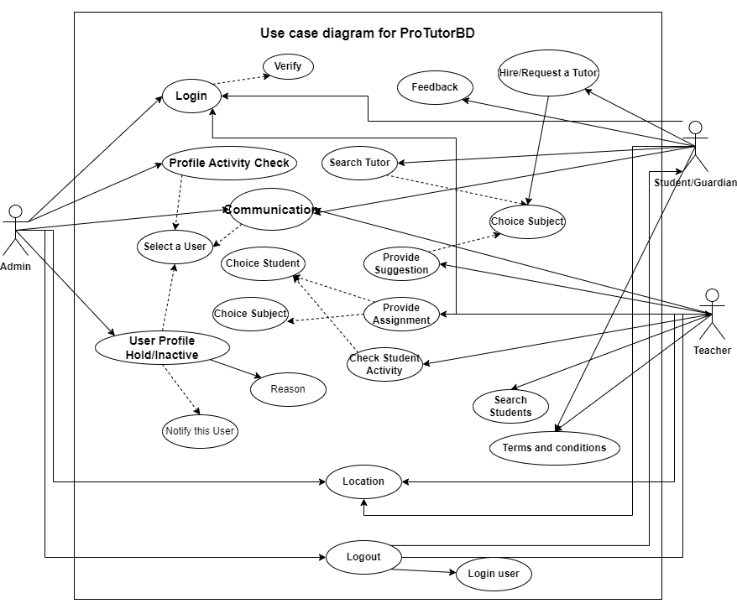

**Fig 4.1.1: Use case Diagram**

**Search Tutor:**

|  |  |
| --- | --- |
| **Use Case Number and Name:** | UC001 – Search Tutor |
| **Primary Actor:** | Students or Guardians |
| **Interests & Stakeholders:** | Students and guardians are browsing and searching for tutors from our platform**.** |
| **Prerequisites:** | The student or guardian is must be logged in. |
| **Success Scenario:** | 1. Student or guardian search tutor by typing in search box. 2. Auto suggested tutor list in dropdown. 3. Click on tutor name and search him/her. |
| **Alternative Scenario:** | 1. In step 1 after typing something then it will not match from our database and show “no records” 2. In step 2 type something and click on it. If this tutor are not available for this course then show “Tutor is not available right now” |
| **Post condition:** | After typing the tutor name for searching then it will go to backend and search this tutor from our database. Then it will redirect new page with this tutor related information and show it. |

**Provide Suggestions:**

|  |  |
| --- | --- |
| **Use Case Number and Name:** | UC002 – Suggestion Provide |
| **Primary Actor:** | Teacher |
| **Interests & Stakeholders:** | A Teacher are browsing and sharing subject related suggestion for his/her student from our platform**.** |
| **Prerequisites:** | The teacher is must be logged in and selected subject. |
| **Success Scenario:** | * + 1. Teacher choice the subject     2. Uploaded pdf as suggestion |
| **Alternative Scenario:** | * + 1. In step 1 after choice this subject, if this subject has not enroll of any student then it will show “No enrolled student”     2. In step 2 when upload a pdf , if the pdf size is larger then 10mb it will show “Large File Uploaded” |
| **Post condition:** | After successfully uploaded file it will show suggest list. |

## 4.2 Activity Diagram:

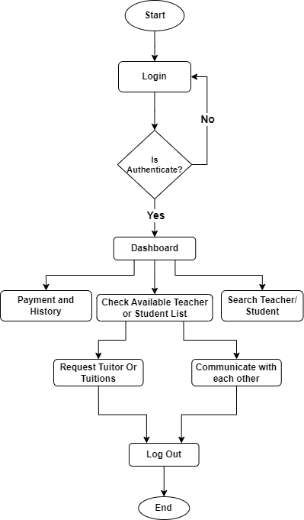

**Fig 4.2.1: Activity Diagram**

## 4.3 Sequence diagram:

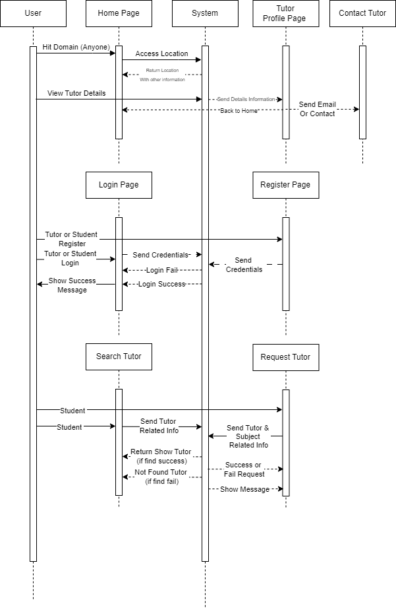

## 4.4 Class Name:

public function **Admin**{

updateuser();

verifyUser()

}

public function **Student**{

searchTutor();

payCourse()

}

public function **Tutor**{

search_Tuiton();

chatWithStudent()

}

public function **Course**{

registerCourse();

courseFee()

}

public function **Student** {

registerCourse();

payFee();

searchLocation();

}

Public function **Location** (){

suggestTutor();

access();

}

## 4.5 State Diagram:

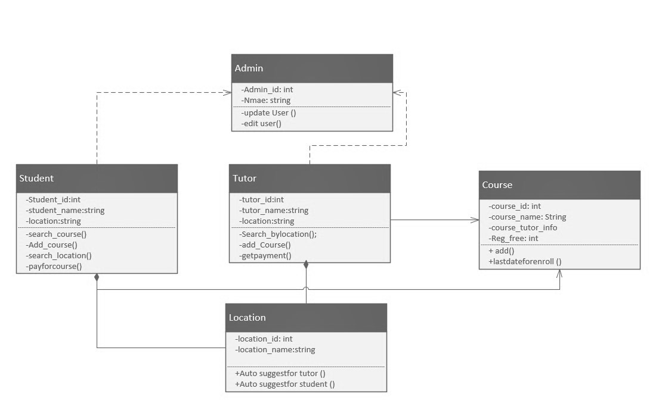

# 5. UI Design

UI (User Interface) design refers to the process of designing the interface through which users interact with a digital product or system, such as a website, mobile app, or software application. The goal of UI design is to create interfaces that are visually appealing, intuitive to use, and effectively communicate the functionality and content of the product to the user.

Key aspects of UI design include:

**Visual Design:** This involves creating visually appealing interfaces that use color, typography, imagery, and layout to convey the brand identity, establish hierarchy, and guide the user's attention. Visual design aims to create an aesthetic experience that resonates with users and enhances their perception of the product.

**Layout and Composition:** UI designers determine the arrangement of elements on the interface to optimize usability and readability. They consider factors such as information hierarchy, spacing, alignment, and grouping to organize content and interactions in a logical and visually appealing manner.

**Interaction Design:** Interaction design focuses on designing the interactive elements of the interface, such as buttons, menus, forms, and navigation controls. Interaction designers define how users interact with these elements and ensure that interactions are intuitive, consistent, and responsive to user input.

**Usability and Accessibility:** UI designers prioritize usability and accessibility to ensure that the interface is easy to use and accessible to users of all abilities. They consider factors such as navigation patterns, feedback mechanisms, error handling, and compliance with accessibility standards to create inclusive and user-friendly interfaces.

**Prototyping and Testing:** UI designers create prototypes or mockups of the interface to visualize design concepts and gather feedback from stakeholders or users. They conduct usability testing to identify usability issues, gather insights into user behavior, and iterate on the design to improve the user experience.

**Responsive Design:** With the proliferation of devices with different screen sizes and resolutions, UI designers employ responsive design techniques to ensure that the interface adapts and displays optimally across various devices and screen sizes, providing a consistent experience to users on desktops, tablets, and smartphones.

Overall, UI design is a multidisciplinary field that combines principles of visual design, interaction design, usability, and technology to create interfaces that are visually appealing, user-friendly, and effective in facilitating user interactions with digital products and systems.

## 5.1 UI Design Rules

UI design is guided by a set of principles and best practices aimed at creating interfaces that are visually appealing, intuitive to use, and effective in communicating the functionality and content of the product to the user. Here are some common UI design rules to consider:

**Keep it Simple:** Strive for simplicity in design by removing unnecessary elements, minimizing clutter, and focusing on the core functionality of the interface. Simple designs are easier to understand and navigate for users.

**Consistency:** Maintain consistency in design elements such as layout, typography, colors, and interactions throughout the interface to provide a cohesive and familiar experience for users. Consistency helps users understand how to interact with the interface and reduces cognitive load.

**Clarity and Readability:** Ensure that text, icons, and other visual elements are clear and legible. Use appropriate font sizes, contrast ratios, and whitespace to enhance readability and make content easy to scan and understand.

**Hierarchy:** Establish a clear hierarchy of information to guide users' attention and help them understand the relative importance of different elements on the interface. Use visual cues such as size, color, and positioning to indicate hierarchy and emphasize key content.

**Feedback:** Provide visual feedback to users when they interact with interface elements such as buttons, links, or form fields. Feedback mechanisms such as hover effects, animations, and status indicators help users understand the outcome of their actions and reinforce the sense of control.

**Accessibility:** Design interfaces that are accessible to users of all abilities by following accessibility standards and guidelines. Ensure that interface elements are perceivable, operable, and understandable for users with disabilities, such as providing alternative text for images and using semantic HTML markup.

**User-Centered Design:** Design interfaces with the needs and preferences of the target users in mind. Conduct user research, gather feedback, and iterate on the design to ensure that it meets the expectations and goals of the users.

**Mobile Responsiveness:** Design interfaces that are responsive and adapt to different screen sizes and devices. Prioritize mobile-friendly design patterns such as touch-friendly targets, scalable layouts, and simplified navigation for smaller screens.

**Visual Hierarchy:** Use visual hierarchy techniques such as color, contrast, and typography to organize content and guide users' attention. Highlight important elements and create clear visual paths to lead users through the interface.

**Usability Testing:** Conduct usability testing with real users to identify usability issues, gather feedback, and validate design decisions. Iteratively improve the design based on user insights and observations to enhance the overall user experience.

By following these UI design rules and best practices, designers can create interfaces that are intuitive, visually appealing, and user-friendly, ultimately leading to a positive user experience and improved product adoption.

## 5.2 Figma Design

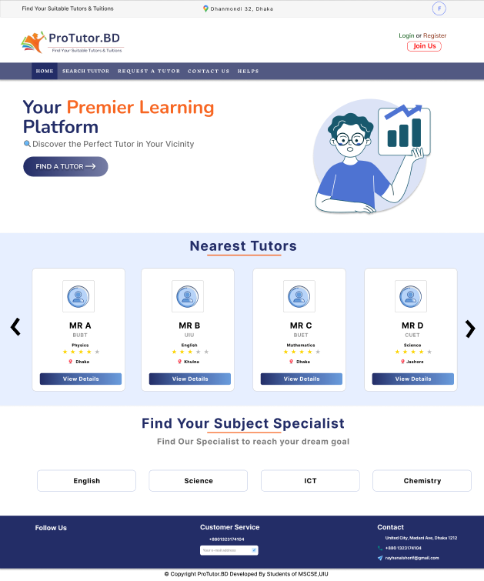

*Fig 5.2.1: Home Page*

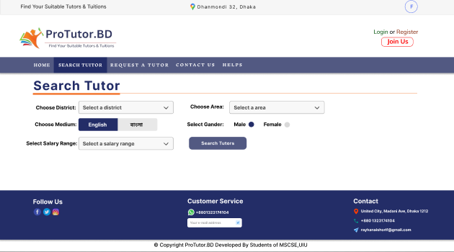

*Fig 5.2.2: Search Tutor*

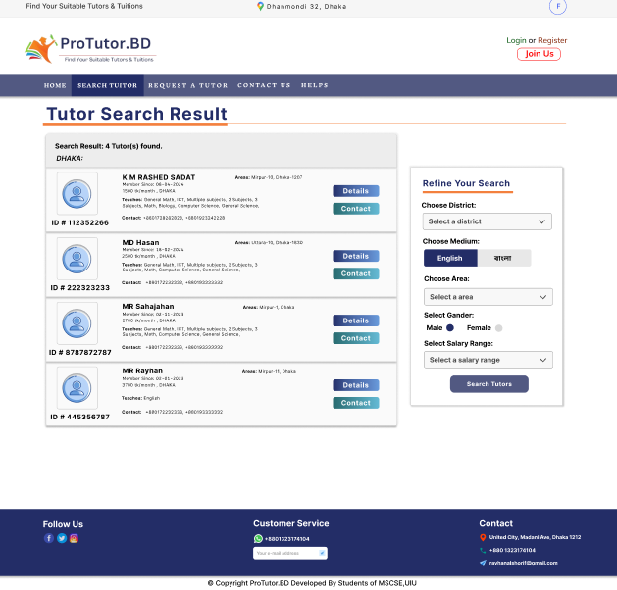

*Fig 5.2.3: Tutor Search Result_1*

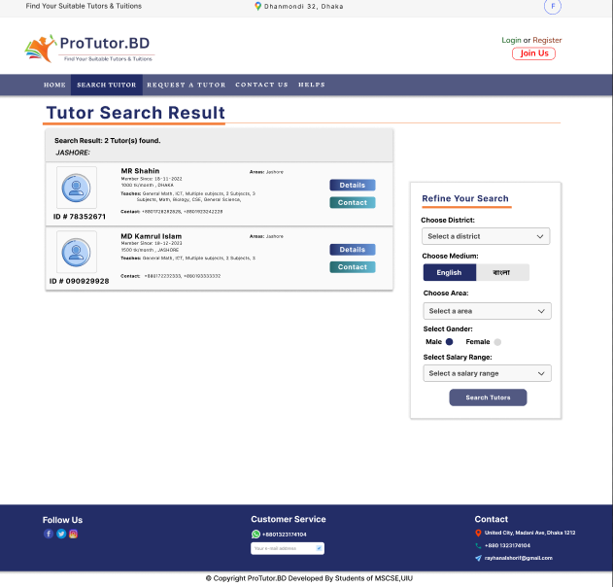

*Fig 5.2.4: Tutor Search Result_2*

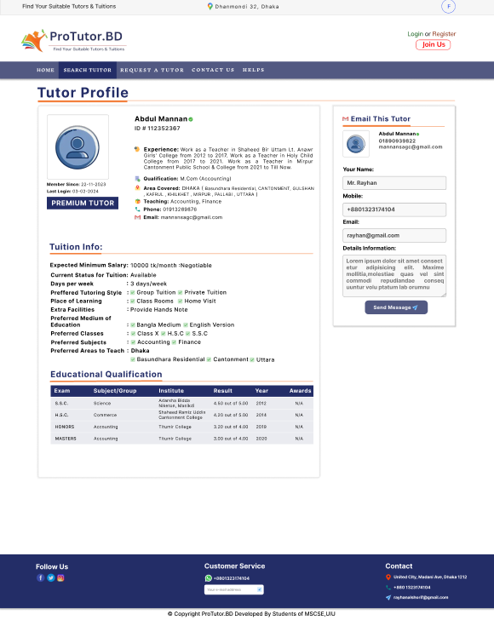

*Fig 5.2.5: Tutor Profile*

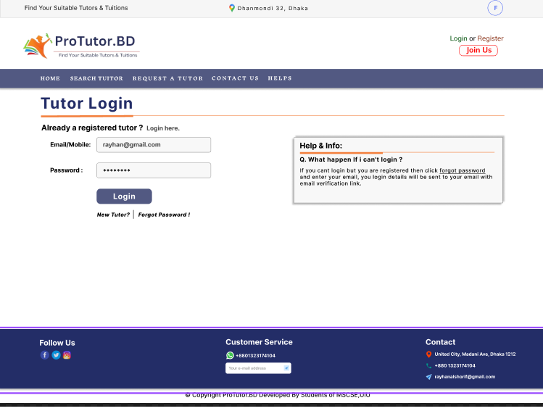

*Fig 5.2.6: Tutor Login*

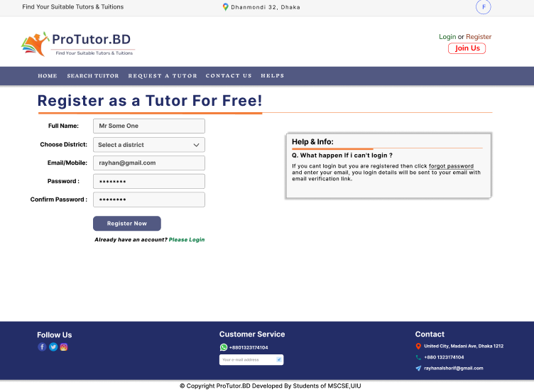

*Fig 5.2.7: Tutor Register*

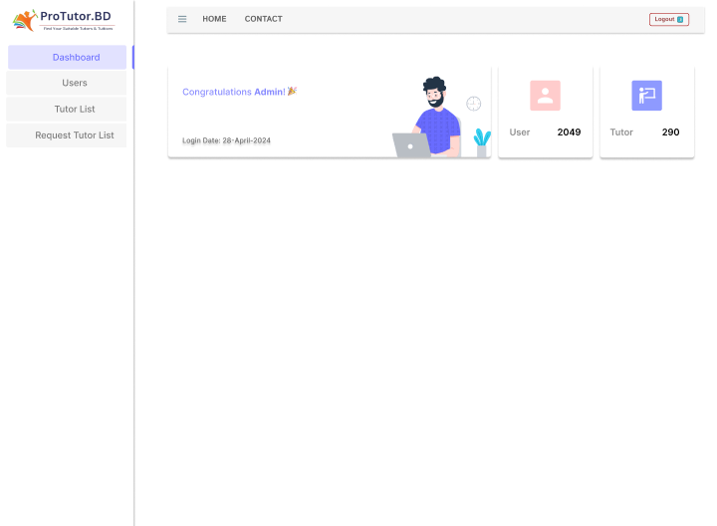

*Fig 5.2.8: Admin Dashboard*

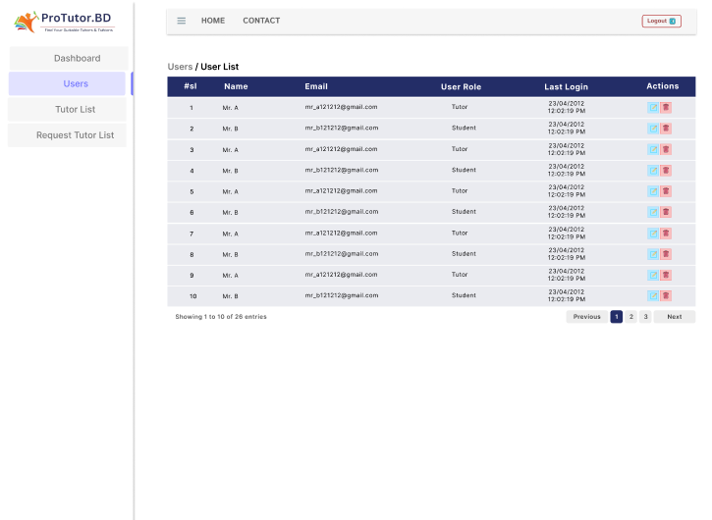

*Fig 5.2.9: User List (Admin Panel)*

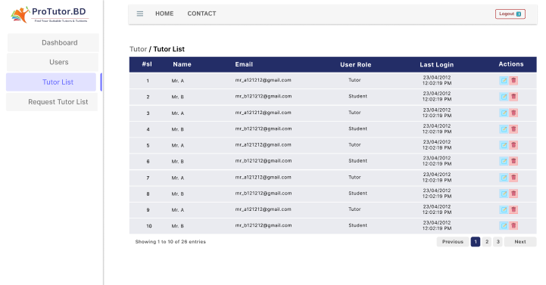

*Fig 5.2.10: Tutor List (Admin Panel)*

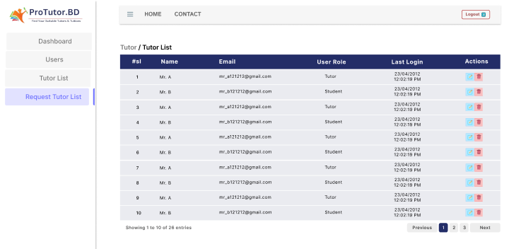

*Fig 5.2.11: Request Tutor List (Admin Panel)*

# 6. Tools and Technologies

For ProTutorBD, a platform presumably focused on education or tutoring services, several tools and technologies could be beneficial for various aspects of its operation. Here's a list of potential tools and technologies across different areas:

**Learning Management System (LMS):** Utilize an LMS platform such as Moodle, Canvas, or Blackboard to manage course content, deliver online lessons, track student progress, and facilitate communication between students and instructors.

**Video Conferencing Software:** Implement video conferencing tools like Zoom, Microsoft Teams, or Google Meet for conducting live virtual classes, one-on-one tutoring sessions, or group discussions.

**Content Creation Tools:** Use tools like Articulate Storyline, Adobe Captivate, or Camtasia for creating interactive and engaging multimedia content such as video lectures, presentations, quizzes, and simulations.

**Student Management System (SMS):** Employ SMS software to manage student enrollment, registration, scheduling, and billing processes efficiently. Examples include SchoolMint, PowerSchool, or Alma.

**Collaboration and Communication Tools:** Utilize communication and collaboration tools like Slack, Microsoft Teams, or Discord to facilitate communication and collaboration among students, instructors, and administrative staff.

**Virtual Classroom Platforms:** Explore virtual classroom platforms such as BigBlueButton or WizIQ, which offer features like interactive whiteboards, screen sharing, breakout rooms, and real-time chat for a collaborative learning experience.

**Online Assessment and Evaluation Tools:** Use assessment tools like Google Forms, Kahoot!, or Quizizz to create and administer quizzes, tests, and assignments, as well as to collect and analyze student performance data.

**Learning Analytics Platforms:** Implement learning analytics tools like Learning Locker or Brightspace Insights to track and analyze learner data, monitor engagement and progress, and gain insights for personalized learning interventions.

**Content Management System (CMS):** Utilize a CMS platform such as WordPress, Drupal, or Joomla to manage and publish website content, blogs, announcements, and other relevant information.

**Payment Gateway Integration:** Integrate payment gateways like PayPal, Stripe, or Razorpay to facilitate secure online payments for course enrollment fees or subscription plans.

**CRM Software:** Implement a CRM system like Salesforce or HubSpot to manage leads, inquiries, and customer relationships effectively, as well as to track sales and marketing activities.

**Cloud Hosting Services:** Host the platform on reliable cloud hosting services like Amazon Web Services (AWS), Microsoft Azure, or Google Cloud Platform (GCP) for scalability, security, and performance.

These are just a few examples of tools and technologies that ProTutorBD could consider incorporating into its platform to enhance its functionality, user experience, and overall effectiveness in delivering educational services. The specific tools chosen would depend on the platform's requirements, budget, and target audience.

# 7. Conclusion:

In conclusion, ProTutorBD represents a pivotal advancement in the realm of educational support, offering a comprehensive platform that combines convenience, accessibility, and quality. Through its innovative features and dedicated team of tutors, ProTutorBD is poised to empower learners of all backgrounds to achieve their academic goals with confidence and success.

# 8. References:

## 8.1 Paper Based:

[1] G. Mustafa, A. Ishaque, A. Iqbal, N. Ahmad, S. Malik, and A. Anwar, "The Demand for Shadow Education: Socioeconomic Determinants and Implications," *International Journal of Innovation, Creativity and Change*, vol. 15, no. 2, pp. 492, 2021.

[2] S. Bhorkar and M. Bray, "The Expansion and Roles of Private Tutoring in India: From Supplementation to Supplantation," *UCL Institute of Education, London, United Kingdom and Comparative Education Research Centre, The University of Hong Kong, Pokfulam, Hong Kong*

[3] M. Bray, "The impact of shadow education on student academic achievement: Why the research is inconclusive and what can be done about it," *Asia Pacific Education Review,* vol. 15, pp. 381–389, 2014. DOI: 10.1007/s12564-014-9326-9

[4] A. Raffick Foondun, "The issue of private tuition: An analysis of the practice in Mauritius and selected South-East Asian countries."

[5] E. Smyth, "The more, the better? Intensity of involvement in private tuition and examination performance," *Educational Research and Evaluation: An International Journal on Theory and* Practice, Economic and Social Research Institute, Dublin, Ireland, Published online: 02 Oct 2008.

[6] M. Mustary, "The Shadow Education System in Bangladesh: A Blessing or a Curse?", *Glocal Education in Practice: Teaching, Researching, and Citizenship*, BCES Conference Books, vol. 17, Sofia: Bulgarian Comparative Education Society, 2019, pp. 64, ISSN 1314-4693 (print), ISSN 2534-8426 (online), ISBN 978-619-7326-07-9 (print), ISBN 978-619-7326-08-6 (online), © 2019 BCES.

## 8.2 Information Based:

* + - * Benchmarking learning and teaching: Developing a method ([Link](https://www.researchgate.net/publication/235312267_Benchmarking_learning_and_teaching_Developing_a_method)).
* [Tutorsheba.com](https://tutorsheba.com/) (Google search engine) ([Link](https://tutorsheba.com/)).
* [Bdtutors.com](https://bdtutors.com/) (Google search engine) ([Link](https://bdtutors.com/)).
* [Caretutors.com](https://caretutors.com/) (Google search engine) ([Link](https://caretutors.com/)).
* [Dhakatutors.com](https://www.dhakatutors.com/) (Google search engine) ([Link](https://www.dhakatutors.com/)).
* [Deshtutor.com](https://deshtutor.com/) (Google search engine) ([Link](https://deshtutor.com/)).