**United International University**

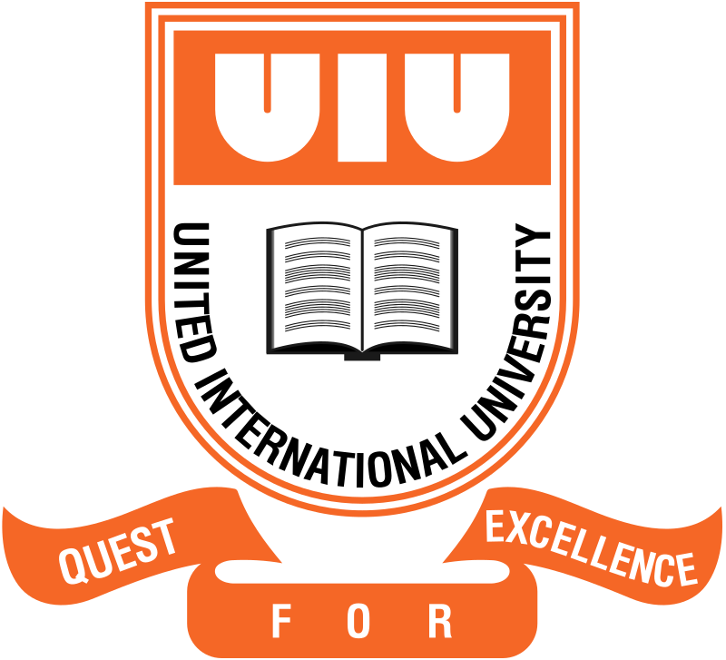

**Mid Exam Report On**

**Smart Sage: IOT-Driven Home Automation**

**Framework with Predictive Machine Learning**

**Submitted to**

Dr. Khondaker Abdullah -Al-Mamun

Professor, Dept. of CSE, UIU

**Submitted by**

Rayhan Al Shorif

ID: 0122410022

Student of MSCSE, UIU

Date of Submission: 15th March, 2024