SYSTEM DESIGN AND IMPLEMENTATION
Healthcare Cloud Platform
Standalone thesis chapter based on the validated project implementation
Implementation snapshot: local production environment, August 2026
Public cloud deployment and HTTPS termination remain pending institutional VM access.

1. Introduction
This chapter presents the system design and implementation of the Healthcare Cloud Platform, a containerized healthcare data management prototype designed to support secure access, modular clinical-data services, object storage, auditability, and reproducible deployment. The implementation follows a layered architecture in which Nginx provides the external reverse-proxy entry point, FastAPI exposes the application programming interface, PostgreSQL stores structured transactional data and audit records, and MinIO stores binary diagnostic reports and related healthcare attachments. The services are orchestrated through Docker Compose and separated through dedicated edge and internal data networks.
The chapter is grounded in the inspected project source files and the validated local production environment. It documents what is implemented in the current system rather than describing an aspirational architecture. Accordingly, the chapter distinguishes the completed local production configuration from the later institutional cloud-deployment stage. The current stack is operational on a local host through port 8080, while public-domain configuration, certificate-based HTTPS termination, and deployment on a remote university virtual machine remain future deployment activities.

2. Design Objectives and Implementation Scope
The implementation was organized around five principal objectives: security, modularity, portability, operational resilience, and cost awareness. Security is addressed through bcrypt password hashing, signed JSON Web Tokens, role-based authorization, restrictive HTTP response headers, controlled CORS origins, production host validation, service isolation, and audit logging. Modularity is achieved by separating API endpoints, configuration, dependencies, database models, schemas, services, and ingestion utilities. Portability is supported through containerization and environment-driven configuration. Operational resilience is supported by health checks, restart policies, persistent Docker volumes, and validated backup-and-restore procedures. Cost awareness is reflected in the use of open-source components that can be deployed on modest infrastructure.
The present implementation covers authentication, patient records, encounters, observations, prescriptions, diagnostic reports, FHIR-related routes, structured database persistence, binary object storage, and audit-event persistence. The source inventory confirms distinct endpoint modules for authentication, patients, encounters, observations, prescriptions, diagnostic reports, FHIR resources, and FHIR conditions. All versioned routes are aggregated through a central API router and mounted under the /api/v1 prefix.

3. Overall System Architecture
The platform uses a layered client-proxy-application-data architecture. Requests from authorized clients enter through Nginx. Nginx forwards the request to the FastAPI backend and preserves the host, protocol, client address, and forwarding chain through proxy headers. FastAPI applies middleware, validates authentication, enforces role requirements, invokes domain services, and communicates with the appropriate persistence service. Structured healthcare and administrative data are stored in PostgreSQL, while binary healthcare objects are stored in MinIO. Audit events are also persisted in PostgreSQL, allowing access decisions and security-relevant operations to be traced.
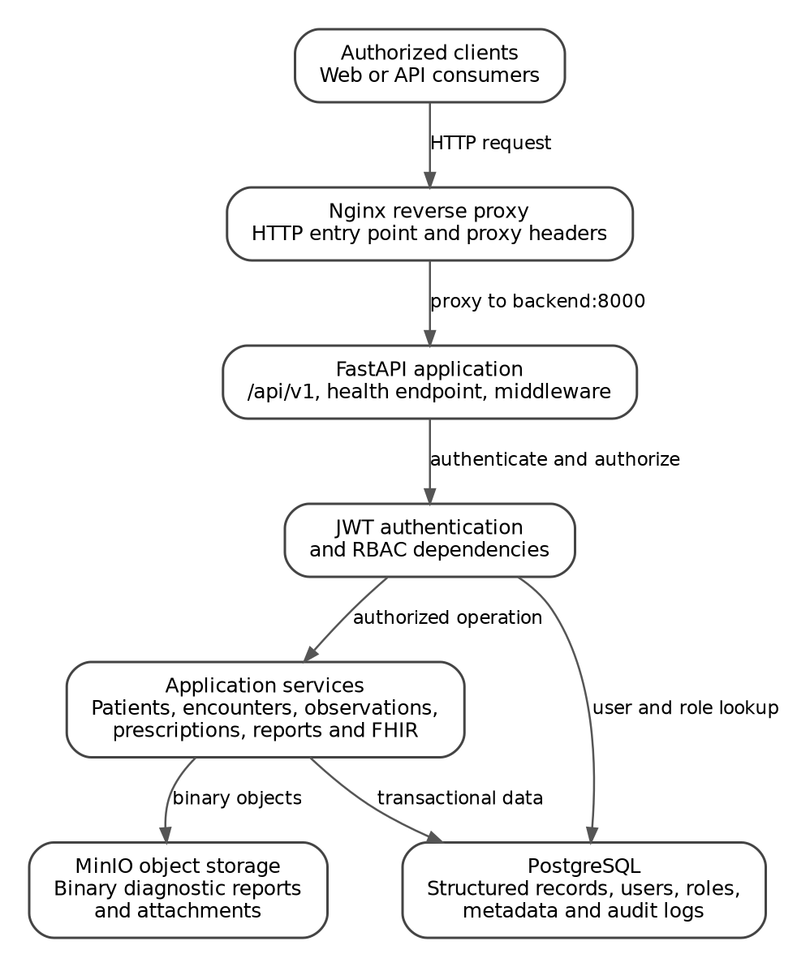
Figure 1. Implemented logical architecture of the Healthcare Cloud Platform.
Layer | Implemented component | Primary responsibility
Entry layer | Nginx stable-alpine | Receives host traffic, applies proxy headers, enforces upload limit, and forwards requests to the backend.
Application layer | FastAPI backend | Exposes versioned APIs, applies middleware, authenticates users, authorizes roles, and coordinates services.
Relational persistence | PostgreSQL 16 | Stores users, roles, clinical entities, metadata, and audit logs.
Object persistence | MinIO | Stores diagnostic report files and other binary healthcare objects.
Orchestration | Docker Compose | Defines service topology, health checks, networks, volumes, environment files, and restart behavior.

Table 1. Implemented system layers and responsibilities.

4. Backend Application Organization
The backend follows a modular package structure. The main application module initializes FastAPI, applies middleware, includes the versioned API router, and exposes root and health endpoints. The api package contains authentication and role dependencies together with versioned endpoint modules. The core package centralizes configuration and security functions. The db package manages SQLAlchemy sessions and model registration. The models package defines the database entities, while the schemas package defines request and response structures. The services package contains the application logic for audit recording, diagnostic reports, encounters, observations, patients, prescriptions, object storage, and Synthea ingestion. Supporting scripts automate dataset import and demonstration-user creation.
This separation limits the amount of business logic in routing modules and creates clear implementation boundaries. Endpoint functions can focus on HTTP request handling, dependencies can focus on authentication and authorization, service classes can coordinate application operations, and models can focus on persistence. The presence of a repositories package indicates an intended repository abstraction; however, the inspected structure shows that this package is not yet populated. The current implementation therefore relies primarily on service and endpoint layers for application coordination.
Backend area | Observed modules | Implementation role
API dependencies | auth.py, rbac.py | Bearer-token validation, current-user loading, and role authorization.
API endpoints | auth, patients, encounters, observations, prescriptions, diagnostic reports, FHIR, FHIR conditions | Versioned domain routes exposed through /api/v1.
Core | config.py, security.py | Environment settings, password hashing, JWT creation, and JWT decoding.
Models | User, Role, Patient, Encounter, Observation, Prescription, DiagnosticReport, Condition, AuditLog | Relational persistence entities.
Services | Audit, storage, patient, encounter, observation, prescription, diagnostic report, ingestion | Reusable business and integration logic.
Scripts | Synthea import and demo-user scripts | Controlled data ingestion and environment preparation.

Table 2. Backend modular organization.

5. API Composition and Routing
The versioned API is assembled by a central APIRouter instance. Authentication, patient, encounter, observation, prescription, diagnostic-report, FHIR, and FHIR-condition routers are included in a single v1 router. The main application then mounts this router under /api/v1. This arrangement provides a consistent namespace and allows future versions to be introduced without restructuring existing endpoint modules.
The root endpoint returns an application-running message and a success status, while /health returns a compact service-health response. The health route is used both for operational verification and by the backend container health check. Documentation endpoints are enabled only when the documentation setting is true and the application is not running in production. Consequently, /docs, /redoc, and /openapi.json are disabled in the production environment, reducing unnecessary public exposure of the API schema.

6. Configuration Management
Runtime configuration is centralized through a Pydantic Settings class. The configuration includes the application environment, bind host and port, database URL, JWT parameters, MinIO connection properties, documentation settings, CORS origins, and trusted hosts. Comma-separated origin and host values are converted into normalized lists through properties. Unknown environment variables are ignored, allowing the same settings class to operate across development and production environment files.
The implementation uses environment variables to separate configuration from source code. This is appropriate for containerized deployment because database credentials, JWT keys, MinIO credentials, and host-specific values can be injected at runtime. The committed repository should contain only an example environment file; operational secrets belong in the non-versioned .env.production file. The current defaults in config.py are development placeholders and must never be treated as production credentials.

7. Authentication and Token Security
Password security is implemented with Passlib and bcrypt. The hash_password function rejects passwords shorter than eight characters and stores only a bcrypt-derived hash. Login verification compares the submitted plaintext password with the stored hash through verify_password. This approach avoids retaining plaintext passwords in the database.
Authenticated sessions use signed JSON Web Tokens. The token payload includes the subject identifier, issued-at timestamp, and expiration timestamp. The algorithm and expiration interval are configurable; the inspected defaults specify HS256 and a 30-minute access-token lifetime. Token decoding validates the signature and expiration. Invalid or expired tokens are converted into a controlled application error rather than being accepted or silently ignored.
The FastAPI authentication dependency uses OAuth2PasswordBearer and expects tokens issued by /api/v1/auth/login. After decoding the token, it extracts the subject as the user identifier, retrieves the corresponding user from PostgreSQL, and rejects missing, invalid, or inactive accounts. Invalid credentials return HTTP 401 with a Bearer authentication challenge, while inactive users return HTTP 403. This distinction separates authentication failure from account-state authorization failure.

8. Role-Based Access Control
Authorization is implemented through a reusable dependency factory named require_roles. Each protected endpoint can declare one or more allowed role names. The dependency first resolves the authenticated user, retrieves the associated role name, and compares it with the explicitly permitted role set. A missing role or an unauthorized role produces HTTP 403 with a consistent insufficient-permissions message.
Denied authorization attempts are recorded through the audit service. The event includes the action ACCESS_DENIED, the DENIED outcome, the user identifier, requested endpoint path, user role, and allowed roles. This design provides traceability for authorization failures and supports later security review. The project validation environment includes six demonstration roles: Admin, Doctor, Nurse, Lab Staff, Pharmacist, and Data Manager. Endpoint-level authorization can therefore be expressed in terms of professional responsibilities rather than only authenticated versus unauthenticated access.

9. Audit Logging and Accountability
Auditability is implemented as a centralized application service that persists security-relevant and healthcare-data access events in PostgreSQL. Each event may include the user identifier, action, resource type, resource identifier, outcome, HTTP method, endpoint, client IP address, user agent, and structured details serialized as compact JSON. The client address is obtained from X-Forwarded-For when present and otherwise from the direct request connection. User-agent strings are limited to 500 characters.
The audit service defines a design rule that passwords, JWTs, authorization headers, and file contents must not be placed in audit details. This rule is important because audit logs require sufficient context for accountability without becoming a secondary repository of sensitive secrets. The safe_record_event method prevents an audit-write failure from causing the primary application operation to fail. When an audit exception occurs, the database transaction is rolled back and the method returns no audit object. This choice favors service continuity, although operational monitoring should still detect and investigate repeated audit-write failures.

10. Relational Data Management
PostgreSQL 16 provides structured persistence for users, roles, patients, encounters, observations, prescriptions, diagnostic-report metadata, conditions, and audit logs. The backend receives its database URL through the production environment file. PostgreSQL is attached only to the internal data network and is not mapped to a host port in the production compose configuration. This reduces the exposed attack surface because external clients cannot directly access the database service through Docker port publishing.
Schema evolution is managed through Alembic. The validated production environment reported revision 685666386ae6 at head. Transactional DDL is used by the PostgreSQL implementation. Database migration status should be checked before application release, and migration execution should be incorporated into the remote deployment procedure to ensure that application code and schema remain synchronized.

11. MinIO Object Storage
The platform separates structured metadata from binary healthcare files. PostgreSQL stores records and object metadata, while MinIO stores the binary payload. The StorageService initializes a MinIO client from environment-driven endpoint, credential, bucket, and transport-security settings. The service can verify or create the configured bucket, test bucket readiness, upload byte sequences, download stored objects, verify SHA-256 integrity, and delete objects.
During upload, the service validates that the object key and payload are non-empty, calculates the SHA-256 digest, records the byte length, and returns persistence metadata including the bucket name, object key, content type, file size, and checksum. Integrity verification downloads the object and compares its digest with the expected checksum. Deletion supports compensating cleanup when a file upload succeeds but the corresponding PostgreSQL transaction fails. This prevents orphaned objects from remaining in storage after an incomplete application operation.
The validated lifecycle test confirmed bucket existence, bucket access, upload/download integrity, and object deletion. The bucket is created lazily by the storage service when required. For the future remote deployment, an explicit startup initialization or readiness procedure would make bucket availability deterministic before the first user operation.

12. HTTP Security Controls
The FastAPI application applies CORS middleware using an explicit set of allowed origins. Credentials are permitted, while allowed methods are restricted to GET, POST, PUT, PATCH, DELETE, and OPTIONS. Allowed request headers are limited to Authorization, Content-Type, and Accept. In production, TrustedHostMiddleware restricts accepted host headers to configured host names, mitigating host-header attacks when the final domain or server address is known.
A custom HTTP middleware adds several response-security headers. X-Content-Type-Options is set to nosniff, X-Frame-Options is set to DENY, Referrer-Policy is set to no-referrer, and Permissions-Policy disables camera, microphone, and geolocation. Cache-Control is set to no-store. For ordinary API routes, the Content-Security-Policy defaults to none and disallows framing, base URIs, and form actions. Documentation routes receive a less restrictive policy only when they are enabled. In production, the application also sets Strict-Transport-Security for one year with subdomain inclusion.
The HSTS header assumes that the request is delivered over HTTPS. The current local Nginx configuration listens on HTTP port 80 and is mapped to host port 8080, so certificate termination is not yet implemented in the inspected compose stack. Therefore, the HSTS control should be considered deployment-ready but not fully effective until the future remote server is configured with a domain and TLS certificates.

13. Containerized Production Architecture
Docker Compose defines four production services: nginx, backend, postgres, and minio. Nginx depends on a healthy backend. The backend depends on a healthy PostgreSQL service and a started MinIO service. The backend health check invokes the local /health endpoint every 15 seconds, with a seven-second timeout, five retries, and a 20-second start period. PostgreSQL uses pg_isready every ten seconds. All services use the restart policy unless-stopped.
The network topology separates north-south traffic from internal data traffic. Nginx is attached only to the edge network. The backend is attached to both edge and data networks, allowing it to receive proxied requests and communicate with persistence services. PostgreSQL and MinIO are attached only to the internal data network. Because the data network is marked internal, it is isolated from direct external access. This arrangement implements a simple two-zone container architecture and limits direct communication paths.
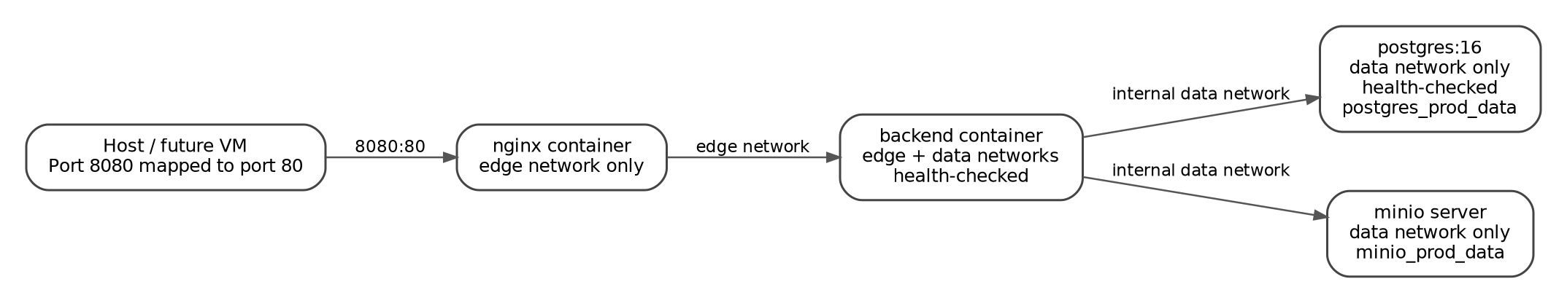
Figure 2. Docker Compose network segmentation and persistent services.
Service | Host exposure | Networks | Persistence and health
nginx | 8080:80 | edge | Read-only Nginx configuration; depends on healthy backend.
backend | No published host port; exposes 8000 internally | edge and data | HTTP health check against /health; restart unless-stopped.
postgres | No published host port | data | postgres_prod_data volume; pg_isready health check.
minio | No published host port | data | minio_prod_data volume; server command with console on 9001 internally.

Table 3. Production container topology.

14. Nginx Reverse Proxy
Nginx is the only service published to the host. It listens on container port 80 and receives traffic from host port 8080. The proxy forwards all locations to backend:8000 using HTTP/1.1. It transmits the original host, direct client address, forwarding chain, and original scheme through standard proxy headers. Connection timeout is ten seconds, while send and read timeouts are sixty seconds. The maximum request-body size is 25 MB, accommodating diagnostic files while maintaining a defined upload limit.
Nginx duplicates several defensive response headers, including nosniff, frame denial, no-referrer, and restricted permissions. Defense in depth is beneficial, but header ownership should be documented to avoid conflicting values when the deployment evolves. For remote production, the Nginx server block must be extended with the assigned domain, HTTPS listener, certificate files, secure TLS parameters, and an HTTP-to-HTTPS redirect.

15. Persistence, Health, and Recovery Design
PostgreSQL and MinIO data are stored in named Docker volumes, allowing container recreation without automatic data loss. The health-check and dependency configuration prevents Nginx from starting before the backend is healthy and prevents the backend from proceeding before PostgreSQL is ready. MinIO startup is checked at the service-start level rather than through a native health check, so application-level readiness is additionally validated by the storage lifecycle test.
The validated project evidence reported successful PostgreSQL and MinIO backup-and-restore procedures. PostgreSQL restoration passed all 19 checks, while MinIO restoration passed all 23 checks. These results demonstrate that the persistence design is not limited to normal operation; the stored state can also be backed up, restored, and verified. The future remote deployment should schedule these procedures automatically and copy backups to storage independent of the primary server.

16. Implementation Verification
The local production implementation was subjected to a consolidated validation matrix. All seven validation domains completed successfully, with no failures, pending checks, or review items. The matrix included production HTTP security, strict diagnostic-report auditing, end-to-end diagnostic-report storage, MinIO service lifecycle, PostgreSQL recovery, MinIO recovery, and optimized 200-user load testing.
Validation domain | Observed result
Production HTTP security | PASS, 17 of 17 checks
Diagnostic-report strict audit | PASS, 9 of 9 checks
Diagnostic-report end-to-end storage | PASS, 10 of 10 checks
MinIO service lifecycle | PASS, 4 of 4 checks
PostgreSQL backup and restore | PASS, 19 of 19 checks
MinIO backup and restore | PASS, 23 of 23 checks
Optimized 200-user load | PASS, zero failures, 146.77 requests/s, P95 latency 110 ms

Table 4. Consolidated local production verification.

17. Deployment Readiness and Current Limitations
The implementation is cloud-ready because it is containerized, environment-configured, network-segmented, persistent, health-checked, and independent of a specific local installation path. However, the current evidence supports a validated local production deployment rather than a completed public-cloud deployment. The following boundaries should be stated clearly in the thesis.
- The current Nginx service publishes HTTP on host port 8080; public HTTPS termination and domain configuration are not yet implemented.
- The production compose file does not define a frontend service. The validated deployment therefore represents the API and data-services platform.
- The MinIO and Nginx images use floating tags. Pinning exact image versions would improve reproducibility for institutional deployment.
- The API metadata reports version 0.1.0, while the repository has a local production release tag. These version identifiers should be synchronized before final submission.
- The repository abstraction package is currently unpopulated. A future refactoring could introduce explicit repository interfaces for more rigorous separation of persistence logic.
- The HSTS header becomes operationally meaningful only after trusted HTTPS termination is configured on the remote server.
These limitations do not invalidate the implementation. They define the remaining infrastructure tasks and prevent the thesis from overstating the current deployment status. Once the university VM is provided, the same Docker Compose architecture can be deployed remotely, followed by host hardening, firewall configuration, domain resolution, TLS certificates, automated backup scheduling, and external verification.

18. Summary
The Healthcare Cloud Platform implements a coherent, security-oriented, containerized architecture for structured healthcare records and binary diagnostic objects. FastAPI provides modular versioned APIs; bcrypt and JWT provide credential and session security; PostgreSQL provides transactional persistence; MinIO separates binary storage from relational metadata; role dependencies enforce professional access boundaries; and the audit service records security-relevant events. Nginx provides the controlled entry point, while Docker networks isolate data services from host exposure. Persistent volumes, health checks, restart policies, and validated recovery procedures support operational continuity.
The local production environment has been comprehensively validated and is suitable as the technical foundation for the thesis. The remaining work is primarily infrastructural rather than architectural: deployment to the institutional VM, secure public-domain configuration, HTTPS termination, automated off-server backups, and final external testing. The implemented design therefore provides a defensible transition from a validated local production prototype to a remotely hosted cloud-based healthcare platform.

Appendix A. Implementation Traceability
The following traceability table links the principal chapter claims to the inspected implementation artifacts. This supports reproducibility and allows the thesis author or reviewer to locate the relevant source evidence.
Chapter claim | Primary implementation evidence
API initialization, middleware, health route, production documentation behavior | backend/app/main.py
Versioned API composition | backend/app/api/v1/router.py and api_routes_inventory.txt
Environment-driven configuration | backend/app/core/config.py
Bcrypt hashing and JWT lifecycle | backend/app/core/security.py
Bearer authentication and active-user validation | backend/app/api/dependencies/auth.py
Role authorization and denied-access auditing | backend/app/api/dependencies/rbac.py
MinIO upload, download, integrity verification, and deletion | backend/app/services/storage_service.py
Audit-event structure and persistence behavior | backend/app/services/audit_service.py
Service topology, networks, volumes, and health checks | docker-compose.prod.yml
Reverse proxy and request-header forwarding | nginx/default.conf
Operational validation | tests/final_validation, tests/security, tests/storage, tests/recovery, and tests/performance evidence

Table A1. Traceability between documented claims and implementation artifacts.
Editorial note: The chapter is intentionally written as a standalone academic section. Heading numbers and table/figure numbering should be adapted when it is inserted into the university thesis template.

