[UNIVERSITY NAME]
[SCHOOL / FACULTY / DEPARTMENT]
DESIGN AND VALIDATION OF A SECURE, INTEROPERABLE,
SCALABLE AND RESILIENT HEALTHCARE CLOUD PLATFORM
A thesis submitted in partial fulfillment of the requirements
for the degree of [DEGREE NAME]
Submitted by
[CANDIDATE NAME]
[STUDENT ID]
Supervisor
[SUPERVISOR NAME AND TITLE]
[CITY, COUNTRY]
2026
DECLARATION
I declare that this thesis is my own work and that all sources used in its preparation have been acknowledged appropriately. This thesis has not been submitted, in whole or in part, for another degree or qualification at this or any other institution.

Candidate name: ______________________________
Signature: __________________________________
Date: ______________________________________
ACKNOWLEDGEMENTS
[Insert the final acknowledgement text after receiving the supervisor's guidance. A concise acknowledgement normally recognizes the supervisor, research institution, technical support, funding where applicable, colleagues, friends, and family.]
ABSTRACT
Healthcare data platforms must protect sensitive information while providing reliable clinical-data access, interoperability, recoverability, and acceptable performance under concurrent workloads. This research designed, implemented, and validated a modular healthcare cloud platform integrating FastAPI, PostgreSQL, MinIO, Nginx, Alembic, JSON Web Token authentication, role-based access control, audit logging, clinical application programming interfaces, a FHIR-inspired interoperability layer, and Synthea data-ingestion utilities. Structured clinical and security data were stored in PostgreSQL, while diagnostic-report objects were stored privately in MinIO and linked to relational metadata through object keys, file sizes, content types, and SHA-256 checksums.
The final validation framework covered production HTTP security, strict audit behavior, end-to-end diagnostic-report storage, MinIO object lifecycle, PostgreSQL recovery, MinIO recovery, and optimized concurrent-load performance. All seven validations passed, representing 83 of 83 recorded checks with no failed, pending, or review item. The optimized 200-user load completed 43,814 requests with zero failures, throughput of 146.77 requests per second, mean response time of 29.27 ms, P95 latency of 110 ms, and P99 latency of 240 ms. PostgreSQL recovery passed 19 of 19 checks, while MinIO recovery passed 23 of 23 checks.
The results support a local production-readiness and cloud-readiness claim for the measured Docker environment. The work does not claim full HL7 FHIR compliance, regulatory certification, high availability, complete host-loss disaster recovery, or validated public deployment. The next stage is deployment on the institutional UESTC virtual machine, followed by repetition of the full validation suite under the actual remote hardware, network, security, backup, and operational conditions.
Keywords: healthcare cloud platform; FastAPI; PostgreSQL; MinIO; role-based access control; FHIR-inspired interoperability; Synthea; disaster recovery; scalability; Docker
RÉSUMÉ
Les plateformes de données de santé doivent protéger les informations sensibles tout en assurant un accès fiable aux données cliniques, une interopérabilité suffisante, une capacité de récupération et des performances acceptables sous charge concurrente. Cette recherche a conçu, implémenté et validé une plateforme cloud de santé modulaire intégrant FastAPI, PostgreSQL, MinIO, Nginx, Alembic, l'authentification par jeton JWT, le contrôle d'accès fondé sur les rôles, la journalisation d'audit, des interfaces cliniques, une couche d'interopérabilité inspirée de FHIR et des utilitaires d'importation Synthea. Les données cliniques structurées et les données de sécurité sont enregistrées dans PostgreSQL, tandis que les rapports diagnostiques binaires sont conservés de manière privée dans MinIO.
Le cadre final d'évaluation a couvert la sécurité HTTP en production, l'audit strict, le stockage diagnostique de bout en bout, le cycle de vie MinIO, la restauration PostgreSQL, la restauration MinIO et les performances sous charge optimisée. Les sept validations ont réussi, soit 83 contrôles réussis sur 83, sans échec ni élément en attente. Le test optimisé avec 200 utilisateurs a exécuté 43 814 requêtes sans échec, avec un débit de 146,77 requêtes par seconde, une latence moyenne de 29,27 ms, un P95 de 110 ms et un P99 de 240 ms.
Les résultats justifient une conclusion de préparation locale à la production et de préparation au cloud pour l'environnement Docker mesuré. Ils ne démontrent pas une conformité FHIR complète, une certification réglementaire, une haute disponibilité ou un déploiement public distant. L'étape suivante consiste à déployer la plateforme sur la machine virtuelle institutionnelle UESTC et à répéter l'ensemble des validations dans les conditions réelles du serveur distant.
Mots-clés : plateforme cloud de santé ; FastAPI ; PostgreSQL ; MinIO ; contrôle d'accès par rôles ; interopérabilité inspirée de FHIR ; Synthea ; reprise après sinistre ; scalabilité ; Docker
LIST OF ABBREVIATIONS
Abbreviation | Meaning
API | Application Programming Interface
CORS | Cross-Origin Resource Sharing
DBMS | Database Management System
FHIR | Fast Healthcare Interoperability Resources
HSTS | HTTP Strict Transport Security
HTTP | Hypertext Transfer Protocol
HTTPS | Hypertext Transfer Protocol Secure
JWT | JSON Web Token
P95 | 95th-percentile response time
P99 | 99th-percentile response time
RBAC | Role-Based Access Control
RPO | Recovery Point Objective
RPS | Requests Per Second
RTO | Recovery Time Objective
SHA-256 | Secure Hash Algorithm, 256-bit
SQL | Structured Query Language
TLS | Transport Layer Security
UESTC | University of Electronic Science and Technology of China
VM | Virtual Machine

TABLE OF CONTENTS
Right-click and select Update Field after assembling the full thesis.
LIST OF FIGURES
This list will be generated after all chapters are assembled and figure captions are standardized using Word caption fields.
LIST OF TABLES
This list will be generated after all chapters are assembled and table captions are standardized using Word caption fields.

Chapter 1. General Introduction

1. Background and Research Context
Healthcare information systems increasingly depend on networked software, distributed data storage, application programming interfaces, and remote infrastructure. Cloud computing provides on-demand access to configurable computing resources and is commonly discussed through service and deployment models such as infrastructure, platform, and software services [1]. In healthcare, these capabilities can support wider data availability, centralized maintenance, elastic resource allocation, and more consistent deployment; however, they also intensify concerns related to confidentiality, authorization, interoperability, operational continuity, and evidence of system reliability [11], [13], [14].
Healthcare data are heterogeneous. A single platform may need to manage patient demographics, encounters, conditions, laboratory observations, prescriptions, diagnostic reports, user accounts, role assignments, and audit events. Structured clinical records benefit from relational integrity, while binary reports and attachments require object-oriented storage. The resulting architecture must preserve references between these data domains while preventing direct and unauthorized access.
Interoperability is another central requirement. FHIR is an HL7 standard for healthcare data exchange and defines resources, REST interactions, search mechanisms, conformance artifacts, terminology support, and security-related components [2]. FHIR-oriented research and platforms such as SMART on FHIR have demonstrated the value of standardized web-based application interfaces [3], [4]. Nevertheless, implementing selected FHIR-shaped resources does not by itself establish full FHIR conformance.
The development and testing of healthcare systems are further constrained by the sensitivity of real patient records. Synthea addresses this problem by generating synthetic longitudinal health records for research, education, and software testing without using identifiable real-patient data [5]. Synthetic data are therefore suitable for validating software workflows, although they cannot replace real clinical data for every biomedical or clinical-discovery purpose.
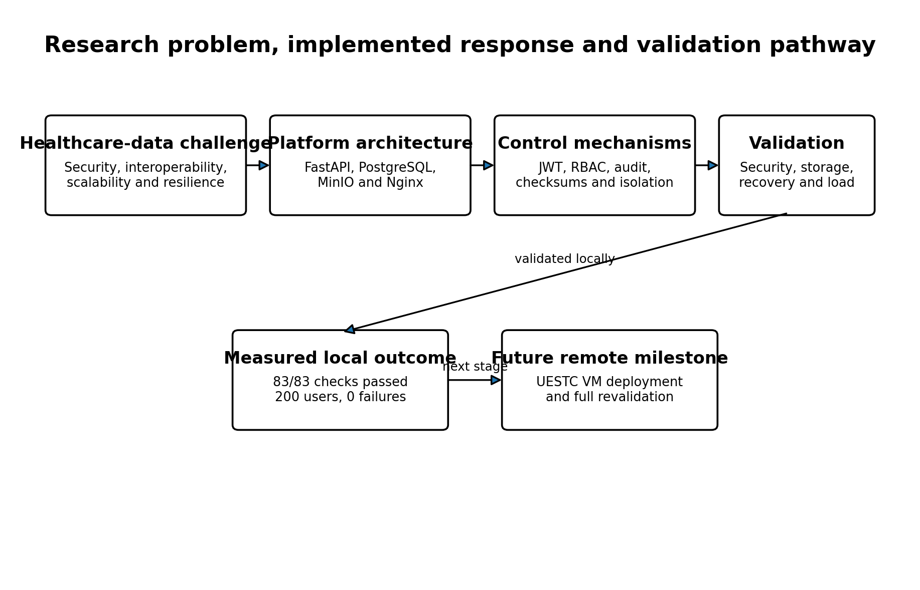
Figure 1. Research problem, implemented response, measured local outcome and future remote milestone.

2. Problem Statement
Many healthcare-platform studies and prototypes focus on one principal concern, such as cloud migration, data exchange, access control, privacy, or application scalability. The practical challenge is that these concerns interact. A healthcare API that performs well but lacks role restrictions is unsafe. A secure database without auditable file access provides incomplete accountability. A backup that is never restored does not demonstrate recoverability. Similarly, a containerized application cannot be described as cloud-deployed until it is installed and validated on actual remote infrastructure.
The research problem addressed in this thesis is therefore the design and validation of a modular healthcare cloud platform that combines: structured clinical-data management; private diagnostic-object storage; authenticated and role-restricted access; auditability; FHIR-inspired interoperability; synthetic-data ingestion; containerized deployment; backup and recovery; and concurrent-load evaluation.
The problem is not only to implement these features, but also to produce executable evidence showing that they function together. This requirement motivates an integrated validation framework rather than a feature checklist.

3. Research Aim
The aim of this research is to design, implement, and validate a secure, interoperable, scalable, and recoverable healthcare cloud platform using open-source technologies and synthetic healthcare data.

4. Research Objectives
Objective | Description
O1 | Design a modular backend architecture that separates API routing, security dependencies, database models, schemas, business services, storage operations, and ingestion utilities.
O2 | Implement authentication, active-user validation, role-based authorization, and audit logging for healthcare operations.
O3 | Develop a patient-centered PostgreSQL data model for clinical records, users, roles, diagnostic metadata, and audit events.
O4 | Integrate private MinIO object storage for diagnostic reports, with relational metadata and SHA-256 integrity verification.
O5 | Provide native clinical APIs and a bounded FHIR-inspired interoperability layer for selected healthcare resources.
O6 | Implement reproducible ingestion of synthetic Synthea patient, encounter, observation, and medication data.
O7 | Package the platform as an isolated multi-service Docker production stack.
O8 | Validate security, storage, auditability, disaster recovery, and concurrent-load performance through executable tests.
O9 | Prepare the platform for deployment and revalidation on an institutional virtual machine.

5. Research Questions
Research question | Question
RQ1 | How can a modular architecture integrate healthcare APIs, relational persistence, object storage, security services, and ingestion workflows without exposing internal data services directly?
RQ2 | How can JWT authentication, role-based access control, and audit logging be combined to restrict and trace healthcare-data operations?
RQ3 | How can structured clinical records, binary diagnostic objects, selected FHIR-inspired representations, and synthetic-data ingestion be integrated in one platform?
RQ4 | What security, storage-integrity, recovery, latency, throughput, and failure-rate outcomes are achieved in the measured local production environment?
RQ5 | What limitations remain before the platform can be described as remotely cloud-deployed and operationally production-ready?

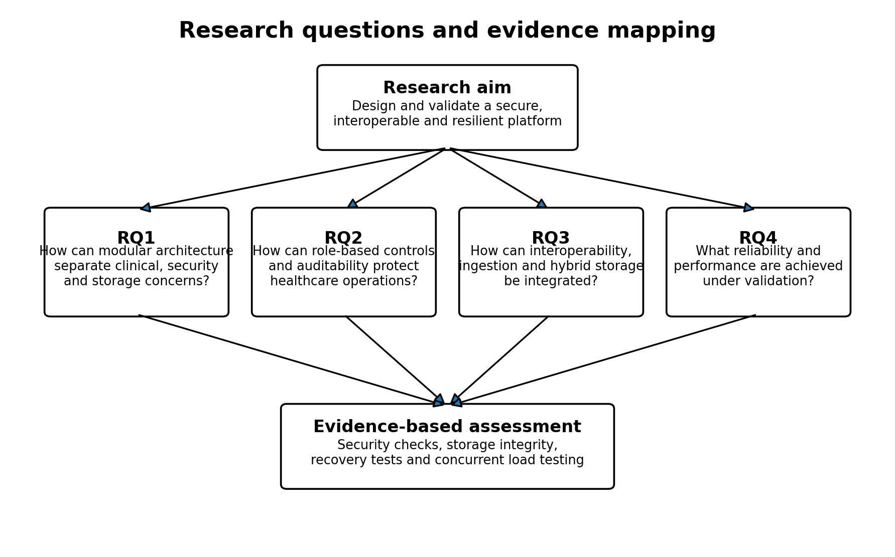
Figure 2. Mapping of the research aim and questions to the integrated evidence framework.

6. Research Scope

6.1 Included scope
- Backend development using FastAPI and Python.
- PostgreSQL models and Alembic migrations for clinical, security, and audit data.
- MinIO integration for private diagnostic-report objects.
- JWT-based authentication and six-role RBAC.
- Audit recording for authentication, authorization, clinical access, report upload, and report download.
- Native REST APIs and selected FHIR-inspired read and search resources.
- Synthea CSV ingestion for patients, encounters, observations, and medications.
- Docker Compose deployment with Nginx, backend, PostgreSQL, and MinIO.
- Functional security, storage, recovery, and Locust-based load validation.

6.2 Excluded or incomplete scope
- Full HL7 FHIR conformance certification.
- Use of identifiable real-patient data.
- Clinical decision support or medical diagnosis.
- Public Internet deployment before the UESTC VM becomes available.
- High-availability clustering and multi-region failover.
- Formal certification against a healthcare regulation.
- Measured financial cost-effectiveness without verified infrastructure prices.

7. Methodological Overview
The research follows a design, implementation, and empirical validation approach. First, the platform requirements were translated into modular software and deployment components. Second, healthcare models, endpoints, security dependencies, ingestion utilities, storage operations, and recovery procedures were implemented. Third, the system was exercised using synthetic data and executable validation scripts.
Methodological stage | Application in this research
Architecture design | Define services, modules, data domains, security boundaries and deployment topology
Implementation | Develop FastAPI, SQLAlchemy, Alembic, MinIO, Nginx and Docker components
Data preparation | Validate and import Synthea CSV datasets
Functional validation | Test authentication, RBAC, audit, clinical operations and object lifecycle
Recovery validation | Create and restore PostgreSQL and MinIO backups into isolated temporary targets
Performance validation | Run authenticated Locust workloads at 10, 50, 100 and 200 users
Evidence consolidation | Preserve CSV results, summaries, figures, status matrices and thesis chapters

8. Significance of the Research
The research is significant in three respects. First, it provides an integrated open-source implementation rather than a purely conceptual architecture. Second, it links security, structured data, object storage, interoperability, recovery, and performance within the same measured system. Third, it preserves negative and positive experimental evidence, particularly the initial failed 200-user scenario and the optimized zero-failure result.
The contribution is deliberately bounded. The platform is a validated local production-like system and a cloud-ready prototype. Its value lies in the reproducible design and evidence chain, not in a claim of universal healthcare deployment readiness.

9. Thesis Organization
Chapter | Title | Purpose
Chapter 1 | General Introduction | Research context, problem, aim, objectives, questions, scope and methodology
Chapter 2 | Literature Review and Related Work | Cloud healthcare, security, interoperability, synthetic data, deployment, resilience and research gap
Chapter 3 | System Design and Implementation | Architecture and implementation modules
Chapter 4 | Security Architecture and Validation | Authentication, RBAC, auditability and HTTP security
Chapter 5 | Healthcare Data Model, FHIR Interoperability and Synthea Ingestion | Clinical schema, hybrid storage and data ingestion
Chapter 6 | Performance, Scalability and Cost-Efficiency Evaluation | Load testing and resource interpretation
Chapter 7 | Backup, Recovery and Data Resilience | PostgreSQL and MinIO restoration evidence
Chapter 8 | Cloud Deployment Architecture and Production Readiness | Local production stack and remote VM requirements
Chapter 9 | Integrated Validation Results and Discussion | Cross-domain interpretation and limitations
Chapter 10 | General Conclusion, Contributions and Future Work | Final synthesis and future research

10. Chapter Summary
This chapter established the research problem and defined the aim, objectives, questions, scope, methodology, significance, and organization of the thesis. The next chapter reviews the literature and standards that motivate the platform architecture and identifies the gap addressed by the project.

Chapter 2. Literature Review and Related Work

1. Review Scope and Structure
This chapter reviews the concepts, standards, and prior work that inform the Healthcare Cloud Platform. The review is thematic rather than a formal systematic review. It covers cloud computing in healthcare, RESTful service architecture, authentication and role-based authorization, audit management, FHIR interoperability, synthetic healthcare data, containerization, hybrid persistence, contingency planning, and performance evaluation.
The selected literature combines foundational models, official technical standards, primary research papers, and systematic reviews. The purpose is to establish the theoretical and engineering basis for the implemented platform and to position its integrated validation contribution.
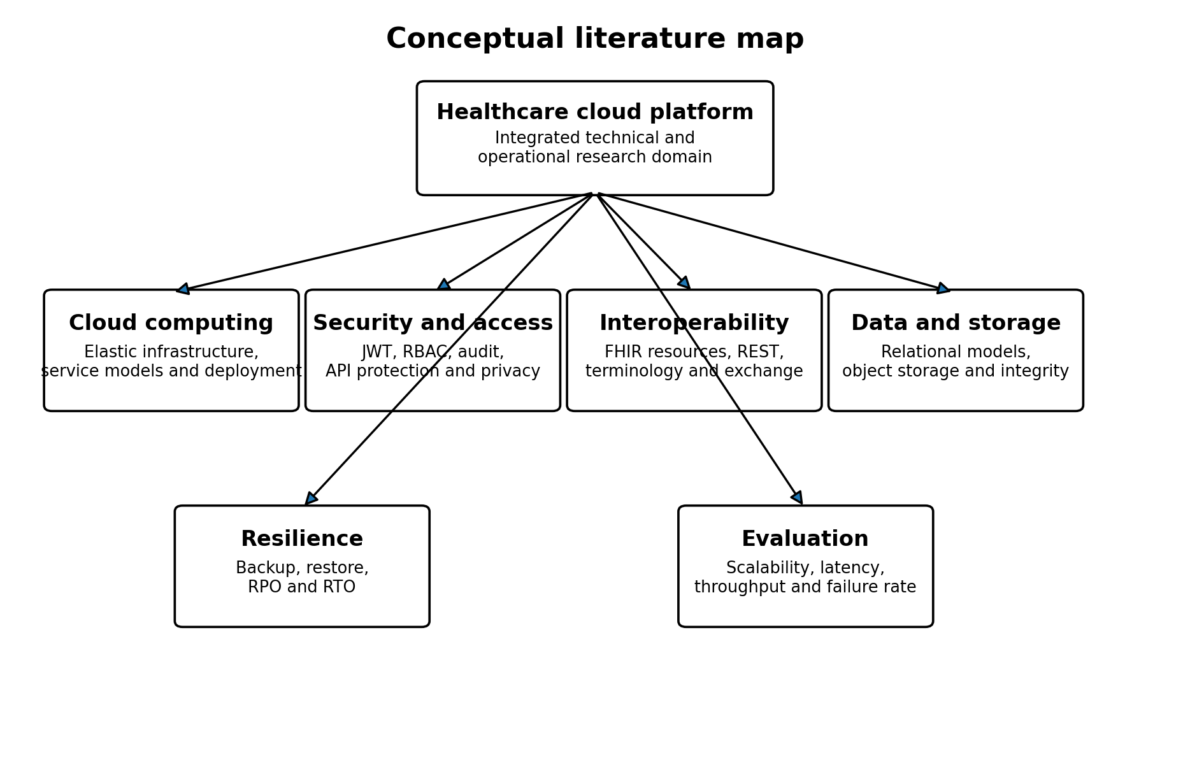
Figure 1. Conceptual map of the literature domains relevant to the platform.

2. Cloud Computing in Healthcare
NIST defines cloud computing as on-demand access to a shared pool of configurable resources that can be rapidly provisioned and released [1]. This definition distinguishes essential characteristics, service models, and deployment models. For healthcare applications, cloud-oriented infrastructure can centralize maintenance, support distributed access, and permit resource scaling; however, its usefulness depends on trust, data governance, availability, and secure integration.
Research on cloud-based electronic health records identifies accessibility, resource flexibility, reduced local infrastructure burden, and centralized data services as potential advantages [11]. At the same time, reviews of cloud computing in eHealth emphasize security, privacy, interoperability, and immature real-world evaluation as recurring challenges [13], [14]. These findings support an architecture that treats security and resilience as first-class design concerns rather than deployment additions.
The present platform is containerized and designed for deployment on a virtual machine. This corresponds most closely to an infrastructure-oriented deployment model, because the application owner manages the operating system environment, containers, databases, storage, reverse proxy, and application services. The local Docker host is cloud-ready but does not become cloud infrastructure merely through virtualization.

3. RESTful APIs and Modular Service Architecture
Fielding introduced REST as an architectural style for network-based software and emphasized constraints such as client-server separation, stateless interaction, cacheability, a uniform interface, layered systems, and optional code-on-demand [15]. Modern healthcare APIs often adopt HTTP, JSON, resource-oriented paths, and stateless authorization tokens, although not every JSON API satisfies the full REST architectural style.
Modular service architecture supports separation of concerns between routing, authentication, authorization, business logic, persistence, validation, storage, and auditing. In the present project, FastAPI endpoints depend on separate security and database components, while domain operations are delegated to service modules. This structure improves testability and limits direct coupling between HTTP handling and persistence logic.
API exposure introduces distinct security risks. The OWASP API Security Top 10 highlights recurring categories such as broken object-level authorization, broken authentication, unrestricted resource consumption, security misconfiguration, and unsafe API consumption [16]. These concerns justify explicit authorization on patient, report, prescription, and FHIR-oriented endpoints, together with bounded pagination and upload size.

4. Authentication, JWT and Role-Based Access Control

4.1 JWT authentication
RFC 7519 defines JWT as a compact, URL-safe representation of claims that may be signed, integrity-protected, or encrypted [7]. JWTs are widely used in HTTP authorization workflows because they can convey subject, issue time, expiration, and application-specific claims without requiring a server-side session object for every request.
JWT alone does not define user authorization policy. Token validation must verify the expected algorithm, signature, expiration, and subject semantics. Applications must also resolve the current user and account state. The platform therefore combines token decoding with database-backed active-user checks.

4.2 Role-based access control
Sandhu et al. formalized a family of RBAC reference models in which permissions are associated with roles and users are assigned to appropriate roles [6]. The central administrative advantage is that permissions can be managed around organizational functions rather than maintained separately for each user.
Healthcare organizations naturally contain function-specific roles such as physician, nurse, pharmacist, laboratory staff, data manager, and administrator. RBAC can therefore reflect competency, responsibility, and duty assignment. The platform applies explicit role sets to clinical creation, reading, updating, report upload, report download, prescription, and FHIR-oriented operations.
RBAC is not automatically equivalent to least privilege. Roles must be reviewed, excessive permissions must be removed, and sensitive operations may require additional contextual constraints. The current implementation uses a direct role-permission matrix and does not implement role hierarchies, dynamic attributes, or separation-of-duty constraints.

5. Audit Logging and Accountability
NIST SP 800-92 describes log management as the development, implementation, and maintenance of processes and infrastructure for security logging [8]. Effective audit systems must address event generation, collection, storage, analysis, retention, and disposal.
In healthcare-data systems, logs support accountability for authentication, authorization, record access, uploads, downloads, and administrative actions. The platform records actor, action, resource, outcome, HTTP method, endpoint, address, user agent, details, and timestamp.
Application-level logging has limitations. A database model described as immutable is not necessarily protected against update or deletion unless database permissions, append-only mechanisms, triggers, or external log replication enforce that property. Centralized monitoring and retention policies remain future work.

6. Healthcare Interoperability and FHIR
FHIR is an HL7 standard for healthcare data exchange [2]. Release 4 includes resources, REST interactions, search, terminology, profiling, capability statements, implementation guides, security, consent, provenance, and audit-related artifacts. Its resource-oriented and web-compatible design makes it suitable for modern APIs.
Bender and Sartipi presented FHIR as an agile and RESTful approach to healthcare exchange [3]. SMART on FHIR demonstrated how standards-based application platforms can connect substitutable applications to electronic health-record data [4]. Later reviews show broad interest in FHIR implementations while also identifying challenges in profiles, terminology, semantic consistency, integration, and implementation maturity [12].
A conformant FHIR server requires more than fields named after FHIR resources. It must identify the FHIR release, respect resource definitions and cardinalities, implement search and Bundle semantics correctly, expose capability metadata, apply profiles where needed, and support appropriate terminology. The current project therefore uses the term FHIR-inspired for its selected Patient, Encounter, Observation, MedicationRequest, and Condition mappings.
FHIR concern | Project status | Interpretation
Resource-oriented JSON | Implemented | Selected resourceType-based responses
Read and search interactions | Partially implemented | Patient, Observation and Condition searches; selected reads
CapabilityStatement | Minimal | Software and JSON format only
Profiles and implementation guides | Not demonstrated | Future interoperability work
Terminology validation | Not demonstrated | Codes stored but not validated against terminology services
Full Bundle semantics and pagination | Partial | Some totals and links require refinement

7. Synthetic Healthcare Data and Synthea
Access to real electronic health records is constrained by privacy, consent, legal, security, and intellectual-property concerns. Walonoski et al. developed Synthea as an open-source simulator of synthetic patient lifespans and health records [5]. The published system generates records in standard formats and is intended for research, education, innovation, and software testing.
Synthetic data support reproducible development without exposing real patient identities. They are especially useful for validating database schemas, API behavior, import pipelines, search, pagination, and load generation. They do not prove clinical validity and should not be treated as substitutes for real-world clinical evidence.
The platform imports Synthea patients, encounters, observations, and medications. Source-system and external-identifier fields support repeatable create-or-update behavior. Deterministic hashes are used when source rows lack a single stable identifier.

8. Containerization and Cloud-Native Deployment
Docker packages applications and their dependencies into portable, isolated containers [10]. Compared with a manually configured host, containerized deployment improves environmental consistency and supports reproducible development, testing, and release workflows.
Containerization does not by itself provide high availability, security, backup, monitoring, or cloud elasticity. These properties depend on network design, image management, secret handling, health checks, persistent storage, orchestration, and operational controls.
The platform uses four services: Nginx, FastAPI, PostgreSQL, and MinIO. Network segmentation keeps the database and object store internal. Named volumes preserve data across ordinary container recreation, while separate backup tests address logical recovery.

9. Relational Data and Object Storage
Healthcare platforms commonly combine structured and unstructured data. Relational databases are appropriate for normalized patient, encounter, observation, prescription, user, role, and audit records because foreign keys, constraints, indexes, and transactions support integrity and queryability.
Binary diagnostic reports are better represented as objects than as large database fields in many application architectures. Object storage separates byte persistence from relational metadata and permits the application to record bucket, object key, content type, file size, checksum, uploader, patient, and encounter references.
This hybrid design introduces a consistency problem: an object upload may succeed while metadata persistence fails, or metadata may remain after object deletion. The project addresses this through service-level sequencing, compensating object deletion, uniqueness constraints, and checksum validation during download.

10. Backup, Recovery and Resilience
NIST SP 800-34 treats contingency planning as part of organizational resilience and system lifecycle management [9]. Recovery planning requires identification of priorities, backup procedures, restoration processes, testing, and operational responsibilities.
Backup creation is insufficient evidence of recoverability. A usable validation process must restore data into an isolated target and compare the restored state with the source. The platform restores a PostgreSQL archive into a temporary database and MinIO objects into a temporary bucket, then verifies structure, row counts, object counts, sizes, and checksums.
The current recovery design remains local. It does not demonstrate encrypted off-site retention, recovery from total host loss, point-in-time database recovery, or measured recovery objectives. These limitations are consistent with the distinction between functional backup validation and complete disaster-recovery capability.

11. Performance and Scalability Evaluation
Performance evaluation of API platforms should report concurrency, request volume, failure rate, throughput, and latency distribution. Mean latency alone can hide long-tail behavior; percentiles such as P95 and P99 provide additional information about slower requests.
Scalability is not demonstrated by a single maximum-load result. A useful evaluation includes multiple load levels, preserves failed scenarios, identifies bottlenecks, applies remediation, and repeats the workload. The platform's initial 200-user test exposed a severe failure condition, while the optimized test achieved zero failures and substantially improved throughput and latency.
The result remains bounded by the workload, host, test duration, database state, and request mix. It cannot be generalized automatically to the future institutional VM or to write-heavy clinical workloads.
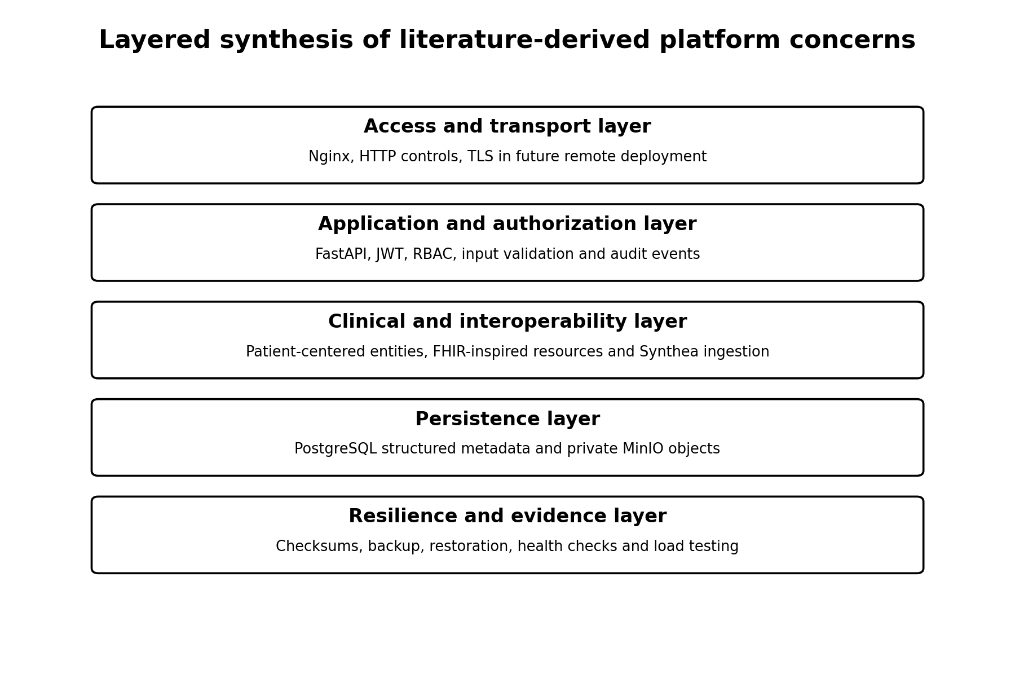
Figure 2. Layered synthesis of literature-derived concerns and their mapping to the implemented platform.

12. Comparative Synthesis of Related Work
Literature stream | Primary contribution | Remaining issue
Cloud-eHealth studies | Cloud benefits, architecture, privacy and deployment challenges | Often conceptual or limited real-world validation [11], [14]
FHIR research | Resource-oriented interoperability and standardized app integration | Implementation complexity, profiles and semantics remain challenges [3], [4], [12]
RBAC literature | Role-centered permission administration | Requires careful role design and may need constraints beyond basic RBAC [6]
Security guidance | JWT, API risks, logging and accountability | Standards provide mechanisms, not a complete application-specific implementation [7], [8], [16]
Container literature | Portability and consistent deployment | Operational resilience and security require additional controls [10]
Contingency guidance | Recovery planning and lifecycle integration | Actual restoration testing is necessary [9]

13. Research Gap and Project Positioning
The reviewed literature establishes strong foundations for cloud computing, REST APIs, RBAC, JWT, audit logging, FHIR, synthetic health records, containerization, and contingency planning. However, these concerns are frequently studied or implemented separately.
Based on the selected literature, the project is positioned as an integrated engineering and validation study. Its distinctive contribution is not a new cryptographic algorithm, access-control theory, FHIR standard, database engine, or container technology. The contribution is the combination of these established mechanisms into one healthcare-data platform with executable cross-domain evidence.
The evidence includes authorized and denied operations, audit outcomes, relational-object checksum consistency, PostgreSQL and MinIO restoration, container health, and before-and-after load testing. This positioning should be understood as a bounded project-level contribution rather than a claim that the literature has no other integrated healthcare platforms.
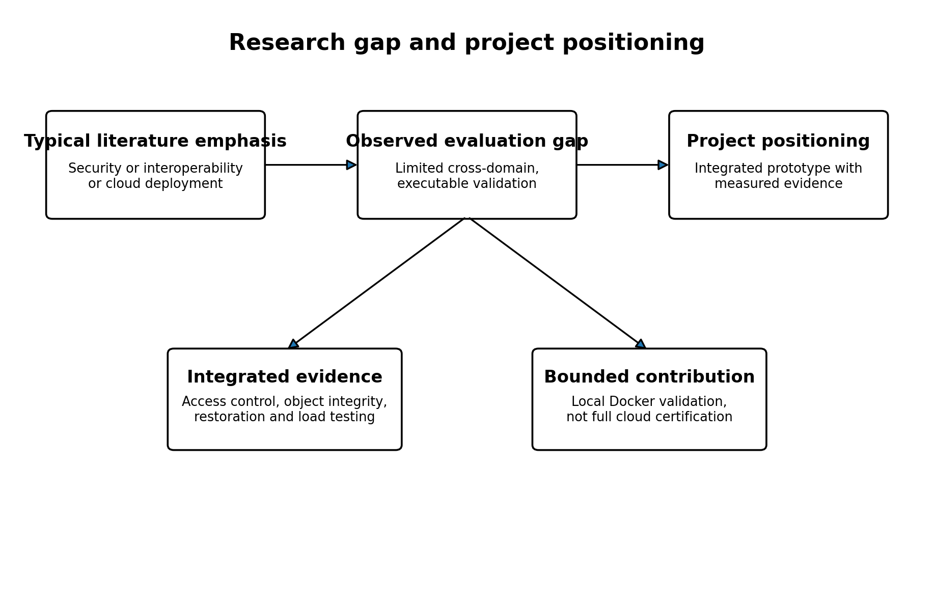
Figure 3. Research gap and bounded positioning of the Healthcare Cloud Platform.
Theme | Common literature emphasis | Project contribution
Security | Frequently discussed as policy, cryptography or privacy | Integrated JWT, RBAC, HTTP security and audit validation
Interoperability | FHIR resources and app platforms | Selected FHIR-inspired layer connected to the same clinical database
Storage | Relational or cloud storage considered separately | PostgreSQL metadata plus private MinIO objects with SHA-256
Recovery | Backup and contingency planning guidance | Executable isolated restoration for both persistence domains
Performance | Scalability often stated as an architectural goal | Measured multi-load Locust testing with failed and optimized 200-user runs
Deployment | Cloud or container architecture descriptions | Versioned four-service production Compose stack with validation evidence

14. Conceptual Framework for the Thesis
The conceptual framework derived from the review is that healthcare-platform readiness is a function of multiple interdependent domains. Security restricts and records access. Interoperability structures exchange. Data models and storage preserve clinical content. Containerization supports reproducible deployment. Recovery protects continuity. Performance evaluation tests whether the integrated system remains useful under concurrency.
No single domain is sufficient. The thesis therefore evaluates the platform using an integrated matrix rather than treating security, storage, recovery, and performance as unrelated appendices.

15. Chapter Summary
This chapter reviewed the standards and research that inform the platform. Cloud computing motivates remote and elastic infrastructure; REST and FHIR motivate resource-oriented exchange; JWT and RBAC motivate authenticated role-based access; log-management guidance motivates auditability; Synthea enables privacy-preserving software testing; Docker supports portable deployment; and contingency-planning guidance motivates restoration testing. The next chapter presents the system design and implementation.

Chapter 3. System Design and Implementation

1. Introduction
This chapter presents the system design and implementation of the Healthcare Cloud Platform, a containerized healthcare data management prototype designed to support secure access, modular clinical-data services, object storage, auditability, and reproducible deployment. The implementation follows a layered architecture in which Nginx provides the external reverse-proxy entry point, FastAPI exposes the application programming interface, PostgreSQL stores structured transactional data and audit records, and MinIO stores binary diagnostic reports and related healthcare attachments. The services are orchestrated through Docker Compose and separated through dedicated edge and internal data networks.
The chapter is grounded in the inspected project source files and the validated local production environment. It documents what is implemented in the current system rather than describing an aspirational architecture. Accordingly, the chapter distinguishes the completed local production configuration from the later institutional cloud-deployment stage. The current stack is operational on a local host through port 8080, while public-domain configuration, certificate-based HTTPS termination, and deployment on a remote university virtual machine remain future deployment activities.

2. Design Objectives and Implementation Scope
The implementation was organized around five principal objectives: security, modularity, portability, operational resilience, and cost awareness. Security is addressed through bcrypt password hashing, signed JSON Web Tokens, role-based authorization, restrictive HTTP response headers, controlled CORS origins, production host validation, service isolation, and audit logging. Modularity is achieved by separating API endpoints, configuration, dependencies, database models, schemas, services, and ingestion utilities. Portability is supported through containerization and environment-driven configuration. Operational resilience is supported by health checks, restart policies, persistent Docker volumes, and validated backup-and-restore procedures. Cost awareness is reflected in the use of open-source components that can be deployed on modest infrastructure.
The present implementation covers authentication, patient records, encounters, observations, prescriptions, diagnostic reports, FHIR-related routes, structured database persistence, binary object storage, and audit-event persistence. The source inventory confirms distinct endpoint modules for authentication, patients, encounters, observations, prescriptions, diagnostic reports, FHIR resources, and FHIR conditions. All versioned routes are aggregated through a central API router and mounted under the /api/v1 prefix.

3. Overall System Architecture
The platform uses a layered client-proxy-application-data architecture. Requests from authorized clients enter through Nginx. Nginx forwards the request to the FastAPI backend and preserves the host, protocol, client address, and forwarding chain through proxy headers. FastAPI applies middleware, validates authentication, enforces role requirements, invokes domain services, and communicates with the appropriate persistence service. Structured healthcare and administrative data are stored in PostgreSQL, while binary healthcare objects are stored in MinIO. Audit events are also persisted in PostgreSQL, allowing access decisions and security-relevant operations to be traced.
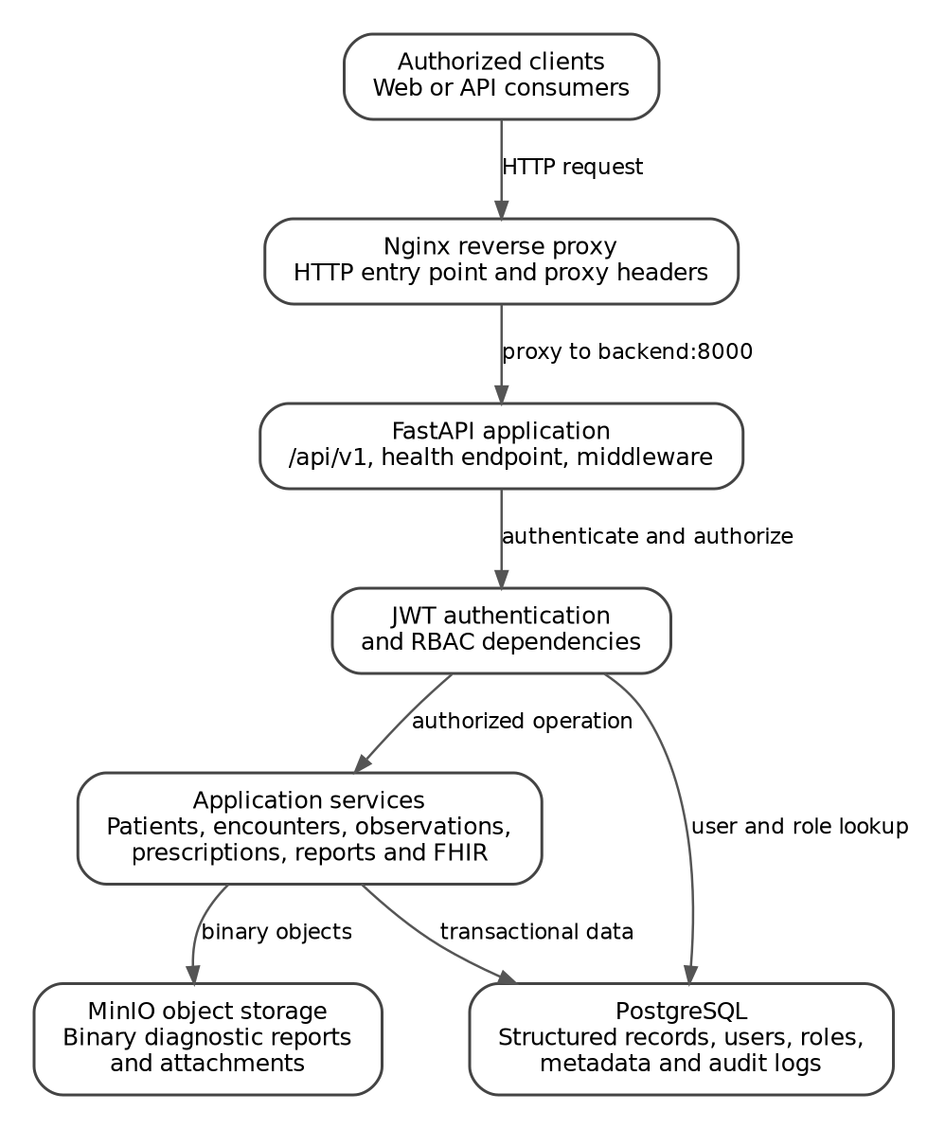
Figure 1. Implemented logical architecture of the Healthcare Cloud Platform.
Layer | Implemented component | Primary responsibility
Entry layer | Nginx stable-alpine | Receives host traffic, applies proxy headers, enforces upload limit, and forwards requests to the backend.
Application layer | FastAPI backend | Exposes versioned APIs, applies middleware, authenticates users, authorizes roles, and coordinates services.
Relational persistence | PostgreSQL 16 | Stores users, roles, clinical entities, metadata, and audit logs.
Object persistence | MinIO | Stores diagnostic report files and other binary healthcare objects.
Orchestration | Docker Compose | Defines service topology, health checks, networks, volumes, environment files, and restart behavior.

Table 1. Implemented system layers and responsibilities.

4. Backend Application Organization
The backend follows a modular package structure. The main application module initializes FastAPI, applies middleware, includes the versioned API router, and exposes root and health endpoints. The api package contains authentication and role dependencies together with versioned endpoint modules. The core package centralizes configuration and security functions. The db package manages SQLAlchemy sessions and model registration. The models package defines the database entities, while the schemas package defines request and response structures. The services package contains the application logic for audit recording, diagnostic reports, encounters, observations, patients, prescriptions, object storage, and Synthea ingestion. Supporting scripts automate dataset import and demonstration-user creation.
This separation limits the amount of business logic in routing modules and creates clear implementation boundaries. Endpoint functions can focus on HTTP request handling, dependencies can focus on authentication and authorization, service classes can coordinate application operations, and models can focus on persistence. The presence of a repositories package indicates an intended repository abstraction; however, the inspected structure shows that this package is not yet populated. The current implementation therefore relies primarily on service and endpoint layers for application coordination.
Backend area | Observed modules | Implementation role
API dependencies | auth.py, rbac.py | Bearer-token validation, current-user loading, and role authorization.
API endpoints | auth, patients, encounters, observations, prescriptions, diagnostic reports, FHIR, FHIR conditions | Versioned domain routes exposed through /api/v1.
Core | config.py, security.py | Environment settings, password hashing, JWT creation, and JWT decoding.
Models | User, Role, Patient, Encounter, Observation, Prescription, DiagnosticReport, Condition, AuditLog | Relational persistence entities.
Services | Audit, storage, patient, encounter, observation, prescription, diagnostic report, ingestion | Reusable business and integration logic.
Scripts | Synthea import and demo-user scripts | Controlled data ingestion and environment preparation.

Table 2. Backend modular organization.

5. API Composition and Routing
The versioned API is assembled by a central APIRouter instance. Authentication, patient, encounter, observation, prescription, diagnostic-report, FHIR, and FHIR-condition routers are included in a single v1 router. The main application then mounts this router under /api/v1. This arrangement provides a consistent namespace and allows future versions to be introduced without restructuring existing endpoint modules.
The root endpoint returns an application-running message and a success status, while /health returns a compact service-health response. The health route is used both for operational verification and by the backend container health check. Documentation endpoints are enabled only when the documentation setting is true and the application is not running in production. Consequently, /docs, /redoc, and /openapi.json are disabled in the production environment, reducing unnecessary public exposure of the API schema.

6. Configuration Management
Runtime configuration is centralized through a Pydantic Settings class. The configuration includes the application environment, bind host and port, database URL, JWT parameters, MinIO connection properties, documentation settings, CORS origins, and trusted hosts. Comma-separated origin and host values are converted into normalized lists through properties. Unknown environment variables are ignored, allowing the same settings class to operate across development and production environment files.
The implementation uses environment variables to separate configuration from source code. This is appropriate for containerized deployment because database credentials, JWT keys, MinIO credentials, and host-specific values can be injected at runtime. The committed repository should contain only an example environment file; operational secrets belong in the non-versioned .env.production file. The current defaults in config.py are development placeholders and must never be treated as production credentials.

7. Authentication and Token Security
Password security is implemented with Passlib and bcrypt. The hash_password function rejects passwords shorter than eight characters and stores only a bcrypt-derived hash. Login verification compares the submitted plaintext password with the stored hash through verify_password. This approach avoids retaining plaintext passwords in the database.
Authenticated sessions use signed JSON Web Tokens. The token payload includes the subject identifier, issued-at timestamp, and expiration timestamp. The algorithm and expiration interval are configurable; the inspected defaults specify HS256 and a 30-minute access-token lifetime. Token decoding validates the signature and expiration. Invalid or expired tokens are converted into a controlled application error rather than being accepted or silently ignored.
The FastAPI authentication dependency uses OAuth2PasswordBearer and expects tokens issued by /api/v1/auth/login. After decoding the token, it extracts the subject as the user identifier, retrieves the corresponding user from PostgreSQL, and rejects missing, invalid, or inactive accounts. Invalid credentials return HTTP 401 with a Bearer authentication challenge, while inactive users return HTTP 403. This distinction separates authentication failure from account-state authorization failure.

8. Role-Based Access Control
Authorization is implemented through a reusable dependency factory named require_roles. Each protected endpoint can declare one or more allowed role names. The dependency first resolves the authenticated user, retrieves the associated role name, and compares it with the explicitly permitted role set. A missing role or an unauthorized role produces HTTP 403 with a consistent insufficient-permissions message.
Denied authorization attempts are recorded through the audit service. The event includes the action ACCESS_DENIED, the DENIED outcome, the user identifier, requested endpoint path, user role, and allowed roles. This design provides traceability for authorization failures and supports later security review. The project validation environment includes six demonstration roles: Admin, Doctor, Nurse, Lab Staff, Pharmacist, and Data Manager. Endpoint-level authorization can therefore be expressed in terms of professional responsibilities rather than only authenticated versus unauthenticated access.

9. Audit Logging and Accountability
Auditability is implemented as a centralized application service that persists security-relevant and healthcare-data access events in PostgreSQL. Each event may include the user identifier, action, resource type, resource identifier, outcome, HTTP method, endpoint, client IP address, user agent, and structured details serialized as compact JSON. The client address is obtained from X-Forwarded-For when present and otherwise from the direct request connection. User-agent strings are limited to 500 characters.
The audit service defines a design rule that passwords, JWTs, authorization headers, and file contents must not be placed in audit details. This rule is important because audit logs require sufficient context for accountability without becoming a secondary repository of sensitive secrets. The safe_record_event method prevents an audit-write failure from causing the primary application operation to fail. When an audit exception occurs, the database transaction is rolled back and the method returns no audit object. This choice favors service continuity, although operational monitoring should still detect and investigate repeated audit-write failures.

10. Relational Data Management
PostgreSQL 16 provides structured persistence for users, roles, patients, encounters, observations, prescriptions, diagnostic-report metadata, conditions, and audit logs. The backend receives its database URL through the production environment file. PostgreSQL is attached only to the internal data network and is not mapped to a host port in the production compose configuration. This reduces the exposed attack surface because external clients cannot directly access the database service through Docker port publishing.
Schema evolution is managed through Alembic. The validated production environment reported revision 685666386ae6 at head. Transactional DDL is used by the PostgreSQL implementation. Database migration status should be checked before application release, and migration execution should be incorporated into the remote deployment procedure to ensure that application code and schema remain synchronized.

11. MinIO Object Storage
The platform separates structured metadata from binary healthcare files. PostgreSQL stores records and object metadata, while MinIO stores the binary payload. The StorageService initializes a MinIO client from environment-driven endpoint, credential, bucket, and transport-security settings. The service can verify or create the configured bucket, test bucket readiness, upload byte sequences, download stored objects, verify SHA-256 integrity, and delete objects.
During upload, the service validates that the object key and payload are non-empty, calculates the SHA-256 digest, records the byte length, and returns persistence metadata including the bucket name, object key, content type, file size, and checksum. Integrity verification downloads the object and compares its digest with the expected checksum. Deletion supports compensating cleanup when a file upload succeeds but the corresponding PostgreSQL transaction fails. This prevents orphaned objects from remaining in storage after an incomplete application operation.
The validated lifecycle test confirmed bucket existence, bucket access, upload/download integrity, and object deletion. The bucket is created lazily by the storage service when required. For the future remote deployment, an explicit startup initialization or readiness procedure would make bucket availability deterministic before the first user operation.

12. HTTP Security Controls
The FastAPI application applies CORS middleware using an explicit set of allowed origins. Credentials are permitted, while allowed methods are restricted to GET, POST, PUT, PATCH, DELETE, and OPTIONS. Allowed request headers are limited to Authorization, Content-Type, and Accept. In production, TrustedHostMiddleware restricts accepted host headers to configured host names, mitigating host-header attacks when the final domain or server address is known.
A custom HTTP middleware adds several response-security headers. X-Content-Type-Options is set to nosniff, X-Frame-Options is set to DENY, Referrer-Policy is set to no-referrer, and Permissions-Policy disables camera, microphone, and geolocation. Cache-Control is set to no-store. For ordinary API routes, the Content-Security-Policy defaults to none and disallows framing, base URIs, and form actions. Documentation routes receive a less restrictive policy only when they are enabled. In production, the application also sets Strict-Transport-Security for one year with subdomain inclusion.
The HSTS header assumes that the request is delivered over HTTPS. The current local Nginx configuration listens on HTTP port 80 and is mapped to host port 8080, so certificate termination is not yet implemented in the inspected compose stack. Therefore, the HSTS control should be considered deployment-ready but not fully effective until the future remote server is configured with a domain and TLS certificates.

13. Containerized Production Architecture
Docker Compose defines four production services: nginx, backend, postgres, and minio. Nginx depends on a healthy backend. The backend depends on a healthy PostgreSQL service and a started MinIO service. The backend health check invokes the local /health endpoint every 15 seconds, with a seven-second timeout, five retries, and a 20-second start period. PostgreSQL uses pg_isready every ten seconds. All services use the restart policy unless-stopped.
The network topology separates north-south traffic from internal data traffic. Nginx is attached only to the edge network. The backend is attached to both edge and data networks, allowing it to receive proxied requests and communicate with persistence services. PostgreSQL and MinIO are attached only to the internal data network. Because the data network is marked internal, it is isolated from direct external access. This arrangement implements a simple two-zone container architecture and limits direct communication paths.
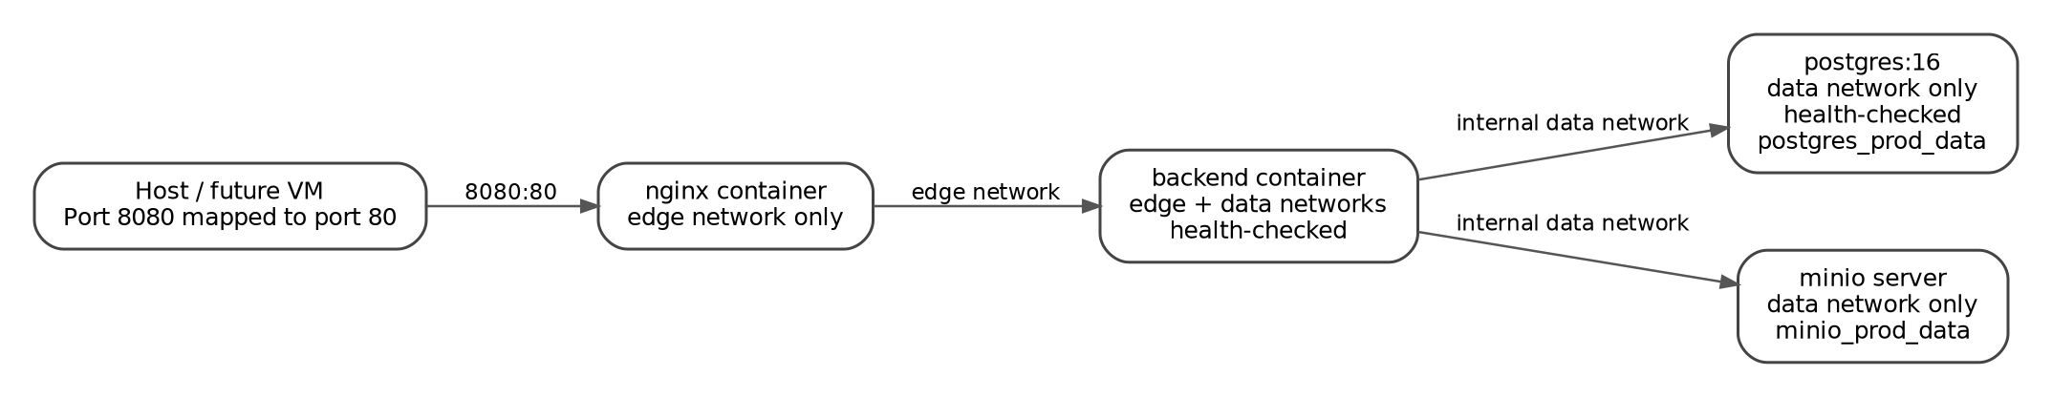
Figure 2. Docker Compose network segmentation and persistent services.
Service | Host exposure | Networks | Persistence and health
nginx | 8080:80 | edge | Read-only Nginx configuration; depends on healthy backend.
backend | No published host port; exposes 8000 internally | edge and data | HTTP health check against /health; restart unless-stopped.
postgres | No published host port | data | postgres_prod_data volume; pg_isready health check.
minio | No published host port | data | minio_prod_data volume; server command with console on 9001 internally.

Table 3. Production container topology.

14. Nginx Reverse Proxy
Nginx is the only service published to the host. It listens on container port 80 and receives traffic from host port 8080. The proxy forwards all locations to backend:8000 using HTTP/1.1. It transmits the original host, direct client address, forwarding chain, and original scheme through standard proxy headers. Connection timeout is ten seconds, while send and read timeouts are sixty seconds. The maximum request-body size is 25 MB, accommodating diagnostic files while maintaining a defined upload limit.
Nginx duplicates several defensive response headers, including nosniff, frame denial, no-referrer, and restricted permissions. Defense in depth is beneficial, but header ownership should be documented to avoid conflicting values when the deployment evolves. For remote production, the Nginx server block must be extended with the assigned domain, HTTPS listener, certificate files, secure TLS parameters, and an HTTP-to-HTTPS redirect.

15. Persistence, Health, and Recovery Design
PostgreSQL and MinIO data are stored in named Docker volumes, allowing container recreation without automatic data loss. The health-check and dependency configuration prevents Nginx from starting before the backend is healthy and prevents the backend from proceeding before PostgreSQL is ready. MinIO startup is checked at the service-start level rather than through a native health check, so application-level readiness is additionally validated by the storage lifecycle test.
The validated project evidence reported successful PostgreSQL and MinIO backup-and-restore procedures. PostgreSQL restoration passed all 19 checks, while MinIO restoration passed all 23 checks. These results demonstrate that the persistence design is not limited to normal operation; the stored state can also be backed up, restored, and verified. The future remote deployment should schedule these procedures automatically and copy backups to storage independent of the primary server.

16. Implementation Verification
The local production implementation was subjected to a consolidated validation matrix. All seven validation domains completed successfully, with no failures, pending checks, or review items. The matrix included production HTTP security, strict diagnostic-report auditing, end-to-end diagnostic-report storage, MinIO service lifecycle, PostgreSQL recovery, MinIO recovery, and optimized 200-user load testing.
Validation domain | Observed result
Production HTTP security | PASS, 17 of 17 checks
Diagnostic-report strict audit | PASS, 9 of 9 checks
Diagnostic-report end-to-end storage | PASS, 10 of 10 checks
MinIO service lifecycle | PASS, 4 of 4 checks
PostgreSQL backup and restore | PASS, 19 of 19 checks
MinIO backup and restore | PASS, 23 of 23 checks
Optimized 200-user load | PASS, zero failures, 146.77 requests/s, P95 latency 110 ms

Table 4. Consolidated local production verification.

17. Deployment Readiness and Current Limitations
The implementation is cloud-ready because it is containerized, environment-configured, network-segmented, persistent, health-checked, and independent of a specific local installation path. However, the current evidence supports a validated local production deployment rather than a completed public-cloud deployment. The following boundaries should be stated clearly in the thesis.
- The current Nginx service publishes HTTP on host port 8080; public HTTPS termination and domain configuration are not yet implemented.
- The production compose file does not define a frontend service. The validated deployment therefore represents the API and data-services platform.
- The MinIO and Nginx images use floating tags. Pinning exact image versions would improve reproducibility for institutional deployment.
- The API metadata reports version 0.1.0, while the repository has a local production release tag. These version identifiers should be synchronized before final submission.
- The repository abstraction package is currently unpopulated. A future refactoring could introduce explicit repository interfaces for more rigorous separation of persistence logic.
- The HSTS header becomes operationally meaningful only after trusted HTTPS termination is configured on the remote server.
These limitations do not invalidate the implementation. They define the remaining infrastructure tasks and prevent the thesis from overstating the current deployment status. Once the university VM is provided, the same Docker Compose architecture can be deployed remotely, followed by host hardening, firewall configuration, domain resolution, TLS certificates, automated backup scheduling, and external verification.

18. Summary
The Healthcare Cloud Platform implements a coherent, security-oriented, containerized architecture for structured healthcare records and binary diagnostic objects. FastAPI provides modular versioned APIs; bcrypt and JWT provide credential and session security; PostgreSQL provides transactional persistence; MinIO separates binary storage from relational metadata; role dependencies enforce professional access boundaries; and the audit service records security-relevant events. Nginx provides the controlled entry point, while Docker networks isolate data services from host exposure. Persistent volumes, health checks, restart policies, and validated recovery procedures support operational continuity.
The local production environment has been comprehensively validated and is suitable as the technical foundation for the thesis. The remaining work is primarily infrastructural rather than architectural: deployment to the institutional VM, secure public-domain configuration, HTTPS termination, automated off-server backups, and final external testing. The implemented design therefore provides a defensible transition from a validated local production prototype to a remotely hosted cloud-based healthcare platform.

Appendix A. Implementation Traceability
The following traceability table links the principal chapter claims to the inspected implementation artifacts. This supports reproducibility and allows the thesis author or reviewer to locate the relevant source evidence.
Chapter claim | Primary implementation evidence
API initialization, middleware, health route, production documentation behavior | backend/app/main.py
Versioned API composition | backend/app/api/v1/router.py and api_routes_inventory.txt
Environment-driven configuration | backend/app/core/config.py
Bcrypt hashing and JWT lifecycle | backend/app/core/security.py
Bearer authentication and active-user validation | backend/app/api/dependencies/auth.py
Role authorization and denied-access auditing | backend/app/api/dependencies/rbac.py
MinIO upload, download, integrity verification, and deletion | backend/app/services/storage_service.py
Audit-event structure and persistence behavior | backend/app/services/audit_service.py
Service topology, networks, volumes, and health checks | docker-compose.prod.yml
Reverse proxy and request-header forwarding | nginx/default.conf
Operational validation | tests/final_validation, tests/security, tests/storage, tests/recovery, and tests/performance evidence

Table A1. Traceability between documented claims and implementation artifacts.

Chapter 4. Security Architecture and Validation

Executive Summary
This chapter presents the security architecture and empirical validation of the Healthcare Cloud Platform. The implemented controls follow a layered model that combines password protection, token-based authentication, active-account verification, route-level role-based access control, security-relevant audit logging, HTTP response hardening, origin and host restrictions, and infrastructure isolation. The discussion is grounded in the supplied source code and test artifacts rather than in a generic reference architecture.
The evidence base reports complete success for the tested local production configuration. Seventeen HTTP security checks passed, eight JWT tests passed, nine diagnostic-report audit checks passed, and the final validation matrix reported seven passing domains with no failed, pending, or review items. These results support a local production-readiness claim for the measured environment. They do not, by themselves, establish compliance with a specific health information regulation or prove the security of a future Internet-facing deployment.
Validation area | Measured result | Status
Production HTTP security | 17/17 | PASS
JWT authentication security | 8/8 | PASS
Diagnostic-report audit validation | 9/9 | PASS
Role inventory | 31 API operations inventoried | 29 role-protected; 2 authentication routes
Final project validation matrix | 7/7 domains | PASS

Primary evidence: tests/security/production_security_results.csv; tests/security/jwt_security_results.csv; tests/security/rbac_matrix.csv; tests/security/diagnostic_report_audit_results.csv; docs/evidence/final_validation_matrix.md.

1. Security Objectives and Trust Boundaries
The platform security design addresses four primary objectives: confidentiality of healthcare data, integrity of stored and transmitted information, controlled availability of services, and accountability for security-relevant operations. The implementation separates these objectives across complementary controls rather than relying on a single mechanism.
- Identity assurance: a request must carry a valid signed access token linked to an existing active user.
- Authorization: authenticated users may invoke only operations assigned to their role.
- Accountability: denied access and healthcare-data actions are recorded with contextual metadata.
- Attack-surface reduction: production documentation routes are disabled and untrusted hosts and origins are rejected.
- Persistence protection: structured audit data is stored in PostgreSQL, while object-storage operations are independently validated.
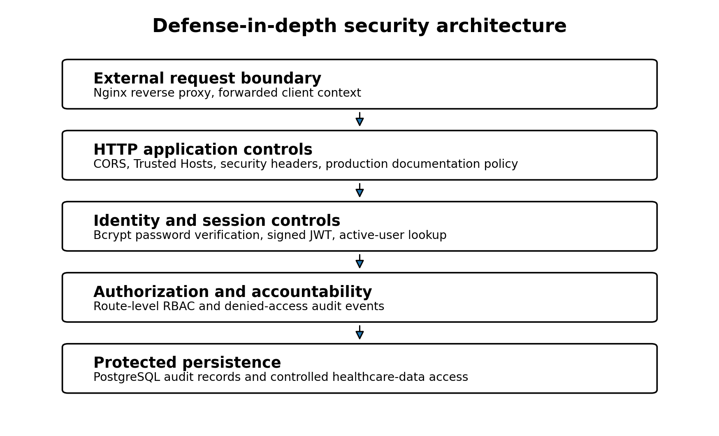
Figure 1. Layered security architecture implemented in the platform.
The outer trust boundary is the HTTP entry point. Requests reaching the FastAPI application are subject to host validation, CORS policy, response-header hardening, authentication dependencies, and route-specific authorization. The persistence boundary contains user identities, roles, and audit records. Object storage is addressed separately by the system implementation and lifecycle validation.

2. Password Protection and Credential Handling

2.1 Password hashing
The security module uses Passlib's CryptContext with the bcrypt scheme. Plaintext passwords are not intended for database persistence. During account creation, the hash_password function rejects passwords shorter than eight characters and returns a bcrypt hash. During login, verify_password compares the supplied plaintext credential with the stored hash.
Control | Implementation | Security effect
Password storage | Bcrypt hash through Passlib CryptContext | Reduces exposure if the user table is disclosed
Minimum length | At least 8 characters | Rejects trivially short credentials
Verification | Constant library-managed hash verification | Avoids direct plaintext comparison
Database field | hashed_password, non-nullable | Prevents normal user records without a stored credential hash

2.2 Review observations
The implemented baseline is technically sound for a prototype, but the supplied source does not show password complexity rules beyond minimum length, breached-password screening, login lockout, password history, password-expiration policy, or multi-factor authentication. These omissions should be described as future hardening requirements rather than silently assumed to exist.

3. JWT Authentication and Authenticated-User Resolution

3.1 Token construction and validation
Access tokens are JSON Web Tokens signed with the configured algorithm and secret key. The token payload contains the subject identifier (sub), issue time (iat), and expiration time (exp). The supplied configuration sets HS256 as the algorithm and a default access-token lifetime of 30 minutes. Token decoding is restricted to the configured algorithm. Invalid or expired tokens are converted into a controlled authentication failure.
JWT element | Implemented value or behavior | Purpose
Subject | User identifier stored in sub | Links the token to a database identity
Issued at | UTC timestamp in iat | Records token issuance time
Expiration | UTC timestamp in exp | Limits token lifetime
Signature | Configured symmetric JWT secret and algorithm | Detects tampering
Validation failure | HTTP 401 through the authentication dependency | Prevents unauthorized endpoint use

3.2 Database-backed identity validation
A successfully decoded token is not treated as sufficient evidence of current authorization. The get_current_user dependency extracts the subject, converts it to a user identifier, retrieves the corresponding User record from PostgreSQL, and verifies that the account remains active. A missing or nonexistent identity produces HTTP 401. An inactive account produces HTTP 403. This design allows administrators to disable access without waiting for all previously issued tokens to expire.
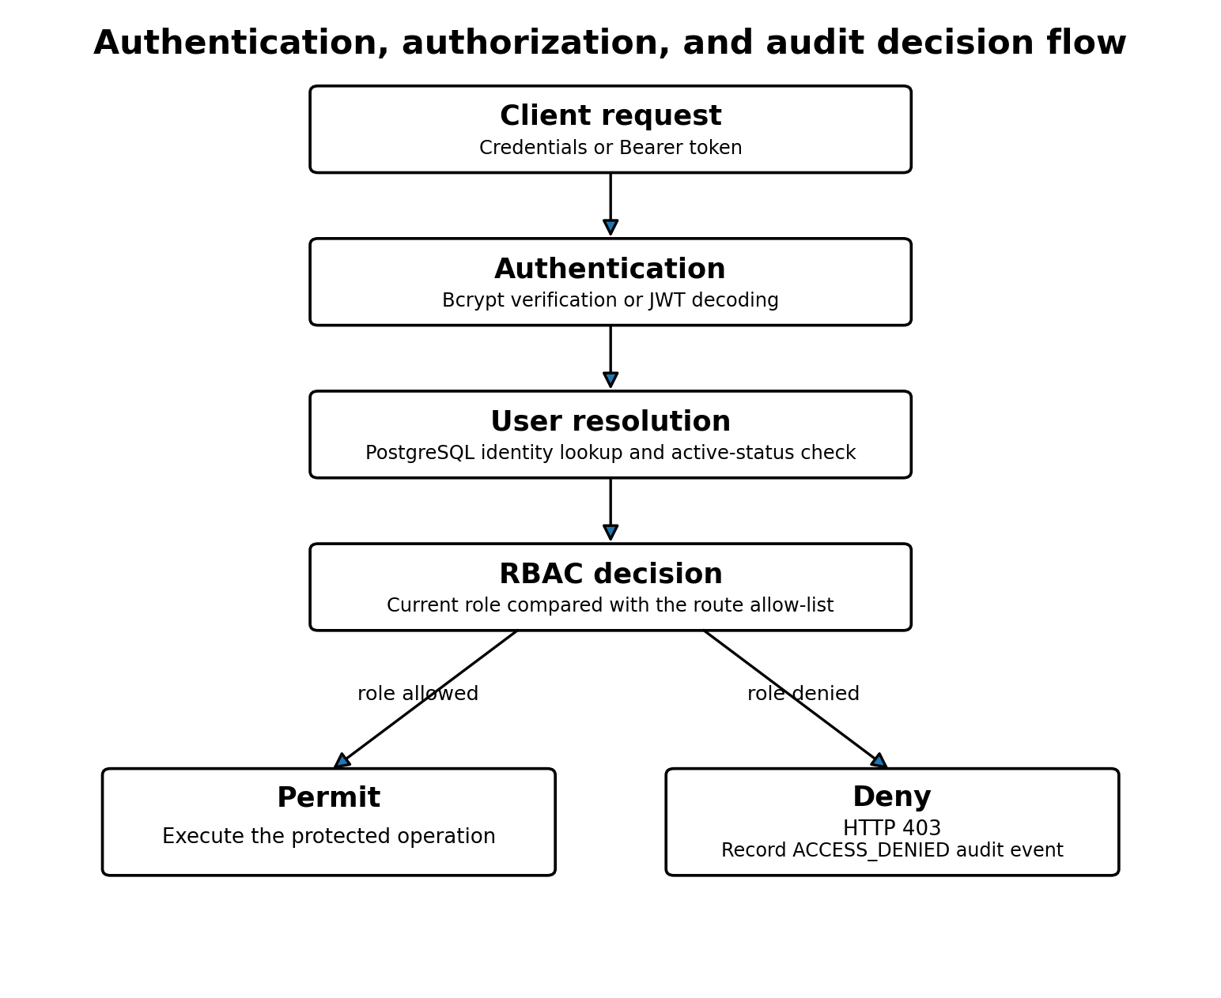
Figure 2. Authentication, user-resolution, authorization, and denial-audit flow.

3.3 Authentication validation results
Test | Expected | Actual | Result
Valid login | 200 | 200 | PASS
Invalid password | 401 | 401 | PASS
Unknown username | 401 | 401 | PASS
Valid JWT on protected endpoint | 200 | 200 | PASS
Missing JWT | 401 | 401 | PASS
Malformed JWT | 401 | 401 | PASS
Tampered JWT signature | 401 | 401 | PASS
Wrong authorization scheme | 401 | 401 | PASS

All eight authentication scenarios passed. Valid login and valid-token access returned HTTP 200. Invalid passwords, unknown usernames, missing tokens, malformed tokens, tampered signatures, and incorrect authorization schemes returned HTTP 401 as expected. The test set therefore covers both positive and representative negative authentication paths.

4. Role-Based Access Control

4.1 Authorization mechanism
Route authorization is implemented through the require_roles dependency factory. Each protected operation declares an explicit set of allowed role names. At request time, the dependency obtains the authenticated user, resolves the linked role, and compares the role name with the allowed set. A mismatch produces HTTP 403 and triggers an ACCESS_DENIED audit event containing the user role, the permitted roles, the endpoint, and request context.
The Role model enforces unique role names, while each User record contains a non-nullable foreign key to a role. This relational design prevents normal authenticated users from existing without a role assignment.

4.2 Endpoint coverage
API module | Inventoried operations
fhir | 8
encounters | 4
patients | 4
observations | 4
prescriptions | 4
diagnostic_reports | 3
auth | 2
fhir_conditions | 2

Role | Operations in which role is permitted
Admin | 29
Doctor | 27
Nurse | 26
Data Manager | 25
Lab Staff | 11
Pharmacist | 11

The inventory contains 31 operations. Twenty-nine healthcare and interoperability operations carry an explicit role set. The two authentication operations, login and current-user retrieval, are marked not_detected in the static RBAC inventory because they are governed by credential or token authentication rather than by a route-specific role list. This distinction should not be misinterpreted as unrestricted anonymous access to the current-user endpoint.

4.3 Least-privilege observations
- Administrative access is the broadest, covering all 29 role-protected operations.
- Doctors and nurses receive broad clinical access, but patient creation and modification exclude doctors.
- Pharmacists are concentrated in prescription and selected FHIR read operations.
- Laboratory staff receive diagnostic-report and observation access but limited prescription access.
- Data managers receive broad data-management and read access but are excluded from selected clinically authoritative writes.

5. Audit Logging and Accountability

5.1 Audit record structure
The AuditLog model records the acting user, action, resource type and identifier, outcome, HTTP method, endpoint, IP address, user agent, structured details, and server-generated timestamp. Composite indexes on user plus creation time and action plus creation time support investigation and chronological analysis.
Audit field | Security relevance
user_id | Associates an event with the acting identity when available
action and outcome | Expresses what occurred and whether it succeeded, failed, or was denied
resource_type and resource_id | Identifies the affected protected object
http_method and endpoint | Links the event to the invoked application operation
ip_address and user_agent | Provides request-origin and client context
details | Stores structured non-sensitive contextual data as JSON text
created_at | Provides a server-side timestamp for chronology

5.2 Safe audit recording
The audit service explicitly states that passwords, JWTs, authorization headers, and file contents must not be included in audit details. The safe_record_event method rolls back an audit transaction and returns None if logging fails, preventing an audit failure from interrupting the primary healthcare operation. This favors service availability, but it also introduces a risk of silent audit gaps. A production enhancement should emit a secondary operational alert or metric whenever an audit write fails.

5.3 Diagnostic-report audit validation
Test | Expected | Actual | Result
Diagnostic report E2E test | exit code 0 | exit code 0 | PASS
New audit records | at least 6 | 6 | PASS
Audit action ACCESS_DENIED | present | present | PASS
Audit action LOGIN_SUCCESS | present | present | PASS
Audit action REPORT_DOWNLOAD | present | present | PASS
Audit action REPORT_READ | present | present | PASS
Audit action REPORT_UPLOAD | present | present | PASS
Diagnostic report audit context | present | present | PASS
Diagnostic report cleanup | 5 | 5 | PASS

The diagnostic-report end-to-end security test created six new audit records and confirmed ACCESS_DENIED, LOGIN_SUCCESS, REPORT_UPLOAD, REPORT_READ, and REPORT_DOWNLOAD actions. It also verified report-specific context and cleanup. All nine checks passed.

6. HTTP and Application-Layer Hardening

6.1 Security headers
The application adds defensive HTTP headers to every response. These controls reduce browser-side content interpretation, framing, referrer disclosure, permission use, caching, and content-loading risks. In production mode, the application also adds Strict-Transport-Security.
Control or test | Expected | Observed | Result
Backend health | HTTP 200 | HTTP 200 | PASS
X-Content-Type-Options | nosniff | nosniff | PASS
X-Frame-Options | DENY | DENY | PASS
Referrer-Policy | no-referrer | no-referrer | PASS
Content-Security-Policy | present | default-src 'none'; frame-ancestors 'none'; base-uri 'none'; form-action 'none' | PASS
Permissions-Policy | present | camera=(), microphone=(), geolocation=() | PASS
Strict-Transport-Security | present | max-age=31536000; includeSubDomains | PASS
Cache-Control | contains no-store | no-store | PASS
Server disclosure | uvicorn not disclosed | absent | PASS
Production route /docs | HTTP 404 | HTTP 404 | PASS
Production route /redoc | HTTP 404 | HTTP 404 | PASS
Production route /openapi.json | HTTP 404 | HTTP 404 | PASS
Trusted CORS origin | http://localhost:3000 | http://localhost:3000 | PASS
Untrusted CORS origin | not allowed | not allowed | PASS
Trusted Host | HTTP 200 | HTTP 200 | PASS
Untrusted Host | HTTP 400 | HTTP 400 | PASS
Development configuration restored | healthy | healthy | PASS

6.2 CORS, Trusted Hosts, and production documentation
CORS is configured as an allow-list rather than a wildcard policy. The validation confirmed that the trusted localhost origin was accepted and an untrusted origin was not allowed. In production, TrustedHostMiddleware restricts accepted Host headers. The trusted host returned HTTP 200, while an untrusted host returned HTTP 400.
Interactive API documentation, ReDoc, and the OpenAPI document are disabled when the application runs in production. The corresponding routes returned HTTP 404 in the security test. This reduces unnecessary production exposure, although operational teams may choose to provide authenticated internal documentation through a separate channel.

6.3 HSTS interpretation
The test confirms the presence of the HSTS header. However, HSTS provides meaningful browser protection only when the application is delivered over HTTPS. The current local deployment uses HTTP on localhost. Consequently, the test establishes correct header configuration, not completed TLS deployment. TLS termination and certificate validation must be retested on the future UESTC or external server.

7. Container and Network Isolation
The production Docker Compose configuration separates an edge network from an internal data network. Nginx is attached only to the edge network. PostgreSQL and MinIO are attached only to the data network, which is declared internal. The backend is the sole service connected to both networks. PostgreSQL and MinIO are not published directly to the host, while Nginx is the only publicly mapped entry point in the local production topology.
Service | Network exposure | Security implication
Nginx | Edge network; host port 8080 mapped to container port 80 | Controlled reverse-proxy entry point
FastAPI backend | Edge and internal data networks; port 8000 exposed only to containers | Mediates all application access to persistence services
PostgreSQL | Internal data network only; no host port mapping | Reduces direct database attack surface
MinIO | Internal data network only; no host port mapping | Prevents direct host or Internet access to object storage

This architecture limits lateral reach from the external boundary. It is not a substitute for database credentials, MinIO credentials, host hardening, patch management, or firewall rules on the future VM, but it provides a defensible default segmentation model.

8. Empirical Security Validation

8.1 Validation design
The evidence set combines static inspection and executable tests. Static inspection maps route operations to allowed roles and identifies the implementation of password hashing, JWT validation, account-state verification, audit recording, and security headers. Executable tests evaluate authentication failure modes, production HTTP behavior, audit-event generation, storage behavior, backup and restore, and optimized load performance.

8.2 Consolidated outcomes
Domain | Validation | Checks | Status
Security | Production HTTP security | 17/17 | PASS
Security | Diagnostic report strict audit | 9/9 | PASS
Storage | Diagnostic report end-to-end storage | 10/10 | PASS
Storage | MinIO service lifecycle | 4/4 | PASS
Disaster recovery | PostgreSQL backup and restore | 19/19 | PASS
Disaster recovery | MinIO backup and restore | 23/23 | PASS
Performance | Optimized 200-user load | 1/1 | PASS

The final matrix contains seven passing validation items and no failed, pending, or review items. According to the project criterion recorded in the matrix, a production-readiness claim is justified only when no item remains in those non-passing states. The platform satisfies that criterion for the tested local production configuration.

9. Critical Appraisal, Limitations, and Recommendations

9.1 Strengths supported by evidence
- Authentication is not accepted solely on token syntax; the linked user must exist and remain active.
- Authorization is declared at route level and denied operations are audited.
- HTTP hardening was tested through positive and negative origin and host scenarios.
- Audit coverage was validated through a diagnostic-report workflow rather than only through unit-level assertions.
- Database and object-storage services are isolated from the host in the production Compose topology.
- The validation matrix is complete, reproducible, and linked to explicit evidence files.

9.2 Limitations that must be reported
- The current results are from a local production-like Docker environment, not from the final public VM.
- The presence of the HSTS header does not demonstrate encrypted transport until HTTPS is configured and tested.
- No multi-factor authentication, account lockout, rate limiting, password breach checking, or password-history mechanism is shown in the supplied source.
- JWT signing uses a symmetric secret. Automated key rotation and centralized secret management are not evidenced.
- The audit model is described as immutable, but the supplied source does not demonstrate database-level prevention of update or deletion.
- safe_record_event protects application availability but can silently lose audit events when the audit write fails.
- No web application firewall, intrusion-detection integration, SIEM forwarding, or automated vulnerability scan is evidenced.
- Passing functional security tests does not establish legal compliance with HIPAA, GDPR, Chinese data-protection law, or any other regulatory framework.

9.3 Prioritized recommendations for the remote deployment
Priority | Recommended action
P1 | Configure a real domain, TLS certificate, HTTPS-only redirection, and then retest HSTS.
P1 | Replace all local secrets with high-entropy production secrets and document a rotation procedure.
P1 | Add firewall rules that expose only SSH, HTTP, and HTTPS, with administrative access restricted where possible.
P1 | Implement rate limiting and login-throttling at Nginx or application level.
P2 | Emit monitoring alerts for failed audit writes and verify audit-retention and tamper-resistance controls.
P2 | Introduce an external encrypted backup destination and periodically test restoration.
P2 | Perform dependency, container-image, and dynamic application security scans against the deployed VM.
P3 | Evaluate multi-factor authentication for privileged and clinical roles.

10. Evidence Traceability and Conclusion
Chapter claim or component | Primary project evidence
Password hashing and JWT | backend/app/core/security.py
Authenticated-user resolution | backend/app/api/dependencies/auth.py
RBAC and denied-access audit | backend/app/api/dependencies/rbac.py
Audit service | backend/app/services/audit_service.py
Audit schema | backend/app/models/audit_log.py
User and role models | backend/app/models/user.py; backend/app/models/role.py
HTTP security validation | tests/security/production_security_results.csv
JWT validation | tests/security/jwt_security_results.csv
RBAC inventory | tests/security/rbac_matrix.csv
Diagnostic-report audit validation | tests/security/diagnostic_report_audit_results.csv
Overall validation status | docs/evidence/final_validation_matrix.md
Network isolation | docker-compose.prod.yml and nginx/default.conf, as documented in the implementation source extract

The Healthcare Cloud Platform implements a coherent defense-in-depth baseline. Bcrypt protects stored credentials, signed JWTs establish short-lived authenticated sessions, PostgreSQL-backed identity resolution supports immediate account deactivation, route-level RBAC enforces explicit professional permissions, and audit records provide accountability for denied and healthcare-data operations. HTTP hardening, origin and host restrictions, documentation suppression, and container network segmentation further reduce exposure.
The supplied evidence demonstrates that the implemented controls behaved as expected in the local production configuration. The result is a validated, cloud-ready security baseline. Final claims about public-cloud security must await deployment to the remote VM, activation of HTTPS, external network testing, and completion of the prioritized hardening measures.

Appendix A. Role-to-Module Access Summary
Module | Operations | Roles represented
auth | 2 | Authentication-dependent; no route-level role list
diagnostic_reports | 3 | Admin, Data Manager, Doctor, Lab Staff, Nurse
encounters | 4 | Admin, Data Manager, Doctor, Lab Staff, Nurse
fhir | 8 | Admin, Data Manager, Doctor, Nurse, Pharmacist
fhir_conditions | 2 | Admin, Data Manager, Doctor, Nurse
observations | 4 | Admin, Data Manager, Doctor, Lab Staff, Nurse
patients | 4 | Admin, Data Manager, Doctor, Lab Staff, Nurse
prescriptions | 4 | Admin, Data Manager, Doctor, Nurse, Pharmacist

Chapter 5. Healthcare Data Model, FHIR Interoperability and Synthea Data Ingestion

Executive Summary
The Healthcare Cloud Platform implements a normalized relational model for patients, encounters, conditions, observations, prescriptions, diagnostic-report metadata, users, roles, and audit logs. Clinical records are stored in PostgreSQL, while binary diagnostic objects are stored privately in MinIO and referenced through bucket, object-key, size, content-type, and SHA-256 metadata.
The supplied validated table inventory contains 117,581 patients, 121,649 encounters, 643,513 conditions, 592,173 observations, and 66,458 prescriptions. Foreign keys preserve core subject, encounter, prescriber, uploader, role, and audit relationships.
The interoperability layer exposes JSON resources named Patient, Encounter, Observation, MedicationRequest, and Condition, together with search bundles, a minimal CapabilityStatement, and a Patient/$everything collection. The implementation is explicitly lightweight and FHIR-inspired. The source does not support a claim of full HL7 FHIR conformance.
The Synthea import pipeline validates required files and headers, imports patients before dependent entities, maps external identifiers to internal keys, performs create-or-update logic, and tracks created, updated, skipped, and skip-reason counts. The uploaded source demonstrates ingestion for patients, encounters, observations, and medications. It does not show the importer that produced the condition records present in the database.
Domain | Implemented evidence | Important qualification
Relational model | Nine application and security entities plus Alembic migration state | SQLAlchemy relationships are mostly represented by foreign keys rather than rich ORM relationships
FHIR surface | Patient, Encounter, Observation, MedicationRequest, Condition and Bundle-like responses | FHIR-inspired JSON, not demonstrated full conformance
Hybrid storage | PostgreSQL metadata plus private MinIO objects and SHA-256 verification | Binary files are not represented through a FHIR Binary or full DiagnosticReport resource
Synthea ingestion | Patients, encounters, observations and medications | Condition ingestion source is absent from the uploaded extract

1. Healthcare Data Architecture
The platform separates structured clinical and security data from binary objects. PostgreSQL is the authoritative store for identifiers, relationships, timestamps, codes, statuses, values, user roles, audit events, and diagnostic-report metadata. MinIO stores the report bytes. The application backend is the only component exposed to clients for report upload and download.
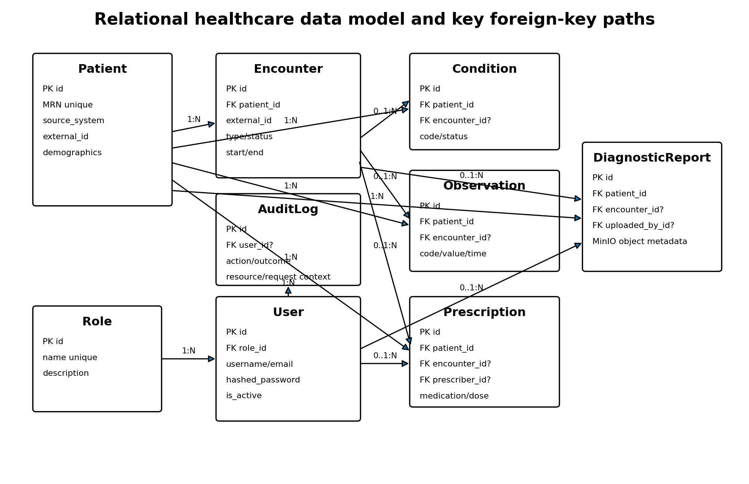
Figure 1. Relational healthcare data model and principal foreign-key paths.
The database design follows a patient-centered structure. Patient is the principal subject entity. Encounters are mandatory children of patients. Conditions, observations, prescriptions, and diagnostic reports are linked to a patient and may optionally reference an encounter. Prescriptions may reference a prescriber, diagnostic reports may reference an uploader, and audit records may reference the user responsible for an event.

2. Core PostgreSQL Clinical Entities

2.1 Patient
The Patient table uses an integer primary key and a globally unique medical record number. The combination of source_system and external_id is also unique, supporting multi-source ingestion without treating external identifiers as globally unique. Demographic fields include name, date of birth, gender, phone, email, address, city, state, postal code, and country.
Patient design element | Implementation
Primary identifier | Integer id
Clinical identifier | Unique medical_record_number
Source identity | Unique pair: source_system + external_id
Demographics | Name, birth date, gender, contact and address fields
Lifecycle metadata | created_at and updated_at

2.2 Encounter
Encounter requires a valid patient_id and records encounter type, status, start time, optional end time, and optional location. API validation prevents an end time earlier than the start time. The source-system and external-identifier pair is unique.

2.3 Condition
Condition records contain patient and optional encounter relationships, code and code-system values, display text, clinical status, optional verification status, onset, abatement, and recorded times. Indexes support searches by patient, code, status, onset time, source system, external identifier, and encounter.

2.4 Observation
Observation supports numeric and textual results. A create request must supply at least one of value_numeric or value_text. Numeric values use Numeric(18,6). The record also supports unit, reference range, category, code, code system, display name, status, observation time, and issue time. A composite patient-and-observed-time index supports chronological patient queries.

2.5 Prescription
Prescription links a medication order to a patient, an optional encounter, and an optional prescriber. It records medication identity, dosage, unit, route, frequency, instructions, status, authored time, and optional treatment dates. Validation requires the end date not to precede the start date and requires a dosage unit whenever a dosage amount is present.
Entity | Validated rows | Key integrity feature
Patients | 117,581 | Unique MRN and source identity
Encounters | 121,649 | Required patient relation
Conditions | 643,513 | Patient plus optional encounter
Observations | 592,173 | Numeric or textual clinical result
Prescriptions | 66,458 | Patient, optional encounter and prescriber

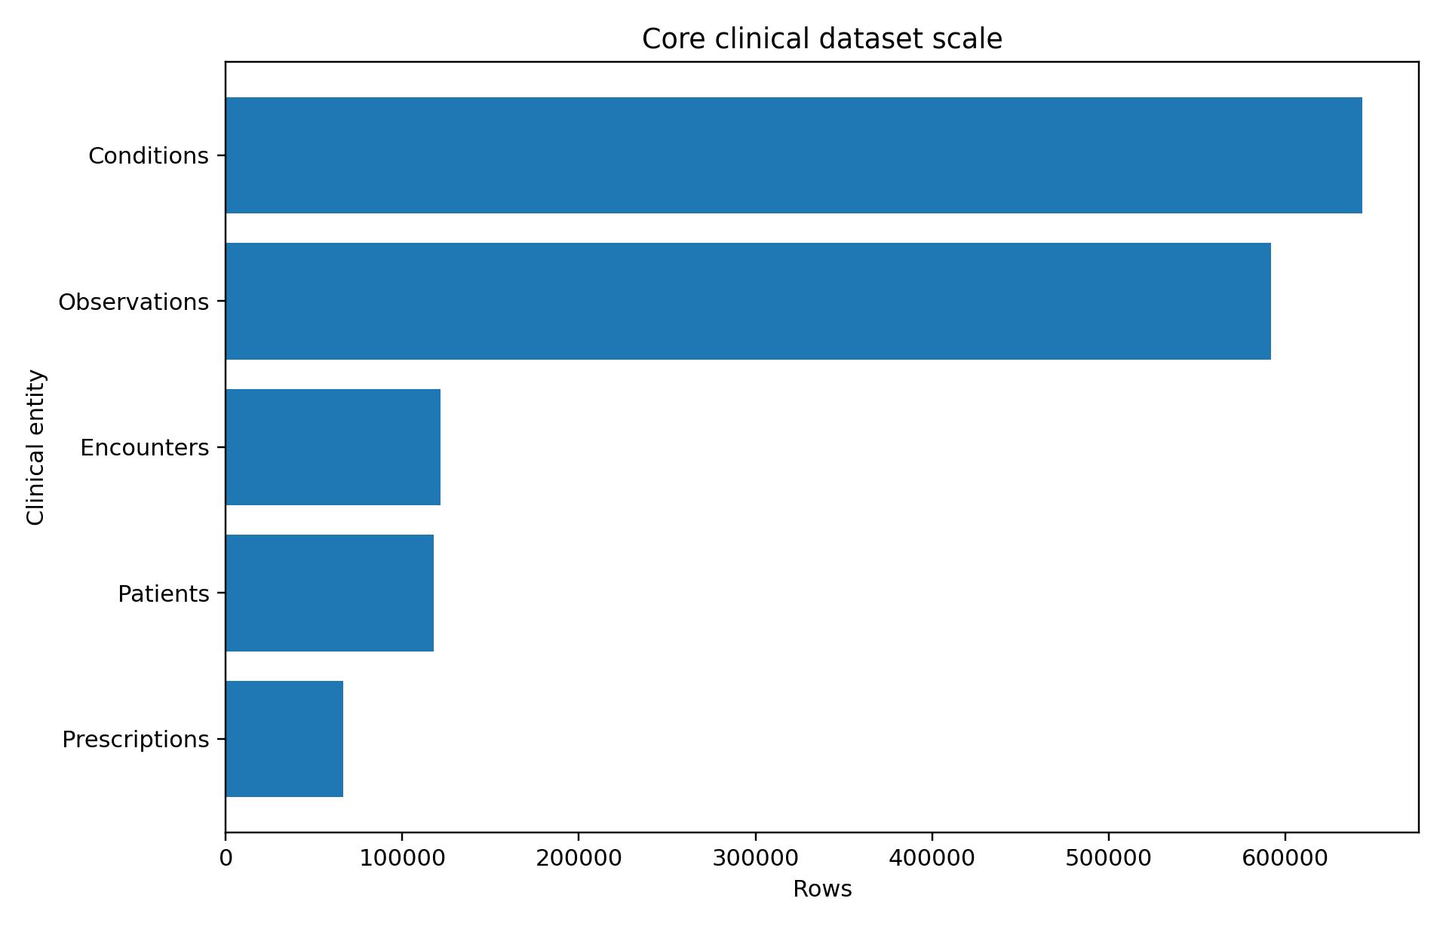
Figure 2. Core clinical dataset scale based on the validated database inventory.

3. Security and Accountability Entities

3.1 Roles and users
Role contains a unique name and optional description. User contains unique username and email fields, a hashed password, an active-state flag, and a mandatory foreign key to Role. The demonstrated design supports the six operational roles used elsewhere in the project.

3.2 Audit logs
AuditLog stores action, outcome, resource type, resource identifier, HTTP method, endpoint, IP address, user agent, details, and creation time. User linkage is optional so that events can still be recorded when a user identity is unavailable. Composite indexes support user-time and action-time investigations.
The model documentation calls audit records immutable, but the uploaded database definition does not show a database trigger, append-only permission model, or update/delete prohibition. Immutability is therefore an intended application property rather than a demonstrated database-enforced guarantee.

4. Hybrid Diagnostic-Report Storage
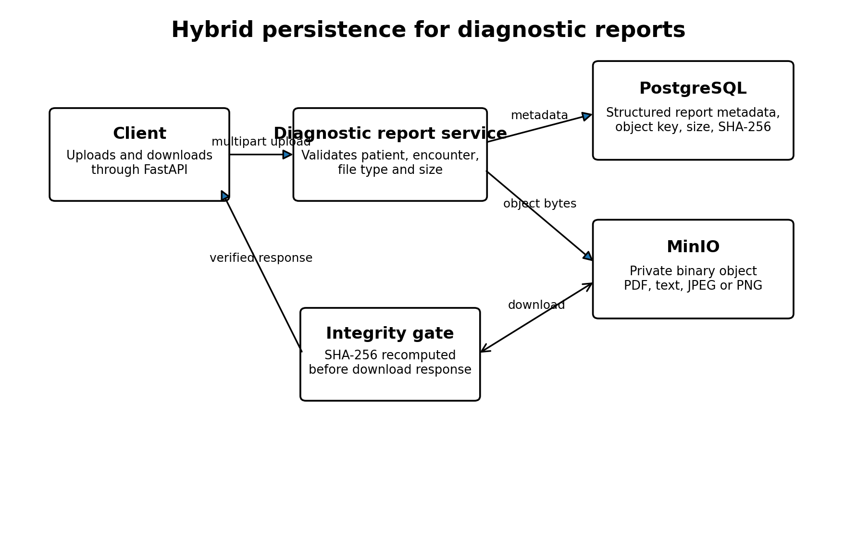
Figure 3. Hybrid persistence for diagnostic-report metadata and binary objects.
DiagnosticReport stores patient, optional encounter, and optional uploader relationships together with report type, status, title, conclusion, issue time, original filename, content type, byte size, and SHA-256 digest. The combination of bucket_name and object_key is unique.
Uploads are restricted to PDF, plain text, JPEG, and PNG, with a 10 MB application-level maximum. The endpoint validates patient and encounter consistency before storage. Downloads pass through the backend, retrieve bytes from private MinIO, recompute SHA-256 when a checksum is stored, and return HTTP 409 if integrity verification fails.
Control | Implementation
Storage separation | Metadata in PostgreSQL; object bytes in MinIO
Object uniqueness | Unique bucket_name + object_key
Allowed content types | PDF, plain text, JPEG and PNG
Maximum application upload size | 10 MB
Download integrity | SHA-256 comparison before response
Client access | Backend-mediated; MinIO remains private

Nginx permits request bodies up to 25 MB, while the application accepts diagnostic files only up to 10 MB. The stricter application limit is authoritative for this endpoint.

5. FHIR-Inspired Resource Representation
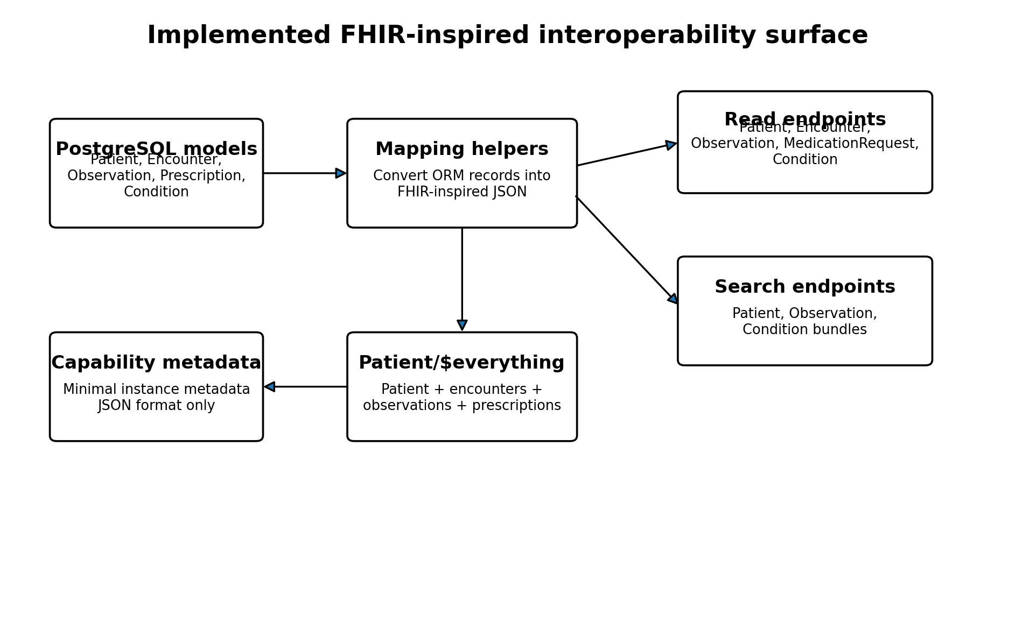
Figure 4. Implemented FHIR-inspired interoperability surface.

5.1 Capability metadata
GET /fhir/metadata returns a JSON object labeled CapabilityStatement with active status, instance kind, software name and version, and JSON format. This provides lightweight discovery but does not enumerate REST resources, interactions, search parameters, security declarations, implementation guides, or FHIR version. It is not sufficient evidence of a conformant FHIR CapabilityStatement.

5.2 Patient resource and search
Patient mapping exposes resourceType, id, identifier, name, gender, and birthDate. Patient search accepts an optional name substring and a maximum _count of 100, returning a searchset-like Bundle. The reported Bundle total equals the number of returned rows rather than the full number of matches because the query does not execute a separate count.

5.3 Encounter, Observation and MedicationRequest
Encounter mapping exposes id, status, and a Patient reference. Observation exposes status, subject, code, and either valueQuantity or valueString. MedicationRequest exposes id, status, subject, medication text, and authoredOn.
These representations omit several fields commonly expected in interoperable implementations. Examples include Encounter class and period, Observation category, effective time and encounter reference, and MedicationRequest intent, requester and dosageInstruction. The omissions reinforce the project's own description of the API as FHIR-inspired rather than fully compliant.

5.4 Condition resources
Condition mapping is more detailed. It includes clinicalStatus coding, optional verificationStatus, coded condition identity, subject, optional encounter, onset, abatement, and recorded date. Search supports patient, code, clinical status and _count. Unlike the Patient and Observation search implementations, Condition search calculates total before limiting the result set.
Endpoint | Purpose | Observed limitation
GET /fhir/metadata | CapabilityStatement-like metadata | Minimal discovery only
GET /fhir/Patient | Name search Bundle | total reports returned count, not all matches
GET /fhir/Patient/{id} | Patient read | Lightweight subset
GET /fhir/Patient/{id}/$everything | Collection Bundle | Excludes Conditions and DiagnosticReports
GET /fhir/Encounter/{id} | Encounter read | Limited resource content
GET /fhir/Observation | Patient/code search Bundle | No full-match count
GET /fhir/Observation/{id} | Observation read | Limited resource content
GET /fhir/MedicationRequest/{id} | MedicationRequest read | No search endpoint in supplied FHIR router
GET /fhir/Condition | Condition search Bundle | Supports patient, code and clinical status
GET /fhir/Condition/{id} | Condition read | Most detailed FHIR-inspired mapping

6. Patient $everything Aggregation
The Patient/$everything endpoint verifies that the patient exists and then assembles one collection Bundle containing the patient, all patient encounters, all patient observations, and all patient prescriptions. Resource entries are appended sequentially, and total equals the number of resources in the collection.
The implementation does not include Condition resources or DiagnosticReport metadata and does not support date filters, pagination, continuation links, or resource-type selection. For large longitudinal records, loading all related rows in one request may also create response-size and query-cost concerns.
Included in current $everything | Not included in current $everything
Patient | Condition
Encounter | DiagnosticReport
Observation | AuditLog
MedicationRequest derived from Prescription | Binary report objects

7. Native REST APIs and Data-Integrity Validation
In addition to the FHIR-inspired read layer, the platform exposes native REST endpoints with Pydantic schemas, pagination, RBAC, audit recording, and domain validation.
Module | Supported operations in supplied source | Key integrity checks
Patients | Create, list, read, partial update | MRN and external-identity conflict handling
Encounters | Create, list, read, partial update | Patient existence and time-range validation
Observations | Create, list, read, partial update | Patient/encounter ownership and value presence
Prescriptions | Create, list, read, partial update | Patient, encounter, prescriber, dosage and date checks
Diagnostic reports | Upload, metadata read, download | File type, size, patient/encounter and SHA-256 checks

These native endpoints contain stronger validation than the FHIR-inspired read surface. For example, observation creation confirms that an encounter belongs to the specified patient, and prescription creation confirms patient, encounter and active prescriber validity.

8. Synthea Data-Ingestion Workflow
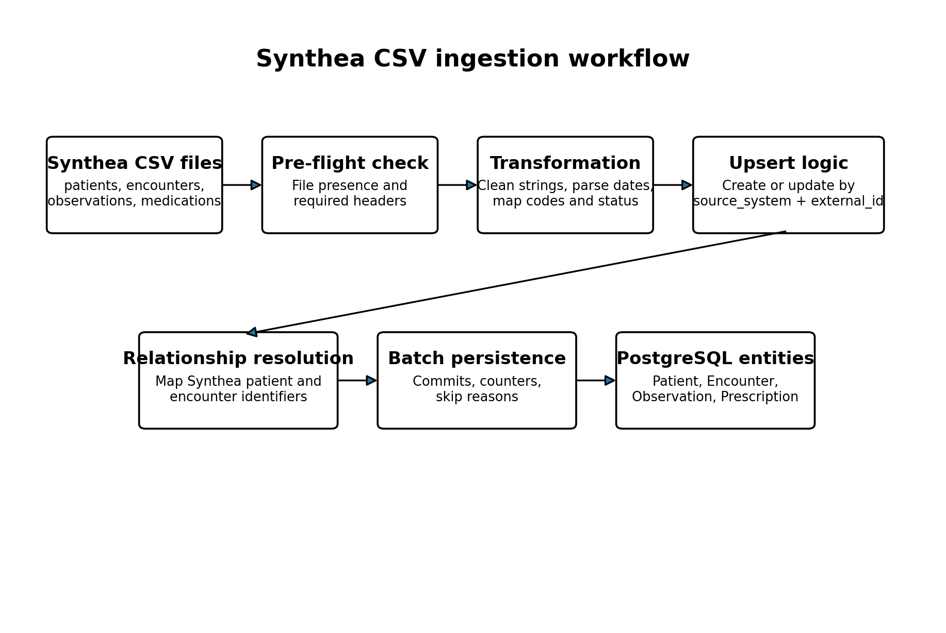
Figure 5. Synthea CSV ingestion workflow.

8.1 Pre-flight validation
The check_synthea_files script expects patients.csv, encounters.csv, observations.csv, and medications.csv. It verifies file presence, required headers, and data-row counts before import.
CSV file | Required source fields shown in the validator
patients.csv | Id, FIRST, LAST, BIRTHDATE, GENDER
encounters.csv | Id, PATIENT, START, ENCOUNTERCLASS
observations.csv | DATE, PATIENT, CODE, DESCRIPTION, VALUE, UNITS
medications.csv | START, PATIENT, CODE, DESCRIPTION

8.2 Import order
The combined pipeline imports patients first, followed by encounters, observations, and medications. This order is necessary because dependent importers resolve patient and encounter external identifiers before creating child records.

8.3 Idempotent source identity
Patient and encounter importers use Synthea identifiers directly as external_id with source_system set to synthea. Observation and medication files do not rely on a single source row identifier. Their importers construct deterministic SHA-256-based identifiers from selected source fields. Existing records with the same source identity are updated rather than duplicated.

8.4 Transformations and batching
Importers normalize optional strings, parse ISO date/time values, convert timezone-aware values to UTC and remove timezone information before persistence, map Synthea gender values, select default coding systems, derive record status, and separate numeric from textual observation values. Observation and medication importers commit in batches of 1,000 processed rows and report skip reasons.

8.5 Conditions ingestion gap
The validated database contains 643,513 Condition rows and the API contains a Condition model and FHIR router. However, the uploaded source does not include a Synthea condition importer or an all-pipeline step for conditions. The chapter therefore cannot attribute those rows to a specific demonstrated ingestion procedure. The missing importer should be documented or added to the evidence set.

9. Database Migration Management
Alembic manages schema evolution. The current recorded revision is 685666386ae6, which adds the conditions table and is marked as head. Earlier migrations shown in the source create patients, encounters, observations, prescriptions, and diagnostic reports.
Revision | Schema contribution
67172335d89c | Patients table
b734f3f99abc | Encounters table
5cda57afee5d | Observations table
dd10de0050e3 | Prescriptions table
f3c250badef9 | Diagnostic reports table
685666386ae6 | Conditions table; current head

The supplied encounter downgrade migration attempts to drop indexes that are not all created in the shown upgrade function. This should be reviewed because a downgrade may fail when an index name is absent. Migration downgrade paths require the same level of testing as upgrade paths.
The base_imports module imports Condition after the __all__ declaration and does not include Condition in __all__. Direct module import still executes the final import, but the organization is inconsistent and should be cleaned to avoid migration-discovery confusion.

10. Interoperability and Data-Quality Limitations
- The resource mappings are intentionally lightweight and do not demonstrate full HL7 FHIR conformance.
- No FHIR version is declared in the minimal CapabilityStatement-like response.
- FHIR resources do not show profiles, meta.profile, narrative text, OperationOutcome responses, or terminology validation.
- Patient and Observation search totals report returned rows rather than all matching rows.
- Patient/$everything omits Conditions and DiagnosticReports and has no pagination or date filtering.
- Diagnostic reports are available only through the native REST API, not as a FHIR DiagnosticReport resource.
- The uploaded source does not demonstrate a Condition ingestion pipeline.
- Timestamps are stored in timezone-capable database columns, while importers convert aware values to UTC and then remove tzinfo before persistence. This behavior should be standardized and tested.
- Source-system uniqueness depends on both source_system and external_id. Null combinations require careful handling because SQL uniqueness semantics may permit multiple null external identifiers.
- Most SQLAlchemy models define foreign keys but do not expose ORM relationship collections for clinical navigation.

11. Recommended Improvements
Priority | Recommended action
P1 | Document the exact FHIR release and explicitly state the supported subset.
P1 | Expand CapabilityStatement content to list resources, interactions, search parameters, formats and security.
P1 | Add Condition and DiagnosticReport to Patient/$everything, with pagination or date bounds.
P1 | Provide and validate the missing Condition ingestion workflow.
P2 | Add a FHIR DiagnosticReport representation and a controlled Binary or attachment retrieval strategy.
P2 | Correct Bundle total behavior and add pagination links for search endpoints.
P2 | Add required or commonly expected fields such as MedicationRequest.intent and Encounter.class/period.
P2 | Standardize UTC timezone persistence and round-trip tests.
P2 | Test all Alembic downgrade paths and correct inconsistent index operations.
P3 | Add terminology validation for LOINC, RxNorm and condition code systems where feasible.
P3 | Add ORM relationships for patient-centered navigation while retaining explicit query controls.
P3 | Create data-quality reports for skipped imports, duplicate source rows and unresolved encounters.

12. Conclusion
The Healthcare Cloud Platform provides a substantial patient-centered data layer with relational integrity, source-aware ingestion, application validation, auditability, and hybrid object storage. The validated database contains 1,541,374 core clinical rows across five major clinical entities.
The Synthea pipeline demonstrates reproducible ingestion for patients, encounters, observations, and medications. Deterministic external identifiers, create-or-update logic, relationship resolution, batch commits, and skip accounting support repeatable imports.
The interoperability layer provides a useful FHIR-inspired read interface but remains a partial mapping. The scientifically accurate claim is that the platform exposes selected FHIR-named resources and Bundle-like responses, not that it is fully FHIR compliant. Addressing CapabilityStatement completeness, missing resource fields, Bundle semantics, $everything coverage, diagnostic-report representation, and the missing condition ingestion evidence would materially strengthen the interoperability contribution.

Appendix A. Validated Table Inventory
Table or entity | Rows | Restore evidence
Patients | 117,581 | 0 difference in supplied restore comparison
Encounters | 121,649 | 0 difference in supplied restore comparison
Conditions | 643,513 | 0 difference in supplied restore comparison
Observations | 592,173 | 0 difference in supplied restore comparison
Prescriptions | 66,458 | 0 difference in supplied restore comparison
Diagnostic reports | 5 | 0 difference in supplied restore comparison
Audit logs | 40,535 | 0 difference in supplied restore comparison
Users | 6 | 0 difference in supplied restore comparison
Roles | 6 | 0 difference in supplied restore comparison

Appendix B. Evidence Traceability
Claim area | Primary source
Clinical models | backend/app/models/patient.py, encounter.py, condition.py, observation.py, prescription.py
Diagnostic-report model | backend/app/models/diagnostic_report.py
Security entities | backend/app/models/user.py, role.py, audit_log.py
FHIR-inspired API | backend/app/api/v1/endpoints/fhir.py and fhir_conditions.py
Native clinical APIs | patients.py, encounters.py, observations.py, prescriptions.py, diagnostic_reports.py
Object storage | backend/app/services/storage_service.py
Synthea pre-flight | backend/app/scripts/check_synthea_files.py
Combined import pipeline | backend/app/scripts/import_synthea_all.py
Importers | backend/app/services/ingestion/synthea_*_importer.py
Migration state | Alembic revisions and 685666386ae6 head
Validated scale | docs/tables/backup_restore_validation.csv

Appendix C. Key Source-Review Findings
Finding | Evidence-based interpretation
FHIR compliance wording | Models and documentation consistently state lightweight FHIR-inspired design without full compliance.
Condition ingestion | Database and API evidence exist, but no importer is included in the supplied source extract.
Patient/$everything | Includes patient, encounters, observations and prescriptions only.
Bundle total inconsistency | Condition search counts all matches; Patient and Observation searches count only returned rows.
Migration hygiene | Encounter downgrade and base_imports organization require review.
Hybrid file integrity | Diagnostic-report download recomputes SHA-256 before returning stored bytes.

Chapter 6. Performance, Scalability and Cost-Efficiency Evaluation

Executive Summary
This chapter evaluates the performance and scalability of the Healthcare Cloud Platform using an authenticated Locust workload. Five scenarios were consolidated: 10, 50, 100, an initial 200-user run, and an optimized 200-user run. The workload exercised the health endpoint and representative FHIR read operations for patients, complete patient records, encounters, and conditions. Each simulated user authenticated once and then reused a bearer token.
The platform completed the 10-user, 50-user, 100-user, and optimized 200-user scenarios with zero failed requests. Throughput increased from 7.94 requests/s at 10 users to 146.77 requests/s at 200 optimized users. The initial 200-user test exposed a severe bottleneck: 357 failures, a 23.99% failure rate, a mean latency of 33,132.66 ms, and throughput of only 5.23 requests/s. After remediation, failures fell to zero, mean latency fell to 29.27 ms, and throughput rose by 141.54 requests/s.
The evidence supports a scalability claim for the measured Docker environment up to 200 concurrent users. It does not support unrestricted extrapolation to other hardware, longer test durations, write-heavy workloads, geographically distributed clients, or a future remote VM. Monetary cost-effectiveness also remains unquantified because verified infrastructure and operational costs were not supplied.
Scenario | Requests | Failures | Mean latency | P95 | RPS
10 users | 465 | 0 | 26.72 ms | 71 ms | 7.94
50 users | 4,557 | 0 | 19.48 ms | 59 ms | 38.35
100 users | 13,695 | 0 | 39.27 ms | 130 ms | 76.46
200 users, initial | 1,488 | 357 | 33,132.66 ms | 90,000 ms | 5.23
200 users, optimized | 43,814 | 0 | 29.27 ms | 110 ms | 146.77

1. Evaluation Objectives
The performance evaluation was designed to determine whether the backend could sustain increasing numbers of authenticated concurrent users while maintaining reliability, bounded response time, and increasing useful throughput. The analysis focuses on five questions:
- Does throughput increase as the number of concurrent users rises?
- Do average and tail latencies remain operationally bounded under successful loads?
- At what tested load does the first major bottleneck appear?
- Does the optimized configuration remove the measured bottleneck?
- What resource and cost-efficiency conclusions are justified by the available evidence?
The principal outcome metric is successful throughput. Raw requests per second can overstate useful capacity when requests fail. For the initial 200-user scenario, reliability-adjusted throughput was 3.98 successful requests/s rather than the raw value of 5.23 requests/s.

2. Experimental Workload and Methodology

2.1 Load-generation framework
Locust was used to model concurrent authenticated API users. Each virtual user executed the on_start routine once, submitted credentials to the login endpoint, retrieved a JWT access token, and attached the bearer token to subsequent requests. A missing load-test password caused the test user to fail immediately, preventing accidental unauthenticated execution.
The simulated think time was uniformly selected between 0.5 and 2.0 seconds. This introduces a more realistic pause between requests than an unbounded tight loop, although it remains a synthetic workload rather than an observational model of actual hospital staff behavior.

2.2 Task composition
Request | Weight | Approx. share | Purpose
GET /health | 1 | 7.14% | Public service-health check
GET /api/v1/fhir/Patient/{id} | 4 | 28.57% | Read a known patient
GET /api/v1/fhir/Patient/{id}/  $everything | 1 | 7.14% | Read aggregated patient record
GET /api/v1/fhir/Encounter/{id} | 2 | 14.29% | Read a known encounter
GET /api/v1/fhir/Condition/{id} | 3 | 21.43% | Read a known condition
GET /api/v1/fhir/Condition  ?patient={id}&_count=20 | 3 | 21.43% | Search patient conditions

The task weights total 14. Patient retrieval is the most frequent operation, while condition retrieval and condition search jointly represent 42.86% of task selections. The workload is therefore read-dominant and FHIR-oriented. It does not measure the same behavior as a write-heavy clinical transaction workload involving report uploads, prescription creation, or concurrent database updates.

2.3 Consolidation procedure
The consolidation script reads Locust CSV files, identifies the aggregated result row, normalizes column names, and extracts request count, failure count, average latency, median latency, P95, P99, and requests per second. The failure rate is calculated as failed requests divided by total requests. The initial and optimized 200-user runs are intentionally retained as separate scenarios so that the original bottleneck and its remediation remain auditable.

3. Consolidated Performance Results
Scenario | Users | Requests | Failures | Failure rate | Avg ms | Median ms | P95 ms | P99 ms | RPS
10 users | 10 | 465 | 0 | 0.00% | 26.72 | 16.00 | 71.00 | 290.00 | 7.94
50 users | 50 | 4557 | 0 | 0.00% | 19.48 | 10.00 | 59.00 | 230.00 | 38.35
100 users | 100 | 13695 | 0 | 0.00% | 39.27 | 15.00 | 130.00 | 450.00 | 76.46
200 users initial | 200 | 1488 | 357 | 23.99% | 33,132.66 | 29,000.00 | 90,000.00 | 91,000.00 | 5.23
200 users optimized | 200 | 43814 | 0 | 0.00% | 29.27 | 13.00 | 110.00 | 240.00 | 146.77

Four scenarios completed without failures. The optimized 200-user run is the strongest validated result, combining the highest tested concurrency with the highest throughput and zero failures. The initial 200-user run is qualitatively different from the other scenarios because latency rose from tens of milliseconds to tens of seconds and failures became substantial.

4. Scaling Behavior at 10, 50, and 100 Users

4.1 Ten concurrent users
At 10 concurrent users, the platform processed 465 requests with no failures. Mean response time was 26.72 ms, median response time was 16 ms, P95 was 71 ms, P99 was 290 ms, and throughput was 7.94 requests/s. This scenario establishes the low-load baseline.

4.2 Fifty concurrent users
At 50 concurrent users, the platform processed 4,557 requests with no failures. Throughput rose to 38.35 requests/s. Mean latency decreased to 19.48 ms and P95 decreased to 59 ms. The lower measured latency relative to the 10-user run does not prove that additional concurrency inherently improves latency. It may reflect run-to-run variation, warm caches, connection reuse, or measurement timing.

4.3 One hundred concurrent users
At 100 concurrent users, 13,695 requests completed with no failures. Throughput reached 76.46 requests/s. Mean response time was 39.27 ms, P95 was 130 ms, and P99 was 450 ms. Compared with the 50-user scenario, throughput approximately doubled while tail latency increased but remained below half a second at P99.
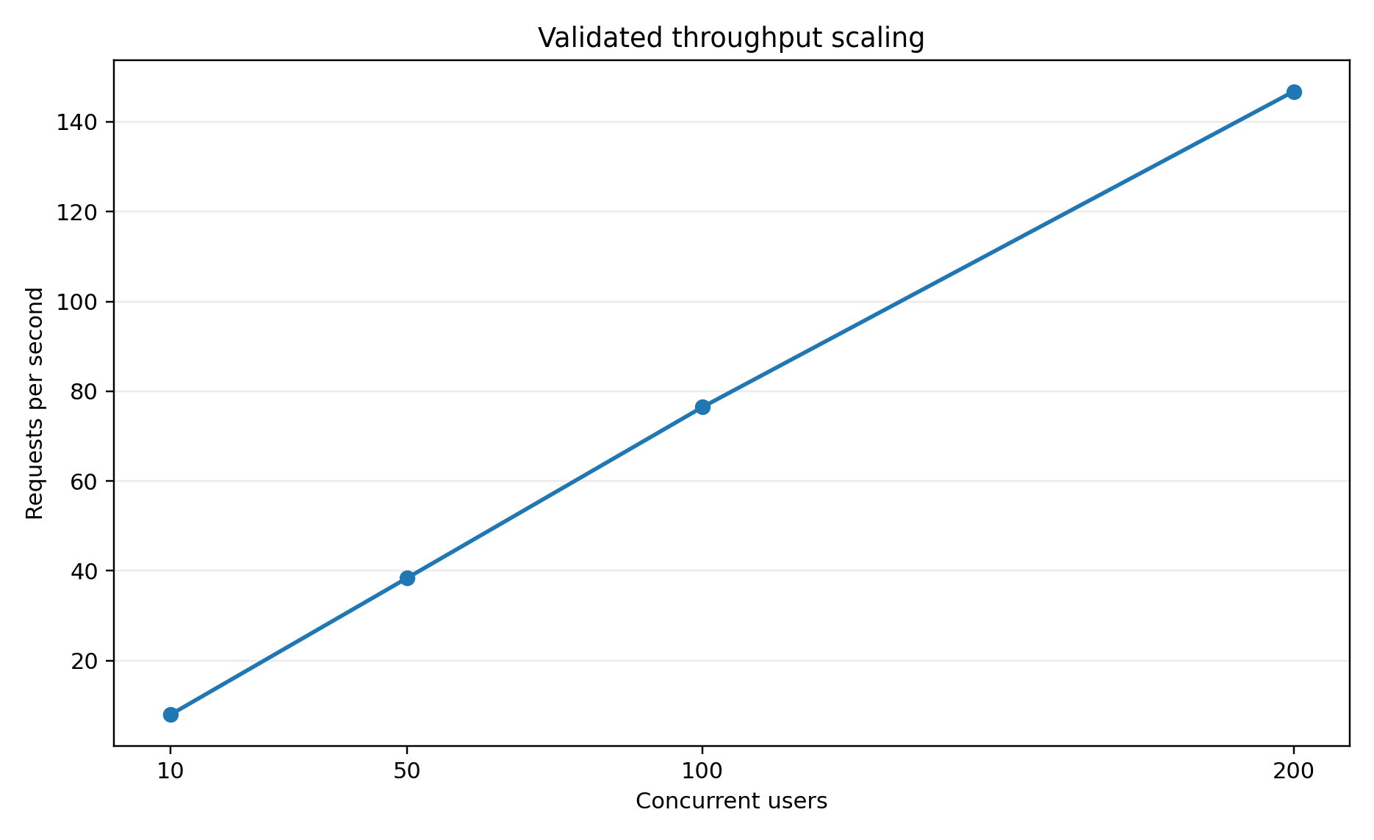
Figure 1. Throughput scaling for all zero-failure scenarios.
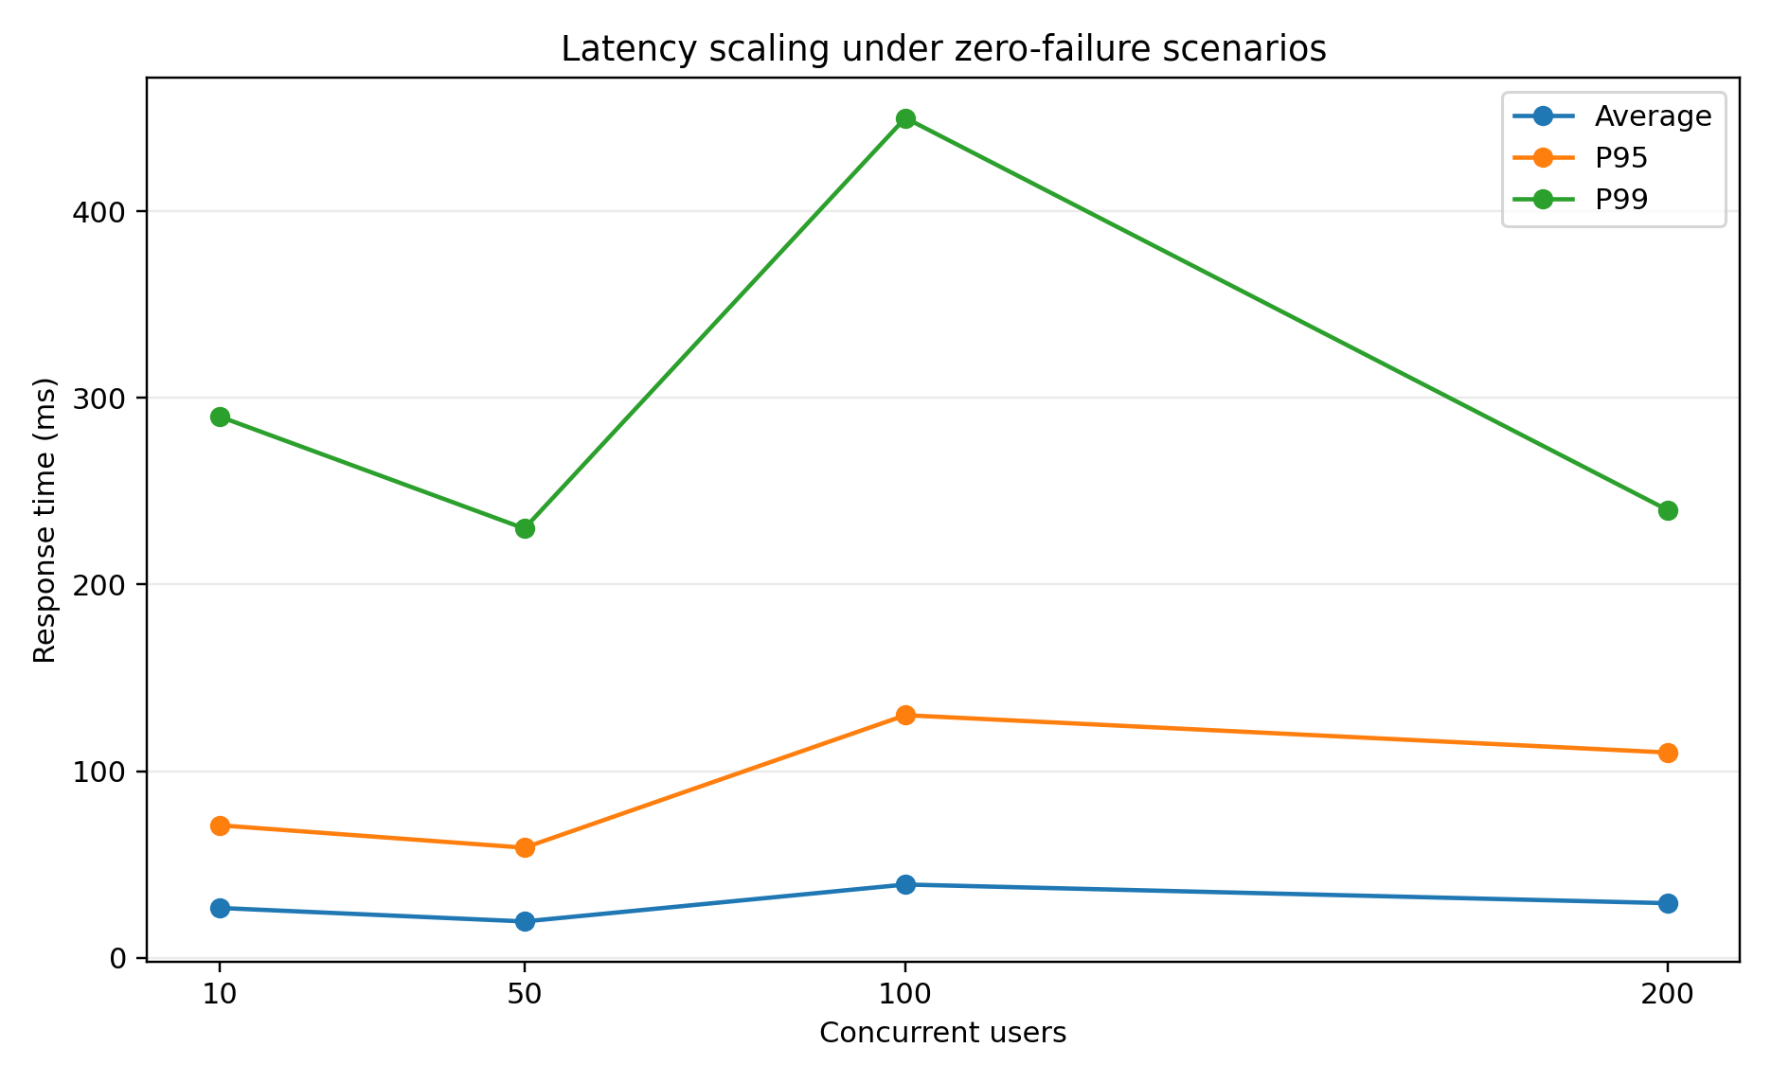
Figure 2. Average, P95, and P99 latency scaling for zero-failure scenarios.

5. Initial 200-User Bottleneck
The first 200-user test exposed a severe loss of capacity. Only 1,488 requests were recorded, 357 failed, and the failure rate reached 23.99%. Mean response time increased to 33,132.66 ms, the median reached 29,000 ms, P95 reached 90,000 ms, and P99 reached 91,000 ms. Raw throughput fell to 5.23 requests/s, below even the 10-user result.
The project evidence identifies this result as an original connection-pool bottleneck. The supplied extract does not document the exact parameter changes used during remediation. Therefore, the chapter treats the bottleneck classification and the before-and-after outcome as supported, but does not attribute the improvement to an undocumented pool size, overflow setting, worker count, or timeout value.
Reliability-adjusted throughput was 3.98 successful requests/s. This value is more informative than the raw 5.23 requests/s because nearly one quarter of requests failed. The latency-adjusted efficiency metric calculated by the project script was only 0.1165, confirming that the run produced little useful work relative to its latency.
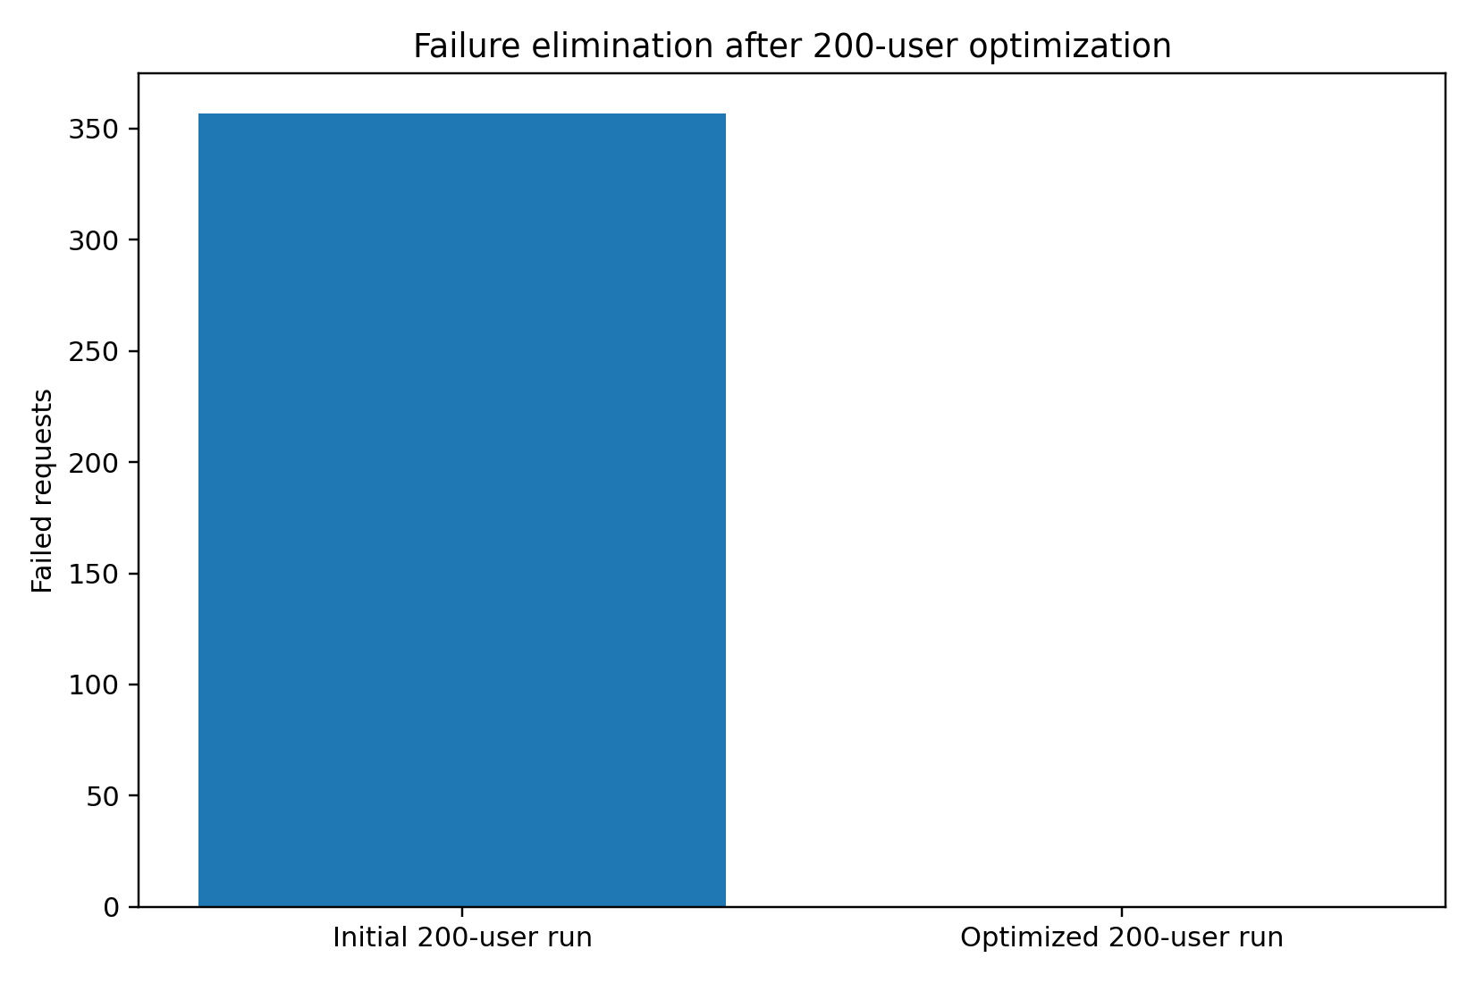
Figure 3. Failed requests before and after remediation at 200 concurrent users.

6. Optimized 200-User Outcome
The optimized 200-user test processed 43,814 requests without a single failure. Throughput reached 146.77 requests/s, mean response time was 29.27 ms, median response time was 13 ms, P95 was 110 ms, and P99 was 240 ms. This result surpassed the lower-load scenarios while retaining zero failures.
Metric | Initial | Optimized | Change
Failed requests | 357 | 0 | -357
Failure rate | 23.99% | 0.00% | -23.99 percentage points
Throughput | 5.23 RPS | 146.77 RPS | +141.54 RPS
Mean latency | 33,132.66 ms | 29.27 ms | 99.91% improvement
P95 latency | 90,000 ms | 110 ms | 99.88% improvement
P99 latency | 91,000 ms | 240 ms | 99.74% improvement

Relative raw-throughput growth was 2706.31%. The resource-analysis script reports a 3,587.69% change for reliability-adjusted throughput because its denominator is successful throughput rather than raw throughput. Both calculations are valid for their stated definitions, but they must not be presented as the same metric.
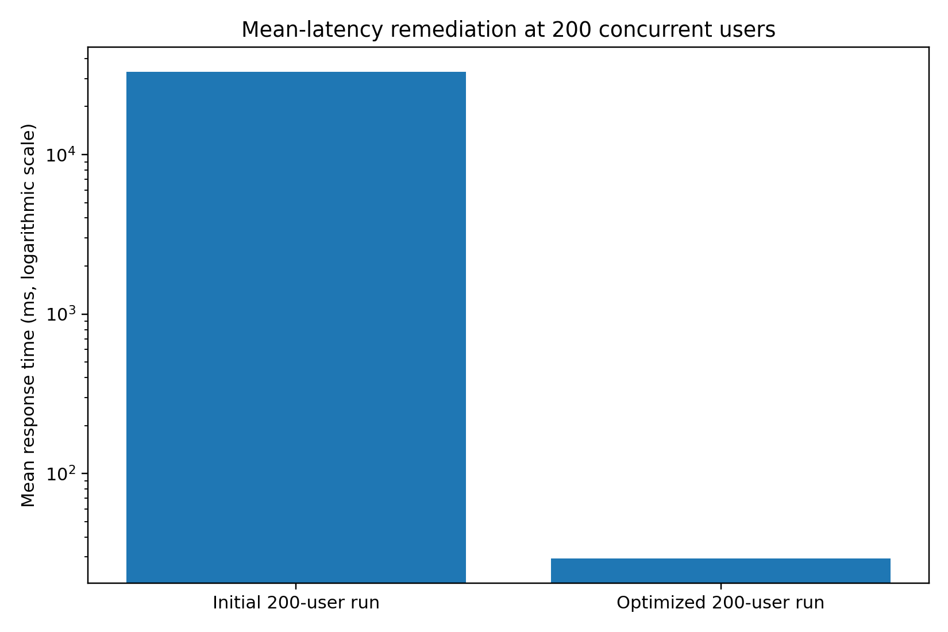
Figure 4. Mean response time before and after remediation. A logarithmic axis is used because the values differ by more than three orders of magnitude.

7. Throughput, Latency, and Reliability Analysis

7.1 Throughput scaling
Across successful scenarios, throughput rose from 7.94 to 38.35, 76.46, and 146.77 requests/s as concurrency increased from 10 to 50, 100, and 200 users. The relationship is broadly proportional over the tested range, although strict linear scalability cannot be claimed without repeated runs, confidence intervals, and a controlled comparison of identical test durations.

7.2 Latency behavior
Mean latency remained between 19.48 and 39.27 ms for all zero-failure scenarios. P95 remained between 59 and 130 ms, while P99 ranged from 230 to 450 ms. The optimized 200-user run produced a lower P99 than the 100-user run. This is a measured result, but it should not be interpreted as a deterministic law of the system because the evidence contains one consolidated result per scenario rather than a distribution across repeated independent experiments.

7.3 Reliability
Reliability was binary across the consolidated scenarios: zero failures at 10, 50, 100, and optimized 200 users, contrasted with 357 failures during the initial 200-user run. This clear discontinuity supports the conclusion that the original problem was configuration- or capacity-related rather than a gradual degradation visible at lower loads.

8. Resource-Efficiency Observations
Scenario | Successful RPS | CPU snapshot % | Memory snapshot MiB | RPS/CPU% | RPS/GiB
10 users | 7.94 | N/A | N/A | N/A | N/A
50 users | 38.35 | 36.66 | 82.59 | 1.0461 | 475.49
100 users | 76.46 | 288.31 | 87.42 | 0.2652 | 895.62
200 users initial | 3.98 | N/A | N/A | N/A | N/A
200 users optimized | 146.77 | 0.35 | 102.10 | 419.3429 | 1472.01

Resource snapshots were available for the 50-user, 100-user, and optimized 200-user scenarios. Memory rose modestly from 82.59 MiB to 87.42 MiB and 102.10 MiB. These values suggest that backend memory consumption remained comparatively small in the recorded snapshots.
The CPU values are not suitable for direct efficiency ranking. The 100-user snapshot reports 288.31%, while the optimized 200-user snapshot reports 0.35%. Docker CPU percentages can exceed 100% on multicore hosts, but the 0.35% value at 146.77 requests/s strongly indicates that the snapshot was not synchronized with a representative steady-state interval. Consequently, the derived value of 419.3429 successful RPS per CPU percentage point must not be used as a headline efficiency claim.
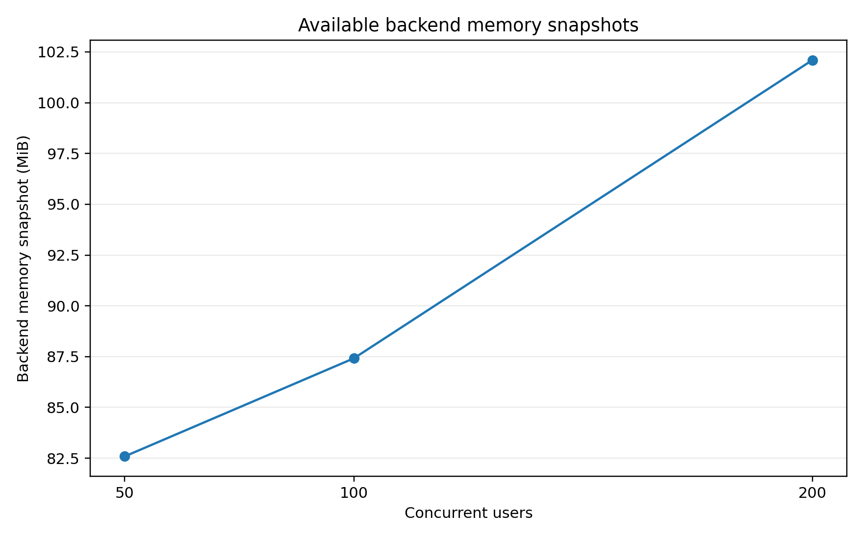
Figure 5. Available backend memory snapshots. The measurements are point-in-time observations, not time-averaged resource profiles.

9. Cost-Efficiency Methodology
The project analysis defines monetary cost-effectiveness as monthly total cost divided by estimated millions of successful requests. The intended formula is:
Cost per million successful requests = Monthly total cost / (Estimated successful monthly requests / 1,000,000)
Monthly total cost should include verified infrastructure and operational costs. Estimated monthly successful requests should be based on a realistic workload profile and utilization factor. The maximum Locust throughput must not be multiplied by every second of a 30-day month unless the deployment is genuinely expected to operate continuously at maximum tested load.
The requested path tests/performance/cost_input_template.csv was missing from the supplied extract. The analysis script is designed to generate the template under tests/performance/results. Regardless of path, the monetary fields were not populated with verified costs. A numerical cost-per-million result would therefore be fabricated and is intentionally not reported.
Model component | Required input
Infrastructure | VM or cloud compute, storage volumes, network transfer, backup storage, domain and certificate services where charged
Operations | Monitoring, maintenance, administration, support, security review, and backup verification
Demand model | Expected active users, request mix, daily operating hours, peak-to-average ratio, and growth allowance
Reliability adjustment | Only successful requests belong in the denominator
Sensitivity analysis | Evaluate conservative, expected, and high-utilization scenarios

10. Limitations and Recommendations

10.1 Limitations
- The results describe one Docker-based environment and do not establish performance on the future UESTC VM.
- The supplied consolidation contains one result per scenario and no repeated-run confidence intervals.
- Test durations and user spawn rates are not included in the extract.
- The workload is read-dominant and uses fixed known resource identifiers.
- Each virtual user authenticates only once, so sustained login pressure is not evaluated.
- The tests do not quantify database query plans, connection-pool occupancy, lock contention, disk I/O, or network latency.
- Resource measurements are point-in-time snapshots and are not synchronized time series.
- No verified monetary inputs are available, so financial cost-effectiveness remains uncalculated.

10.2 Recommended next experiments
Priority | Recommended experiment
P1 | Repeat each load level at least three times and report mean, standard deviation, and confidence intervals.
P1 | Re-run the same workload on the final VM with synchronized CPU, memory, network, disk, and database metrics.
P1 | Record test duration, spawn rate, backend worker count, database pool settings, and host specifications.
P2 | Add write-heavy scenarios for patients, encounters, observations, prescriptions, and diagnostic-report uploads.
P2 | Add mixed-role workloads so that Doctor, Nurse, Lab Staff, Pharmacist, Data Manager, and Admin traffic are represented.
P2 | Perform endurance testing to identify connection leakage, memory growth, and long-term stability problems.
P3 | Populate the cost template with verified deployment prices and evaluate multiple utilization assumptions.

11. Conclusion
The Healthcare Cloud Platform demonstrated reliable scaling from 10 to 200 concurrent users in the tested Docker environment after remediation of the original 200-user bottleneck. The final scenario processed 43,814 requests with zero failures, 146.77 requests/s, a mean response time of 29.27 ms, P95 of 110 ms, and P99 of 240 ms. Relative to the initial 200-user run, 357 failures were eliminated, raw throughput increased by 141.54 requests/s, and mean latency improved by approximately 99.91%.
These results support a measured scalability claim, not an unlimited production-capacity claim. The strongest defensible conclusion is that the optimized local production configuration sustained the tested authenticated, read-dominant workload at 200 concurrent users without failures. Final cloud-deployment conclusions require repeated tests on the remote VM, synchronized resource monitoring, broader workload coverage, and verified cost inputs.

Appendix A. Evidence Traceability
Claim or component | Primary evidence
Consolidated performance metrics | docs/evidence/performance_consolidated_summary.md
Performance CSV | docs/tables/performance_consolidated_summary.csv
Resource and cost analysis | docs/evidence/resource_cost_efficiency_summary.md
Resource-efficiency CSV | docs/tables/resource_cost_efficiency_summary.csv
Locust workload | tests/performance/locustfile.py
Consolidation logic | tests/performance/consolidate_performance_results.py
Resource and cost analysis logic | tests/performance/analyze_resource_cost_efficiency.py
Original result files | locust_10_users_stats.csv; locust_50_users_stats.csv; locust_100_users_stats.csv; locust_200_users_stats.csv; locust_200_users_fixed_stats.csv

Appendix B. Derived Calculations
Metric | Calculation | Result
Initial 200-user reliability-adjusted throughput | 5.23 x (1 - 0.239919) | 3.98 successful RPS
Failed-request reduction | 357 - 0 | 357 requests
Raw-throughput gain | 146.77 - 5.23 | 141.54 RPS
Raw-throughput relative increase | (146.77 / 5.23 - 1) x 100 | 2706.31%
Mean-latency improvement | (33,132.66 - 29.27) / 33,132.66 x 100 | 99.91%
P95 improvement | (90,000 - 110) / 90,000 x 100 | 99.88%
P99 improvement | (91,000 - 240) / 91,000 x 100 | 99.74%

Chapter 7. Backup, Recovery and Data Resilience

Executive Summary
This chapter evaluates the backup, restoration, and data-resilience mechanisms implemented for the Healthcare Cloud Platform. Structured healthcare data are stored in PostgreSQL, while binary diagnostic objects are stored in MinIO. The supplied recovery tests do not merely create backup files. They restore the backups into temporary isolated targets and compare the restored state with the source state.
The current PostgreSQL validation produced a 52,847,810-byte custom archive, recorded SHA-256 digest 2ccded46a6fd14c6ec584bf2bed7fee4c82f37518b5908295ec7184430bbaec3, restored the archive into healthcare_cloud_db_restore_test, verified 10 public tables, 30 constraints, 50 indexes, and exact row counts totaling 1,581,949 rows. All 19 checks passed and the temporary restore database was removed.
The MinIO validation inventoried seven objects totaling 488 bytes, copied each object to a local backup directory, recorded metadata and SHA-256 values, restored the objects into a uniquely named temporary bucket, and reverified object count, total size, per-object size, and per-object checksum. All 23 checks passed and the temporary bucket was removed.
These results demonstrate recoverability for the tested local environment and datasets. They do not establish off-site disaster recovery, encrypted backup retention, point-in-time recovery, defined recovery objectives, or recovery from complete host loss.
Validation | Checks | Scope | Status
PostgreSQL backup and restore | 19/19 | 10 tables; 30 constraints; 50 indexes | PASS
Exact PostgreSQL row comparison | 10/10 tables | 1,581,949 rows matched | PASS
MinIO backup and restore | 23/23 | 7 objects; 488 bytes | PASS
Temporary target cleanup | 2/2 | Database and bucket removed | PASS

1. Resilience Objectives and Data Domains
The recovery design addresses two persistence domains with different data characteristics. PostgreSQL contains relational healthcare records, authentication data, roles, audit records, constraints, indexes, and the Alembic migration state. MinIO contains binary healthcare objects and related object metadata. A complete recovery strategy must protect both domains because restoring only one would produce an inconsistent platform.
- Recoverability: backup artifacts must be readable and restorable into isolated targets.
- Integrity: restored relational rows and binary object hashes must match their sources.
- Completeness: schema objects, tables, object counts, and total object sizes must be verified.
- Isolation: validation must not overwrite the production database or source bucket.
- Cleanup: temporary recovery targets must be removed after validation.
- Evidence: machine-readable CSV files and human-readable summaries must record the result.
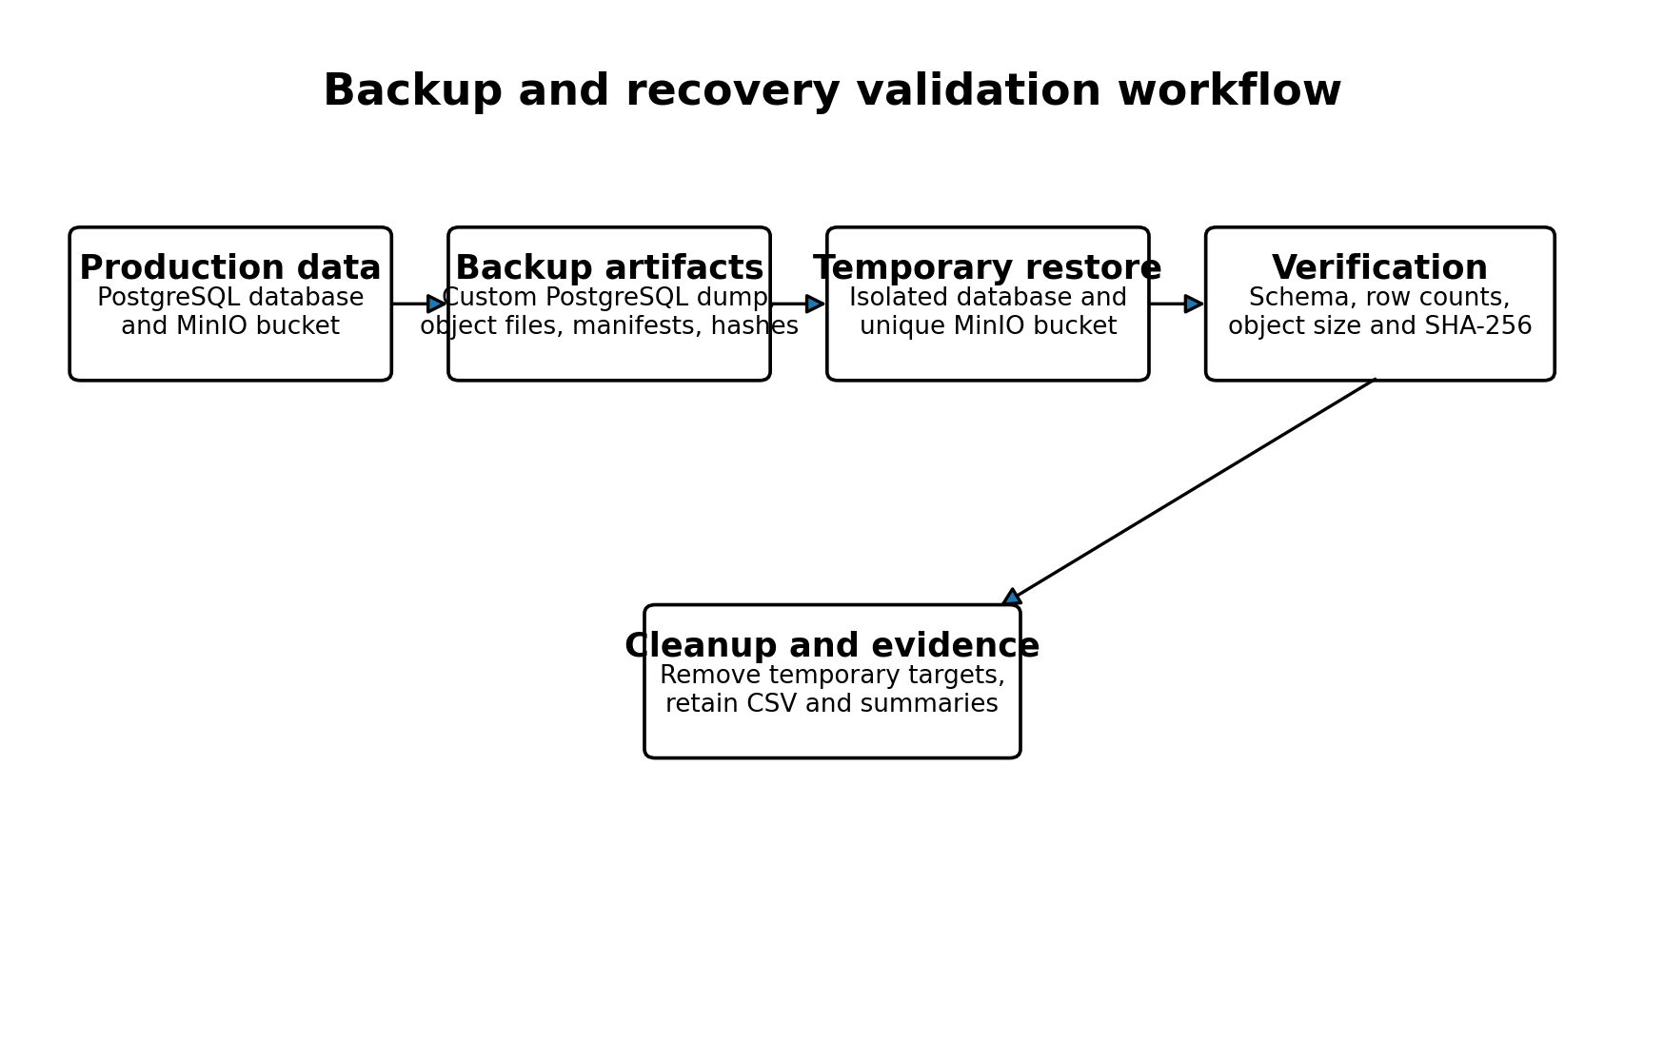
Figure 1. Backup and recovery validation workflow used for PostgreSQL and MinIO.

2. Persistent Storage Architecture
The production Docker Compose configuration assigns PostgreSQL and MinIO separate named volumes: postgres_prod_data and minio_prod_data. The services are attached to an internal data network and are not published directly to the host. The backend is connected to both the edge and data networks and mediates application access to persistence services.
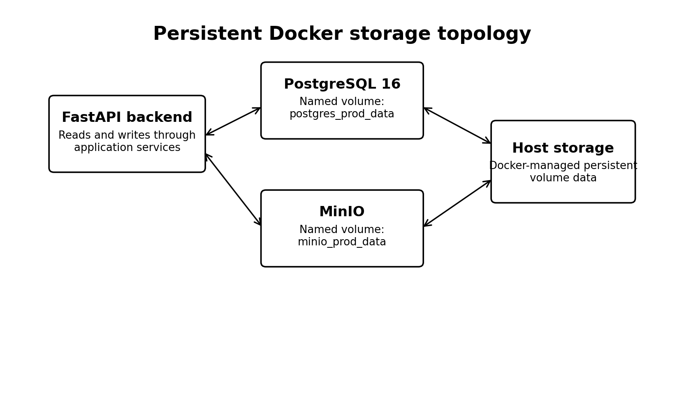
Figure 2. Persistent Docker storage topology.
Named volumes preserve service data across normal container replacement and restart operations. They do not constitute independent backups because volume loss, host failure, administrative deletion, ransomware, or storage corruption can affect both the service and its local volume. The validated logical PostgreSQL dump and MinIO object-copy workflow therefore provide a separate recovery layer.
Service | Persistent volume | Primary contents | Backup form
PostgreSQL | postgres_prod_data | Structured relational records, schema, constraints, indexes | Custom logical dump
MinIO | minio_prod_data | Binary reports and attachments | Object files plus manifest and checksums

3. PostgreSQL Backup Procedure

3.1 Pre-flight validation
The recovery script first confirms that the PostgreSQL container is running. It then queries the source database for the number of public tables, constraints, and indexes. These source values form part of the restoration oracle used later in the test.

3.2 Logical backup creation
The current Python validation invokes pg_dump inside the PostgreSQL container using custom archive format, compression level 6, no ownership statements, and no privilege statements. The archive is created temporarily inside the container and then copied to the host recovery directory.
Setting | Implementation | Reason
Archive format | pg_dump --format=custom | Supports pg_restore and archive inspection
Compression | --compress=6 | Reduces host backup size
Ownership handling | --no-owner | Avoids restoration failures caused by absent source owners
Privilege handling | --no-privileges | Avoids restoring environment-specific grants

3.3 Backup integrity and readability
The validated archive size was 52,847,810 bytes. A SHA-256 digest was calculated over the host archive. The script also used pg_restore --list to confirm that the custom archive was readable before attempting restoration.
2ccded46a6fd14c6ec584bf2bed7fee4c82f37518b5908295ec7184430bbaec3

4. PostgreSQL Restoration and Validation

4.1 Isolated temporary restoration
The script terminates any stale connections to the temporary restore database, removes an earlier test database if present, creates a fresh healthcare_cloud_db_restore_test database, and restores the archive with pg_restore. The --exit-on-error option ensures that restoration stops when a database error occurs.

4.2 Structural verification
Structural element | Source | Restored | Result
Public tables | 10 | 10 | PASS
Constraints | 30 | 30 | PASS
Indexes | 50 | 50 | PASS

Matching row counts alone would not prove that the restored database retained the relational structure needed for correct application behavior. The separate checks for tables, constraints, and indexes therefore strengthen the recovery evidence.

4.3 Exact table-row verification
Table | Source rows | Restored rows | Difference | Result
alembic_version | 1 | 1 | 0 | PASS
audit_logs | 40,557 | 40,557 | 0 | PASS
conditions | 643,513 | 643,513 | 0 | PASS
diagnostic_reports | 5 | 5 | 0 | PASS
encounters | 121,649 | 121,649 | 0 | PASS
observations | 592,173 | 592,173 | 0 | PASS
patients | 117,581 | 117,581 | 0 | PASS
prescriptions | 66,458 | 66,458 | 0 | PASS
roles | 6 | 6 | 0 | PASS
users | 6 | 6 | 0 | PASS

All 10 public tables matched exactly, representing 1,581,949 rows across application, audit, security, and migration tables.
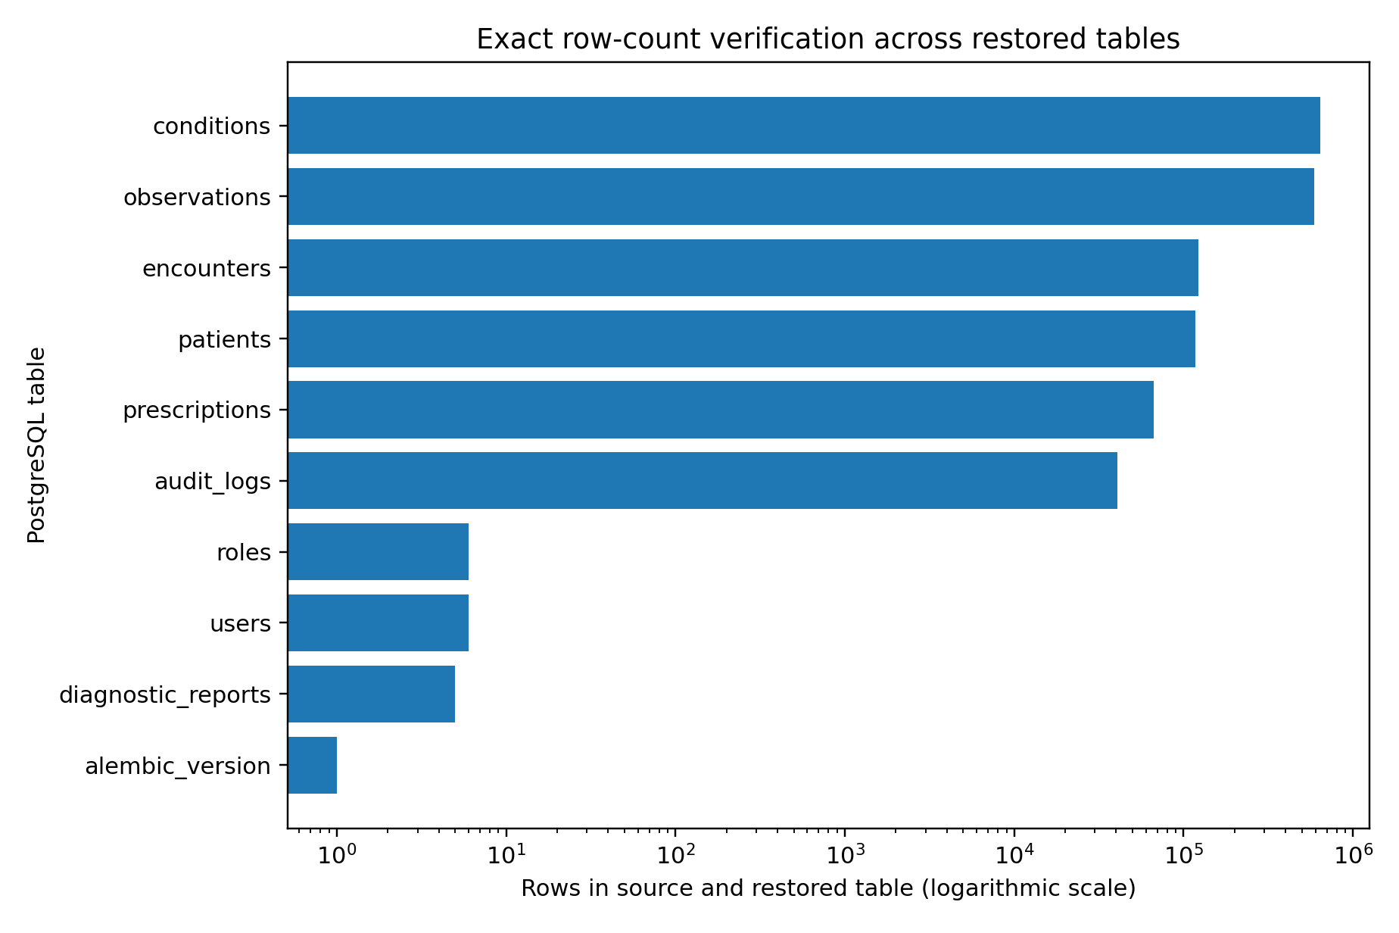
Figure 3. Exact PostgreSQL row-count verification. A logarithmic scale is used because table sizes range from 1 to more than 600,000 rows.

4.4 Cleanup
After validation, the temporary database is dropped and the temporary container archive is removed. The recorded result confirms successful cleanup. Removing recovery targets is important because stale test databases can consume storage, expose copied healthcare data, and interfere with future validation runs.

5. MinIO Backup Procedure

5.1 Source inventory
The MinIO script resolves the configured endpoint and source bucket, verifies that the source bucket exists, and recursively lists all objects. The validated source bucket healthcare-files contained seven objects with a combined size of 488 bytes.

5.2 Local backup representation
Each MinIO object is downloaded to a local backup directory. The local filename is derived from a SHA-256 hash of the object name, while the original object name is preserved in a manifest and CSV inventory. For every object, the backup records local size, SHA-256 content checksum, ETag, content type, and last-modified timestamp when available.
Manifest element | Recorded information
Object identity | Original object name and position
Backup file | Relative local .bin file path
Integrity | SHA-256 digest and byte size
Object metadata | ETag, content type, last-modified timestamp
Backup context | Creation time, endpoint, source bucket, temporary bucket

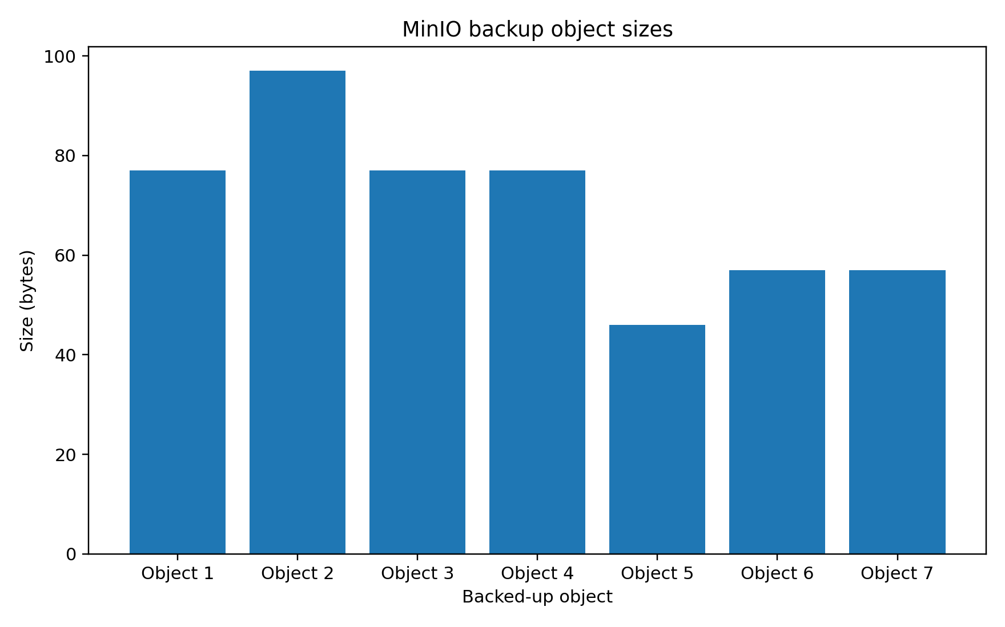
Figure 4. Sizes of the seven MinIO objects included in the validated backup.

6. MinIO Restoration and Object-Integrity Validation

6.1 Temporary bucket creation
A unique temporary bucket name is generated from the source bucket name and a random suffix. If an object with the same temporary bucket name somehow exists, the script removes its objects and bucket before creating a clean restore target. This avoids overwriting the source bucket.

6.2 Object restoration
The script uploads each locally backed-up file to the temporary bucket under its original object name and content type. It then compares the restored object count and aggregate restored size with the backup inventory. Both values matched: seven restored objects and 488 restored bytes.

6.3 Per-object integrity checks
Object | Size | SHA-256 prefix | Result
Object 1 | 77 bytes | 8e13b3b62dcfcd5e... | PASS
Object 2 | 97 bytes | 733a5f7961289e7a... | PASS
Object 3 | 77 bytes | 8e13b3b62dcfcd5e... | PASS
Object 4 | 77 bytes | 8e13b3b62dcfcd5e... | PASS
Object 5 | 46 bytes | 476559fb6977b2b0... | PASS
Object 6 | 57 bytes | 75e916658673c9e2... | PASS
Object 7 | 57 bytes | 75e916658673c9e2... | PASS

For each restored object, the script downloads the restored content, recomputes SHA-256, and verifies both the digest and byte size against the local backup record. All seven restored objects passed.

6.4 Temporary bucket cleanup
The script removes every restored object and then removes the temporary bucket. Cleanup is performed in a finally block so that it is attempted even when another validation step fails. The recorded result confirms successful removal.

7. Consolidated Validation Results
PostgreSQL validation area | Expected | Observed | Result
PostgreSQL container | running | running | PASS
Backup file created | non-empty | 52,847,810 bytes | PASS
Backup SHA-256 | 64 hexadecimal characters | valid digest | PASS
Archive readability | readable pg_restore archive | readable | PASS
Temporary restore | successful | successful | PASS
Public table count | 10 | 10 | PASS
Constraint count | 30 | 30 | PASS
Index count | 50 | 50 | PASS
Exact table rows | 10 matching tables | 10 matching tables | PASS
Temporary database cleanup | removed | removed | PASS

MinIO validation area | Expected | Observed | Result
Source bucket | accessible | present | PASS
Source inventory | completed | 7 objects | PASS
Backup object count | 7 | 7 | PASS
Backup total size | 488 bytes | 488 bytes | PASS
Temporary bucket | created | created | PASS
Restored object count | 7 | 7 | PASS
Restored total size | 488 bytes | 488 bytes | PASS
Per-object integrity | 7 verified | 7 verified | PASS
Temporary bucket cleanup | removed | removed | PASS

The final project validation matrix records PostgreSQL backup and restore as PASS with 19/19 checks and MinIO backup and restore as PASS with 23/23 checks. No failed, pending, or review status remained in the overall matrix.

8. Recovery Limitations and Risk Analysis
- The PostgreSQL and MinIO backups are stored on the same local host used for validation. This does not protect against complete host loss.
- The evidence does not show encryption of backup archives at rest.
- No remote backup repository, immutable storage, or offline backup copy is demonstrated.
- The PostgreSQL method is a full logical backup. Point-in-time recovery through WAL archiving is not implemented in the supplied evidence.
- Recovery time objective (RTO) and recovery point objective (RPO) are not formally defined or measured.
- The MinIO validation sample contains only seven objects totaling 488 bytes, which is sufficient for functional validation but not for large-scale recovery timing.
- The tests validate row counts, schema-object counts, and checksums, but do not perform application-level semantic verification of every restored record.
- Backup retention, rotation, expiration, and periodic scheduling are not documented in the supplied source.
- The earlier evidence files contain an older nine-table PostgreSQL result. This chapter uses the newer detailed 10-table, 19-check validation as the current result.

8.1 Interpretation of the two PostgreSQL summaries
The supplied evidence includes an earlier PostgreSQL summary with nine tables and a 52,847,270-byte archive, and a later detailed result with ten tables and a 52,847,810-byte archive. The later test includes the Alembic migration table, verifies constraints and indexes, reports 19 checks, and confirms cleanup. It is therefore treated as the authoritative current result. The earlier artifact should be retained only as historical validation evidence.

9. Remote Backup and Disaster-Recovery Recommendations
Priority | Recommendation
P1 | Copy PostgreSQL and MinIO backups to a physically or logically separate remote destination.
P1 | Encrypt backup archives and manifests before remote transfer, with keys stored separately.
P1 | Define target RPO and RTO values and measure actual backup and restoration durations.
P1 | Schedule automatic backups and alert when a job, upload, checksum, or restoration test fails.
P2 | Implement backup retention rules with daily, weekly, and monthly generations.
P2 | Evaluate PostgreSQL WAL archiving and point-in-time recovery for lower data-loss exposure.
P2 | Enable MinIO versioning or an equivalent object-version strategy where operationally appropriate.
P2 | Test recovery on the final VM and on a second clean host to demonstrate independence from the source environment.
P3 | Run periodic large-data recovery tests with representative report sizes and object counts.
P3 | Document a recovery runbook with responsible roles, escalation contacts, and acceptance criteria.

9.1 Suggested recovery acceptance criteria
Criterion | Required evidence
Backup success | Archive or object set created, non-empty, and checksum recorded
Restore success | Fresh isolated target created and restoration completed without error
Database completeness | Tables, constraints, indexes, and exact row counts match
Object completeness | Object count, total size, per-object size, and SHA-256 match
Application readiness | Backend starts and representative API queries succeed against the restored environment
Cleanup | Temporary targets removed and sensitive local test copies controlled
Operational evidence | Timestamped manifest, result CSV, summary, and alert status retained

10. Conclusion
The Healthcare Cloud Platform implements and validates two complementary recovery workflows. PostgreSQL recovery uses a compressed custom logical archive, SHA-256 verification, archive readability testing, isolated restoration, structural comparison, exact row-count verification, and cleanup. MinIO recovery uses recursive source inventory, local object copies, manifests, per-object checksums, isolated bucket restoration, count and size comparison, checksum verification, and cleanup.
The current evidence demonstrates exact restoration of 1,581,949 PostgreSQL rows across ten tables and exact restoration of seven MinIO objects. PostgreSQL passed 19 of 19 checks, while MinIO passed 23 of 23 checks. These results justify a local recoverability claim for the measured dataset and configuration.
A complete disaster-recovery claim requires additional controls: remote and encrypted backup copies, scheduled execution, retention rules, defined RPO and RTO targets, recovery timing, point-in-time recovery where required, and validation on a clean remote host. The implemented workflow provides a strong and auditable foundation for those next steps.

Appendix A. Evidence Traceability
Claim or component | Primary evidence
PostgreSQL current summary | docs/evidence/postgres_backup_restore_summary.txt
PostgreSQL test results | tests/recovery/postgres_backup_restore_results.csv
PostgreSQL validation script | tests/recovery/validate_postgres_backup_restore.py
PostgreSQL PowerShell workflow | tests/recovery/validate_postgres_backup_restore.ps1
MinIO current summary | docs/evidence/minio_backup_restore_summary.txt
MinIO test results | tests/recovery/minio_backup_restore_results.csv
MinIO validation script | tests/recovery/validate_minio_backup_restore.py
MinIO wrapper script | tests/recovery/run_minio_recovery_validation.ps1
Recovery finalization | tests/recovery/finalize_disaster_recovery.ps1
Persistent storage configuration | docker-compose.prod.yml
Application object-integrity service | backend/app/services/storage_service.py
Overall validation status | docs/evidence/final_validation_matrix.md

Appendix B. Key Recovery Metrics
Metric | Value
PostgreSQL archive size | 52,847,810 bytes
PostgreSQL SHA-256 | 2ccded46a6fd14c6ec584bf2bed7fee4c82f37518b5908295ec7184430bbaec3
PostgreSQL public tables | 10
PostgreSQL exact rows verified | 1,581,949
PostgreSQL constraints | 30
PostgreSQL indexes | 50
MinIO objects verified | 7
MinIO total size verified | 488 bytes
Total recovery checks | 42
Failed recovery checks | 0

Chapter 8. Cloud Deployment Architecture and Production Readiness

Executive Summary
The Healthcare Cloud Platform has been packaged as a four-service production stack composed of Nginx, a FastAPI backend, PostgreSQL 16, and MinIO. The backend is built from a Python 3.11 slim image and starts Uvicorn with four workers, a five-second keep-alive timeout, and server-header suppression. Nginx is the only service mapped to a host port, exposing localhost port 8080 and forwarding requests to the backend.
The deployment uses two Docker networks. The edge network connects Nginx and the backend. The internal data network connects the backend, PostgreSQL, and MinIO. PostgreSQL and MinIO are not published to the host. Named volumes preserve relational and object-storage data across ordinary container recreation.
The running production snapshot shows all four containers active, with the backend and PostgreSQL reported as healthy. The final project matrix reports seven passing validation domains with no failed, pending, or review items. This supports a local production-readiness claim for the tested Docker environment.
The platform has not yet been deployed as an Internet-facing service on the planned UESTC virtual machine. HTTPS, a production domain, remote firewall policy, remote secret rotation, off-host backups, monitoring, and remote post-deployment testing remain required. The accurate status is therefore cloud-ready, not fully cloud-deployed.
Component | Technology | Deployment state | Observed status
Reverse proxy | Nginx stable-alpine | Host port 8080 to container port 80 | Running
Application | Python 3.11 / FastAPI / Uvicorn | Internal port 8000; 4 workers | Healthy
Database | PostgreSQL 16 | Internal data network; named volume | Healthy
Object storage | MinIO latest image | Internal data network; named volume | Running
Validation | 7 domains | 7 PASS; 0 FAIL; 0 PENDING; 0 REVIEW | PASS

1. Deployment Objectives and Status Terminology
The deployment design aims to provide a reproducible application environment, isolate persistence services from direct external access, preserve data across container recreation, expose a single controlled HTTP entry point, and support automated service readiness and restart behavior.
- Reproducibility: the application image and service topology are declared in version-controlled files.
- Isolation: PostgreSQL and MinIO are restricted to an internal Docker network.
- Availability: health checks and restart policies support service recovery after process or host restart.
- Persistence: named Docker volumes protect data from normal container replacement.
- Traceability: Git history, tags, release artifacts, and validation evidence record the deployed state.

1.1 Distinguishing three deployment states
State | Definition | Project status
Development-ready | Application runs for coding and local debugging | Completed
Local production-ready | Production Compose stack runs with hardening and validation on the local host | Completed and validated
Remote cloud-deployed | Stack runs on a remote VM with domain, TLS, firewall, remote backups, and external validation | Not yet completed

The term cloud-ready is appropriate because the platform is containerized, environment-driven, network-segmented, persistent, health-checked, and versioned. The term cloud-deployed would be premature until the remote VM is available and the stack is installed and validated there.

2. Production Container Architecture
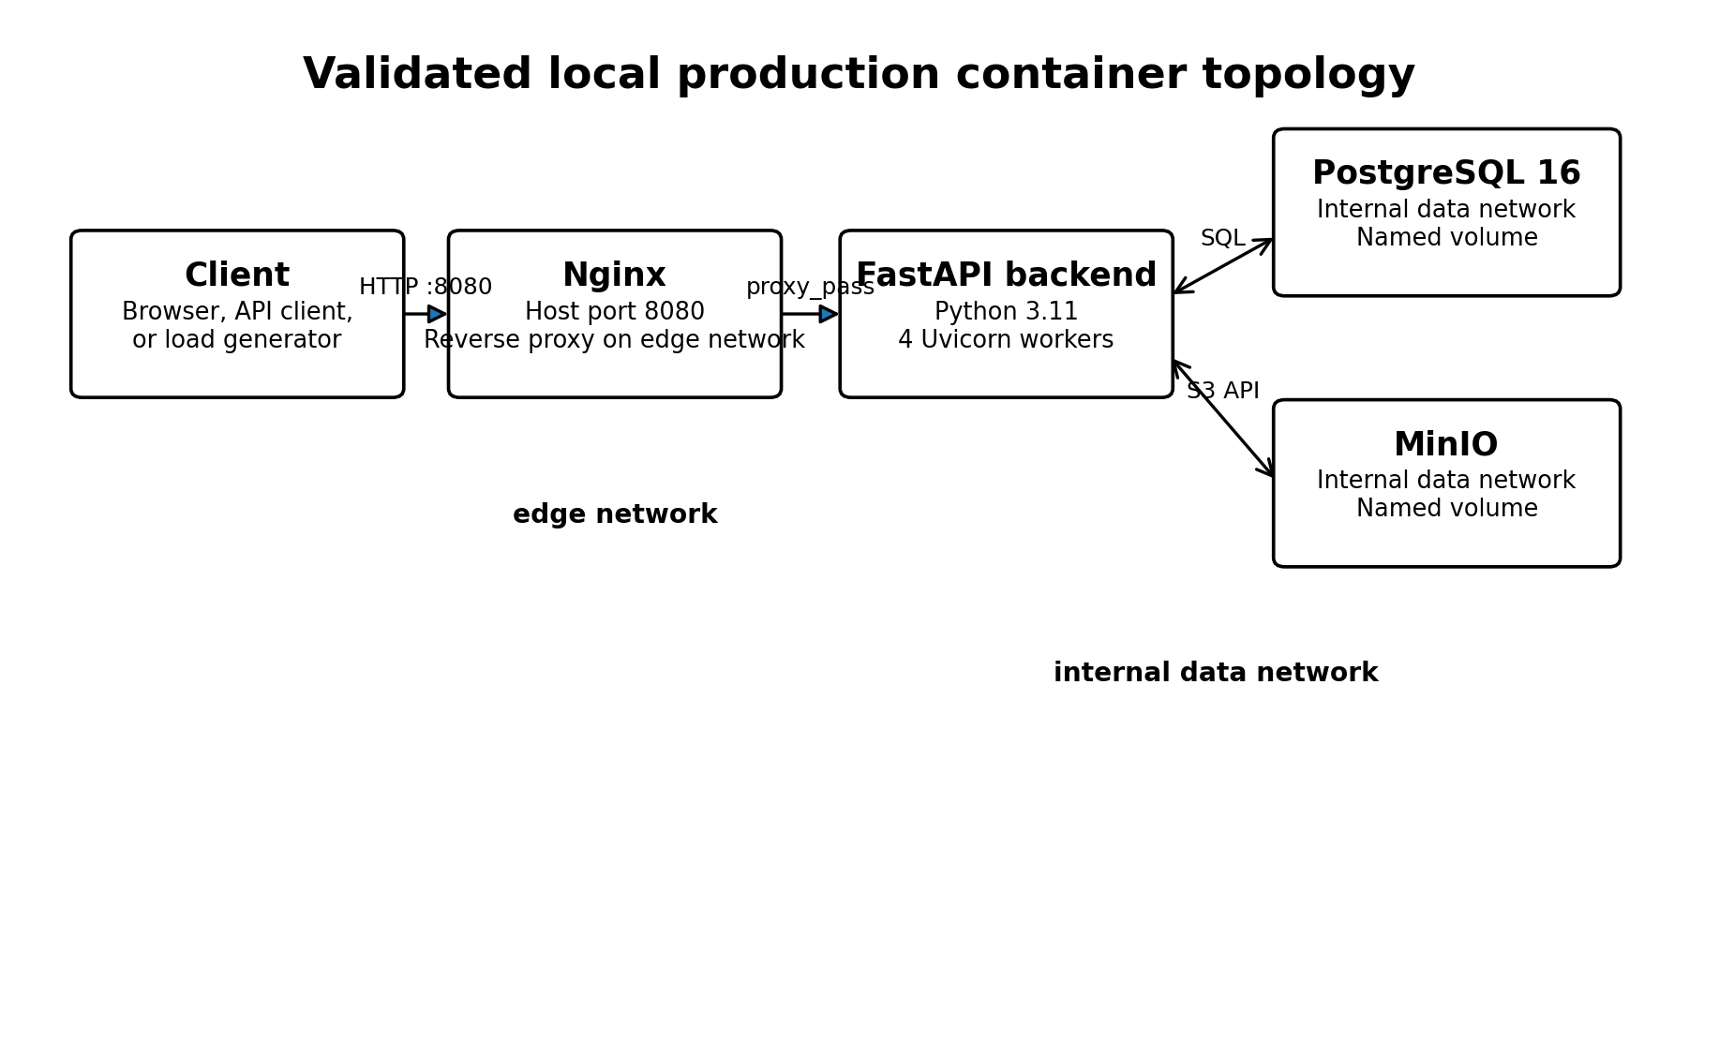
Figure 1. Validated local production container topology.
The Compose file defines four services. Nginx occupies the external boundary, the backend mediates all business logic and persistence access, PostgreSQL stores structured healthcare data, and MinIO stores binary reports and attachments. The architecture deliberately avoids publishing PostgreSQL port 5432 and MinIO port 9000 to the host.
Service | Image | Port exposure | Networks | Function
nginx | nginx:stable-alpine | 8080:80 | edge | Reverse proxy and external entry point
backend | locally built image | 8000 exposed to containers | edge + data | FastAPI application and service mediation
postgres | postgres:16 | No host mapping | data | Relational persistence
minio | minio/minio:latest | No host mapping | data | Binary object storage

3. Nginx Reverse-Proxy Configuration
Nginx listens on container port 80 and accepts any host name through server_name _. It forwards all request paths to backend:8000 using HTTP/1.1. The proxy preserves the original Host header and adds X-Real-IP, X-Forwarded-For, and X-Forwarded-Proto so that the application can record request context and determine the originating protocol.
Control | Configured value | Operational purpose
Client upload limit | 25 MB | Allows diagnostic files while bounding request size
Connection timeout | 10 seconds | Limits backend connection establishment delay
Send timeout | 60 seconds | Bounds time spent transmitting a proxied request
Read timeout | 60 seconds | Bounds time waiting for the backend response
Security headers | nosniff, DENY, no-referrer, restricted permissions | Adds edge-layer browser protections

3.1 Current limitation: HTTP only
The supplied Nginx configuration listens only on HTTP port 80 inside the container, and the local host mapping uses port 8080. No certificate, TLS listener, HTTP-to-HTTPS redirect, or automated certificate renewal is configured. This is acceptable for isolated localhost validation, but not for transmitting healthcare data over an untrusted network.

4. FastAPI Backend Container
The backend image is based on python:3.11-slim. The build installs packages from requirements.txt, copies the application, copies Alembic migration files, and starts Uvicorn directly.
Backend property | Observed configuration
Base image | python:3.11-slim
Application server | Uvicorn
Bind address | 0.0.0.0:8000
Workers | 4
Keep-alive timeout | 5 seconds
Server header | Disabled
Migration artifacts | alembic directory and alembic.ini included
Current Alembic revision | 685666386ae6 (head)

4.1 Dependency packaging
The requirements file includes FastAPI, Uvicorn, SQLAlchemy, psycopg2-binary, Alembic, Pydantic, JWT and password libraries, multipart handling, and the MinIO client. passlib and bcrypt are pinned to explicit versions, while most other packages are not pinned.
Unpinned production dependencies reduce build reproducibility because a later image rebuild may resolve different package versions. A production hardening step should lock all direct and transitive dependencies, record hashes where practical, and scan the resulting image.

4.2 Health check
The backend health check calls http://localhost:8000/health from inside the container every 15 seconds. It allows a 20-second startup period, a seven-second timeout, and five retries. Nginx does not start until the backend becomes healthy.

5. PostgreSQL and MinIO Services

5.1 PostgreSQL
PostgreSQL uses the postgres:16 image and loads its configuration from .env.production. Its data directory is attached to the postgres_prod_data named volume. The health check runs pg_isready against healthcare_cloud_db using healthcare_prod_user every 10 seconds, with five retries and a 10-second startup period.
The database is not exposed through a host port. Only services attached to the internal data network can reach it. This materially reduces the attack surface compared with publishing port 5432 on the VM.

5.2 MinIO
MinIO uses minio/minio:latest and starts the object server on port 9000 with the administrative console configured on port 9001. The minio_prod_data named volume stores persistent objects. The service is attached only to the internal data network and has no host port mapping in the production Compose file.
The use of the latest image tag is a reproducibility and supply-chain risk. A future rebuild can pull a different MinIO version without an explicit change to the repository. The deployment should pin MinIO to a tested immutable version or digest.

6. Networks, Health Checks, and Restart Behavior
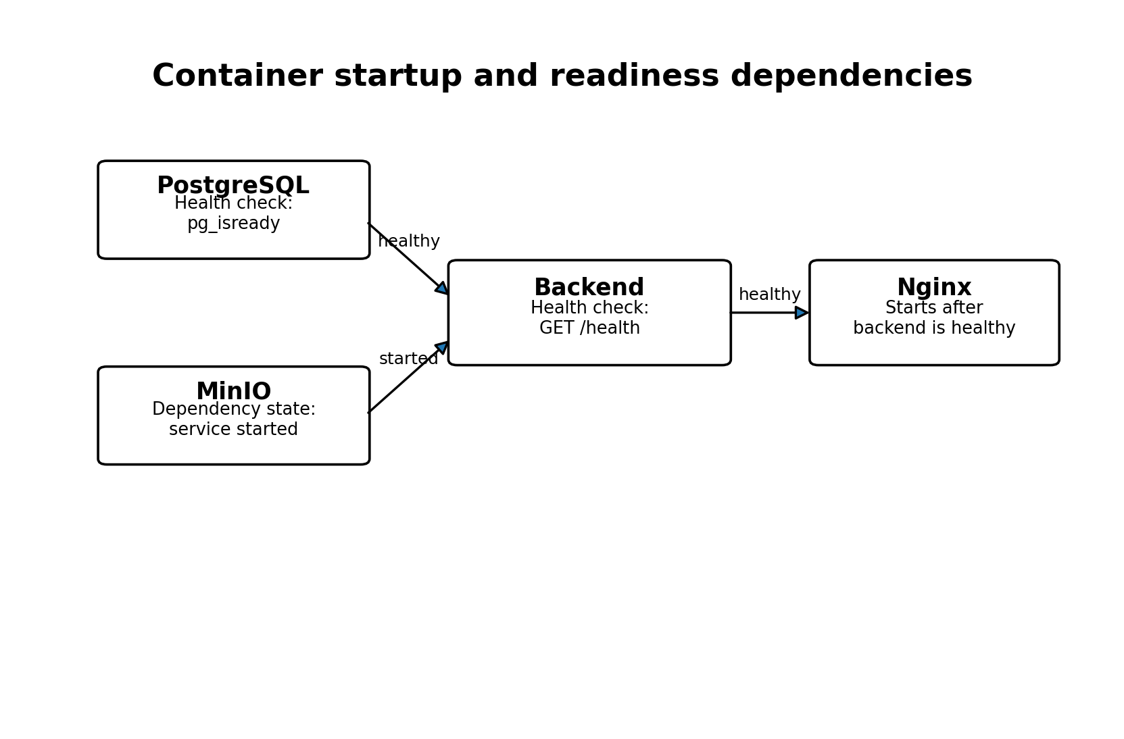
Figure 2. Container startup and readiness dependencies.

6.1 Network segmentation
Network | Connected services | Security purpose
edge | Nginx and backend | External request path
data | Backend, PostgreSQL, MinIO | Internal persistence path
data internal flag | true | Prevents direct external routing to data-network services

6.2 Dependency semantics
The backend waits for PostgreSQL to become healthy and for MinIO to reach the service_started state. Nginx waits for the backend to become healthy. This ordering reduces failed startup attempts. However, service_started is weaker than a MinIO readiness check, so the backend can start before MinIO has been functionally verified.

6.3 Restart policy
All four services use restart: unless-stopped. Docker therefore restarts them after unexpected termination or host restart unless an administrator deliberately stopped the service. This improves basic resilience but does not replace orchestration, alerting, or automated failover.

7. Persistent Storage and Environment Management

7.1 Named volumes
Volume | Container mount | Purpose
postgres_prod_data | /var/lib/postgresql/data | PostgreSQL database cluster
minio_prod_data | /data | MinIO object data

Named volumes preserve data when a container is recreated. They remain local to the Docker host, so independent backup and recovery procedures remain necessary for host-level disaster recovery.

7.2 Production environment file
The production services read .env.production, while the repository includes .env.production.example with placeholders for PostgreSQL, JWT, and MinIO secrets. The example sets APP_ENV=production, APP_DEBUG=false, DOCS_ENABLED=false, a 30-minute JWT lifetime, and explicit CORS and allowed-host values.
Configuration group | Variables represented
Application mode | APP_ENV=production; APP_DEBUG=false
Database | PostgreSQL user, password, database, host, port, and DATABASE_URL
Authentication | JWT secret, algorithm, and token lifetime
Object storage | MinIO endpoint, root credentials, bucket, and secure flag
HTTP policy | Documentation disabled, CORS origins, allowed hosts

7.3 Secret-management limitations
Environment files are appropriate for a controlled prototype, but they are not a dedicated secret management system. The remote deployment should generate new high-entropy values, restrict file permissions, exclude real secret files from Git, and document rotation and incident-response procedures.

7.4 Docker build context
A backend-specific .dockerignore excludes virtual environments, caches, test artifacts, logs, and environment files. A root-level .dockerignore was not present in the supplied evidence. The current backend build context is ./backend, so the backend .dockerignore applies to that image. A root-level ignore file would still be useful for future root-context images and repository hygiene.

8. Version Control and Release Evidence
The repository is hosted on GitHub under rayhanatou-dot/HealthcareCloudPlatform.git. The recorded history includes commits for production Docker isolation, complete validation, evidence organization, architecture documentation, and four thesis chapters.
Commit | Recorded change
5962739 | Add backup recovery and data resilience thesis chapter
e618828 | Add performance scalability and cost efficiency thesis chapter
58d31e8 | Add security architecture and validation thesis chapter
1984233 | Add system design and implementation thesis chapter
bd39e4a | Complete MinIO lifecycle validation and final project verification
202320f | Complete production validation, security, recovery and performance testing
a99d3d3 | Add isolated production Docker configuration

8.1 Tags and release state
Tag | Interpretation
v1.0.0-local-production | Marks the local production release state
validated-platform-2026-07-30 | Marks the validated platform snapshot

The local-production tag is correctly scoped. It does not imply that the release was deployed to a remote public cloud environment.

9. Local Production-Readiness Evidence
The captured production status shows Nginx, backend, PostgreSQL, and MinIO running for approximately eight hours. The backend and PostgreSQL were reported healthy. Nginx exposed host port 8080, while the backend, database, and object store remained internally reachable.
Validation domain | Measured result | Status
Production HTTP security | 17/17 | PASS
Diagnostic report strict audit | 9/9 | PASS
Diagnostic report end-to-end storage | 10/10 | PASS
MinIO service lifecycle | 4/4 | PASS
PostgreSQL backup and restore | 19/19 | PASS
MinIO backup and restore | 23/23 | PASS
Optimized 200-user load | 0 failures; 146.77 RPS; P95 110 ms | PASS

The final matrix reports seven passing domains and no failures, pending items, or review items. This is strong evidence for the local environment. It does not automatically transfer to a new VM because host resources, network latency, operating-system configuration, and external exposure will change.

10. Recommended UESTC VM Profile and Remote Deployment Procedure
The following VM profile is a deployment recommendation derived from the observed architecture and validated workload. It is not a specification supplied by UESTC.
VM property | Recommended profile
Operating system | Ubuntu Server 22.04 LTS or 24.04 LTS
CPU | Minimum 2 vCPU; preferred 4 vCPU for the current four-worker backend
Memory | Minimum 4 GB; preferred 8 GB for database, object storage, proxy, and operating-system headroom
Storage | At least 50 GB persistent disk, increased according to dataset and backup retention
Network | Public IP or institutionally routable address
Inbound ports | 22 for SSH, 80 for certificate provisioning or redirect, 443 for production HTTPS
Privileges | Permission to install and operate Docker Engine and Docker Compose

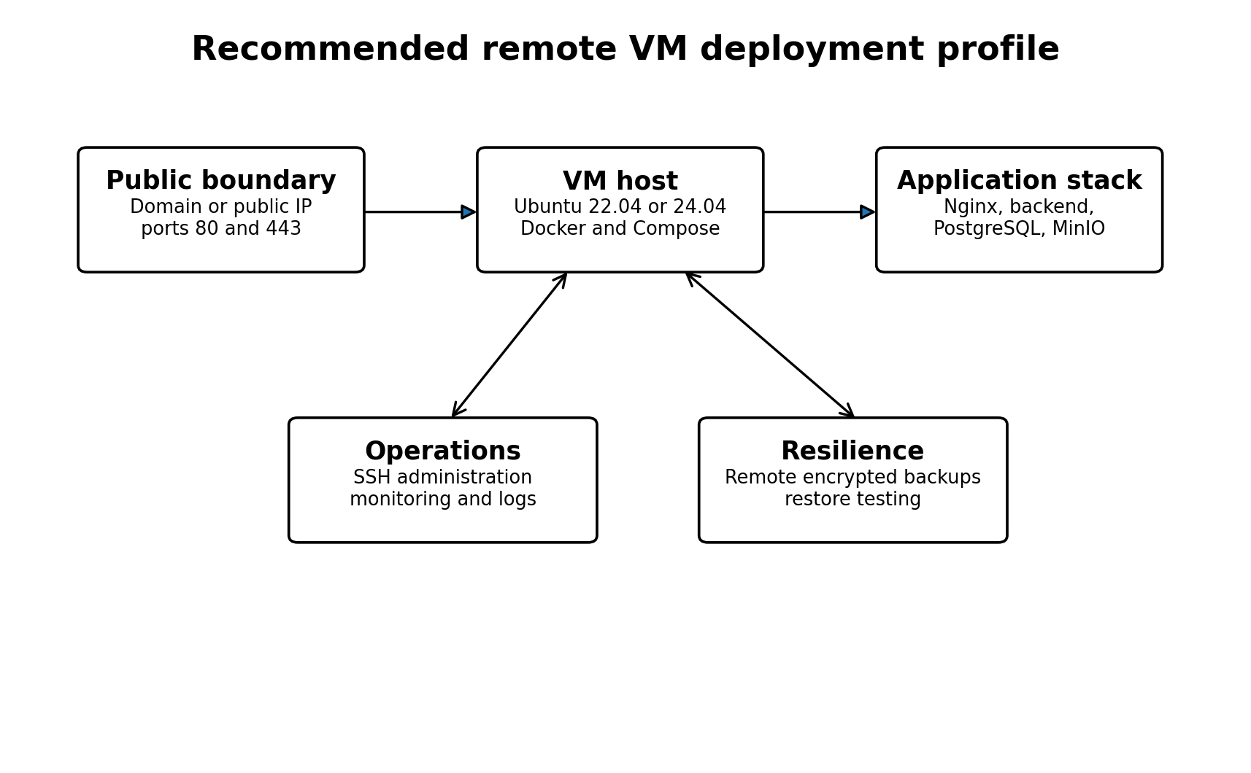
Figure 3. Recommended remote VM deployment profile. Values are proposed engineering requirements, not confirmed UESTC allocations.

10.1 Proposed remote deployment sequence
- Provision the Ubuntu VM, create an administrative account, configure SSH keys, and apply operating-system updates.
- Install Docker Engine and the Docker Compose plugin.
- Clone the GitHub repository at the intended release tag or verified commit.
- Create .env.production from the example file using new production-only secrets.
- Restrict environment-file permissions and verify that it is not tracked by Git.
- Configure DNS to point the selected domain to the VM.
- Replace the local Nginx configuration with an HTTPS configuration and certificate-renewal process.
- Open only required firewall ports and keep PostgreSQL and MinIO unexposed.
- Build and start the Compose stack.
- Run Alembic migrations against the production database before accepting application traffic.
- Create or restore required data and verify the MinIO bucket.
- Repeat security, storage, recovery, and performance tests against the remote endpoint.
- Enable monitoring, log retention, and remote encrypted backups.
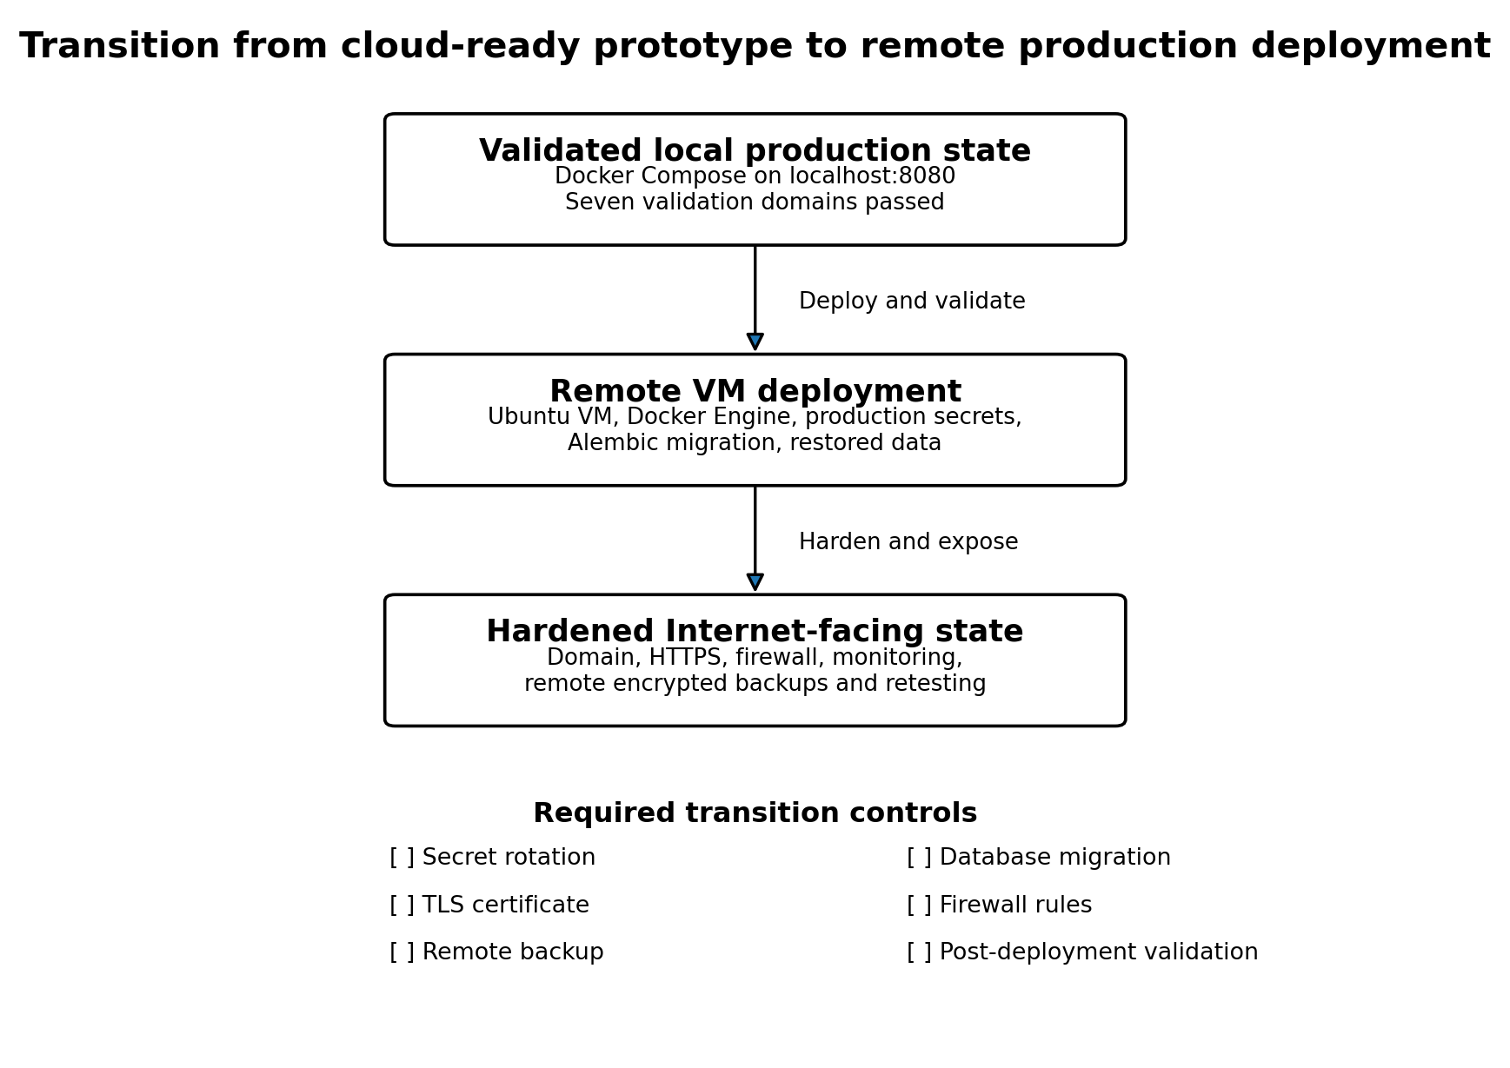
Figure 4. Transition from the validated local environment to a hardened remote deployment.

11. Gaps, Risks, and Hardening Priorities
Priority | Observed gap or risk | Required action
P1 | TLS is absent | Configure HTTPS, redirect HTTP to HTTPS, and verify certificate renewal.
P1 | Production secrets are file-based | Generate new high-entropy secrets, restrict access, and document rotation.
P1 | No remote deployment evidence | Repeat the full validation suite on the UESTC VM.
P1 | No off-host backup in the deployment design | Copy encrypted PostgreSQL and MinIO backups to a separate destination.
P2 | MinIO uses the latest tag | Pin a tested release or immutable image digest.
P2 | Most Python dependencies are unpinned | Generate a locked dependency file and scan the built image.
P2 | No MinIO health check | Add a readiness test and make backend startup depend on it.
P2 | No Nginx health check | Add a proxy-level health check for operational monitoring.
P2 | No declared CPU or memory limits | Measure remote usage and define appropriate container constraints.
P2 | No separate migration job | Run Alembic explicitly as a controlled deployment step.
P3 | No centralized logging or alerting | Forward logs and create alerts for health, security, backup, and capacity events.
P3 | Single-host architecture | Document recovery procedures and evaluate high availability if service requirements demand it.

11.1 Additional source-quality observations
- The saved production container inventory contains character-encoding corruption in truncated command text. Regenerate it with UTF-8 output before using it as a thesis figure or appendix.
- The development example environment file contains duplicated MinIO comments and duplicate MINIO_CONSOLE_PORT entries. Remove the duplicates to improve configuration clarity.
- The production Compose file uses an explicit project invocation during validation, which is appropriate. The same project name should be documented and reused on the remote VM.
- The source evidence includes production security scripts that temporarily switch environment mode and then restore it. Remote testing should avoid modifying live configuration without a maintenance procedure.

12. Conclusion
The Healthcare Cloud Platform has a coherent and validated local production architecture. The four-service Docker Compose stack separates the external request boundary from internal persistence, uses named volumes, applies service dependencies and health checks, suppresses direct exposure of PostgreSQL and MinIO, and records its release state through Git commits and tags.
The final local validation matrix reports seven passing domains with no unresolved items. The backend and PostgreSQL were healthy, all four containers were running, recovery tests passed, security controls passed, and the optimized 200-user workload completed with zero failures.
The remaining work is deployment hardening rather than core application construction. The platform must still be installed on the remote UESTC VM, configured with new secrets, protected by TLS and firewall rules, connected to remote backups and monitoring, and retested under the remote host and network conditions. Until those steps are completed, the scientifically accurate conclusion is that the platform is locally production-ready and cloud-ready, but not yet publicly cloud-deployed.

Appendix A. Evidence Traceability
Claim or component | Primary evidence
Production topology | docker-compose.prod.yml
Backend image | backend/Dockerfile
Python dependencies | backend/requirements.txt
Reverse proxy | nginx/default.conf
Build exclusions | backend/.dockerignore
Environment templates | .env.example and .env.production.example
Service inventory | docs/02_implementation/docker_services.txt
Container snapshot | docs/02_implementation/production_containers.txt
Database migration state | docs/02_implementation/alembic_current.txt
Overall project status | docs/evidence/final_project_status.txt
Validation matrix | docs/evidence/final_validation_matrix.md
Repository history | git log output in cloud deployment source extract
Release tags | v1.0.0-local-production and validated-platform-2026-07-30

Appendix B. Deployment Acceptance Checklist
Acceptance area | Required evidence
Source version | Release tag or commit recorded
Secrets | New remote-only secrets generated and protected
Database | PostgreSQL healthy and Alembic at expected head
Object storage | MinIO healthy, bucket accessible, lifecycle test passed
Proxy | Nginx healthy, domain correct, request-size and timeout policy reviewed
Transport security | Valid HTTPS certificate, redirect active, HSTS verified over HTTPS
Network | Only required ports exposed; data services remain internal
Recovery | Remote backup completed and restoration test passed
Security | Production HTTP, JWT, RBAC, and audit validations passed
Performance | Remote baseline and target-load tests passed
Monitoring | Health, logs, capacity, security, and backup alerts active

Chapter 9. Integrated Validation Results and Discussion

Executive Summary
This chapter integrates the final validation evidence for the Healthcare Cloud Platform. Seven validations were assessed across security, storage, disaster recovery, and performance. The matrix records 83 passing checks out of 83, with no failed, pending, or review status.
Production HTTP validation passed 17 of 17 checks, including backend health, browser security headers, disabled production documentation routes, CORS behavior, trusted-host enforcement, and restoration of the development configuration. Diagnostic-report audit validation passed 9 of 9 checks.
Storage validation demonstrated authorized upload, metadata persistence, PostgreSQL checksum and file-size accuracy, MinIO object integrity, authorized download, unauthenticated rejection, role-based denial, and cleanup. PostgreSQL recovery passed 19 of 19 checks and MinIO recovery passed 23 of 23 checks.
The optimized 200-user workload completed 43,814 requests with no failures, 146.77 requests per second, mean latency of 29.27 ms, P95 of 110 ms, and P99 of 240 ms. This result followed an initial 200-user test with 357 failures and a 23.99% failure rate.
The evidence supports a local production-readiness claim for the measured Docker environment. It does not establish public cloud deployment, full regulatory compliance, Internet-facing TLS readiness, long-duration availability, point-in-time recovery, or financial cost-effectiveness.
Domain | Passed | Total | Integrated interpretation | Status
Security | 26 | 26 | HTTP controls and strict audit | PASS
Storage | 14 | 14 | End-to-end report storage and MinIO lifecycle | PASS
Disaster recovery | 42 | 42 | PostgreSQL and MinIO restoration | PASS
Performance | 1 | 1 | Optimized 200-user load | PASS

1. Integrated Evaluation Framework
The evaluation treats production readiness as a cross-domain property. A platform cannot be considered ready merely because its API responds, its containers run, or its load test succeeds. Security, integrity, recoverability, and performance must operate together.
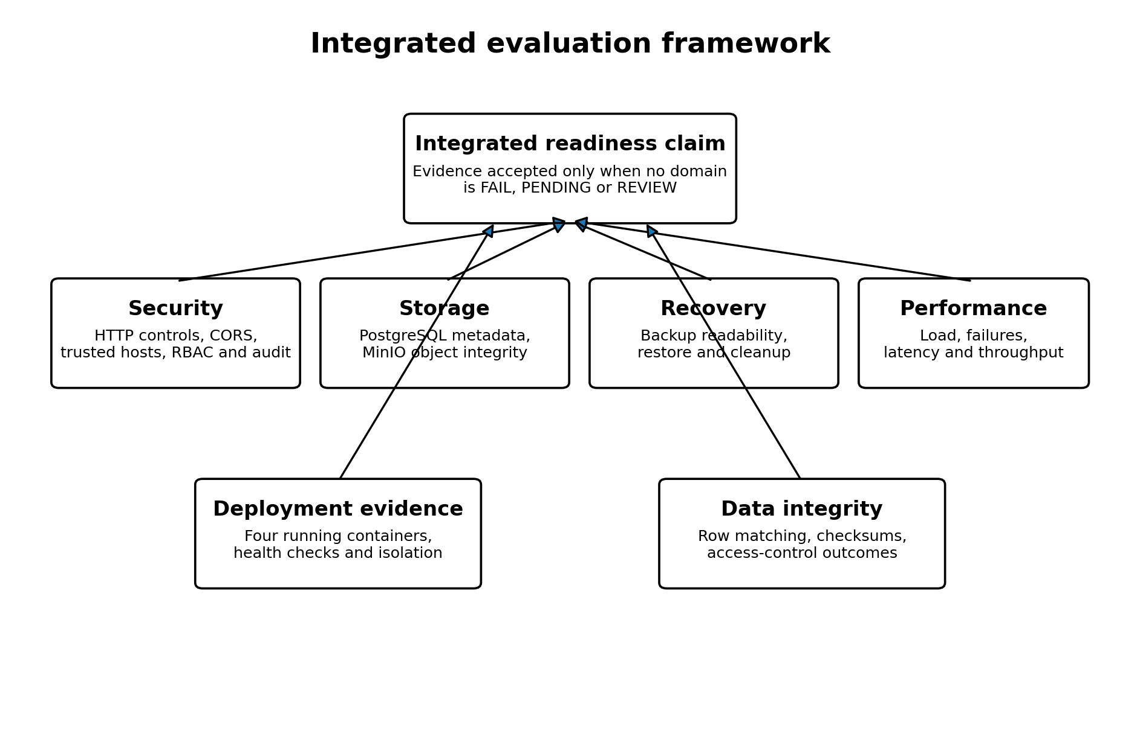
Figure 1. Integrated evaluation framework used to interpret the seven final validations.
The final matrix applies a strict rule: a production-readiness claim is justified only when no item is marked FAIL, PENDING, or REVIEW. This rule was satisfied in the local validated environment.
- Security controls must prevent unauthorized access and unsafe production exposure.
- Storage validation must show that metadata and binary objects remain consistent.
- Recovery validation must prove that backups can be restored into isolated targets.
- Performance validation must measure useful throughput rather than raw request volume alone.
- Deployment evidence must show that the intended production services actually run together.

2. Final Validation Matrix
Domain | Validation | Checks | Status
Security | Production HTTP security | 17/17 | PASS
Security | Diagnostic report strict audit | 9/9 | PASS
Storage | Diagnostic report end-to-end storage | 10/10 | PASS
Storage | MinIO service lifecycle | 4/4 | PASS
Disaster recovery | PostgreSQL backup and restore | 19/19 | PASS
Disaster recovery | MinIO backup and restore | 23/23 | PASS
Performance | Optimized 200-user load | 1/1 | PASS

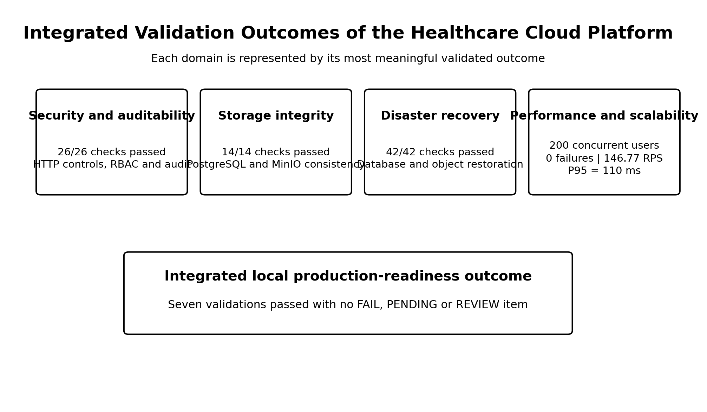
Figure 2. Integrated validation outcomes across security, storage, disaster recovery, and performance.
The domains are reported using outcome-specific measures rather than a direct comparison of check counts. The performance result consolidates concurrency, request volume, failure rate, throughput, and latency into one validated load scenario; it must not be interpreted as weaker merely because it occupies one line in the final validation matrix.

3. Security and Access-Control Results

3.1 Production HTTP controls
All 17 production HTTP checks passed. The backend returned HTTP 200 on the health endpoint. The tested responses included X-Content-Type-Options, X-Frame-Options, Referrer-Policy, Content-Security-Policy, Permissions-Policy, Strict-Transport-Security, and Cache-Control.
Control group | Observed outcome | Status
Security headers | Required values present | PASS
Server disclosure | Uvicorn not disclosed | PASS
Swagger, ReDoc and OpenAPI | HTTP 404 in production | PASS
Trusted CORS origin | Allowed | PASS
Untrusted CORS origin | Not allowed | PASS
Trusted host | HTTP 200 | PASS
Untrusted host | HTTP 400 | PASS
Configuration restoration | Development environment healthy after test | PASS

The presence of a Strict-Transport-Security header in an HTTP validation does not prove that TLS was deployed. HSTS becomes operationally meaningful only when the application is served over HTTPS.

3.2 RBAC coverage
The RBAC inventory contains 31 operations. Twenty-nine clinical, FHIR, storage, and update operations have explicit role lists at route or router scope. The login and current-user routes do not use route-level role lists because they serve authentication and identity-resolution functions.
The role matrix demonstrates differentiated permissions. Examples include diagnostic-report upload for Admin, Doctor, and Lab Staff; prescription creation for Admin and Doctor; and prescription updates for Admin, Doctor, and Pharmacist.

4. Audit and Diagnostic-Report Validation
The diagnostic-report workflow provides a high-value cross-domain test because it combines RBAC, PostgreSQL metadata, MinIO object storage, SHA-256 integrity, downloads, and audit events.
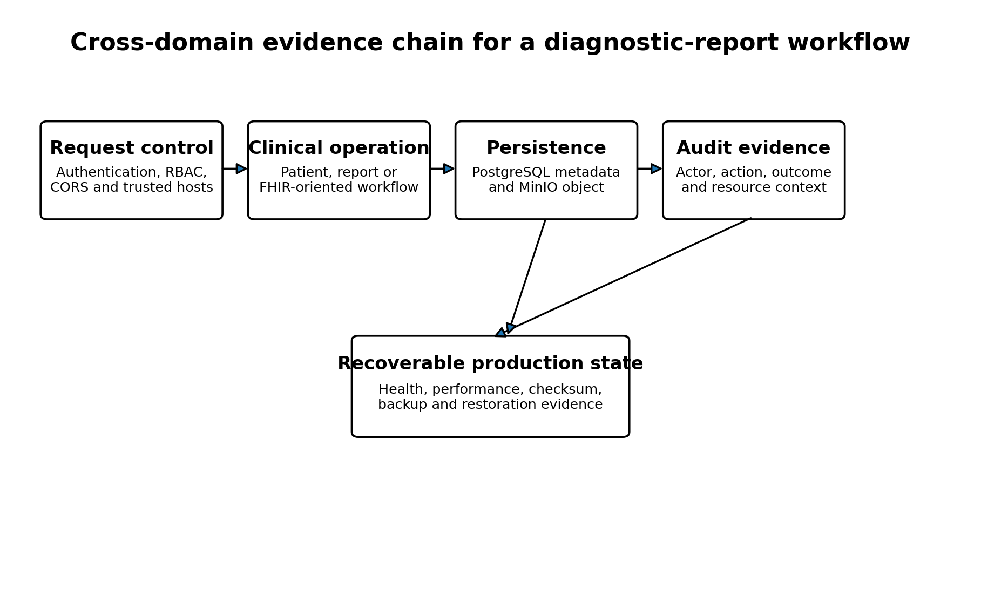
Figure 3. Cross-domain evidence chain for a diagnostic-report workflow.
End-to-end check | Observed outcome | Status
Authorized upload | HTTP 201 | PASS
Authorized metadata read | HTTP 200 | PASS
PostgreSQL metadata | Row present | PASS
Database checksum | Expected and actual SHA-256 matched | PASS
Database file size | 67 bytes matched | PASS
MinIO integrity | Expected and actual SHA-256 matched | PASS
Authorized download | HTTP 200 and matching bytes | PASS
Download without JWT | HTTP 401 | PASS
Pharmacist download | HTTP 403 | PASS
Cleanup | Expected final count retained | PASS

The strict audit validation passed 9 of 9 checks. The combined evidence shows that a permitted actor can upload and retrieve a report, a prohibited actor is denied, the binary object matches its metadata, and security-relevant actions are recorded.

5. PostgreSQL and MinIO Storage Integrity

5.1 MinIO lifecycle
The MinIO lifecycle validation passed four checks: bucket existence, bucket access, object upload and download with matching SHA-256, and object deletion.
This validates functional object persistence and cleanup. It does not measure large-object throughput, versioning, retention, encryption at rest, or multi-node MinIO behavior.

5.2 PostgreSQL table-level integrity
The supplied table comparison lists nine application and security tables containing 1,581,926 rows. Every listed source count matched the restored count with a difference of zero.
Table | Source rows | Restored rows | Difference | Status
patients | 117,581 | 117,581 | 0 | PASS
encounters | 121,649 | 121,649 | 0 | PASS
conditions | 643,513 | 643,513 | 0 | PASS
observations | 592,173 | 592,173 | 0 | PASS
prescriptions | 66,458 | 66,458 | 0 | PASS
diagnostic_reports | 5 | 5 | 0 | PASS
audit_logs | 40,535 | 40,535 | 0 | PASS
users | 6 | 6 | 0 | PASS
roles | 6 | 6 | 0 | PASS

The newer PostgreSQL summary reports ten verified tables and 19 passing checks. The uploaded integrated extract does not enumerate the tenth table in its table-level CSV. The likely additional table is the Alembic migration table, but this chapter does not treat that inference as a confirmed row-level result.

6. Backup and Restoration Results

6.1 PostgreSQL recovery
The current PostgreSQL recovery summary reports a 52,847,810-byte custom archive with SHA-256 2ccded46a6fd14c6ec584bf2bed7fee4c82f37518b5908295ec7184430bbaec3. Ten tables matched, all 19 checks passed, and the temporary restore database was removed.
The integrated evidence also contains an earlier nine-table backup result with a slightly different archive size and checksum. This is historical evidence. The later 10-table, 19-check result is the current authoritative summary.

6.2 MinIO recovery
The MinIO recovery test backed up seven objects totaling 488 bytes, restored seven objects totaling 488 bytes, verified all 23 checks, and removed the temporary bucket.
Recovery target | Backup evidence | Restore evidence | Checks | Status
PostgreSQL | 52,847,810-byte archive and SHA-256 | 10 tables matched; temporary database removed | 19/19 | PASS
MinIO | 7 objects; 488 bytes | 7 objects; 488 bytes; temporary bucket removed | 23/23 | PASS

The recovery evidence proves local functional restoration. It does not demonstrate recovery from total host loss, off-site backups, point-in-time database recovery, encrypted retention, or measured RPO and RTO.

7. Performance and Scalability Results
Scenario | Requests | Failures | Failure rate | Avg ms | P95 ms | P99 ms | RPS
10 users | 465 | 0 | 0.00% | 26.72 | 71 | 290 | 7.94
50 users | 4557 | 0 | 0.00% | 19.48 | 59 | 230 | 38.35
100 users | 13695 | 0 | 0.00% | 39.27 | 130 | 450 | 76.46
200 users initial | 1488 | 357 | 23.99% | 33,132.66 | 90,000 | 91,000 | 5.23
200 users optimized | 43814 | 0 | 0.00% | 29.27 | 110 | 240 | 146.77

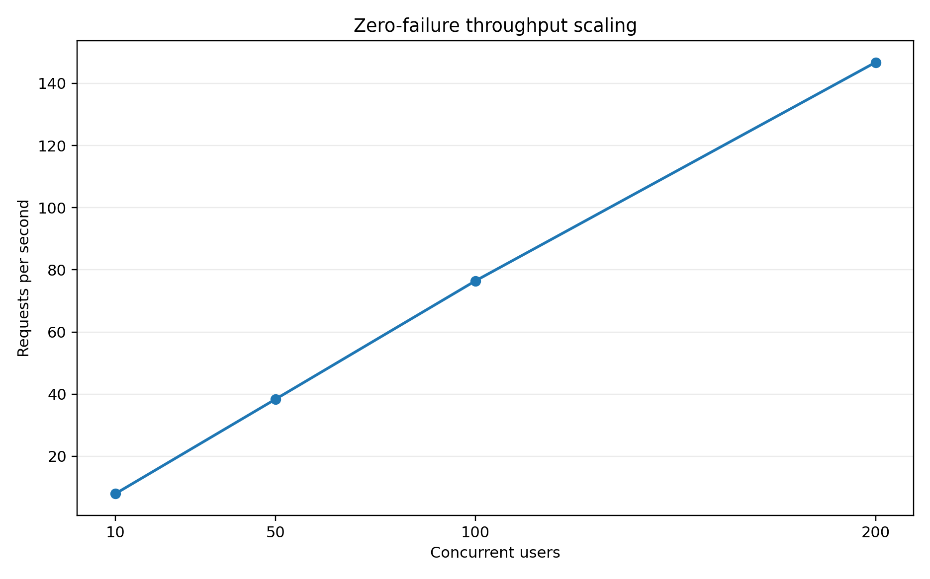
Figure 4. Throughput scaling across all zero-failure scenarios.
Throughput increased from 7.94 requests per second at 10 users to 146.77 requests per second at the optimized 200-user load. The successful scenarios completed with zero failures.
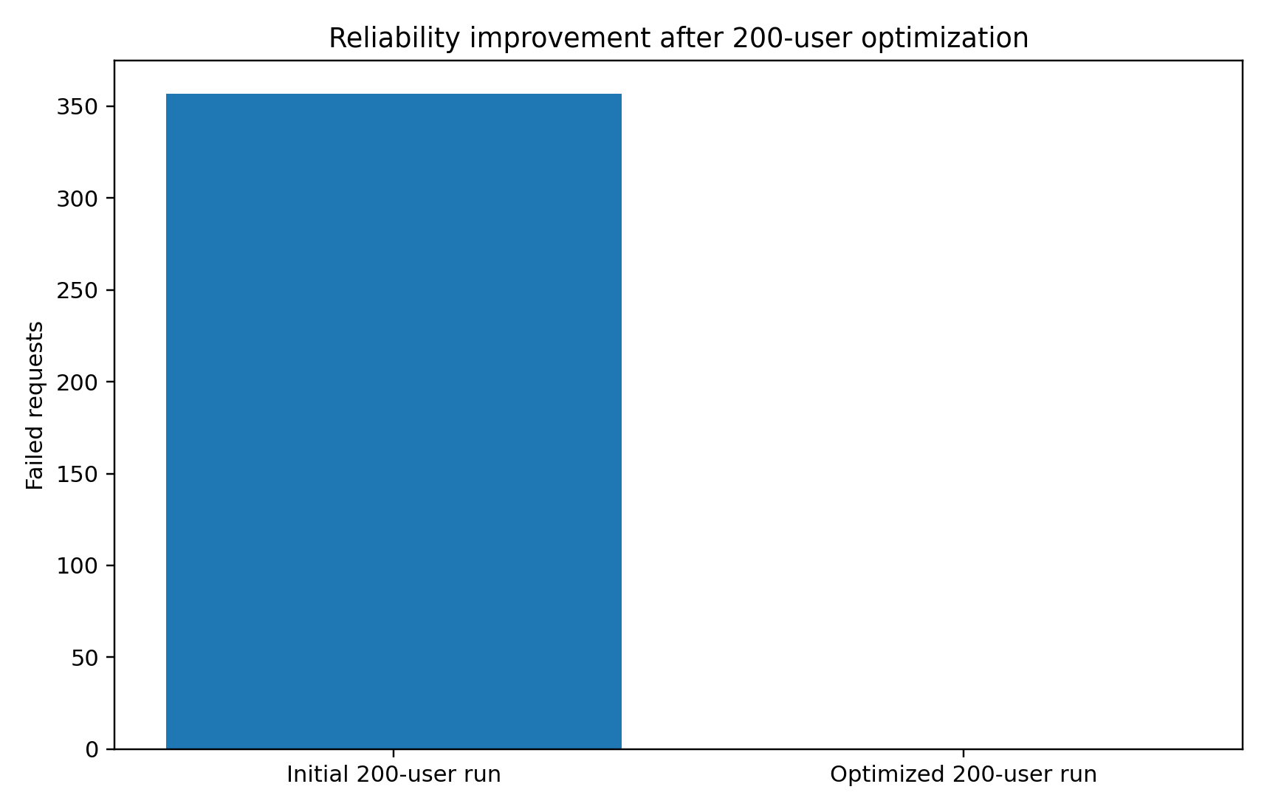
Figure 5. Elimination of failed requests after optimization of the 200-user configuration.
The initial 200-user run produced 357 failures, a 23.99% failure rate, mean latency of 33,132.66 ms, and raw throughput of 5.23 requests per second. After remediation, failures fell to zero, mean latency fell to 29.27 ms, and throughput increased by 141.54 requests per second.
The performance evidence supports scalability for the measured authenticated workload. It does not establish performance for write-heavy traffic, geographically distributed clients, long endurance tests, a different host, or the future UESTC VM.

7.1 Resource and cost-efficiency interpretation
Resource snapshots were available for three scenarios. The optimized 200-user snapshot reported only 0.35% backend CPU while processing 146.77 requests per second. This point-in-time value is not credible as a steady-state CPU measurement and should not be used as a headline efficiency claim.
A monetary cost model was defined, but verified monthly infrastructure and operations costs were not provided. Financial cost-effectiveness therefore remains uncalculated.

8. Production-Container Readiness
The production snapshot shows four active containers: Nginx, the FastAPI backend, PostgreSQL, and MinIO. The backend and PostgreSQL were reported healthy. Nginx exposed host port 8080, while the backend, database, and MinIO remained internally reachable.
Container | Observed status | Exposure
healthcare_prod_nginx | Up | Host port 8080 to container port 80
healthcare_prod_backend | Up and healthy | Internal port 8000
healthcare_prod_postgres | Up and healthy | Internal port 5432
healthcare_prod_minio | Up | Internal port 9000

The saved command column contains character-encoding corruption in truncated text. This does not affect the service-status interpretation, but the inventory should be regenerated in clean UTF-8 before final publication.

9. Cross-Domain Interpretation
The strongest result is not any single PASS outcome. It is the consistency among the domains. The same platform that passed access-control tests also preserved report bytes, recorded audit events, restored its database and object store, and sustained the target 200-user workload after optimization.
Risk | Control or evidence | Integrated result
Unauthorized access | JWT and RBAC | 401 and 403 outcomes were observed in the report workflow
Object corruption | SHA-256 in PostgreSQL and MinIO | Stored and downloaded bytes matched
Metadata-object divergence | End-to-end storage test | File size and checksum matched across layers
Database loss | PostgreSQL custom archive and restore | 10 tables matched; 19/19 checks
Object-store loss | MinIO backup and temporary restore | 7 objects and 488 bytes restored
Load-induced failure | Locust testing and optimization | 357 failures reduced to zero

10. Objectives and Achieved Outcomes
Project objective | Evidence | Assessment
Implement secure authentication and role-based access | JWT, active-user resolution and route/router role restrictions | Achieved in tested scope
Protect healthcare records and files | PostgreSQL metadata, private MinIO objects and SHA-256 verification | Achieved in tested scope
Provide auditability | Strict diagnostic-report audit validation passed 9/9 | Achieved in tested scope
Demonstrate recoverability | PostgreSQL 19/19 and MinIO 23/23 | Achieved locally
Demonstrate scalability | Optimized 200-user load at 146.77 RPS and zero failures | Achieved for measured workload
Prepare a production deployment architecture | Four-service isolated Docker Compose stack | Achieved locally
Deploy to institutional cloud infrastructure | UESTC VM not yet available | Pending external dependency
Quantify monetary cost-effectiveness | Method defined but cost inputs absent | Not yet achieved

11. Research and Engineering Contributions
- A reproducible four-service healthcare platform integrating FastAPI, PostgreSQL, MinIO, Nginx, Alembic, JWT, RBAC, and audit logging.
- A patient-centered data platform validated with large synthetic clinical tables and a FHIR-inspired read layer.
- A hybrid report-storage design that validates both relational metadata and private object bytes.
- A cross-domain validation matrix linking security, storage, recovery, and performance evidence.
- A before-and-after scalability experiment that preserves the failed 200-user run as bottleneck evidence and the optimized run as remediation evidence.
- Executable disaster-recovery tests that restore PostgreSQL and MinIO into temporary isolated targets rather than merely creating backups.

12. Threats to Validity and Limitations
- The results describe one local Docker environment and cannot be generalized to the future UESTC VM without retesting.
- The performance scenarios are consolidated single-run results without repeated-run confidence intervals.
- The workload is predominantly authenticated read traffic and does not represent every clinical write workflow.
- The security tests validate selected controls but do not prove legal or regulatory compliance.
- The HSTS header was observed, but the supplied production deployment remains HTTP-only at the Nginx boundary.
- The recovery tests are local and do not demonstrate complete-host disaster recovery or off-site retention.
- The MinIO recovery sample contains only seven small objects totaling 488 bytes.
- The resource snapshots are not synchronized time-series measurements.
- The table-level restore CSV lists nine tables, while the newer recovery summary reports ten tables.
- No verified monetary cost inputs were available.
- The saved production container inventory contains encoding corruption in the command column.

13. Recommendations for Remote VM Validation
Priority | Recommended validation step
P1 | Deploy the tagged production release to the UESTC VM and record the exact host specification.
P1 | Configure HTTPS, domain routing, firewall rules, and new production-only secrets.
P1 | Repeat all seven validations against the remote endpoint.
P1 | Synchronize CPU, memory, disk, network, database-pool, and latency monitoring with the load test.
P1 | Create encrypted off-host PostgreSQL and MinIO backups and perform restoration on a clean host.
P2 | Repeat each performance scenario at least three times and report uncertainty.
P2 | Add write-heavy, mixed-role, upload, and endurance workloads.
P2 | Define and measure recovery point and recovery time objectives.
P2 | Regenerate UTF-8 evidence inventories and preserve immutable test artifacts.
P3 | Populate the cost model with verified institutional or cloud prices and realistic utilization assumptions.

14. Overall System-Readiness Conclusion
The final matrix records 83 of 83 checks passed across seven validations, with no failed, pending, or review status. Security controls, diagnostic-report auditability, PostgreSQL-MinIO consistency, backup restoration, and optimized 200-user performance all passed.
The platform is therefore defensibly described as locally production-ready and cloud-ready for the measured configuration. This conclusion is narrower than full production certification. It does not assert public cloud deployment, legal compliance, high availability, complete disaster recovery, or universal scalability.
The next decisive milestone is not further local feature expansion. It is controlled deployment to the institutional VM followed by repetition of the complete validation suite under the actual remote hardware, network, security, backup, and operational conditions.

Appendix A. Evidence Traceability
Claim area | Primary evidence
Overall validation status | docs/evidence/final_project_status.txt
Final validation matrix | docs/evidence/final_validation_matrix.md
HTTP security | docs/evidence/production_security_summary.txt and docs/tables/production_security_results.csv
Diagnostic-report storage | docs/tables/diagnostic_report_e2e_results.csv
MinIO lifecycle | docs/tables/minio_storage_results.csv
PostgreSQL recovery | docs/evidence/postgres_backup_restore_summary.txt
MinIO recovery | docs/evidence/minio_backup_restore_summary.txt
Table-level restore | docs/tables/backup_restore_validation.csv
Performance | docs/evidence/performance_consolidated_summary.md and docs/tables/performance_consolidated_summary.csv
Resource interpretation | docs/evidence/resource_cost_efficiency_summary.md
RBAC coverage | docs/tables/rbac_matrix.csv
Container state | docs/02_implementation/production_containers.txt
API inventory | docs/02_implementation/api_routes_inventory.txt
Migration state | docs/02_implementation/alembic_current.txt

Appendix B. Consolidated Headline Metrics
Metric | Validated value
Final validation checks | 83/83 passed
Unresolved validation items | 0
HTTP security | 17/17
Strict audit | 9/9
Diagnostic-report storage | 10/10
MinIO lifecycle | 4/4
PostgreSQL recovery | 19/19
MinIO recovery | 23/23
Maximum zero-failure load | 200 concurrent users
Optimized throughput | 146.77 requests/s
Optimized P95 latency | 110 ms
Failed requests after optimization | 0
Listed restored rows | 1,581,926 across 9 enumerated tables

Chapter 10. General Conclusion, Contributions and Future Work

1. General Conclusion
This research produced and validated a healthcare data platform designed to combine secure access, structured clinical-data management, private object storage, containerized deployment, auditability, recoverability, and measured scalability. The implementation integrates FastAPI, PostgreSQL, MinIO, Nginx, Alembic, JWT authentication, role-based access control, audit logging, clinical APIs, a FHIR-inspired interoperability layer, and Synthea ingestion utilities.
The final validation matrix records seven successful validations and no failed, pending, or review item. Production HTTP security passed 17 of 17 checks, strict diagnostic-report audit validation passed 9 of 9, end-to-end diagnostic-report storage passed 10 of 10, the MinIO lifecycle passed 4 of 4, PostgreSQL recovery passed 19 of 19, MinIO recovery passed 23 of 23, and the optimized 200-user workload completed without failures.
The evidence supports a carefully scoped conclusion. The platform is locally production-ready and cloud-ready for the measured Docker configuration. It has not yet been validated as a publicly accessible remote production system on the planned UESTC virtual machine.
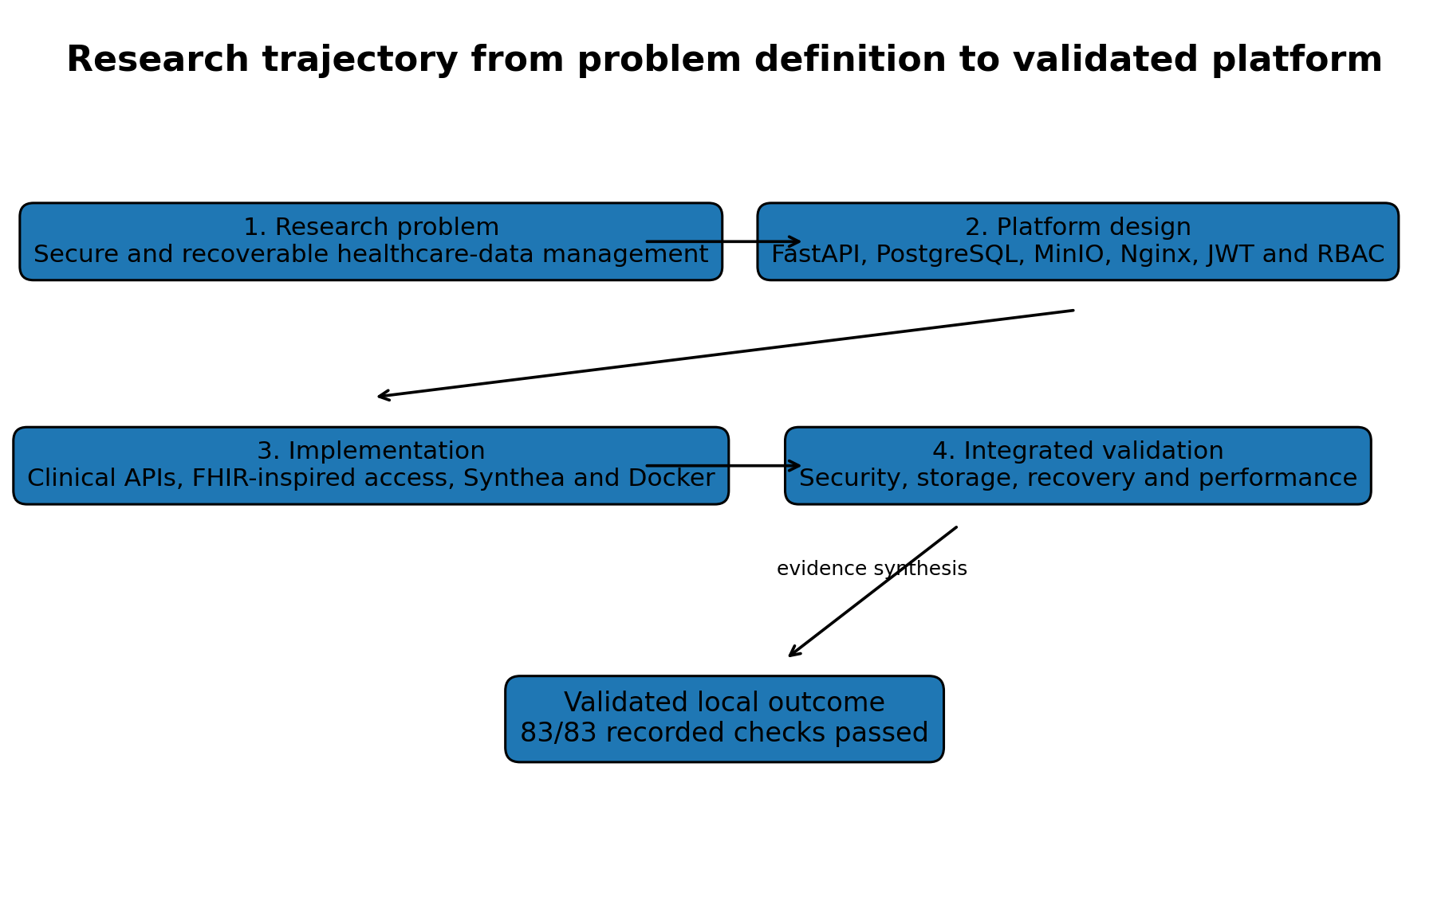
Figure 1. Research trajectory from the identified platform problem to the validated local outcome.

2. Research Problem and Implemented Solution
Based on the available implementation and validation evidence, the research addressed the need for a healthcare data platform that can manage structured and binary data while enforcing access control, preserving traceability, supporting interoperable representations, recovering from data loss, and maintaining acceptable performance under concurrent use.
The implemented solution organizes the backend into API dependencies, versioned endpoints, core security and configuration modules, database models and sessions, Pydantic schemas, business services, ingestion utilities, and database migrations. The deployment layer consists of four services: Nginx, the FastAPI backend, PostgreSQL, and MinIO.
Research need | Implemented response
Secure access to healthcare functions | JWT authentication, active-user checks, RBAC and production HTTP controls
Structured healthcare-data management | PostgreSQL models for patients, encounters, conditions, observations, prescriptions and reports
Binary report storage | Private MinIO objects with PostgreSQL metadata and SHA-256 integrity
Interoperable data access | FHIR-inspired Patient, Encounter, Observation, MedicationRequest and Condition resources
Reproducible synthetic-data ingestion | Synthea patient, encounter, observation and medication import utilities
Cloud-oriented deployment | Containerized Nginx, backend, PostgreSQL and MinIO production stack
Operational resilience | Executable PostgreSQL and MinIO backup-and-restore validation
Scalability evidence | Authenticated Locust testing up to 200 concurrent users

3. Achievement of the Research Objectives
Objective | Evidence | Assessment
Design a modular healthcare backend | FastAPI modules, services, schemas, models and API routing implemented | Achieved
Enforce authentication and authorization | JWT, active-user resolution and six-role RBAC model | Achieved in tested scope
Manage clinical records and diagnostic files | PostgreSQL clinical entities plus private MinIO report objects | Achieved in tested scope
Support interoperability | FHIR-inspired endpoints and CapabilityStatement-like metadata | Partially achieved
Support synthetic-data ingestion | Synthea patients, encounters, observations and medications | Achieved for demonstrated importers
Demonstrate local production deployment | Four-service production Docker stack | Achieved
Validate security, storage and auditability | 40 combined checks across HTTP security, audit and storage | Achieved
Validate backup and recovery | 42 passing PostgreSQL and MinIO recovery checks | Achieved locally
Validate scalability | 200 users, 146.77 requests/s and zero failures after optimization | Achieved for measured workload
Deploy on institutional cloud infrastructure | UESTC VM remains an external dependency | Not yet completed
Quantify monetary cost-effectiveness | Method defined but verified cost inputs unavailable | Not yet completed

4. Main Scientific and Engineering Contributions
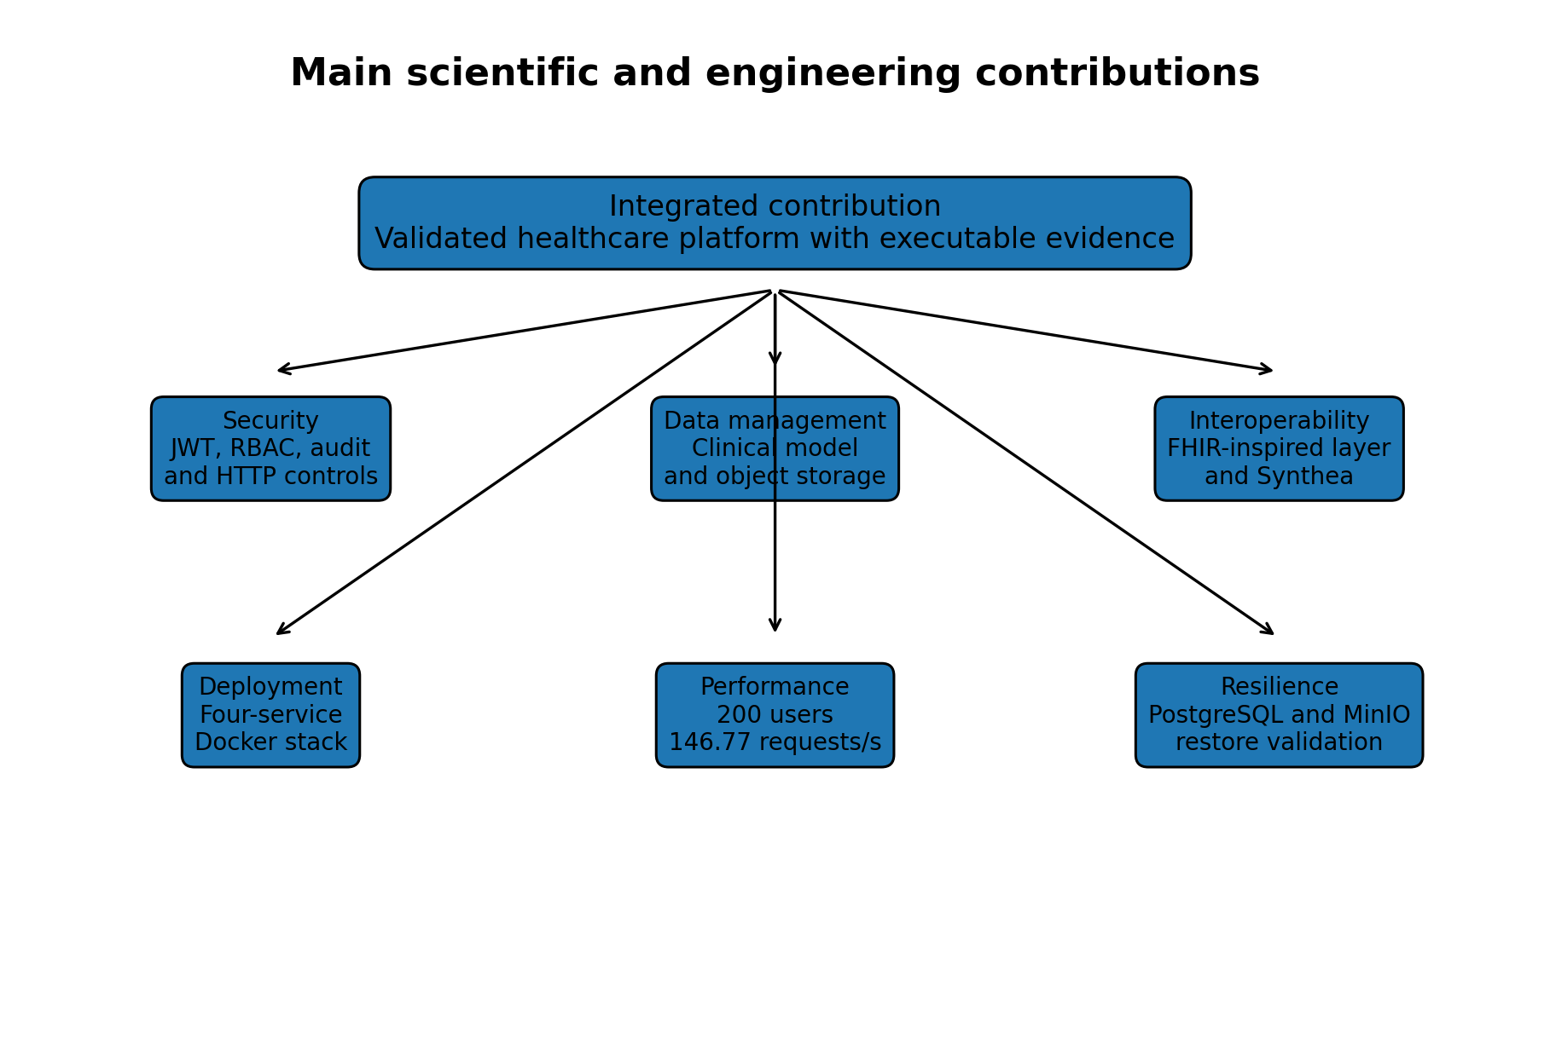
Figure 2. Principal scientific and engineering contributions of the research.

4.1 Security contribution
The project integrates password protection, JWT-based authentication, active-account checking, six operational roles, route-level and router-level RBAC, production HTTP security controls, and audit logging. The contribution is not merely architectural. It is supported by executable security evidence, including 17 of 17 production HTTP checks and 9 of 9 strict audit checks.

4.2 Healthcare data-management contribution
The platform provides a patient-centered relational model for encounters, conditions, observations, prescriptions, diagnostic-report metadata, users, roles, and audit records. Diagnostic-report bytes are separated from structured metadata and stored privately in MinIO. File size and SHA-256 values connect the relational and object-storage layers.

4.3 FHIR-inspired interoperability contribution
The implementation exposes selected FHIR-named resources and Bundle-like responses for Patient, Encounter, Observation, MedicationRequest, and Condition, together with a Patient/$everything operation and minimal capability metadata. This provides an interoperability foundation while remaining explicitly narrower than full HL7 FHIR conformance.

4.4 Containerization and cloud-readiness contribution
The system is packaged as a four-service Docker Compose architecture. Nginx provides the external entry point, the backend mediates application access, and PostgreSQL and MinIO remain on an internal data network. Named volumes, health checks, dependencies, restart policies, environment-driven configuration, Git tags, and release history support reproducibility and deployment readiness.

4.5 Performance and scalability contribution
The study preserves both the failed initial 200-user experiment and the optimized result. The initial run produced 357 failed requests, 23.99% failure rate, mean latency of 33,132.66 ms, and 5.23 requests per second. The optimized run completed 43,814 requests with zero failures, 29.27 ms mean latency, 110 ms P95 latency, and 146.77 requests per second.
This before-and-after evidence demonstrates the identification and remediation of a software bottleneck. It does not demonstrate unlimited scalability or performance on different infrastructure.

4.6 Backup and disaster-recovery contribution
The recovery contribution is based on restoration rather than backup creation alone. PostgreSQL was restored into a temporary database and verified across ten tables. MinIO objects were restored into a temporary bucket and checked for count, size, and SHA-256 integrity. Temporary recovery targets were removed after validation.

5. Integrated Validation Outcome
Validation | Checks | Status
Production HTTP security | 17/17 | PASS
Diagnostic report strict audit | 9/9 | PASS
Diagnostic report end-to-end storage | 10/10 | PASS
MinIO service lifecycle | 4/4 | PASS
PostgreSQL backup and restore | 19/19 | PASS
MinIO backup and restore | 23/23 | PASS
Optimized 200-user load | 1/1 | PASS

The seven validations contain 83 recorded checks, all of which passed. These checks represent heterogeneous forms of evidence and should not be interpreted as a statistical score. Their value lies in the combined coverage of security, auditability, storage, recovery, and performance.
The strongest conclusion is cross-domain consistency. Authorized operations succeeded, unauthorized operations were denied, stored bytes matched recorded metadata, backups were recoverable, and the optimized workload met the measured reliability target.

6. Study Limitations and Threats to Generalization
- The final evidence describes one local Docker host and must be repeated on the UESTC VM.
- The performance results are consolidated single-run scenarios without repeated-run confidence intervals.
- The measured workload does not represent every write-heavy, upload-heavy, or geographically distributed use case.
- Security tests validate selected controls but do not prove compliance with a healthcare regulation or certification framework.
- The production reverse proxy remains HTTP-only in the supplied local configuration.
- The recovery tests do not demonstrate recovery from complete host loss, off-site backup retention, or point-in-time recovery.
- The MinIO recovery sample contains seven small objects totaling 488 bytes.
- The resource snapshots are not synchronized time-series measurements and should not support strong efficiency claims.
- Verified monthly infrastructure and operational costs were not available.
- The FHIR-inspired layer is partial and does not demonstrate full conformance.
- The supplied evidence does not include a demonstrated Synthea Condition importer.
- High availability, multi-node database replication, and automatic failover were outside the validated scope.
These limitations narrow the claims that can be made, but they do not invalidate the measured results. They define the boundary between the completed local research contribution and the next deployment phase.

7. Future Work
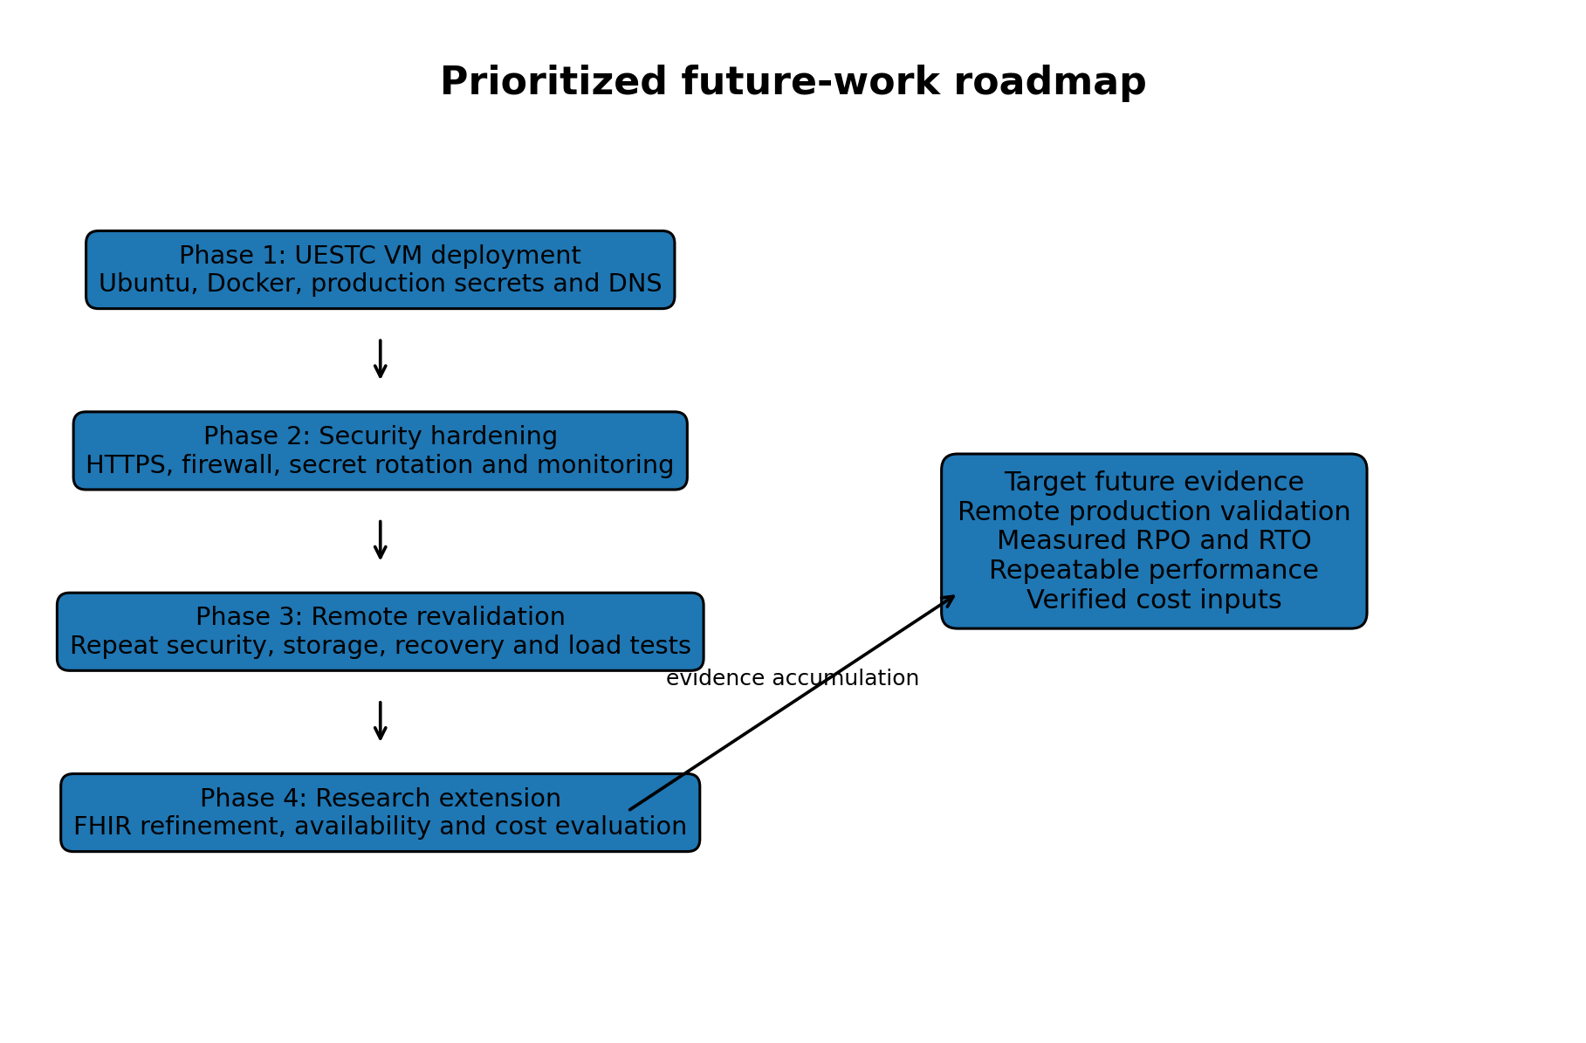
Figure 3. Prioritized roadmap from the validated local platform to remote production evidence.

7.1 Deployment on the UESTC virtual machine
The immediate next step is deployment of the tagged production release on the institutionally provided UESTC virtual machine. The deployment should record the operating system, CPU, memory, storage, network configuration, public or institutional IP, Docker versions, release commit, and migration revision.
Remote deployment action | Required evidence
Provision and harden the VM | Host specification, SSH-key access, operating-system updates and firewall state
Install the application stack | Docker and Compose versions, release tag, container status and health
Configure production secrets | New remote-only values, protected permissions and rotation record
Configure domain and HTTPS | DNS record, valid certificate, HTTP redirect and renewal process
Migrate or restore data | Alembic head, PostgreSQL integrity and MinIO bucket validation
Repeat validation | Remote security, storage, recovery and performance result files

7.2 Future security improvements
- Deploy TLS and validate HSTS over HTTPS.
- Introduce dedicated secret management or protected institutional secret storage.
- Define secret rotation and incident-response procedures.
- Add rate limiting, account lockout or throttling, and multifactor authentication where appropriate.
- Forward audit and system logs to centralized monitoring.
- Add image, dependency, and vulnerability scanning.
- Evaluate database-level controls for stronger audit immutability.

7.3 Future interoperability improvements
- Declare the target FHIR release and supported implementation subset.
- Expand capability metadata to enumerate resources, interactions, search parameters, formats, and security.
- Correct search Bundle totals and add pagination links.
- Extend Patient/$everything to include Conditions and DiagnosticReports with date bounds.
- Add a FHIR DiagnosticReport representation and controlled binary retrieval strategy.
- Add terminology validation for LOINC, RxNorm, and condition code systems where practical.
- Add and validate the missing Condition ingestion workflow.

7.4 Future performance and cost evaluation
- Repeat each load scenario multiple times and report variability.
- Add mixed read/write, file-upload, role-specific, endurance, and recovery-under-load scenarios.
- Collect synchronized CPU, memory, network, storage, database-pool, and latency time series.
- Compare local and UESTC VM performance using the same workload.
- Define target service-level objectives for availability and latency.
- Populate the cost model with verified infrastructure and operational costs.
- Use realistic utilization rather than treating maximum Locust throughput as continuous monthly traffic.

7.5 Future resilience and operational work
- Create encrypted off-host PostgreSQL and MinIO backups.
- Define backup schedules, retention rules, and automated failure alerts.
- Measure recovery point objective and recovery time objective.
- Evaluate PostgreSQL write-ahead-log archiving for point-in-time recovery.
- Perform restoration on a clean second host.
- Document an operational recovery runbook and responsible roles.
- Evaluate high availability only after the remote single-host baseline is stable.

8. Final Research Statement
The research demonstrates that a modular open-source healthcare platform can integrate structured clinical data, protected object storage, role-based security, auditability, interoperability-oriented APIs, reproducible synthetic-data ingestion, containerized deployment, executable disaster recovery, and measured scalability within one coherent implementation.
The final evidence is strong because the platform was not evaluated through a single success criterion. It was assessed through security controls, authorization outcomes, storage checksums, table-level restoration, object-level restoration, container health, and authenticated load testing.
The completed work establishes a validated local foundation. The next research milestone is to transfer that foundation to the UESTC virtual machine and reproduce the evidence under the real remote deployment conditions. Only after that step should the platform be described as institutionally cloud-deployed.

Appendix A. Evidence Traceability
Conclusion area | Primary evidence
Overall validation | docs/evidence/final_project_status.txt and final_validation_matrix.md
Performance | docs/evidence/performance_consolidated_summary.md
Production HTTP security | docs/evidence/production_security_summary.txt
PostgreSQL recovery | docs/evidence/postgres_backup_restore_summary.txt
MinIO recovery | docs/evidence/minio_backup_restore_summary.txt
Resource and cost method | docs/evidence/resource_cost_efficiency_summary.md
Backend organization | docs/02_implementation/backend_structure.txt
Container services | docs/02_implementation/docker_services.txt
Migration state | docs/02_implementation/alembic_current.txt
Prior thesis chapters | Seven Word chapters listed in docs/08_thesis_text

References
[1] P. Mell and T. Grance, The NIST Definition of Cloud Computing, NIST Special Publication 800-145, 2011. doi: 10.6028/NIST.SP.800-145.
[2] HL7 International, HL7 FHIR Release 4, Version 4.0.1, 2019.
[3] D. Bender and K. Sartipi, “HL7 FHIR: An agile and RESTful approach to healthcare information exchange,” in Proc. 26th IEEE International Symposium on Computer-Based Medical Systems, 2013, pp. 326-331. doi: 10.1109/CBMS.2013.6627810.
[4] J. C. Mandel, D. A. Kreda, K. D. Mandl, I. S. Kohane, and R. B. Ramoni, “SMART on FHIR: a standards-based, interoperable apps platform for electronic health records,” Journal of the American Medical Informatics Association, vol. 23, no. 5, pp. 899-908, 2016. doi: 10.1093/jamia/ocv189.
[5] J. Walonoski et al., “Synthea: An approach, method, and software mechanism for generating synthetic patients and the synthetic electronic health care record,” Journal of the American Medical Informatics Association, vol. 25, no. 3, pp. 230-238, 2018. doi: 10.1093/jamia/ocx079.
[6] R. S. Sandhu, E. J. Coyne, H. L. Feinstein, and C. E. Youman, “Role-based access control models,” Computer, vol. 29, no. 2, pp. 38-47, 1996. doi: 10.1109/2.485845.
[7] M. Jones, J. Bradley, and N. Sakimura, JSON Web Token (JWT), RFC 7519, Internet Engineering Task Force, 2015.
[8] K. Kent and M. Souppaya, Guide to Computer Security Log Management, NIST Special Publication 800-92, 2006. doi: 10.6028/NIST.SP.800-92.
[9] M. Swanson, P. Bowen, A. Phillips, D. Gallup, and D. Lynes, Contingency Planning Guide for Federal Information Systems, NIST Special Publication 800-34 Revision 1, 2010. doi: 10.6028/NIST.SP.800-34r1.
[10] D. Merkel, “Docker: Lightweight Linux containers for consistent development and deployment,” Linux Journal, no. 239, 2014.
[11] M. Ahmadi and N. Aslani, “Capabilities and advantages of cloud computing in the implementation of electronic health record,” Acta Informatica Medica, vol. 26, no. 1, pp. 24-28, 2018. doi: 10.5455/aim.2018.26.24-28.
[12] M. Ayaz, M. F. Pasha, M. Y. Alzahrani, R. Budiarto, and D. Stiawan, “The Fast Health Interoperability Resources standard: systematic literature review of implementations, applications, challenges and opportunities,” JMIR Medical Informatics, vol. 9, no. 7, e21929, 2021. doi: 10.2196/21929.
[13] S. Chenthara, K. Ahmed, H. Wang, and F. Whittaker, “Security and privacy-preserving challenges of e-health solutions in cloud computing,” IEEE Access, vol. 7, pp. 74361-74382, 2019. doi: 10.1109/ACCESS.2019.2919982.
[14] Y. Hu and G. Bai, “A systematic literature review of cloud computing in eHealth,” arXiv:1412.2494, 2014.
[15] R. T. Fielding, Architectural Styles and the Design of Network-Based Software Architectures, Ph.D. dissertation, University of California, Irvine, 2000.
[16] OWASP Foundation, OWASP API Security Top 10 - 2023, 2023.

