SECURITY ARCHITECTURE
AND VALIDATION
Healthcare Cloud Platform
A source-grounded technical chapter based on the implemented authentication, authorization, audit, HTTP hardening, and validation artifacts
Local production validation status: PASS (7/7 domains)

Executive Summary
This chapter presents the security architecture and empirical validation of the Healthcare Cloud Platform. The implemented controls follow a layered model that combines password protection, token-based authentication, active-account verification, route-level role-based access control, security-relevant audit logging, HTTP response hardening, origin and host restrictions, and infrastructure isolation. The discussion is grounded in the supplied source code and test artifacts rather than in a generic reference architecture.
The evidence base reports complete success for the tested local production configuration. Seventeen HTTP security checks passed, eight JWT tests passed, nine diagnostic-report audit checks passed, and the final validation matrix reported seven passing domains with no failed, pending, or review items. These results support a local production-readiness claim for the measured environment. They do not, by themselves, establish compliance with a specific health information regulation or prove the security of a future Internet-facing deployment.
Validation area | Measured result | Status
Production HTTP security | 17/17 | PASS
JWT authentication security | 8/8 | PASS
Diagnostic-report audit validation | 9/9 | PASS
Role inventory | 31 API operations inventoried | 29 role-protected; 2 authentication routes
Final project validation matrix | 7/7 domains | PASS

Primary evidence: tests/security/production_security_results.csv; tests/security/jwt_security_results.csv; tests/security/rbac_matrix.csv; tests/security/diagnostic_report_audit_results.csv; docs/evidence/final_validation_matrix.md.

Chapter Structure
1. Security objectives and trust boundaries
2. Password protection and credential handling
3. JWT authentication and authenticated-user resolution
4. Role-based access control
5. Audit logging and accountability
6. HTTP and application-layer hardening
7. Container and network isolation
8. Empirical security validation
9. Critical appraisal, limitations, and recommendations
10. Evidence traceability and chapter conclusion

1. Security Objectives and Trust Boundaries
The platform security design addresses four primary objectives: confidentiality of healthcare data, integrity of stored and transmitted information, controlled availability of services, and accountability for security-relevant operations. The implementation separates these objectives across complementary controls rather than relying on a single mechanism.
- Identity assurance: a request must carry a valid signed access token linked to an existing active user.
- Authorization: authenticated users may invoke only operations assigned to their role.
- Accountability: denied access and healthcare-data actions are recorded with contextual metadata.
- Attack-surface reduction: production documentation routes are disabled and untrusted hosts and origins are rejected.
- Persistence protection: structured audit data is stored in PostgreSQL, while object-storage operations are independently validated.
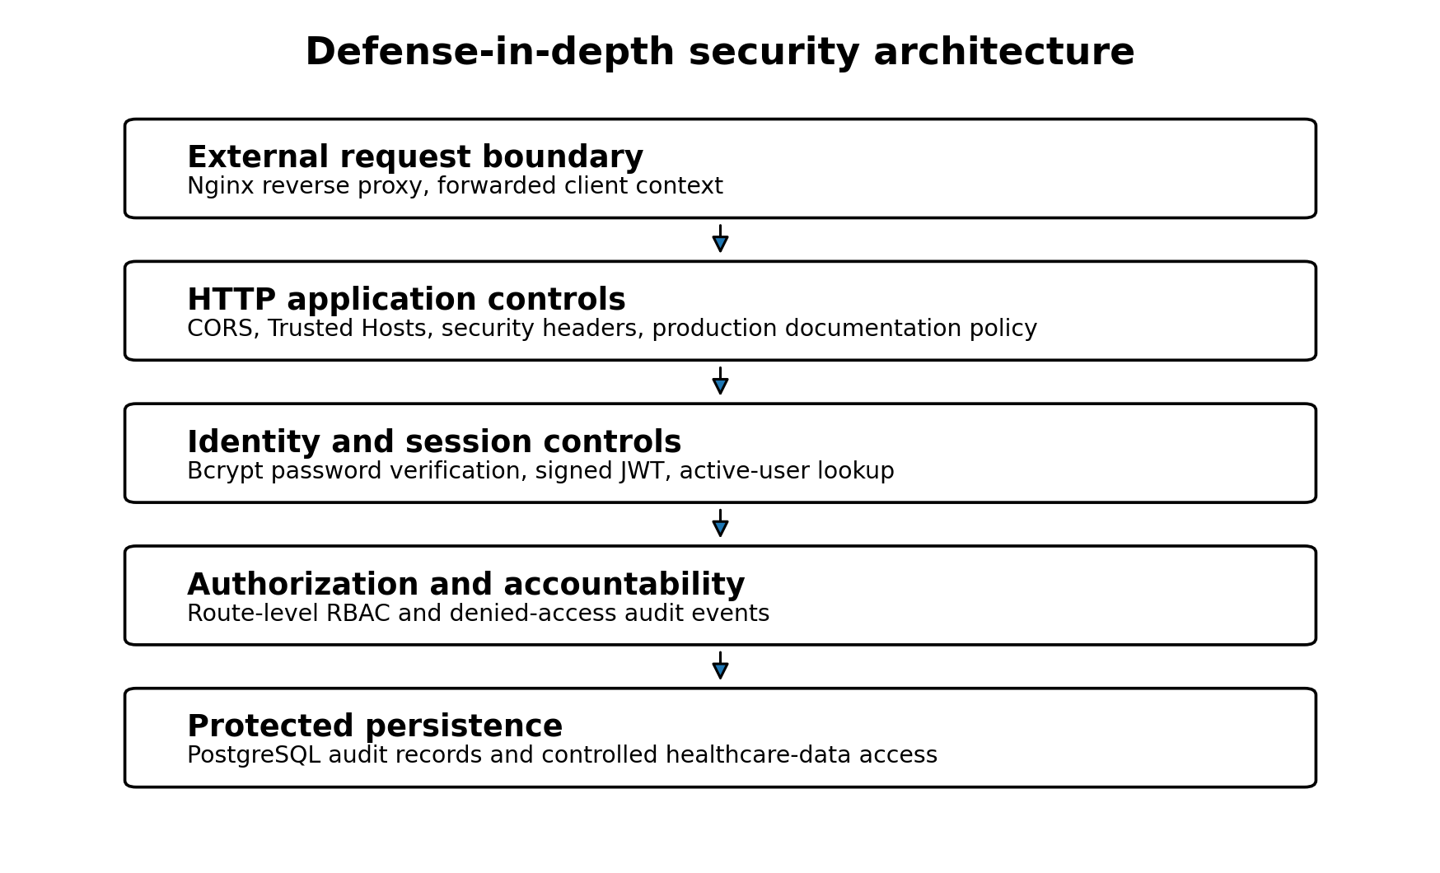
Figure 1. Layered security architecture implemented in the platform.
The outer trust boundary is the HTTP entry point. Requests reaching the FastAPI application are subject to host validation, CORS policy, response-header hardening, authentication dependencies, and route-specific authorization. The persistence boundary contains user identities, roles, and audit records. Object storage is addressed separately by the system implementation and lifecycle validation.

2. Password Protection and Credential Handling

2.1 Password hashing
The security module uses Passlib's CryptContext with the bcrypt scheme. Plaintext passwords are not intended for database persistence. During account creation, the hash_password function rejects passwords shorter than eight characters and returns a bcrypt hash. During login, verify_password compares the supplied plaintext credential with the stored hash.
Control | Implementation | Security effect
Password storage | Bcrypt hash through Passlib CryptContext | Reduces exposure if the user table is disclosed
Minimum length | At least 8 characters | Rejects trivially short credentials
Verification | Constant library-managed hash verification | Avoids direct plaintext comparison
Database field | hashed_password, non-nullable | Prevents normal user records without a stored credential hash

2.2 Review observations
The implemented baseline is technically sound for a prototype, but the supplied source does not show password complexity rules beyond minimum length, breached-password screening, login lockout, password history, password-expiration policy, or multi-factor authentication. These omissions should be described as future hardening requirements rather than silently assumed to exist.

3. JWT Authentication and Authenticated-User Resolution

3.1 Token construction and validation
Access tokens are JSON Web Tokens signed with the configured algorithm and secret key. The token payload contains the subject identifier (sub), issue time (iat), and expiration time (exp). The supplied configuration sets HS256 as the algorithm and a default access-token lifetime of 30 minutes. Token decoding is restricted to the configured algorithm. Invalid or expired tokens are converted into a controlled authentication failure.
JWT element | Implemented value or behavior | Purpose
Subject | User identifier stored in sub | Links the token to a database identity
Issued at | UTC timestamp in iat | Records token issuance time
Expiration | UTC timestamp in exp | Limits token lifetime
Signature | Configured symmetric JWT secret and algorithm | Detects tampering
Validation failure | HTTP 401 through the authentication dependency | Prevents unauthorized endpoint use

3.2 Database-backed identity validation
A successfully decoded token is not treated as sufficient evidence of current authorization. The get_current_user dependency extracts the subject, converts it to a user identifier, retrieves the corresponding User record from PostgreSQL, and verifies that the account remains active. A missing or nonexistent identity produces HTTP 401. An inactive account produces HTTP 403. This design allows administrators to disable access without waiting for all previously issued tokens to expire.
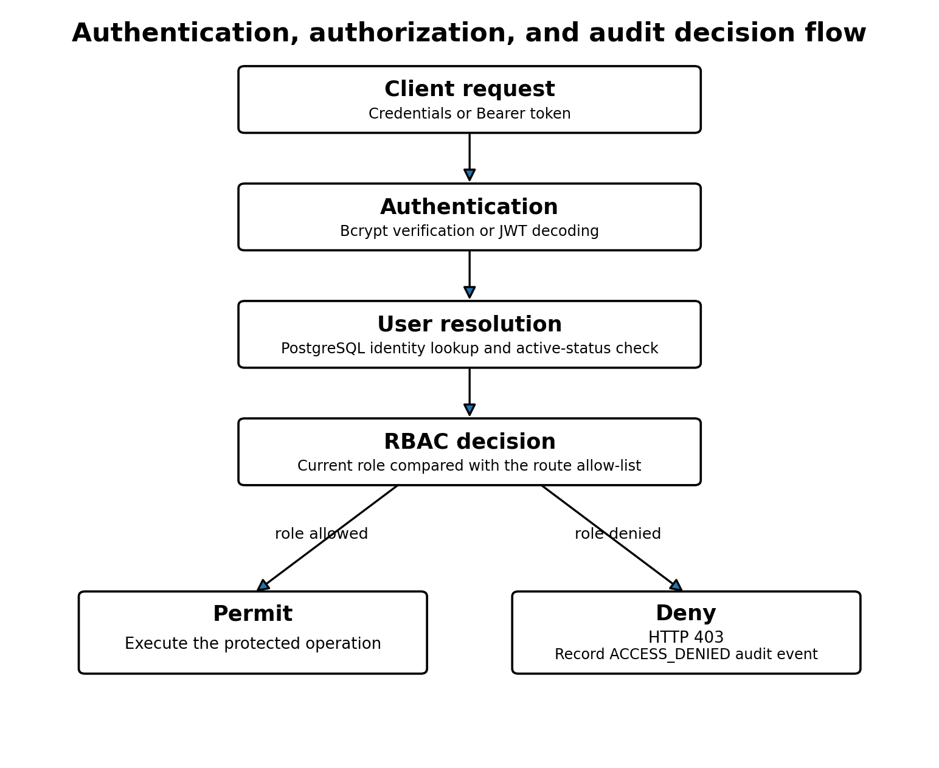
Figure 2. Authentication, user-resolution, authorization, and denial-audit flow.

3.3 Authentication validation results
Test | Expected | Actual | Result
Valid login | 200 | 200 | PASS
Invalid password | 401 | 401 | PASS
Unknown username | 401 | 401 | PASS
Valid JWT on protected endpoint | 200 | 200 | PASS
Missing JWT | 401 | 401 | PASS
Malformed JWT | 401 | 401 | PASS
Tampered JWT signature | 401 | 401 | PASS
Wrong authorization scheme | 401 | 401 | PASS

All eight authentication scenarios passed. Valid login and valid-token access returned HTTP 200. Invalid passwords, unknown usernames, missing tokens, malformed tokens, tampered signatures, and incorrect authorization schemes returned HTTP 401 as expected. The test set therefore covers both positive and representative negative authentication paths.

4. Role-Based Access Control

4.1 Authorization mechanism
Route authorization is implemented through the require_roles dependency factory. Each protected operation declares an explicit set of allowed role names. At request time, the dependency obtains the authenticated user, resolves the linked role, and compares the role name with the allowed set. A mismatch produces HTTP 403 and triggers an ACCESS_DENIED audit event containing the user role, the permitted roles, the endpoint, and request context.
The Role model enforces unique role names, while each User record contains a non-nullable foreign key to a role. This relational design prevents normal authenticated users from existing without a role assignment.

4.2 Endpoint coverage
API module | Inventoried operations
fhir | 8
encounters | 4
patients | 4
observations | 4
prescriptions | 4
diagnostic_reports | 3
auth | 2
fhir_conditions | 2

Role | Operations in which role is permitted
Admin | 29
Doctor | 27
Nurse | 26
Data Manager | 25
Lab Staff | 11
Pharmacist | 11

The inventory contains 31 operations. Twenty-nine healthcare and interoperability operations carry an explicit role set. The two authentication operations, login and current-user retrieval, are marked not_detected in the static RBAC inventory because they are governed by credential or token authentication rather than by a route-specific role list. This distinction should not be misinterpreted as unrestricted anonymous access to the current-user endpoint.

4.3 Least-privilege observations
- Administrative access is the broadest, covering all 29 role-protected operations.
- Doctors and nurses receive broad clinical access, but patient creation and modification exclude doctors.
- Pharmacists are concentrated in prescription and selected FHIR read operations.
- Laboratory staff receive diagnostic-report and observation access but limited prescription access.
- Data managers receive broad data-management and read access but are excluded from selected clinically authoritative writes.

5. Audit Logging and Accountability

5.1 Audit record structure
The AuditLog model records the acting user, action, resource type and identifier, outcome, HTTP method, endpoint, IP address, user agent, structured details, and server-generated timestamp. Composite indexes on user plus creation time and action plus creation time support investigation and chronological analysis.
Audit field | Security relevance
user_id | Associates an event with the acting identity when available
action and outcome | Expresses what occurred and whether it succeeded, failed, or was denied
resource_type and resource_id | Identifies the affected protected object
http_method and endpoint | Links the event to the invoked application operation
ip_address and user_agent | Provides request-origin and client context
details | Stores structured non-sensitive contextual data as JSON text
created_at | Provides a server-side timestamp for chronology

5.2 Safe audit recording
The audit service explicitly states that passwords, JWTs, authorization headers, and file contents must not be included in audit details. The safe_record_event method rolls back an audit transaction and returns None if logging fails, preventing an audit failure from interrupting the primary healthcare operation. This favors service availability, but it also introduces a risk of silent audit gaps. A production enhancement should emit a secondary operational alert or metric whenever an audit write fails.

5.3 Diagnostic-report audit validation
Test | Expected | Actual | Result
Diagnostic report E2E test | exit code 0 | exit code 0 | PASS
New audit records | at least 6 | 6 | PASS
Audit action ACCESS_DENIED | present | present | PASS
Audit action LOGIN_SUCCESS | present | present | PASS
Audit action REPORT_DOWNLOAD | present | present | PASS
Audit action REPORT_READ | present | present | PASS
Audit action REPORT_UPLOAD | present | present | PASS
Diagnostic report audit context | present | present | PASS
Diagnostic report cleanup | 5 | 5 | PASS

The diagnostic-report end-to-end security test created six new audit records and confirmed ACCESS_DENIED, LOGIN_SUCCESS, REPORT_UPLOAD, REPORT_READ, and REPORT_DOWNLOAD actions. It also verified report-specific context and cleanup. All nine checks passed.

6. HTTP and Application-Layer Hardening

6.1 Security headers
The application adds defensive HTTP headers to every response. These controls reduce browser-side content interpretation, framing, referrer disclosure, permission use, caching, and content-loading risks. In production mode, the application also adds Strict-Transport-Security.
Control or test | Expected | Observed | Result
Backend health | HTTP 200 | HTTP 200 | PASS
X-Content-Type-Options | nosniff | nosniff | PASS
X-Frame-Options | DENY | DENY | PASS
Referrer-Policy | no-referrer | no-referrer | PASS
Content-Security-Policy | present | default-src 'none'; frame-ancestors 'none'; base-uri 'none'; form-action 'none' | PASS
Permissions-Policy | present | camera=(), microphone=(), geolocation=() | PASS
Strict-Transport-Security | present | max-age=31536000; includeSubDomains | PASS
Cache-Control | contains no-store | no-store | PASS
Server disclosure | uvicorn not disclosed | absent | PASS
Production route /docs | HTTP 404 | HTTP 404 | PASS
Production route /redoc | HTTP 404 | HTTP 404 | PASS
Production route /openapi.json | HTTP 404 | HTTP 404 | PASS
Trusted CORS origin | http://localhost:3000 | http://localhost:3000 | PASS
Untrusted CORS origin | not allowed | not allowed | PASS
Trusted Host | HTTP 200 | HTTP 200 | PASS
Untrusted Host | HTTP 400 | HTTP 400 | PASS
Development configuration restored | healthy | healthy | PASS

6.2 CORS, Trusted Hosts, and production documentation
CORS is configured as an allow-list rather than a wildcard policy. The validation confirmed that the trusted localhost origin was accepted and an untrusted origin was not allowed. In production, TrustedHostMiddleware restricts accepted Host headers. The trusted host returned HTTP 200, while an untrusted host returned HTTP 400.
Interactive API documentation, ReDoc, and the OpenAPI document are disabled when the application runs in production. The corresponding routes returned HTTP 404 in the security test. This reduces unnecessary production exposure, although operational teams may choose to provide authenticated internal documentation through a separate channel.

6.3 HSTS interpretation
The test confirms the presence of the HSTS header. However, HSTS provides meaningful browser protection only when the application is delivered over HTTPS. The current local deployment uses HTTP on localhost. Consequently, the test establishes correct header configuration, not completed TLS deployment. TLS termination and certificate validation must be retested on the future UESTC or external server.

7. Container and Network Isolation
The production Docker Compose configuration separates an edge network from an internal data network. Nginx is attached only to the edge network. PostgreSQL and MinIO are attached only to the data network, which is declared internal. The backend is the sole service connected to both networks. PostgreSQL and MinIO are not published directly to the host, while Nginx is the only publicly mapped entry point in the local production topology.
Service | Network exposure | Security implication
Nginx | Edge network; host port 8080 mapped to container port 80 | Controlled reverse-proxy entry point
FastAPI backend | Edge and internal data networks; port 8000 exposed only to containers | Mediates all application access to persistence services
PostgreSQL | Internal data network only; no host port mapping | Reduces direct database attack surface
MinIO | Internal data network only; no host port mapping | Prevents direct host or Internet access to object storage

This architecture limits lateral reach from the external boundary. It is not a substitute for database credentials, MinIO credentials, host hardening, patch management, or firewall rules on the future VM, but it provides a defensible default segmentation model.

8. Empirical Security Validation

8.1 Validation design
The evidence set combines static inspection and executable tests. Static inspection maps route operations to allowed roles and identifies the implementation of password hashing, JWT validation, account-state verification, audit recording, and security headers. Executable tests evaluate authentication failure modes, production HTTP behavior, audit-event generation, storage behavior, backup and restore, and optimized load performance.

8.2 Consolidated outcomes
Domain | Validation | Checks | Status
Security | Production HTTP security | 17/17 | PASS
Security | Diagnostic report strict audit | 9/9 | PASS
Storage | Diagnostic report end-to-end storage | 10/10 | PASS
Storage | MinIO service lifecycle | 4/4 | PASS
Disaster recovery | PostgreSQL backup and restore | 19/19 | PASS
Disaster recovery | MinIO backup and restore | 23/23 | PASS
Performance | Optimized 200-user load | 1/1 | PASS

The final matrix contains seven passing validation items and no failed, pending, or review items. According to the project criterion recorded in the matrix, a production-readiness claim is justified only when no item remains in those non-passing states. The platform satisfies that criterion for the tested local production configuration.

9. Critical Appraisal, Limitations, and Recommendations

9.1 Strengths supported by evidence
- Authentication is not accepted solely on token syntax; the linked user must exist and remain active.
- Authorization is declared at route level and denied operations are audited.
- HTTP hardening was tested through positive and negative origin and host scenarios.
- Audit coverage was validated through a diagnostic-report workflow rather than only through unit-level assertions.
- Database and object-storage services are isolated from the host in the production Compose topology.
- The validation matrix is complete, reproducible, and linked to explicit evidence files.

9.2 Limitations that must be reported
- The current results are from a local production-like Docker environment, not from the final public VM.
- The presence of the HSTS header does not demonstrate encrypted transport until HTTPS is configured and tested.
- No multi-factor authentication, account lockout, rate limiting, password breach checking, or password-history mechanism is shown in the supplied source.
- JWT signing uses a symmetric secret. Automated key rotation and centralized secret management are not evidenced.
- The audit model is described as immutable, but the supplied source does not demonstrate database-level prevention of update or deletion.
- safe_record_event protects application availability but can silently lose audit events when the audit write fails.
- No web application firewall, intrusion-detection integration, SIEM forwarding, or automated vulnerability scan is evidenced.
- Passing functional security tests does not establish legal compliance with HIPAA, GDPR, Chinese data-protection law, or any other regulatory framework.

9.3 Prioritized recommendations for the remote deployment
Priority | Recommended action
P1 | Configure a real domain, TLS certificate, HTTPS-only redirection, and then retest HSTS.
P1 | Replace all local secrets with high-entropy production secrets and document a rotation procedure.
P1 | Add firewall rules that expose only SSH, HTTP, and HTTPS, with administrative access restricted where possible.
P1 | Implement rate limiting and login-throttling at Nginx or application level.
P2 | Emit monitoring alerts for failed audit writes and verify audit-retention and tamper-resistance controls.
P2 | Introduce an external encrypted backup destination and periodically test restoration.
P2 | Perform dependency, container-image, and dynamic application security scans against the deployed VM.
P3 | Evaluate multi-factor authentication for privileged and clinical roles.

10. Evidence Traceability and Conclusion
Chapter claim or component | Primary project evidence
Password hashing and JWT | backend/app/core/security.py
Authenticated-user resolution | backend/app/api/dependencies/auth.py
RBAC and denied-access audit | backend/app/api/dependencies/rbac.py
Audit service | backend/app/services/audit_service.py
Audit schema | backend/app/models/audit_log.py
User and role models | backend/app/models/user.py; backend/app/models/role.py
HTTP security validation | tests/security/production_security_results.csv
JWT validation | tests/security/jwt_security_results.csv
RBAC inventory | tests/security/rbac_matrix.csv
Diagnostic-report audit validation | tests/security/diagnostic_report_audit_results.csv
Overall validation status | docs/evidence/final_validation_matrix.md
Network isolation | docker-compose.prod.yml and nginx/default.conf, as documented in the implementation source extract

The Healthcare Cloud Platform implements a coherent defense-in-depth baseline. Bcrypt protects stored credentials, signed JWTs establish short-lived authenticated sessions, PostgreSQL-backed identity resolution supports immediate account deactivation, route-level RBAC enforces explicit professional permissions, and audit records provide accountability for denied and healthcare-data operations. HTTP hardening, origin and host restrictions, documentation suppression, and container network segmentation further reduce exposure.
The supplied evidence demonstrates that the implemented controls behaved as expected in the local production configuration. The result is a validated, cloud-ready security baseline. Final claims about public-cloud security must await deployment to the remote VM, activation of HTTPS, external network testing, and completion of the prioritized hardening measures.

Appendix A. Role-to-Module Access Summary
Module | Operations | Roles represented
auth | 2 | Authentication-dependent; no route-level role list
diagnostic_reports | 3 | Admin, Data Manager, Doctor, Lab Staff, Nurse
encounters | 4 | Admin, Data Manager, Doctor, Lab Staff, Nurse
fhir | 8 | Admin, Data Manager, Doctor, Nurse, Pharmacist
fhir_conditions | 2 | Admin, Data Manager, Doctor, Nurse
observations | 4 | Admin, Data Manager, Doctor, Lab Staff, Nurse
patients | 4 | Admin, Data Manager, Doctor, Lab Staff, Nurse
prescriptions | 4 | Admin, Data Manager, Doctor, Nurse, Pharmacist

