BACKUP, RECOVERY
AND DATA RESILIENCE
Healthcare Cloud Platform
A source-grounded evaluation of PostgreSQL and MinIO backup, isolated restoration, integrity verification, cleanup, and persistent Docker storage
PostgreSQL: 19/19 checks passed | MinIO: 23/23 checks passed

Executive Summary
This chapter evaluates the backup, restoration, and data-resilience mechanisms implemented for the Healthcare Cloud Platform. Structured healthcare data are stored in PostgreSQL, while binary diagnostic objects are stored in MinIO. The supplied recovery tests do not merely create backup files. They restore the backups into temporary isolated targets and compare the restored state with the source state.
The current PostgreSQL validation produced a 52,847,810-byte custom archive, recorded SHA-256 digest 2ccded46a6fd14c6ec584bf2bed7fee4c82f37518b5908295ec7184430bbaec3, restored the archive into healthcare_cloud_db_restore_test, verified 10 public tables, 30 constraints, 50 indexes, and exact row counts totaling 1,581,949 rows. All 19 checks passed and the temporary restore database was removed.
The MinIO validation inventoried seven objects totaling 488 bytes, copied each object to a local backup directory, recorded metadata and SHA-256 values, restored the objects into a uniquely named temporary bucket, and reverified object count, total size, per-object size, and per-object checksum. All 23 checks passed and the temporary bucket was removed.
These results demonstrate recoverability for the tested local environment and datasets. They do not establish off-site disaster recovery, encrypted backup retention, point-in-time recovery, defined recovery objectives, or recovery from complete host loss.
Validation | Checks | Scope | Status
PostgreSQL backup and restore | 19/19 | 10 tables; 30 constraints; 50 indexes | PASS
Exact PostgreSQL row comparison | 10/10 tables | 1,581,949 rows matched | PASS
MinIO backup and restore | 23/23 | 7 objects; 488 bytes | PASS
Temporary target cleanup | 2/2 | Database and bucket removed | PASS

Chapter Structure
1. Resilience objectives and data domains
2. Persistent storage architecture
3. PostgreSQL backup procedure
4. PostgreSQL restoration and validation
5. MinIO backup procedure
6. MinIO restoration and object-integrity validation
7. Validation results and evidence
8. Recovery limitations and risk analysis
9. Remote backup and disaster-recovery recommendations
10. Conclusion

1. Resilience Objectives and Data Domains
The recovery design addresses two persistence domains with different data characteristics. PostgreSQL contains relational healthcare records, authentication data, roles, audit records, constraints, indexes, and the Alembic migration state. MinIO contains binary healthcare objects and related object metadata. A complete recovery strategy must protect both domains because restoring only one would produce an inconsistent platform.
- Recoverability: backup artifacts must be readable and restorable into isolated targets.
- Integrity: restored relational rows and binary object hashes must match their sources.
- Completeness: schema objects, tables, object counts, and total object sizes must be verified.
- Isolation: validation must not overwrite the production database or source bucket.
- Cleanup: temporary recovery targets must be removed after validation.
- Evidence: machine-readable CSV files and human-readable summaries must record the result.
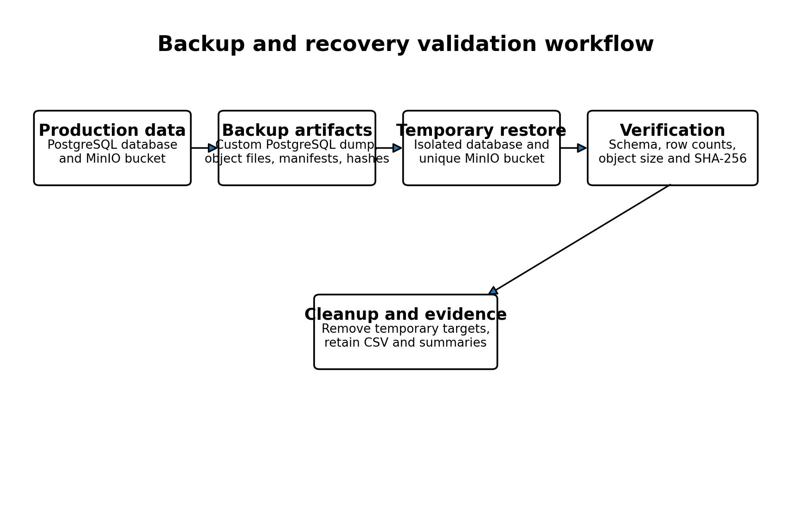
Figure 1. Backup and recovery validation workflow used for PostgreSQL and MinIO.

2. Persistent Storage Architecture
The production Docker Compose configuration assigns PostgreSQL and MinIO separate named volumes: postgres_prod_data and minio_prod_data. The services are attached to an internal data network and are not published directly to the host. The backend is connected to both the edge and data networks and mediates application access to persistence services.
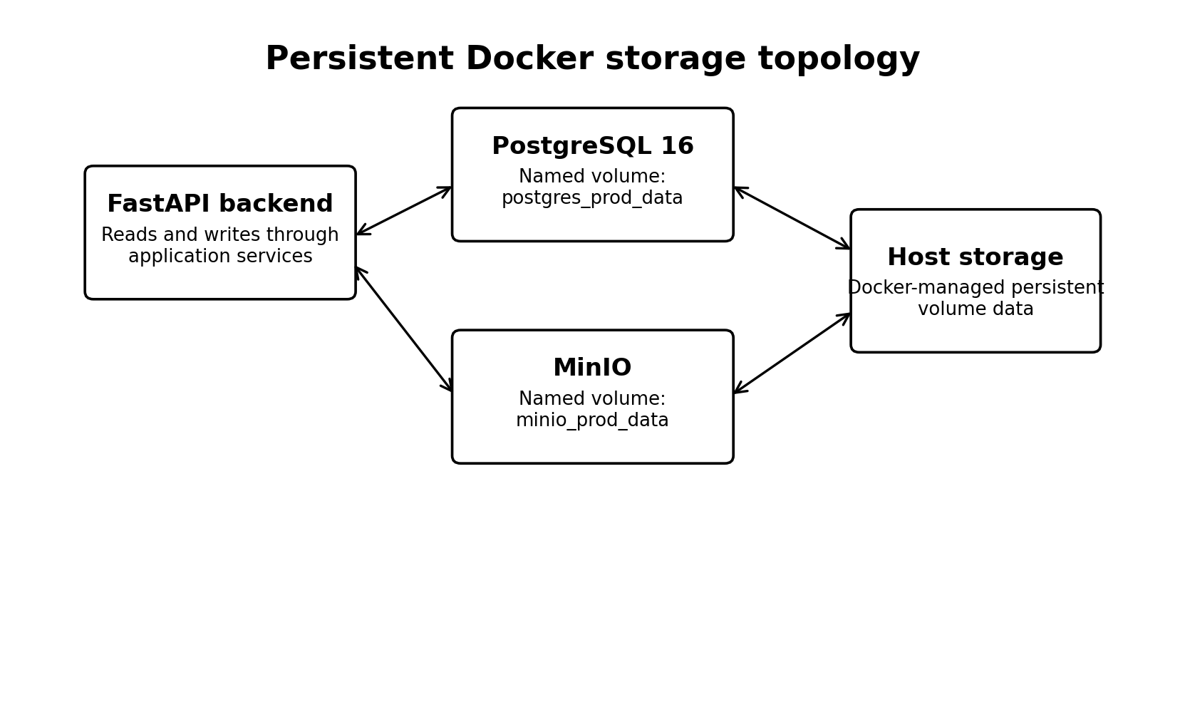
Figure 2. Persistent Docker storage topology.
Named volumes preserve service data across normal container replacement and restart operations. They do not constitute independent backups because volume loss, host failure, administrative deletion, ransomware, or storage corruption can affect both the service and its local volume. The validated logical PostgreSQL dump and MinIO object-copy workflow therefore provide a separate recovery layer.
Service | Persistent volume | Primary contents | Backup form
PostgreSQL | postgres_prod_data | Structured relational records, schema, constraints, indexes | Custom logical dump
MinIO | minio_prod_data | Binary reports and attachments | Object files plus manifest and checksums

3. PostgreSQL Backup Procedure

3.1 Pre-flight validation
The recovery script first confirms that the PostgreSQL container is running. It then queries the source database for the number of public tables, constraints, and indexes. These source values form part of the restoration oracle used later in the test.

3.2 Logical backup creation
The current Python validation invokes pg_dump inside the PostgreSQL container using custom archive format, compression level 6, no ownership statements, and no privilege statements. The archive is created temporarily inside the container and then copied to the host recovery directory.
Setting | Implementation | Reason
Archive format | pg_dump --format=custom | Supports pg_restore and archive inspection
Compression | --compress=6 | Reduces host backup size
Ownership handling | --no-owner | Avoids restoration failures caused by absent source owners
Privilege handling | --no-privileges | Avoids restoring environment-specific grants

3.3 Backup integrity and readability
The validated archive size was 52,847,810 bytes. A SHA-256 digest was calculated over the host archive. The script also used pg_restore --list to confirm that the custom archive was readable before attempting restoration.
2ccded46a6fd14c6ec584bf2bed7fee4c82f37518b5908295ec7184430bbaec3

4. PostgreSQL Restoration and Validation

4.1 Isolated temporary restoration
The script terminates any stale connections to the temporary restore database, removes an earlier test database if present, creates a fresh healthcare_cloud_db_restore_test database, and restores the archive with pg_restore. The --exit-on-error option ensures that restoration stops when a database error occurs.

4.2 Structural verification
Structural element | Source | Restored | Result
Public tables | 10 | 10 | PASS
Constraints | 30 | 30 | PASS
Indexes | 50 | 50 | PASS

Matching row counts alone would not prove that the restored database retained the relational structure needed for correct application behavior. The separate checks for tables, constraints, and indexes therefore strengthen the recovery evidence.

4.3 Exact table-row verification
Table | Source rows | Restored rows | Difference | Result
alembic_version | 1 | 1 | 0 | PASS
audit_logs | 40,557 | 40,557 | 0 | PASS
conditions | 643,513 | 643,513 | 0 | PASS
diagnostic_reports | 5 | 5 | 0 | PASS
encounters | 121,649 | 121,649 | 0 | PASS
observations | 592,173 | 592,173 | 0 | PASS
patients | 117,581 | 117,581 | 0 | PASS
prescriptions | 66,458 | 66,458 | 0 | PASS
roles | 6 | 6 | 0 | PASS
users | 6 | 6 | 0 | PASS

All 10 public tables matched exactly, representing 1,581,949 rows across application, audit, security, and migration tables.
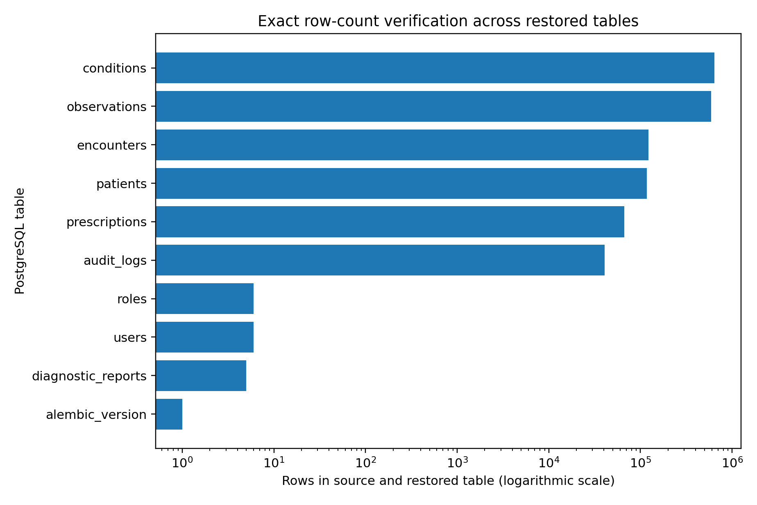
Figure 3. Exact PostgreSQL row-count verification. A logarithmic scale is used because table sizes range from 1 to more than 600,000 rows.

4.4 Cleanup
After validation, the temporary database is dropped and the temporary container archive is removed. The recorded result confirms successful cleanup. Removing recovery targets is important because stale test databases can consume storage, expose copied healthcare data, and interfere with future validation runs.

5. MinIO Backup Procedure

5.1 Source inventory
The MinIO script resolves the configured endpoint and source bucket, verifies that the source bucket exists, and recursively lists all objects. The validated source bucket healthcare-files contained seven objects with a combined size of 488 bytes.

5.2 Local backup representation
Each MinIO object is downloaded to a local backup directory. The local filename is derived from a SHA-256 hash of the object name, while the original object name is preserved in a manifest and CSV inventory. For every object, the backup records local size, SHA-256 content checksum, ETag, content type, and last-modified timestamp when available.
Manifest element | Recorded information
Object identity | Original object name and position
Backup file | Relative local .bin file path
Integrity | SHA-256 digest and byte size
Object metadata | ETag, content type, last-modified timestamp
Backup context | Creation time, endpoint, source bucket, temporary bucket

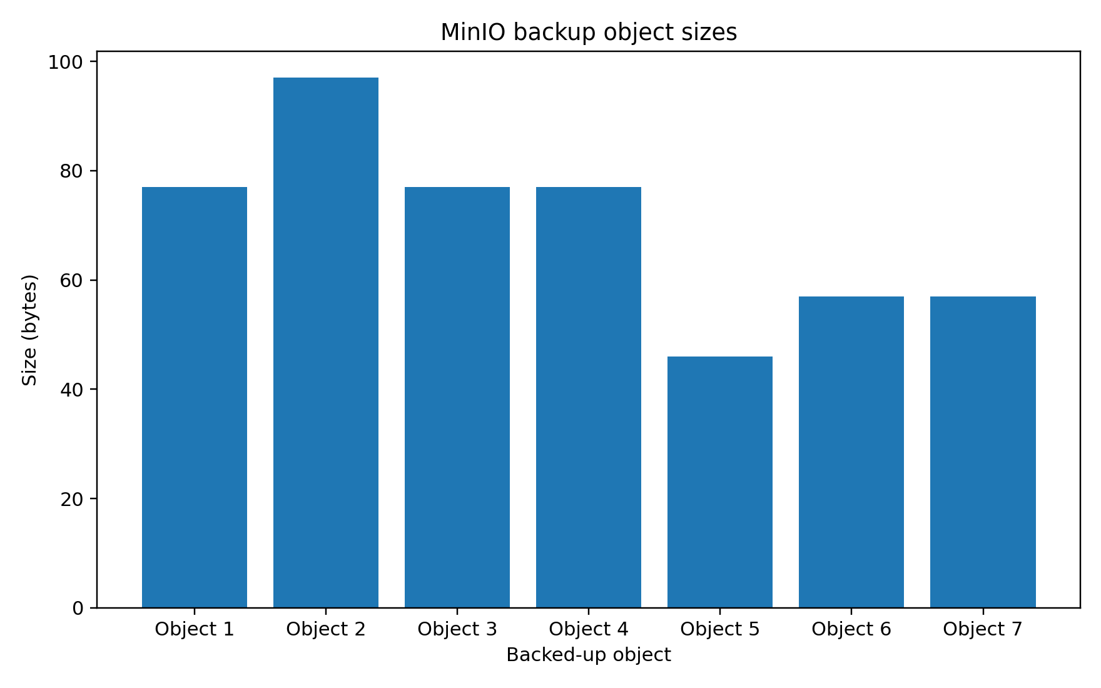
Figure 4. Sizes of the seven MinIO objects included in the validated backup.

6. MinIO Restoration and Object-Integrity Validation

6.1 Temporary bucket creation
A unique temporary bucket name is generated from the source bucket name and a random suffix. If an object with the same temporary bucket name somehow exists, the script removes its objects and bucket before creating a clean restore target. This avoids overwriting the source bucket.

6.2 Object restoration
The script uploads each locally backed-up file to the temporary bucket under its original object name and content type. It then compares the restored object count and aggregate restored size with the backup inventory. Both values matched: seven restored objects and 488 restored bytes.

6.3 Per-object integrity checks
Object | Size | SHA-256 prefix | Result
Object 1 | 77 bytes | 8e13b3b62dcfcd5e... | PASS
Object 2 | 97 bytes | 733a5f7961289e7a... | PASS
Object 3 | 77 bytes | 8e13b3b62dcfcd5e... | PASS
Object 4 | 77 bytes | 8e13b3b62dcfcd5e... | PASS
Object 5 | 46 bytes | 476559fb6977b2b0... | PASS
Object 6 | 57 bytes | 75e916658673c9e2... | PASS
Object 7 | 57 bytes | 75e916658673c9e2... | PASS

For each restored object, the script downloads the restored content, recomputes SHA-256, and verifies both the digest and byte size against the local backup record. All seven restored objects passed.

6.4 Temporary bucket cleanup
The script removes every restored object and then removes the temporary bucket. Cleanup is performed in a finally block so that it is attempted even when another validation step fails. The recorded result confirms successful removal.

7. Consolidated Validation Results
PostgreSQL validation area | Expected | Observed | Result
PostgreSQL container | running | running | PASS
Backup file created | non-empty | 52,847,810 bytes | PASS
Backup SHA-256 | 64 hexadecimal characters | valid digest | PASS
Archive readability | readable pg_restore archive | readable | PASS
Temporary restore | successful | successful | PASS
Public table count | 10 | 10 | PASS
Constraint count | 30 | 30 | PASS
Index count | 50 | 50 | PASS
Exact table rows | 10 matching tables | 10 matching tables | PASS
Temporary database cleanup | removed | removed | PASS

MinIO validation area | Expected | Observed | Result
Source bucket | accessible | present | PASS
Source inventory | completed | 7 objects | PASS
Backup object count | 7 | 7 | PASS
Backup total size | 488 bytes | 488 bytes | PASS
Temporary bucket | created | created | PASS
Restored object count | 7 | 7 | PASS
Restored total size | 488 bytes | 488 bytes | PASS
Per-object integrity | 7 verified | 7 verified | PASS
Temporary bucket cleanup | removed | removed | PASS

The final project validation matrix records PostgreSQL backup and restore as PASS with 19/19 checks and MinIO backup and restore as PASS with 23/23 checks. No failed, pending, or review status remained in the overall matrix.

8. Recovery Limitations and Risk Analysis
- The PostgreSQL and MinIO backups are stored on the same local host used for validation. This does not protect against complete host loss.
- The evidence does not show encryption of backup archives at rest.
- No remote backup repository, immutable storage, or offline backup copy is demonstrated.
- The PostgreSQL method is a full logical backup. Point-in-time recovery through WAL archiving is not implemented in the supplied evidence.
- Recovery time objective (RTO) and recovery point objective (RPO) are not formally defined or measured.
- The MinIO validation sample contains only seven objects totaling 488 bytes, which is sufficient for functional validation but not for large-scale recovery timing.
- The tests validate row counts, schema-object counts, and checksums, but do not perform application-level semantic verification of every restored record.
- Backup retention, rotation, expiration, and periodic scheduling are not documented in the supplied source.
- The earlier evidence files contain an older nine-table PostgreSQL result. This chapter uses the newer detailed 10-table, 19-check validation as the current result.

8.1 Interpretation of the two PostgreSQL summaries
The supplied evidence includes an earlier PostgreSQL summary with nine tables and a 52,847,270-byte archive, and a later detailed result with ten tables and a 52,847,810-byte archive. The later test includes the Alembic migration table, verifies constraints and indexes, reports 19 checks, and confirms cleanup. It is therefore treated as the authoritative current result. The earlier artifact should be retained only as historical validation evidence.

9. Remote Backup and Disaster-Recovery Recommendations
Priority | Recommendation
P1 | Copy PostgreSQL and MinIO backups to a physically or logically separate remote destination.
P1 | Encrypt backup archives and manifests before remote transfer, with keys stored separately.
P1 | Define target RPO and RTO values and measure actual backup and restoration durations.
P1 | Schedule automatic backups and alert when a job, upload, checksum, or restoration test fails.
P2 | Implement backup retention rules with daily, weekly, and monthly generations.
P2 | Evaluate PostgreSQL WAL archiving and point-in-time recovery for lower data-loss exposure.
P2 | Enable MinIO versioning or an equivalent object-version strategy where operationally appropriate.
P2 | Test recovery on the final VM and on a second clean host to demonstrate independence from the source environment.
P3 | Run periodic large-data recovery tests with representative report sizes and object counts.
P3 | Document a recovery runbook with responsible roles, escalation contacts, and acceptance criteria.

9.1 Suggested recovery acceptance criteria
Criterion | Required evidence
Backup success | Archive or object set created, non-empty, and checksum recorded
Restore success | Fresh isolated target created and restoration completed without error
Database completeness | Tables, constraints, indexes, and exact row counts match
Object completeness | Object count, total size, per-object size, and SHA-256 match
Application readiness | Backend starts and representative API queries succeed against the restored environment
Cleanup | Temporary targets removed and sensitive local test copies controlled
Operational evidence | Timestamped manifest, result CSV, summary, and alert status retained

10. Conclusion
The Healthcare Cloud Platform implements and validates two complementary recovery workflows. PostgreSQL recovery uses a compressed custom logical archive, SHA-256 verification, archive readability testing, isolated restoration, structural comparison, exact row-count verification, and cleanup. MinIO recovery uses recursive source inventory, local object copies, manifests, per-object checksums, isolated bucket restoration, count and size comparison, checksum verification, and cleanup.
The current evidence demonstrates exact restoration of 1,581,949 PostgreSQL rows across ten tables and exact restoration of seven MinIO objects. PostgreSQL passed 19 of 19 checks, while MinIO passed 23 of 23 checks. These results justify a local recoverability claim for the measured dataset and configuration.
A complete disaster-recovery claim requires additional controls: remote and encrypted backup copies, scheduled execution, retention rules, defined RPO and RTO targets, recovery timing, point-in-time recovery where required, and validation on a clean remote host. The implemented workflow provides a strong and auditable foundation for those next steps.

Appendix A. Evidence Traceability
Claim or component | Primary evidence
PostgreSQL current summary | docs/evidence/postgres_backup_restore_summary.txt
PostgreSQL test results | tests/recovery/postgres_backup_restore_results.csv
PostgreSQL validation script | tests/recovery/validate_postgres_backup_restore.py
PostgreSQL PowerShell workflow | tests/recovery/validate_postgres_backup_restore.ps1
MinIO current summary | docs/evidence/minio_backup_restore_summary.txt
MinIO test results | tests/recovery/minio_backup_restore_results.csv
MinIO validation script | tests/recovery/validate_minio_backup_restore.py
MinIO wrapper script | tests/recovery/run_minio_recovery_validation.ps1
Recovery finalization | tests/recovery/finalize_disaster_recovery.ps1
Persistent storage configuration | docker-compose.prod.yml
Application object-integrity service | backend/app/services/storage_service.py
Overall validation status | docs/evidence/final_validation_matrix.md

Appendix B. Key Recovery Metrics
Metric | Value
PostgreSQL archive size | 52,847,810 bytes
PostgreSQL SHA-256 | 2ccded46a6fd14c6ec584bf2bed7fee4c82f37518b5908295ec7184430bbaec3
PostgreSQL public tables | 10
PostgreSQL exact rows verified | 1,581,949
PostgreSQL constraints | 30
PostgreSQL indexes | 50
MinIO objects verified | 7
MinIO total size verified | 488 bytes
Total recovery checks | 42
Failed recovery checks | 0

