GENERAL CONCLUSION,
CONTRIBUTIONS AND FUTURE WORK
Healthcare Cloud Platform
A final synthesis of the research problem, implemented platform, achieved objectives, scientific and engineering contributions, study limitations, and the roadmap toward remote institutional deployment
Validated local outcome: 83/83 recorded checks passed

1. General Conclusion
This research produced and validated a healthcare data platform designed to combine secure access, structured clinical-data management, private object storage, containerized deployment, auditability, recoverability, and measured scalability. The implementation integrates FastAPI, PostgreSQL, MinIO, Nginx, Alembic, JWT authentication, role-based access control, audit logging, clinical APIs, a FHIR-inspired interoperability layer, and Synthea ingestion utilities.
The final validation matrix records seven successful validations and no failed, pending, or review item. Production HTTP security passed 17 of 17 checks, strict diagnostic-report audit validation passed 9 of 9, end-to-end diagnostic-report storage passed 10 of 10, the MinIO lifecycle passed 4 of 4, PostgreSQL recovery passed 19 of 19, MinIO recovery passed 23 of 23, and the optimized 200-user workload completed without failures.
The evidence supports a carefully scoped conclusion. The platform is locally production-ready and cloud-ready for the measured Docker configuration. It has not yet been validated as a publicly accessible remote production system on the planned UESTC virtual machine.
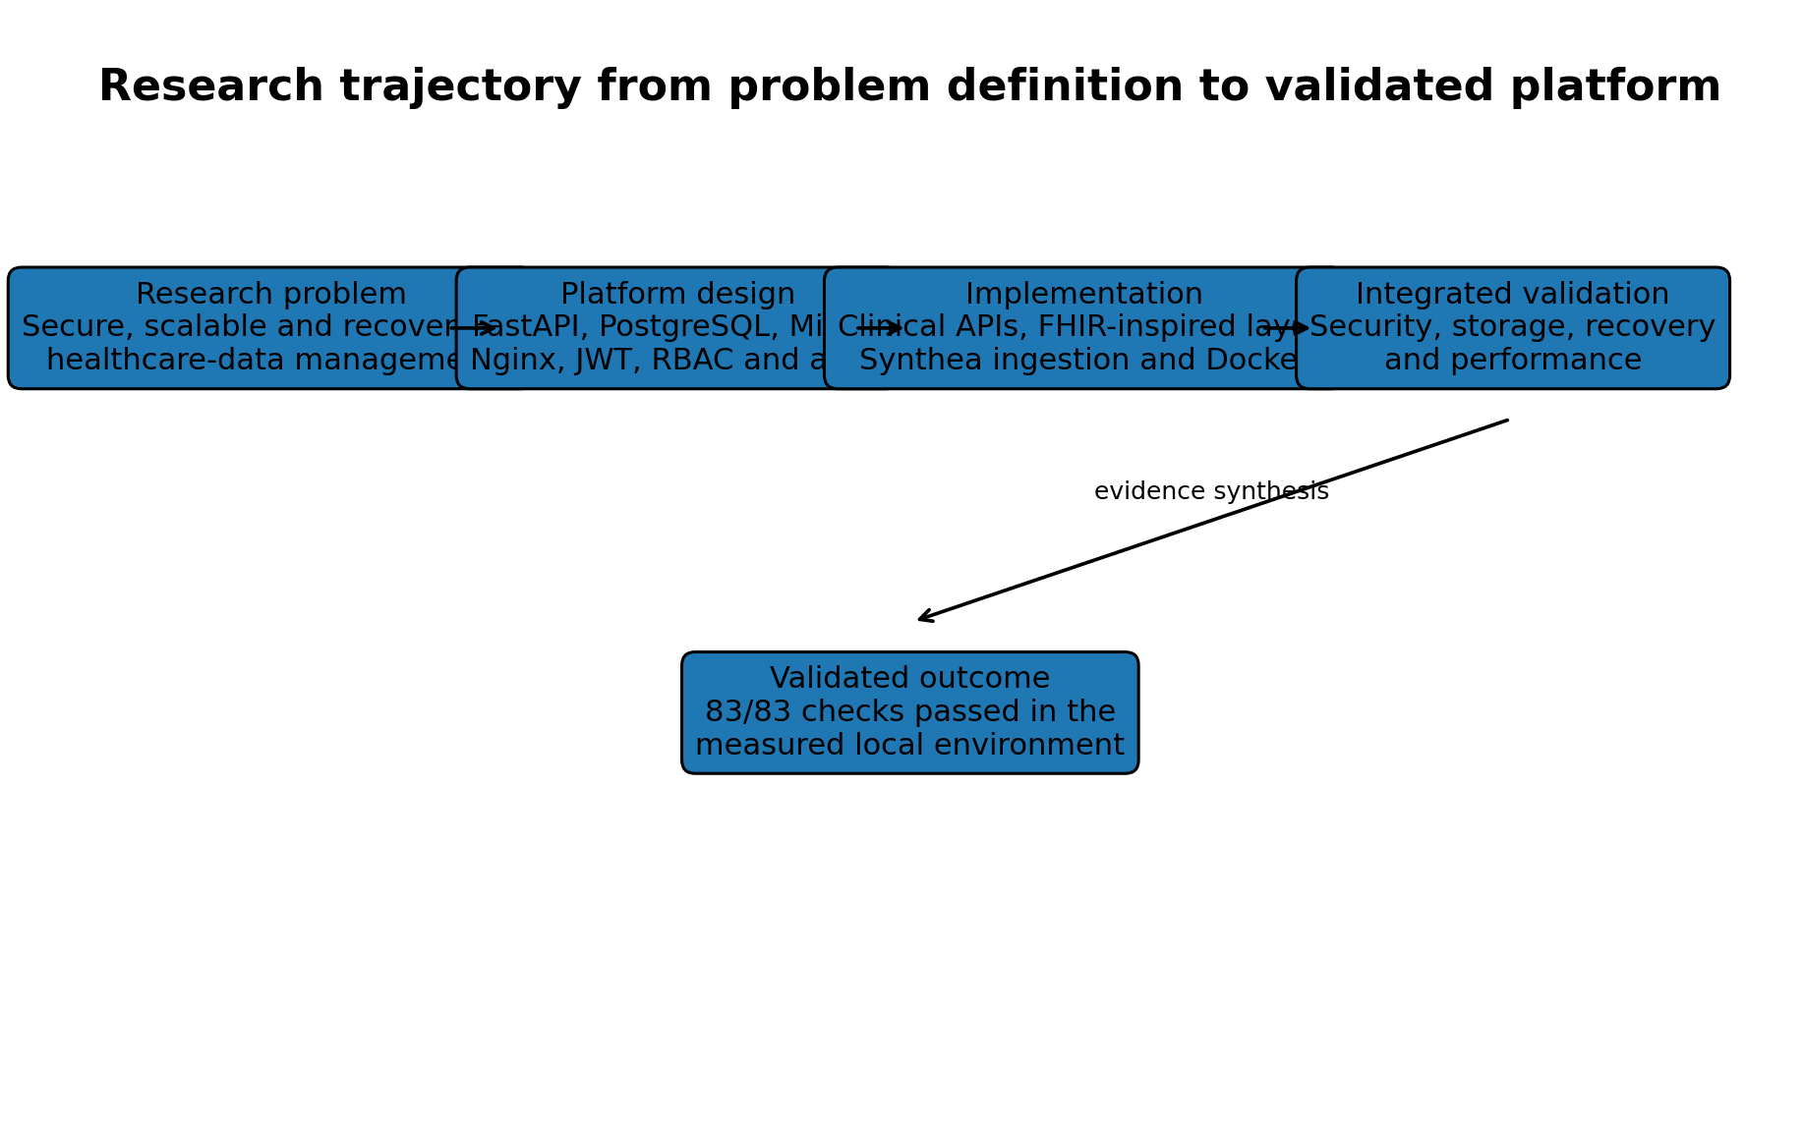
Figure 1. Research trajectory from the identified platform problem to the validated local outcome.

2. Research Problem and Implemented Solution
Based on the available implementation and validation evidence, the research addressed the need for a healthcare data platform that can manage structured and binary data while enforcing access control, preserving traceability, supporting interoperable representations, recovering from data loss, and maintaining acceptable performance under concurrent use.
The implemented solution organizes the backend into API dependencies, versioned endpoints, core security and configuration modules, database models and sessions, Pydantic schemas, business services, ingestion utilities, and database migrations. The deployment layer consists of four services: Nginx, the FastAPI backend, PostgreSQL, and MinIO.
Research need | Implemented response
Secure access to healthcare functions | JWT authentication, active-user checks, RBAC and production HTTP controls
Structured healthcare-data management | PostgreSQL models for patients, encounters, conditions, observations, prescriptions and reports
Binary report storage | Private MinIO objects with PostgreSQL metadata and SHA-256 integrity
Interoperable data access | FHIR-inspired Patient, Encounter, Observation, MedicationRequest and Condition resources
Reproducible synthetic-data ingestion | Synthea patient, encounter, observation and medication import utilities
Cloud-oriented deployment | Containerized Nginx, backend, PostgreSQL and MinIO production stack
Operational resilience | Executable PostgreSQL and MinIO backup-and-restore validation
Scalability evidence | Authenticated Locust testing up to 200 concurrent users

3. Achievement of the Research Objectives
Objective | Evidence | Assessment
Design a modular healthcare backend | FastAPI modules, services, schemas, models and API routing implemented | Achieved
Enforce authentication and authorization | JWT, active-user resolution and six-role RBAC model | Achieved in tested scope
Manage clinical records and diagnostic files | PostgreSQL clinical entities plus private MinIO report objects | Achieved in tested scope
Support interoperability | FHIR-inspired endpoints and CapabilityStatement-like metadata | Partially achieved
Support synthetic-data ingestion | Synthea patients, encounters, observations and medications | Achieved for demonstrated importers
Demonstrate local production deployment | Four-service production Docker stack | Achieved
Validate security, storage and auditability | 40 combined checks across HTTP security, audit and storage | Achieved
Validate backup and recovery | 42 passing PostgreSQL and MinIO recovery checks | Achieved locally
Validate scalability | 200 users, 146.77 requests/s and zero failures after optimization | Achieved for measured workload
Deploy on institutional cloud infrastructure | UESTC VM remains an external dependency | Not yet completed
Quantify monetary cost-effectiveness | Method defined but verified cost inputs unavailable | Not yet completed

4. Main Scientific and Engineering Contributions
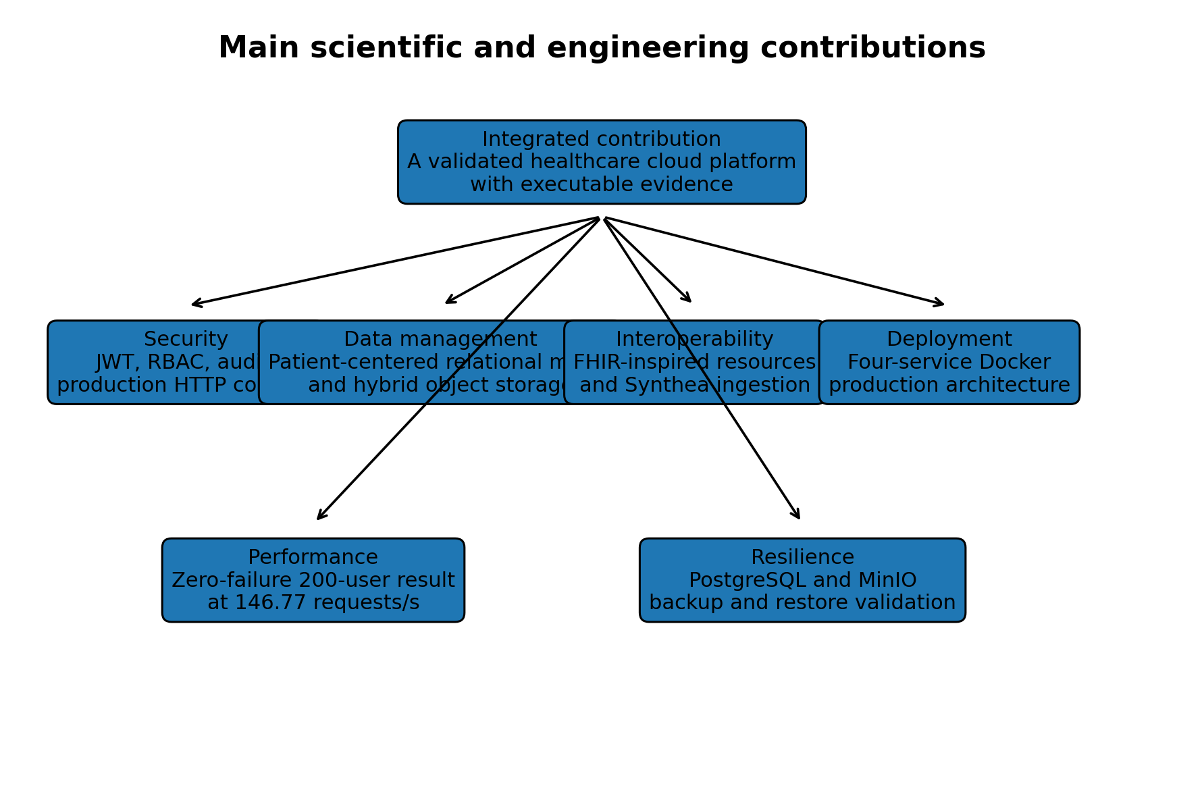
Figure 2. Principal scientific and engineering contributions of the research.

4.1 Security contribution
The project integrates password protection, JWT-based authentication, active-account checking, six operational roles, route-level and router-level RBAC, production HTTP security controls, and audit logging. The contribution is not merely architectural. It is supported by executable security evidence, including 17 of 17 production HTTP checks and 9 of 9 strict audit checks.

4.2 Healthcare data-management contribution
The platform provides a patient-centered relational model for encounters, conditions, observations, prescriptions, diagnostic-report metadata, users, roles, and audit records. Diagnostic-report bytes are separated from structured metadata and stored privately in MinIO. File size and SHA-256 values connect the relational and object-storage layers.

4.3 FHIR-inspired interoperability contribution
The implementation exposes selected FHIR-named resources and Bundle-like responses for Patient, Encounter, Observation, MedicationRequest, and Condition, together with a Patient/$everything operation and minimal capability metadata. This provides an interoperability foundation while remaining explicitly narrower than full HL7 FHIR conformance.

4.4 Containerization and cloud-readiness contribution
The system is packaged as a four-service Docker Compose architecture. Nginx provides the external entry point, the backend mediates application access, and PostgreSQL and MinIO remain on an internal data network. Named volumes, health checks, dependencies, restart policies, environment-driven configuration, Git tags, and release history support reproducibility and deployment readiness.

4.5 Performance and scalability contribution
The study preserves both the failed initial 200-user experiment and the optimized result. The initial run produced 357 failed requests, 23.99% failure rate, mean latency of 33,132.66 ms, and 5.23 requests per second. The optimized run completed 43,814 requests with zero failures, 29.27 ms mean latency, 110 ms P95 latency, and 146.77 requests per second.
This before-and-after evidence demonstrates the identification and remediation of a software bottleneck. It does not demonstrate unlimited scalability or performance on different infrastructure.

4.6 Backup and disaster-recovery contribution
The recovery contribution is based on restoration rather than backup creation alone. PostgreSQL was restored into a temporary database and verified across ten tables. MinIO objects were restored into a temporary bucket and checked for count, size, and SHA-256 integrity. Temporary recovery targets were removed after validation.

5. Integrated Validation Outcome
Validation | Checks | Status
Production HTTP security | 17/17 | PASS
Diagnostic report strict audit | 9/9 | PASS
Diagnostic report end-to-end storage | 10/10 | PASS
MinIO service lifecycle | 4/4 | PASS
PostgreSQL backup and restore | 19/19 | PASS
MinIO backup and restore | 23/23 | PASS
Optimized 200-user load | 1/1 | PASS

The seven validations contain 83 recorded checks, all of which passed. These checks represent heterogeneous forms of evidence and should not be interpreted as a statistical score. Their value lies in the combined coverage of security, auditability, storage, recovery, and performance.
The strongest conclusion is cross-domain consistency. Authorized operations succeeded, unauthorized operations were denied, stored bytes matched recorded metadata, backups were recoverable, and the optimized workload met the measured reliability target.

6. Study Limitations and Threats to Generalization
- The final evidence describes one local Docker host and must be repeated on the UESTC VM.
- The performance results are consolidated single-run scenarios without repeated-run confidence intervals.
- The measured workload does not represent every write-heavy, upload-heavy, or geographically distributed use case.
- Security tests validate selected controls but do not prove compliance with a healthcare regulation or certification framework.
- The production reverse proxy remains HTTP-only in the supplied local configuration.
- The recovery tests do not demonstrate recovery from complete host loss, off-site backup retention, or point-in-time recovery.
- The MinIO recovery sample contains seven small objects totaling 488 bytes.
- The resource snapshots are not synchronized time-series measurements and should not support strong efficiency claims.
- Verified monthly infrastructure and operational costs were not available.
- The FHIR-inspired layer is partial and does not demonstrate full conformance.
- The supplied evidence does not include a demonstrated Synthea Condition importer.
- High availability, multi-node database replication, and automatic failover were outside the validated scope.
These limitations narrow the claims that can be made, but they do not invalidate the measured results. They define the boundary between the completed local research contribution and the next deployment phase.

7. Future Work
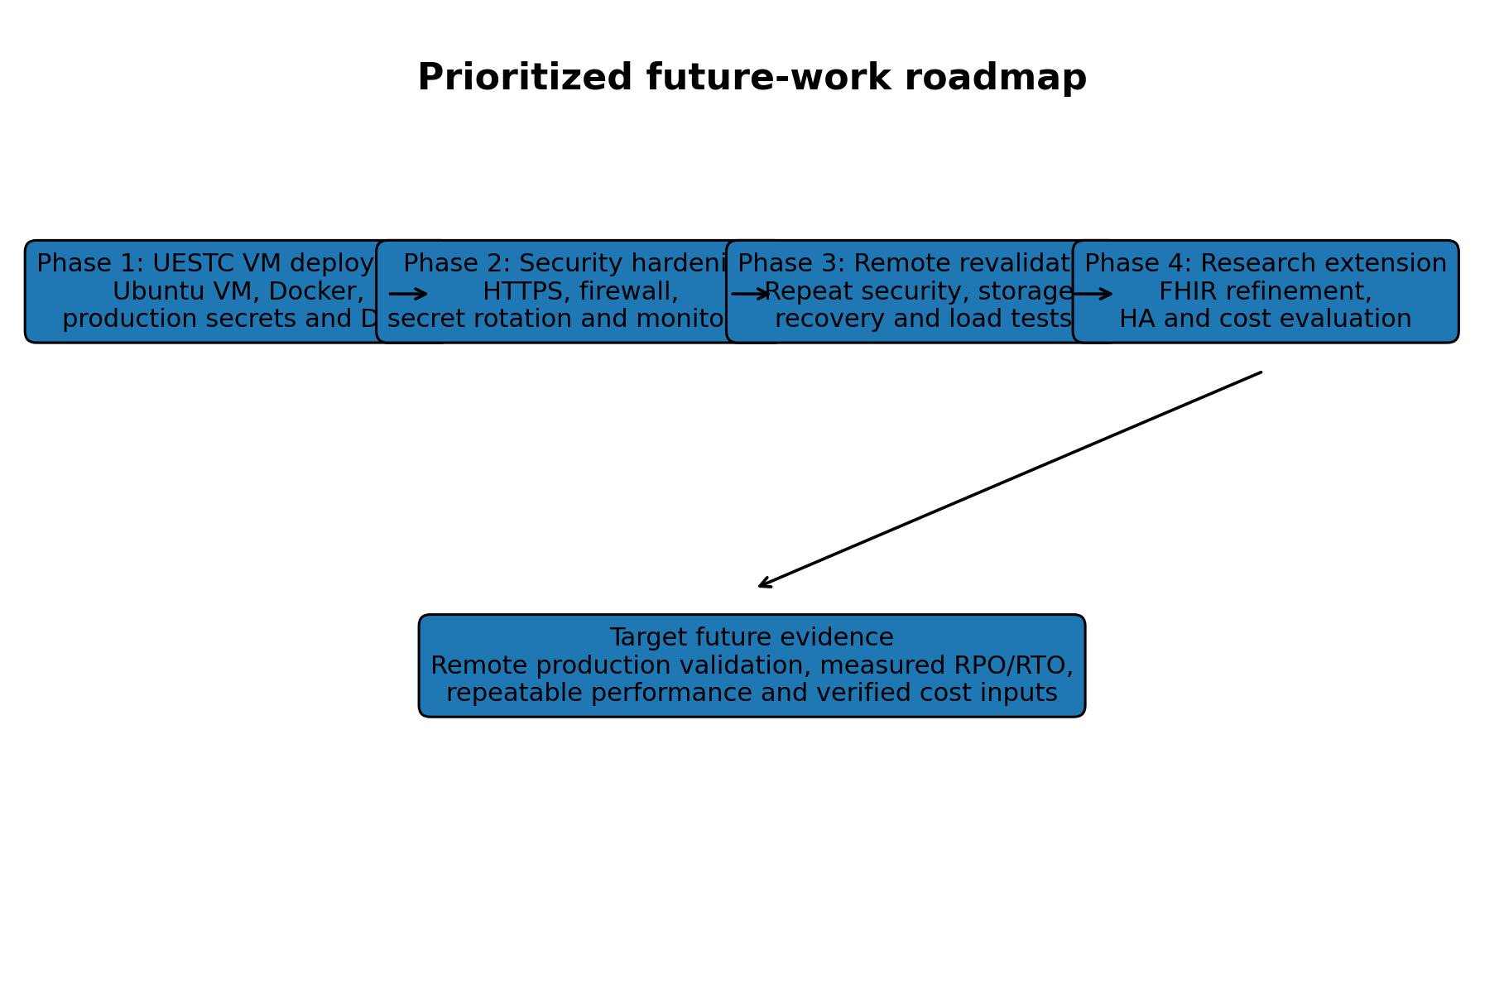
Figure 3. Prioritized roadmap from the validated local platform to remote production evidence.

7.1 Deployment on the UESTC virtual machine
The immediate next step is deployment of the tagged production release on the institutionally provided UESTC virtual machine. The deployment should record the operating system, CPU, memory, storage, network configuration, public or institutional IP, Docker versions, release commit, and migration revision.
Remote deployment action | Required evidence
Provision and harden the VM | Host specification, SSH-key access, operating-system updates and firewall state
Install the application stack | Docker and Compose versions, release tag, container status and health
Configure production secrets | New remote-only values, protected permissions and rotation record
Configure domain and HTTPS | DNS record, valid certificate, HTTP redirect and renewal process
Migrate or restore data | Alembic head, PostgreSQL integrity and MinIO bucket validation
Repeat validation | Remote security, storage, recovery and performance result files

7.2 Future security improvements
- Deploy TLS and validate HSTS over HTTPS.
- Introduce dedicated secret management or protected institutional secret storage.
- Define secret rotation and incident-response procedures.
- Add rate limiting, account lockout or throttling, and multifactor authentication where appropriate.
- Forward audit and system logs to centralized monitoring.
- Add image, dependency, and vulnerability scanning.
- Evaluate database-level controls for stronger audit immutability.

7.3 Future interoperability improvements
- Declare the target FHIR release and supported implementation subset.
- Expand capability metadata to enumerate resources, interactions, search parameters, formats, and security.
- Correct search Bundle totals and add pagination links.
- Extend Patient/$everything to include Conditions and DiagnosticReports with date bounds.
- Add a FHIR DiagnosticReport representation and controlled binary retrieval strategy.
- Add terminology validation for LOINC, RxNorm, and condition code systems where practical.
- Add and validate the missing Condition ingestion workflow.

7.4 Future performance and cost evaluation
- Repeat each load scenario multiple times and report variability.
- Add mixed read/write, file-upload, role-specific, endurance, and recovery-under-load scenarios.
- Collect synchronized CPU, memory, network, storage, database-pool, and latency time series.
- Compare local and UESTC VM performance using the same workload.
- Define target service-level objectives for availability and latency.
- Populate the cost model with verified infrastructure and operational costs.
- Use realistic utilization rather than treating maximum Locust throughput as continuous monthly traffic.

7.5 Future resilience and operational work
- Create encrypted off-host PostgreSQL and MinIO backups.
- Define backup schedules, retention rules, and automated failure alerts.
- Measure recovery point objective and recovery time objective.
- Evaluate PostgreSQL write-ahead-log archiving for point-in-time recovery.
- Perform restoration on a clean second host.
- Document an operational recovery runbook and responsible roles.
- Evaluate high availability only after the remote single-host baseline is stable.

8. Final Research Statement
The research demonstrates that a modular open-source healthcare platform can integrate structured clinical data, protected object storage, role-based security, auditability, interoperability-oriented APIs, reproducible synthetic-data ingestion, containerized deployment, executable disaster recovery, and measured scalability within one coherent implementation.
The final evidence is strong because the platform was not evaluated through a single success criterion. It was assessed through security controls, authorization outcomes, storage checksums, table-level restoration, object-level restoration, container health, and authenticated load testing.
The completed work establishes a validated local foundation. The next research milestone is to transfer that foundation to the UESTC virtual machine and reproduce the evidence under the real remote deployment conditions. Only after that step should the platform be described as institutionally cloud-deployed.

Appendix A. Evidence Traceability
Conclusion area | Primary evidence
Overall validation | docs/evidence/final_project_status.txt and final_validation_matrix.md
Performance | docs/evidence/performance_consolidated_summary.md
Production HTTP security | docs/evidence/production_security_summary.txt
PostgreSQL recovery | docs/evidence/postgres_backup_restore_summary.txt
MinIO recovery | docs/evidence/minio_backup_restore_summary.txt
Resource and cost method | docs/evidence/resource_cost_efficiency_summary.md
Backend organization | docs/02_implementation/backend_structure.txt
Container services | docs/02_implementation/docker_services.txt
Migration state | docs/02_implementation/alembic_current.txt
Prior thesis chapters | Seven Word chapters listed in docs/08_thesis_text

Appendix B. Repository Completion Note
The supplied Git history confirms commits for the seven preceding thesis chapters. At the time of the source extraction, general_conclusion_source_extract.txt and performance_source_extract.txt were local untracked working files. They are evidence-preparation artifacts rather than thesis deliverables and should be removed or ignored after use.

