INTEGRATED VALIDATION RESULTS
AND DISCUSSION
Healthcare Cloud Platform
An integrated interpretation of security, auditability, storage integrity, disaster recovery, scalability, and local production readiness
Final validation result: 83/83 recorded checks passed across seven validations

Executive Summary
This chapter integrates the final validation evidence for the Healthcare Cloud Platform. Seven validations were assessed across security, storage, disaster recovery, and performance. The matrix records 83 passing checks out of 83, with no failed, pending, or review status.
Production HTTP validation passed 17 of 17 checks, including backend health, browser security headers, disabled production documentation routes, CORS behavior, trusted-host enforcement, and restoration of the development configuration. Diagnostic-report audit validation passed 9 of 9 checks.
Storage validation demonstrated authorized upload, metadata persistence, PostgreSQL checksum and file-size accuracy, MinIO object integrity, authorized download, unauthenticated rejection, role-based denial, and cleanup. PostgreSQL recovery passed 19 of 19 checks and MinIO recovery passed 23 of 23 checks.
The optimized 200-user workload completed 43,814 requests with no failures, 146.77 requests per second, mean latency of 29.27 ms, P95 of 110 ms, and P99 of 240 ms. This result followed an initial 200-user test with 357 failures and a 23.99% failure rate.
The evidence supports a local production-readiness claim for the measured Docker environment. It does not establish public cloud deployment, full regulatory compliance, Internet-facing TLS readiness, long-duration availability, point-in-time recovery, or financial cost-effectiveness.
Domain | Passed | Total | Integrated interpretation | Status
Security | 26 | 26 | HTTP controls and strict audit | PASS
Storage | 14 | 14 | End-to-end report storage and MinIO lifecycle | PASS
Disaster recovery | 42 | 42 | PostgreSQL and MinIO restoration | PASS
Performance | 1 | 1 | Optimized 200-user load | PASS

1. Integrated Evaluation Framework
The evaluation treats production readiness as a cross-domain property. A platform cannot be considered ready merely because its API responds, its containers run, or its load test succeeds. Security, integrity, recoverability, and performance must operate together.
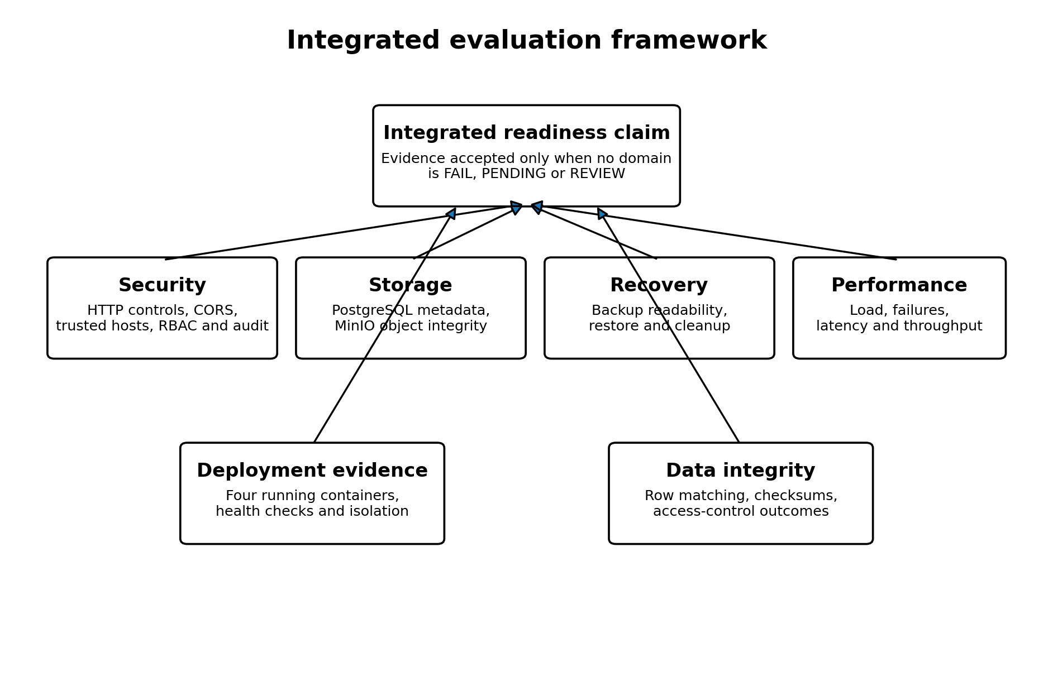
Figure 1. Integrated evaluation framework used to interpret the seven final validations.
The final matrix applies a strict rule: a production-readiness claim is justified only when no item is marked FAIL, PENDING, or REVIEW. This rule was satisfied in the local validated environment.
- Security controls must prevent unauthorized access and unsafe production exposure.
- Storage validation must show that metadata and binary objects remain consistent.
- Recovery validation must prove that backups can be restored into isolated targets.
- Performance validation must measure useful throughput rather than raw request volume alone.
- Deployment evidence must show that the intended production services actually run together.

2. Final Validation Matrix
Domain | Validation | Checks | Status
Security | Production HTTP security | 17/17 | PASS
Security | Diagnostic report strict audit | 9/9 | PASS
Storage | Diagnostic report end-to-end storage | 10/10 | PASS
Storage | MinIO service lifecycle | 4/4 | PASS
Disaster recovery | PostgreSQL backup and restore | 19/19 | PASS
Disaster recovery | MinIO backup and restore | 23/23 | PASS
Performance | Optimized 200-user load | 1/1 | PASS

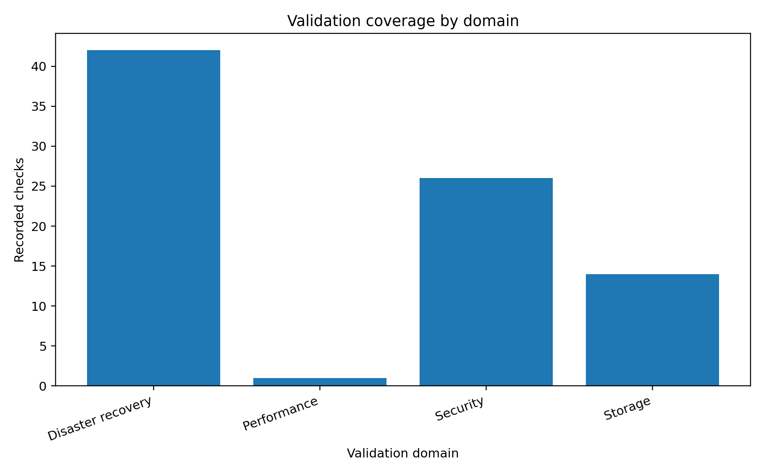
Figure 2. Recorded validation checks grouped by domain.
The check counts are heterogeneous. A security check, a restored database row-count comparison, and the optimized performance scenario do not represent identical units of assurance. The total of 83 is therefore a coverage count, not a statistical score.

3. Security and Access-Control Results

3.1 Production HTTP controls
All 17 production HTTP checks passed. The backend returned HTTP 200 on the health endpoint. The tested responses included X-Content-Type-Options, X-Frame-Options, Referrer-Policy, Content-Security-Policy, Permissions-Policy, Strict-Transport-Security, and Cache-Control.
Control group | Observed outcome | Status
Security headers | Required values present | PASS
Server disclosure | Uvicorn not disclosed | PASS
Swagger, ReDoc and OpenAPI | HTTP 404 in production | PASS
Trusted CORS origin | Allowed | PASS
Untrusted CORS origin | Not allowed | PASS
Trusted host | HTTP 200 | PASS
Untrusted host | HTTP 400 | PASS
Configuration restoration | Development environment healthy after test | PASS

The presence of a Strict-Transport-Security header in an HTTP validation does not prove that TLS was deployed. HSTS becomes operationally meaningful only when the application is served over HTTPS.

3.2 RBAC coverage
The RBAC inventory contains 31 operations. Twenty-nine clinical, FHIR, storage, and update operations have explicit role lists at route or router scope. The login and current-user routes do not use route-level role lists because they serve authentication and identity-resolution functions.
The role matrix demonstrates differentiated permissions. Examples include diagnostic-report upload for Admin, Doctor, and Lab Staff; prescription creation for Admin and Doctor; and prescription updates for Admin, Doctor, and Pharmacist.

4. Audit and Diagnostic-Report Validation
The diagnostic-report workflow provides a high-value cross-domain test because it combines RBAC, PostgreSQL metadata, MinIO object storage, SHA-256 integrity, downloads, and audit events.
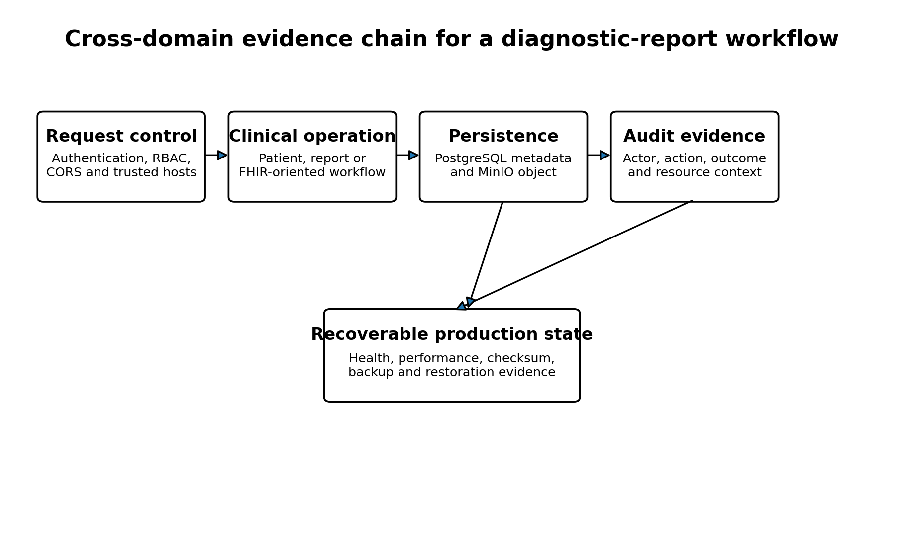
Figure 3. Cross-domain evidence chain for a diagnostic-report workflow.
End-to-end check | Observed outcome | Status
Authorized upload | HTTP 201 | PASS
Authorized metadata read | HTTP 200 | PASS
PostgreSQL metadata | Row present | PASS
Database checksum | Expected and actual SHA-256 matched | PASS
Database file size | 67 bytes matched | PASS
MinIO integrity | Expected and actual SHA-256 matched | PASS
Authorized download | HTTP 200 and matching bytes | PASS
Download without JWT | HTTP 401 | PASS
Pharmacist download | HTTP 403 | PASS
Cleanup | Expected final count retained | PASS

The strict audit validation passed 9 of 9 checks. The combined evidence shows that a permitted actor can upload and retrieve a report, a prohibited actor is denied, the binary object matches its metadata, and security-relevant actions are recorded.

5. PostgreSQL and MinIO Storage Integrity

5.1 MinIO lifecycle
The MinIO lifecycle validation passed four checks: bucket existence, bucket access, object upload and download with matching SHA-256, and object deletion.
This validates functional object persistence and cleanup. It does not measure large-object throughput, versioning, retention, encryption at rest, or multi-node MinIO behavior.

5.2 PostgreSQL table-level integrity
The supplied table comparison lists nine application and security tables containing 1,581,926 rows. Every listed source count matched the restored count with a difference of zero.
Table | Source rows | Restored rows | Difference | Status
patients | 117,581 | 117,581 | 0 | PASS
encounters | 121,649 | 121,649 | 0 | PASS
conditions | 643,513 | 643,513 | 0 | PASS
observations | 592,173 | 592,173 | 0 | PASS
prescriptions | 66,458 | 66,458 | 0 | PASS
diagnostic_reports | 5 | 5 | 0 | PASS
audit_logs | 40,535 | 40,535 | 0 | PASS
users | 6 | 6 | 0 | PASS
roles | 6 | 6 | 0 | PASS

The newer PostgreSQL summary reports ten verified tables and 19 passing checks. The uploaded integrated extract does not enumerate the tenth table in its table-level CSV. The likely additional table is the Alembic migration table, but this chapter does not treat that inference as a confirmed row-level result.

6. Backup and Restoration Results

6.1 PostgreSQL recovery
The current PostgreSQL recovery summary reports a 52,847,810-byte custom archive with SHA-256 2ccded46a6fd14c6ec584bf2bed7fee4c82f37518b5908295ec7184430bbaec3. Ten tables matched, all 19 checks passed, and the temporary restore database was removed.
The integrated evidence also contains an earlier nine-table backup result with a slightly different archive size and checksum. This is historical evidence. The later 10-table, 19-check result is the current authoritative summary.

6.2 MinIO recovery
The MinIO recovery test backed up seven objects totaling 488 bytes, restored seven objects totaling 488 bytes, verified all 23 checks, and removed the temporary bucket.
Recovery target | Backup evidence | Restore evidence | Checks | Status
PostgreSQL | 52,847,810-byte archive and SHA-256 | 10 tables matched; temporary database removed | 19/19 | PASS
MinIO | 7 objects; 488 bytes | 7 objects; 488 bytes; temporary bucket removed | 23/23 | PASS

The recovery evidence proves local functional restoration. It does not demonstrate recovery from total host loss, off-site backups, point-in-time database recovery, encrypted retention, or measured RPO and RTO.

7. Performance and Scalability Results
Scenario | Requests | Failures | Failure rate | Avg ms | P95 ms | P99 ms | RPS
10 users | 465 | 0 | 0.00% | 26.72 | 71 | 290 | 7.94
50 users | 4557 | 0 | 0.00% | 19.48 | 59 | 230 | 38.35
100 users | 13695 | 0 | 0.00% | 39.27 | 130 | 450 | 76.46
200 users initial | 1488 | 357 | 23.99% | 33,132.66 | 90,000 | 91,000 | 5.23
200 users optimized | 43814 | 0 | 0.00% | 29.27 | 110 | 240 | 146.77

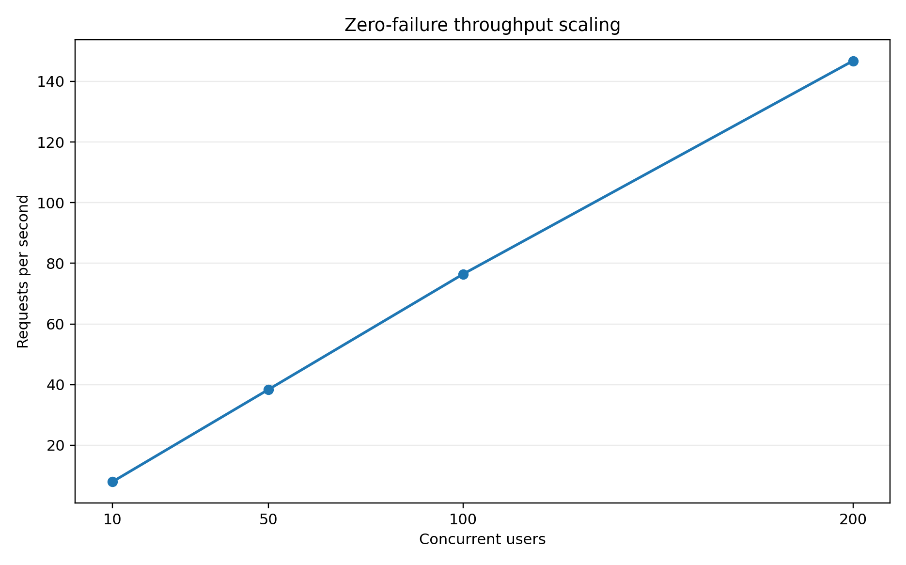
Figure 4. Throughput scaling across all zero-failure scenarios.
Throughput increased from 7.94 requests per second at 10 users to 146.77 requests per second at the optimized 200-user load. The successful scenarios completed with zero failures.
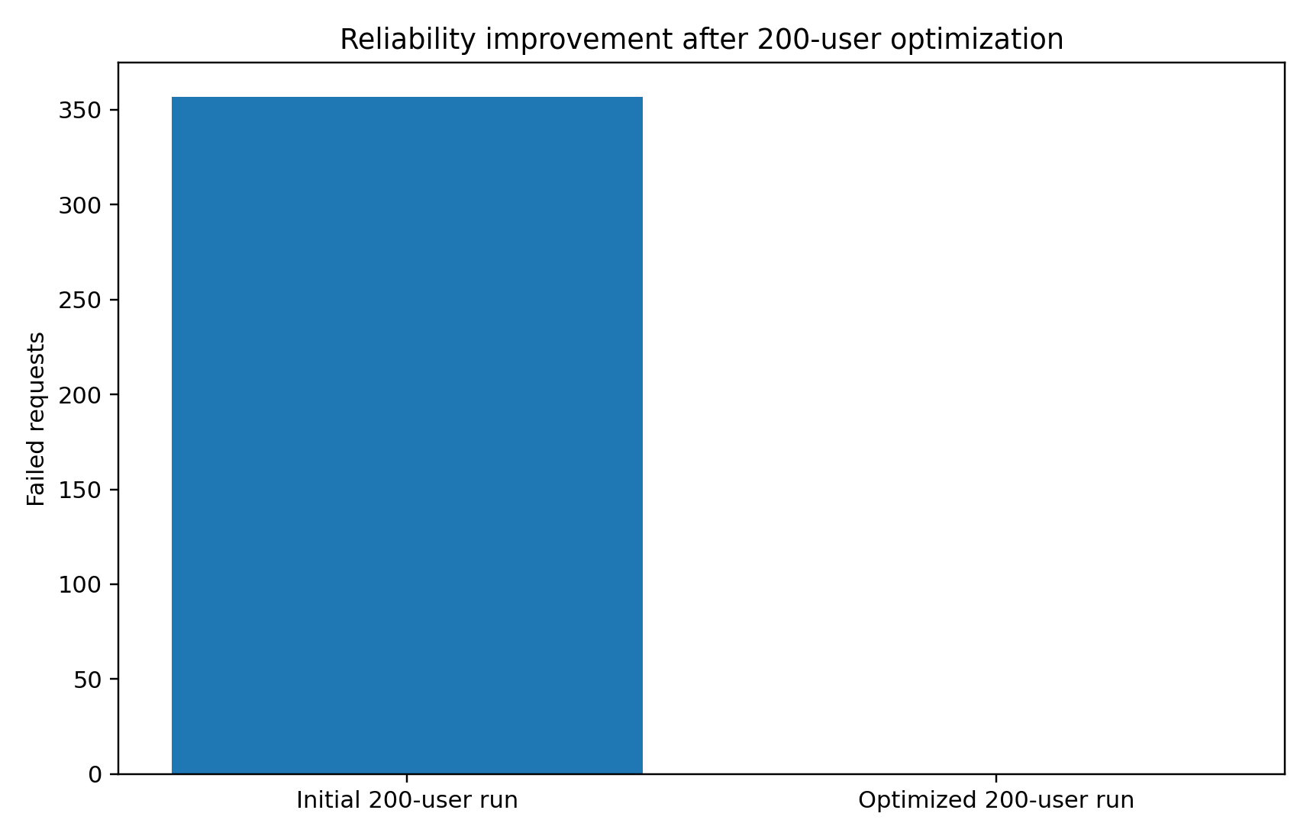
Figure 5. Elimination of failed requests after optimization of the 200-user configuration.
The initial 200-user run produced 357 failures, a 23.99% failure rate, mean latency of 33,132.66 ms, and raw throughput of 5.23 requests per second. After remediation, failures fell to zero, mean latency fell to 29.27 ms, and throughput increased by 141.54 requests per second.
The performance evidence supports scalability for the measured authenticated workload. It does not establish performance for write-heavy traffic, geographically distributed clients, long endurance tests, a different host, or the future UESTC VM.

7.1 Resource and cost-efficiency interpretation
Resource snapshots were available for three scenarios. The optimized 200-user snapshot reported only 0.35% backend CPU while processing 146.77 requests per second. This point-in-time value is not credible as a steady-state CPU measurement and should not be used as a headline efficiency claim.
A monetary cost model was defined, but verified monthly infrastructure and operations costs were not provided. Financial cost-effectiveness therefore remains uncalculated.

8. Production-Container Readiness
The production snapshot shows four active containers: Nginx, the FastAPI backend, PostgreSQL, and MinIO. The backend and PostgreSQL were reported healthy. Nginx exposed host port 8080, while the backend, database, and MinIO remained internally reachable.
Container | Observed status | Exposure
healthcare_prod_nginx | Up | Host port 8080 to container port 80
healthcare_prod_backend | Up and healthy | Internal port 8000
healthcare_prod_postgres | Up and healthy | Internal port 5432
healthcare_prod_minio | Up | Internal port 9000

The saved command column contains character-encoding corruption in truncated text. This does not affect the service-status interpretation, but the inventory should be regenerated in clean UTF-8 before final publication.

9. Cross-Domain Interpretation
The strongest result is not any single PASS outcome. It is the consistency among the domains. The same platform that passed access-control tests also preserved report bytes, recorded audit events, restored its database and object store, and sustained the target 200-user workload after optimization.
Risk | Control or evidence | Integrated result
Unauthorized access | JWT and RBAC | 401 and 403 outcomes were observed in the report workflow
Object corruption | SHA-256 in PostgreSQL and MinIO | Stored and downloaded bytes matched
Metadata-object divergence | End-to-end storage test | File size and checksum matched across layers
Database loss | PostgreSQL custom archive and restore | 10 tables matched; 19/19 checks
Object-store loss | MinIO backup and temporary restore | 7 objects and 488 bytes restored
Load-induced failure | Locust testing and optimization | 357 failures reduced to zero

10. Objectives and Achieved Outcomes
Project objective | Evidence | Assessment
Implement secure authentication and role-based access | JWT, active-user resolution and route/router role restrictions | Achieved in tested scope
Protect healthcare records and files | PostgreSQL metadata, private MinIO objects and SHA-256 verification | Achieved in tested scope
Provide auditability | Strict diagnostic-report audit validation passed 9/9 | Achieved in tested scope
Demonstrate recoverability | PostgreSQL 19/19 and MinIO 23/23 | Achieved locally
Demonstrate scalability | Optimized 200-user load at 146.77 RPS and zero failures | Achieved for measured workload
Prepare a production deployment architecture | Four-service isolated Docker Compose stack | Achieved locally
Deploy to institutional cloud infrastructure | UESTC VM not yet available | Pending external dependency
Quantify monetary cost-effectiveness | Method defined but cost inputs absent | Not yet achieved

11. Research and Engineering Contributions
- A reproducible four-service healthcare platform integrating FastAPI, PostgreSQL, MinIO, Nginx, Alembic, JWT, RBAC, and audit logging.
- A patient-centered data platform validated with large synthetic clinical tables and a FHIR-inspired read layer.
- A hybrid report-storage design that validates both relational metadata and private object bytes.
- A cross-domain validation matrix linking security, storage, recovery, and performance evidence.
- A before-and-after scalability experiment that preserves the failed 200-user run as bottleneck evidence and the optimized run as remediation evidence.
- Executable disaster-recovery tests that restore PostgreSQL and MinIO into temporary isolated targets rather than merely creating backups.

12. Threats to Validity and Limitations
- The results describe one local Docker environment and cannot be generalized to the future UESTC VM without retesting.
- The performance scenarios are consolidated single-run results without repeated-run confidence intervals.
- The workload is predominantly authenticated read traffic and does not represent every clinical write workflow.
- The security tests validate selected controls but do not prove legal or regulatory compliance.
- The HSTS header was observed, but the supplied production deployment remains HTTP-only at the Nginx boundary.
- The recovery tests are local and do not demonstrate complete-host disaster recovery or off-site retention.
- The MinIO recovery sample contains only seven small objects totaling 488 bytes.
- The resource snapshots are not synchronized time-series measurements.
- The table-level restore CSV lists nine tables, while the newer recovery summary reports ten tables.
- No verified monetary cost inputs were available.
- The saved production container inventory contains encoding corruption in the command column.

13. Recommendations for Remote VM Validation
Priority | Recommended validation step
P1 | Deploy the tagged production release to the UESTC VM and record the exact host specification.
P1 | Configure HTTPS, domain routing, firewall rules, and new production-only secrets.
P1 | Repeat all seven validations against the remote endpoint.
P1 | Synchronize CPU, memory, disk, network, database-pool, and latency monitoring with the load test.
P1 | Create encrypted off-host PostgreSQL and MinIO backups and perform restoration on a clean host.
P2 | Repeat each performance scenario at least three times and report uncertainty.
P2 | Add write-heavy, mixed-role, upload, and endurance workloads.
P2 | Define and measure recovery point and recovery time objectives.
P2 | Regenerate UTF-8 evidence inventories and preserve immutable test artifacts.
P3 | Populate the cost model with verified institutional or cloud prices and realistic utilization assumptions.

14. Overall System-Readiness Conclusion
The final matrix records 83 of 83 checks passed across seven validations, with no failed, pending, or review status. Security controls, diagnostic-report auditability, PostgreSQL-MinIO consistency, backup restoration, and optimized 200-user performance all passed.
The platform is therefore defensibly described as locally production-ready and cloud-ready for the measured configuration. This conclusion is narrower than full production certification. It does not assert public cloud deployment, legal compliance, high availability, complete disaster recovery, or universal scalability.
The next decisive milestone is not further local feature expansion. It is controlled deployment to the institutional VM followed by repetition of the complete validation suite under the actual remote hardware, network, security, backup, and operational conditions.

Appendix A. Evidence Traceability
Claim area | Primary evidence
Overall validation status | docs/evidence/final_project_status.txt
Final validation matrix | docs/evidence/final_validation_matrix.md
HTTP security | docs/evidence/production_security_summary.txt and docs/tables/production_security_results.csv
Diagnostic-report storage | docs/tables/diagnostic_report_e2e_results.csv
MinIO lifecycle | docs/tables/minio_storage_results.csv
PostgreSQL recovery | docs/evidence/postgres_backup_restore_summary.txt
MinIO recovery | docs/evidence/minio_backup_restore_summary.txt
Table-level restore | docs/tables/backup_restore_validation.csv
Performance | docs/evidence/performance_consolidated_summary.md and docs/tables/performance_consolidated_summary.csv
Resource interpretation | docs/evidence/resource_cost_efficiency_summary.md
RBAC coverage | docs/tables/rbac_matrix.csv
Container state | docs/02_implementation/production_containers.txt
API inventory | docs/02_implementation/api_routes_inventory.txt
Migration state | docs/02_implementation/alembic_current.txt

Appendix B. Consolidated Headline Metrics
Metric | Validated value
Final validation checks | 83/83 passed
Unresolved validation items | 0
HTTP security | 17/17
Strict audit | 9/9
Diagnostic-report storage | 10/10
MinIO lifecycle | 4/4
PostgreSQL recovery | 19/19
MinIO recovery | 23/23
Maximum zero-failure load | 200 concurrent users
Optimized throughput | 146.77 requests/s
Optimized P95 latency | 110 ms
Failed requests after optimization | 0
Listed restored rows | 1,581,926 across 9 enumerated tables

