HEALTHCARE DATA MODEL,
FHIR INTEROPERABILITY AND
SYNTHEA DATA INGESTION
Healthcare Cloud Platform
A source-grounded analysis of the PostgreSQL clinical schema, hybrid object storage, FHIR-inspired API mappings, migration control, and synthetic-data ingestion workflow
Validated clinical scale: 1,541,374 rows across patients, encounters, conditions, observations and prescriptions

Executive Summary
The Healthcare Cloud Platform implements a normalized relational model for patients, encounters, conditions, observations, prescriptions, diagnostic-report metadata, users, roles, and audit logs. Clinical records are stored in PostgreSQL, while binary diagnostic objects are stored privately in MinIO and referenced through bucket, object-key, size, content-type, and SHA-256 metadata.
The supplied validated table inventory contains 117,581 patients, 121,649 encounters, 643,513 conditions, 592,173 observations, and 66,458 prescriptions. Foreign keys preserve core subject, encounter, prescriber, uploader, role, and audit relationships.
The interoperability layer exposes JSON resources named Patient, Encounter, Observation, MedicationRequest, and Condition, together with search bundles, a minimal CapabilityStatement, and a Patient/$everything collection. The implementation is explicitly lightweight and FHIR-inspired. The source does not support a claim of full HL7 FHIR conformance.
The Synthea import pipeline validates required files and headers, imports patients before dependent entities, maps external identifiers to internal keys, performs create-or-update logic, and tracks created, updated, skipped, and skip-reason counts. The uploaded source demonstrates ingestion for patients, encounters, observations, and medications. It does not show the importer that produced the condition records present in the database.
Domain | Implemented evidence | Important qualification
Relational model | Nine application and security entities plus Alembic migration state | SQLAlchemy relationships are mostly represented by foreign keys rather than rich ORM relationships
FHIR surface | Patient, Encounter, Observation, MedicationRequest, Condition and Bundle-like responses | FHIR-inspired JSON, not demonstrated full conformance
Hybrid storage | PostgreSQL metadata plus private MinIO objects and SHA-256 verification | Binary files are not represented through a FHIR Binary or full DiagnosticReport resource
Synthea ingestion | Patients, encounters, observations and medications | Condition ingestion source is absent from the uploaded extract

1. Healthcare Data Architecture
The platform separates structured clinical and security data from binary objects. PostgreSQL is the authoritative store for identifiers, relationships, timestamps, codes, statuses, values, user roles, audit events, and diagnostic-report metadata. MinIO stores the report bytes. The application backend is the only component exposed to clients for report upload and download.
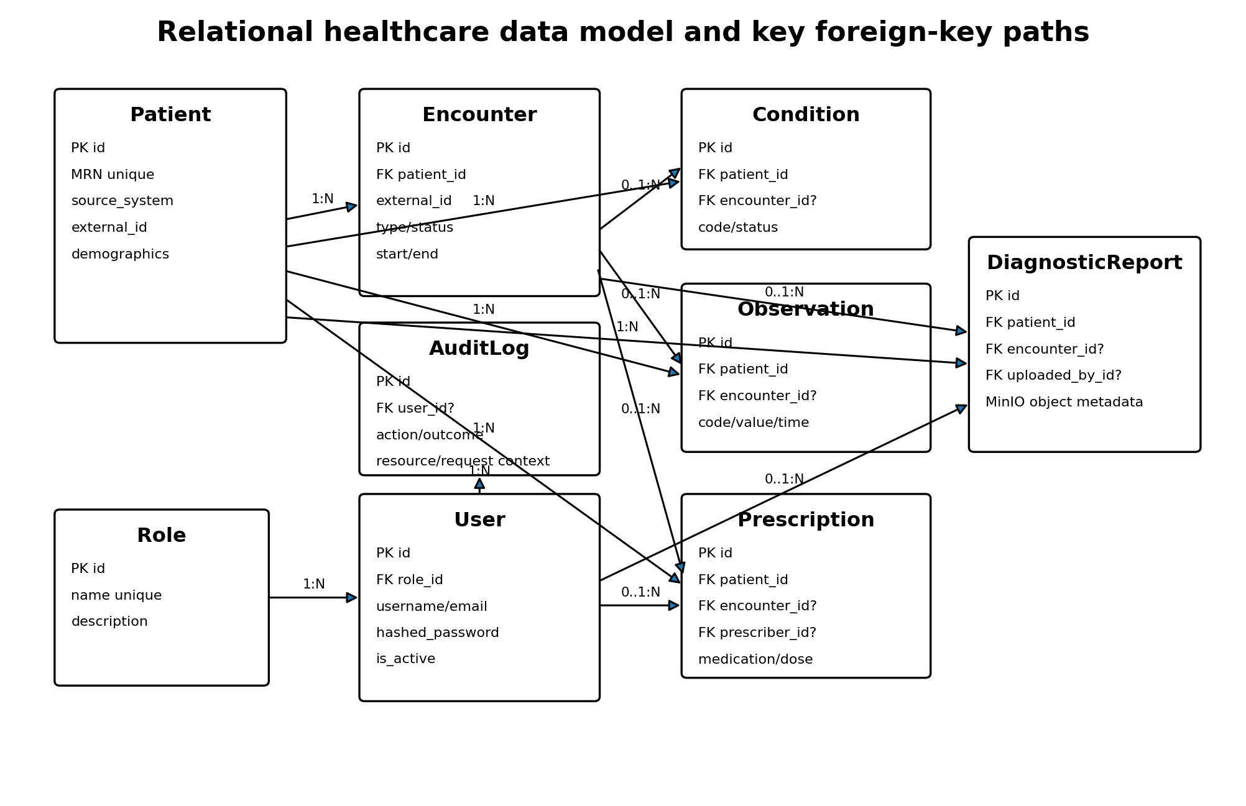
Figure 1. Relational healthcare data model and principal foreign-key paths.
The database design follows a patient-centered structure. Patient is the principal subject entity. Encounters are mandatory children of patients. Conditions, observations, prescriptions, and diagnostic reports are linked to a patient and may optionally reference an encounter. Prescriptions may reference a prescriber, diagnostic reports may reference an uploader, and audit records may reference the user responsible for an event.

2. Core PostgreSQL Clinical Entities

2.1 Patient
The Patient table uses an integer primary key and a globally unique medical record number. The combination of source_system and external_id is also unique, supporting multi-source ingestion without treating external identifiers as globally unique. Demographic fields include name, date of birth, gender, phone, email, address, city, state, postal code, and country.
Patient design element | Implementation
Primary identifier | Integer id
Clinical identifier | Unique medical_record_number
Source identity | Unique pair: source_system + external_id
Demographics | Name, birth date, gender, contact and address fields
Lifecycle metadata | created_at and updated_at

2.2 Encounter
Encounter requires a valid patient_id and records encounter type, status, start time, optional end time, and optional location. API validation prevents an end time earlier than the start time. The source-system and external-identifier pair is unique.

2.3 Condition
Condition records contain patient and optional encounter relationships, code and code-system values, display text, clinical status, optional verification status, onset, abatement, and recorded times. Indexes support searches by patient, code, status, onset time, source system, external identifier, and encounter.

2.4 Observation
Observation supports numeric and textual results. A create request must supply at least one of value_numeric or value_text. Numeric values use Numeric(18,6). The record also supports unit, reference range, category, code, code system, display name, status, observation time, and issue time. A composite patient-and-observed-time index supports chronological patient queries.

2.5 Prescription
Prescription links a medication order to a patient, an optional encounter, and an optional prescriber. It records medication identity, dosage, unit, route, frequency, instructions, status, authored time, and optional treatment dates. Validation requires the end date not to precede the start date and requires a dosage unit whenever a dosage amount is present.
Entity | Validated rows | Key integrity feature
Patients | 117,581 | Unique MRN and source identity
Encounters | 121,649 | Required patient relation
Conditions | 643,513 | Patient plus optional encounter
Observations | 592,173 | Numeric or textual clinical result
Prescriptions | 66,458 | Patient, optional encounter and prescriber

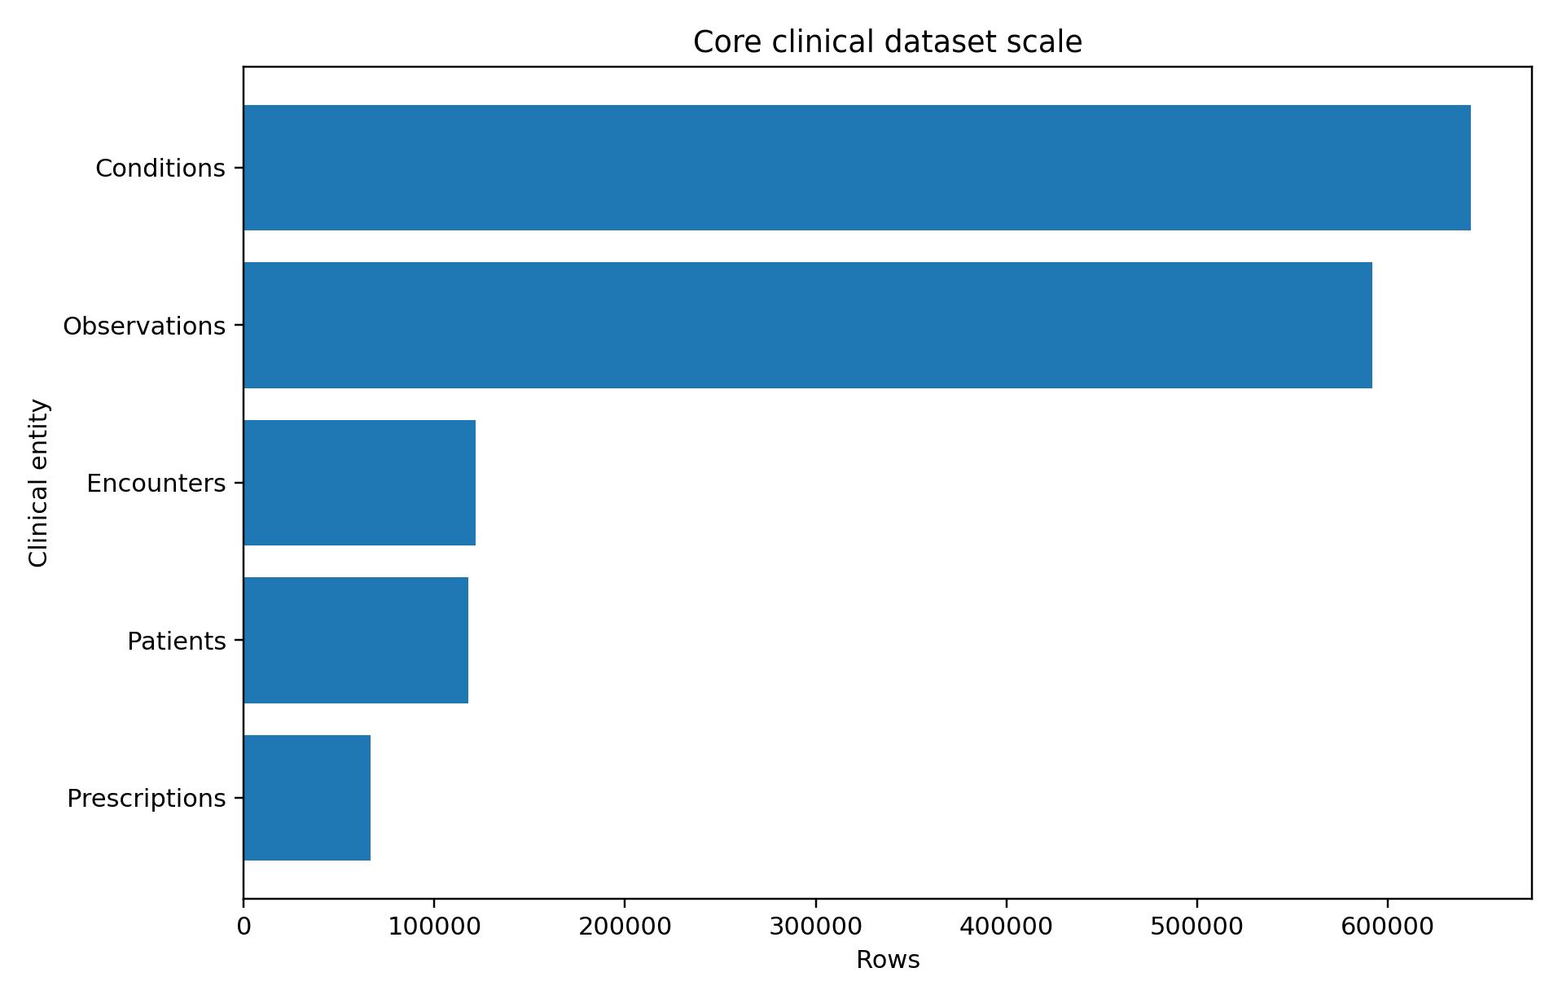
Figure 2. Core clinical dataset scale based on the validated database inventory.

3. Security and Accountability Entities

3.1 Roles and users
Role contains a unique name and optional description. User contains unique username and email fields, a hashed password, an active-state flag, and a mandatory foreign key to Role. The demonstrated design supports the six operational roles used elsewhere in the project.

3.2 Audit logs
AuditLog stores action, outcome, resource type, resource identifier, HTTP method, endpoint, IP address, user agent, details, and creation time. User linkage is optional so that events can still be recorded when a user identity is unavailable. Composite indexes support user-time and action-time investigations.
The model documentation calls audit records immutable, but the uploaded database definition does not show a database trigger, append-only permission model, or update/delete prohibition. Immutability is therefore an intended application property rather than a demonstrated database-enforced guarantee.

4. Hybrid Diagnostic-Report Storage
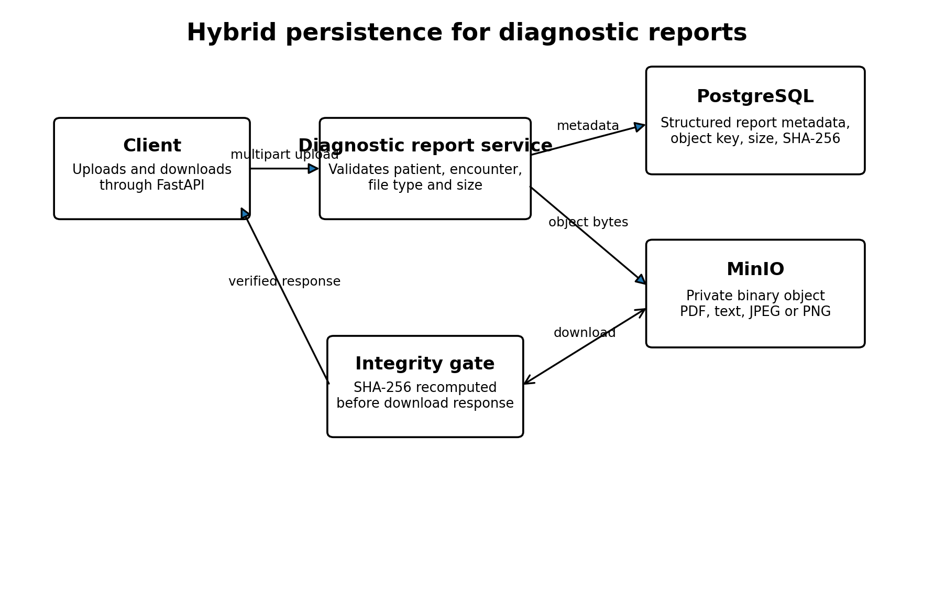
Figure 3. Hybrid persistence for diagnostic-report metadata and binary objects.
DiagnosticReport stores patient, optional encounter, and optional uploader relationships together with report type, status, title, conclusion, issue time, original filename, content type, byte size, and SHA-256 digest. The combination of bucket_name and object_key is unique.
Uploads are restricted to PDF, plain text, JPEG, and PNG, with a 10 MB application-level maximum. The endpoint validates patient and encounter consistency before storage. Downloads pass through the backend, retrieve bytes from private MinIO, recompute SHA-256 when a checksum is stored, and return HTTP 409 if integrity verification fails.
Control | Implementation
Storage separation | Metadata in PostgreSQL; object bytes in MinIO
Object uniqueness | Unique bucket_name + object_key
Allowed content types | PDF, plain text, JPEG and PNG
Maximum application upload size | 10 MB
Download integrity | SHA-256 comparison before response
Client access | Backend-mediated; MinIO remains private

Nginx permits request bodies up to 25 MB, while the application accepts diagnostic files only up to 10 MB. The stricter application limit is authoritative for this endpoint.

5. FHIR-Inspired Resource Representation
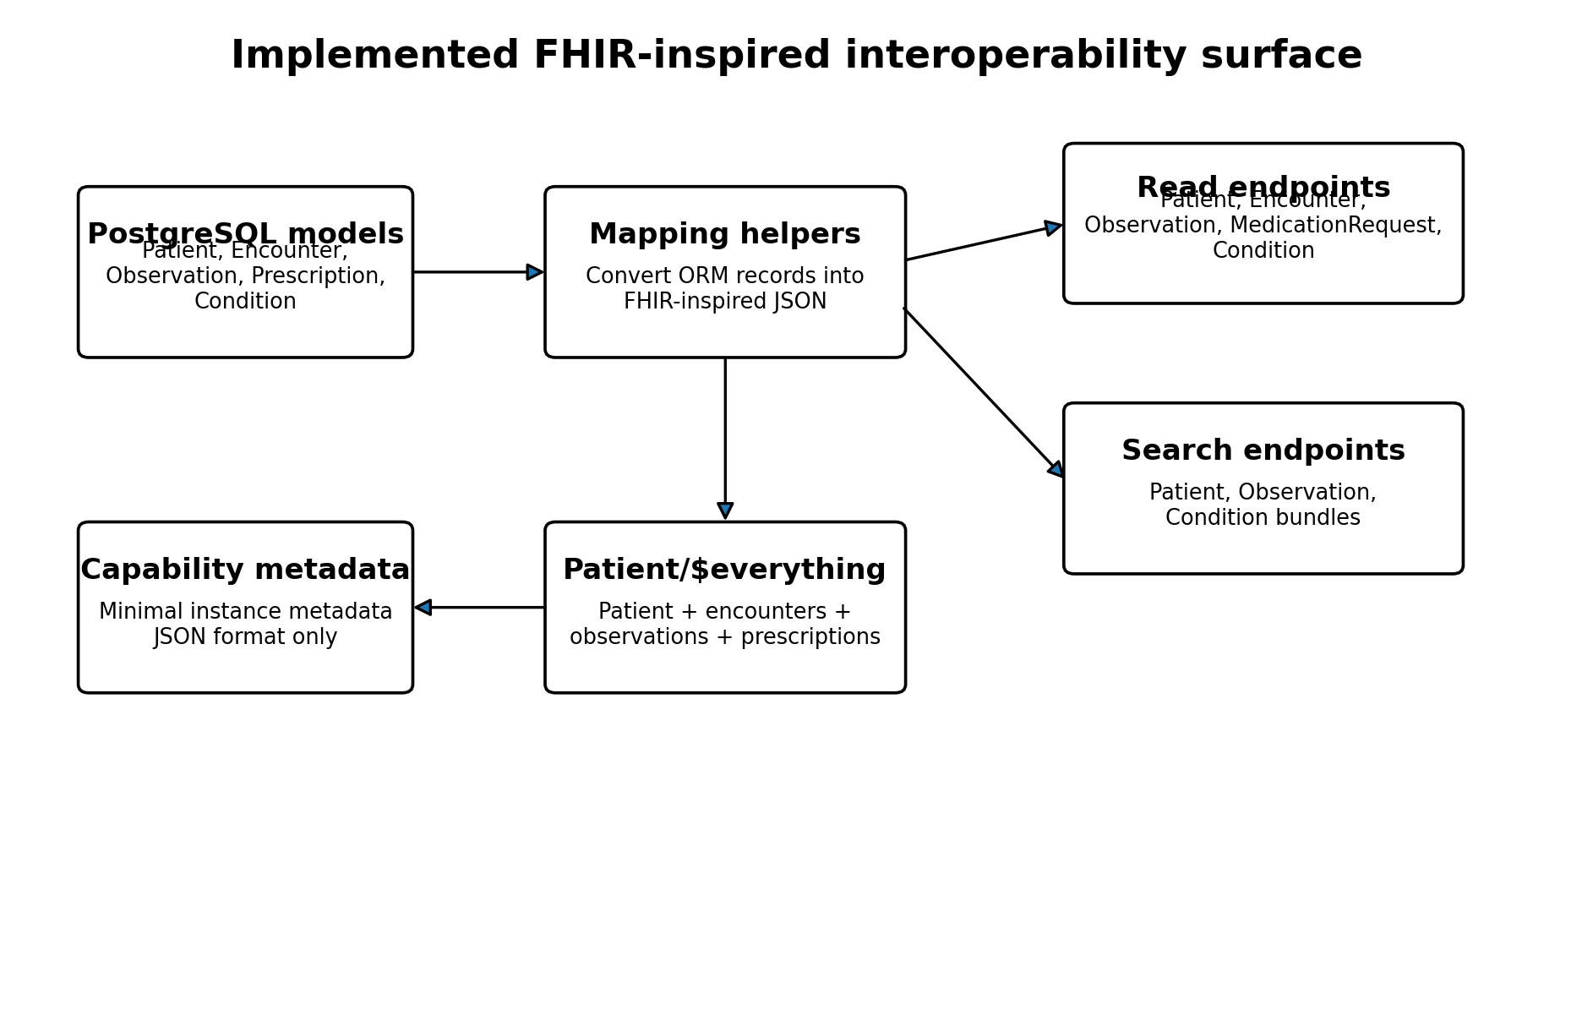
Figure 4. Implemented FHIR-inspired interoperability surface.

5.1 Capability metadata
GET /fhir/metadata returns a JSON object labeled CapabilityStatement with active status, instance kind, software name and version, and JSON format. This provides lightweight discovery but does not enumerate REST resources, interactions, search parameters, security declarations, implementation guides, or FHIR version. It is not sufficient evidence of a conformant FHIR CapabilityStatement.

5.2 Patient resource and search
Patient mapping exposes resourceType, id, identifier, name, gender, and birthDate. Patient search accepts an optional name substring and a maximum _count of 100, returning a searchset-like Bundle. The reported Bundle total equals the number of returned rows rather than the full number of matches because the query does not execute a separate count.

5.3 Encounter, Observation and MedicationRequest
Encounter mapping exposes id, status, and a Patient reference. Observation exposes status, subject, code, and either valueQuantity or valueString. MedicationRequest exposes id, status, subject, medication text, and authoredOn.
These representations omit several fields commonly expected in interoperable implementations. Examples include Encounter class and period, Observation category, effective time and encounter reference, and MedicationRequest intent, requester and dosageInstruction. The omissions reinforce the project's own description of the API as FHIR-inspired rather than fully compliant.

5.4 Condition resources
Condition mapping is more detailed. It includes clinicalStatus coding, optional verificationStatus, coded condition identity, subject, optional encounter, onset, abatement, and recorded date. Search supports patient, code, clinical status and _count. Unlike the Patient and Observation search implementations, Condition search calculates total before limiting the result set.
Endpoint | Purpose | Observed limitation
GET /fhir/metadata | CapabilityStatement-like metadata | Minimal discovery only
GET /fhir/Patient | Name search Bundle | total reports returned count, not all matches
GET /fhir/Patient/{id} | Patient read | Lightweight subset
GET /fhir/Patient/{id}/$everything | Collection Bundle | Excludes Conditions and DiagnosticReports
GET /fhir/Encounter/{id} | Encounter read | Limited resource content
GET /fhir/Observation | Patient/code search Bundle | No full-match count
GET /fhir/Observation/{id} | Observation read | Limited resource content
GET /fhir/MedicationRequest/{id} | MedicationRequest read | No search endpoint in supplied FHIR router
GET /fhir/Condition | Condition search Bundle | Supports patient, code and clinical status
GET /fhir/Condition/{id} | Condition read | Most detailed FHIR-inspired mapping

6. Patient $everything Aggregation
The Patient/$everything endpoint verifies that the patient exists and then assembles one collection Bundle containing the patient, all patient encounters, all patient observations, and all patient prescriptions. Resource entries are appended sequentially, and total equals the number of resources in the collection.
The implementation does not include Condition resources or DiagnosticReport metadata and does not support date filters, pagination, continuation links, or resource-type selection. For large longitudinal records, loading all related rows in one request may also create response-size and query-cost concerns.
Included in current $everything | Not included in current $everything
Patient | Condition
Encounter | DiagnosticReport
Observation | AuditLog
MedicationRequest derived from Prescription | Binary report objects

7. Native REST APIs and Data-Integrity Validation
In addition to the FHIR-inspired read layer, the platform exposes native REST endpoints with Pydantic schemas, pagination, RBAC, audit recording, and domain validation.
Module | Supported operations in supplied source | Key integrity checks
Patients | Create, list, read, partial update | MRN and external-identity conflict handling
Encounters | Create, list, read, partial update | Patient existence and time-range validation
Observations | Create, list, read, partial update | Patient/encounter ownership and value presence
Prescriptions | Create, list, read, partial update | Patient, encounter, prescriber, dosage and date checks
Diagnostic reports | Upload, metadata read, download | File type, size, patient/encounter and SHA-256 checks

These native endpoints contain stronger validation than the FHIR-inspired read surface. For example, observation creation confirms that an encounter belongs to the specified patient, and prescription creation confirms patient, encounter and active prescriber validity.

8. Synthea Data-Ingestion Workflow
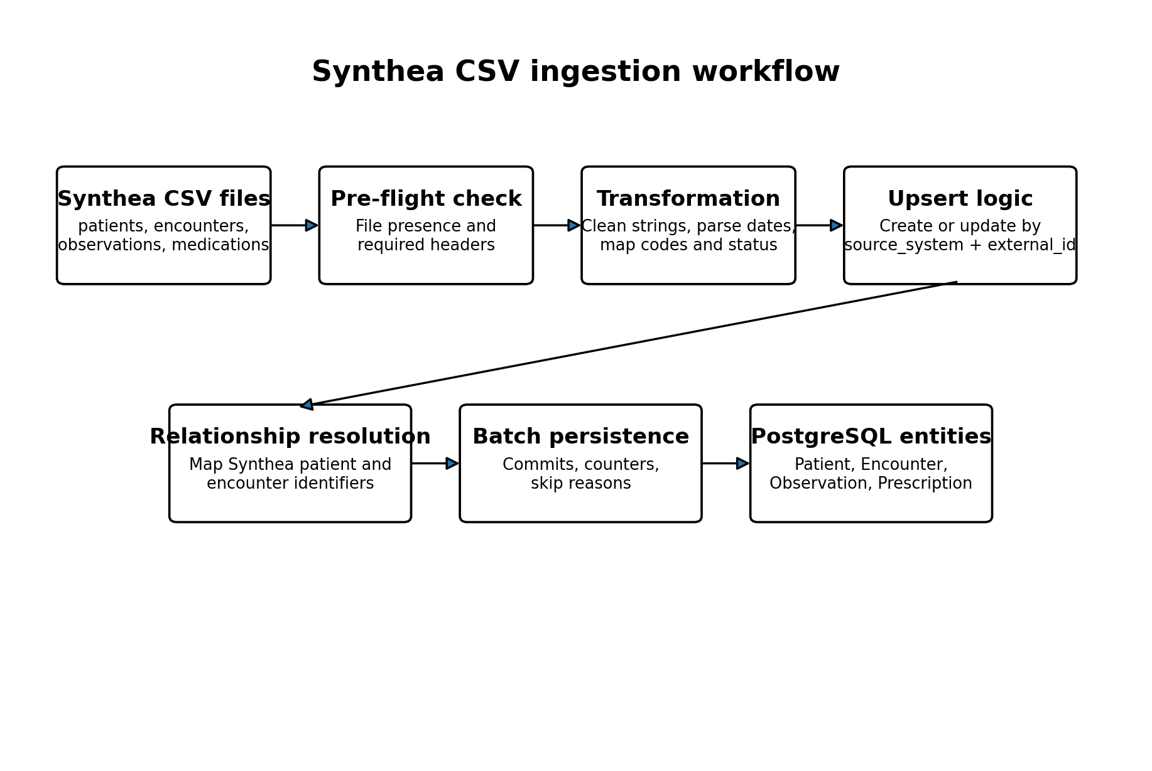
Figure 5. Synthea CSV ingestion workflow.

8.1 Pre-flight validation
The check_synthea_files script expects patients.csv, encounters.csv, observations.csv, and medications.csv. It verifies file presence, required headers, and data-row counts before import.
CSV file | Required source fields shown in the validator
patients.csv | Id, FIRST, LAST, BIRTHDATE, GENDER
encounters.csv | Id, PATIENT, START, ENCOUNTERCLASS
observations.csv | DATE, PATIENT, CODE, DESCRIPTION, VALUE, UNITS
medications.csv | START, PATIENT, CODE, DESCRIPTION

8.2 Import order
The combined pipeline imports patients first, followed by encounters, observations, and medications. This order is necessary because dependent importers resolve patient and encounter external identifiers before creating child records.

8.3 Idempotent source identity
Patient and encounter importers use Synthea identifiers directly as external_id with source_system set to synthea. Observation and medication files do not rely on a single source row identifier. Their importers construct deterministic SHA-256-based identifiers from selected source fields. Existing records with the same source identity are updated rather than duplicated.

8.4 Transformations and batching
Importers normalize optional strings, parse ISO date/time values, convert timezone-aware values to UTC and remove timezone information before persistence, map Synthea gender values, select default coding systems, derive record status, and separate numeric from textual observation values. Observation and medication importers commit in batches of 1,000 processed rows and report skip reasons.

8.5 Conditions ingestion gap
The validated database contains 643,513 Condition rows and the API contains a Condition model and FHIR router. However, the uploaded source does not include a Synthea condition importer or an all-pipeline step for conditions. The chapter therefore cannot attribute those rows to a specific demonstrated ingestion procedure. The missing importer should be documented or added to the evidence set.

9. Database Migration Management
Alembic manages schema evolution. The current recorded revision is 685666386ae6, which adds the conditions table and is marked as head. Earlier migrations shown in the source create patients, encounters, observations, prescriptions, and diagnostic reports.
Revision | Schema contribution
67172335d89c | Patients table
b734f3f99abc | Encounters table
5cda57afee5d | Observations table
dd10de0050e3 | Prescriptions table
f3c250badef9 | Diagnostic reports table
685666386ae6 | Conditions table; current head

The supplied encounter downgrade migration attempts to drop indexes that are not all created in the shown upgrade function. This should be reviewed because a downgrade may fail when an index name is absent. Migration downgrade paths require the same level of testing as upgrade paths.
The base_imports module imports Condition after the __all__ declaration and does not include Condition in __all__. Direct module import still executes the final import, but the organization is inconsistent and should be cleaned to avoid migration-discovery confusion.

10. Interoperability and Data-Quality Limitations
- The resource mappings are intentionally lightweight and do not demonstrate full HL7 FHIR conformance.
- No FHIR version is declared in the minimal CapabilityStatement-like response.
- FHIR resources do not show profiles, meta.profile, narrative text, OperationOutcome responses, or terminology validation.
- Patient and Observation search totals report returned rows rather than all matching rows.
- Patient/$everything omits Conditions and DiagnosticReports and has no pagination or date filtering.
- Diagnostic reports are available only through the native REST API, not as a FHIR DiagnosticReport resource.
- The uploaded source does not demonstrate a Condition ingestion pipeline.
- Timestamps are stored in timezone-capable database columns, while importers convert aware values to UTC and then remove tzinfo before persistence. This behavior should be standardized and tested.
- Source-system uniqueness depends on both source_system and external_id. Null combinations require careful handling because SQL uniqueness semantics may permit multiple null external identifiers.
- Most SQLAlchemy models define foreign keys but do not expose ORM relationship collections for clinical navigation.

11. Recommended Improvements
Priority | Recommended action
P1 | Document the exact FHIR release and explicitly state the supported subset.
P1 | Expand CapabilityStatement content to list resources, interactions, search parameters, formats and security.
P1 | Add Condition and DiagnosticReport to Patient/$everything, with pagination or date bounds.
P1 | Provide and validate the missing Condition ingestion workflow.
P2 | Add a FHIR DiagnosticReport representation and a controlled Binary or attachment retrieval strategy.
P2 | Correct Bundle total behavior and add pagination links for search endpoints.
P2 | Add required or commonly expected fields such as MedicationRequest.intent and Encounter.class/period.
P2 | Standardize UTC timezone persistence and round-trip tests.
P2 | Test all Alembic downgrade paths and correct inconsistent index operations.
P3 | Add terminology validation for LOINC, RxNorm and condition code systems where feasible.
P3 | Add ORM relationships for patient-centered navigation while retaining explicit query controls.
P3 | Create data-quality reports for skipped imports, duplicate source rows and unresolved encounters.

12. Conclusion
The Healthcare Cloud Platform provides a substantial patient-centered data layer with relational integrity, source-aware ingestion, application validation, auditability, and hybrid object storage. The validated database contains 1,541,374 core clinical rows across five major clinical entities.
The Synthea pipeline demonstrates reproducible ingestion for patients, encounters, observations, and medications. Deterministic external identifiers, create-or-update logic, relationship resolution, batch commits, and skip accounting support repeatable imports.
The interoperability layer provides a useful FHIR-inspired read interface but remains a partial mapping. The scientifically accurate claim is that the platform exposes selected FHIR-named resources and Bundle-like responses, not that it is fully FHIR compliant. Addressing CapabilityStatement completeness, missing resource fields, Bundle semantics, $everything coverage, diagnostic-report representation, and the missing condition ingestion evidence would materially strengthen the interoperability contribution.

Appendix A. Validated Table Inventory
Table or entity | Rows | Restore evidence
Patients | 117,581 | 0 difference in supplied restore comparison
Encounters | 121,649 | 0 difference in supplied restore comparison
Conditions | 643,513 | 0 difference in supplied restore comparison
Observations | 592,173 | 0 difference in supplied restore comparison
Prescriptions | 66,458 | 0 difference in supplied restore comparison
Diagnostic reports | 5 | 0 difference in supplied restore comparison
Audit logs | 40,535 | 0 difference in supplied restore comparison
Users | 6 | 0 difference in supplied restore comparison
Roles | 6 | 0 difference in supplied restore comparison

Appendix B. Evidence Traceability
Claim area | Primary source
Clinical models | backend/app/models/patient.py, encounter.py, condition.py, observation.py, prescription.py
Diagnostic-report model | backend/app/models/diagnostic_report.py
Security entities | backend/app/models/user.py, role.py, audit_log.py
FHIR-inspired API | backend/app/api/v1/endpoints/fhir.py and fhir_conditions.py
Native clinical APIs | patients.py, encounters.py, observations.py, prescriptions.py, diagnostic_reports.py
Object storage | backend/app/services/storage_service.py
Synthea pre-flight | backend/app/scripts/check_synthea_files.py
Combined import pipeline | backend/app/scripts/import_synthea_all.py
Importers | backend/app/services/ingestion/synthea_*_importer.py
Migration state | Alembic revisions and 685666386ae6 head
Validated scale | docs/tables/backup_restore_validation.csv

Appendix C. Key Source-Review Findings
Finding | Evidence-based interpretation
FHIR compliance wording | Models and documentation consistently state lightweight FHIR-inspired design without full compliance.
Condition ingestion | Database and API evidence exist, but no importer is included in the supplied source extract.
Patient/$everything | Includes patient, encounters, observations and prescriptions only.
Bundle total inconsistency | Condition search counts all matches; Patient and Observation searches count only returned rows.
Migration hygiene | Encounter downgrade and base_imports organization require review.
Hybrid file integrity | Diagnostic-report download recomputes SHA-256 before returning stored bytes.

