CLOUD DEPLOYMENT ARCHITECTURE
AND PRODUCTION READINESS
Healthcare Cloud Platform
A source-grounded chapter covering the validated Docker production stack, reverse proxy, service isolation, persistence, health checks, release management, and the remaining steps for remote VM deployment
Current status: locally validated and cloud-ready; remote public deployment not yet completed

Executive Summary
The Healthcare Cloud Platform has been packaged as a four-service production stack composed of Nginx, a FastAPI backend, PostgreSQL 16, and MinIO. The backend is built from a Python 3.11 slim image and starts Uvicorn with four workers, a five-second keep-alive timeout, and server-header suppression. Nginx is the only service mapped to a host port, exposing localhost port 8080 and forwarding requests to the backend.
The deployment uses two Docker networks. The edge network connects Nginx and the backend. The internal data network connects the backend, PostgreSQL, and MinIO. PostgreSQL and MinIO are not published to the host. Named volumes preserve relational and object-storage data across ordinary container recreation.
The running production snapshot shows all four containers active, with the backend and PostgreSQL reported as healthy. The final project matrix reports seven passing validation domains with no failed, pending, or review items. This supports a local production-readiness claim for the tested Docker environment.
The platform has not yet been deployed as an Internet-facing service on the planned UESTC virtual machine. HTTPS, a production domain, remote firewall policy, remote secret rotation, off-host backups, monitoring, and remote post-deployment testing remain required. The accurate status is therefore cloud-ready, not fully cloud-deployed.
Component | Technology | Deployment state | Observed status
Reverse proxy | Nginx stable-alpine | Host port 8080 to container port 80 | Running
Application | Python 3.11 / FastAPI / Uvicorn | Internal port 8000; 4 workers | Healthy
Database | PostgreSQL 16 | Internal data network; named volume | Healthy
Object storage | MinIO latest image | Internal data network; named volume | Running
Validation | 7 domains | 7 PASS; 0 FAIL; 0 PENDING; 0 REVIEW | PASS

Chapter Overview
The chapter proceeds from the validated local container architecture through proxy, backend, database, storage, networking, environment, release, and validation evidence, before defining the recommended UESTC VM deployment procedure and remaining hardening priorities.

1. Deployment Objectives and Status Terminology
The deployment design aims to provide a reproducible application environment, isolate persistence services from direct external access, preserve data across container recreation, expose a single controlled HTTP entry point, and support automated service readiness and restart behavior.
- Reproducibility: the application image and service topology are declared in version-controlled files.
- Isolation: PostgreSQL and MinIO are restricted to an internal Docker network.
- Availability: health checks and restart policies support service recovery after process or host restart.
- Persistence: named Docker volumes protect data from normal container replacement.
- Traceability: Git history, tags, release artifacts, and validation evidence record the deployed state.

1.1 Distinguishing three deployment states
State | Definition | Project status
Development-ready | Application runs for coding and local debugging | Completed
Local production-ready | Production Compose stack runs with hardening and validation on the local host | Completed and validated
Remote cloud-deployed | Stack runs on a remote VM with domain, TLS, firewall, remote backups, and external validation | Not yet completed

The term cloud-ready is appropriate because the platform is containerized, environment-driven, network-segmented, persistent, health-checked, and versioned. The term cloud-deployed would be premature until the remote VM is available and the stack is installed and validated there.

2. Production Container Architecture
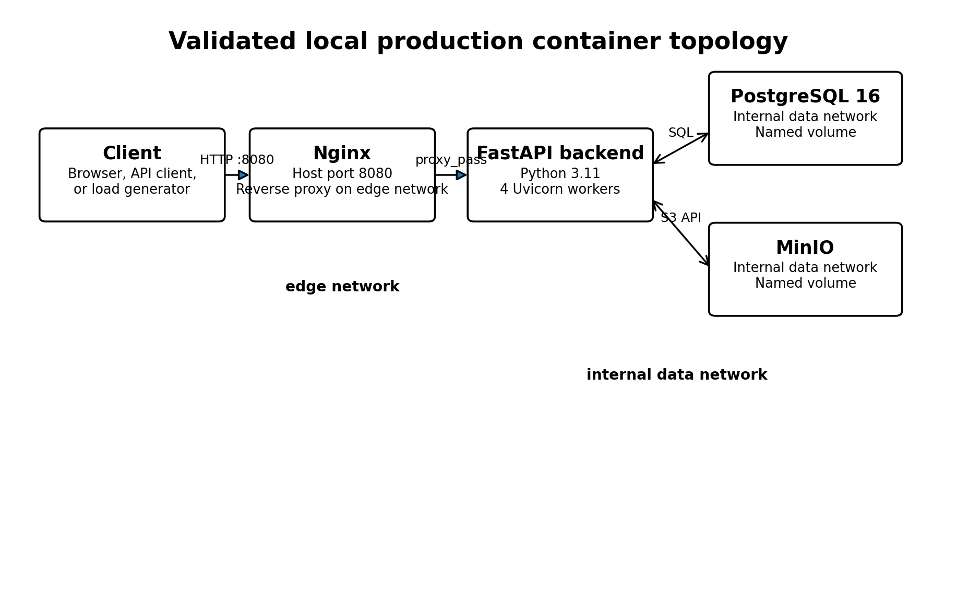
Figure 1. Validated local production container topology.
The Compose file defines four services. Nginx occupies the external boundary, the backend mediates all business logic and persistence access, PostgreSQL stores structured healthcare data, and MinIO stores binary reports and attachments. The architecture deliberately avoids publishing PostgreSQL port 5432 and MinIO port 9000 to the host.
Service | Image | Port exposure | Networks | Function
nginx | nginx:stable-alpine | 8080:80 | edge | Reverse proxy and external entry point
backend | locally built image | 8000 exposed to containers | edge + data | FastAPI application and service mediation
postgres | postgres:16 | No host mapping | data | Relational persistence
minio | minio/minio:latest | No host mapping | data | Binary object storage

3. Nginx Reverse-Proxy Configuration
Nginx listens on container port 80 and accepts any host name through server_name _. It forwards all request paths to backend:8000 using HTTP/1.1. The proxy preserves the original Host header and adds X-Real-IP, X-Forwarded-For, and X-Forwarded-Proto so that the application can record request context and determine the originating protocol.
Control | Configured value | Operational purpose
Client upload limit | 25 MB | Allows diagnostic files while bounding request size
Connection timeout | 10 seconds | Limits backend connection establishment delay
Send timeout | 60 seconds | Bounds time spent transmitting a proxied request
Read timeout | 60 seconds | Bounds time waiting for the backend response
Security headers | nosniff, DENY, no-referrer, restricted permissions | Adds edge-layer browser protections

3.1 Current limitation: HTTP only
The supplied Nginx configuration listens only on HTTP port 80 inside the container, and the local host mapping uses port 8080. No certificate, TLS listener, HTTP-to-HTTPS redirect, or automated certificate renewal is configured. This is acceptable for isolated localhost validation, but not for transmitting healthcare data over an untrusted network.

4. FastAPI Backend Container
The backend image is based on python:3.11-slim. The build installs packages from requirements.txt, copies the application, copies Alembic migration files, and starts Uvicorn directly.
Backend property | Observed configuration
Base image | python:3.11-slim
Application server | Uvicorn
Bind address | 0.0.0.0:8000
Workers | 4
Keep-alive timeout | 5 seconds
Server header | Disabled
Migration artifacts | alembic directory and alembic.ini included
Current Alembic revision | 685666386ae6 (head)

4.1 Dependency packaging
The requirements file includes FastAPI, Uvicorn, SQLAlchemy, psycopg2-binary, Alembic, Pydantic, JWT and password libraries, multipart handling, and the MinIO client. passlib and bcrypt are pinned to explicit versions, while most other packages are not pinned.
Unpinned production dependencies reduce build reproducibility because a later image rebuild may resolve different package versions. A production hardening step should lock all direct and transitive dependencies, record hashes where practical, and scan the resulting image.

4.2 Health check
The backend health check calls http://localhost:8000/health from inside the container every 15 seconds. It allows a 20-second startup period, a seven-second timeout, and five retries. Nginx does not start until the backend becomes healthy.

5. PostgreSQL and MinIO Services

5.1 PostgreSQL
PostgreSQL uses the postgres:16 image and loads its configuration from .env.production. Its data directory is attached to the postgres_prod_data named volume. The health check runs pg_isready against healthcare_cloud_db using healthcare_prod_user every 10 seconds, with five retries and a 10-second startup period.
The database is not exposed through a host port. Only services attached to the internal data network can reach it. This materially reduces the attack surface compared with publishing port 5432 on the VM.

5.2 MinIO
MinIO uses minio/minio:latest and starts the object server on port 9000 with the administrative console configured on port 9001. The minio_prod_data named volume stores persistent objects. The service is attached only to the internal data network and has no host port mapping in the production Compose file.
The use of the latest image tag is a reproducibility and supply-chain risk. A future rebuild can pull a different MinIO version without an explicit change to the repository. The deployment should pin MinIO to a tested immutable version or digest.

6. Networks, Health Checks, and Restart Behavior
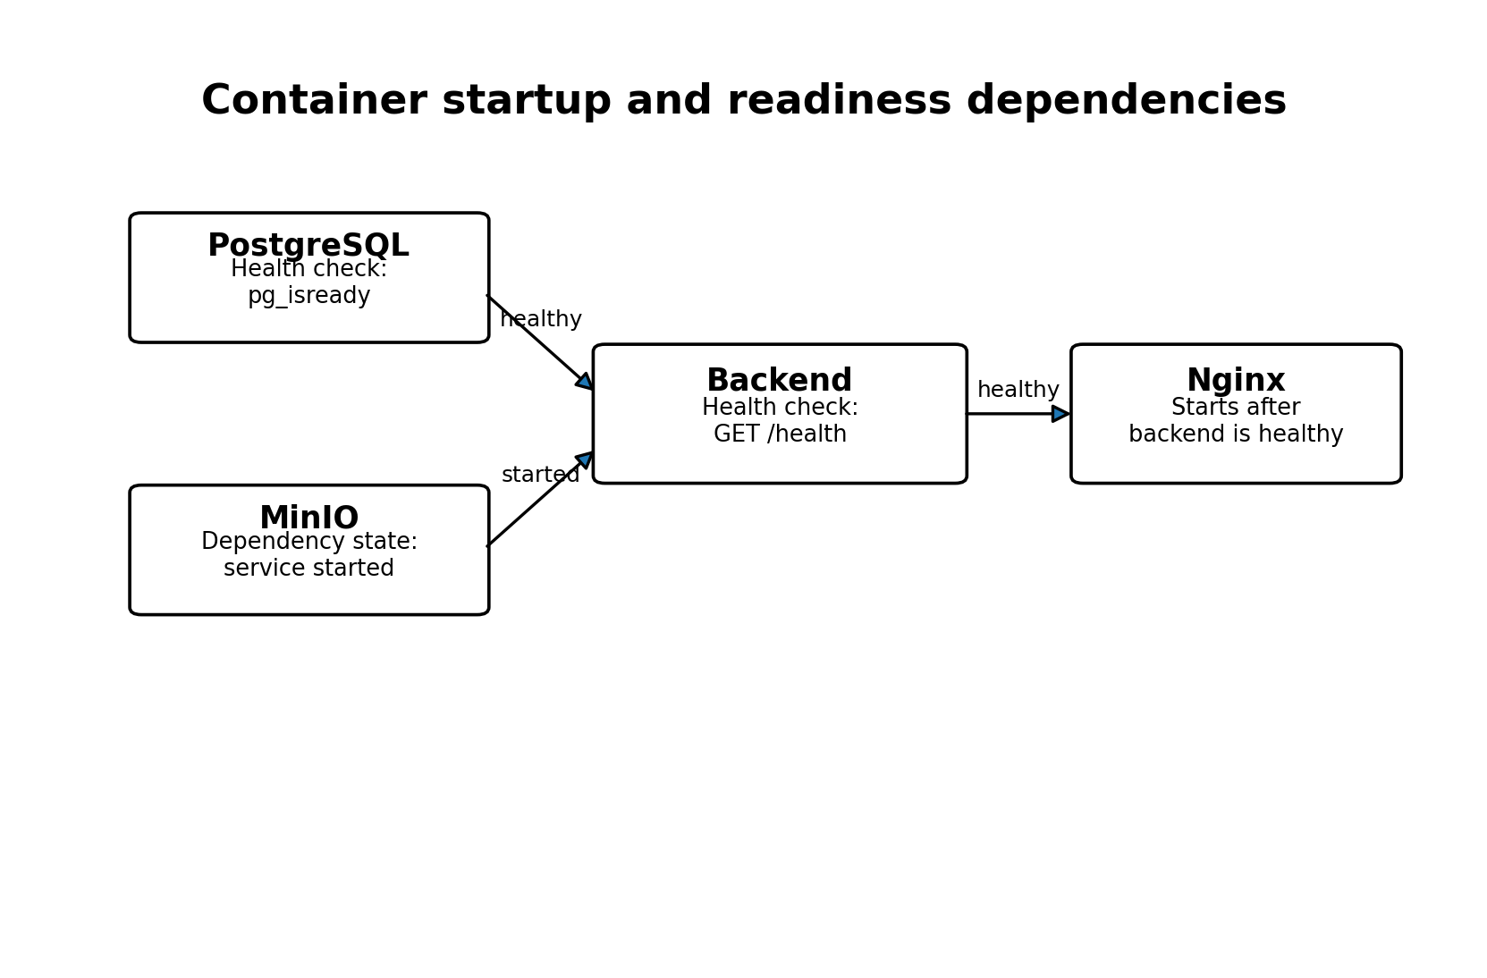
Figure 2. Container startup and readiness dependencies.

6.1 Network segmentation
Network | Connected services | Security purpose
edge | Nginx and backend | External request path
data | Backend, PostgreSQL, MinIO | Internal persistence path
data internal flag | true | Prevents direct external routing to data-network services

6.2 Dependency semantics
The backend waits for PostgreSQL to become healthy and for MinIO to reach the service_started state. Nginx waits for the backend to become healthy. This ordering reduces failed startup attempts. However, service_started is weaker than a MinIO readiness check, so the backend can start before MinIO has been functionally verified.

6.3 Restart policy
All four services use restart: unless-stopped. Docker therefore restarts them after unexpected termination or host restart unless an administrator deliberately stopped the service. This improves basic resilience but does not replace orchestration, alerting, or automated failover.

7. Persistent Storage and Environment Management

7.1 Named volumes
Volume | Container mount | Purpose
postgres_prod_data | /var/lib/postgresql/data | PostgreSQL database cluster
minio_prod_data | /data | MinIO object data

Named volumes preserve data when a container is recreated. They remain local to the Docker host, so independent backup and recovery procedures remain necessary for host-level disaster recovery.

7.2 Production environment file
The production services read .env.production, while the repository includes .env.production.example with placeholders for PostgreSQL, JWT, and MinIO secrets. The example sets APP_ENV=production, APP_DEBUG=false, DOCS_ENABLED=false, a 30-minute JWT lifetime, and explicit CORS and allowed-host values.
Configuration group | Variables represented
Application mode | APP_ENV=production; APP_DEBUG=false
Database | PostgreSQL user, password, database, host, port, and DATABASE_URL
Authentication | JWT secret, algorithm, and token lifetime
Object storage | MinIO endpoint, root credentials, bucket, and secure flag
HTTP policy | Documentation disabled, CORS origins, allowed hosts

7.3 Secret-management limitations
Environment files are appropriate for a controlled prototype, but they are not a dedicated secret management system. The remote deployment should generate new high-entropy values, restrict file permissions, exclude real secret files from Git, and document rotation and incident-response procedures.

7.4 Docker build context
A backend-specific .dockerignore excludes virtual environments, caches, test artifacts, logs, and environment files. A root-level .dockerignore was not present in the supplied evidence. The current backend build context is ./backend, so the backend .dockerignore applies to that image. A root-level ignore file would still be useful for future root-context images and repository hygiene.

8. Version Control and Release Evidence
The repository is hosted on GitHub under rayhanatou-dot/HealthcareCloudPlatform.git. The recorded history includes commits for production Docker isolation, complete validation, evidence organization, architecture documentation, and four thesis chapters.
Commit | Recorded change
5962739 | Add backup recovery and data resilience thesis chapter
e618828 | Add performance scalability and cost efficiency thesis chapter
58d31e8 | Add security architecture and validation thesis chapter
1984233 | Add system design and implementation thesis chapter
bd39e4a | Complete MinIO lifecycle validation and final project verification
202320f | Complete production validation, security, recovery and performance testing
a99d3d3 | Add isolated production Docker configuration

8.1 Tags and release state
Tag | Interpretation
v1.0.0-local-production | Marks the local production release state
validated-platform-2026-07-30 | Marks the validated platform snapshot

The local-production tag is correctly scoped. It does not imply that the release was deployed to a remote public cloud environment.

9. Local Production-Readiness Evidence
The captured production status shows Nginx, backend, PostgreSQL, and MinIO running for approximately eight hours. The backend and PostgreSQL were reported healthy. Nginx exposed host port 8080, while the backend, database, and object store remained internally reachable.
Validation domain | Measured result | Status
Production HTTP security | 17/17 | PASS
Diagnostic report strict audit | 9/9 | PASS
Diagnostic report end-to-end storage | 10/10 | PASS
MinIO service lifecycle | 4/4 | PASS
PostgreSQL backup and restore | 19/19 | PASS
MinIO backup and restore | 23/23 | PASS
Optimized 200-user load | 0 failures; 146.77 RPS; P95 110 ms | PASS

The final matrix reports seven passing domains and no failures, pending items, or review items. This is strong evidence for the local environment. It does not automatically transfer to a new VM because host resources, network latency, operating-system configuration, and external exposure will change.

10. Recommended UESTC VM Profile and Remote Deployment Procedure
The following VM profile is a deployment recommendation derived from the observed architecture and validated workload. It is not a specification supplied by UESTC.
VM property | Recommended profile
Operating system | Ubuntu Server 22.04 LTS or 24.04 LTS
CPU | Minimum 2 vCPU; preferred 4 vCPU for the current four-worker backend
Memory | Minimum 4 GB; preferred 8 GB for database, object storage, proxy, and operating-system headroom
Storage | At least 50 GB persistent disk, increased according to dataset and backup retention
Network | Public IP or institutionally routable address
Inbound ports | 22 for SSH, 80 for certificate provisioning or redirect, 443 for production HTTPS
Privileges | Permission to install and operate Docker Engine and Docker Compose

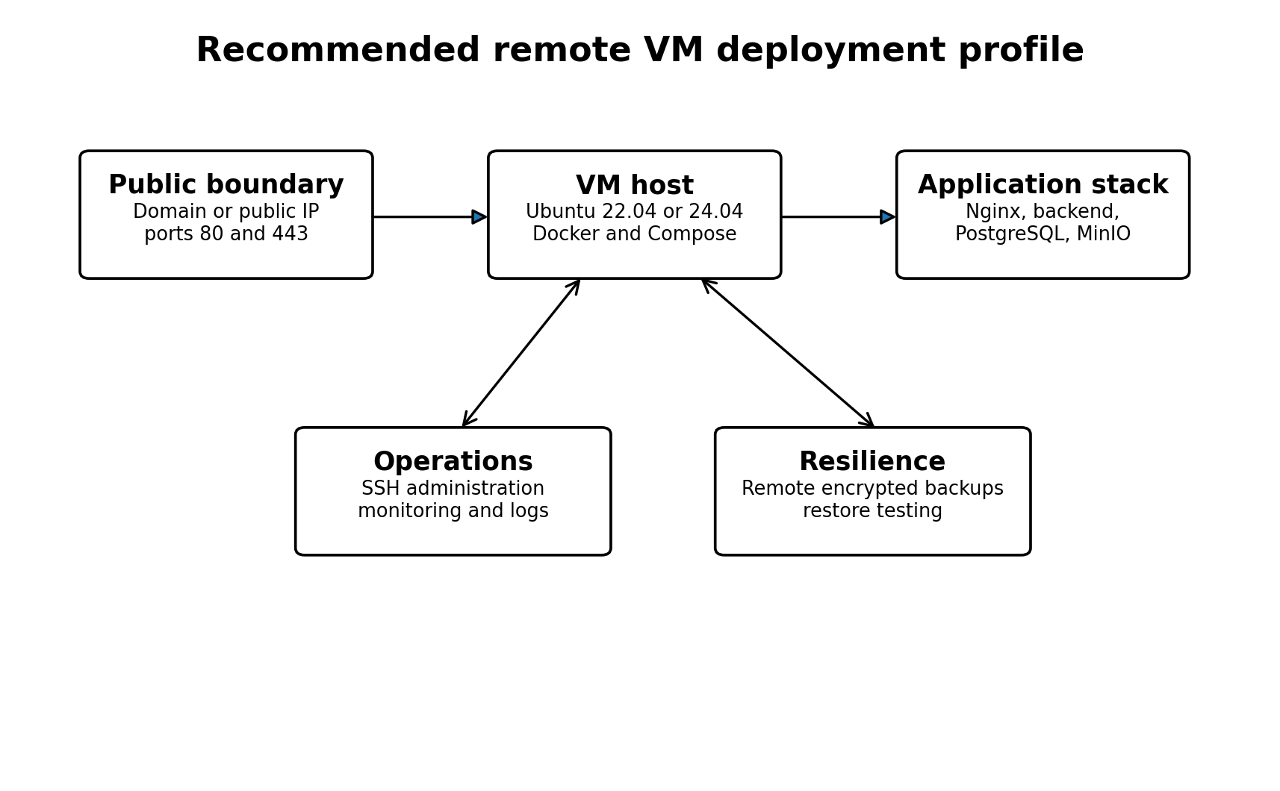
Figure 3. Recommended remote VM deployment profile. Values are proposed engineering requirements, not confirmed UESTC allocations.

10.1 Proposed remote deployment sequence
- Provision the Ubuntu VM, create an administrative account, configure SSH keys, and apply operating-system updates.
- Install Docker Engine and the Docker Compose plugin.
- Clone the GitHub repository at the intended release tag or verified commit.
- Create .env.production from the example file using new production-only secrets.
- Restrict environment-file permissions and verify that it is not tracked by Git.
- Configure DNS to point the selected domain to the VM.
- Replace the local Nginx configuration with an HTTPS configuration and certificate-renewal process.
- Open only required firewall ports and keep PostgreSQL and MinIO unexposed.
- Build and start the Compose stack.
- Run Alembic migrations against the production database before accepting application traffic.
- Create or restore required data and verify the MinIO bucket.
- Repeat security, storage, recovery, and performance tests against the remote endpoint.
- Enable monitoring, log retention, and remote encrypted backups.
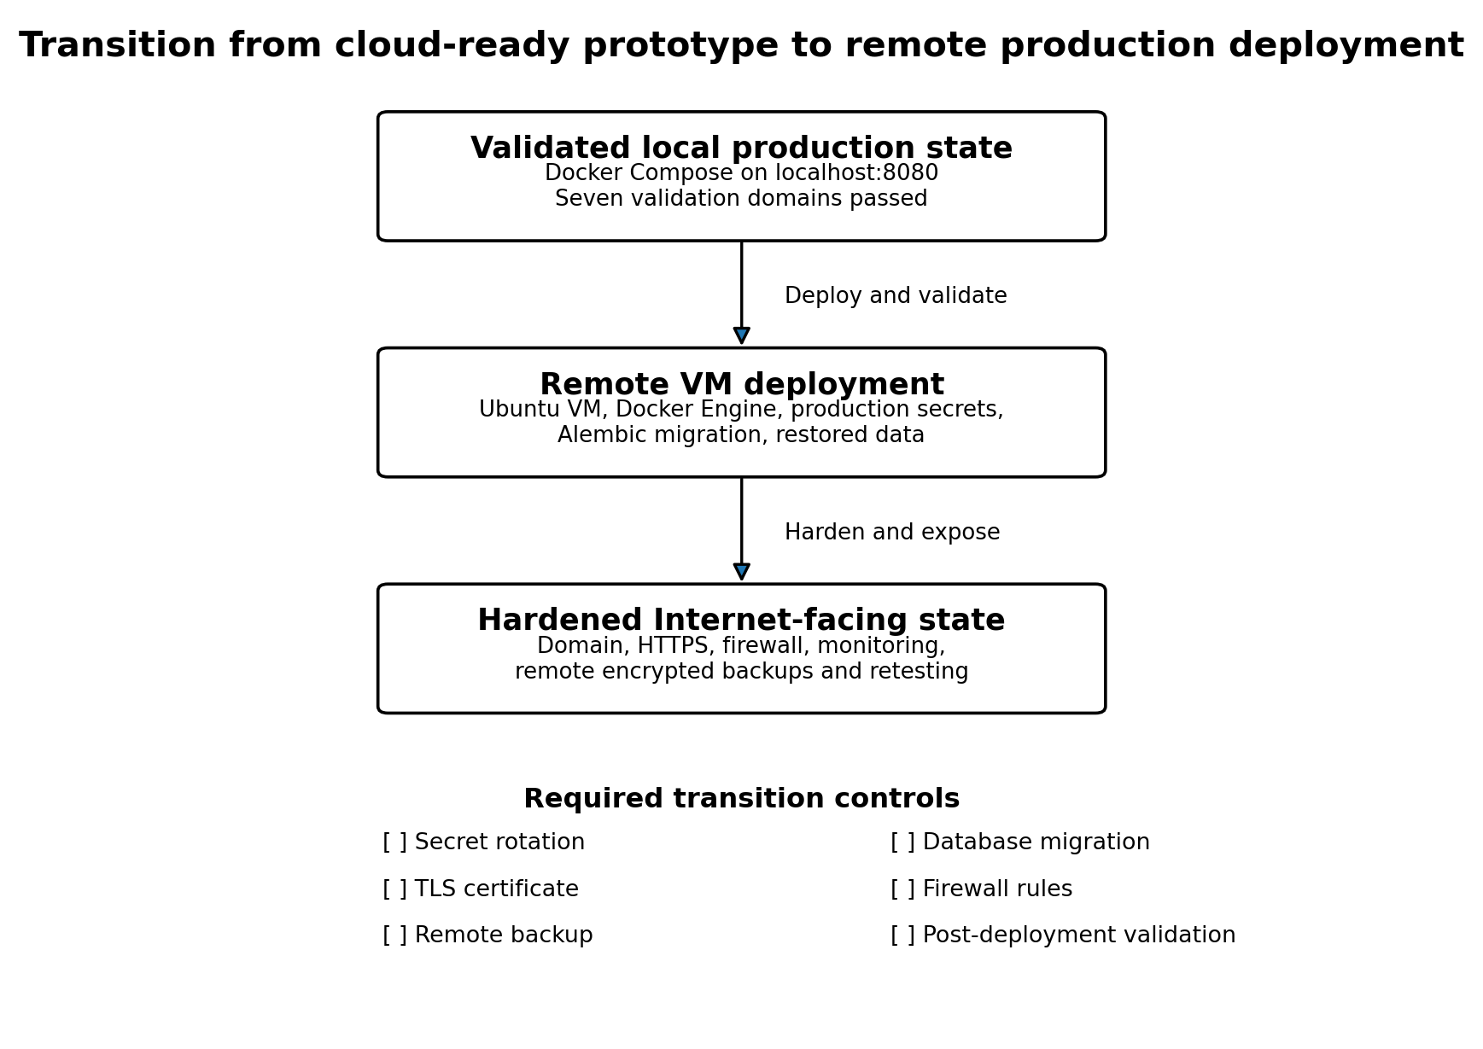
Figure 4. Transition from the validated local environment to a hardened remote deployment.

11. Gaps, Risks, and Hardening Priorities
Priority | Observed gap or risk | Required action
P1 | TLS is absent | Configure HTTPS, redirect HTTP to HTTPS, and verify certificate renewal.
P1 | Production secrets are file-based | Generate new high-entropy secrets, restrict access, and document rotation.
P1 | No remote deployment evidence | Repeat the full validation suite on the UESTC VM.
P1 | No off-host backup in the deployment design | Copy encrypted PostgreSQL and MinIO backups to a separate destination.
P2 | MinIO uses the latest tag | Pin a tested release or immutable image digest.
P2 | Most Python dependencies are unpinned | Generate a locked dependency file and scan the built image.
P2 | No MinIO health check | Add a readiness test and make backend startup depend on it.
P2 | No Nginx health check | Add a proxy-level health check for operational monitoring.
P2 | No declared CPU or memory limits | Measure remote usage and define appropriate container constraints.
P2 | No separate migration job | Run Alembic explicitly as a controlled deployment step.
P3 | No centralized logging or alerting | Forward logs and create alerts for health, security, backup, and capacity events.
P3 | Single-host architecture | Document recovery procedures and evaluate high availability if service requirements demand it.

11.1 Additional source-quality observations
- The saved production container inventory contains character-encoding corruption in truncated command text. Regenerate it with UTF-8 output before using it as a thesis figure or appendix.
- The development example environment file contains duplicated MinIO comments and duplicate MINIO_CONSOLE_PORT entries. Remove the duplicates to improve configuration clarity.
- The production Compose file uses an explicit project invocation during validation, which is appropriate. The same project name should be documented and reused on the remote VM.
- The source evidence includes production security scripts that temporarily switch environment mode and then restore it. Remote testing should avoid modifying live configuration without a maintenance procedure.

12. Conclusion
The Healthcare Cloud Platform has a coherent and validated local production architecture. The four-service Docker Compose stack separates the external request boundary from internal persistence, uses named volumes, applies service dependencies and health checks, suppresses direct exposure of PostgreSQL and MinIO, and records its release state through Git commits and tags.
The final local validation matrix reports seven passing domains with no unresolved items. The backend and PostgreSQL were healthy, all four containers were running, recovery tests passed, security controls passed, and the optimized 200-user workload completed with zero failures.
The remaining work is deployment hardening rather than core application construction. The platform must still be installed on the remote UESTC VM, configured with new secrets, protected by TLS and firewall rules, connected to remote backups and monitoring, and retested under the remote host and network conditions. Until those steps are completed, the scientifically accurate conclusion is that the platform is locally production-ready and cloud-ready, but not yet publicly cloud-deployed.

Appendix A. Evidence Traceability
Claim or component | Primary evidence
Production topology | docker-compose.prod.yml
Backend image | backend/Dockerfile
Python dependencies | backend/requirements.txt
Reverse proxy | nginx/default.conf
Build exclusions | backend/.dockerignore
Environment templates | .env.example and .env.production.example
Service inventory | docs/02_implementation/docker_services.txt
Container snapshot | docs/02_implementation/production_containers.txt
Database migration state | docs/02_implementation/alembic_current.txt
Overall project status | docs/evidence/final_project_status.txt
Validation matrix | docs/evidence/final_validation_matrix.md
Repository history | git log output in cloud deployment source extract
Release tags | v1.0.0-local-production and validated-platform-2026-07-30

Appendix B. Deployment Acceptance Checklist
Acceptance area | Required evidence
Source version | Release tag or commit recorded
Secrets | New remote-only secrets generated and protected
Database | PostgreSQL healthy and Alembic at expected head
Object storage | MinIO healthy, bucket accessible, lifecycle test passed
Proxy | Nginx healthy, domain correct, request-size and timeout policy reviewed
Transport security | Valid HTTPS certificate, redirect active, HSTS verified over HTTPS
Network | Only required ports exposed; data services remain internal
Recovery | Remote backup completed and restoration test passed
Security | Production HTTP, JWT, RBAC, and audit validations passed
Performance | Remote baseline and target-load tests passed
Monitoring | Health, logs, capacity, security, and backup alerts active

