GENERAL INTRODUCTION
Healthcare Cloud Platform
Research context, problem statement, objectives, questions, scope, methodology and thesis organization

1. Background and Research Context
Healthcare information systems increasingly depend on networked software, distributed data storage, application programming interfaces, and remote infrastructure. Cloud computing provides on-demand access to configurable computing resources and is commonly discussed through service and deployment models such as infrastructure, platform, and software services [1]. In healthcare, these capabilities can support wider data availability, centralized maintenance, elastic resource allocation, and more consistent deployment; however, they also intensify concerns related to confidentiality, authorization, interoperability, operational continuity, and evidence of system reliability [11], [13], [14].
Healthcare data are heterogeneous. A single platform may need to manage patient demographics, encounters, conditions, laboratory observations, prescriptions, diagnostic reports, user accounts, role assignments, and audit events. Structured clinical records benefit from relational integrity, while binary reports and attachments require object-oriented storage. The resulting architecture must preserve references between these data domains while preventing direct and unauthorized access.
Interoperability is another central requirement. FHIR is an HL7 standard for healthcare data exchange and defines resources, REST interactions, search mechanisms, conformance artifacts, terminology support, and security-related components [2]. FHIR-oriented research and platforms such as SMART on FHIR have demonstrated the value of standardized web-based application interfaces [3], [4]. Nevertheless, implementing selected FHIR-shaped resources does not by itself establish full FHIR conformance.
The development and testing of healthcare systems are further constrained by the sensitivity of real patient records. Synthea addresses this problem by generating synthetic longitudinal health records for research, education, and software testing without using identifiable real-patient data [5]. Synthetic data are therefore suitable for validating software workflows, although they cannot replace real clinical data for every biomedical or clinical-discovery purpose.
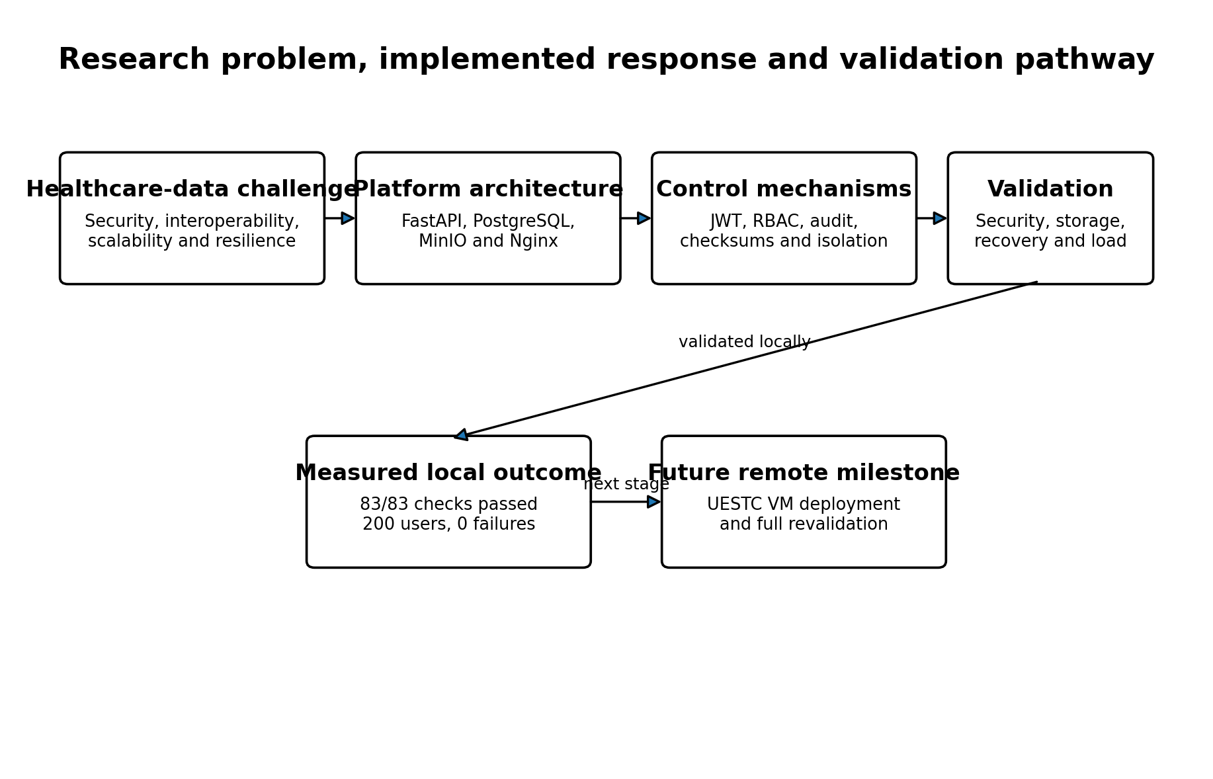
Figure 1. Research problem, implemented response, measured local outcome and future remote milestone.

2. Problem Statement
Many healthcare-platform studies and prototypes focus on one principal concern, such as cloud migration, data exchange, access control, privacy, or application scalability. The practical challenge is that these concerns interact. A healthcare API that performs well but lacks role restrictions is unsafe. A secure database without auditable file access provides incomplete accountability. A backup that is never restored does not demonstrate recoverability. Similarly, a containerized application cannot be described as cloud-deployed until it is installed and validated on actual remote infrastructure.
The research problem addressed in this thesis is therefore the design and validation of a modular healthcare cloud platform that combines: structured clinical-data management; private diagnostic-object storage; authenticated and role-restricted access; auditability; FHIR-inspired interoperability; synthetic-data ingestion; containerized deployment; backup and recovery; and concurrent-load evaluation.
The problem is not only to implement these features, but also to produce executable evidence showing that they function together. This requirement motivates an integrated validation framework rather than a feature checklist.

3. Research Aim
The aim of this research is to design, implement, and validate a secure, interoperable, scalable, and recoverable healthcare cloud platform using open-source technologies and synthetic healthcare data.

4. Research Objectives
Objective | Description
O1 | Design a modular backend architecture that separates API routing, security dependencies, database models, schemas, business services, storage operations, and ingestion utilities.
O2 | Implement authentication, active-user validation, role-based authorization, and audit logging for healthcare operations.
O3 | Develop a patient-centered PostgreSQL data model for clinical records, users, roles, diagnostic metadata, and audit events.
O4 | Integrate private MinIO object storage for diagnostic reports, with relational metadata and SHA-256 integrity verification.
O5 | Provide native clinical APIs and a bounded FHIR-inspired interoperability layer for selected healthcare resources.
O6 | Implement reproducible ingestion of synthetic Synthea patient, encounter, observation, and medication data.
O7 | Package the platform as an isolated multi-service Docker production stack.
O8 | Validate security, storage, auditability, disaster recovery, and concurrent-load performance through executable tests.
O9 | Prepare the platform for deployment and revalidation on an institutional virtual machine.

5. Research Questions
Research question | Question
RQ1 | How can a modular architecture integrate healthcare APIs, relational persistence, object storage, security services, and ingestion workflows without exposing internal data services directly?
RQ2 | How can JWT authentication, role-based access control, and audit logging be combined to restrict and trace healthcare-data operations?
RQ3 | How can structured clinical records, binary diagnostic objects, selected FHIR-inspired representations, and synthetic-data ingestion be integrated in one platform?
RQ4 | What security, storage-integrity, recovery, latency, throughput, and failure-rate outcomes are achieved in the measured local production environment?
RQ5 | What limitations remain before the platform can be described as remotely cloud-deployed and operationally production-ready?

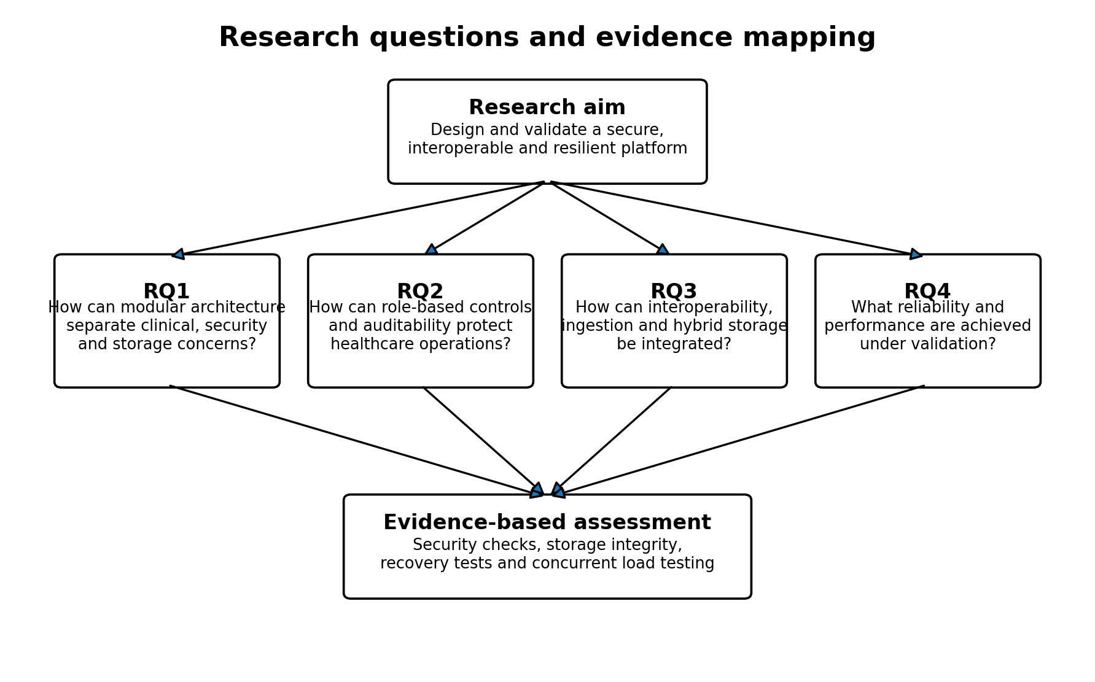
Figure 2. Mapping of the research aim and questions to the integrated evidence framework.

6. Research Scope

6.1 Included scope
- Backend development using FastAPI and Python.
- PostgreSQL models and Alembic migrations for clinical, security, and audit data.
- MinIO integration for private diagnostic-report objects.
- JWT-based authentication and six-role RBAC.
- Audit recording for authentication, authorization, clinical access, report upload, and report download.
- Native REST APIs and selected FHIR-inspired read and search resources.
- Synthea CSV ingestion for patients, encounters, observations, and medications.
- Docker Compose deployment with Nginx, backend, PostgreSQL, and MinIO.
- Functional security, storage, recovery, and Locust-based load validation.

6.2 Excluded or incomplete scope
- Full HL7 FHIR conformance certification.
- Use of identifiable real-patient data.
- Clinical decision support or medical diagnosis.
- Public Internet deployment before the UESTC VM becomes available.
- High-availability clustering and multi-region failover.
- Formal certification against a healthcare regulation.
- Measured financial cost-effectiveness without verified infrastructure prices.

7. Methodological Overview
The research follows a design, implementation, and empirical validation approach. First, the platform requirements were translated into modular software and deployment components. Second, healthcare models, endpoints, security dependencies, ingestion utilities, storage operations, and recovery procedures were implemented. Third, the system was exercised using synthetic data and executable validation scripts.
Methodological stage | Application in this research
Architecture design | Define services, modules, data domains, security boundaries and deployment topology
Implementation | Develop FastAPI, SQLAlchemy, Alembic, MinIO, Nginx and Docker components
Data preparation | Validate and import Synthea CSV datasets
Functional validation | Test authentication, RBAC, audit, clinical operations and object lifecycle
Recovery validation | Create and restore PostgreSQL and MinIO backups into isolated temporary targets
Performance validation | Run authenticated Locust workloads at 10, 50, 100 and 200 users
Evidence consolidation | Preserve CSV results, summaries, figures, status matrices and thesis chapters

8. Significance of the Research
The research is significant in three respects. First, it provides an integrated open-source implementation rather than a purely conceptual architecture. Second, it links security, structured data, object storage, interoperability, recovery, and performance within the same measured system. Third, it preserves negative and positive experimental evidence, particularly the initial failed 200-user scenario and the optimized zero-failure result.
The contribution is deliberately bounded. The platform is a validated local production-like system and a cloud-ready prototype. Its value lies in the reproducible design and evidence chain, not in a claim of universal healthcare deployment readiness.

9. Thesis Organization
Chapter | Title | Purpose
Chapter 1 | General Introduction | Research context, problem, aim, objectives, questions, scope and methodology
Chapter 2 | Literature Review and Related Work | Cloud healthcare, security, interoperability, synthetic data, deployment, resilience and research gap
Chapter 3 | System Design and Implementation | Architecture and implementation modules
Chapter 4 | Security Architecture and Validation | Authentication, RBAC, auditability and HTTP security
Chapter 5 | Healthcare Data Model, FHIR Interoperability and Synthea Ingestion | Clinical schema, hybrid storage and data ingestion
Chapter 6 | Performance, Scalability and Cost-Efficiency Evaluation | Load testing and resource interpretation
Chapter 7 | Backup, Recovery and Data Resilience | PostgreSQL and MinIO restoration evidence
Chapter 8 | Cloud Deployment Architecture and Production Readiness | Local production stack and remote VM requirements
Chapter 9 | Integrated Validation Results and Discussion | Cross-domain interpretation and limitations
Chapter 10 | General Conclusion, Contributions and Future Work | Final synthesis and future research

10. Chapter Summary
This chapter established the research problem and defined the aim, objectives, questions, scope, methodology, significance, and organization of the thesis. The next chapter reviews the literature and standards that motivate the platform architecture and identifies the gap addressed by the project.

References
[1] P. Mell and T. Grance, The NIST Definition of Cloud Computing, NIST Special Publication 800-145, 2011. doi: 10.6028/NIST.SP.800-145.
[2] HL7 International, HL7 FHIR Release 4, Version 4.0.1, 2019.
[3] D. Bender and K. Sartipi, “HL7 FHIR: An agile and RESTful approach to healthcare information exchange,” in Proc. 26th IEEE International Symposium on Computer-Based Medical Systems, 2013, pp. 326-331. doi: 10.1109/CBMS.2013.6627810.
[4] J. C. Mandel, D. A. Kreda, K. D. Mandl, I. S. Kohane, and R. B. Ramoni, “SMART on FHIR: a standards-based, interoperable apps platform for electronic health records,” Journal of the American Medical Informatics Association, vol. 23, no. 5, pp. 899-908, 2016. doi: 10.1093/jamia/ocv189.
[5] J. Walonoski et al., “Synthea: An approach, method, and software mechanism for generating synthetic patients and the synthetic electronic health care record,” Journal of the American Medical Informatics Association, vol. 25, no. 3, pp. 230-238, 2018. doi: 10.1093/jamia/ocx079.
[11] M. Ahmadi and N. Aslani, “Capabilities and advantages of cloud computing in the implementation of electronic health record,” Acta Informatica Medica, vol. 26, no. 1, pp. 24-28, 2018. doi: 10.5455/aim.2018.26.24-28.
[13] S. Chenthara, K. Ahmed, H. Wang, and F. Whittaker, “Security and privacy-preserving challenges of e-health solutions in cloud computing,” IEEE Access, vol. 7, pp. 74361-74382, 2019. doi: 10.1109/ACCESS.2019.2919982.
[14] Y. Hu and G. Bai, “A systematic literature review of cloud computing in eHealth,” arXiv:1412.2494, 2014.

