LITERATURE REVIEW
AND RELATED WORK
Healthcare Cloud Platform
Cloud healthcare architecture, security, interoperability, synthetic data, containerization, storage, recovery and performance evaluation

1. Review Scope and Structure
This chapter reviews the concepts, standards, and prior work that inform the Healthcare Cloud Platform. The review is thematic rather than a formal systematic review. It covers cloud computing in healthcare, RESTful service architecture, authentication and role-based authorization, audit management, FHIR interoperability, synthetic healthcare data, containerization, hybrid persistence, contingency planning, and performance evaluation.
The selected literature combines foundational models, official technical standards, primary research papers, and systematic reviews. The purpose is to establish the theoretical and engineering basis for the implemented platform and to position its integrated validation contribution.
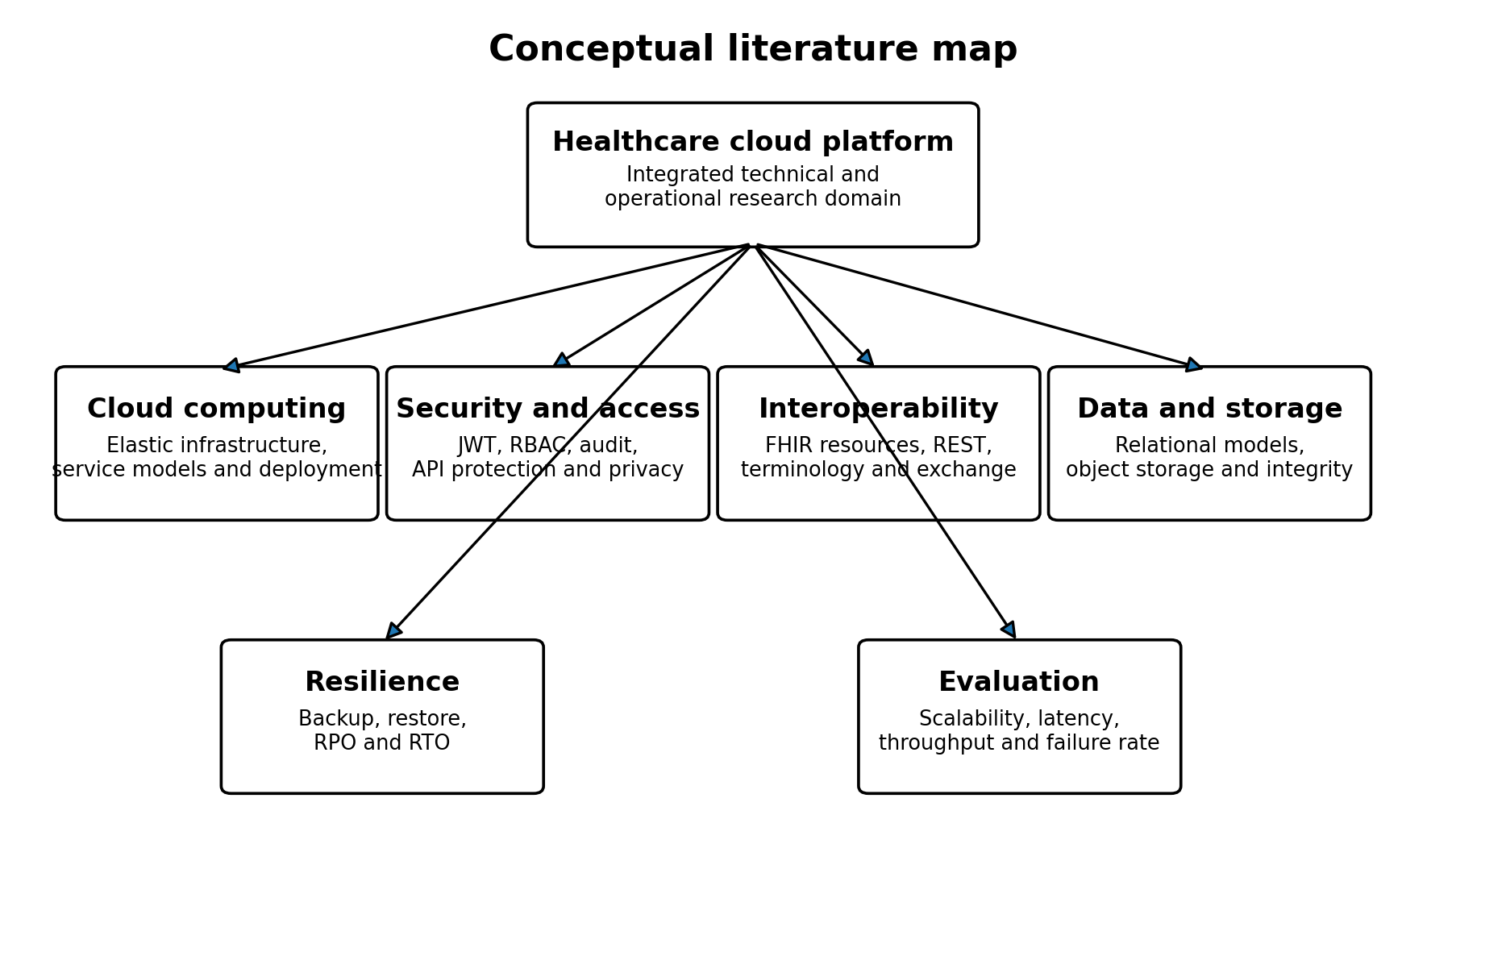
Figure 1. Conceptual map of the literature domains relevant to the platform.

2. Cloud Computing in Healthcare
NIST defines cloud computing as on-demand access to a shared pool of configurable resources that can be rapidly provisioned and released [1]. This definition distinguishes essential characteristics, service models, and deployment models. For healthcare applications, cloud-oriented infrastructure can centralize maintenance, support distributed access, and permit resource scaling; however, its usefulness depends on trust, data governance, availability, and secure integration.
Research on cloud-based electronic health records identifies accessibility, resource flexibility, reduced local infrastructure burden, and centralized data services as potential advantages [11]. At the same time, reviews of cloud computing in eHealth emphasize security, privacy, interoperability, and immature real-world evaluation as recurring challenges [13], [14]. These findings support an architecture that treats security and resilience as first-class design concerns rather than deployment additions.
The present platform is containerized and designed for deployment on a virtual machine. This corresponds most closely to an infrastructure-oriented deployment model, because the application owner manages the operating system environment, containers, databases, storage, reverse proxy, and application services. The local Docker host is cloud-ready but does not become cloud infrastructure merely through virtualization.

3. RESTful APIs and Modular Service Architecture
Fielding introduced REST as an architectural style for network-based software and emphasized constraints such as client-server separation, stateless interaction, cacheability, a uniform interface, layered systems, and optional code-on-demand [15]. Modern healthcare APIs often adopt HTTP, JSON, resource-oriented paths, and stateless authorization tokens, although not every JSON API satisfies the full REST architectural style.
Modular service architecture supports separation of concerns between routing, authentication, authorization, business logic, persistence, validation, storage, and auditing. In the present project, FastAPI endpoints depend on separate security and database components, while domain operations are delegated to service modules. This structure improves testability and limits direct coupling between HTTP handling and persistence logic.
API exposure introduces distinct security risks. The OWASP API Security Top 10 highlights recurring categories such as broken object-level authorization, broken authentication, unrestricted resource consumption, security misconfiguration, and unsafe API consumption [16]. These concerns justify explicit authorization on patient, report, prescription, and FHIR-oriented endpoints, together with bounded pagination and upload size.

4. Authentication, JWT and Role-Based Access Control

4.1 JWT authentication
RFC 7519 defines JWT as a compact, URL-safe representation of claims that may be signed, integrity-protected, or encrypted [7]. JWTs are widely used in HTTP authorization workflows because they can convey subject, issue time, expiration, and application-specific claims without requiring a server-side session object for every request.
JWT alone does not define user authorization policy. Token validation must verify the expected algorithm, signature, expiration, and subject semantics. Applications must also resolve the current user and account state. The platform therefore combines token decoding with database-backed active-user checks.

4.2 Role-based access control
Sandhu et al. formalized a family of RBAC reference models in which permissions are associated with roles and users are assigned to appropriate roles [6]. The central administrative advantage is that permissions can be managed around organizational functions rather than maintained separately for each user.
Healthcare organizations naturally contain function-specific roles such as physician, nurse, pharmacist, laboratory staff, data manager, and administrator. RBAC can therefore reflect competency, responsibility, and duty assignment. The platform applies explicit role sets to clinical creation, reading, updating, report upload, report download, prescription, and FHIR-oriented operations.
RBAC is not automatically equivalent to least privilege. Roles must be reviewed, excessive permissions must be removed, and sensitive operations may require additional contextual constraints. The current implementation uses a direct role-permission matrix and does not implement role hierarchies, dynamic attributes, or separation-of-duty constraints.

5. Audit Logging and Accountability
NIST SP 800-92 describes log management as the development, implementation, and maintenance of processes and infrastructure for security logging [8]. Effective audit systems must address event generation, collection, storage, analysis, retention, and disposal.
In healthcare-data systems, logs support accountability for authentication, authorization, record access, uploads, downloads, and administrative actions. The platform records actor, action, resource, outcome, HTTP method, endpoint, address, user agent, details, and timestamp.
Application-level logging has limitations. A database model described as immutable is not necessarily protected against update or deletion unless database permissions, append-only mechanisms, triggers, or external log replication enforce that property. Centralized monitoring and retention policies remain future work.

6. Healthcare Interoperability and FHIR
FHIR is an HL7 standard for healthcare data exchange [2]. Release 4 includes resources, REST interactions, search, terminology, profiling, capability statements, implementation guides, security, consent, provenance, and audit-related artifacts. Its resource-oriented and web-compatible design makes it suitable for modern APIs.
Bender and Sartipi presented FHIR as an agile and RESTful approach to healthcare exchange [3]. SMART on FHIR demonstrated how standards-based application platforms can connect substitutable applications to electronic health-record data [4]. Later reviews show broad interest in FHIR implementations while also identifying challenges in profiles, terminology, semantic consistency, integration, and implementation maturity [12].
A conformant FHIR server requires more than fields named after FHIR resources. It must identify the FHIR release, respect resource definitions and cardinalities, implement search and Bundle semantics correctly, expose capability metadata, apply profiles where needed, and support appropriate terminology. The current project therefore uses the term FHIR-inspired for its selected Patient, Encounter, Observation, MedicationRequest, and Condition mappings.
FHIR concern | Project status | Interpretation
Resource-oriented JSON | Implemented | Selected resourceType-based responses
Read and search interactions | Partially implemented | Patient, Observation and Condition searches; selected reads
CapabilityStatement | Minimal | Software and JSON format only
Profiles and implementation guides | Not demonstrated | Future interoperability work
Terminology validation | Not demonstrated | Codes stored but not validated against terminology services
Full Bundle semantics and pagination | Partial | Some totals and links require refinement

7. Synthetic Healthcare Data and Synthea
Access to real electronic health records is constrained by privacy, consent, legal, security, and intellectual-property concerns. Walonoski et al. developed Synthea as an open-source simulator of synthetic patient lifespans and health records [5]. The published system generates records in standard formats and is intended for research, education, innovation, and software testing.
Synthetic data support reproducible development without exposing real patient identities. They are especially useful for validating database schemas, API behavior, import pipelines, search, pagination, and load generation. They do not prove clinical validity and should not be treated as substitutes for real-world clinical evidence.
The platform imports Synthea patients, encounters, observations, and medications. Source-system and external-identifier fields support repeatable create-or-update behavior. Deterministic hashes are used when source rows lack a single stable identifier.

8. Containerization and Cloud-Native Deployment
Docker packages applications and their dependencies into portable, isolated containers [10]. Compared with a manually configured host, containerized deployment improves environmental consistency and supports reproducible development, testing, and release workflows.
Containerization does not by itself provide high availability, security, backup, monitoring, or cloud elasticity. These properties depend on network design, image management, secret handling, health checks, persistent storage, orchestration, and operational controls.
The platform uses four services: Nginx, FastAPI, PostgreSQL, and MinIO. Network segmentation keeps the database and object store internal. Named volumes preserve data across ordinary container recreation, while separate backup tests address logical recovery.

9. Relational Data and Object Storage
Healthcare platforms commonly combine structured and unstructured data. Relational databases are appropriate for normalized patient, encounter, observation, prescription, user, role, and audit records because foreign keys, constraints, indexes, and transactions support integrity and queryability.
Binary diagnostic reports are better represented as objects than as large database fields in many application architectures. Object storage separates byte persistence from relational metadata and permits the application to record bucket, object key, content type, file size, checksum, uploader, patient, and encounter references.
This hybrid design introduces a consistency problem: an object upload may succeed while metadata persistence fails, or metadata may remain after object deletion. The project addresses this through service-level sequencing, compensating object deletion, uniqueness constraints, and checksum validation during download.

10. Backup, Recovery and Resilience
NIST SP 800-34 treats contingency planning as part of organizational resilience and system lifecycle management [9]. Recovery planning requires identification of priorities, backup procedures, restoration processes, testing, and operational responsibilities.
Backup creation is insufficient evidence of recoverability. A usable validation process must restore data into an isolated target and compare the restored state with the source. The platform restores a PostgreSQL archive into a temporary database and MinIO objects into a temporary bucket, then verifies structure, row counts, object counts, sizes, and checksums.
The current recovery design remains local. It does not demonstrate encrypted off-site retention, recovery from total host loss, point-in-time database recovery, or measured recovery objectives. These limitations are consistent with the distinction between functional backup validation and complete disaster-recovery capability.

11. Performance and Scalability Evaluation
Performance evaluation of API platforms should report concurrency, request volume, failure rate, throughput, and latency distribution. Mean latency alone can hide long-tail behavior; percentiles such as P95 and P99 provide additional information about slower requests.
Scalability is not demonstrated by a single maximum-load result. A useful evaluation includes multiple load levels, preserves failed scenarios, identifies bottlenecks, applies remediation, and repeats the workload. The platform's initial 200-user test exposed a severe failure condition, while the optimized test achieved zero failures and substantially improved throughput and latency.
The result remains bounded by the workload, host, test duration, database state, and request mix. It cannot be generalized automatically to the future institutional VM or to write-heavy clinical workloads.
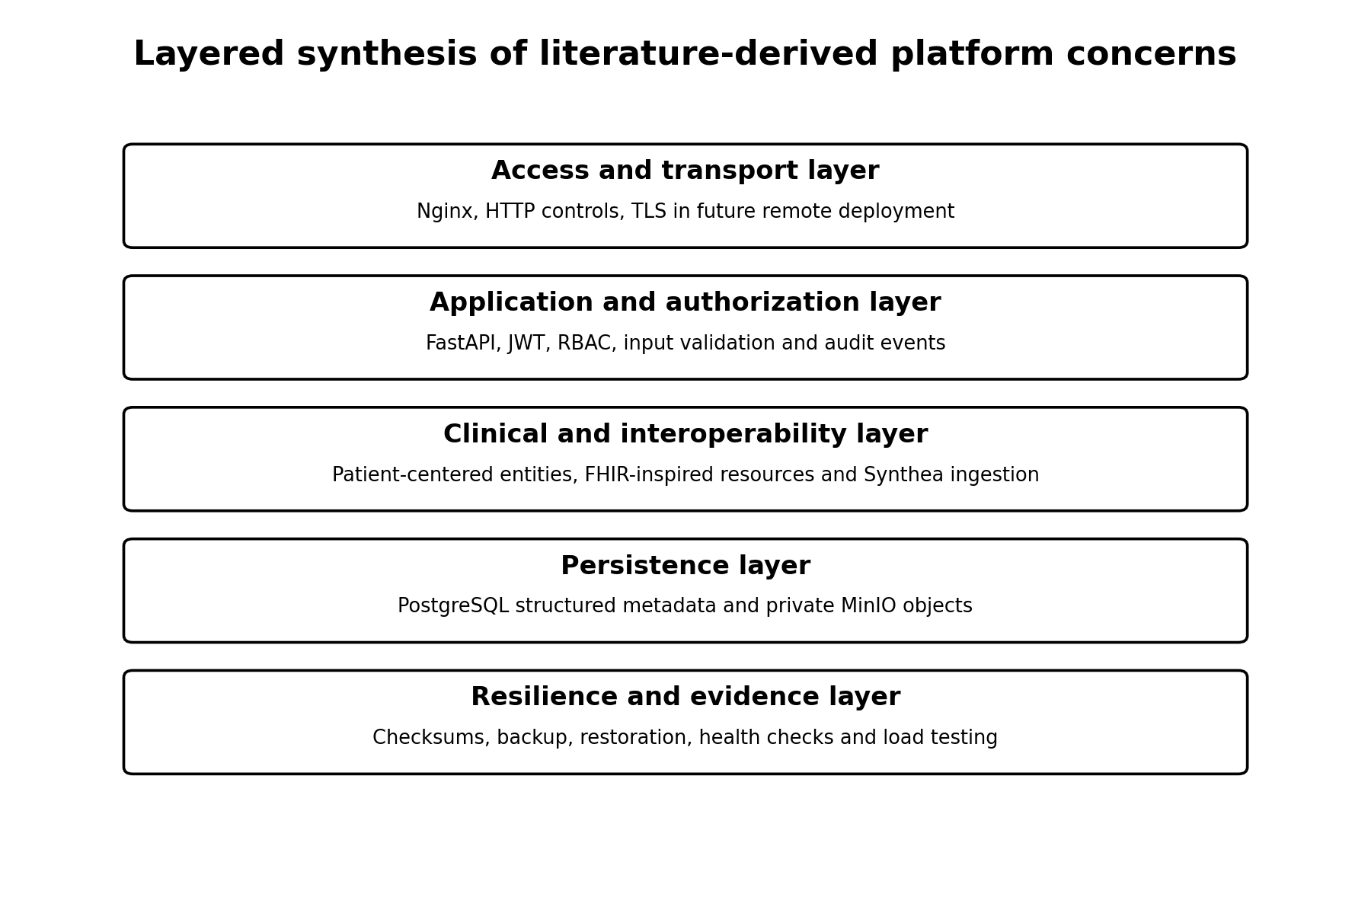
Figure 2. Layered synthesis of literature-derived concerns and their mapping to the implemented platform.

12. Comparative Synthesis of Related Work
Literature stream | Primary contribution | Remaining issue
Cloud-eHealth studies | Cloud benefits, architecture, privacy and deployment challenges | Often conceptual or limited real-world validation [11], [14]
FHIR research | Resource-oriented interoperability and standardized app integration | Implementation complexity, profiles and semantics remain challenges [3], [4], [12]
RBAC literature | Role-centered permission administration | Requires careful role design and may need constraints beyond basic RBAC [6]
Security guidance | JWT, API risks, logging and accountability | Standards provide mechanisms, not a complete application-specific implementation [7], [8], [16]
Container literature | Portability and consistent deployment | Operational resilience and security require additional controls [10]
Contingency guidance | Recovery planning and lifecycle integration | Actual restoration testing is necessary [9]

13. Research Gap and Project Positioning
The reviewed literature establishes strong foundations for cloud computing, REST APIs, RBAC, JWT, audit logging, FHIR, synthetic health records, containerization, and contingency planning. However, these concerns are frequently studied or implemented separately.
Based on the selected literature, the project is positioned as an integrated engineering and validation study. Its distinctive contribution is not a new cryptographic algorithm, access-control theory, FHIR standard, database engine, or container technology. The contribution is the combination of these established mechanisms into one healthcare-data platform with executable cross-domain evidence.
The evidence includes authorized and denied operations, audit outcomes, relational-object checksum consistency, PostgreSQL and MinIO restoration, container health, and before-and-after load testing. This positioning should be understood as a bounded project-level contribution rather than a claim that the literature has no other integrated healthcare platforms.
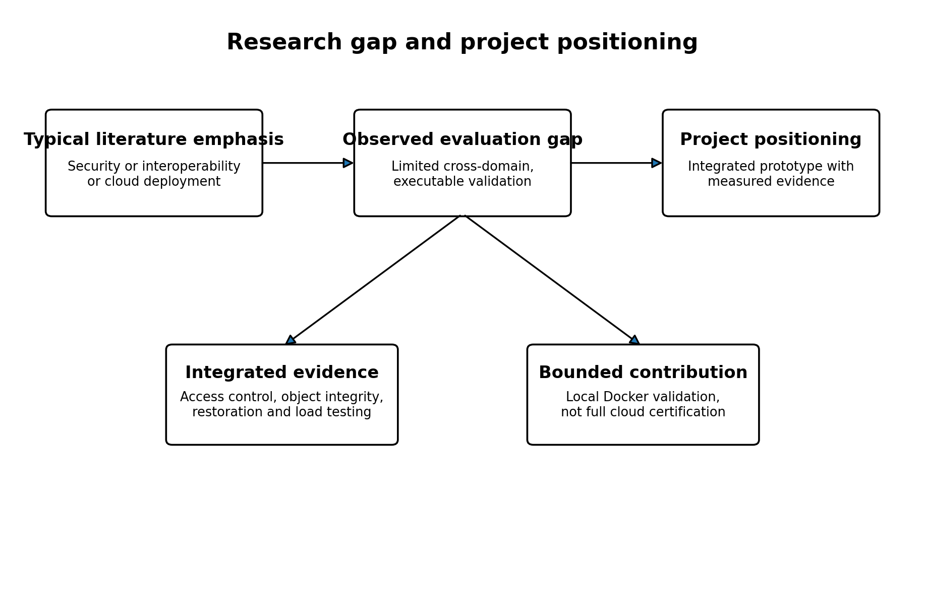
Figure 3. Research gap and bounded positioning of the Healthcare Cloud Platform.
Theme | Common literature emphasis | Project contribution
Security | Frequently discussed as policy, cryptography or privacy | Integrated JWT, RBAC, HTTP security and audit validation
Interoperability | FHIR resources and app platforms | Selected FHIR-inspired layer connected to the same clinical database
Storage | Relational or cloud storage considered separately | PostgreSQL metadata plus private MinIO objects with SHA-256
Recovery | Backup and contingency planning guidance | Executable isolated restoration for both persistence domains
Performance | Scalability often stated as an architectural goal | Measured multi-load Locust testing with failed and optimized 200-user runs
Deployment | Cloud or container architecture descriptions | Versioned four-service production Compose stack with validation evidence

14. Conceptual Framework for the Thesis
The conceptual framework derived from the review is that healthcare-platform readiness is a function of multiple interdependent domains. Security restricts and records access. Interoperability structures exchange. Data models and storage preserve clinical content. Containerization supports reproducible deployment. Recovery protects continuity. Performance evaluation tests whether the integrated system remains useful under concurrency.
No single domain is sufficient. The thesis therefore evaluates the platform using an integrated matrix rather than treating security, storage, recovery, and performance as unrelated appendices.

15. Chapter Summary
This chapter reviewed the standards and research that inform the platform. Cloud computing motivates remote and elastic infrastructure; REST and FHIR motivate resource-oriented exchange; JWT and RBAC motivate authenticated role-based access; log-management guidance motivates auditability; Synthea enables privacy-preserving software testing; Docker supports portable deployment; and contingency-planning guidance motivates restoration testing. The next chapter presents the system design and implementation.

References
[1] P. Mell and T. Grance, The NIST Definition of Cloud Computing, NIST Special Publication 800-145, 2011. doi: 10.6028/NIST.SP.800-145.
[2] HL7 International, HL7 FHIR Release 4, Version 4.0.1, 2019.
[3] D. Bender and K. Sartipi, “HL7 FHIR: An agile and RESTful approach to healthcare information exchange,” in Proc. 26th IEEE International Symposium on Computer-Based Medical Systems, 2013, pp. 326-331. doi: 10.1109/CBMS.2013.6627810.
[4] J. C. Mandel, D. A. Kreda, K. D. Mandl, I. S. Kohane, and R. B. Ramoni, “SMART on FHIR: a standards-based, interoperable apps platform for electronic health records,” Journal of the American Medical Informatics Association, vol. 23, no. 5, pp. 899-908, 2016. doi: 10.1093/jamia/ocv189.
[5] J. Walonoski et al., “Synthea: An approach, method, and software mechanism for generating synthetic patients and the synthetic electronic health care record,” Journal of the American Medical Informatics Association, vol. 25, no. 3, pp. 230-238, 2018. doi: 10.1093/jamia/ocx079.
[6] R. S. Sandhu, E. J. Coyne, H. L. Feinstein, and C. E. Youman, “Role-based access control models,” Computer, vol. 29, no. 2, pp. 38-47, 1996. doi: 10.1109/2.485845.
[7] M. Jones, J. Bradley, and N. Sakimura, JSON Web Token (JWT), RFC 7519, Internet Engineering Task Force, 2015.
[8] K. Kent and M. Souppaya, Guide to Computer Security Log Management, NIST Special Publication 800-92, 2006. doi: 10.6028/NIST.SP.800-92.
[9] M. Swanson, P. Bowen, A. Phillips, D. Gallup, and D. Lynes, Contingency Planning Guide for Federal Information Systems, NIST Special Publication 800-34 Revision 1, 2010. doi: 10.6028/NIST.SP.800-34r1.
[10] D. Merkel, “Docker: Lightweight Linux containers for consistent development and deployment,” Linux Journal, no. 239, 2014.
[11] M. Ahmadi and N. Aslani, “Capabilities and advantages of cloud computing in the implementation of electronic health record,” Acta Informatica Medica, vol. 26, no. 1, pp. 24-28, 2018. doi: 10.5455/aim.2018.26.24-28.
[12] M. Ayaz, M. F. Pasha, M. Y. Alzahrani, R. Budiarto, and D. Stiawan, “The Fast Health Interoperability Resources standard: systematic literature review of implementations, applications, challenges and opportunities,” JMIR Medical Informatics, vol. 9, no. 7, e21929, 2021. doi: 10.2196/21929.
[13] S. Chenthara, K. Ahmed, H. Wang, and F. Whittaker, “Security and privacy-preserving challenges of e-health solutions in cloud computing,” IEEE Access, vol. 7, pp. 74361-74382, 2019. doi: 10.1109/ACCESS.2019.2919982.
[14] Y. Hu and G. Bai, “A systematic literature review of cloud computing in eHealth,” arXiv:1412.2494, 2014.
[15] R. T. Fielding, Architectural Styles and the Design of Network-Based Software Architectures, Ph.D. dissertation, University of California, Irvine, 2000.
[16] OWASP Foundation, OWASP API Security Top 10 - 2023, 2023.

