PERFORMANCE, SCALABILITY
AND COST-EFFICIENCY EVALUATION
Healthcare Cloud Platform
A source-grounded evaluation based on authenticated Locust workloads, consolidated performance metrics, and available Docker resource snapshots
Maximum validated zero-failure load: 200 concurrent users at 146.77 requests/s

Executive Summary
This chapter evaluates the performance and scalability of the Healthcare Cloud Platform using an authenticated Locust workload. Five scenarios were consolidated: 10, 50, 100, an initial 200-user run, and an optimized 200-user run. The workload exercised the health endpoint and representative FHIR read operations for patients, complete patient records, encounters, and conditions. Each simulated user authenticated once and then reused a bearer token.
The platform completed the 10-user, 50-user, 100-user, and optimized 200-user scenarios with zero failed requests. Throughput increased from 7.94 requests/s at 10 users to 146.77 requests/s at 200 optimized users. The initial 200-user test exposed a severe bottleneck: 357 failures, a 23.99% failure rate, a mean latency of 33,132.66 ms, and throughput of only 5.23 requests/s. After remediation, failures fell to zero, mean latency fell to 29.27 ms, and throughput rose by 141.54 requests/s.
The evidence supports a scalability claim for the measured Docker environment up to 200 concurrent users. It does not support unrestricted extrapolation to other hardware, longer test durations, write-heavy workloads, geographically distributed clients, or a future remote VM. Monetary cost-effectiveness also remains unquantified because verified infrastructure and operational costs were not supplied.
Scenario | Requests | Failures | Mean latency | P95 | RPS
10 users | 465 | 0 | 26.72 ms | 71 ms | 7.94
50 users | 4,557 | 0 | 19.48 ms | 59 ms | 38.35
100 users | 13,695 | 0 | 39.27 ms | 130 ms | 76.46
200 users, initial | 1,488 | 357 | 33,132.66 ms | 90,000 ms | 5.23
200 users, optimized | 43,814 | 0 | 29.27 ms | 110 ms | 146.77

Chapter Structure
1. Evaluation objectives
2. Experimental workload and methodology
3. Consolidated performance results
4. Scaling behavior at 10, 50, and 100 users
5. Initial 200-user bottleneck
6. Optimized 200-user outcome
7. Throughput, latency, and reliability analysis
8. Resource-efficiency observations
9. Cost-efficiency methodology
10. Limitations, recommendations, and conclusion

1. Evaluation Objectives
The performance evaluation was designed to determine whether the backend could sustain increasing numbers of authenticated concurrent users while maintaining reliability, bounded response time, and increasing useful throughput. The analysis focuses on five questions:
- Does throughput increase as the number of concurrent users rises?
- Do average and tail latencies remain operationally bounded under successful loads?
- At what tested load does the first major bottleneck appear?
- Does the optimized configuration remove the measured bottleneck?
- What resource and cost-efficiency conclusions are justified by the available evidence?
The principal outcome metric is successful throughput. Raw requests per second can overstate useful capacity when requests fail. For the initial 200-user scenario, reliability-adjusted throughput was 3.98 successful requests/s rather than the raw value of 5.23 requests/s.

2. Experimental Workload and Methodology

2.1 Load-generation framework
Locust was used to model concurrent authenticated API users. Each virtual user executed the on_start routine once, submitted credentials to the login endpoint, retrieved a JWT access token, and attached the bearer token to subsequent requests. A missing load-test password caused the test user to fail immediately, preventing accidental unauthenticated execution.
The simulated think time was uniformly selected between 0.5 and 2.0 seconds. This introduces a more realistic pause between requests than an unbounded tight loop, although it remains a synthetic workload rather than an observational model of actual hospital staff behavior.

2.2 Task composition
Request | Weight | Approx. share | Purpose
GET /health | 1 | 7.14% | Public service-health check
GET /api/v1/fhir/Patient/{id} | 4 | 28.57% | Read a known patient
GET /api/v1/fhir/Patient/{id}/  $everything | 1 | 7.14% | Read aggregated patient record
GET /api/v1/fhir/Encounter/{id} | 2 | 14.29% | Read a known encounter
GET /api/v1/fhir/Condition/{id} | 3 | 21.43% | Read a known condition
GET /api/v1/fhir/Condition  ?patient={id}&_count=20 | 3 | 21.43% | Search patient conditions

The task weights total 14. Patient retrieval is the most frequent operation, while condition retrieval and condition search jointly represent 42.86% of task selections. The workload is therefore read-dominant and FHIR-oriented. It does not measure the same behavior as a write-heavy clinical transaction workload involving report uploads, prescription creation, or concurrent database updates.

2.3 Consolidation procedure
The consolidation script reads Locust CSV files, identifies the aggregated result row, normalizes column names, and extracts request count, failure count, average latency, median latency, P95, P99, and requests per second. The failure rate is calculated as failed requests divided by total requests. The initial and optimized 200-user runs are intentionally retained as separate scenarios so that the original bottleneck and its remediation remain auditable.

3. Consolidated Performance Results
Scenario | Users | Requests | Failures | Failure rate | Avg ms | Median ms | P95 ms | P99 ms | RPS
10 users | 10 | 465 | 0 | 0.00% | 26.72 | 16.00 | 71.00 | 290.00 | 7.94
50 users | 50 | 4557 | 0 | 0.00% | 19.48 | 10.00 | 59.00 | 230.00 | 38.35
100 users | 100 | 13695 | 0 | 0.00% | 39.27 | 15.00 | 130.00 | 450.00 | 76.46
200 users initial | 200 | 1488 | 357 | 23.99% | 33,132.66 | 29,000.00 | 90,000.00 | 91,000.00 | 5.23
200 users optimized | 200 | 43814 | 0 | 0.00% | 29.27 | 13.00 | 110.00 | 240.00 | 146.77

Four scenarios completed without failures. The optimized 200-user run is the strongest validated result, combining the highest tested concurrency with the highest throughput and zero failures. The initial 200-user run is qualitatively different from the other scenarios because latency rose from tens of milliseconds to tens of seconds and failures became substantial.

4. Scaling Behavior at 10, 50, and 100 Users

4.1 Ten concurrent users
At 10 concurrent users, the platform processed 465 requests with no failures. Mean response time was 26.72 ms, median response time was 16 ms, P95 was 71 ms, P99 was 290 ms, and throughput was 7.94 requests/s. This scenario establishes the low-load baseline.

4.2 Fifty concurrent users
At 50 concurrent users, the platform processed 4,557 requests with no failures. Throughput rose to 38.35 requests/s. Mean latency decreased to 19.48 ms and P95 decreased to 59 ms. The lower measured latency relative to the 10-user run does not prove that additional concurrency inherently improves latency. It may reflect run-to-run variation, warm caches, connection reuse, or measurement timing.

4.3 One hundred concurrent users
At 100 concurrent users, 13,695 requests completed with no failures. Throughput reached 76.46 requests/s. Mean response time was 39.27 ms, P95 was 130 ms, and P99 was 450 ms. Compared with the 50-user scenario, throughput approximately doubled while tail latency increased but remained below half a second at P99.
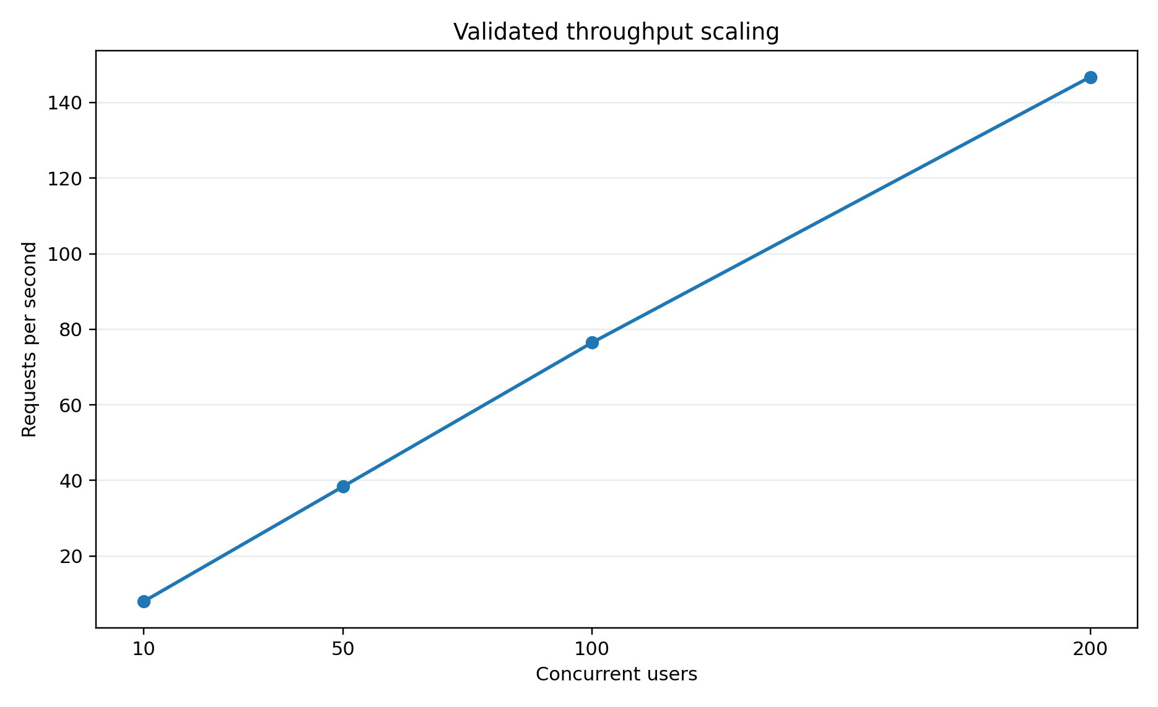
Figure 1. Throughput scaling for all zero-failure scenarios.
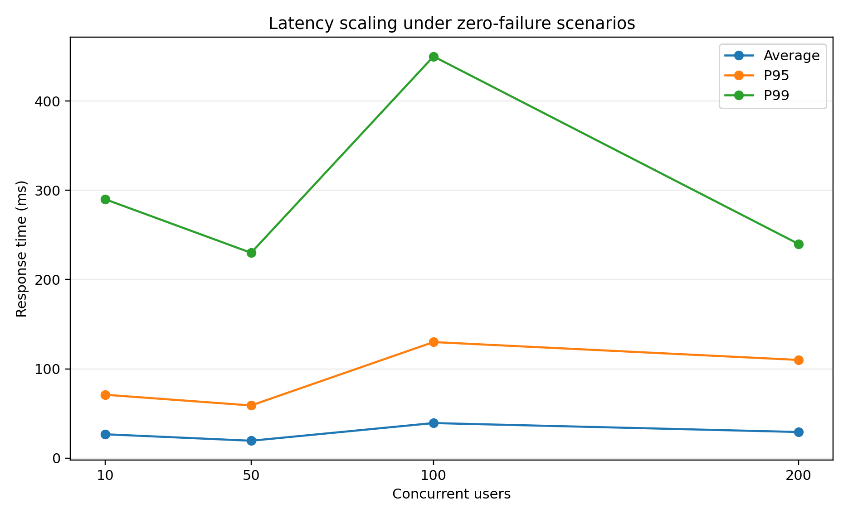
Figure 2. Average, P95, and P99 latency scaling for zero-failure scenarios.

5. Initial 200-User Bottleneck
The first 200-user test exposed a severe loss of capacity. Only 1,488 requests were recorded, 357 failed, and the failure rate reached 23.99%. Mean response time increased to 33,132.66 ms, the median reached 29,000 ms, P95 reached 90,000 ms, and P99 reached 91,000 ms. Raw throughput fell to 5.23 requests/s, below even the 10-user result.
The project evidence identifies this result as an original connection-pool bottleneck. The supplied extract does not document the exact parameter changes used during remediation. Therefore, the chapter treats the bottleneck classification and the before-and-after outcome as supported, but does not attribute the improvement to an undocumented pool size, overflow setting, worker count, or timeout value.
Reliability-adjusted throughput was 3.98 successful requests/s. This value is more informative than the raw 5.23 requests/s because nearly one quarter of requests failed. The latency-adjusted efficiency metric calculated by the project script was only 0.1165, confirming that the run produced little useful work relative to its latency.
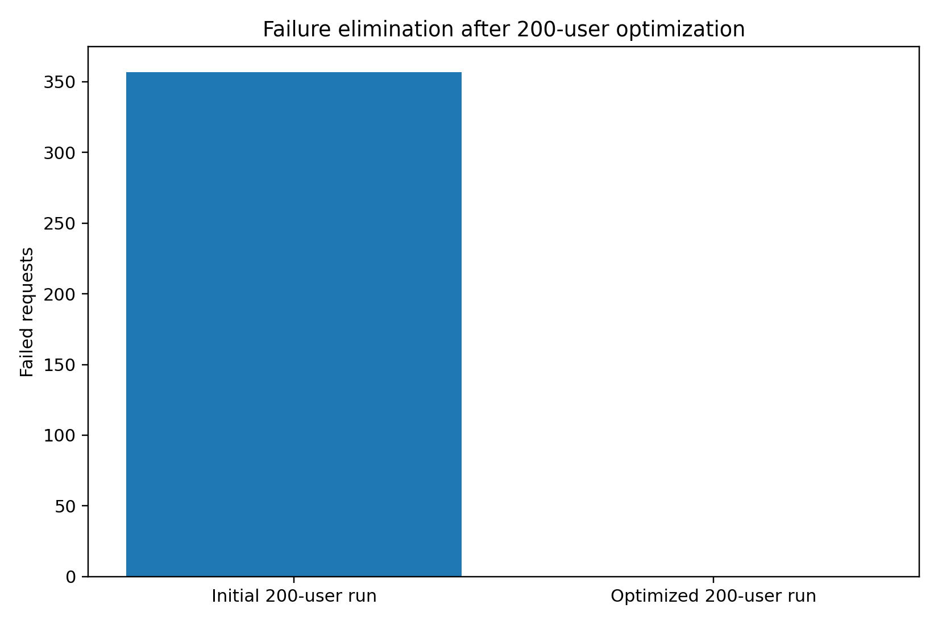
Figure 3. Failed requests before and after remediation at 200 concurrent users.

6. Optimized 200-User Outcome
The optimized 200-user test processed 43,814 requests without a single failure. Throughput reached 146.77 requests/s, mean response time was 29.27 ms, median response time was 13 ms, P95 was 110 ms, and P99 was 240 ms. This result surpassed the lower-load scenarios while retaining zero failures.
Metric | Initial | Optimized | Change
Failed requests | 357 | 0 | -357
Failure rate | 23.99% | 0.00% | -23.99 percentage points
Throughput | 5.23 RPS | 146.77 RPS | +141.54 RPS
Mean latency | 33,132.66 ms | 29.27 ms | 99.91% improvement
P95 latency | 90,000 ms | 110 ms | 99.88% improvement
P99 latency | 91,000 ms | 240 ms | 99.74% improvement

Relative raw-throughput growth was 2706.31%. The resource-analysis script reports a 3,587.69% change for reliability-adjusted throughput because its denominator is successful throughput rather than raw throughput. Both calculations are valid for their stated definitions, but they must not be presented as the same metric.
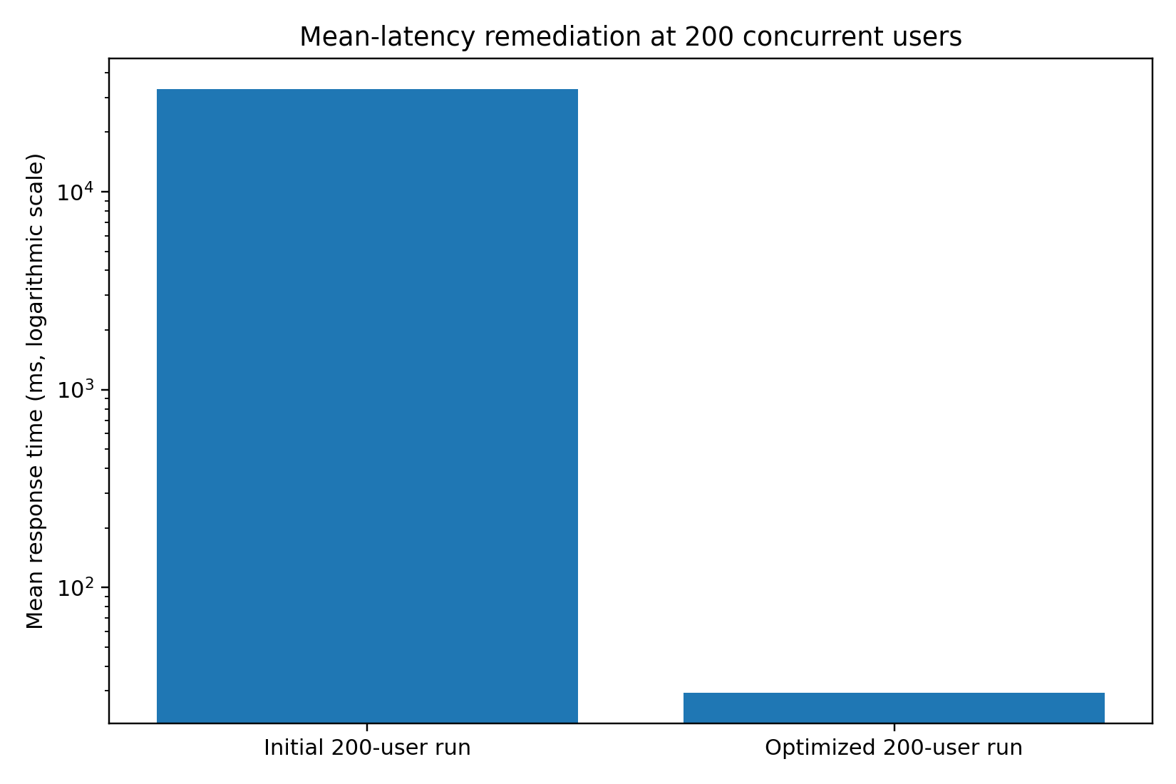
Figure 4. Mean response time before and after remediation. A logarithmic axis is used because the values differ by more than three orders of magnitude.

7. Throughput, Latency, and Reliability Analysis

7.1 Throughput scaling
Across successful scenarios, throughput rose from 7.94 to 38.35, 76.46, and 146.77 requests/s as concurrency increased from 10 to 50, 100, and 200 users. The relationship is broadly proportional over the tested range, although strict linear scalability cannot be claimed without repeated runs, confidence intervals, and a controlled comparison of identical test durations.

7.2 Latency behavior
Mean latency remained between 19.48 and 39.27 ms for all zero-failure scenarios. P95 remained between 59 and 130 ms, while P99 ranged from 230 to 450 ms. The optimized 200-user run produced a lower P99 than the 100-user run. This is a measured result, but it should not be interpreted as a deterministic law of the system because the evidence contains one consolidated result per scenario rather than a distribution across repeated independent experiments.

7.3 Reliability
Reliability was binary across the consolidated scenarios: zero failures at 10, 50, 100, and optimized 200 users, contrasted with 357 failures during the initial 200-user run. This clear discontinuity supports the conclusion that the original problem was configuration- or capacity-related rather than a gradual degradation visible at lower loads.

8. Resource-Efficiency Observations
Scenario | Successful RPS | CPU snapshot % | Memory snapshot MiB | RPS/CPU% | RPS/GiB
10 users | 7.94 | N/A | N/A | N/A | N/A
50 users | 38.35 | 36.66 | 82.59 | 1.0461 | 475.49
100 users | 76.46 | 288.31 | 87.42 | 0.2652 | 895.62
200 users initial | 3.98 | N/A | N/A | N/A | N/A
200 users optimized | 146.77 | 0.35 | 102.10 | 419.3429 | 1472.01

Resource snapshots were available for the 50-user, 100-user, and optimized 200-user scenarios. Memory rose modestly from 82.59 MiB to 87.42 MiB and 102.10 MiB. These values suggest that backend memory consumption remained comparatively small in the recorded snapshots.
The CPU values are not suitable for direct efficiency ranking. The 100-user snapshot reports 288.31%, while the optimized 200-user snapshot reports 0.35%. Docker CPU percentages can exceed 100% on multicore hosts, but the 0.35% value at 146.77 requests/s strongly indicates that the snapshot was not synchronized with a representative steady-state interval. Consequently, the derived value of 419.3429 successful RPS per CPU percentage point must not be used as a headline efficiency claim.
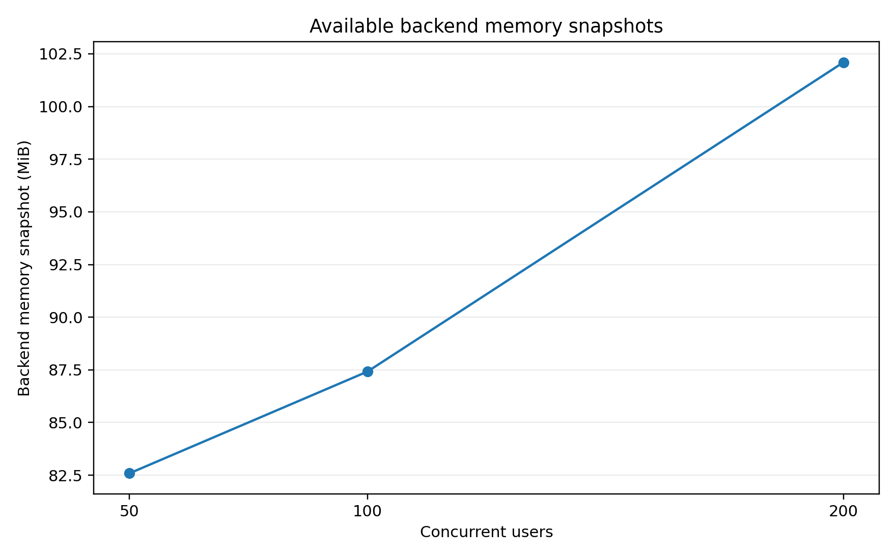
Figure 5. Available backend memory snapshots. The measurements are point-in-time observations, not time-averaged resource profiles.

9. Cost-Efficiency Methodology
The project analysis defines monetary cost-effectiveness as monthly total cost divided by estimated millions of successful requests. The intended formula is:
Cost per million successful requests = Monthly total cost / (Estimated successful monthly requests / 1,000,000)
Monthly total cost should include verified infrastructure and operational costs. Estimated monthly successful requests should be based on a realistic workload profile and utilization factor. The maximum Locust throughput must not be multiplied by every second of a 30-day month unless the deployment is genuinely expected to operate continuously at maximum tested load.
The requested path tests/performance/cost_input_template.csv was missing from the supplied extract. The analysis script is designed to generate the template under tests/performance/results. Regardless of path, the monetary fields were not populated with verified costs. A numerical cost-per-million result would therefore be fabricated and is intentionally not reported.
Model component | Required input
Infrastructure | VM or cloud compute, storage volumes, network transfer, backup storage, domain and certificate services where charged
Operations | Monitoring, maintenance, administration, support, security review, and backup verification
Demand model | Expected active users, request mix, daily operating hours, peak-to-average ratio, and growth allowance
Reliability adjustment | Only successful requests belong in the denominator
Sensitivity analysis | Evaluate conservative, expected, and high-utilization scenarios

10. Limitations and Recommendations

10.1 Limitations
- The results describe one Docker-based environment and do not establish performance on the future UESTC VM.
- The supplied consolidation contains one result per scenario and no repeated-run confidence intervals.
- Test durations and user spawn rates are not included in the extract.
- The workload is read-dominant and uses fixed known resource identifiers.
- Each virtual user authenticates only once, so sustained login pressure is not evaluated.
- The tests do not quantify database query plans, connection-pool occupancy, lock contention, disk I/O, or network latency.
- Resource measurements are point-in-time snapshots and are not synchronized time series.
- No verified monetary inputs are available, so financial cost-effectiveness remains uncalculated.

10.2 Recommended next experiments
Priority | Recommended experiment
P1 | Repeat each load level at least three times and report mean, standard deviation, and confidence intervals.
P1 | Re-run the same workload on the final VM with synchronized CPU, memory, network, disk, and database metrics.
P1 | Record test duration, spawn rate, backend worker count, database pool settings, and host specifications.
P2 | Add write-heavy scenarios for patients, encounters, observations, prescriptions, and diagnostic-report uploads.
P2 | Add mixed-role workloads so that Doctor, Nurse, Lab Staff, Pharmacist, Data Manager, and Admin traffic are represented.
P2 | Perform endurance testing to identify connection leakage, memory growth, and long-term stability problems.
P3 | Populate the cost template with verified deployment prices and evaluate multiple utilization assumptions.

11. Conclusion
The Healthcare Cloud Platform demonstrated reliable scaling from 10 to 200 concurrent users in the tested Docker environment after remediation of the original 200-user bottleneck. The final scenario processed 43,814 requests with zero failures, 146.77 requests/s, a mean response time of 29.27 ms, P95 of 110 ms, and P99 of 240 ms. Relative to the initial 200-user run, 357 failures were eliminated, raw throughput increased by 141.54 requests/s, and mean latency improved by approximately 99.91%.
These results support a measured scalability claim, not an unlimited production-capacity claim. The strongest defensible conclusion is that the optimized local production configuration sustained the tested authenticated, read-dominant workload at 200 concurrent users without failures. Final cloud-deployment conclusions require repeated tests on the remote VM, synchronized resource monitoring, broader workload coverage, and verified cost inputs.

Appendix A. Evidence Traceability
Claim or component | Primary evidence
Consolidated performance metrics | docs/evidence/performance_consolidated_summary.md
Performance CSV | docs/tables/performance_consolidated_summary.csv
Resource and cost analysis | docs/evidence/resource_cost_efficiency_summary.md
Resource-efficiency CSV | docs/tables/resource_cost_efficiency_summary.csv
Locust workload | tests/performance/locustfile.py
Consolidation logic | tests/performance/consolidate_performance_results.py
Resource and cost analysis logic | tests/performance/analyze_resource_cost_efficiency.py
Original result files | locust_10_users_stats.csv; locust_50_users_stats.csv; locust_100_users_stats.csv; locust_200_users_stats.csv; locust_200_users_fixed_stats.csv

Appendix B. Derived Calculations
Metric | Calculation | Result
Initial 200-user reliability-adjusted throughput | 5.23 x (1 - 0.239919) | 3.98 successful RPS
Failed-request reduction | 357 - 0 | 357 requests
Raw-throughput gain | 146.77 - 5.23 | 141.54 RPS
Raw-throughput relative increase | (146.77 / 5.23 - 1) x 100 | 2706.31%
Mean-latency improvement | (33,132.66 - 29.27) / 33,132.66 x 100 | 99.91%
P95 improvement | (90,000 - 110) / 90,000 x 100 | 99.88%
P99 improvement | (91,000 - 240) / 91,000 x 100 | 99.74%

