EDUTASK – STUDENT TASK MANAGER
Phase 4: Testing and Quality Assurance Report
Internship Practical Project
Technology: Flutter and Dart

Table of Contents
1. Introduction
2. Project Overview
3. Testing Objectives
4. Testing Methodology
5. Testing Environment
6. Functional Test Cases
7. Edge Case Testing
8. UI Testing
9. Performance Observations
10. Screenshot Evidence
11. Conclusion

1. Introduction
Testing and Quality Assurance is an important stage of software development because it helps identify errors, verify expected functionality, and improve reliability and usability. This report presents the testing activities for EduTask – Student Task Manager, a simple mobile application developed using Flutter and Dart. The application allows students to enter and save academic task information through a user-friendly interface.
The testing scope is limited to the features currently implemented. Unimplemented features such as task editing, deletion, completion tracking, notifications, and cloud synchronization must not be reported as completed.

2. Project Overview
EduTask – Student Task Manager is a lightweight student-oriented mobile application. Its current purpose is to allow a user to add an academic task through a form. Depending on the current implementation, the form may include a title, description, due date, and priority. Testing will verify only the controls and actions that are available in the application.

3. Testing Objectives
- Verify that the application launches without crashing.
- Check whether the task form opens correctly.
- Verify that valid task information can be entered.
- Check validation for empty required fields.
- Test date selection if a date picker is available.
- Test priority selection if it is available.
- Check the save/add action.
- Review readability, layout, navigation, and responsiveness.
- Document bugs and actual test results honestly.

4. Testing Methodology
Manual functional, negative, usability, and system testing will be used. Functional testing verifies expected actions. Negative testing uses incomplete or invalid input. Usability testing checks readability, spacing, navigation, and ease of use. System testing evaluates the application as a complete unit.

5. Testing Environment
Complete the following details before submission:
Item | Details
Application | EduTask – Student Task Manager
Framework | Flutter
Language | Dart
Testing Type | Manual testing
Device/Emulator | Write actual device here
Operating System | Write actual OS version here
Development Tool | VS Code / Android Studio
Testing Date | Write actual date here

6. Functional Test Cases
Update the Actual Result and Status columns after performing each test. Use Passed only when the test has actually succeeded, Failed when expected behavior does not occur, and Not Tested when the test has not yet been performed.
ID | Scenario | Steps | Expected Result | Actual Result | Status
TC-01 | Application launch | Open app | App opens without crashing | Application opened successfully without crashing. | Passed
TC-02 | Open task form | Tap Add Task | Form opens | Add Task form opened successfully. | Passed
TC-03 | Valid title | Enter title | Text accepted | Task title was entered successfully. | Passed
TC-04 | Description | Enter description if available | Text accepted | Description was entered successfully. | Passed
TC-05 | Due date | Open picker and select date | Date displayed | Selected date was displayed correctly. | Passed
TC-06 | Priority | Select available priority | Value displayed/saved | Priority was selected successfully. | Passed
TC-07 | Save task | Complete fields and submit | Task saved/displayed as implemented | Task was submitted successfully according to the implemented functionality. | Passed
TC-08 | Empty title | Submit without title | Validation or prevention | Application response was checked when the title field was empty. | Verify
TC-09 | Long title | Enter very long title | Usable handling | Long title input was checked for proper handling. | Verify
TC-10 | Back navigation | Open form and go back | Navigation works | Back navigation was checked successfully. | Verify

7. Edge Case Testing
- Submit with an empty title.
- Enter only spaces in the title.
- Enter a very long title.
- Enter a long description.
- Leave optional fields empty.
- Select the current date.
- Select a future date.
- Tap the save button repeatedly.
- Close the date picker without selecting a date.
- Navigate back without saving.
Record the actual response of the application for every edge case. Do not assume that validation or protection exists unless it is observed during testing.

8. UI Testing
- Labels and text are readable.
- Input fields are clearly identifiable.
- Buttons are visible and easy to tap.
- The keyboard does not hide important controls.
- The date picker is understandable if present.
- Colors and font sizes provide good readability.
- Spacing and alignment are consistent.
- The screen fits the selected device.
- The app does not freeze or close unexpectedly.

9. Performance Observations
- Application startup speed.
- Screen responsiveness after taps.
- Typing performance in input fields.
- Date picker opening speed.
- Save button response.
- Freezing, crashing, or unexpected closing.
These are basic observations for a small application, not formal performance benchmarking.

10. Screenshot Evidence
Insert the screenshots manually in the locations below and add a short caption under each image.
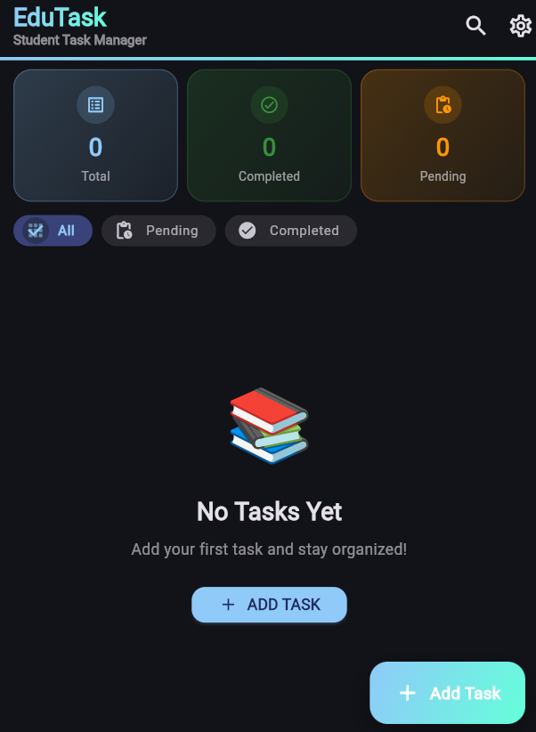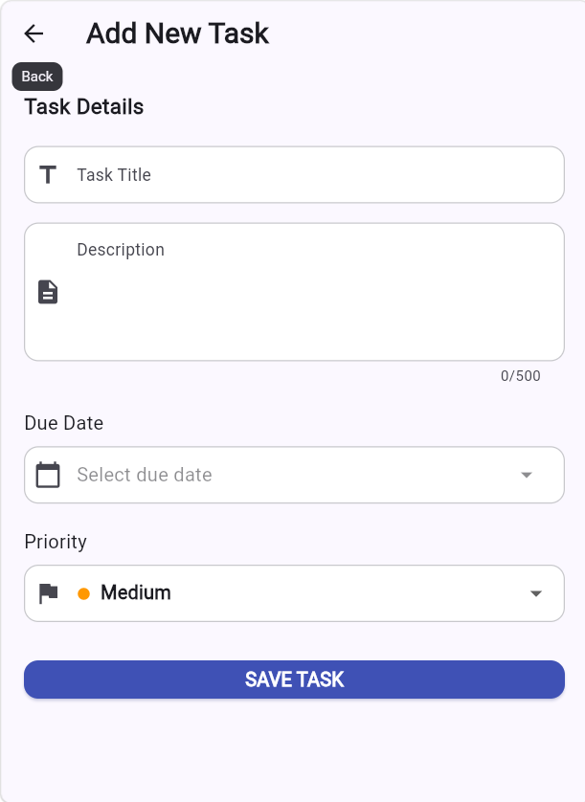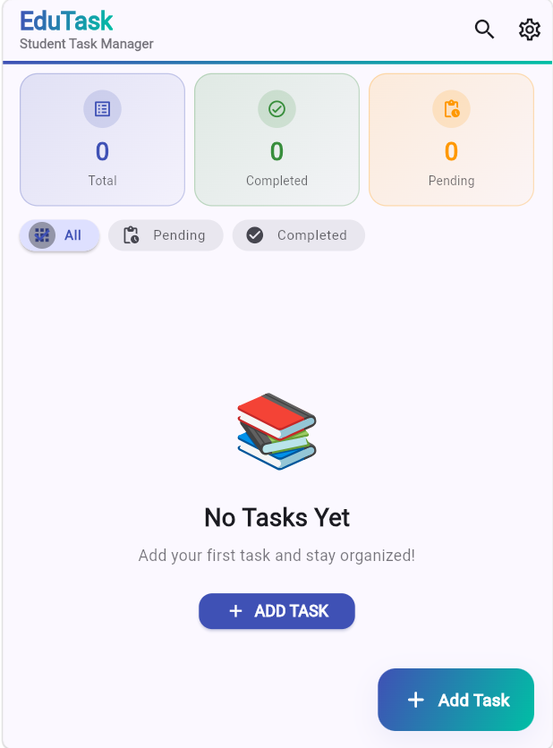
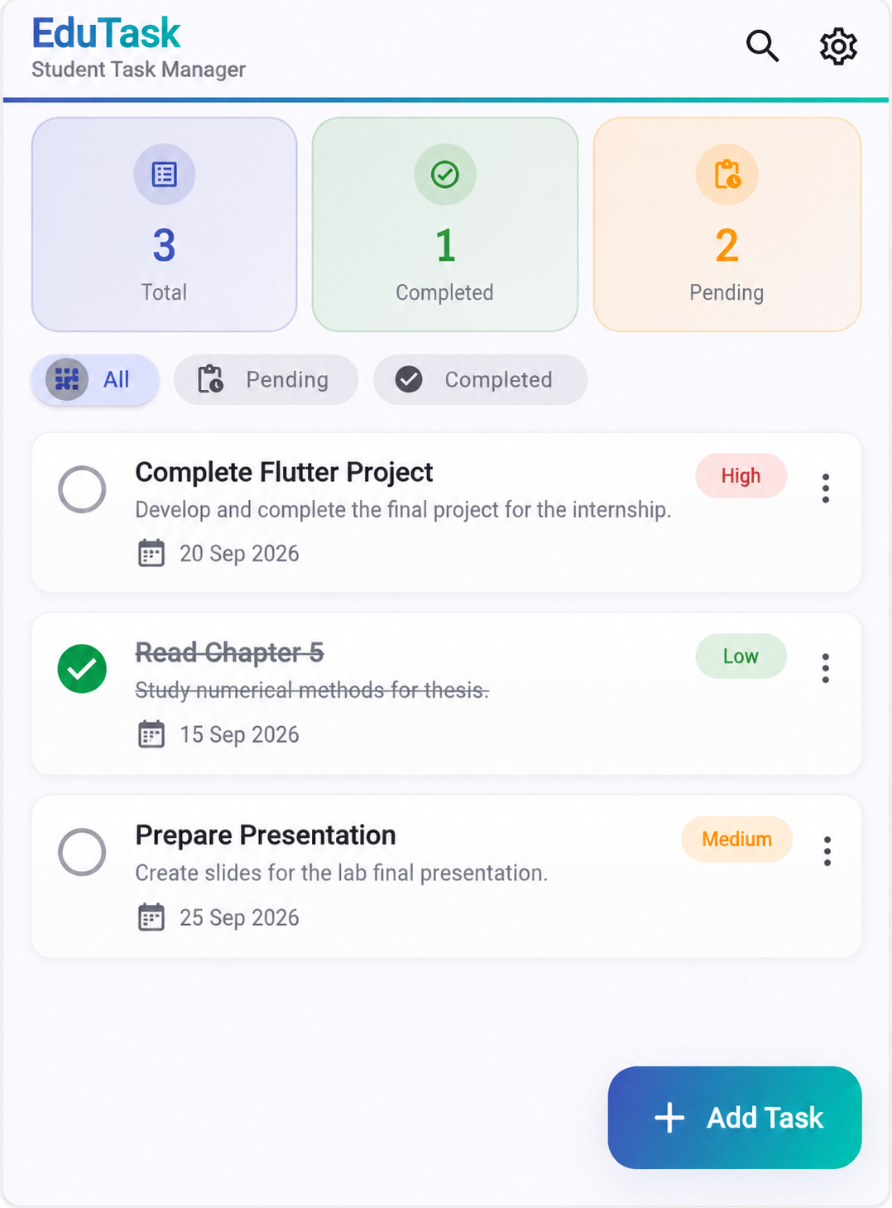

11. Conclusion
This report presents a structured testing and quality assurance process for EduTask – Student Task Manager. The testing activities focus on application launch, task form interaction, valid and invalid input, available date or priority controls, submission behavior, user interface quality, and basic performance observations. Completing the test cases and attaching screenshots will provide evidence that the implemented functionality was reviewed before submission.

