Functional Requirement Specifications

of

Inventory Management System

(IMS)

Submitted to: Md. Sajjad Raihan

Submitted by: Md. Rayhanul Islam Raj (5779)

Date: 2023-06-20

**Table of Contents**

**1. User Management 3**

1.1. Registration 3

1.2 User Dashboard 4

1.3. Manage Roles 5

1.4. Sign in 6

**2. Dashboard 7**

**3. Supplier 7**

3.1. Add a new supplier 7

3.2. All Suppliers 9

**4. Customer 10**

4.1. Add a new customer 10

4.2. All Customers 11

**5. Purchase 12**

5.1. New Purchase 12

5.2. Purchase Report 13

**6. Sale 14**

6.1. New Sale 14

6.2. Sale Report 16

**7. Category 17**

7.1. Add a new category 17

7.2 All Categories 18

**8. Product 19**

8.1. Add a new Product 19

8.2 All Products 20

**9. Profit or Loss Report 22**

# 

# 1. User Management

This system will be accessed only by registered users. To give one access to this system Super Admin (SA) will register a user first. After registration, SA will give roles to the newly registered user.

## **1.1. Registration**

Users must be registered by super admin.

*Figure: User Registration*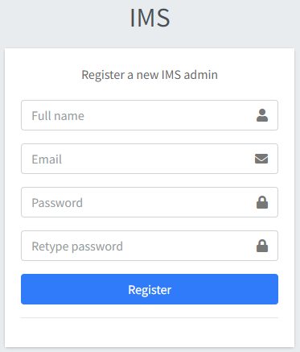

**1.1.1 Components**

**Full name**

* It is a mandatory field.
* Input type must be text.
* Won't accept alphanumeric and special characters.
* Length must be greater than 2 and less than 51 characters.

**Email**

* It is a mandatory field.
* Input type should be email.
* It must be verified as a valid email address by regex.

**Password**

* It is a mandatory field.
* Input type must be password.
* Accept any alphanumeric & special character.
* Length must be greater than 5 and less than 13 characters.

**Retype password**

* Constraints are the same as the password field.
* Password and retype password must be the same.

**Register button**

* Without giving all the information registration won’t be done.
* Registration with the same email twice won’t be possible.
* Show error message during any error and stay still on the registration page.

## **1.2 User Dashboard**

By using this option SA can Edit user information, Manage roles and Delete a user.

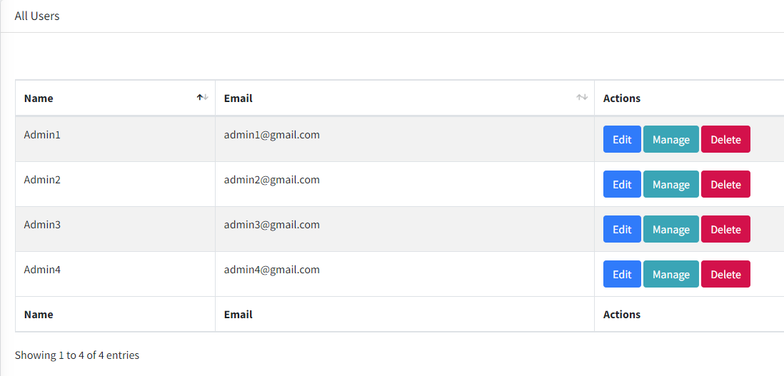

*Figure: User Dashboard*

There are three buttons for every row.  **“Edit”** button creates an opportunity to edit the basic information about a user.  **“Manage”** button creates an opportunity to manage Roles and the  **“Delete”** button will delete a certain user.

## **1.3. Manage Roles**

This feature is used for updating roles of a user/admin. SA will access this feature. SA will find all users and roles. SA will assign or update roles to a user/admin.

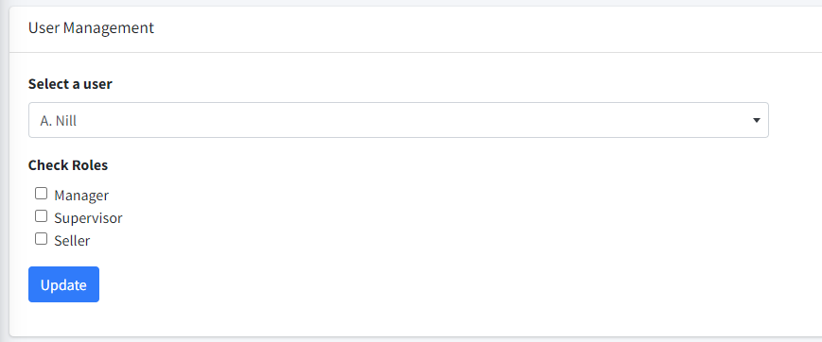

*Figure: User-Role Management*

Components

**Select a user**

* It is a select field
* All existing users are binded to it.
* It must be selected by a user.

**Check roles**

* All roles are binded with individual check buttons.
* Multiple roles can be checked for a single user.

**Update button**

* It won’t work if the user is not selected.
* After clicking on it, users' roles have to be updated.
* Show an error message during any error and stay still on the same page.

## **1.4. Sign in**

Before accessing this system, users must sign in first. After successfully signing in users can access their own features.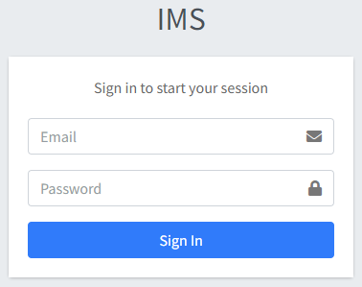

*Figure: Sign in*

**1.4.1 Components**

**Email**

* It is a mandatory field.
* Input type should be email.
* It must be verified as a valid email address by regex.

**Password**

* It is a mandatory field.
* Input type must be password.
* Accept any alphanumeric & special character.
* Length must be greater than 5 and less than 13 characters.

**Sign in button**

* Without giving all the information correctly, users can’t sign in.
* After successfully signing in, users will access features according to their role.
* Show error message, if signing in failed and stay still on the login page.

# 2. Dashboard

Dashboard will show a short summary of the full inventory system.There will be some elements or widget in the dashboard of Inventory Management System.

*Figure: Dashboard*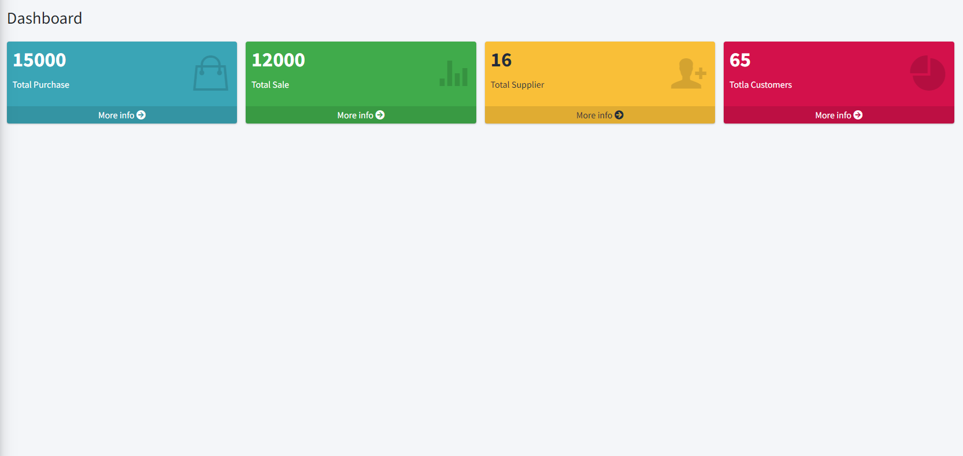

* **Supplier Card:** It shows the total supplier number. It will redirect to the supplier list page when being clicked.
* **Customer Card:** It shows the total customer number. It will redirect to the customer list page when being clicked.
* **Purchase Card:** It shows the total buying in taka and product count of all time . It will redirect to the buying reports page when being clicked.
* **Sale Card:** It shows the total sale in taka and product count of all time . It will redirect to the selling reports page when being clicked.

# 3. Supplier

## **3.1. Add a new supplier**

Using this feature, the admin can create a new supplier. After that, the admin can purchase products from the supplier. Purchasing isn’t possible from an anonymous person or company.

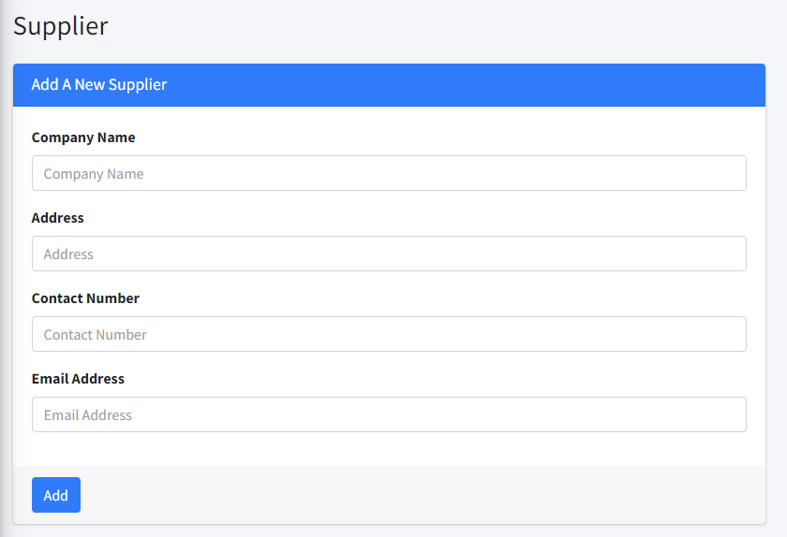

*Figure: Add Supplier*

**3.1.1. Components**

**Company Name**

* It is a mandatory field.
* Input type must be text.
* Won't accept special characters.
* Length must be greater than 2 and less than 101 characters

**Address**

* It is a mandatory field.
* Input type must be text.
* Length must be greater than 9 and less than 201 characters

**Contact No**

* It is a mandatory field.
* Input type should be text.
* It must be verified as a valid phone number by regex.

**Email**

* It is a mandatory field.
* Input type should be email.
* It must be verified as a valid email address by regex.

**Add button**

* Without giving all the information, the adding process won’t be done.
* Saving with the same company name twice won’t be possible.
* Show an error message during any error and stay still on the same page.

## **3.2. All Suppliers**

Users can see all the suppliers using this feature. They also can manage i.e update and delete suppliers if they have permission.

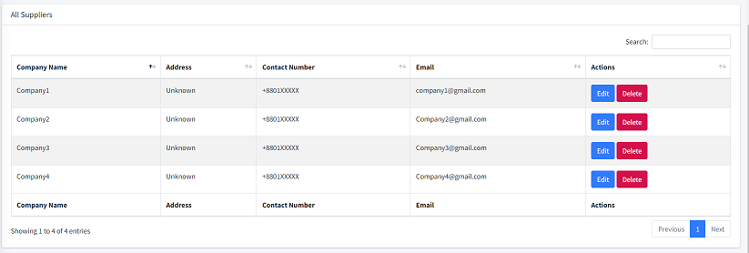

*Figure: All Suppliers*

3.2.1. Components

**Search field:**

* It is a text field.
* Users can search suppliers by Name, Email and Contact Number.
* Pressing ‘Enter’ or clicking on the search icon on the right corner of the search field will show data that users searched for.

**Actions column components**

* Users can use the  **“Edit”** button to update existing suppliers
  + It will redirect to the edit page.
  + Users can edit the information and update suppliers.
* Users can use the  **“Delete”**  button to delete.
  + It will show a pop up
  + Clicking the confirm button on the popup window supplier will be deleted.

# 4. Customer

## **4.1. Add a new customer**

Using this feature, the admin can create a new customer. After that, the admin can sell products to the supplier. Selling to an anonymous person or company is possible. 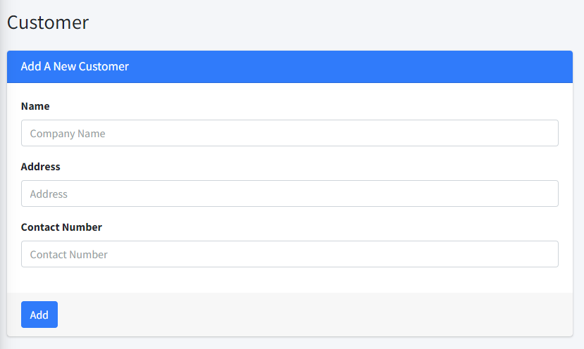

*Figure: Add Customer*

4.1.1. Components

**Name**

* It is a mandatory field.
* Input type must be text.
* Won't accept numeric and special characters.
* Length must be greater than 2 and less than 101 characters.

**Address**

* It is a mandatory field.
* Input type must be text.
* Length must be greater than 9 and less than 201 characters.

**Contact No**

* It is a mandatory field.
* Input type should be text.
* It must be verified as a valid phone number by regex.

**Add button**

* Without giving all the information, customers won’t be added.
* Saving with the same name & contact number twice won’t be possible.
* Show an error message during any error and stay still on the same page.

## **4.2. All Customers**

Users can see all the customers using this feature. They also can manage i.e update and delete customers if they have permission.

*Figure: All Customers*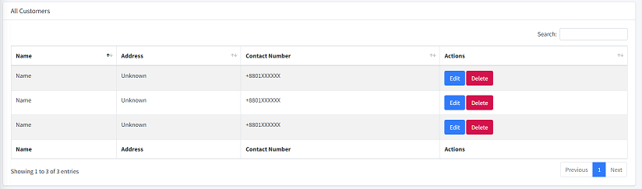

4.2.1. Components

**Search field:**

* It is a text field.
* Users can search customers by Name, Email and Contact Number.
* Pressing ‘Enter’ or clicking on the search icon on the right corner of the search field will show data that users searched for.

**Actions column components**

* Users can use the  **“Edit”** button to update existing customers
  + It will redirect to the edit page.
  + Users can edit the information and update customers.
* Users can use the  **“Delete”**  button to delete.
  + It will show a pop up
  + Clicking the confirm button on the popup window customer will be deleted.

# 5. Purchase

## 

## **5.1. New Purchase**

Product has to be purchased or added to inventory. Using this feature, users can do this.

*Figure: New Purchase*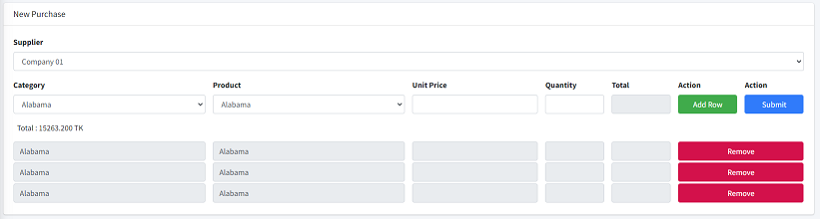

5.1.1. Components

**Select Company:**

* It is a select field.
* All registered companies are binded with this field.
* Users must select a company to purchase products.

There will be a single or multiple row consisting of some elements.

**Select Category:**

* It is a select field.
* All categories are binded with this field
* User must select category to find a product

**Select Product:**

* It is a select field.
* All products are binded according to the selected category with this field.
* Users must select products to add products.

**Unit Price:**

* It is a number field.
* It must be greater than 0.
* Product unit price has to be entered.

**Quantity:**

* It is a number field.
* A positive integer number has to be entered.
* It accepts only a number that is greater than 0.

**Add Row**

* After clicking on, it will add a row if given information product information and other information is right.
* Show an error message during any error and stay still on the same page.

**Submit**

* Without adding a minimum of one product the process won’t be done.
* Show an error message during any error and stay still on the same page.

There will be a **Grand Total Field** that will be ‘read only’ and show the total accordingly of products , unit price and quantities and the **“Remove”**  button removes the self contained row.

## **5.2. Purchase Report**

There will be a purchase list page. Where users can find all purchases and also can filter. Clicking on a view button on the right side of a single purchase following the page will be shown.

*Figure: Purchase List*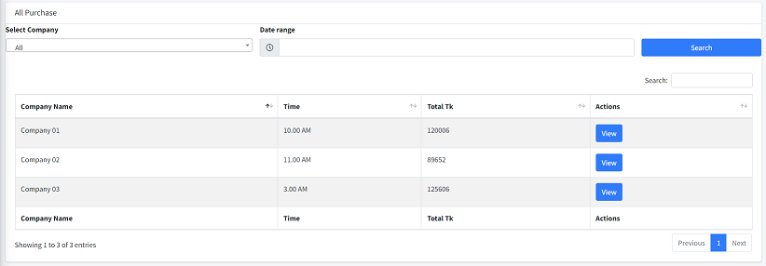

*Figure: Individual Purchase Report*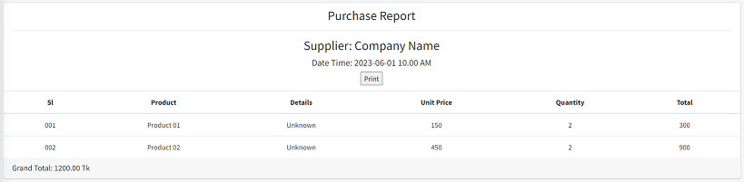

**5.2.1. Description**

This page will be generated by the system. Users can just see the page. This page will consist of Company Name, Company Address, Serial Number, Products Details, Unit Price, Quantity, Total and Grand Total.

# 6. Sale

## **6.1. New Sale**

Product has to be sold or deducted from inventory. This feature will give the opportunity.

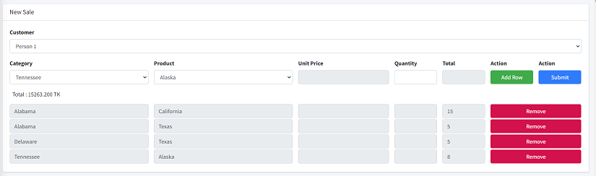

*Figure: New Sale*

6.1.1. Components

**Select Buyer:**

* It is a select field.
* All registered customers are binded with this field.
* Users must select a customer to sell products.

There will be a single or multiple row consisting of some elements.

**Select Category:**

* It is a select field.
* All categories are binded with this field
* User must select category to find a product

**Select Product:**

* It is a select field.
* All products are binded according to the selected category with this field.
* Users must select products to add products.

**Price:**

* It is a read only field.
* Product unit price has to be entered.

**Quantity:**

* It is a number field.
* A positive integer number has to be entered.
* It accepts only a number that is greater than 0.

**Add Row**

* After clicking on, it will add a row if given information product information and other information is right.
* Show an error message during any error and stay still on the same page.

**Submit**

* Without adding a minimum of one product the process won’t be done.
* Show an error message during any error and stay still on the same page.

There will be a **Grand Total Field** that will be ‘read only’ and show the total accordingly of products unit price and quantities and the **“Remove”**  button removes the self contained row.

## **6.2. Sale Report**

There will be a sale list page. Where users can find all sales and also can filter. Clicking on a view button on the right side of a single sale, the following page will be shown.

*Figure: All Sales*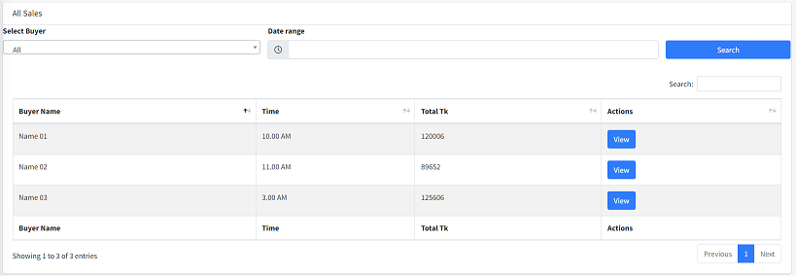

### 

*Figure: Individual Sale Report*

5.2.1. Description

This page will be generated by the system. Users can just see the page. This page will consist of Customer Name, Customer Address, Serial Number, Products Details, Unit Price, Quantity, Total and Grand Total.

# 7. Category

## **7.1. Add a new category**

Category has to be created by SA/Manager.

*Figure: Add Category*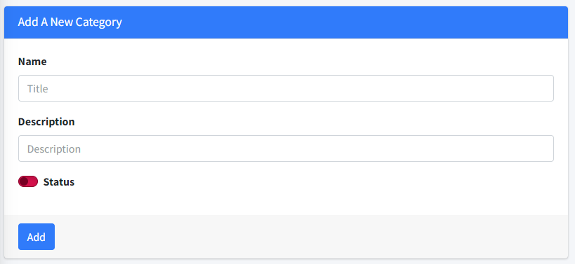

7.1.1. Components

**Name:**

* It is a mandatory field.
* Input type must be text.
* Name must be unique.
* Won't accept special characters.
* Length must be not less than 3 and greater than 50 characters.

**Description:**

* It’s an optional field.
* Input type must be text.
* Alphanumeric and special characters are accepted.
* Length must not be greater than 200 characters.

**Status:**

* Input type must be boolean.
* It toggles between true and false.

**Add**

* It is hidden if the name field is empty.
* After clicking on it, a new category has to be created.
* Show an error message during any error and stay still on the same page.

## **7.2 All Categories**

Users can see all the categories using this feature. They also can manage i.e update and delete categories if they have permission. Users can see data as per need.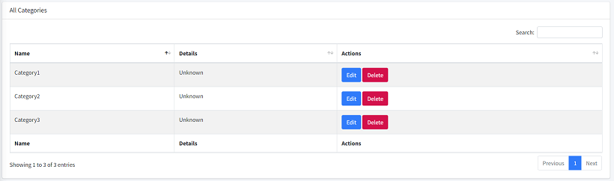

*Figure: All Categories*

7.2.1. Components

**Search field:**

* It is a text field.
* Users can search categories by Name and details.
* Pressing ‘Enter’ or clicking on the search icon on the right corner of the search field will show data that users searched for.

**Actions column components**

* Users can use the  **“Edit”** button to update existing categories
  + It will redirect to the edit page.
  + Users can edit the information and update categories.
* Users can use the  **“Delete”**  button to delete.
  + It will show a pop up
  + Clicking the confirm button on the popup window category will be deleted if there is no product under the category.
  + Category won’t be deleted if there is any product under it

# 8. Product

## **8.1. Add a new Product**

New product has to be created by the SA/Manager. Only registered products can be bought.

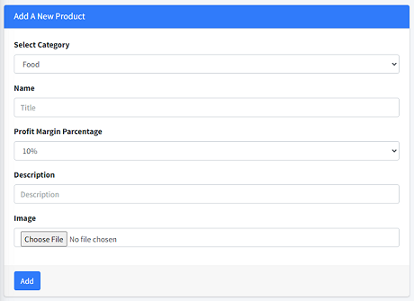

*Figure: Add Product*

8.1.1. Components

**Select Category:**

* It is a select field.
* All categories are binded with this field
* User must select category to create a product

**Name:**

* It is a mandatory field.
* Input type must be text.
* Won't accept special characters.
* Length must be not less than 3 and greater than 50 characters.

**Profit Margin:**

* It is a mandatory field.
* It is a select button.

**Description:**

* It’s an optional field.
* Input type must be text.
* Alphanumeric and special characters are accepted.
* Length must not be greater than 200 characters.

**Status:**

* Input type must be boolean.
* It toggles between true and false.

**Add button:**

* It won't work if the user is not selected.
* After clicking on it, a new product to be added.
* Show an error message during any error and stay still on the same page.

## **8.2 All Products**

Users can see all the products using this feature. They also can manage i.e update and delete products if they have permission. Users can see data as per need.

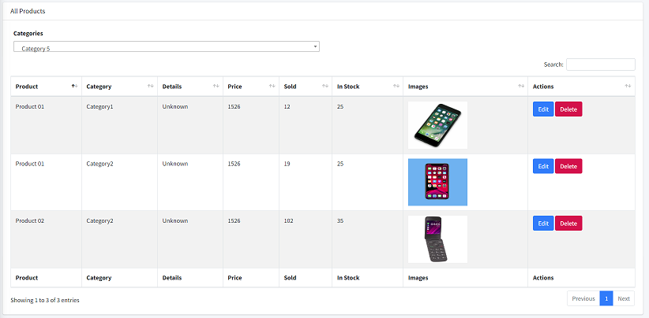

*Figure: All Products*

8.2.1. Components

**Search field:**

* It is a text field.
* Users can filter products by category.
* Users can search products by Name and details.
* Pressing ‘Enter’ or clicking on the search icon on the right corner of the search field will show data that users searched for.

**Actions column components**

* Users can use the  **“Edit”** button to update existing products.
  + It will redirect to the edit page.
  + Users can edit the information and update products.
* Users can use the  **“Delete”**  button to delete.
  + It will show a pop up
  + Clicking the confirm button on the popup window product will be deleted.
  + Products won’t be deleted if this is in stock or available in any quantity.

# 9. Profit or Loss Report

Users can check profit or loss reports using this feature. Content of this page will be generated by the system.Users can set a date range to observe the report of a certain period.

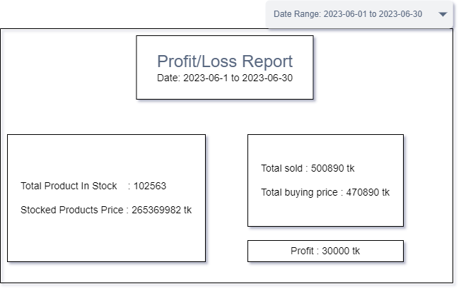

10.1. Components

**Date range picker:**

* It is a date range type field.
* Users can select a start and an end date.
* After setting the value of the date range the content/value of the report section will be updated.