Functional Requirement Specifications

of

Inventory Management System

(IMS)



Submitted to: Md. Sazzad Hossain

Submitted by: Md. Rayhanul Islam Raj (5779)

Date:

**1. Registration, Authentication & Authorization 2**

1.1. Registration 2

1.1.1 Components 3

1.1.2 Buttons 4

1.2. Sign in 4

1.2.1 Components 4

1.2.2 Buttons 5

**2. Header 5**

**3. Left Sidebar 5**

3.1. Brand logo with name 5

3.2. Menus 6

**4. Dashboard 7**

4.1. Cards 8

**5. Supplier 9**

5.1. Add a new supplier 9

5.1.1. Components 10

5.1.2. Buttons 11

**6. Customer 11**

6.1. Add a new customer 11

6.1.1. Components 11

6.1.2. Buttons 12

**7. Purchase 12**

7.1. New Purchase 12

7.2. Purchase Report 12

**8. Sale 12**

8.1. New Sale 12

8.2. SaleReport 12

**10. User Management 13**

10.1. Components 13

10.2. Buttons 13

**11. Category 14**

11.1. Add a new category 14

11.1.1. Components 14

11.1.2. Buttons 15

11.2 All Category 15

**12. Product 15**

12.1. Add a new Product 15

11.1.1. Components 16

11.1.2. Buttons 16

12.2 All Products 16

# Registration, Authentication & Authorization

## **1.1. Registration**

Users must be registered by super admin. This system will be accessed only by registered users.

### 

### **1.1.1 Components**

**Full name**

* It is a mandatory field.
* Input type must be text.
* Won't accept alphanumeric and special characters.
* Length must be greater than 2 and less than 51 characters.

**Email**

* It is a mandatory field.
* Input type should be email.
* It must be verified as a valid email address by regex.

**Password**

* It is a mandatory field.
* Input type must be password.
* Accept any alphanumeric & special character.
* Length must be greater than 5 and less than 13 characters.

**Retype password**

* Constraints are the same as the password field.
* Password and retype password must be the same.

**Register button**

* Without giving all the information the button won’t be clicked.
* Registration with the same email twice won’t be possible.
* Show error message during any error and stay still on the registration page.

## **1.2. Sign in**

Before accessing this system, users must sign in first. After successfully signing in users can access their own features.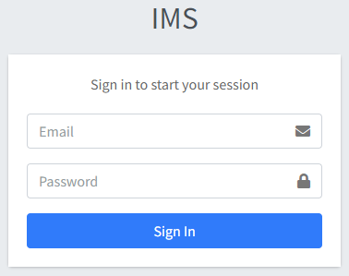

### 

### **1.2.1 Components**

**Email**

* It is a mandatory field.
* Input type should be email.
* It must be verified as a valid email address by regex.

**Password**

* It is a mandatory field.
* Input type must be password.
* Accept any alphanumeric & special character.
* Length must be greater than 5 and less than 13 characters.

**Sign in button**

* Without giving all the information the button won’t be clicked.
* After successfully logged in, users get their claims and access features.
* Show error message, if login failed and stay still on the login page.

# 2. Header

Contents:

**Collapse button:** There will be a collapse button on the left side. It will toggle between show or hide the left menu bar.

**Home button:** It will redirect to the company profile or landing page.

**New Purchase:** It will redirect to the new purchase page.

**New Sale:** It will redirect to the new sale page.

**Full screen button:**It will make full screen the whole webpage.

**Theme customisation button:** It will provide some option to customize page color, mode, etc.

**Sign in/ Sign out button:** If a user is signed in, it will show the sign out option. Otherwise it shows the name of user

# 3. Left Sidebar

## 3.1. Brand logo with name

It has to be on the top of the left sidebar. Here will be a system logo and name.

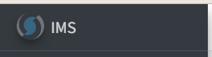

## 3.2. Menus

When a user clicks on any menu or option, the corresponding page will be displayed.Here are the menus:

* Dashboard
* Product
  + Add Product
  + All Products
* Category
  + Add Category
  + All Categories
* Supplier
  + Add Supplier
  + All Suppliers
* Customer
  + Add Customer
  + All Customers
* Purchase
  + New purchase
  + Purchase Report
* Sale
  + New Sale
  + Sale Report
* Profit or Loss Report
* User Management

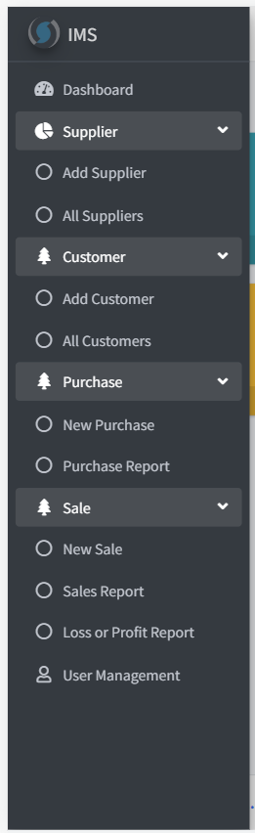

# 4. Dashboard

Dashboard will show a short summary of the full inventory system.There will be some elements or widget in the dashboard of Inventory Management System.

## 4.1. Cards

* **Supplier:** It shows the total supplier number. It will redirect to the supplier list page when being clicked.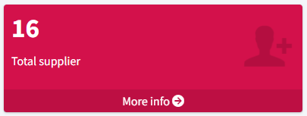
* **Customer:** It shows the total customer number. It will redirect to the customer list page when being clicked.

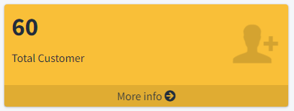

* **Purchase:** It shows the total buying in taka and product count of all time . It will redirect to the buying reports page when being clicked.

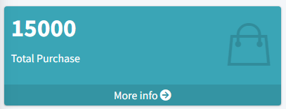

* **Sale:** It shows the total sale in taka and product count of all time . It will redirect to the selling reports page when being clicked.

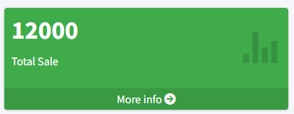

# 5. Supplier

## 5.1. Add a new supplier

Using this feature, the admin can create a new supplier. After that, the admin can purchase products from the supplier. Purchasing isn’t possible from an anonymous person or company.

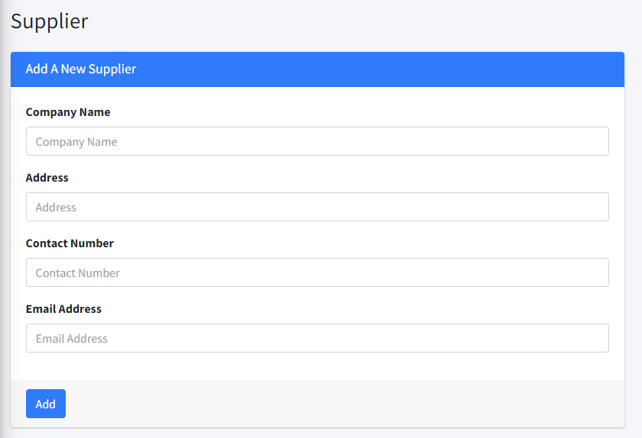

### **5.1.1. Components**

**Company Name**

* It is a mandatory field.
* Input type must be text.
* Won't accept special characters.
* Length must be greater than 2 and less than 101 characters

**Address**

* It is a mandatory field.
* Input type must be text.
* Length must be greater than 9 and less than 201 characters

**Contact No**

* It is a mandatory field.
* Input type should be text.
* It must be verified as a valid phone number by regex.

**Email**

* It is a mandatory field.
* Input type should be email.
* It must be verified as a valid email address by regex.

### **5.1.2. Buttons**

**Add**

* Without giving all the information the button won’t be clicked.
* Saving with the same company name twice won’t be possible.
* Show an error message during any error and stay still on the same page.

# 6. Customer

## 6.1. Add a new customer

Using this feature, the admin can create a new customer. After that, the admin can sell products to the supplier. Selling to an anonymous person or company is possible.

### **6.1.1. Components**

**Name**

* It is a mandatory field.
* Input type must be text.
* Won't accept numeric and special characters.
* Length must be greater than 2 and less than 101 characters.

**Address**

* It is a mandatory field.
* Input type must be text.
* Length must be greater than 9 and less than 201 characters.

**Contact No**

* It is a mandatory field.
* Input type should be text.
* It must be verified as a valid phone number by regex.

### **6.1.2. Buttons**

**Add**

* Without giving all the information the button won’t be clicked.
* Saving with the same name & contact number twice won’t be possible.
* Show an error message during any error and stay still on the same page.

# 7. Purchase

## 7.1. New Purchase

Product has to be purchased or added to inventory. Using this feature, users can do this.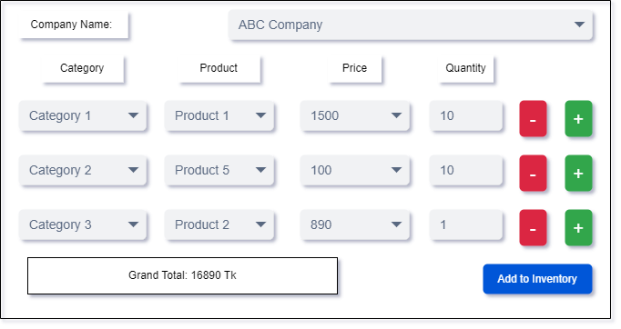

## 7.2. Purchase Report

# 8. Sale

## 8.1. New Sale

## 8.2. SaleReport

# 9. Profit or Loss Report

# 10. User Management

This feature is used for updating roles of a user/admin. SA will access this feature. SA will find all users and roles. SA will assign or update roles to a user/admin.

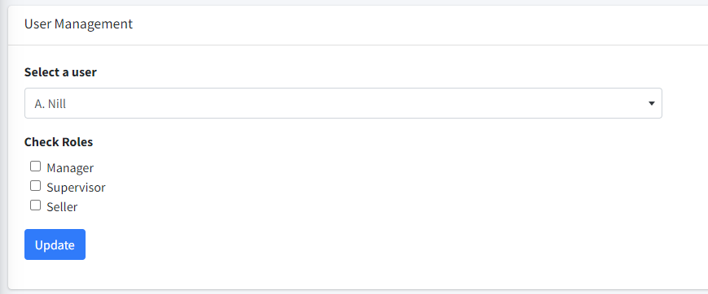

## 10.1. Components

**Select a user**

* It is a select field
* All existing users are binded to it.
* It must be selected by a user.

**Check roles**

* All roles are binded with an individual check button.
* Multiple roles can be checked for a single user.

## 10.2. Buttons

**Update**

* It is hidden if the user is not selected.
* After clicking on it, users' roles have to be updated.
* Show an error message during any error and stay still on the same page.

# 11. Category

## 11.1. Add a new category

Category has to be created by SA/Manager.

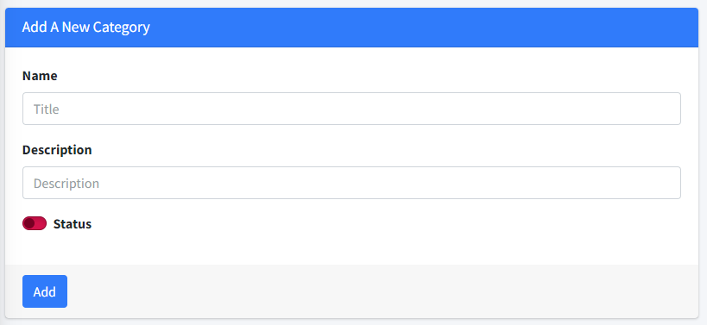

### 11.1.1. Components

**Name:**

* It is a mandatory field.
* Input type must be text.
* Won't accept special characters.
* Length must be not less than 3 and greater than 50 characters.

**Description:**

* It’s an optional field.
* Input type must be text.
* Alphanumeric and special characters are accepted.
* Length must not be greater than 200 characters.

**Status:**

* Input type must be boolean.
* It toggles between true and false.

### 11.1.2. Buttons

**Add**

* It is hidden if the user is not selected.
* After clicking on it, a new category has to be created.
* Show an error message during any error and stay still on the same page.

## 11.2 All Category

# 12. Product

## 12.1. Add a new Product

Product has to be created by SA/Manager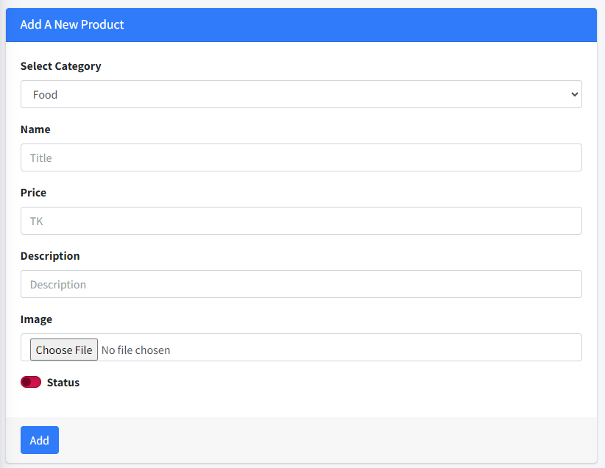

### 11.1.1. Components

**Select Category:**

* It is a select field.
* All categories are binded with this field
* User must select category to create a product

**Name:**

* It is a mandatory field.
* Input type must be text.
* Won't accept special characters.
* Length must be not less than 3 and greater than 50 characters.

**Price:**

* It is a mandatory field.
* Input type must be a number.

**Description:**

* It’s an optional field.
* Input type must be text.
* Alphanumeric and special characters are accepted.
* Length must not be greater than 200 characters.

**Status:**

* Input type must be boolean.
* It toggles between true and false.

### 11.1.2. Buttons

**Add**

* It is hidden if the user is not selected.
* After clicking on it, a new product to be added.
* Show an error message during any error and stay still on the same page.

## 12.2 All Products