2026 Logic System Lab

邏輯系統實驗

Lab3 Report
 | 姓名 | 學號
組員1 | 何家睿 | E24146644
組員2 | 張家榕 | F84131251

組別 : 01
[ Question 1 ]
Prove that C_{out} derived from the two equations is the same
- Hint : $X+\overline{X}Z=X+Z$
- $A⨁{B}=\overline{A}B+A\overline{B}$
- $A∙B+(A⨁{B})∙C_{in}$ => $A∙B+(A+B)∙C_{in}$
$$A∙B+\left(A⊕B\right)∙C_{in}$$
$$=AB+A^{'}BC+AB^{'}C$$
$$=B\left(A+A^{'}C\right)+A\left(B+B^{'}C\right)$$
$$=B\left(A+C\right)+A\left(B+C\right)$$
$$=AB+BC+AC=AB+(A+B)∙C_{in}$$
- $A∙B+(A+B)∙C_{in}$ => $A∙B+(A⨁{B})∙C_{in}$
$$A∙B+(A+B)∙C_{in}$$
$$=AB+BC+AC$$
$$=B\left(A+C\right)+A\left(B+C\right)$$
$$=B\left(A+A^{'}C\right)+A\left(B+B^{'}C\right)$$
$$=AB+A^{'}BC+AB^{'}C=AB+(A^{'}B+AB^{'})=A∙B+\left(A⊕B\right)∙C_{in}$$

[ Question 2 ]
Explain the underlying logic behind this equivalence
$A∙B+(A+B)∙C_{in}≡A∙B+(A⨁{B})∙C_{in}$
Answer: By observing the truth tables of XOR and OR, we can see that the only difference between these two logic gates is when A=1and B=1. In this entire function, there is another term AB. Because AB outputs 1 exactly in the case where A=1 and B=1, it already covers this specific condition. Thus, $(A⨁{B})$can be replaced by (A + B).

[ Practice 1 ~ 4 ]
Enter Pass/Fail only (No screenshots required)
 | pass or fail
RCA_4 | pass
RCA_8 | pass
CLL_4 | pass
CLA_4 | pass
CLA_64 | pass
Adder_8_OV | Pass
ALU_8 | Pass
[ Question 3-1 ]
Screenshot the waveform for each case and explain why the values appear as they do
- Case 1 : A = 4’b1010, B = 4’b0101, C_{in} = 1’b1
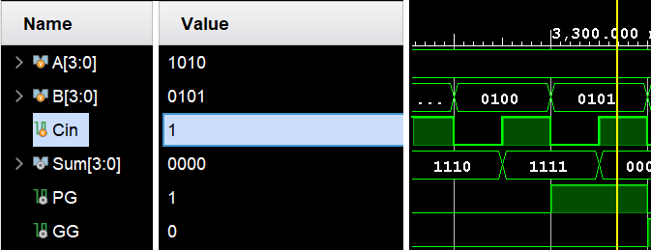

Explanation:
Note that 1010 + 0101 + 0001 = 10000, which triggers an overflow in a 4-bit display (Sum=0000) . However, this specific value was captured by the PG (Propagator-Generator) unit, indicating a carry-out generated during the propagation process.

- Case 2 : A = 4’b0011, B = 4’b1110, C_{in} = 1’b0
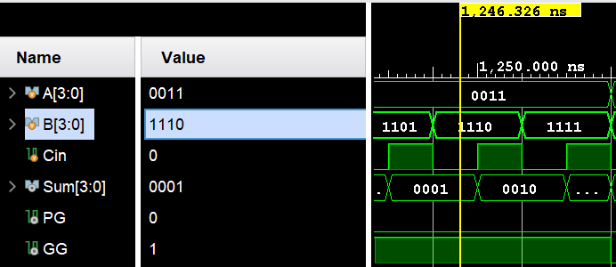

Explanation:
Note that 0011 + 1110 + 0000 = 10001, which also results in a 4-bit overflow. Consequently, the Sum = 0001. Nevertheless, this operation was recorded by the GG (Group Generate) signal, indicating a carry was generated.

[ Question 3-2 ]
Screenshot the waveform for each case and explain why the values appear as they do
- Case 1 : A = 64’hFFFF_FFFF_FFFF_FFFF, B = 64’d0, C_{in} = 1’b1
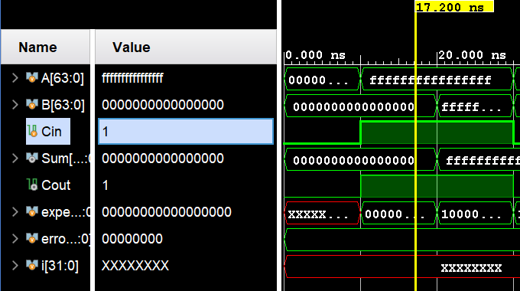

Explanation:
Similar to Q3-1, adding FFFF,FFFF,FFFF,FFFF and 0000,0000,0000,0001 results in a 65-bit value (1,0000,0000,0000,0000), which causes a 64-bit overflow. Consequently, the Sum remains 0. However, this overflow bit is stored at Cout, which can then be propagated to subsequent modules.

[ Question 4 : Overflow for Adder_8_OV ]
- Please describe when overflow occurs
Answer: An overflow occurs when both operands (A and B) have the same MSB (sign bit), but the resulting Sum has a different sign bit.

- Please derive the Boolean expression of overflow
- $OV= \left(A\left[7\right]+B\left[7\right]+S'\left[7\right]\right) +\left(A'\left[7\right]+B'\left[7\right]+S\left[7\right]\right)$

- assign OV = ((AsignBit & BsignBit & ~SumsignBit) | (~AsignBit & ~BsignBit & SumsignBit));

- assign OV = (AsignBit == BsignBit) & (SumsignBit != AsignBit);

[ Question 5 : Overflow for ALU_8 ]
- Please discuss whether overflow conditions need to be modified
Answer:
Overflow detection is essential for signed addition to ensure the result is correct. However, for unsigned addition, the overflow bit is simply the Carry-out, so it is often considered less of a 'problem' and more of just an extra bit.

- Please derive the Boolean expression of overflow
Answer:
I use Adder_8_OV module , which Logic is:
$$OV= \left(A\left[7\right]+B\left[7\right]+S'\left[7\right]\right) +\left(A'\left[7\right]+B'\left[7\right]+S\left[7\right]\right)$$

[ Question 6 ]
Please explain CARRY4 in FPGA
- How it works ?
CARRY4 是一個 4-bit 的硬體加速單元。它不像 RCA 要在那邊等 Gates 一個接一個傳遞訊號，而是利用 FPGA 內部預先連好的「專用進位線」（Dedicated Carry Chain）。它會同時接收 4 位元的資料，並配合旁邊的 LUT（查找表）產生的 P、G 訊號，瞬間把進位算出來並丟給下一級。

- Its Pros & Cons (優缺點) compared to RCA and CLA
Pros :
- 速度快： 在 FPGA 裡，一般的佈線延遲很大；CARRY4 是快速通道」，專門給進位訊號跑，速度比我們自己用 Gates 寫出來的 RCA 快得多。
- 省算力： 如果自己寫 CLA，會用到超多 LUT 資源，電路會變得很亂。用 CARRY4 的話，它是 FPGA 裡本來就有的閒置專用硬體，是人家寫好的LUT。
Cons :
- 硬體通用性差： 這是我覺得最明顯的缺點。CLA 的概念是通用的，不管在哪都能跑；但 CARRY4 是 Xilinx 特有的。如果今天換成別家的 FPGA，這套邏輯就得重寫，沒辦法直接搬過去。
- 位元固定： 一次只能處理 4 bits。雖然可串聯，但如果要做一些很奇怪位元的運算，就會需要調整一下，不像自己寫的加法器那麼有彈性。

[ Question 7 ]
Check if the synthesis tool utilized a CARRY4 primitive for RCA & CLA, providing the reason why or why not
RCA_8:
Since my design uses gate-level descriptions for the basic units (Half Adder and Full Adder), Vivado treats the circuit as a collection of individual logic gates rather than a high-level addition operation. View to the schematic, proof that synthesis tool does not automatically replace them with the CARRY4 primitive.
CLA_64:
For the same reason as the RCA_8, my CLA design utilizes gate-level descriptions for its two basic units: the PFA and CLL. Maybe the synthesis tool prefert to remaining this manual gate-level structure, it implements the design using LUTs instead of the CARRY4 primitive.

[ 心得 ]
組員一 何家睿 E24146644
In this lab, I gained hands-on experience with adder circuits, which are the fundamental building blocks of a CPU's ALU. By building each module step-by-step in Verilog, I gained a great sense of accomplishment. The most rewarding part was implementing the ALU itself, as it allowed me to integrate everything I learned in this course into a single, functioning system.

組員二 張家榕 F84131251
在本週因為期中考等因素，所以我還沒開始動工，但依照先前我們兩個都喜歡各自做一份自己的報告來看，這次的Lab3 4我也會在截止日前完成一份的，很感謝助教用心做的教學影片，然後也感謝組員讓我可以比較沒有壓力的完成這次的實驗！

