2026 Logic System Lab

邏輯系統實驗

Lab4 Report

 | 姓名 | 學號
組員1 | 何家睿 | E24146644
組員2 | 張家榕 | F84131251

組別 : 01
[ Question 1 ]
- Describe in detail what race condition
the cross-coupled gates enter a metastable or oscillatory state. In this condition, neither output resolves immediately because each gate reacts to the other’s change — a phenomenon known as a critical race. During a race condition, the latch momentarily hesitates between both possible stable states, and settling depends on minute variations in transistor delay, supply noise, or temperature.
- Under what circumstances does it occur ?
When the set=1 and reset =1. Weather it occur by human or physic error.
- How to avoid or solve it ?
Apply, flip-flops, shift registers, and synchronous systems.

[ Question 2 ]
- Explain why Setup and Hold times are physically necessary based on the gate-level diagram.
Physically, logic gates have propagation delays.
Setup time is necessary because the data D needs time to pass through the input gates of the Master latch and stabilize at the internal node before the clock gate closes.
Hold time is necessary because the transistors take time to fully switch off; the data must remain stable immediately after the clock edge to prevent the Master latch from capturing an incorrect transition while closing.

- How we can correct timing violations when they occur ?
For hold time violations: we can add some buffer to deal it.
For set time violations: 會遇到timing問題的通常是因為combination運算太過複雜，一個clock做不完的邏輯運算(時鐘上沿來了，我還沒辦法吐出數據)，所以要拆成兩個clock去運算，EX:原本的邏輯運算需要12ns，如果run在100MHz(10ns)的clock rate的板子下就會有timing violation，所以找到出問題的path，在中間多加一個register進去then deal it.
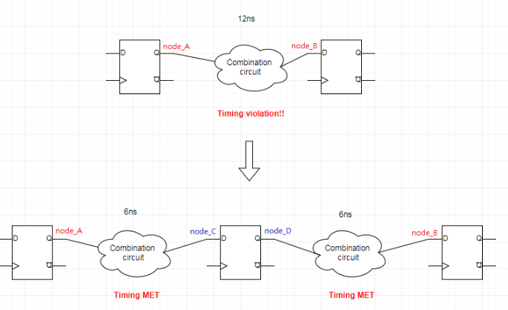
https://ithelp.ithome.com.tw/articles/10196141

[ Practice 2 ]
- Describe how you prepare to test each design
- What test cases you have ?
- What is the basis for selecting these test cases ?
- Why these test cases are sufficient to ensure the designs work flawlessly ?
- SR Latch
- 依照真值表，模擬(s,r)=(0,0),(1,0),(0,1),(1,1)

- Gated SR Latch
- 依照(1)真值表，模擬(s,r)=(0,0),(1,0),(0,1),(1,1)
- 新增e=1,e=0條件判斷
- Gated D Latch
- 操控e=1,e=0判斷
- 觀察穩定周期的d訊號，能否由人為操控的e去選擇要存入甚麼
- 對於e有特別設計setup/hold time餘裕

- D Flip-Flop
- 操控d訊號，觀察是否能隨穩定clk週期存入數據
- 對於d有特別設計setup/hold time餘裕

- Screenshot the waveform for each design and explain how to determine if it is functioning correctly
  - SR Latch
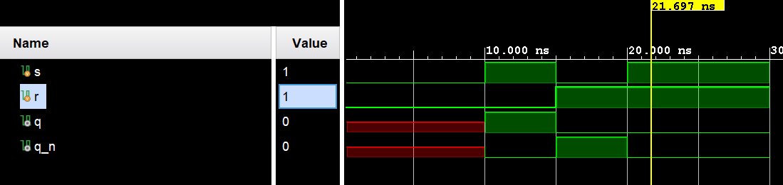
S使的數據1存入q, r使數據0存入q, simulation成功.
  - Gated SR Latch
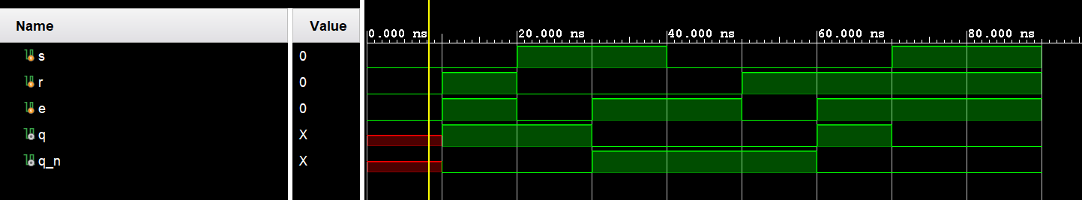
- E開則: S使的數據1存入q, r使數據0存入q, simulation成功.
- E關則: q中的數據不受r,s影響
- Simulation成功

  - Gated D Latch
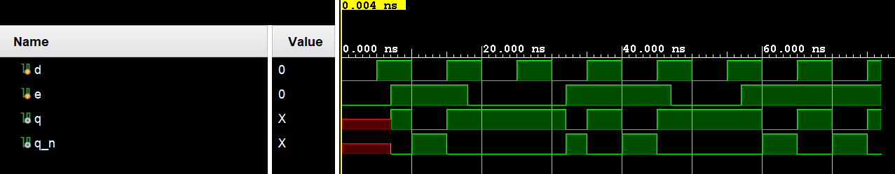
- E開則: 週期d數據可成功存入q : (d=0 then q=0)(d=1 then q=1)
- E關則: q中的數據不受d影響
- Simulation成功

  - D Flip-Flop
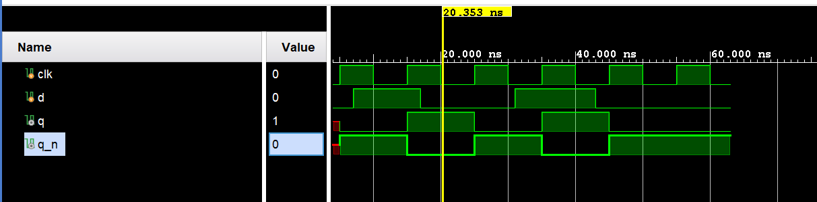
- 當時脈來臨，d的數據可以成功存入q, simulation成功

[ Practice 3 ]
- Screenshot the waveform and explain how to determine if it is functioning correctly
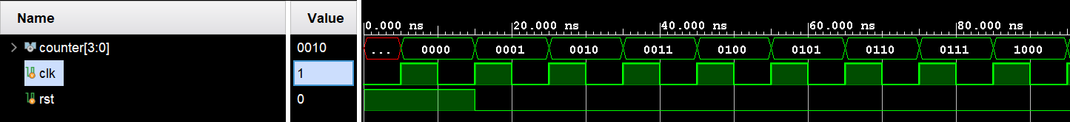
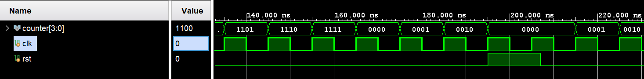
- 呈現Counter 每遇到一時脈週期就+1
- 呈現到第16個波包後(BCD=15)會因為overflow達到reset的效果
- 呈現在溢位後第三個週期，設立reset，使數據歸零。
- Simulation 成功

[ Question 3 ]
- Explain your improved idea
(Please cover pipeline, latency, overlap, throughput concepts )
- The original circuit has a critical path at stage 2 with a delay of 2 gates, which causes other stages to wait. We should add a pipeline register in stage 2 to balance the circuit so that each stage has exactly 1 gate delay.
- By doing this, we can shorten the clock period and increase the frequency. This allows for perfect execution overlap without idle time. Consequently, the throughput is doubled (from 1 result per 2 gates to 1 result per 1 gate), and the overall absolute latency is reduced because the wasted waiting time is eliminate
- “Compare” and “analyze” the waveform of 3 circuits,
(2 from TA, 1 from your improved circuit)
(Use the waveform to prove (support) your improved idea)
(Please use Wavedrom)
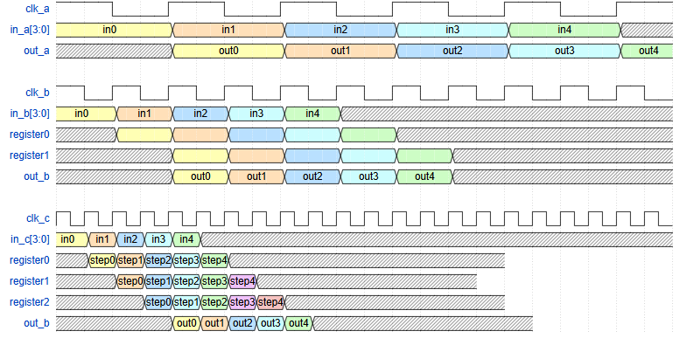
- 以上三張圖可以看到長度(執行時間)a>b>c : lower latency
- 同時處理的step數 c>b>a : better execution overlap
- Register 數 c>b>a : deeper pipeline
- C的每一個步驟都可以在一個時脈週期完成: throughput :1 result per 1 gate
- 時脈週期c<b<a : (圖中直觀看到)

[ 心得 ]
組員一 何家睿 E24146644
In Lab 4, I learned about the fundamental units of sequential circuits, including various types of latches and flip-flops. Furthermore, I learned how to properly terminate a testbench simulation independently. I am now confident in utilizing the testbenches provided by the TAs, as well as leveraging LLMs to assist in my coding for future labs. Additionally, I acquired knowledge about pipelining and other techniques used to improve sequential circuit efficiency. I am very happy with my progress, as I initially felt these concepts were intimidating and completely unfamiliar to me. By the end of this semester, I hope to apply all these concepts to design a small CPU system on my own.

組員二 張家榕 F84131251
在本週因為期中考等因素，所以我還沒開始動工，但依照先前我們兩個都喜歡各自做一份自己的報告來看，這次的Lab3 4我也會在截止日前完成一份的，很感謝助教用心做的教學影片，然後也感謝組員讓我可以比較沒有壓力的完成這次的實驗！

