Join Raymond Sheliah as they travel to beautiful Punta Cana, Dominican Repubic for their Wedding

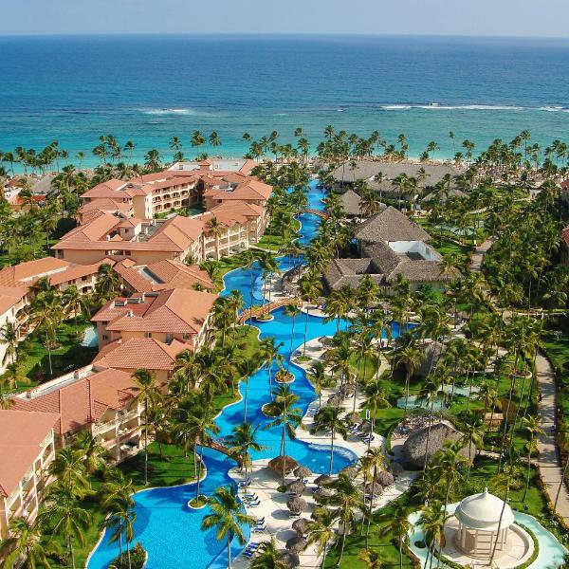

**WHERE**: MAJESTIC COLONIAL PUNTA CANA   
 ***Passport Required***  
  
**WHEN**: Depart Thurs 0726/19. You have the option to return Mon 07/29/19 or Tues 07/30/2019  
  
**COST**: Non-Refundable Deposit of $100 Due on Before: Oct 26, 2018  
  
**Balance due**: April 30, 2019  
  
Two Options - Both Jacuzzi Junior Suite & Majestic Junior Suite Swimup are available. Price is Per Person based on Double-Occupancy. Single/Triple rates available upon request.

|  |  |  |
| --- | --- | --- |
|  | Jacuzzi Ste. | Swimup Ste. |
| Thurs July 26th – Mon July 29th : | $645 | $685 |
| Thurs July 26th - Tues July 30h : | $795 | $840 |

Price Includes: Four or Five nights at the Majestic Colonial Punta, 24 –Hour All Inclusive foods and drinks, nightly entertainment, specialty restaurants, taxes and fees. This is hotel and transfers only; Airfare to be added at a later date.  
  
**BOOKING DIRECTIONS:**   
  
\*\*\****CALL***\*\*\* Ruby Jackson with your credit card number to secure your spot. *Tell her you're with the Raymond & Sheliah group headed to Punta Cana.*  
If you need additional information/alternate pricing options, please contact Ruby Jackson:   
rubydst@verizon.net | 410.426.3739 (h) | 410.667.6090 (w)   
  
Registration form to specify roommate(s) is attached. You can *call* today with YOUR deposit information (only) and indicate who your roommate is at a later date.  
  
**Roeder Travel charges a $ 100.00 administrative fee per person for all cancellations.**

**Select Room Package:**

* Jacuzzi Junior Suite for 4 Nights (Thurs 07/26/2019 – Mon 07/29/19)
* Junior Suite Swimup for 4 Nights (Thurs 07/26/19 – Mon 07/29/19)
* Jacuzzi Junior Suite for 5 Nights (Thurs 07/26/19– Tues 07/30/2019)
* Junior Suite Swimup for 5 Nights (Thurs 07/26/19 – Tues 07/30/19

**Provide Roommate(s) Information:**

* Single Rate
* Double Rate
* Triple Rate

|  |  |  |  |  |  |  |  |  |
| --- | --- | --- | --- | --- | --- | --- | --- | --- |
| **NAME :** |  | | | | | | | |
|  | **(On Passport)** | | | | | | | |
| **ADDRESS:** |  | | | | | **State/Zip:** | |  |
| **PHONE:** |  | | **EMAIL:** | |  | | | |
| **PASSPORT**  **NUMBER:** | |  | | **EXPIRATION DATE:** | | |  | |
|  | |  | |  | | |  | |
| **NAME :** |  | | | | | | | |
|  | **(On Passport)** | | | | | | | |
| **ADDRESS:** |  | | | | | **State/Zip:** | |  |
| **PHONE:** |  | | **EMAIL:** | |  | | | |
| **PASSPORT**  **NUMBER:** | |  | | **EXPIRATION DATE:** | | |  | |

For credit card payments, call Ruby Jackson at (410) 426-3739 with card information. Or, please make checks payable to Roeder Travel and mail/fax to:

Roeder Travel

57 West Timonium Road, Suite 110

Timonium, MD 21093

Attn: Ruby Jackson

Fax: 410-667-0106

**Questions: Contact Ruby Jackson: rubydst@verizon.net | 410.426.3739 (h) | 410.667.6090 (w)**