Name: 黃廷睿

ID: r11631026

**Problem 1 (Regression).**

可發現階數越高能越好的擬合原始資料，並且經計算殘差值的總和，非常接近0，滿足least squares assumptions的條件

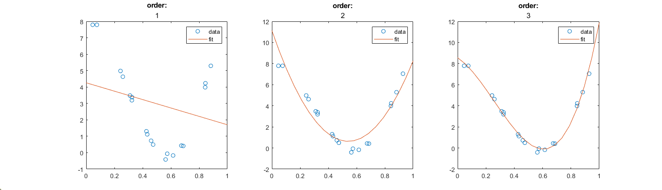

|  |
| --- |
| **Order: 1**    **Sum of error: 7.5495e-15** |
| **Order: 2**    **Sum of error: 7.5495e-15** |
| **Order: 3**    **Sum of error: 7.2553e-14** |

**Problem 2 (Variance of linear regression model)**

**Problem 3 (Residue analysis)**

1. Generate a scatter plot of the yields vs maturity. Comment on the figures.

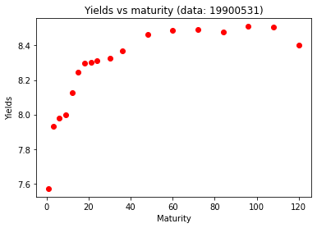

1. You want to fit a polynomial regression model to the data. Since you don't know the order you need, you fit six polynomial models, with orders from 1 to 6. Plot the 𝑅2 vs the polynomial order 𝑘. Comment on the result.

由下圖可以觀察不同階數的擬合情況，越高階數擬合的狀況就越佳，並且R2值與階數關係也滿足階數越高，R2越高的趨勢，意即高階擬合結果較能解釋yields的分布狀況。

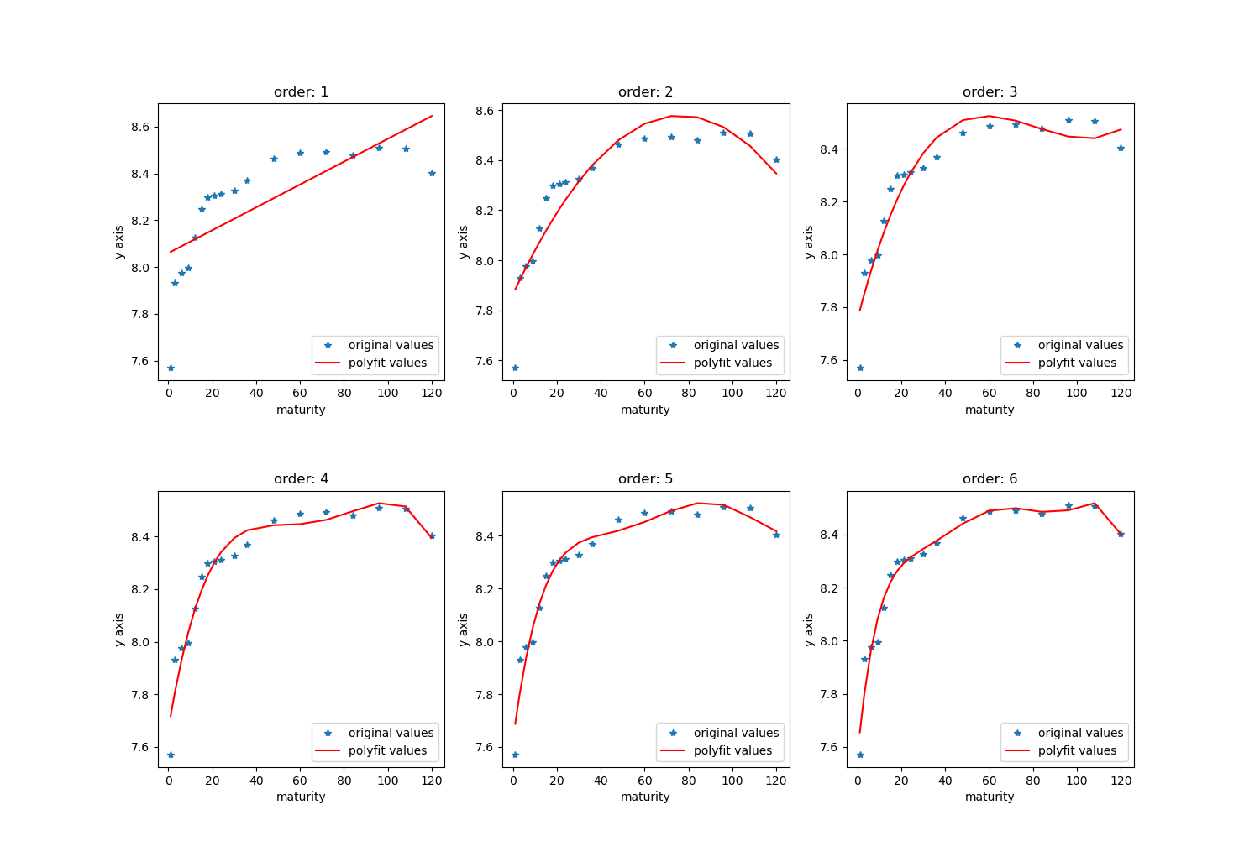

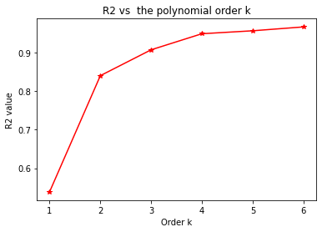

1. For the 4th-order polynomial model, draw a residual plot (vs maturity). Comment on it.

經計算residual，可發現殘差值大致皆落在0上下，並且其均值大致為0

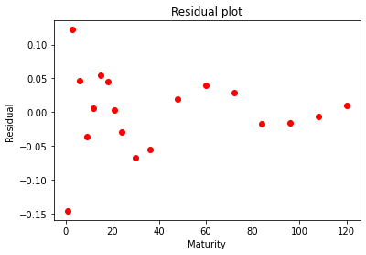

1. Draw a histogram and a quantile-quantile (Q-Q) plot of the residuals. Comment on it.

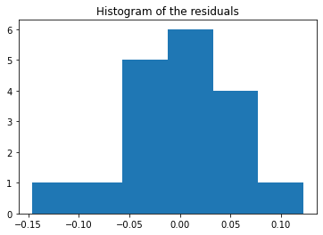

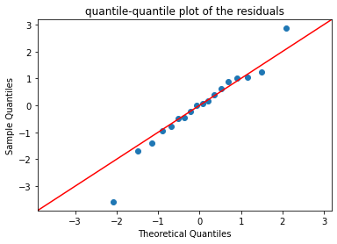

透過QQplot趨勢可發現圖中點多數皆分散在對角線上，意即這筆資料大致為常態分佈的