CS 255 Business Requirements Document
DriverPass
Rayia J. Lagard
System Components and Design

Purpose
- DriverPass needs a web-based system that gives customers better preparation for DMV driving tests through online classes, practice tests, and on-the-road training.
- The system will organize customer registration, training packages, lesson reservations, test progress, driver notes, reports, and account administration in one place.
- The system will support customers, the DriverPass owner, the IT officer, the secretary, and drivers while giving each user only the access needed for that role.

System Background
- DriverPass was created because many students fail their DMV driving tests after preparing mainly with previous test questions instead of receiving complete training.
- Customers can choose from three training packages. Package One provides six hours of driving instruction, Package Two provides eight hours of driving instruction plus an in-person DMV rules and policies lesson, and Package Three provides twelve hours of driving instruction, an in-person lesson, and access to the online class and practice tests.
- Every on-the-road driving session is two hours. Reservations must identify the customer, driver, vehicle, date, and time.
- DriverPass currently has 10 cars, with a driver assigned to each car.
- The system must keep DriverPass training information current by receiving notifications when DMV rules, policies, or sample questions are updated.

Objectives and Goals
- Provide customers with convenient browser-based access to training information, online classes, practice tests, and driving-lesson scheduling.
- Allow customers and authorized staff to create, modify, and cancel driving reservations while preventing scheduling information from becoming inconsistent.
- Track the customer, driver, vehicle, lesson time, and selected package for driving appointments.
- Track online test progress using the test name, time taken, score, and status of not taken, in progress, failed, or passed.
- Store driver comments and the start and end times of lessons so DriverPass can review student progress.
- Maintain an activity history showing who created, modified, or canceled a reservation and allow management to print activity reports.
- Allow management to download reports and information for offline review, including use in Excel, while requiring an online connection for changes to system data.
- Allow an existing training package to be disabled so new customers cannot register for it.
Requirements

Nonfunctional Requirements

Performance Requirements
- The system should operate as a web-based application hosted in the cloud and be accessible from computers and mobile devices with an internet connection.
- Users should be able to access system information from different locations. Data changes must occur while online to avoid duplicate or conflicting records.
- The system should support timely scheduling, account, test-progress, and report functions without unnecessary delays during normal business use.
- DMV-related content should be updated when DriverPass receives new rules, policies, or sample questions, and appropriate users should be notified of those updates.

Platform Constraints
- The primary platform will be a web browser rather than software limited to one desktop operating system.
- The system should use cloud hosting so DriverPass does not have to manage local backup and security infrastructure.
- The back end will require persistent data storage for customer accounts, packages, reservations, vehicles, drivers, test results, notes, roles, and activity history.
- Downloaded reports may be used offline, but the live system must be online for users to create or modify records.

Accuracy and Precision
- Each user must be identified through an individual account so actions can be associated with the correct person.
- The system must accurately match each reservation to the correct customer, driver, car, date, time, and package.
- The system must preserve accurate lesson start and end times, driver comments, test scores, test status, and activity history.
- The system should validate required registration and scheduling information before saving a record and alert authorized staff when an account or system problem requires attention.

Adaptability
- The IT officer must have administrative access to maintain user accounts, reset accounts, and block access when an employee leaves.
- Existing packages must be capable of being disabled without changing program code.
- The design should separate system components so later releases can support adding, removing, or changing package modules with developer or systems analyst assistance.
- Because the application is web- and cloud-based, the interface should remain usable across common computers and mobile devices as supported browsers and platforms change.

Security
- Users must authenticate with their own accounts, and access must be controlled according to user role and permissions.
- The IT officer must have full account-administration rights, including resetting accounts and blocking access for former employees.
- Customers must have a secure password-reset method when they forget a password.
- Sensitive customer information, including payment-card information, must be protected during transmission and storage.
- The system should use secure client-server communication and protect accounts from repeated unauthorized login attempts.
- The system must keep an auditable record of reservation creation, modification, and cancellation so DriverPass can identify the user responsible for a change.

Functional Requirements
- The system shall allow customers to create and use an account.
- The system shall allow authorized users to enter customer information, including first name, last name, address, phone number, state, payment information, pickup location, and drop-off location.
- The system shall require the customer's drop-off location to be the same as the pickup location.
- The system shall allow customers to select an available DriverPass training package.
- The system shall allow DriverPass to disable an existing package so new customers cannot register for it.
- The system shall allow customers to schedule two-hour driving lessons online.
- The system shall allow the secretary to schedule a lesson for a customer who calls or visits the office.
- The system shall allow authorized users to modify and cancel appointments.
- The system shall associate each driving appointment with a customer, driver, car, date, and time.
- The system shall provide eligible customers with access to online class content and practice tests.
- The system shall record practice-test name, time taken, score, and status.
- The system shall support test statuses of not taken, in progress, failed, and passed.
- The system shall store driver comments and lesson start and end times.
- The system shall maintain an activity history identifying who created, modified, or canceled a reservation.
- The system shall allow authorized users to print activity reports.
- The system shall allow Liam to access data from different computers and mobile devices and download reports or information for offline work.
- The system shall allow the IT officer to administer accounts, reset access, and block user accounts.
- The system shall allow customers to reset forgotten passwords.
- The system shall receive or support updates to DMV rules, policies, and sample questions and notify DriverPass when updates occur.
- The system shall provide a contact page and a method for DriverPass to contact a student.

User Interface
- Customers will use a browser-based interface from a computer or mobile device to manage their accounts, select packages, schedule or change lessons, access available online training, take practice tests, review progress, and reset forgotten passwords.
- The secretary will use an interface for entering student information and creating, modifying, or canceling appointments for customers who contact the office.
- The owner will need access to operational information, student progress, driver notes, reservation activity, and downloadable or printable reports.
- The IT officer will need an administrative interface with full account-management access for maintaining, resetting, and blocking accounts.
- Driver-related information will include lesson start time, end time, and driver comments.
- The online test progress area will display test name, time taken, score, and status.
- The interface will include a contact page and a way for DriverPass to communicate with students.
- The interface should be clear and consistent across supported desktop and mobile browsers.

Assumptions
- Customers and employees who change live system data will have a working internet connection and a supported web browser.
- DriverPass will provide or approve the final visual design, wording, training content, package details, employee roles, and business rules before implementation is finalized.
- DMV information can be obtained in a form that allows DriverPass to receive updates or notifications; the interview does not specify the technical integration method.
- DriverPass will provide accurate driver, vehicle, schedule, and customer information for entry into the system.
- Full self-service creation or removal of package modules is not part of the current release; that capability would require future developer or systems analyst work.

Limitations
- Users cannot modify live system data while offline. Offline access is limited to information or reports that were downloaded while connected.
- The first release will allow DriverPass to disable an existing package, but it will not provide a nondeveloper tool for adding or removing package modules.
- The interview does not define a specific cloud vendor, database product, browser list, payment processor, DMV integration method, response-time target, or project budget, so those implementation choices require later technical decisions.
- The project schedule assumes customer approval on March 10–11 without major requested changes. Significant revisions could delay interface development and later dependent tasks.
- The system depends on accurate and timely DMV updates and on reliable internet/cloud availability.

Gantt Chart
The schedule below follows the dates and dependencies provided by Sam and Jennifer in the DriverPass interview.
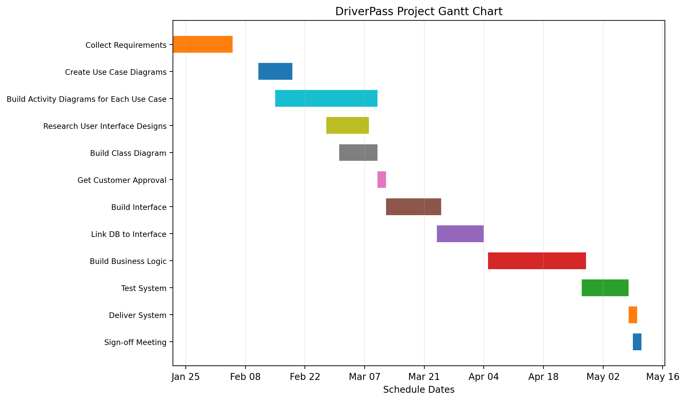
Figure 1. DriverPass project schedule based on the interview transcript.

