Retail Sales Data Processing and Business Insights Generation

INTRODUCTION
The objective of this project is to design and implement an end-to-end Retail Sales Analytics Solution that transforms raw retail transaction data into meaningful business insights. The solution includes data ingestion, data cleaning, transformation, validation, KPI generation, privacy protection, and interactive dashboard development using Python and Power BI.
The final solution enables business users to analyze sales performance, revenue trends, product performance, and category-wise contributions through interactive dashboards.

ARCHITECTURE DIAGRAM
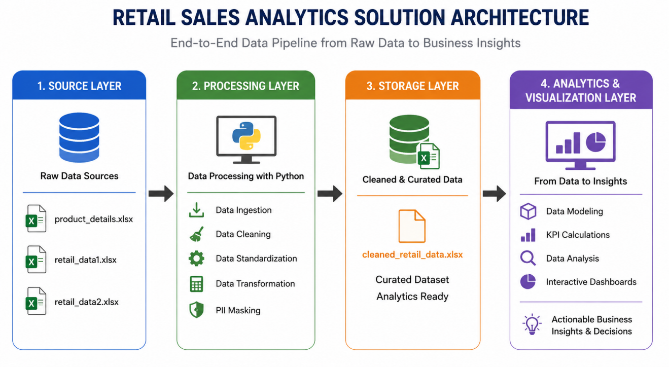

Architecture Overview
The solution follows a layered architecture consisting of data sources, processing, storage, and visualization components.

Architecture Flow -
- SOURCE LAYER -
The source layer consists of the following datasets from the Excel sheet:
- product_details
- retail_data1
- retail_data2
These datasets contain product information, transaction details, customer information, pricing, discounts, and purchase locations.
- PROCESSING LAYER -
Python and Pandas are used to perform:
- Data ingestion
- Dataset merging
- Missing value handling
- Duplicate removal
- Data standardization
- Revenue calculation
- PII masking
- STORAGE LAYER -
The transformed dataset is stored as:
cleaned_retail_data.xlsx
This serves as the final analytics-ready dataset.
- VISUALIZATION LAYER
Power BI imports the cleaned dataset and generates interactive dashboards for business analysis.

DATA FLOW DIAGRAM
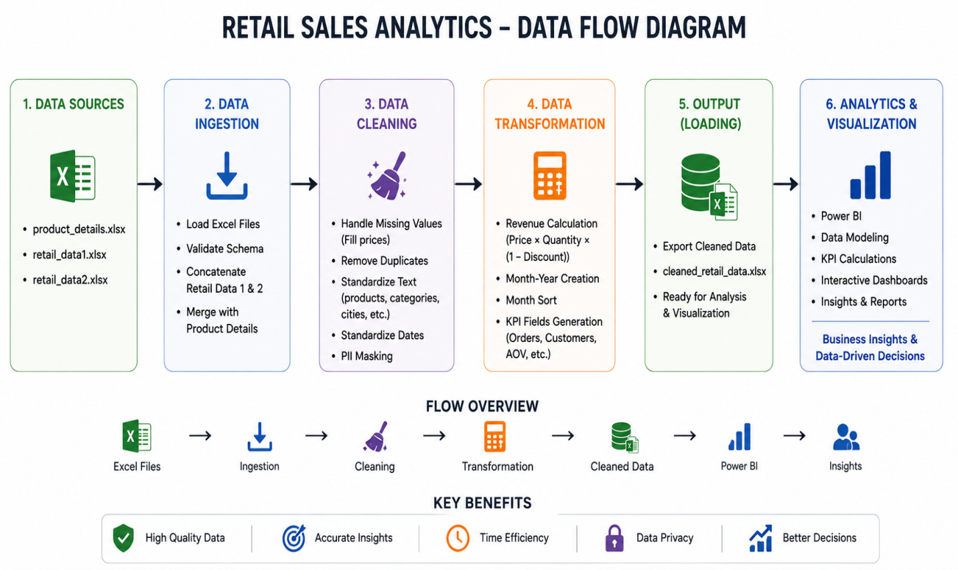

Data Flow Explaination
The product reference dataset and retail transaction datasets are first loaded into the Python environment. Initial validation checks are performed to understand the structure of the data and identify potential data quality issues.
The next stage involves identifying missing values and duplicate records. Missing prices are populated using information from the product reference dataset. Duplicate records are removed to ensure accurate reporting.
Category names, product names, city names, and date formats are standardized to maintain consistency across the datasets.
Sensitive customer information is masked before any reporting activity. Revenue and analytical fields are then calculated, and the cleaned datasets are merged into a single curated dataset.
Finally, the processed dataset is imported into Power BI where it is used for dashboard creation and business analysis.

The complete workflow follows the sequence below:

DATA INGESTION
Raw retail datasets are loaded into Python using Pandas.
- DATA VALIDATION
Initial quality checks are performed to identify:
- Missing values
- Duplicate records
- Invalid formats
- Inconsistent categories

DATA CLEANING
Data quality issues are resolved through cleaning operations.
- DATA TRANSFORMATION
Business-specific transformations are applied, including revenue calculation and date formatting.
- DATA PRIVACY PROTECTION
Sensitive customer information is masked.
- DATASET EXPORT
The processed dataset is exported into a cleaned Excel file.
- REPORTING AND VISUALIZATION
The cleaned dataset is imported into Power BI for dashboard creation and KPI reporting.

DATA MODEL
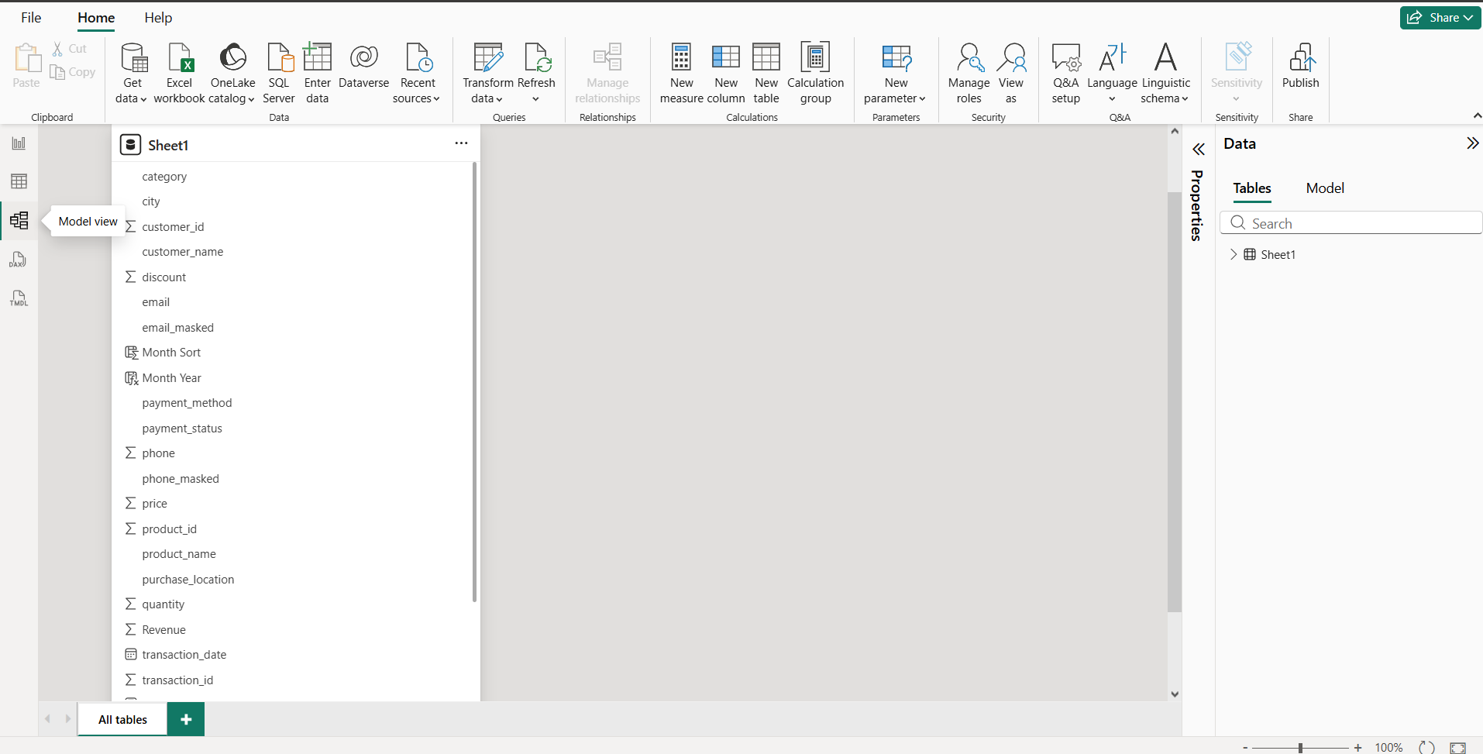

Data Model Explaination
The final Power BI solution uses a single analytical table named Sheet1, which contains all cleaned and transformed transaction data.
The table includes:
- CUSTOMER ATTRIBUTES
- customer_id
- customer_name
- email_masked
- phone_masked
- PRODUCT ATTRIBUTES
- product_id
- product_name
- category

TRANSACTION ATTRIBUTES
- transaction_id
- transaction_date
- payment_method
- payment_status

LOCATION ATTRIBUTES
- city
- purchase_location

CALCULATED ATTRIBUTES
- Revenue
- Month Year
- Month Sort
This model supports KPI calculations, filtering, slicing, and dashboard interactions.

ASSUMPTIONS MADE
Several assumptions were made during the implementation of this project to ensure consistency and completeness of the final solution.
- Product IDs are unique and correctly represent products across all datasets.
- Missing product prices can be populated using the corresponding Product ID from the Product Details reference table.
- Duplicate transaction records represent redundant entries and can be safely removed without affecting business logic.
- Revenue is calculated using the formula in Python:
Revenue = Price × Quantity × (1 – Discount)
- Product category variations such as ELEC, electronics, and Electronics refer to the same category and should be standardized.
- Product name variations such as PHONE, phone, and Phone represent the same product and should be standardized.
- Customer email addresses and phone numbers are considered Personally Identifiable Information (PII) and should be masked before reporting.
- Date values appearing in different formats represent valid transaction dates and should be standardized into a consistent reporting format.
- The cleaned and transformed dataset is considered the single source of truth for Power BI reporting.

DATA CLEANING STRATEGY
Data quality plays a critical role in generating reliable business insights. Therefore, a comprehensive cleaning strategy was implemented before performing any analysis.

Handling Missing Values
The first step involved identifying missing values across all columns.
During analysis, missing values were primarily observed in the Price column. Since a standardized product reference table was available, missing prices were populated using the corresponding Product ID from the Product Details dataset.This ensured that all revenue calculations could be performed without data loss.

Duplicate Removal
Duplicate records can lead to inflated revenue figures and inaccurate reporting.
Duplicate transactions were identified using Pandas duplicate detection techniques and removed from the dataset to maintain data integrity.

Product Name Standardization
The same products appeared with different naming conventions and letter cases.
Examples:
- PHONE
- phone
- Phone
All product names were standardized into title case to improve consistency and reporting accuracy.

Category Standardization
Category names also appeared in multiple formats.
Examples:
- ELEC
- electronics
- Electronics
These values were standardized into a single business-friendly format.
Examples:
- ELEC → Electronics
- FURN → Furniture
- CLOTH → Clothing
- HOME → Home Appliances

Date Standardization
The datasets contained multiple date formats including:
- DD-MM-YYYY
- MM-DD-YYYY
- YYYY-MM-DD
To ensure accurate trend analysis and reporting, all dates were converted into a consistent format.
Additional reporting fields such as Month Year and Month Sort were created to support chronological sorting within Power BI.

Validation Checks
Data validation checks were performed to ensure:
- Product IDs were valid
- Prices were populated
- Quantities were positive
- Discounts were within acceptable ranges
- Revenue calculations were accurate

PII Masking
Customer privacy was protected by masking sensitive information.

Email Masking Example
Before:
johnsmith@gmail.com
After:
jo****@gmail.com

Phone Number Masking Example
Before:
9876543210
After:
******3210
This approach allows analysis while protecting customer confidentiality.

TRANSFORMATION LOGIC
After cleaning the data, several transformation steps were implemented to convert the raw dataset into an analytics-ready format.

Dataset Consolidation
Retail transaction data from multiple source systems was merged into a single unified dataset.
This created a centralized repository for reporting and analysis.

Revenue Calculation
A Revenue column was created using the following formula in Python:
Revenue = Price × Quantity × (1 – Discount)
This became the primary metric used throughout the dashboards.

Month-Year Generation
A Month Year field was created from the transaction date.
Examples:
- Jan 2025
- Feb 2025
- Mar 2025
This field was used for trend analysis within Power BI.

Month Sorting Logic
Power BI typically sorts month names alphabetically.
To ensure chronological ordering, a Month Sort field was created.
Examples:
- Jan 2025 → 202501
- Feb 2025 → 202502
- Mar 2025 → 202503

KPI Calculations
The transformed dataset supports the calculation of several business KPIs:
- Total Revenue
- Total Orders
- Total Customers
- Average Order Value
- Revenue by Category
- Revenue by City
- Revenue by Product
- Quantity Sold by Product

VISUAL INSIGHTS

RETAIL SALES EXECUTIVE DASHBOARD
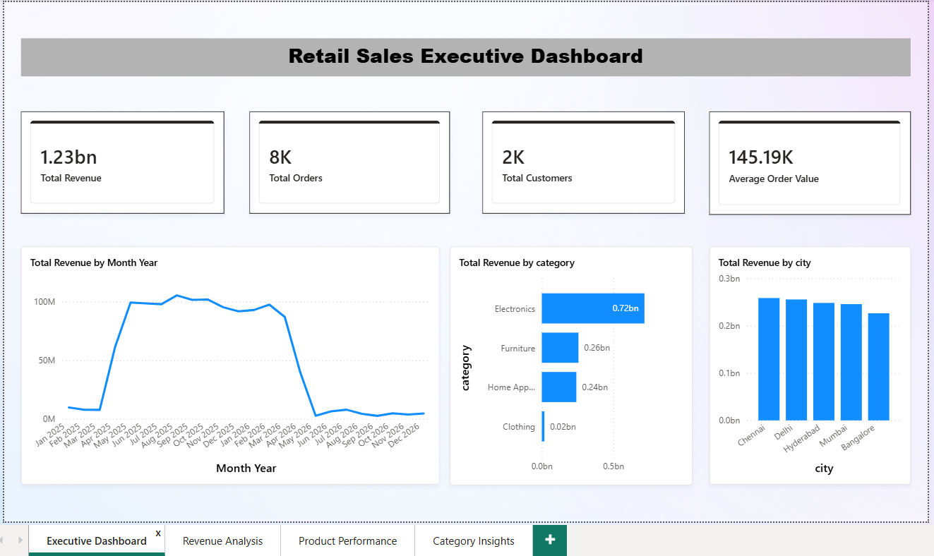

INSIGHTS
- Total Revenue exceeded 1.23 Billion.
- More than 8,000 orders were processed.
- Over 2,000 customers contributed to sales.
- Electronics generated the highest revenue contribution.
- Chennai and Delhi emerged as leading revenue-generating cities.

REVENUE ANALYSIS DASHBOARD

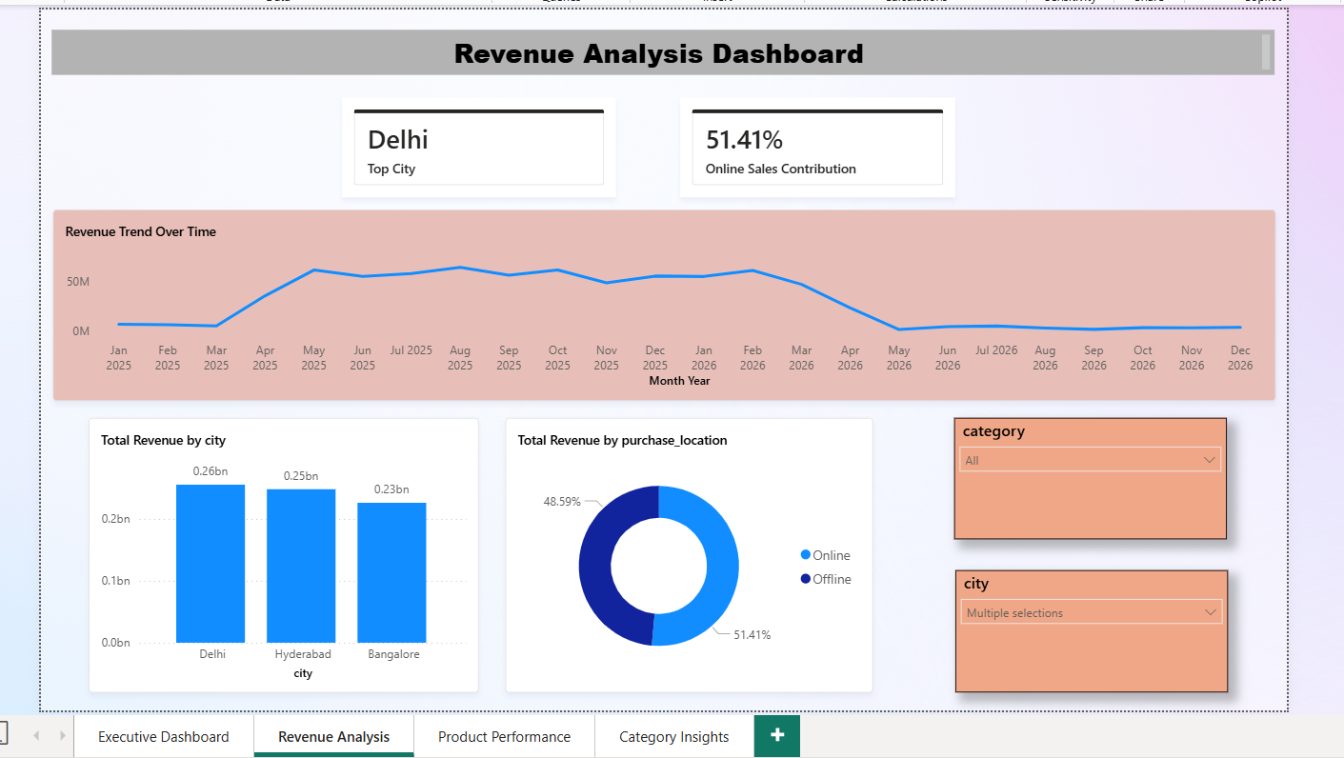

INSIGHTS
- Revenue trends can be analyzed monthly using the trend line.
- Revenue was highest between May 2025 and February 2026.
- City-wise filtering enables regional revenue analysis.
- Delhi was the leading revenue-generating city.
- Online and Offline channels contribute almost equally to total revenue.
- Interactive slicers support dynamic analysis.

PRODUCT PERFORMANCE DASHBOARD
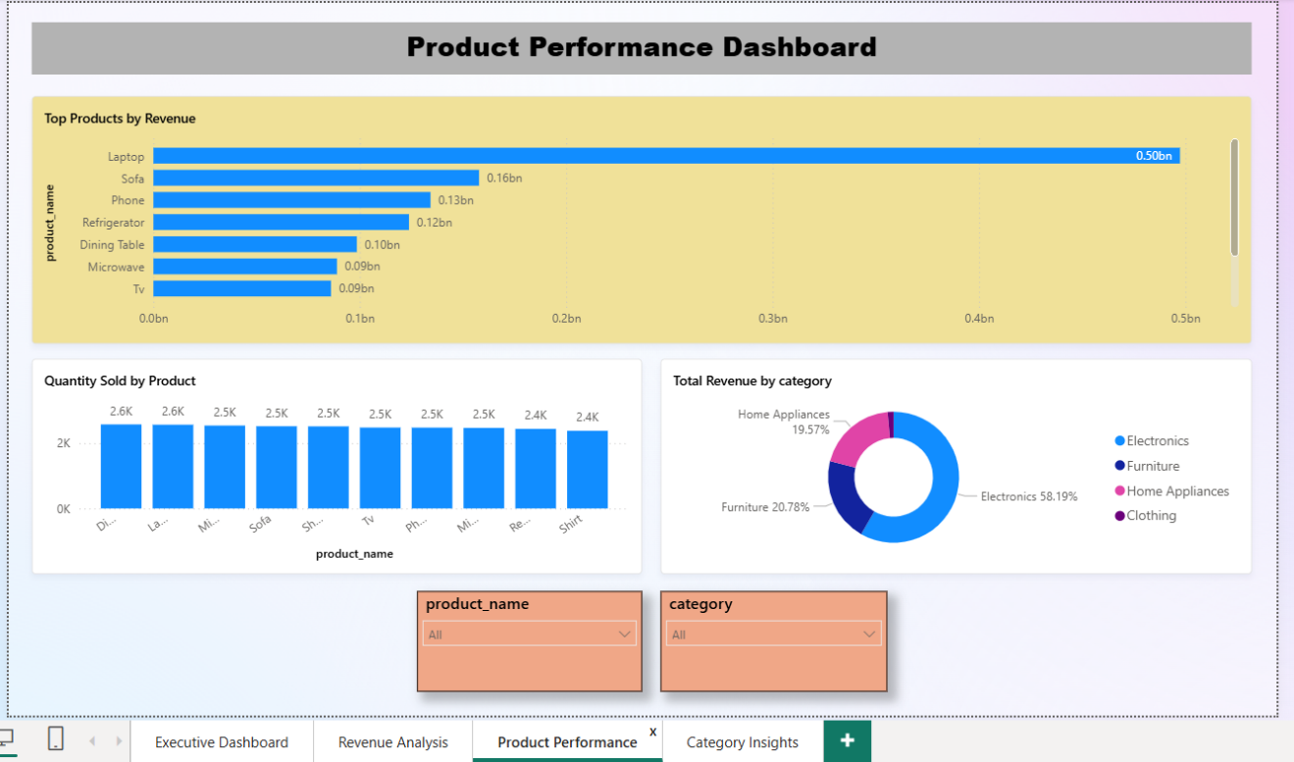

INSIGHTS
- Laptop is the highest revenue-generating product.
- Electronics products dominate overall sales performance.
- Product-level filters allow detailed performance tracking.
- Quantity analysis highlights customer demand patterns.
- Top-performing products should be prioritized for promotions and inventory planning.

CATEGORY INSIGHTS DASHBOARD
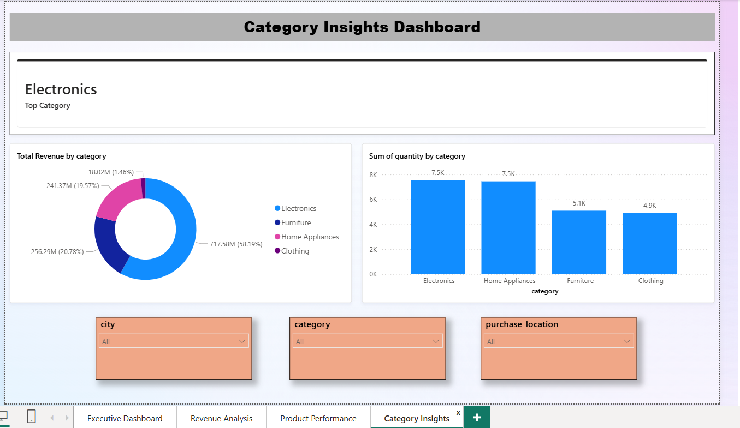

INSIGHTS
- Electronics contributes approximately 58% of total revenue.
- Furniture and Home Appliances are significant secondary contributors.
- Clothing contributes the lowest revenue share.
- Category-wise quantity analysis reveals customer purchasing behavior.
- Growth opportunities lie in expanding high-performing categories.

CONCLUSION
The Retail Sales Analytics Solution successfully transformed raw retail transaction data into actionable business insights through a structured data engineering and business intelligence workflow.
The solution incorporated data ingestion, validation, cleaning, transformation, privacy protection, KPI generation, and dashboard reporting. The resulting Power BI dashboards provide business users with a comprehensive view of revenue trends, product performance, customer activity, and category-level contributions, enabling informed decision-making and improved business visibility.

