**Week : 3 Handson.**

**Lab – 1**

**Object-Relational Mapping (ORM)** is a technique that lets developers interact with a database using high-level programming constructs.

* **Class-to-Table Mapping**: C# classes represent database tables; properties map to table columns.

**EF Core vs EF Framework :**

| **Feature** | **EF Core** | **EF Framework (EF6)** |
| --- | --- | --- |
| Platform | Cross-platform (Windows, Linux, macOS) | Windows-only |
| Weight | Lightweight | More mature, less flexible |
| Modern Features | LINQ, async queries, compiled queries | Limited support |
| Flexibility | Better for modern app development | Legacy compatibility |

**Creating a .NET Console App:**

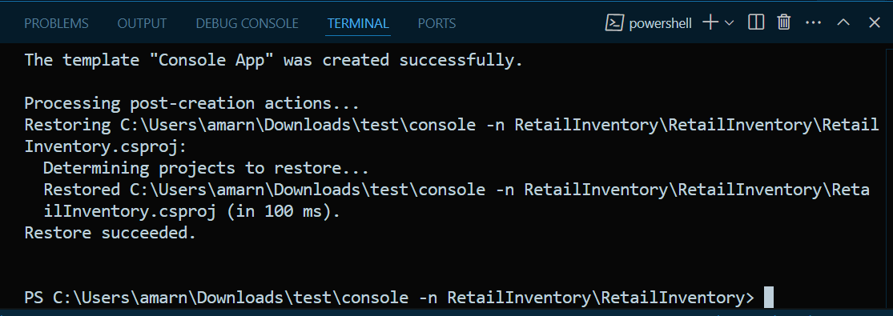

**Installing EF Core Packages :**

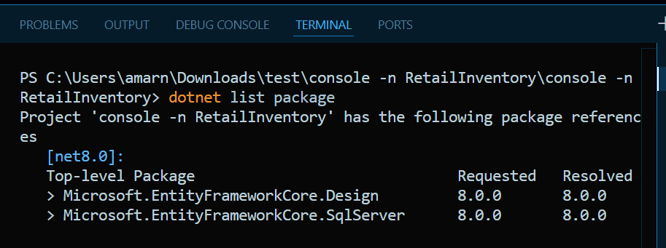

**Lab 2: Setting Up the Database Context for a Retail Store.**

**Steps:**

1. **Creating Models:**

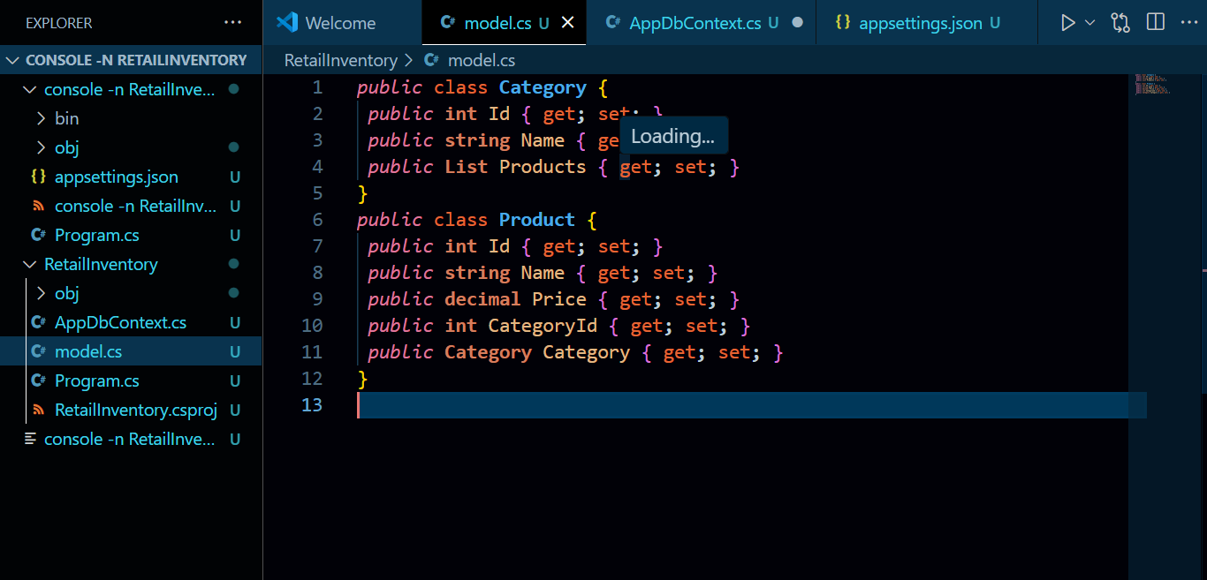

The models have been created successfully.

**2.Create AppDbContext:**

The app dbcontext has been created

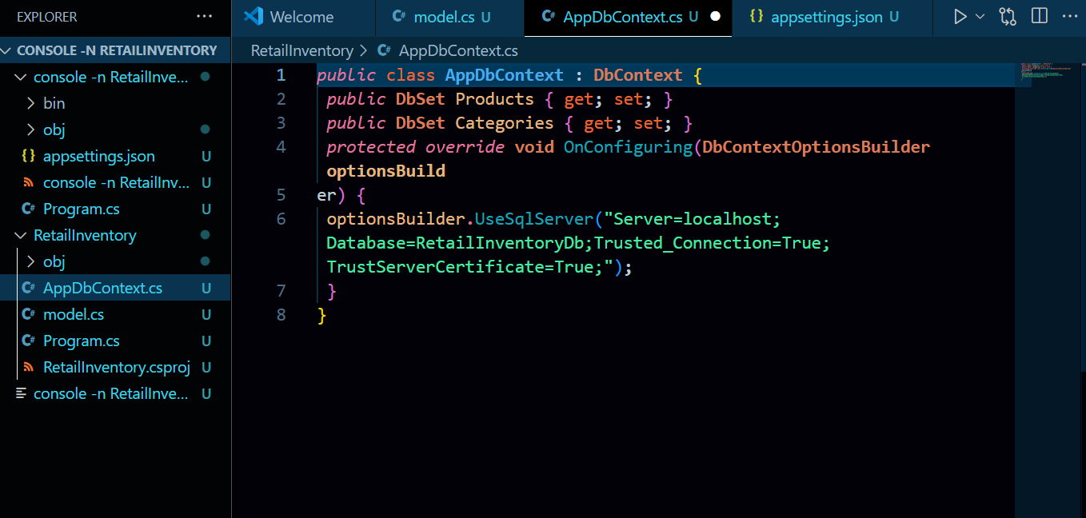

1. **Addding Connection String in appsettings.json :**

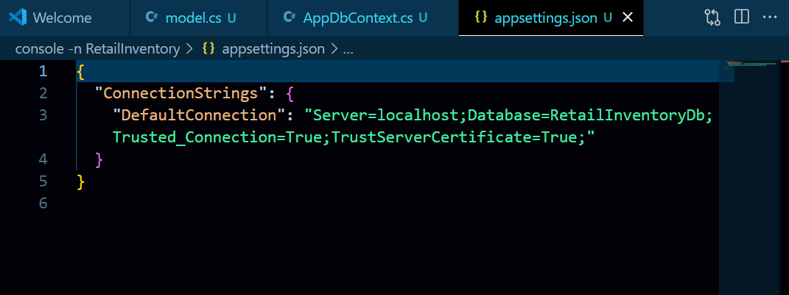

**Lab 3: Using EF Core CLI to Create and Apply**

**Migrations.**

**Steps:**

1. **Installing EF Core CLI.**

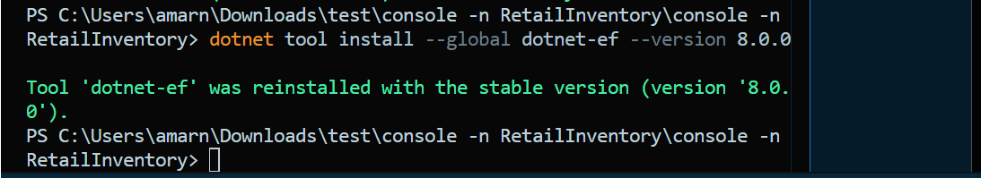

1. **Create Initial Migration:**

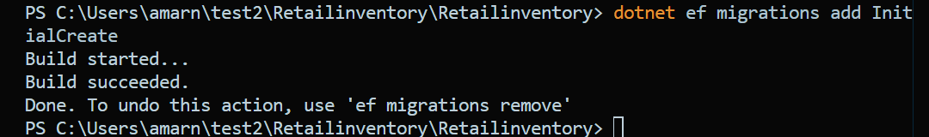

**3.Applying Migration to Create Database:**

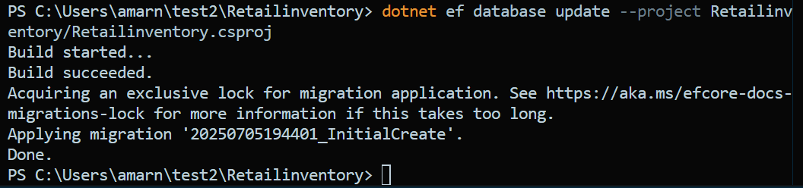

1. **Verifying in SQL Server:**

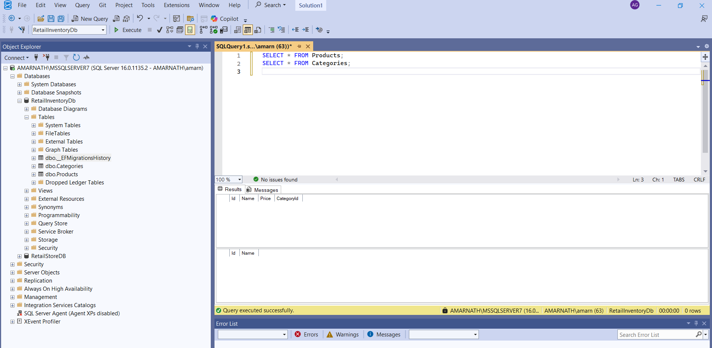

**Lab 4: Inserting Initial Data into the Database**

**Steps:**

**1.Inserting Data in Program.cs :**

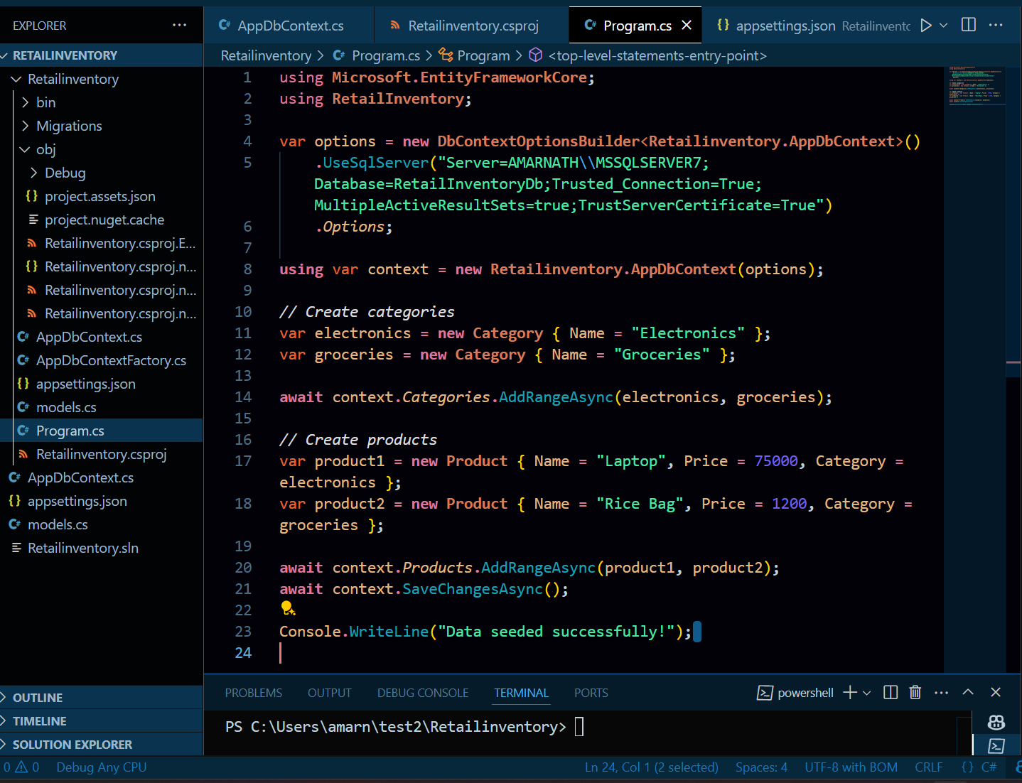

**2.Run the App: dotnet run**

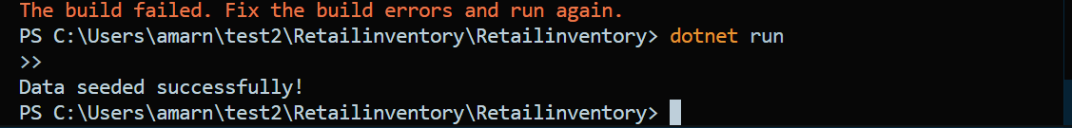

**3.Verifying in SQL Server: Check that the data is inserted correctly.**

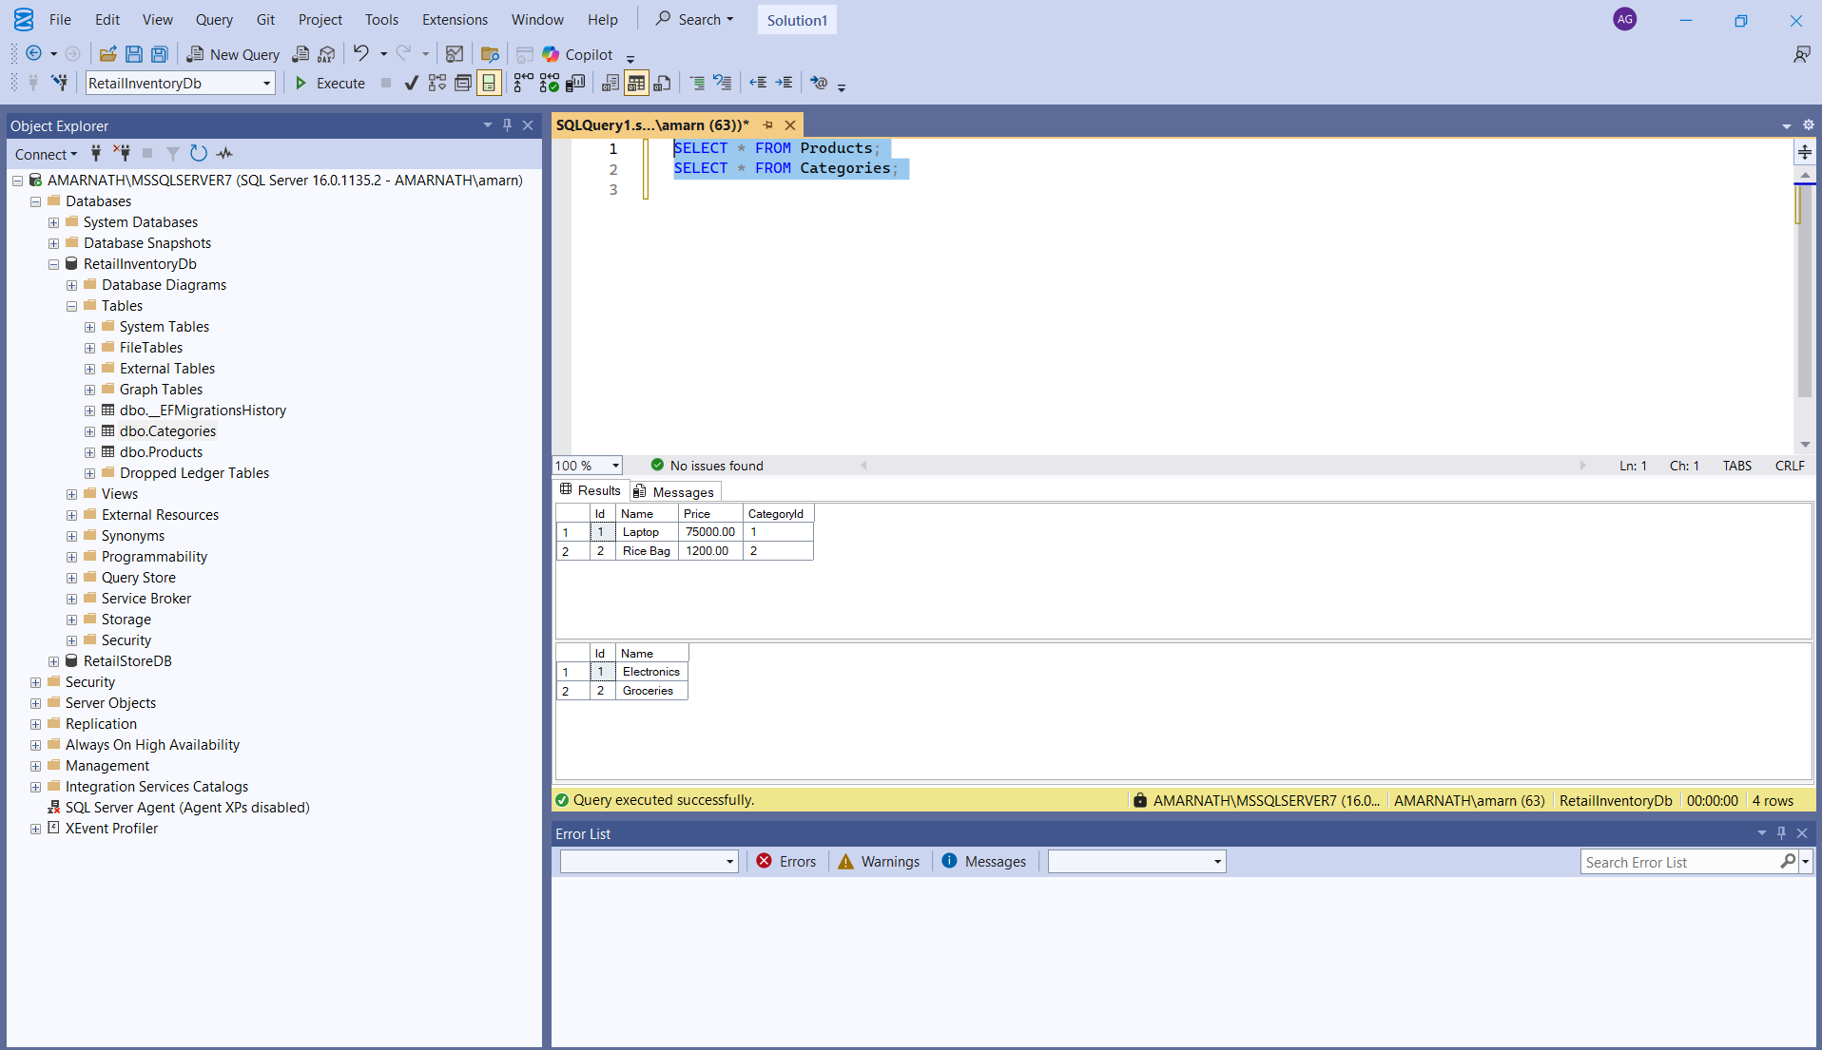

**Lab 5: Retrieving Data from the Database.**

**Steps:**

1. **Retrieve All Products:**

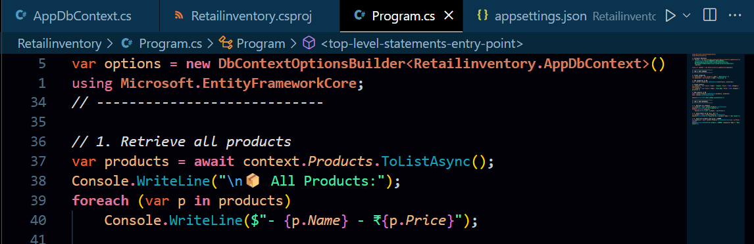

1. **Find by ID:**

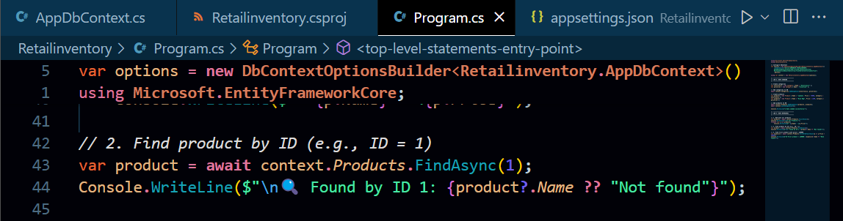

1. **FirstOrDefault with Condition:**

