בס"ד

Unfold
A Meaningful Seder

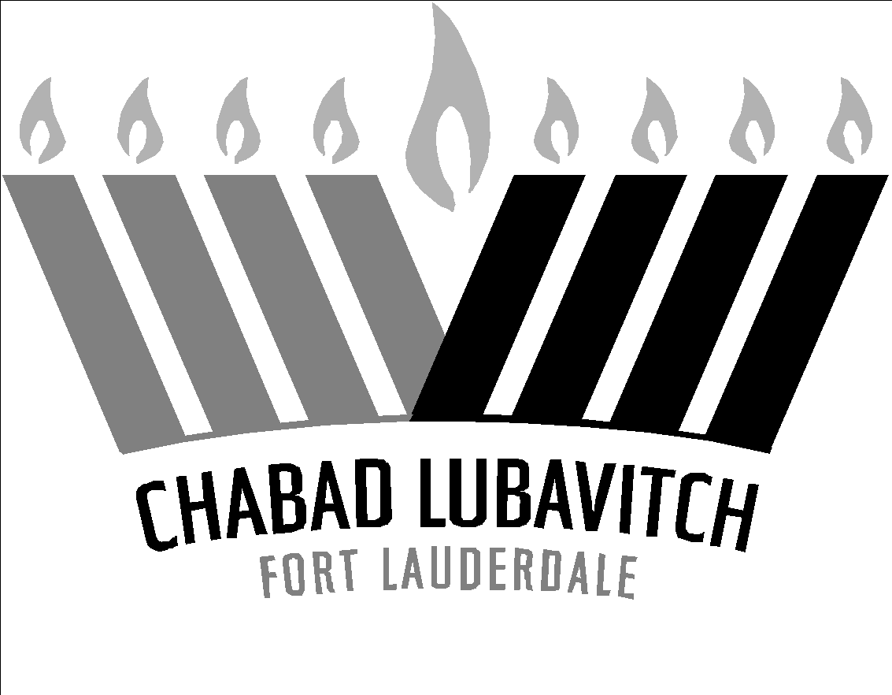

Content
Part I – Passover Night:
The basis for the Passover mitzvot and traditions
I. The obligations for the Seder night
II. Pesach, Matzah and Maror
III. Recounting the story of the Exodus
IV. The additional Mitzvot
Part II – The Seder:
How to prepare and conduct a Seder from the first cup of wine until the last
I. Introduction
II. The Seder plate
III. The structure and order of the Seder
IV. Lel Shimurim (“The night which is guarded”)

Part I – Passover Night:
I. The obligations for the Seder night

1) Mitzvot from the Torah:
1. Pesach
2. Matzah
3. Maror
4. Recounting the story of the Exodus

2) Mitzvot from our Sages:
1. Four cups of wine
2. Recline
3. Charoset
4. Hallel

II. Pesach, Matzah and Maror

1) Exodus 12:1-20
¹ G-d spoke to Moshe and Aharon in the land of Egypt saying: ² This month shall be the head of the month for you. It shall be the first of the months of the year.
³ Speak to the entire community of Israel, saying: On the tenth of this month, every man must take a lamb for each extended family, a lamb for each household. ⁴ If the household is too small for a lamb, then he and a close neighbor can obtain a [lamb together], according to the number of people involved. Each person should be counted for the lamb according to his ability to eat.
⁵ You must have a flawless male lamb, in its first year. You may take either sheep or goats. ⁶ Hold it in safekeeping until the 14th day of this month.
The entire community of Israel shall then slaughter [their sacrifices] in the afternoon. ⁷ They shall take some of its blood and put it on the two doorposts and on the lintel of the houses in which they will be eating it.
⁸ On that night, they shall eat the meat. They should eat it roasted over fire, together with matzos and bitter herbs.
⁹ Do not eat it undercooked or boiled in water, only roasted over the fire, its head with its legs and with its innards.
¹⁰ Do not leave any of it over until morning. Any part of it that is left over until morning shall be burned in fire.
¹¹ This is how you shall eat it: Your waist should be belted, your shoes on your feet, and your staff in your hand. You should eat it quickly. It is a Passover (Pesach) offering to G-d.
¹² I will pass through the land of Egypt on this night, and I will smite every first-born in the land of Egypt, both man and beast, and upon all the gods of Egypt I will perform acts of judgment. I [alone] am G-d.
¹³ The blood will be for you as a sign upon the houses where you are. I will see the blood and pass over you (Pasach). There will not be any deadly plague among you when I strike Egypt.
¹⁴ This day shall be for you as a memorial, and you shall celebrate it as a festival for G-d. For all generations you shall celebrate it as an eternal statute.
¹⁵ Eat matzahs for seven days. But on the preceding day, you must have your homes cleared of all leaven. For whoever eats leaven from the first day until the seventh day will have his soul cut off from Israel.
¹⁶ The first day shall be a sacred holiday, and the seventh day shall [also] be a sacred holiday. No work may be done on these [days]. The only [work] that you may do is that which is needed so that everyone will be able to eat.
¹⁷ You shall guard the matzos, for on this very day I have brought your legions out of Egypt. You shall observe this day throughout your generations as an eternal statute. ¹⁸ In the first month, on the 14th day of the month in the evening, you shall eat matzahs, until the 21st day of the month in the evening. ¹⁹ For seven days, leaven shall not be found in your homes. If any person eats a leavening substance, his soul will be cut off from the community of Israel, whether he is a convert or a native of the land. ²⁰ You shall not eat any leavening substance. In all the areas where you live, you shall eat matzahs.

2) Pesach Offering:
1. Eating the meat of the Pesach sacrifice is a Mitzvah, as Exodus [12:8] states: “On that night, they shall eat the meat. They should eat it roasted over fire, together with matzos and bitter herbs.”
2. To commemorate the Pesach offering, we are required to have meat on the Seder table (the Zro’a, shankbone).

3) Matzah:
1. Eating the matzah on the fifteenth of Nisan is a Mitzvah from the Torah, as Exodus [12:18] states: “In the evening, you shall eat matzah.” This applies in every place, whether in the land of Israel or in the Diaspora, and at every time, even when the Temple is destroyed.
Throughout the other days of the festival, eating matzah is left to one’s choice.
2. One is required to eat at least a kezayit of Matzah – a measurement formally described as the size of one olive and traditionally determined as one ounce or 25.6 grams.
The consumption of the required amount should be completed in less than four minutes.

4) Maror:
1. According to the Torah, the eating of the bitter herbs is not a mitzvah in its own right: It is dependent on the consumption of the Pesach sacrifice. It is one positive commandment to eat the meat of the Pesach sacrifice together with matzah and bitter herbs. However, the Sages established it as a mitzvah, instructing us to eat the bitter herbs alone on this night even if there is no Pesach sacrifice.
2. The bitter herbs referred to by the Torah are Romaine lettuce, endives, horseradish, date ivy and wormwood. All of these five species of vegetable are called Maror. However, it is popular to use either Romaine lettuce and/or pure horseradish (chrein).
3. One is required to eat at least a kezayit of Maror – a measurement formally described as the size of one olive and traditionally determined as one ounce, 25.6 grams. If one finds it difficult to consume this amount, one can suffice with a smaller measure of two-thirds of an ounce, since this is a rabbinic precept.
The consumption of the required amount should be completed in less than four minutes. If this should prove difficult, one can extend the time to a maximum of 6 or 7 minutes.

5) A passage from the Haggadah:
Rabban Gamliel used to say: Whoever did not say [did not explain the reasons for] these three things on the night of Passover, has not fulfilled his obligation [in an ideal manner]. And these are: The Pesach offering, Matztah and Maror.
The Pesach sacrifice that our fathers ate during the times of the Bet Hamikdash – for what reason did they do so? Because the Omnipresent passed over our fathers’ houses in Egypt, as it is said [Exodus 12:27]: “You shall say, it is a Pesach-offering to the Lord because He passed over the houses of the children of Israel in Egypt when He struck the Egyptians with a plague, and He saved our houses. And the people bowed and prostrated themselves.”
This matzah that we eat, is for what reason? Because the dough of our fathers did not have time to become leavened before the King of the Kings, the Holy One, blessed be He, revealed Himself to them and redeemed them. Thus it is said [Exodus 12:39]: “They baked matzah-cakes from the dough that they had brought out of Egypt, because it was not leavened; for they had been driven out of Egypt and could not delay, and they had also not prepared any [other] provisions.”
This maror that we eat, is for what reason? Because the Egyptians embittered our fathers’ lives in Egypt, as it is said [Exodus 1:14]: “They made their lives bitter with hard service, with mortar and with bricks, and with all manners of service in the field; all their service which they made them serve with rigor.”

III. Recounting the story of the Exodus

1) Exodus 13:3-8
³ Moshe said to the people: Remember this day, when you went out of Egypt, from the house of bondage, for with a mighty hand G-d took you out of here. No leaven may be eaten. ⁴ Today you are going out, in the month of Aviv (spring).
⁵ When G-d will bring you into the land of the Canaanites, Hittites, Amorites, the Hivites and Yebusites, which He swore to our ancestors to give you – a land flowing with milk and honey, you shall perform this ritual (Pesach) in this month. ⁶ For seven days, you shall eat matzahs, the seventh day is a festival for G-d.
⁷ Matzahs shall be eaten during the seven days, and no leaven that belongs to you shall be seen in your possession. No leaven that belongs to you shall be seen throughout your borders.
⁸ You shall tell your son on that day, saying, “Because of this (these mitzvos of Pesach, Matzah and Maror) G-d did this for me when I went out of Egypt.”

2) You shall tell your son (“Vehigadeta Lebincha”):
It is a positive command from the Torah to relate the miracles and wonders wrought for our ancestors in Egypt on the night of the fifteenth of Nissan, as Exodus [13:3] states: “Remember this day, on which you left Egypt.”
From where is it derived that this Mitzvah is to be fulfilled on the night of the fifteenth? The Torah teaches [Exodus 13:8]: “And you shall tell your son on that day, saying: “It is because of this…””, Implying that the mitzvah is to be fulfilled when matzah and maror are placed before you.
The mitzvah applies even though one does not have a son. Even great Sages are obligated to tell about the Exodus from Egypt. Whoever elaborates on the events which occurred is worthy of praise.
It is a mitzvah to inform one’s son even though they do not ask, as Exodus [13:8] states: “You shall tell your son.” A father should teach his son according to the son’s knowledge.
He should make changes on this night so that children will see and will be motivated to ask: “Why is this night different than all other nights?” to which he replies: “This and this occurred; this and this took place.”
Which changes should be made? He should give them roasted seeds and nuts; the table should be taken away before they eat; (matzot should be snatched from each other) and the like.
If a person does not have a son, his wife should ask him. If he does not have a wife, he and a colleague should ask each other: “Why is this night different?” This applies even if they are all wise. A person who is alone should ask himself: “Why is this night different?”

3) The Haggadah:
The Haggadah was composed for this reason. The term Haggadah derives from Exodus [13:8]: “Vehigadeta Lebincha” (you shall tell your child). It also derives from the expression of hoda’ah, thanksgiving and praise to the Holy One, blessed be He, for taking us out of Egypt.

IV. The additional Mitzvot

1) Four cups of wine:
1. The four cups were instituted by our Sages to correspond to the four expressions of redemption: “I will take you out… I will save you… I will redeem you… I will take you for me” (Exodus 6:6-7).
2. The Sages enacted that we drink four cups at the seder in a manner of freedom.
Each one of the cups is a Mitzvah in itself, and requires its own blessing:
One recites the Kiddush pertaining to the day on the first cup; one recites the Haggadah on the second cup; one recites the grace after meals on the third cup; and one concludes the Hallel on the fourth cup.
3. Each cup must contain at least a revi’it – approximately 3.5 fluid ounces.
Ideally, one should drink the whole cup each time. If this is difficult, one should drink a little more than one half of a revi’it (approximately 2 ounces).

2) To recline:
1. In each and every generation, a person must present himself as if he himself has just left the slavery of Egypt, as Deuteronomy [6:23] states: “He took us out from there”. Regarding this matter, G-d commanded in the Torah [Deuteronomy 5:15]”: “Remember that you were a slave,” i.e., as if you yourself were a slave and went out to freedom and were redeemed. Therefore, our Sages ordained that when a person feasts on this night, he must eat and drink while he is reclining in the manner of free men.
2. When must one recline? When eating the matzah and drinking the four cups of wine. It is praiseworthy if one reclines when eating and drinking at other times, but there is no requirement.
3. We recline on the left side.
Lying on one’s right side, face or back, is not regarded as reclining. It is not a comfortable manner of eating and cannot be regarded as a symbol of freedom and liberation.
In addition, reclining on one’s right side can be dangerous, lest the food go down the windpipe rather than the esophagus.

3) Charoset:
1. The Sages ordained charoset as a Mitzvah.
This is to commemorate the cement with which our ancestors worked as slaves to construct buildings in Egypt.

It also commemorates the apple trees under which the Jewish women in Egypt gave birth without pain, away from the watchful eyes of the Egyptian authorities who were intent on killing their children.
2. The Charoses can be made of dates, dried figs, raisins, apples, nuts, cinnamon, ginger and pomegranates, and other fruits which are metaphoric to the Jewish people in the Torah. We crush them and add vinegar or wine, and mix them as straw is mixed into cement.

4) Hallel:
During the Seder, it is a mitzvah to recite the Hallel (praise of G-d).
Hallel (Psalms 113-118) was recited while the Pesach sacrifice was being offered in the Beth Hamikdash, and while it was eaten during the Seder. Our sages explain that the Jews recited these verses of praise as they left Egypt.

🙠 🙢

Part II – The Seder:
I. Introduction
“Every one must conduct himself with awe and follow the instructions of the sages who arranged the precept of the Seder and the Haggadah.
This matter should not be trivial in one’s eyes!
There are some things at the Seder which may seem insignificant to man, but let him act prudently to observe them, for there is nothing vain among them!”
(Sefer Maharil)
II. The Seder plate:

1) The items on the Seder plate

ג'  מַצּוֹת | Three  Matzot | It is strongly recommended to use Shmurah Matzah, preferably hand made.
זְרוֹעַ | Zro’a | The shankbone
בֵּיצָה | Beitzah | A hard-boiled egg unpeeled
מָרוֹר | Maror | Bitter herbs – romaine lettuce and horseradish together
חֲרוֹסֶת | Charoset | A mixture of ground apples, pears, and nuts, to which red wine is added later
כַּרְפַּס | Karpas | A raw onion or boiled potato
חַזֶרֶת | Chazeret | Same as Maror

2) The significant of these items
Three Matzot – there are several reasons for “three” matzot. It is customary to choose concave matzot, suggesting that the matzot serve as a receptacle for the downward flow of Divine energy.
The Zro’a – commemorates the Pesach offering (see previous course).
The Beitzah – commemorates the Chagigah [festive] offering which was brought together with the Pesach offering in the time of the Bet Hamikdash.
Zro’a literally means an Arm, and an egg in Aramaic is called beya, a word which may also mean to pray, and find favor, “please”, suggesting “May it please the Merciful G-d to redeem us with an uplifted arm”.
Other reasons for using a hard-boiled egg: 1) it symbolizes the character of the Jewish people. 2) To remind us of the mourning over the destruction of the Temple.
Maror – see previous course.
The Charoset – is a reminder of the clay with which our ancestors were made to work. An acrid substance is added to it as a reminder how the teeth of Israel were set on edge by the harshness of their bondage.
The Charoset is made of a mixture of fruits to which the people of Israel have been compared. This mixture is then softened by a red liquid, as a reminder of the blood which was the first of the ten plagues. (See also previous course).
Karpas – The letters of the word Karpas, when reversed, read the letter samech [which stands for the number 60] perach [harsh labor], alluding to the sixty myriads of Jews subjected to harsh labor. כַּרְפַּס – ס' פֶּרֶך
Chazeret – Used for the Koreich sandwich.

3) The placing of the items (the three matzhas are placed beneath the plate or tray)

זְרוֹעַ בֵּיצָה
SHANKBONE EGG

מָרוֹר
MAROR

חֲרוֹסֶת כַּרְפַּס
CHAROSET VEGETABLE

חַזֶרֶת
CHAZERET
III. The structure and order of the Seder:

- Different customs for the Seder

2) The order of the Pesach Seder (in bold are those precepts which are added on the Seder night):

קַדֵּשׁ | Kadeish | Reciting Kiddush
וּרְחַץ | Urechatz | Washing the hands
כַּרְפַּס | Karpas | Eating a vegetable dipped in salt-water
יַחַץ | Yachatz | Breaking the middle matzah
מַגִּיד | Maggid | Reciting the Haggadah
רָחְצָה | Rachtzah | Washing the hands a second time (for the matzah)
מוֹצִיא | Motzi | Reciting the blessing “Hamotzi”
מַצָּה | Matzah | Reciting the blessing “al achilat matzah” and eating the matzah
מָרוֹר | Maror | Blessing over and eating the bitter herbs
כּוֹרֵךְ | Koreich | Eating a sandwich of matzah and bitter herbs
שֻׁלְחָן-עוֹרֵךְ | Shulchan  Oreich | Eating the festive meal
צָפוּן | Tzafun | Eating the hidden afikoman
בֵּרַךְ | Beirach | Blessing after meal
הַלֵּל | Hallel | Reciting Hallel, psalms of praise
נִרְצָה | Nirtzah | The Seder is favorably accepted by G-d

IV. Lel Shimurim (“The night which is guarded”)

1) Exodus: 12:41-2
⁴¹ At the end of the 430 years, all of G-d’s armies left Egypt in broad daylight. ⁴² There was a night of vigil for G-d, [preparing] to bring them out of Egypt. This night remains for the Israelites a vigil to G-d for all generations.

2) A night which is guarded from that time onward against harmful spirits.

3) “Shifoch Chamascha”
After the fourth cup of wine is poured, before reciting Hallel, we open the door and say “Pour out Your wrath upon the nations that do not call upon you….” We open the door as a reminder that it is “lel Shimurim”, the night of G-d watching over us, and thus, we are not afraid of anything.
By merit of this faith and trust, Moshiach will come and G-d will pour out His wrath upon the nations that do not acknowledge Him.
Another reason for opening the door is to welcome Elijah, the messenger of the Messianic redemption.

4) The additional cup, “The cup of Elijah” (three reasons – Rebbe’s Hagadah)

Wishing you and yours a
Kosher and Happy Passover!

🙠 🙢

“Rabbi Shneur Zalman of Liadi – founder of Chabad – did not insert at the end of the Haggadah, the words “The Order of Pesach is now completed;” for with Chabad, Pesach does not end, but extends continuously.
To be sure, the illumination of every festival radiates every day; but the festival of Pesach extends continuously!”
(The Previous Lubavitcher Rebbe)

