בס"ד
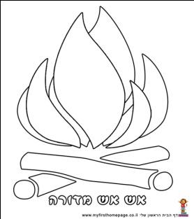
Lag B’omer Signature Hunt!
Fill in 4 Signatures to get a prize! ☺

Signature | Task
1  2  3 | Ask 3 people what “Lag B’omer” means
Lag B’omer is the passing day of Rabbi Shimon Bar Yochai.
Find someone named Shimon and ask him to sign.
Rabbi Shimon had to hide from the Romans inside a cave.
Find someone who once went to Rome (or anywhere else in Italy) Ask them to sign.
While Rabbi Shimon was alive the rainbow never appeared in the sky.
Find an object that looks like a rainbow. What is it?
1  2  3 | On Lag Baomer many people go to Meron in Israel.  Find 3 people who were in Meron and ask them to sign.  What is in Meron?
Rabbi Akiva was Rabbi Shimon’s teacher. At the age of 40 he started to learn how to read and write Hebrew and became a great scholar.
Find someone who is exactly 40 and ask them to sign.

בס"ד

Lag B’omer Signature Hunt!
Fill in 4 Signatures to get a prize! ☺

Signature | Task
1  2  3 | Ask 3 people what “Lag B’omer” means
Lag B’omer is the passing day of Rabbi Shimon Bar Yochai.
Find someone named Shimon and ask him to sign.
Rabbi Shimon had to hide from the Romans inside a cave.
Find someone who was in Rome. Ask them to sign.
While Rabbi Shimon was alive the rainbow never appeared in the sky.
Find an object that looks like a rainbow. What is it?
1  2  3 | On Lag Baomer many people go to Meron in Israel.  Find 3 people who were in Meron and ask them to sign.  What is in Meron?
Rabbi Akiva was Rabbi Shimon’s teacher. At the age of 40 he started to learn how to read and write Hebrew and became a great scholar.
Find someone who is exactly 40 and ask them to sign.

