Schedule: 7:00-7:25- Welcome and Dinner
7:25-7:35- Lesson
7:35-7:45- Worksheets
7:45-8:15 – Craft – anthropology flowers.
8:15-8:30 – Game. Snakes and ladders to har Sinai

Shavuot
- Counting the omer. 7 weeks from pesach to shavuos when we get ourselves ready to receive the Torah. Each day we work on another character trait.
- Hashem took us out of Egypt specially to give us the Torah and make us his people.
- Naseh venishma
- Har Sinai was small and plain. Over night it blossomed with flowers- we celebrate Shavot with lots of flowers
- Every soul was at the foot of the mountain. Moses went up to receive the torah- the entire world was still.
- Hashem called out the 10 commandments. The people couldn’t handle the holiness
- 10 commandments
- Moses stayed up on the mountain for 40 days and nights to learn the whole torah to teach the ppl
On Shavuot we:
- Go to shul to hear the 10 commandments
- Decorate our homes with flowers
- Eat dairy - With the giving of the Torah, the Jews became obligated to observe the kosher laws. As the Torah was given on Shabbat, no cattle could be slaughtered nor could utensils be koshered, and thus on that day they ate dairy.

GET THE JEWS OUT OF EGYPT AND TO HAR SINAI TO RECEIVE THE TORAH!!

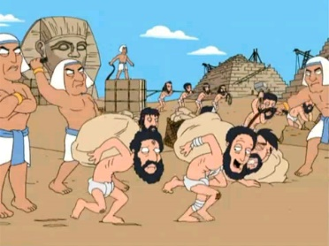

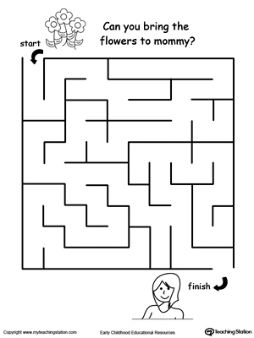

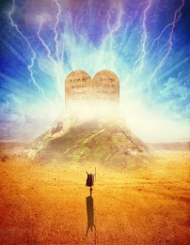

CIRCLE THE FOODS WE EAT ON SHAVUOS

















MATCH THE COMMANDMENT TO THE PICTURE


- I am Hashem your G-d.

- Don’t Serve any other G-ds
- Don’t say hashem’s name in vain
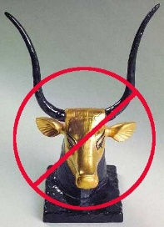

- Keep Shabbos
- Honor your parents


- Don’t Kill
- Don’t steal
- don’t be jealous
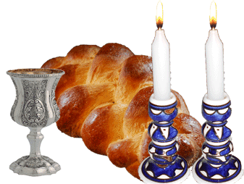
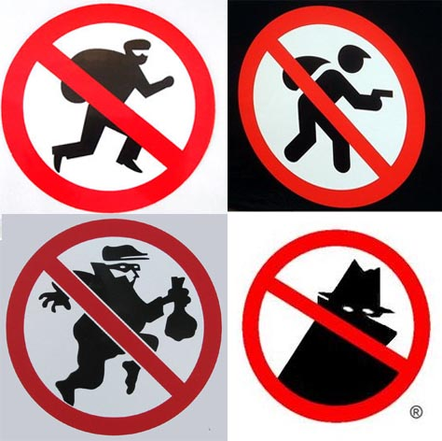
- Don’t be a false witness
- Don’t commit adultery

FILL IN THE BLANKS

Hashem took the Jews out of Egypt specially to make them his chosen people and give them the _________________. Hashem asked us if we wanted the Torah and we said we will __________ and we will ________________ demontsrating that we were ready to serve Hashem no matter what.

The Torah was given on _______________________ a small and plain mountain. A miracle happened and over night _________________ blossomed all over the mountain. In remembrance of that we decorate our home and shul with flowers on _______________________

________________________ climbed the mountain to receive the ____________ commandments. The entire world was quiet as Hashem read the commandments to the Jewish people.
Moses stayed up on the mountain for ________ days and nights learning the whole Torah. That day the Jewish people ate only dairy because they had just learned about Kosher and the right way to slaughter animals but it was shabbos and so they couldn’t slaughter. ON shavuot we have a tradition to have a _____________ meal because of this.

We all go to _______________________ on Shavuot to hear the 10 ______________________________.
Shul | dairy | Shavuot | Moses | Do | Torah
10 | commandments | 40 | Flowers | Hear | Har Sinai

