v"c
Sources for Discussion/class – Shavuot

❶ Talmud Tractate Shabbat, 88b-89a
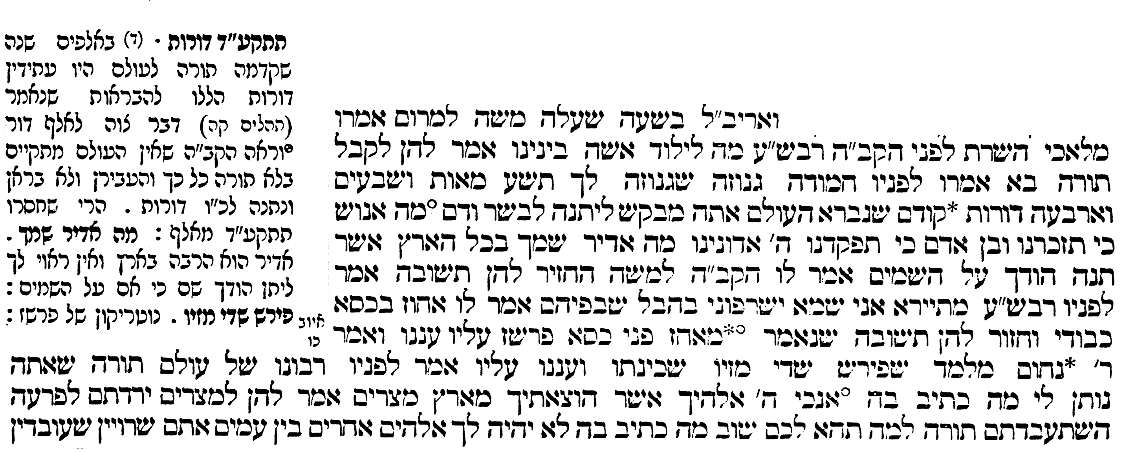

1
2
3
4
5
6
7
8
9
10
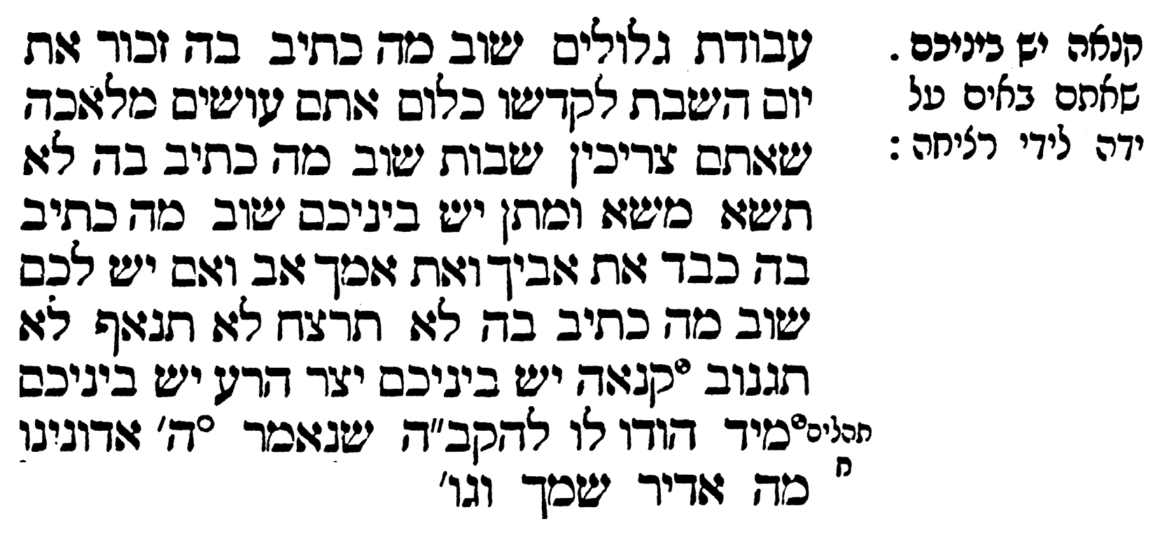
11
12
13
14
15
16
17
18
19
20

(Free translation)
When Moses ascended on high, the ministering angels asked the Holy One, blessed be He: “Master of the world, what is one born of a mother doing among us?”
G-d told them: “He came to receive the Torah.”
The angels protested: “The Torah is a hidden treasure… and You desire to give it to flesh and blood. ‘What is man that You shall remember him? Place Your glory in the heavens.’ (Psalms 8:2)”
The Holy One, blessed be He, told Moses: “Provide them with an answer.”
Moses responded before G-d: “The Torah which You are going to give me, what is written in it? ‘I am G-d, your L-rd who took you out of Egypt.’” Moses told the angels: “Did you descend to Egypt? Were you enslaved to Pharaoh? Why should the Torah be yours?”
And he continued telling them: “What else is written in it? ‘You shall have no other gods.’ Do you live among idol-worshipping nations?
And furthermore, what is written in the Torah? “Remember the Sabbath day to keep it holy.” Do you labor on the week-days to rest on the Sabbath?
“Thou shall not utter the name of G-d in vain.” Do you have business dealings where you must take an oath? “Honor you father and mother." Do you have a father and mother to honor? “Thou shalt not kill,” etc. Is there any jealousy among you? Do you have an Evil Inclination?
How can injunctions such as the prohibitions against murder, adultery, stealing, lying and coveting be for you? You do not have an Evil Inclination that tries to draw you to commit acts of that nature.”
When the angels heard this they immediately admitted to G-d that His intentions were correct.

❷ Maimonides Hilchot Shechainim (Laws of Neighbours) Chapter 12:4-5

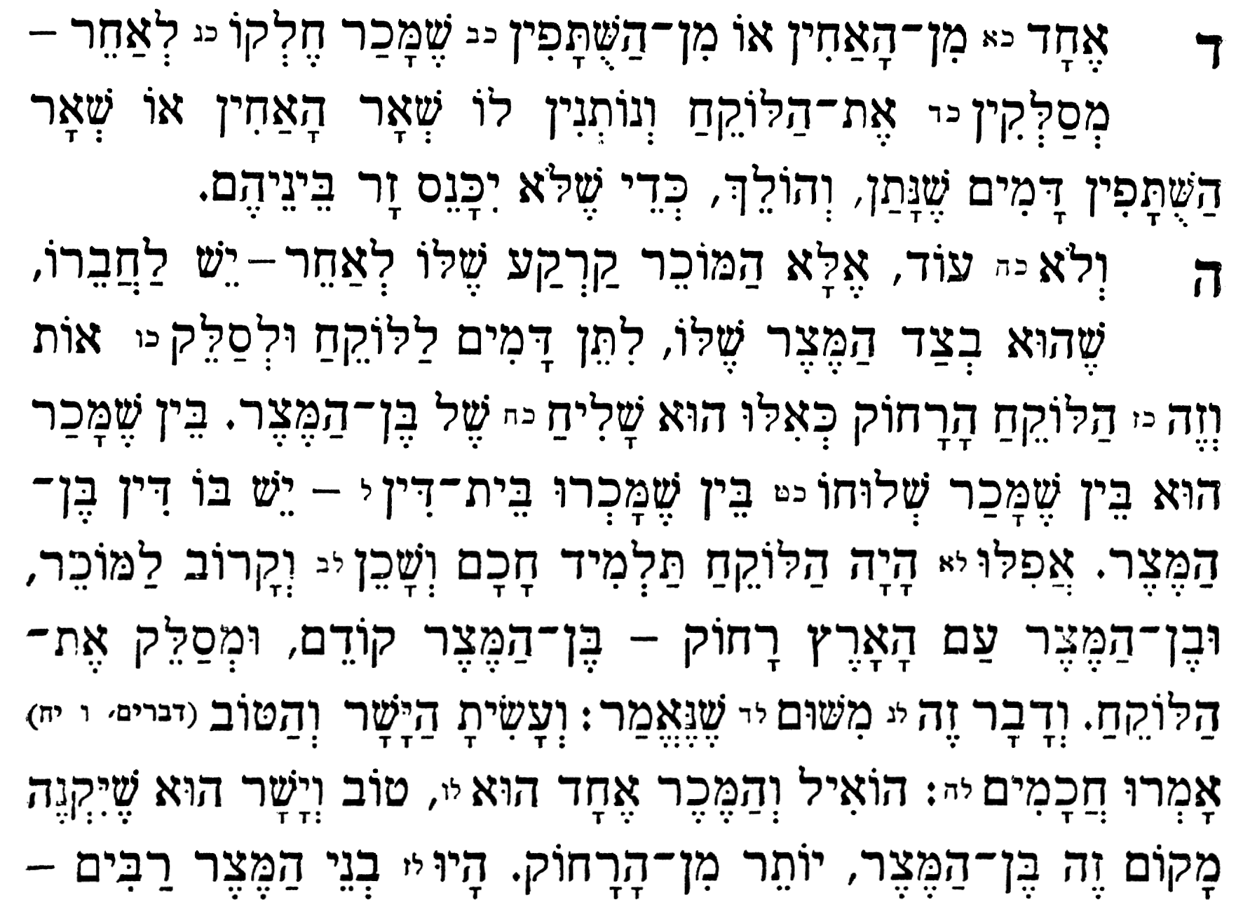
4. If one of the brothers or partners sells his portion to a third party, the other brothers/ partners may force the third party to accept payment for that portion and thus relinquish ownership of it, so that a stranger
does not enter amongst them.

5. Furthermore, if one sells real estate to a third party, a neighbour whose property adjoins the property being sold may force the third party to sell his property, [even if the seller did not wish to sell to the neighbour] whether he sold it directly or through an agent, or it was sold by a Beth Din, the law of Ben Metzar applies. Even if the buyer was a highly-respected scholar to whom honour was due, and a relative, and the next-door neighbour was an ignoramus
and not a relative, nonetheless the neighbour takes precedence. The reason for this is because of the verse in Deuteronomy 6:18 “You shall do what is good and proper in the eyes of G-d”. Said the Sages, since it makes no difference to the seller – he gets his money either way – but the next-door neighbour benefits more by having contiguous property than someone who does not already own property next door, therefore it is good and proper to give him precedence.

❸ Shulchan Aruch (Code of Jewish Law) Choshen Mishpat 175:53
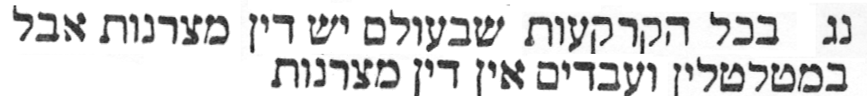
The law of Bar Metzar applies to real-estate
everywhere but not to movable property or possessions.

❹ Tractate Bava Metzia 108a
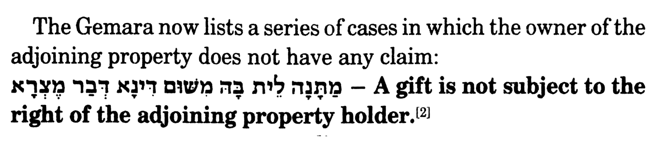
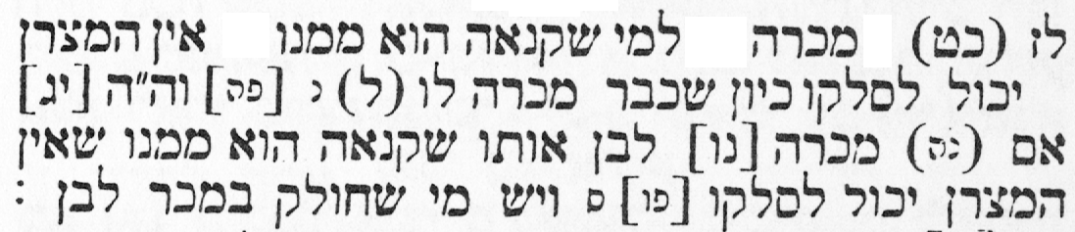
❺ Shulchan Aruch (Code of Jewish Law) Choshen Mishpat 175:37
If a person sold a property back to the person
he initially bought it from, the law of Bar Metzra does
not apply. The same law applies if he sold it to his son.

❻ Tractate Bava Metzia 108a
