Chabad-Sutton Women’s Torah Study Group
Rosh Hashanah

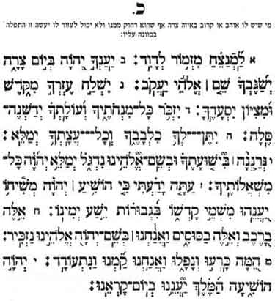
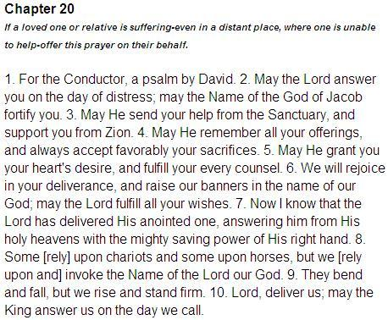
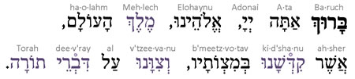

Source 1:
Talmud Tractate Rosh Hashanah 16A
“And recite before Me on Rosh HaShana verses that mention Kingships, Remembrances, and Shofarot: Kingships so that you will crown Me as King over you; Remembrances so that your remembrance will rise before Me for good; and with what will the remembrance rise? It will rise with the shofar…”
Source 2
Lechu Neranena, Friday evening Kabbalat Shabbat
Come, let us sing to Adonoy; let us sound the shofar to the Rock of our deliverance.¹]Let us greet His Presence with thanksgiving, with hymns let us raise our voices unto Him. For a great Almighty is Adonoy and a great King over all gods. For in His hands are the depths of the earth, and the heights of the mountains are His; For the sea is His, and He made it, and the dry land, His hands formed. Come, let us prostrate ourselves and bow; let us kneel before Adonoy, our Maker.
Source 3
Psalm 130
A song of ascents. Out of the depths I call You, O LORD...
O Lord, listen to my cry; let Your ears be attentive to my plea for mercy….

The Five Levels of the Soul
(in ascending order)
- Nefesh
- Ruach
- Neshama

- Chaya
- Yechida
Nefesh is the basic life-force or natural soul in general, and specifically relates to the soul’s basic or external manifestations in terms of the faculties of thought, speech and action. Ruach (Spirit) and Neshamah (Soul, Breath) are the spiritual life-force in man, relating to the Middot (emotive qualities) and Mochin (intellectual qualities) respectively. Chayah (Living), often also referred to as Neshamah leNeshamah (Soul of the Soul), is the sublime root for the lower three grades. Yechidah (Only One; Unique) is the quintessence, the Divine spark as it were, the ultimate source of the soul — compounding yet transcending the lower grades.

