B”H Junior Congregation: Rosh HaShana
September 14-15
10:30-12:00
Program:
- Learn about the special Tefillos said on Rosh HaShana
(Sing some songs/say some of the tefillos depending on age of group)
- Dip the apple in the honey make a bracha
- Unesana Tokef (story- http://www.chabad.org/holidays/JewishNewYear/template_cdo/aid/418982/jewish/The-Unetaneh-Tokef-Prayer.htm)
- Teshuva, Tefillah,Tzedakah
- Akedas Yitzchak
- Tashlich
- Go in for Shofar
- Story time- Stories about Rosh HaShana
- Boy in shul, didn’t know how to daven, animal sounds
- The Fireman (about the shofar) http://www.chabad.org/kids/article_cdo/aid/4745/jewish/The-Fireman.htm
- Lunch/snack
- Apples and honey
- Group games + Board games
- Charades
- Match it with Rosh HaShana pictures
- (Throw away all your bad deeds game)
- The King Says (like simon says) -crown
- Asking for forgiveness (guess the language)
- Taboo
- Rosh Hashana Headbands
- Step on It
- Jewpardy
6) Incentives
- Raffle
7) Discussion (depends on age of group)
- Hachalatos/goals they can take on for the new year
- Why do we eat a head of a fish? (how Jews are compared to fish and Torah is compared to water...)
*Supplies:
English & Hebrew text of specific tefillos -for tefilla
Siddurim
Rosh HaShana pictures + taboo cards- for game +headbands and symbols for headbands game
Crown- for game
(Tickets-for raffle)
Lunch/snack
B”H Schedule: Group One (Younger Group)

Time | Day One | Day Two | Notes
10:30 | Free play until kids come | Free Play
10:45 | Circle time/Davening | Circle Time/  Davening | (What they know) Modeh Ani, Al HaTorah, Hareini, Shema, Dip the apple in the honey...
10:55 | Storybook On Rosh HaShana | Story | Or story with pictures (The Fireman/The boy who didn’t know how to daven)
11:05 | The King Says | Rosh HaShana Bingo | Like Simon Says: on Rosh HaShana we are crowning our King HaShem, explain concept  Want to remember that Hashem gives us everything we want/need. Crown HaShem as King. When people get a new king they make a big deal. Today we try to ask Hashem to be our King and we will try to do everything He wants us to do – make this world a better place.
11:15 | Snack Time  Explain to them about Shofar and how to act when we go inside to hear it  (Mashal of the prince goes away comes back they don’t recognize him, calls out to his father, then explain nimshal very simply) | Snack  “Who Remembers how we act by Shofar?  review about Shofar | Apples and Honey  (Ba-ruch a-tah Ado-nai E-lo-hei-nu me-lech ha-olam bore pri ha-etz.  Blessed are You, L-rd our G d, King of the universe, who creates the fruit of the tree.  Ye-hi ratzon she-ti-cha-desh alei-nu shanah tovah u-m'tu-kah.)  A shofar is a horn of a kosher animal with the marrow removed.  The 'shofar blower', the Baal Tokeya, recites two blessings before sounding the shofar.This is a most suitable moment for self-examination and final repentance.The shofar blower, called the Baal Tokeyah, blows a set sequence of three kinds of blasts: 1) Tekiah ==an uninterrupted blast lasting for several seconds. 2) Shevarim == three medium length blasts. 3) Teruah == a minimum of nine very short blasts.There are three different sounds of the Shofar. “Tekiah” is a long, drawn-out sound. “Shevarim” are the shorter, broken sounds. “Teruah” are the shortest, yap-like blows. These are all meant to signify the sound of crying, to awaken within us the yearning to do Teshuva with all our heart.
11:30 | Shofar Blowing | Shofar | (Whoever is quiet will get a ticket)
11:40 | Rosh HaShana Match It | Tic Tac Toe with RH Questions | With Rosh HaShana pictures  make a tic tac toe board on a cardboard - and in order to put a piece down, the kids has to answer the question correctly.
12:00 | Circle/Discussion | Discussion  Why do we eat a head of a fish? (how Jews are compared to fish and Torah is compared to water...) | Teach Teshuva: Go around everyone says a hachlata (because we throw all our sins away at the fish, we are clean and pure! tashlich)  On the first day of Rosh Hashanah, we visit a river bank, or any flowing body of water, (that contains fish) and recite the Tashlich prayers. There, we “cast away our misdeeds” into the water, and resolve to act properly from now on. If one cannot do Tashlich on the first day, he may do so up until Yom Kippur.After saying the special Tashlich prayer we shake the corners of our garments, as if to dump all our sins into the water. This is symbolic of the words of the prophet, Micah: " …and you shall throw into the depth of the sea all their sins…" Of course, the mere shaking of the corners of our garments will not shake off the sins. But it does remind us that we must give our heart a thorough cleaning and rid it of all evil.Another reason that Tashlich is performed at the side of a body of water is because Tashlich represents our coronating Hashem as King, and it is customary to coronate kings at a riverbank.We try to go to body of water that has fish, because just as the eyes of a fish are always open, so too hashem’s “eyes” are always open, He is always watching us
Lunch

Schedule: Group Two (Older)

Time | Day One | Day Two | Notes
10:30 | Board Games Until More Kids Come | Board Games
10:45 | Daven/Teach Tefillos | Daven  Review- Unesana Tokef  and teach  Teshuva, Tefilla U’tzedakah (By returning to one's innermost self (teshuvah), by attaching oneself to G-d (tefillah) and by distributing one's possessions with righteousness (tzedakah), | (What they know)  Modeh Ani  Al Hatorah  Hareini  Ma Tovu  Adon Olam  Shema  Ein Kelokeinu/Aleinu  Read and teach about Unesana Tokef (story)- Day One
11:10 | Discussion  Spider web Hachlatos | Discussion  (Why we eat a head of a fish) | Hachalatos/goals they can take on for the new year (Teshuva)(because we throw all our sins away at the fish, we are clean and pure! tashlich)
11:15 | Snack  Explain About the Shofar  How We Act in Shul | Snack  How do we act?  Info about Shofar | Story  (The Fireman, The Mashal, or the young boy...)
11:30 | Shofar Blowing | Shofar
11:40 | Match It | Tic Tac Toe  with RH Q’s | Rosh HaShana Pictures
12:00 | Hedbanz Game | Charades | Rosh HaShana Names/objects
Lunch

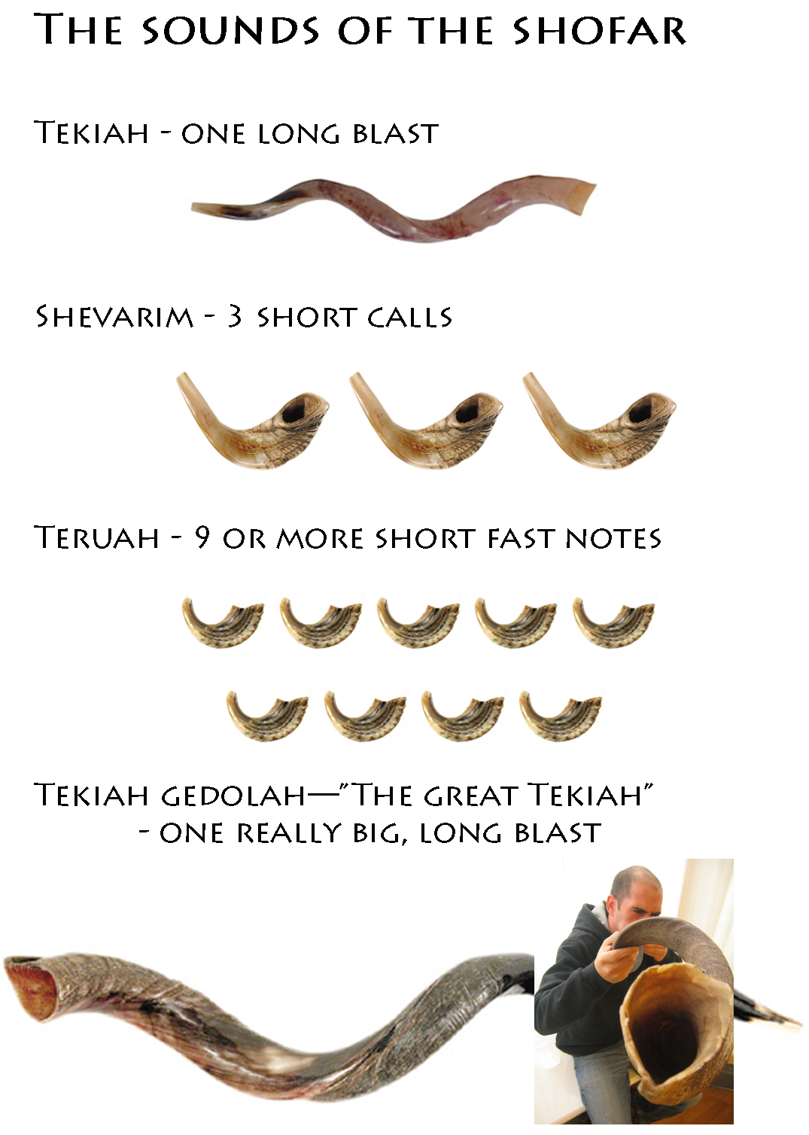

B”H Tic Tac Toe

Instructions: Split into two teams. Team has to answer questions correctly to put down a piece.

1. What do we celebrate on Rosh Hashana? (Birthday of world / Crowning Hashem
as King)

2. How many days of Rosh Hashana are there? (2)

4. Name 1 food we eat on Rosh Hashana: (apple, honey, carrots, round challah,

pomegranates, head of fish, new fruit.) ASK QUESTION A FEW TIMES.

5. How many blows do we hear on Rosh Hashana? (100)

6. How many different kinds of sounds can a shofar make? (3)

7. Where do we go to pray on Rosh Hashana? (synagogue)

8. What do we ask Hashem for on Rosh Hashana? (to become our king / sweet

new year)

9. On Rosh Hashana, we are _______ in the book of life. (written)

10. Rosh Hashana means___________________? (head of the year)

11. Why do we eat apple in honey? (to have a sweet new year!)

12. After looking at what we did in the past year, on Rosh Hashana, we
add___________ for the new year. ( more mitzvot)

13. A shofar comes from a ___________ (ram)

14. We wish everyone we see a ______ (Happy and sweet new year)

15. Before Rosh Hashana comes in, girls and women do what? (light candles)

16. The pomegranate has many seeds which reminds us of what? (many mitzvoth
we want to do in the new year)

17. The Shofar’s sound tells us that today, we are anointing___________ as king.
(Hashem)

18. In kids program, we learned all about which holiday? (rosh hashana)

19. Which special prayers do we say on Rosh HaShana? (Unesana Tokef, U’teshuva..., Avinu Malkeinu...)

