…

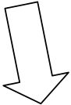
RACE THROUGH THE HOLIDAYS

Booth 3:
Make a Shana Tova card 
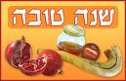

Booth 2:
Blow the shofar 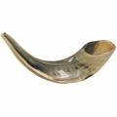
Booth 4:
Find the food that we eat on Rosh Hashana. 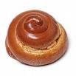

Booth 5:
Write a New Year’s wish on the Western Wall
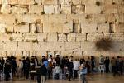
Booth 6:
Shake a Lulav and Etrog and don’t forget the Bracha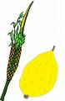
Booth 7:
Run to the Ark, kiss the Torah and answer a question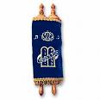
Booth 1:
Dip the apple in the honey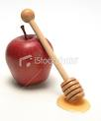

Booth 8:
Fill out the Yom Kippur sheet
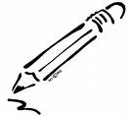

RACE THROUGH THE HOLIDAYS

…

Booth 3:
Make a Shana Tova card

Booth 2:
Blow the shofar
Booth 4:
Find the food that we eat on Rosh Hashana.

Booth 5:
Write a New Year’s wish on the Western Wall
Booth 6:
Shake a Lulav and Etrog and don’t forget the Bracha
Booth 7:
Run to the Ark, kiss the Torah and answer a question
Booth 1:
Dip the apple in the honey

Booth 8:
Fill out the Yom Kippur sheet

