Nissan 2 Lesson Plan
From:
Articles: “the escape hatch” and “the kabbalah of the seder plate”
Homework Review:

Stop:
We will experience this!!!!
Haggada – telling. Ourselves, our children, our friends….t ell and retell every year..

Story of “vehigadetah levincha” (Rebbe telling Rabbi – “here is an extra dollar for ‘vehigadeta levincha’ – the Rebbes concern…)

OUR OWN EGO gets in the way of us NOT experiencing a “release”
Like the tension in a relationship… there might be a way to break out, but our ego gets in the way, etc. …

LETS FIND A WAY OUT!!!

Lecture
Tell it with food
Wine:
Slavery: blood (middle ages – no because of libels…) of beaten by egyptians
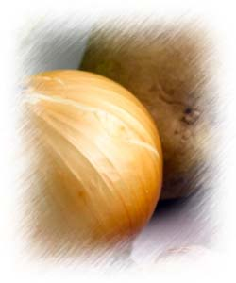
Freedom: smear blood on door posts…
Salt-Water
Slavery: karpas is to get kids to ASK. Saltwater is tears…
Freedom: salt water of sea of reads – when we were FINALLY liberated.
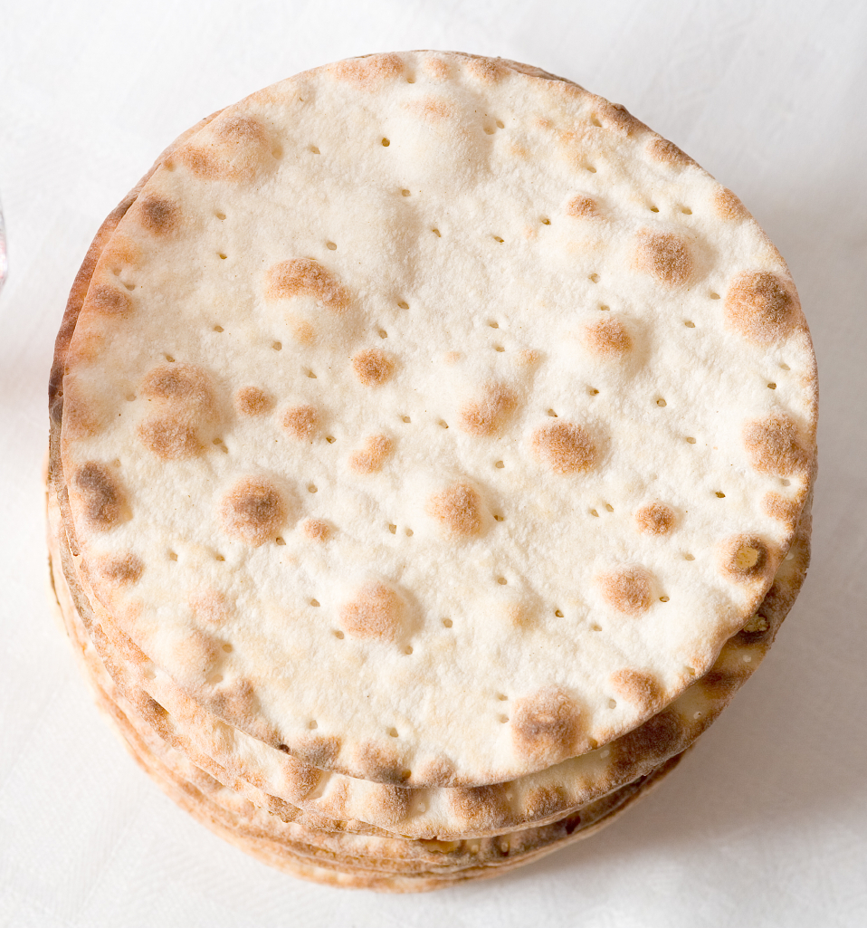
Matzah
Slavery: “bread of affliction” – see in British Museaum – loaves of Egyptian bread… thinck round bread for wealthy. Gave slaves, quick to eat.
Freedom: way out , rushing to freedom.
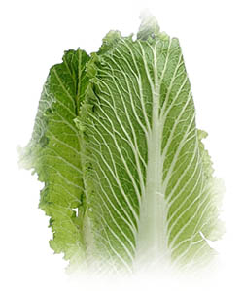
Lettuce
Slavery: greet-white stalk which is very bitter…
Freedom: sweet crisp… truly appreciate “free!!!” BECAUSE we were slaves…
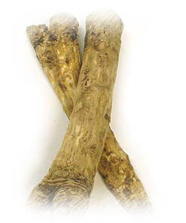
Bitter Herbs
Slavery: bring us to TEARS
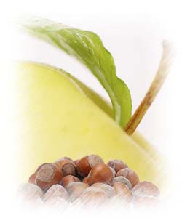
Charoset
Slavery: remind us of mud they made bricks with. (british museaum, see the mud brick with straw still embedded!
Freedom: sweetness that a slave would never taste!!!

Bone & Egg
Holy Temple:
Pssover lamb would be sacrificed each year only in TEMPLE (zecher!)
Egg – the festive sacrifice which was brough every shalosh regalim.

We always have some “zecher” – like break glass at the chasunah!

Chametz vs. Matzah.

Chametz Matzah
Leavened Bread Unleavened Bread

ingredients

letters

The hey – has an opening. I need to FLATTEN myself, EMPTY myself out, BITTUL…. In order to ‘escape”.

Soooo…. Yes – cleaning a whole house – IF I AM DOING G-DS WILL, is EXTREMELY liberating!!! (doing my own cleaning whenever I decided is NERVERACKING because I’ll be second guessing myself, is now the time? Is this how? When?). but doing G-ds will, letting go of my own plans, control… frees me up.

Example: afraid to jump my “ego-cliff” – but I didn’t realize once I jusmp – I’ll FLY FLY FLY!!!

“Bittul Gayt” – the chossid was all bittul. No ego. Nothing.

Example: taking Aydla’s purse and throwing it down – get rid of clutches on real life, only THEN can we dance, get uplifted, eytc….

Usually – a prayer helps. “G-d help me be translucent. Help me get out of the way! Let it be G-d working through me!!!!”

So then when I deal with my child, I act not out of that monstrous power-struggle… but out of sheer humility…..

Home Work
Sell your chometz (literally – do the form on our website!)and also spiritually – get RID OF THE EGOOOO
Burn your chometz –(literally, bring the crumbs, join us to burn!) and spiritually – let’s dump all those clutches of control and our own ideas….. burn it all. Start fresh. LIBERATE MYSELF!!!

