Nissan
ניסן

Dates to Note
1 Nissan: Rosh Chodesh Nissan
13 Nissan: Search for Chametz
14 Nissan: Erev Pesach
15-16 Nissan: First 2 Days of Pesach
17-20 Nissan: Intermediate Days
21 Nissan: Last Days of Pesach
22 Nissan: Moshiach Feast

*11 Nissan: Birthday of the Rebbe

I. Liberation

Describe a moment that you have experienced: liberation, freedom, liberty, release…
________________________________________________________________________
________________________________________________________________________
What can stop us from feeling that “release”? __________________________________ ________________________________________________________________________


II. Tell it with Food

Wine:
Slavery: ________________________________________________________________
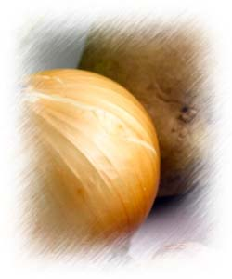
Freedom: _______________________________________________________________
Salt-Water
Slavery: ________________________________________________________________
Freedom: _______________________________________________________________
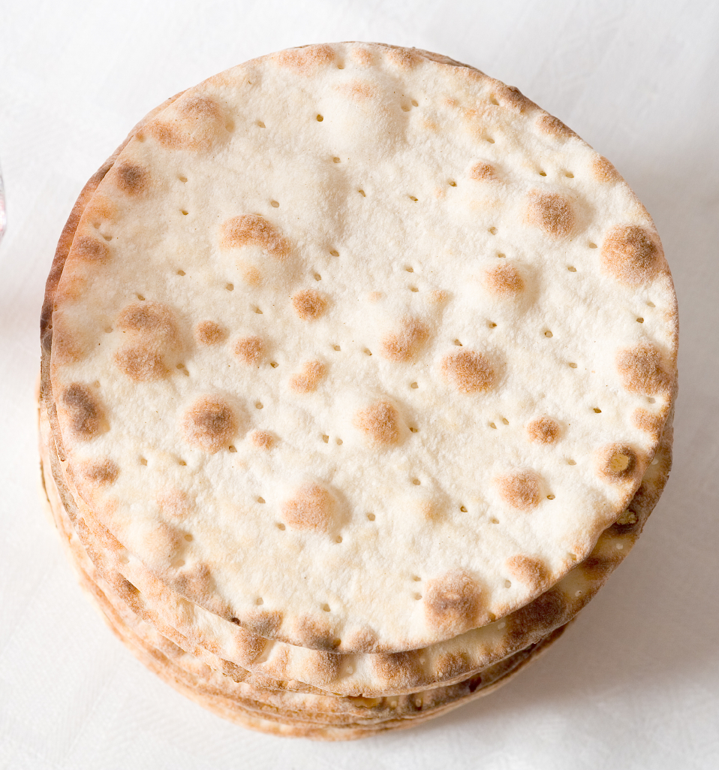
Matzah
Slavery: ________________________________________________________________
Freedom: _______________________________________________________________
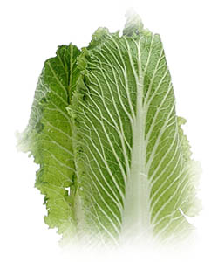
Lettuce
Slavery: ________________________________________________________________
Freedom: _______________________________________________________________
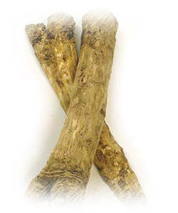
Bitter Herbs
Slavery: ________________________________________________________________
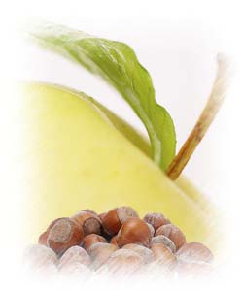
Charoset
Slavery: ________________________________________________________________
Freedom: _______________________________________________________________

Bone & Egg
Holy Temple: ____________________________________________________________

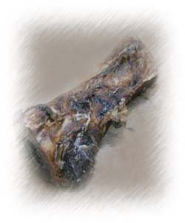
III. The Narrow Escape

Chametz חמץ - Matzah מצה -
Leavened Bread Unleavened Bread

ח ה

FAQ: HOW is CLEANING AN ENTIRE HOUSE FOR PESACH LIBERATING?????
________________________________________________________________________
________________________________________________________________________

Story: The Rebbe’s Matzah-Delivery
________________________________________________________________________
________________________________________________________________________

The Joy and Liberation that comes from fulfilling a Divine Mission:
________________________________________________________________________
________________________________________________________________________

Homework:
________________________________________________________________________
________________________________________________________________________

