Shvat
שבט

Dates to Note
15 Shavat: Tu B’Shvat, New Year for Trees

*10 Shvat: Yartzeit of Previous Chabad Rebbe
*22 Shvat: Yartzeit of Rebbetzin Chaya Mushka

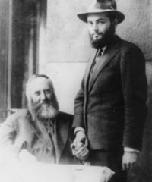
The 10th of Shvat: _____________________________________________ ____________________________________________________________ ____________________________________________________________ ____________________________________________________________

I. Title

Think of 7 things that may come up on a typical day that stop you from feeling "spiritually uplifted"... _____________________________________________________
________________________________________________________________________

II. New Year for Trees

Deuteronomy: Chapter 8
7. For the Lord your God is bringing you to a good land, a land with brooks of water, fountains and depths, that emerge in valleys and mountains,
8. a land of wheat and barley, vines and figs and pomegranates, a land of oil producing olives and honey, ח אֶרֶץ חִטָּה וּשְׂעֹרָה, וְגֶפֶן וּתְאֵנָה וְרִמּוֹן; אֶרֶץ-זֵית שֶׁמֶן, וּדְבָשׁ.
9. a land in which you will eat bread without scarcity, you will lack nothing in it, a land whose stones are iron, and out of whose mountains you will hew copper.
10. And you will eat and be sated, and you shall bless the Lord, your God, for the good land He has given you.

Celebrating “Tu B’Shvat”: ___________________________________________________ _______________________________________________________________________

Boruch ata ad-onay elo-hey-nu melech haolam borey pri haeitz
Boruch ata ado-nay elo-heinu melech haolam she-he-chiyanu vekiyemanu vehigiyanu lazman hazeh.
(ChabadofOxnard.org – Library – Classic Texts – Prayers – Blessings after Certain Foods.)

Land Flowing with Milk & Honey
Rami Bar Yechezkel once came to Bnei Brak and saw goats grazing under a fig tree. Honey was dripping from the figs and milk from the goats and they became intermingled. He said: “Behold, a land flowing with milk and honey!” (Kesubbos 111b)
III. The Kabbala of Fruit
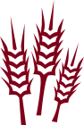
Wheat
According to Torah: Wheat is the mainstay of the human diet.
“…and bread which sustains man’s heart…” (Psalms 104:15)

I feed my divine soul & aspirations, the essence of my humanity.
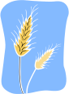
Barley
Torah regards barley as a typical animal food.
“And the barley and the straw for the horses…” (I Kings 5:8)

I nourish and develop my animal soul, with self confidence, courage, and perseverance. I weed out the selfish & profane.

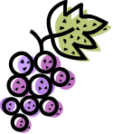
Grape
Grape=Wine=Joy & Revelation.
“…my wine, which makes joyous G-d and men.” (Judges 9:13)
“When wine enters, the concealed emerges.” (Talmud)

I remain joyous in order to allow both of my souls to shine.

Fig
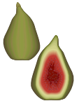
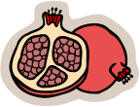
The fig is the fruit of the Tree of Knowledge of Good and Evil – the fruit of which Adam and Eve tasted, thereby committing the first sin in history.

I am completely involved and I am one with what I am doing.

Pomegranate
The pomegranate represents the paradox of how an individual may be empty and, at the same time, be full of good deeds as a pomegranate.
“Even the empty ones amongst you are full of good deeds as a pomegranate [is full of seeds].” (Talmud)

I have the capacity to overreach myself and act in a way that surpasses what I believe is my full potential.

Olive

Just like an olive, which yields its oil only when pressed, so too, do we yield what is best in us only when pressed between the millstones of life and the counterforces of a divided self. – The Sages

I grow from my struggles, I shine during difficult moments.

Date
The Date represents perfection, peace & tranquility.
“The tzaddik (perfectly righteous person) shall bloom as the date palm.” (Psalms 92:13)

I find comfort in the tranquil perfection that resides at the core of my soul.

Homework:
_____________________________________________________________________________________
_____________________________________________________________________________________

