Shvat
שבט

Dates to Note
15 Shavat: Tu B’Shvat, New Year for Trees

*10 Shvat: Yartzeit of Previous Chabad Rebbe
*22 Shvat: Yartzeit of Rebbetzin Chaya Mushka

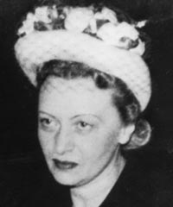
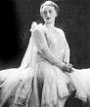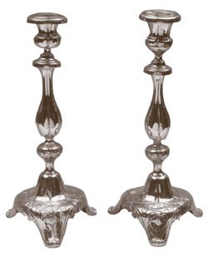

I. Hidden

Can a woman be a Rabbi? Does traditional Judaism not trust the woman? Is she to be kept “hidden”? ___________________________________________________________ ________________________________________________________________________
Why does Halacha* (Jewish Law) not permit a man to shake a woman’s hand? ________ ________________________________________________________________________
Why are the roots of a tree “hidden”? Why are the seed in a fruit “hidden”?
________________________________________________________________________
________________________________________________________________________

II. Jewish Modesty

ה לֹא-יִהְיֶה כְלִי-גֶבֶר עַל-אִשָּׁה, וְלֹא-יִלְבַּשׁ גֶּבֶר שִׂמְלַת אִשָּׁה: כִּי תוֹעֲבַת ה אֱלֶֹיךָ, כָּל-עֹשֵׂה אֵלֶּה.
“Women’s Liberation” has brought about the degradation of women, by demeaning the unique talents and worth of women, suggesting that the only worthwhile choice is to act like someone else…” (From Sicha Vav Tishre 5745)
“The Kabbalists teach that a woman's body has a deeper beauty because her soul comes from a higher place. For this reason her body must be kept discreetly covered.
In a world where the woman's body has been reduced to a cheap advertising gimmick, we need no proof for the truth of this wisdom. Where all is exposed, nothing is sacred. But that which is truly precious to us, we keep under wraps.” Rabbi Aron Moss, Sydney Australia
The Dress: ______________________________________________________________
________________________________________________________________________
________________________________________________________________________
Singing, Public role: ______________________________________________________ ________________________________________________________________________

A Woman’s Hair: _________________________________________________________ ________________________________________________________________________

Intimacy: _______________________________________________________________ ________________________________________________________________________

The First Woman – Chava
________________________________________________________________________________________________________________________________________________

The “Secular” Approach: __________________________________________________ ________________________________________________________________________

Psalms “Kol kevuda bas melech pnima” – “All the honor of the daughter of the King is within.”

“Sip of Inspiration”:
________________________________________________________________________
________________________________________________________________________

III. Rebbetzin Chaya Mushka

Rebbetzin Chaya Mushka (Moussia) Schneerson was born in Babinovitch, near the Russian city of Lubavitch, on Shabbat, the 25th of Adar, in 1901. She was the second of three daughters of the sixth Lubavitcher Rebbe, Rabbi Yosef Yitzchak and his wife, Rebbetzin Nechama Dina Schneersohn…
…Chaya means life; Mushka, an aromatic spice.
…The Rebbetzin passed away on Wednesday, the 22nd of Shevat, 1988, after a brief illness. Her burial took place a few hours afterwards at the Chabad cemetery in Queens, New York.
…Shortly before her passing, Rebbetzin Chaya Mushka requested a glass of water. After reciting the blessing, "...by Whose word all things come into being," she returned her soul to her Maker.

“Sip of Inspiration”:
________________________________________________________________________
________________________________________________________________________

Homework:
________________________________________________________________________
________________________________________________________________________

