Shvat
שבט

Dates to Note
15 Shavat: Tu B’Shvat, New Year for Trees

*10 Shvat: Yartzeit of Previous Chabad Rebbe
*22 Shvat: Yartzeit of Rebbetzin Chaya Mushka

I. Influence

Are there people in my life (any age) that I wish to influence? Is it okay or do I allow others to ‘do their own thing’? How can I inspire someone? __________________________________________
________________________________________________________________________________

II. New Year for Trees

15th of Shevat: ____________________________________________________________________
________________________________________________________________________________

Ma’aser: Tithing: _________________________________________________________________ ________________________________________________________________________________

Orlah: The prohibition of benefiting from the fruit of a tree for the first three years after it is planted. ________________________________________________________________________________
________________________________________________________________________________

III. Shvat – In Kabbala
- The Letter of the Month: צ: ________________________________________________ _________________________________________________________________________
- Mazel: דלי - Aquarius – the pail: _________________________________________ __________________________________________________________________________
- The Speech of Moshe: ________________________________________________________ __________________________________________________________________________

- The Prophecy of Bilam:
Numbers: Chapter 24
17. I see it, but not now; I behold it, but not soon. A star has gone forth from Jacob, and a staff
will arise from Israel which will crush the princes of Moab and uproot all the sons of Seth. יז אֶרְאֶנּוּ וְלֹא עַתָּה, אֲשׁוּרֶנּוּ וְלֹא קָרוֹב; דָּרַךְ כּוֹכָב מִיַּעֲקֹב, וְקָם שֵׁבֶט מִיִּשְׂרָאֵל
__________________________________________________________________________ __________________________________________________________________________

IV. The Tree

Deuteronomy: Chapter 20
19. When you besiege a city for many days to wage war against it to capture it, you shall not destroy its trees by wielding an ax against them, for you may eat from them, but you shall not cut them down. Is the tree of the field a man, to go into the siege before you? כִּי הָאָדָם עֵץ הַשָּׂדֶה

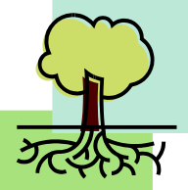
Roots: _____________________________________________________________ ___________________________________________________________________
Trunk, Branches, Leaves: ______________________________________________
___________________________________________________________________
Fruit, Seed: _________________________________________________________
___________________________________________________________________

“Devarim Hayotzim min halev…” “Words that come from the heart, enter the heart…” __________ _________________________________________________________________________________

“Sip of Inspiration”: _____________________________________________________________
_______________________________________________________________________________

Theme of the Month of Shevat: _______________________________________________________ ________________________________________________________________________________

Homework:______________________________________________________________________ ________________________________________________________________________________

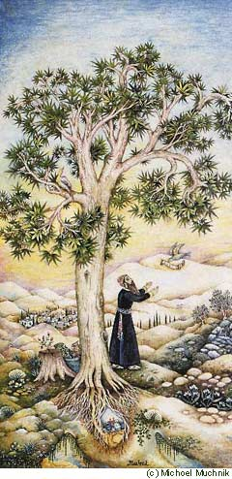
Talmud, Taanit 5b A man was travelling through the desert, hungry, thirsty, and tired, when he came upon a tree bearing luscious fruit and affording plenty of shade, underneath which ran a spring of water. He ate of the fruit, drank of the water, and rested beneath the shade.
When he was about to leave he turned to the tree and said: 'Tree, oh, tree, with what should I bless you?
"Should I bless you that your fruit be sweet? Your fruit is already sweet.
"Should I bless you that your shade be plentiful? Your shade is plentiful. That a spring of water should run beneath you? A spring of water runs beneath you."
"There is one thing with which I can bless you: May it be G-d's will that all the trees planted from your seed should be like you..."

